## LAB ASSIGNMENT DATABASE LAB

**DUE DATE: 04/04/2022**

## TKM COLLEGE OF ENGINEERING

### GROUP 6

1. Consider the database for a banking enterprise. Write the queries for the below questions.
   1. Create the followingtables

|  |  |
| --- | --- |
| Table | Attributes |
| Customer | cid,cname,loc,sex,dob |
| Bank_brn | bcode,bloc,bsate |
| Deposit | Dacno,dtype,ddate,damt |
| Loan | Lacno,ltype,ldate,lamt |
| Accounts_in | Bcode,cid |
| Depositor | cid,dacno |
| Borrower | cid,lacno |

## Script:

* 1. Include necessary constraints.
  2. Tables are created under the database ‘bank’
  3. Display all the tables in bank database
  4. Describe the structure of all tables
  5. Delete tables

create database bank; use bank;

CREATE TABLE Customer( cid varchar(255)NOT NULL,

cname varchar(255)NOT NULL, loc varchar(255)NOT NULL, sex varchar(255)NOT NULL, dob varchar(255)NOT NULL, primary key(cid)

);

INSERT INTO Customer(cid,cname,loc,sex,dob)

VALUES ('1','raising arizona','sgh','f','20/3/00'),

('2','spiderman','kkz','m','5/3/00'),

('3','wonder boys','fds','f','24/3/00'),

('4','fargo','64w','m','23/3/00'),

('5','raising arizona','uy','f','25/3/00'),

('6','wonder boys','utds','m','16/3/00');

CREATE TABLE Bank_brn( bcode varchar(255)NOT NULL, bloc varchar(255)NOT NULL, bsate varchar(255)NOT NULL,

primary key(bcode)

);

INSERT INTO Bank_brn(bcode,bloc,bsate) VALUES ('5','raising arizona','sgh'),

('11','spiderman','kkz'),

('10','wonder boys','fds'),

('9','fargo','64w'),

('6','raising arizona','bgf');

CREATE TABLE Deposit(

Dacno varchar(255)NOT NULL, dtype varchar(255)NOT NULL, ddate varchar(255)NOT NULL, damt varchar(255)NOT NULL, primary key(Dacno)

);

INSERT INTO Deposit(Dacno,dtype,ddate,damt) VALUES ('1','raising arizona','20/3/00','dcs'),

('2','spiderman','5/3/00','wdw'),

('3','wonder boys','24/3/00','dwd'),

('4','fargo','23/3/00','dsc'),

('5','raising arizona','25/3/00','csdc');

CREATE TABLE Loan(

Lacno varchar(255)NOT NULL, ltype varchar(255)NOT NULL, ldate varchar(255)NOT NULL, lamt varchar(255)NOT NULL, primary key(Lacno)

);

INSERT INTO Loan(Lacno,ltype,ldate,lamt) VALUES ('1','raising arizona','20/3/00','dcs'),

('2','spiderman','5/3/00','wdw'),

('3','wonder boys','24/3/00','dwd'),

('4','fargo','23/3/00','dsc'),

('5','raising arizona','25/3/00','csdc');

CREATE TABLE Accounts_in( Bcode varchar(255)NOT NULL, cid varchar(255)NOT NULL,

FOREIGN KEY (cid) REFERENCES Customer(cid), FOREIGN KEY (Bcode) REFERENCES Bank_brn(Bcode)

);

CREATE TABLE Depositor( cid varchar(255)NOT NULL,

dacno varchar(255)NOT NULL,

FOREIGN KEY (cid) REFERENCES Customer(cid), FOREIGN KEY (dacno) REFERENCES Deposit(dacno)

);

CREATE TABLE Borrower( cid varchar(255)NOT NULL, lacno varchar(255)NOT NULL,

FOREIGN KEY (cid) REFERENCES Customer(cid), FOREIGN KEY (lacno) REFERENCES Loan(lacno)

);

select * from loan; select * from Customer; select * from Bank_brn; select * from Deposit;

SHOW TABLES;

drop table Borrower;

**Result:** output is obtained successfully.

# output:

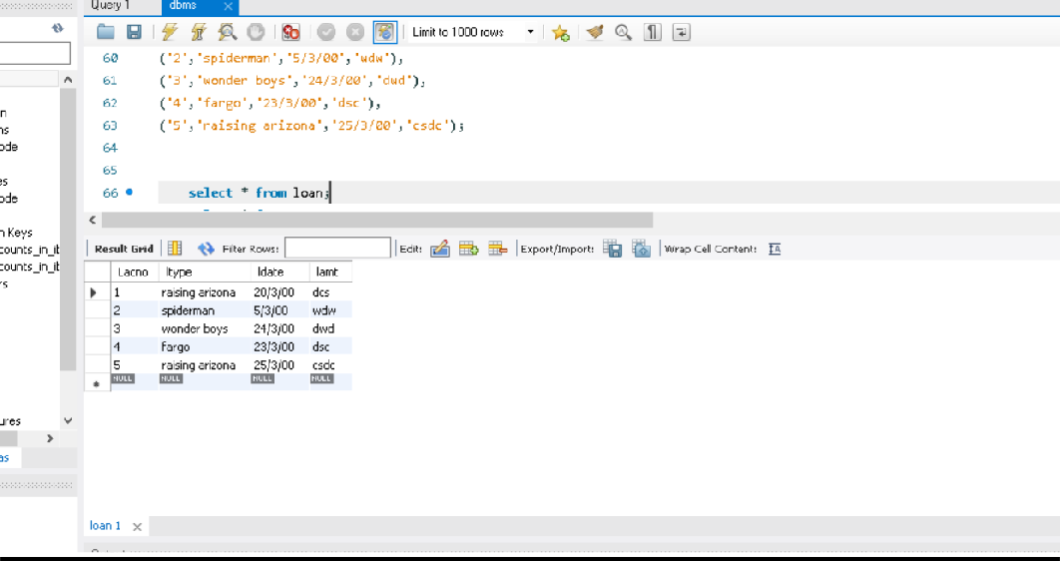

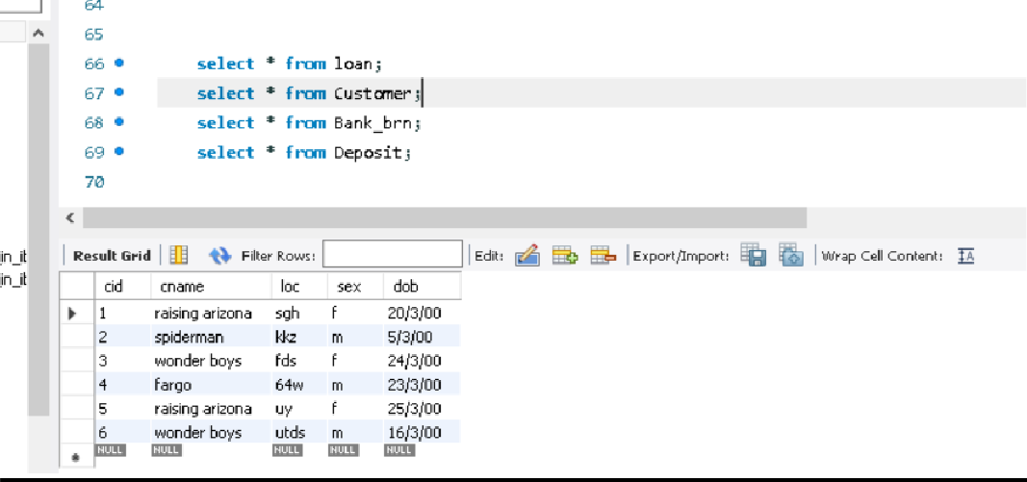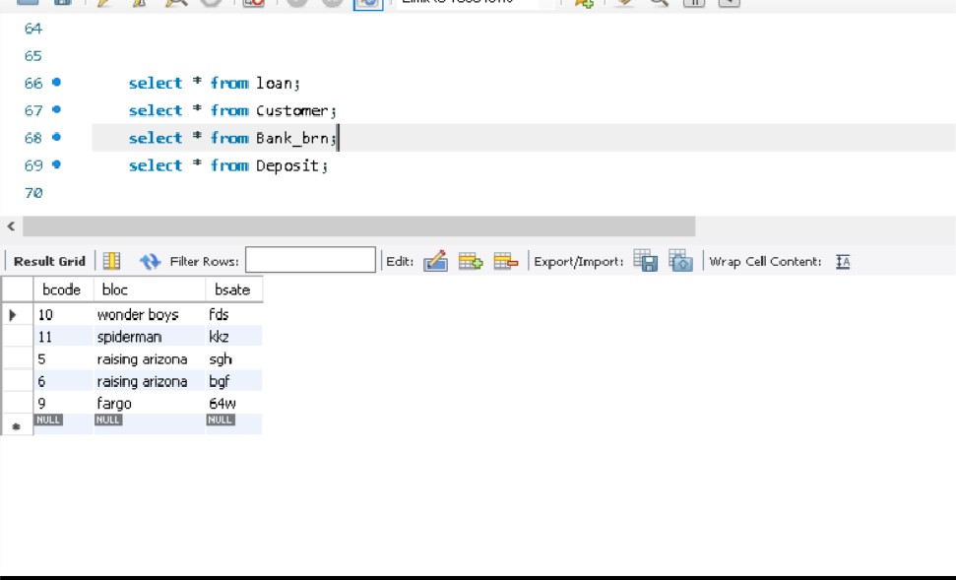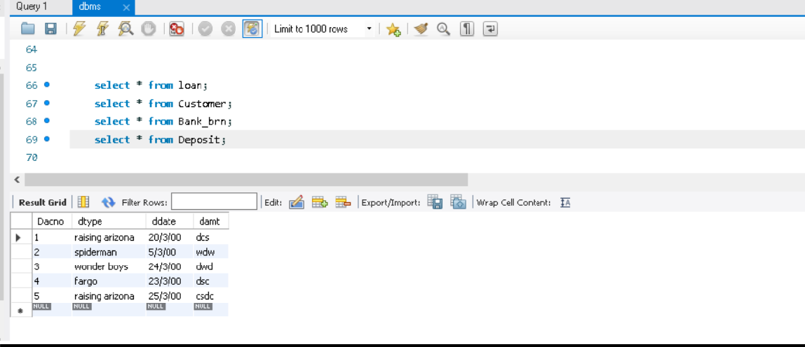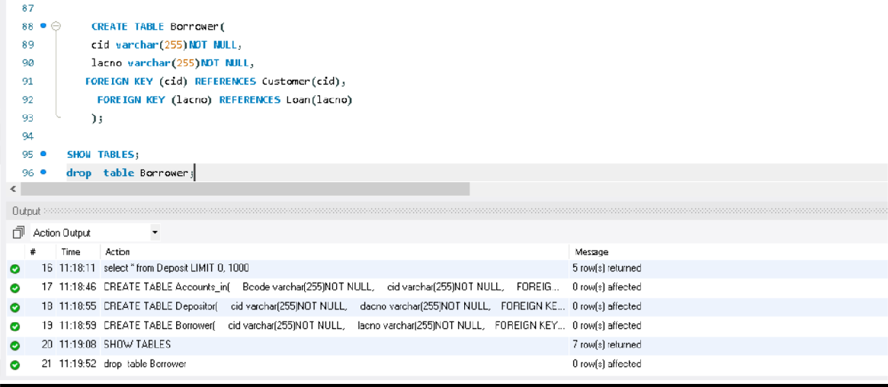

1. Consider the database for a college. Write the query for the following.

## Script:

* Insert at least 5 tuples into each table.
* List the details of students in the ascending order of date of birth
* Display the details of students from computer department
* List the faculties in the descending order of salary
* Display the total number of students in each department
* Display the total number of faculties in each department with salary greater than 25000

create database co; use co;

create table student1(

rollno int,

name varchar(20), dept varchar(20), dob date

);

INSERT INTO student1(rollno,name,dob,dept) values('101','Amit','2000-03-12','computer'); INSERT INTO student1(rollno,name,dob,dept) values('102','Suji','2000-08-02','computer'); INSERT INTO student1(rollno,name,dob,dept) values('103','Anu','1999-12-5','engineering'); INSERT INTO student1(rollno,name,dob,dept) values('104','Karthi','1998-09-24','maths'); INSERT INTO student1(rollno,name,dob,dept) values('105','Kevin','2001-06-30','engineering');

create table faculty( f_id int,

name varchar(20), dept varchar(20), salary int

);

INSERT INTO faculty(f_id,name,dept,salary) values('121','Arya','computer',20000); INSERT INTO faculty(f_id,name,dept,salary) values('122','Anoop','computer',15000); INSERT INTO faculty(f_id,name,dept,salary) values('123','Manju','engineering',45000); INSERT INTO faculty(f_id,name,dept,salary) values('124','Shiji','maths',20000); INSERT INTO faculty(f_id,name,dept,salary) values('125','Sabitha','engineering',35000);

select * from student1 order by dob asc;

select * from student1 where dept='computer'; select * from faculty order by salary desc;

select count(rollno),dept from student1 group by dept;

select count(f_id),dept,salary from faculty where salary>25000;

**Result:** output is obtained successfully.

# output:

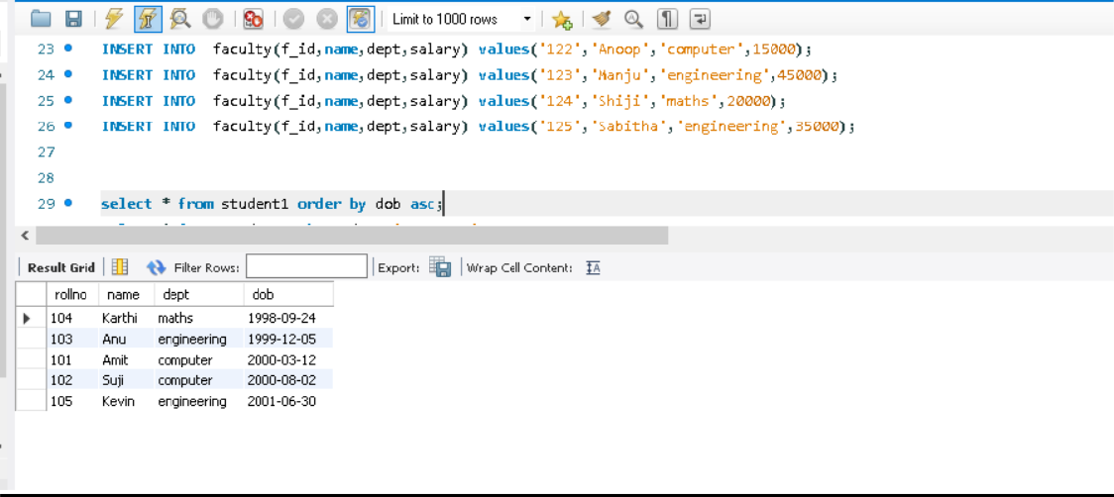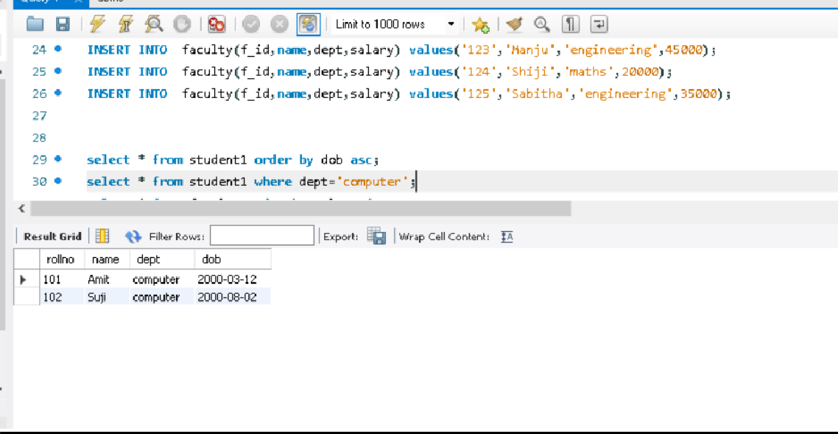

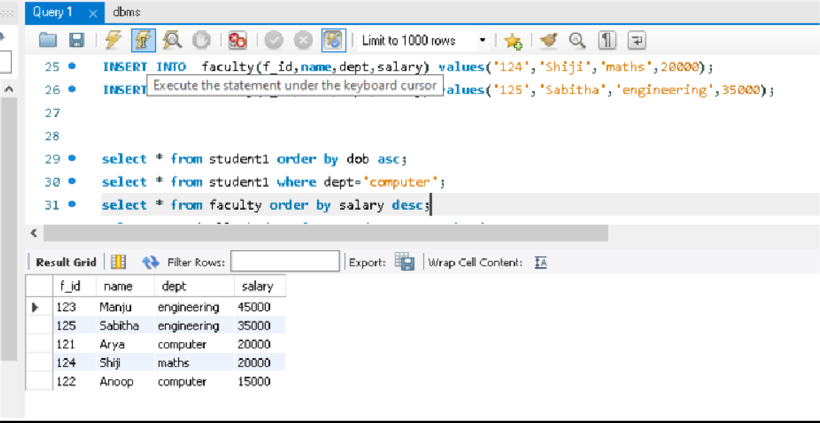

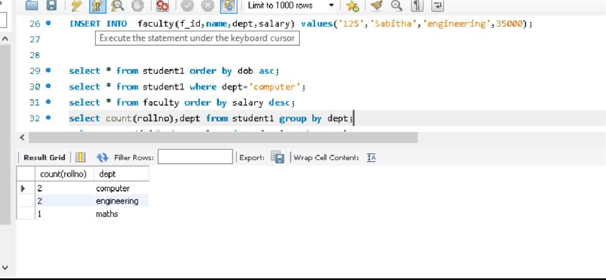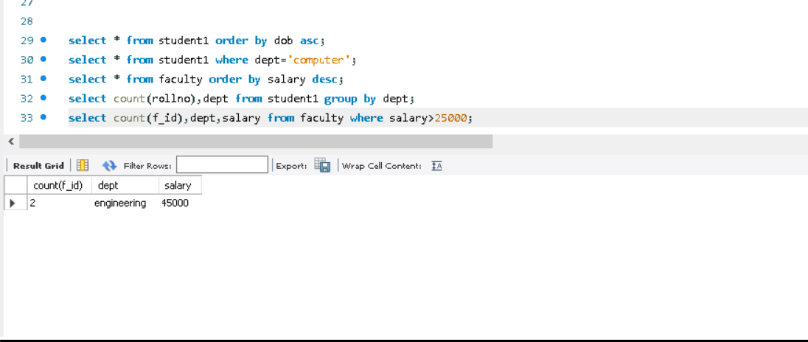

### MANDATORY ASSIGNMENT FOR ALL GROUPS:

Queries using aggregate functions(COUNT,AVG,MIN,MAX,SUM),Group by,Order by,Having.

|  |  |  |  |
| --- | --- | --- | --- |
| E_ID | E_NAME | AGE | SALARY |
| 101 | ANU | 22 | 9000 |
| 102 | Shane | 29 | 8000 |
| 103 | Rohan | 34 | 6000 |
| 104 | Scott | 44 | 10000 |
| 105 | Tiger | 35 | 8000 |
| 106 | Alex | 27 | 7000 |
| 107 | Abhi | 29 | 8000 |

* 1. Create Employee table containing all Records.
  2. Count number of employee names from employee table.
  3. Find the Maximum age from employee table
  4. Find the Minimum age from employee table.
  5. Display the Sum of age employee table.
  6. Display the Average of age from Employee table
  7. Create a View for age in employee table
  8. Display views
  9. Find grouped salaries of employees.
  10. Find salaries of employee in Ascending Order
  11. Find salaries of employee in Descending Order

**Script:**

CREATE DATABASE EMPLOYEE; USE EMPLOYEE;

CREATE TABLE Employee( E_ID INT(25),

E_NAME VARCHAR(25), AGE INT(10),

SALARY FLOAT(10), PRIMARY KEY(E_ID)

);

INSERT INTO Employee VALUES (101,"ANU",22,9000); INSERT INTO Employee VALUES (102,"SHANE",29,8000); INSERT INTO Employee VALUES (103,"ROHAN",34,6000); INSERT INTO Employee VALUES (104,"SCOTT",44,10000); INSERT INTO Employee VALUES (105,"TIGER",35,8000); INSERT INTO Employee VALUES (106,"ALEX",27,7000); INSERT INTO Employee VALUES (107,"ABHI",29,8000);

SELECT * FROM Employee ; SELECT COUNT(*) FROM Employee;

SELECT MAX(AGE) FROM Employee; SELECT MIN(AGE) FROM Employee; SELECT SUM(AGE) FROM Employee; SELECT AVG(AGE) FROM Employee;

CREATE VIEW E_AGE AS

SELECT E_NAME,AGE FROM Employee; SELECT * FROM E_AGE;

SELECT E_NAME,SALARY FROM Employee GROUP BY E_NAME;

SELECT SALARY FROM Employee ORDER BY SALARY ASC;

SELECT SALARY FROM Employee ORDER BY SALARY DESC;

**Result:** output is obtained successfully.

# output:

