**PL/SQL**

1. **AIM:**

Given an integer i, write a PL/SQL procedure to insert the tuple (i, 'xxx') into a given relation

**CODE:**

create database studentdb;

use studentdb;

create table T2(rollno int,name varchar(10),primary key(rollno));

call stud('101','Stefi');

call stud('102','Sreelaya');

select * from T2;

**STORED PROCEDURE:**

CREATE DEFINER=`root`@`localhost` PROCEDURE `stud`(rollno int,name varchar(10))

BEGIN

insert into T2 values(rollno,name);

END

**OUTPUT:**

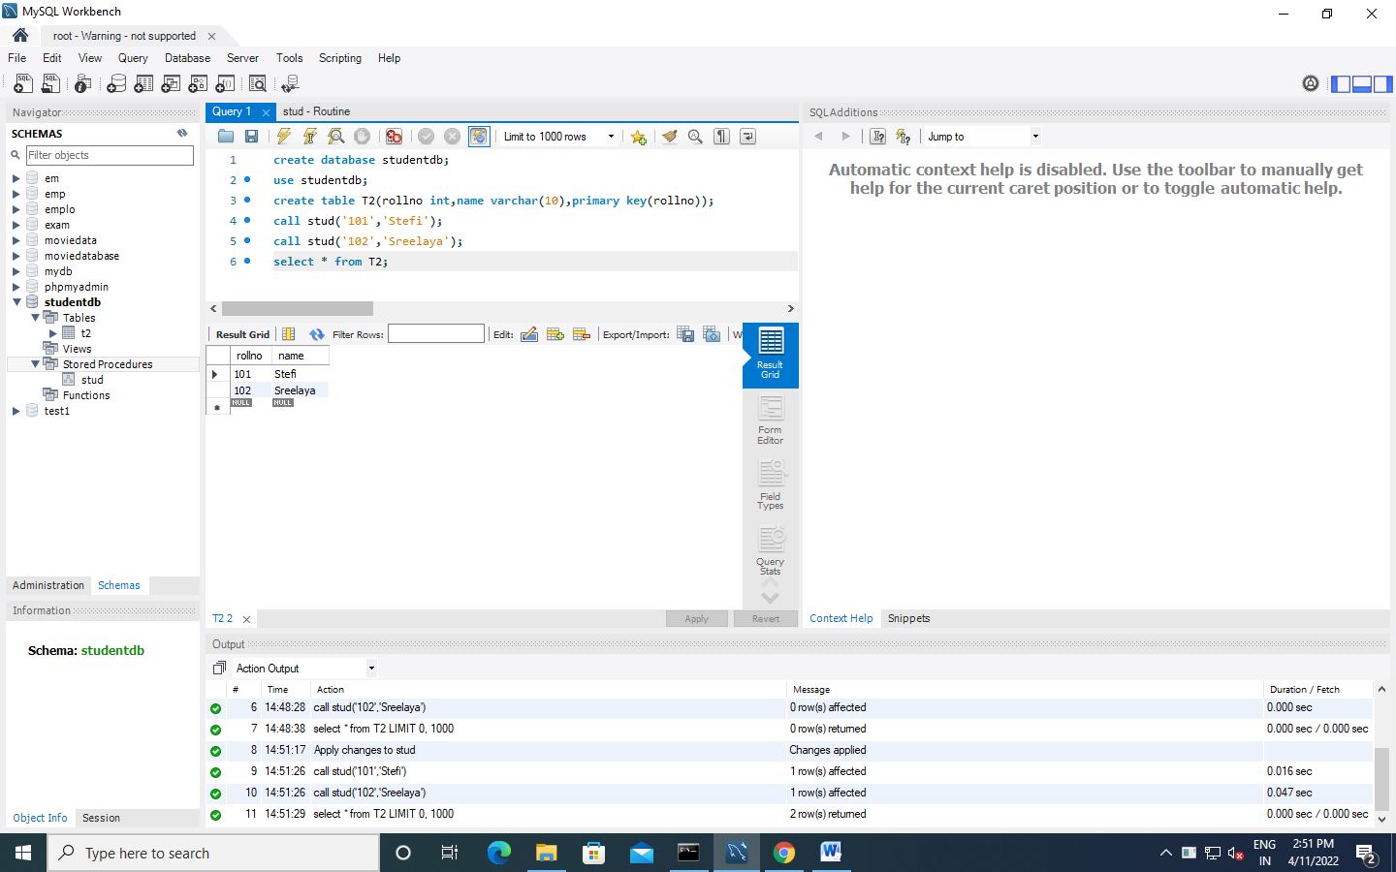

1. **AIM:**

**Write a PL/SQL block to calculate the incentive of an employee whose ID is 110**

**CODE:**

create database employeedb2;

use employeedb2;

create table E1(empid int,empname varchar(10),salary int,primary key(empid));

insert into E1(empid,empname,salary)values('110','Stefi',2000);

insert into E1(empid,empname,salary)values('111','Sreelaya',50000);

select * from E1;

select empid,empname,insentive(empid) from E1;

**FUNCTION:**

CREATE DEFINER=`root`@`localhost` FUNCTION `insentive`(empid int) RETURNS varchar(20) CHARSET latin1

BEGIN

DECLARE i VARCHAR(20);

IF (empid=110)

THEN SET i=3000;

END IF;

RETURN i ;

END

**OUTPUT:**

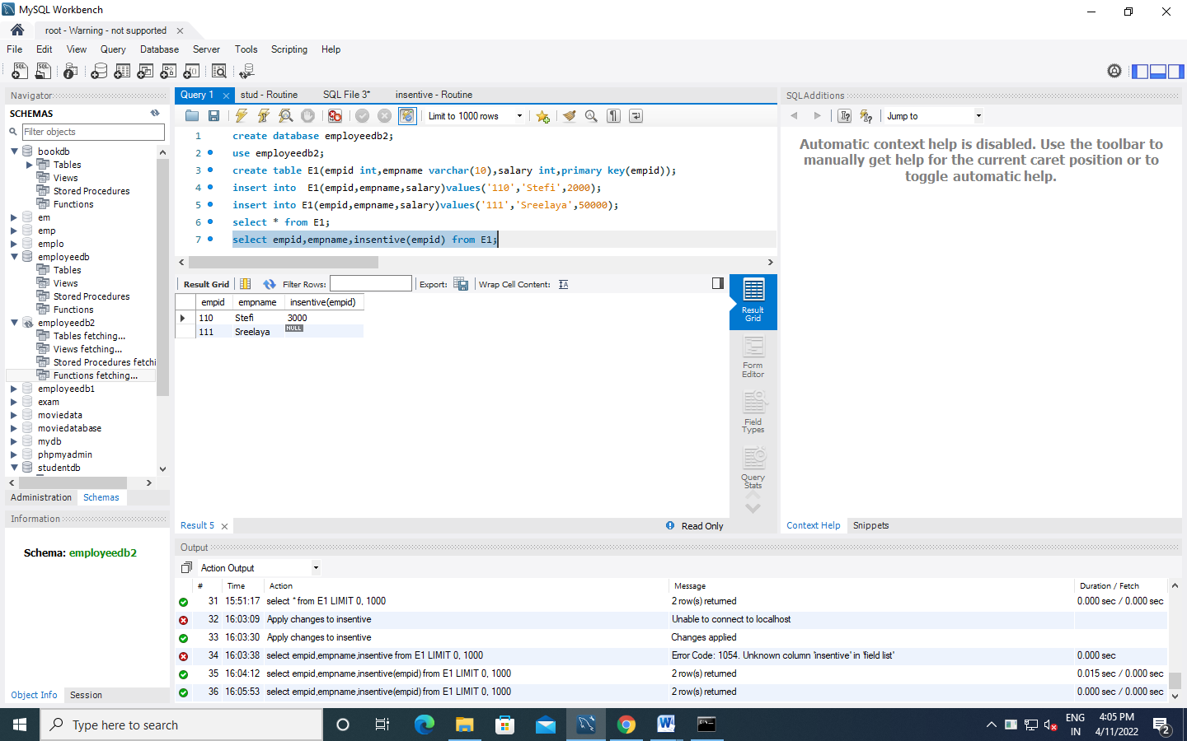

1. **AIM:Create the Book database and do the following: (Consider the attributes based on the question given)**

book(book_name, author_name, price,quantity)

1. Write a query to update the quantity by double in the table book.
2. List all the book_name whose price is greater than those of book named "Database for Dummies"
3. Retrieve the list of author_name whose first letter is ’a’ along with the book_name and price (Explore more about *Like* keyword)
4. Write a PL/SQL Procedure to find the total number of books of same author

create database books;

use books;

create table book_info(book_name varchar (20),author varchar(20),price int,quantity int);

insert into book_info values('randamoozham','MT',300,5);

insert into book_info values('ikigai','hector',500,7);

insert into book_info values('databse of dummies','xyz',250,7);

insert into book_info values('wings of flare','APJ',500,7);

insert into book_info values('oopol','MT',270,3);

select * from book_info;

**a)** set sql_safe_updates=0;

update book_info set quantity=quantity*2;

**b)** select book_name from book_info where price>(select price from book_info where book_name='databse of dummies');

**c)** select author,book_name,price from book_info where author like 'a%';

**OUTPUT**

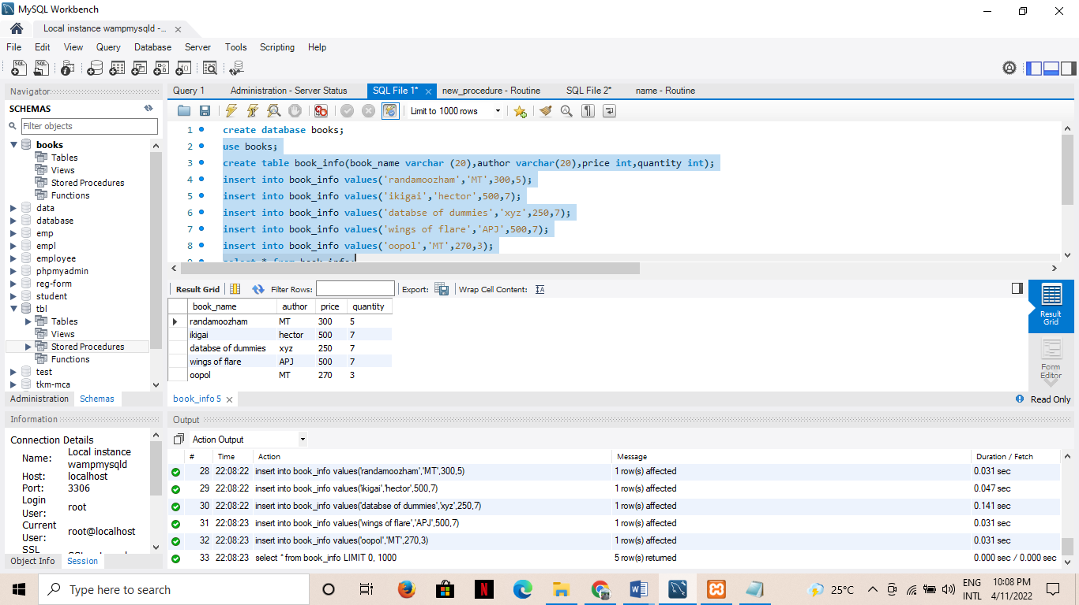

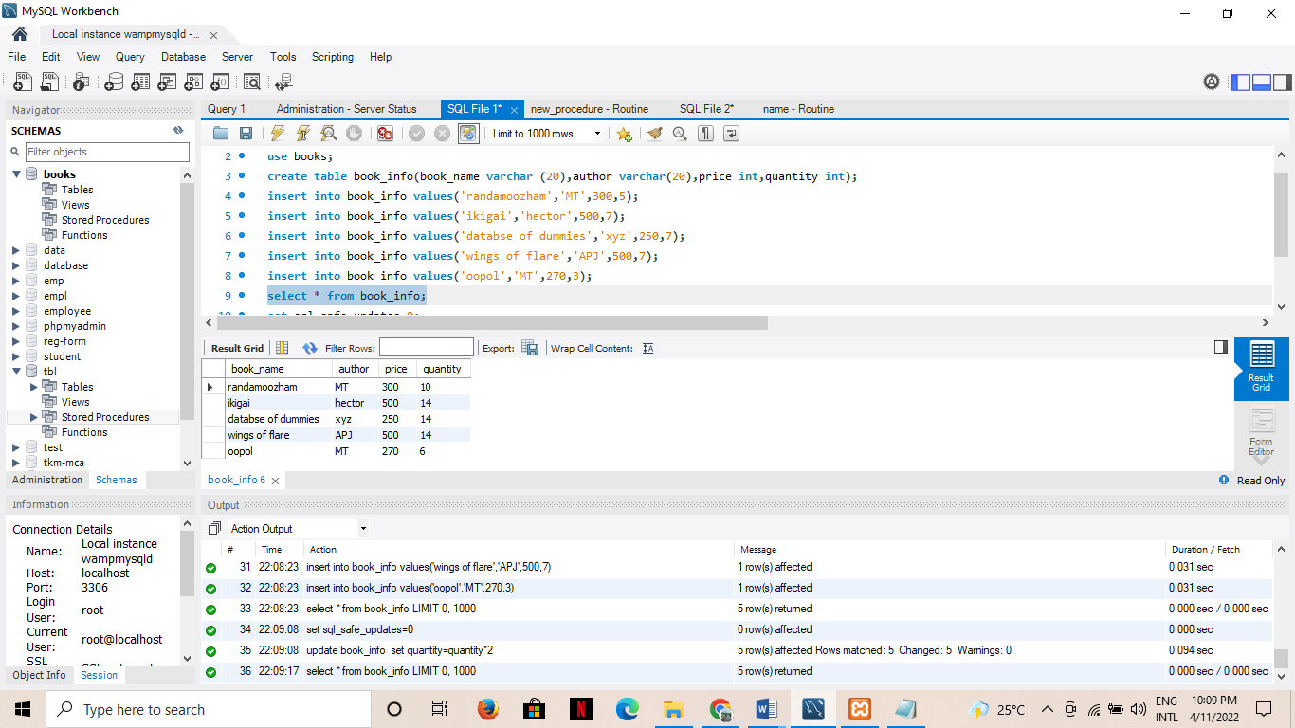

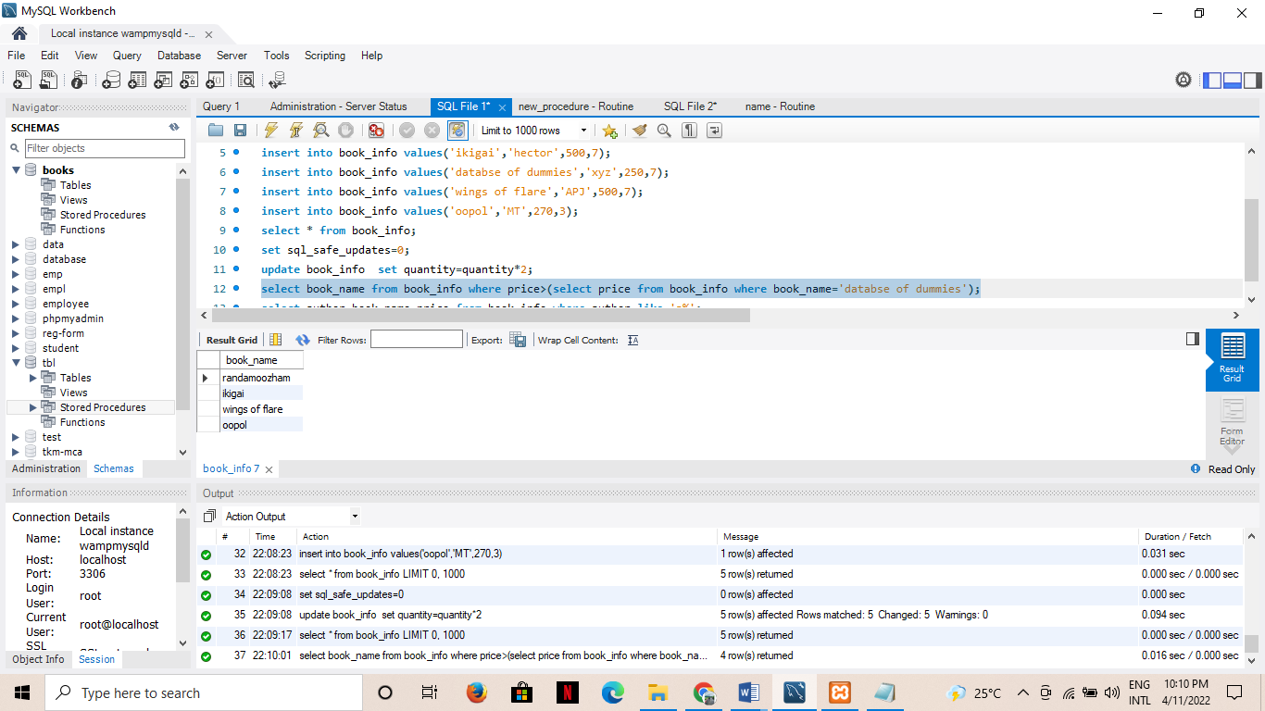

4)**AIM:**

**Create the Company database with the following tables and do the following:**

**Administration (employee_salary, development _cost, fund_ amount, turn_over,bonus)**

**Emp_details (emp_no, emp_name, DOB, address, doj, mobile_no, dept_no, salary).**

1. Calculate the total and average salary amount of the employees of each department.
2. Display total salary spent for employees.
3. Develop a PL/SQL function to display total fund_amount spent by the administration department

create database company;

use company;

CREATE TABLE Admins(

emp_sal double,

dvlp_cost double,

fund_amount double,

turn_over double,

bonus double);

CREATE TABLE Emp_details(

emp_no int,

emp_name varchar(20),

DOB date,

address varchar(20),

doj date,

mobile_no int8,

dept_no int,

salary double);

INSERT INTO Admins VALUES

(12000,25000,560000,65000,5000),

(70000,55000,860000,15000,1000),

(18000,45000,160000,75000,7000),

(10000,27000,520000,60000,5000),

(18000,27000,360000,35000,3000);

INSERT INTO Emp_details VALUES

(1,"sanal","1999-10-10","Street - 2 xyz","2020-10-10",9865986598,10,12000),

(2,"afy","1997-10-10","Street - 2 abc","2020-10-10",9865986598,10,12200),

(3,"don","1996-10-10","Street nhcjn","2020-10-10",9865986598,11,12500),

(4,"adarsh","1957-10-10","Street jdn","2020-10-10",9865986598,11,17200),

(5,"vyshnav","1948-10-10","gsffj","2020-10-10",9865986598,12,12090),

(6,"shibili","1988-10-10","Snsmk","2020-10-10-",9865986598,12,12050);

**a)** SELECT

dept_no,

avg(salary) 'Average salary',

sum(salary) 'Total Salary'

FROM Emp_details

GROUP BY dept_no;

**OUTPUT**

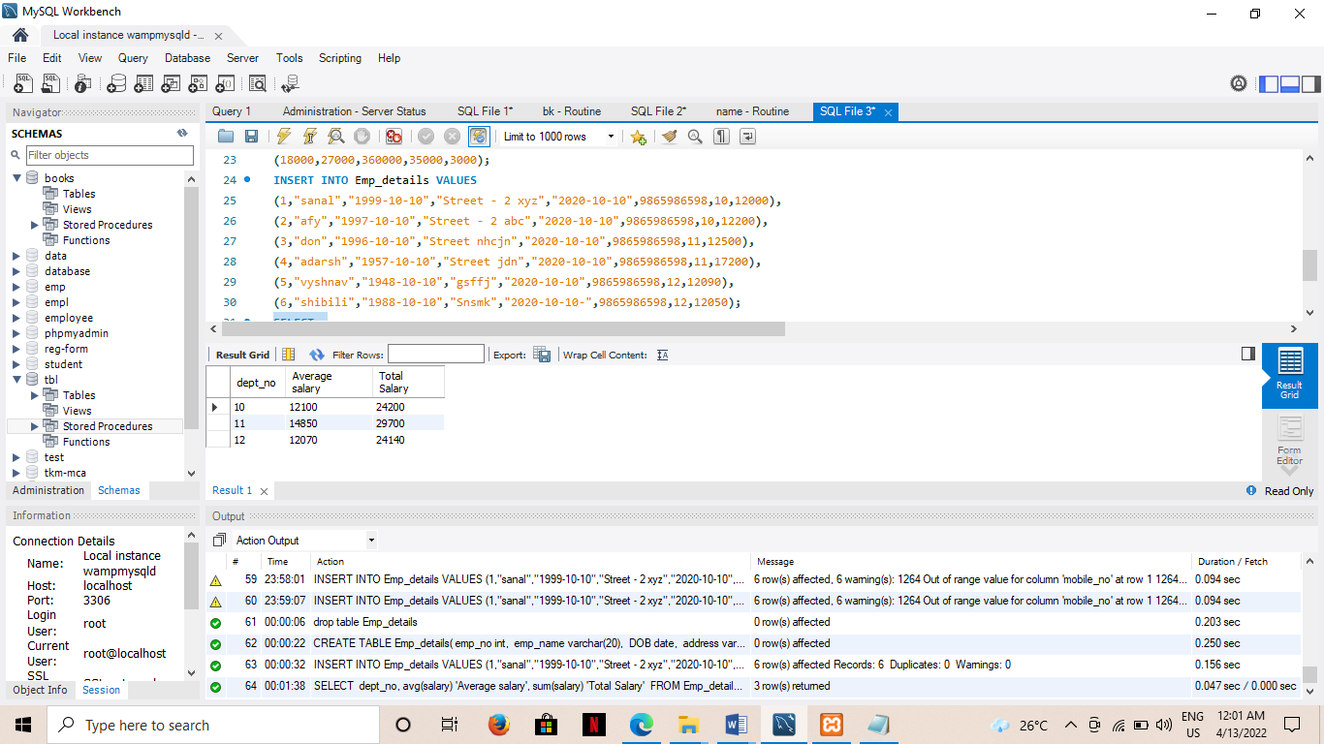

**b)** SELECT

sum(salary) 'SUM OF SALARY'

FROM Emp_details;

**OUTPUT**

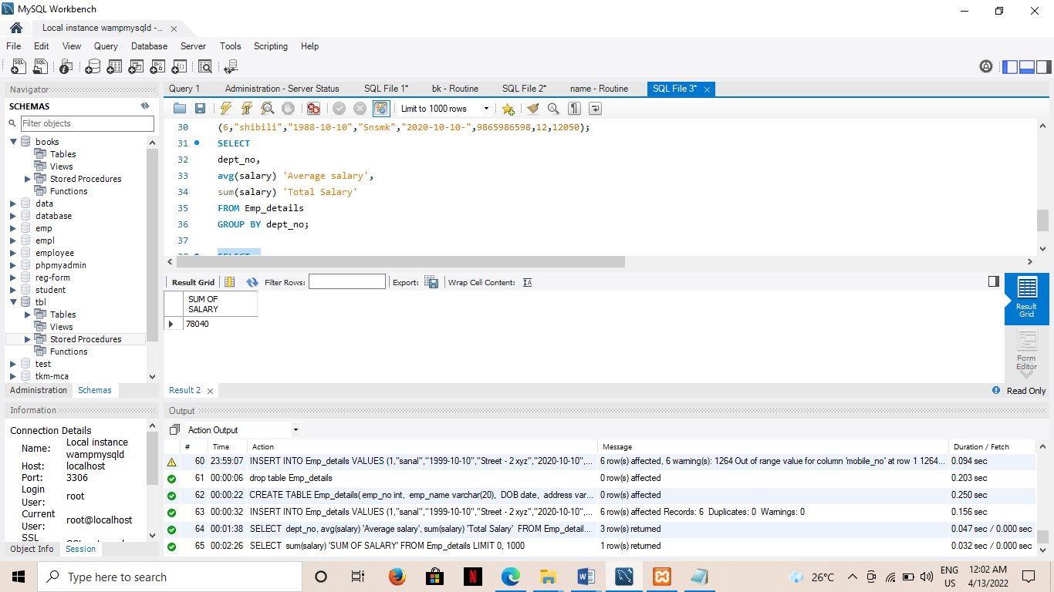

**c)**

**FUCTION**

CREATE DEFINER=`root`@`localhost` FUNCTION `fund_total`() RETURNS double

BEGIN

DECLARE f DOUBLE;

DECLARE i DOUBLE;

SELECT SUM(fund_amount) INTO f

FROM Admins;

RETURN f;

END

**FUNCTION CALL**

SELECT fund_total() from Admins LIMIT 1;

**OUTPUT**

