**PROGRAM -1**

**AIM:** To create a database containing table employee with employee details.Write PLSQL to update the experience level of employee as beginner,intermediate and advanced.

**CODE:**

create database company;

use company;

create table emp(emp_id int primary key,emp_name varchar(20),salary varchar(20));

create table dept(dept_id int primary key,emp_id int,designation varchar(20),experience int(10) ,foreign key(emp_id) references emp(emp_id));

insert into emp(emp_id,emp_name,salary)values(101,'Shibu',25000);

insert into emp(emp_id,emp_name,salary)values(102,'Raju',35000);

insert into emp(emp_id,emp_name,salary)values(103,'Shanku',50000);

select * from emp;

insert into dept(dept_id,emp_id,designation,experience)values(201,101,'Peon',2);

insert into dept(dept_id,emp_id,designation,experience)values(202,102,'Clerk',6);

insert into dept(dept_id,emp_id,designation,experience)values(203,103,'Manager',12);

select * from dept;

create table level(emp_id int,dept_id int,experience_level varchar(20),foreign key(emp_id) references emp(emp_id),foreign key(dept_id) references dept(dept_id));

call exp(2,101,201);

call exp(6,102,201);

call exp(12,103,203);

select * from level;

select emp.emp_name,emp.salary,new_salary(level.experience_level,emp.salary) from emp,level where emp.emp_id=level.emp_id;

////STORED PROCEDURE

CREATE DEFINER=`root`@`localhost` PROCEDURE `exp`(experience int,emp_id int,dept_id int)

BEGIN

DECLARE

levels varchar(45);

if (experience > 0 && experience<5)

then set levels = 'beginner';

insert into employe(emp_id,experience,salary,levels) values(emp_id,experience,salary,levels);

end if;

if( exp>=6 && exp <10)

then set levels = 'intermediate';

insert into employe(emp_id,experience,salary,levels) values(emp_id,experience,salary,levels);

end if;

if (exp >= 10)

then set levels = 'Experienced';

insert into employe(emp_id,experience,salary,levels) values(emp_id,experience,salary,levels);

end if;

END

////FUNCTION////

CREATE DEFINER=`root`@`localhost` FUNCTION `new_salary`(experience_level varchar(20),sal varchar(10)) RETURNS int(11)

BEGIN

if(experience_level = 'Experienced')

then

return(sal+1000);

else

return(sal);

end if;

RETURN 1;

END

**OUTPUT:**

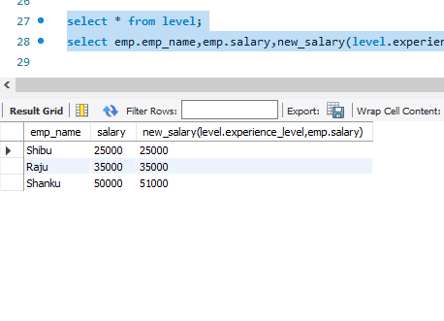

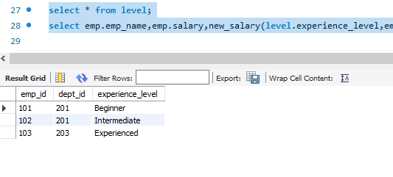

**PROGRAM -2**

**AIM:** Given an integer i, write a PL/SQL procedure to insert the tuple (i, 'xxx') into a given relation

**CODE:**

create database studentdb;

use studentdb;

create table T2(rollno int,name varchar(10),primary key(rollno));

call stud('101','Stefi');

call stud('102','Sreelaya');

select * from T2;

///STORED PROCEDURE///

CREATE DEFINER=`root`@`localhost` PROCEDURE `stud`(rollno int,name varchar(10))

BEGIN

insert into T2 values(rollno,name);

END

**OUTPUT:**

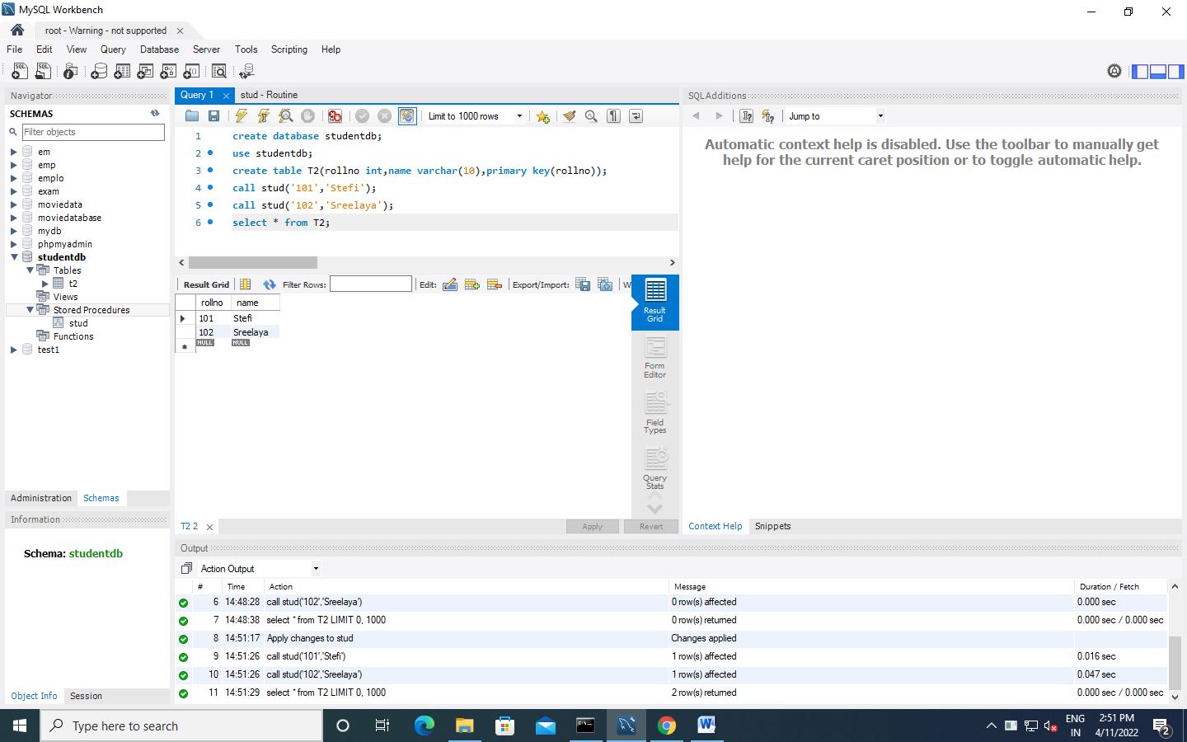

**PROGRAM-3**

**AIM:** To write a PL/SQL block to calculate the incentive of an employee whose ID is 110

**CODE:**

create database employeedb2;

use employeedb2;

create table E1(empid int,empname varchar(10),salary int,primary key(empid));

insert into E1(empid,empname,salary)values('110','Stefi',2000);

insert into E1(empid,empname,salary)values('111','Sreelaya',50000);

select * from E1;

select empid,empname,insentive(empid) from E1;

///FUNCTION///

CREATE DEFINER=`root`@`localhost` FUNCTION `insentive`(empid int) RETURNS varchar(20) CHARSET latin1

BEGIN

DECLARE i VARCHAR(20);

IF (empid=110)

THEN SET i=3000;

END IF;

RETURN i ;

END

**OUTPUT:**

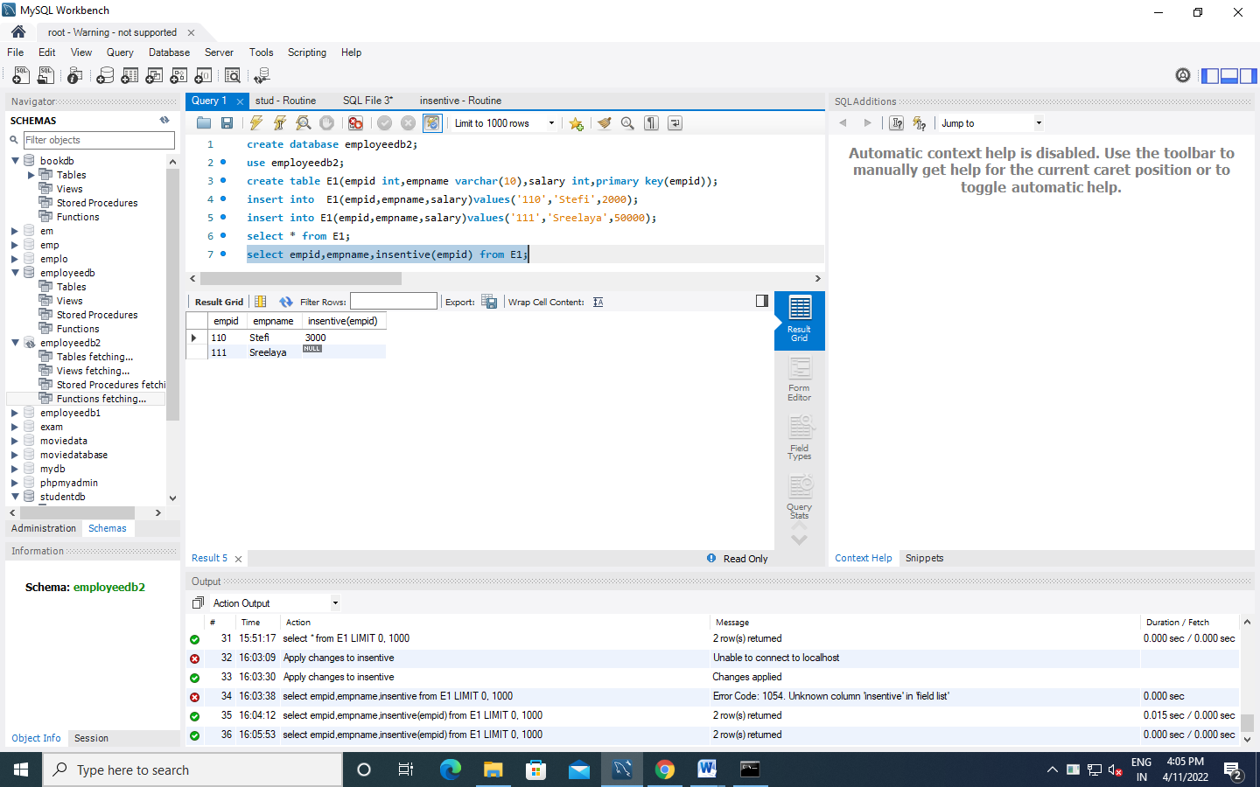

**PROGRAM-4**

**AIM:** To create the Book database and do the following: (Consider the attributes based on the question given)

book(book_name, author_name, price,quantity)

1. Write a query to update the quantity by double in the table book.
2. List all the book_name whose price is greater than those of book named "Database for Dummies"
3. Retrieve the list of author_name whose first letter is ’a’ along with the book_name and price (Explore more about *Like* keyword)
4. Write a PL/SQL Procedure to find the total number of books of same author

**CODE:**

create database books;

use books;

create table book_info(book_name varchar (20),author varchar(20),price int,quantity int);

insert into book_info values('randamoozham','MT',300,5);

insert into book_info values('ikigai','hector',500,7);

insert into book_info values('databse of dummies','xyz',250,7);

insert into book_info values('wings of flare','APJ',500,7);

insert into book_info values('oopol','MT',270,3);

select * from book_info;

**a)** set sql_safe_updates=0;

update book_info set quantity=quantity*2;

**b)** select book_name from book_info where price>(select price from book_info where book_name='databse of dummies');

**c)** select author,book_name,price from book_info where author like 'a%';

**OUTPUT:**

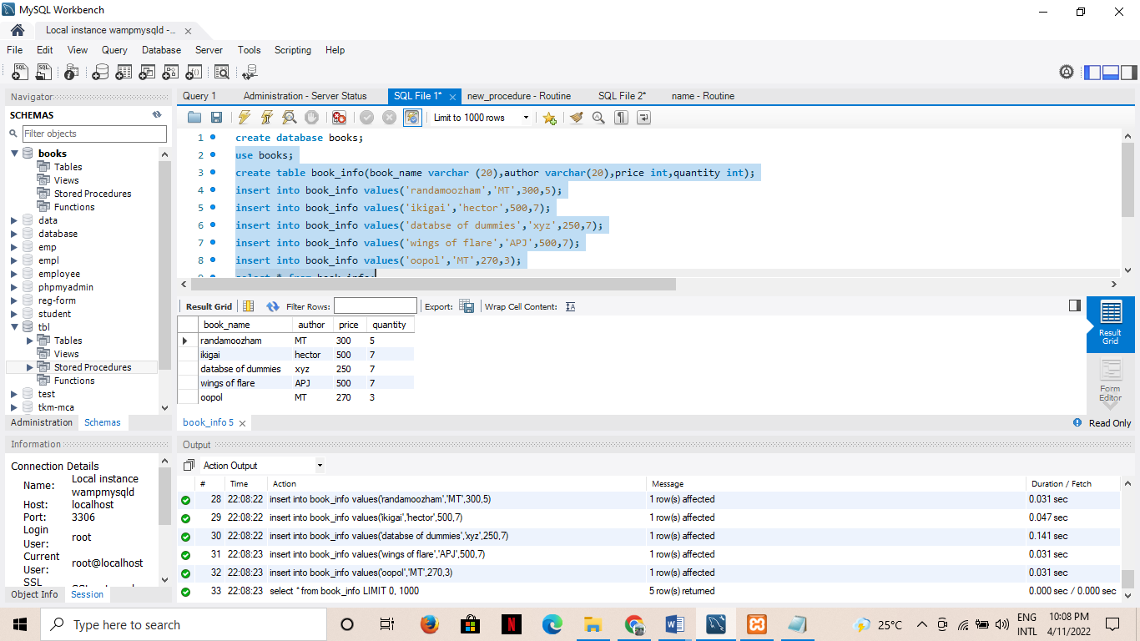

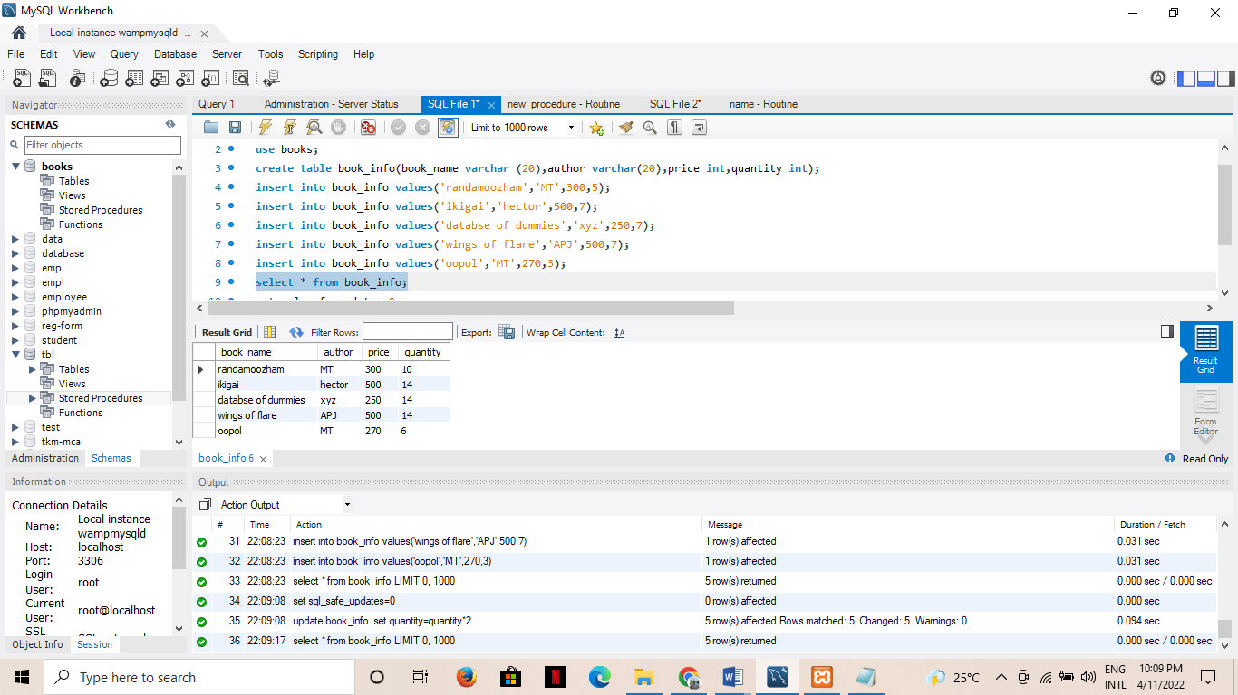

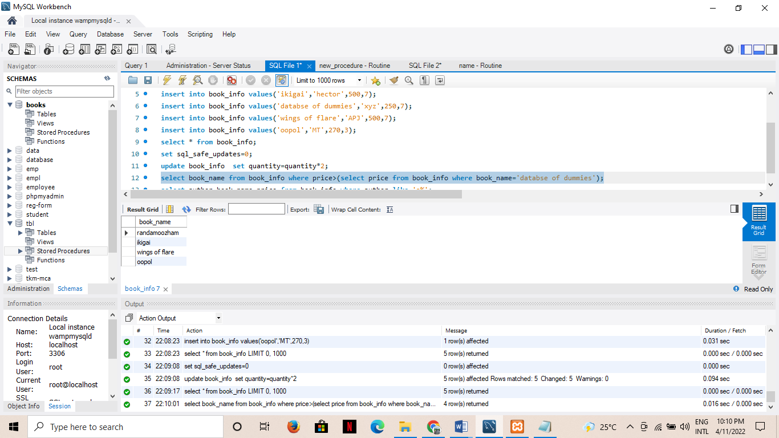

**PROGRAM-5**

**AIM:** Create the Company database with the following tables and do the following:

Administration (employee_salary, development _cost, fund_ amount, turn_over,bonus)

Emp_details (emp_no, emp_name, DOB, address, doj, mobile_no, dept_no, salary).

1. Calculate the total and average salary amount of the employees of each department.
2. Display total salary spent for employees.
3. Develop a PL/SQL function to display total fund_amount spent by the administration department

**CODE:**

create database company;

use company;

CREATE TABLE Admins(

emp_sal double,

dvlp_cost double,

fund_amount double,

turn_over double,

bonus double);

CREATE TABLE Emp_details(

emp_no int,

emp_name varchar(20),

DOB date,

address varchar(20),

doj date,

mobile_no int8,

dept_no int,

salary double);

INSERT INTO Admins VALUES

(12000,25000,560000,65000,5000),

(70000,55000,860000,15000,1000),

(18000,45000,160000,75000,7000),

(10000,27000,520000,60000,5000),

(18000,27000,360000,35000,3000);

INSERT INTO Emp_details VALUES

(1,"hamna","1999-10-10","Street - 2 xyz","2020-10-10",9865986598,10,12000),

(2,"ansi","1997-10-10","Street - 2 abc","2020-10-10",9865986598,10,12200),

(3,"sree","1996-10-10","Street ","2020-10-10",9865986598,11,12500),

(4,"stef","1957-10-10","Street in","2020-10-10",9865986598,11,17200),

(5,"anu","1948-10-10","gared","2020-10-10",9865986598,12,12090),

(6,"shiva","1988-10-10","Sas","2020-10-10-",9865986598,12,12050);

**a)** SELECT dept_no,avg(salary) 'Average salary',sum(salary) 'Total Salary' FROM Emp_details GROUP BY dept_no;

**OUTPUT**

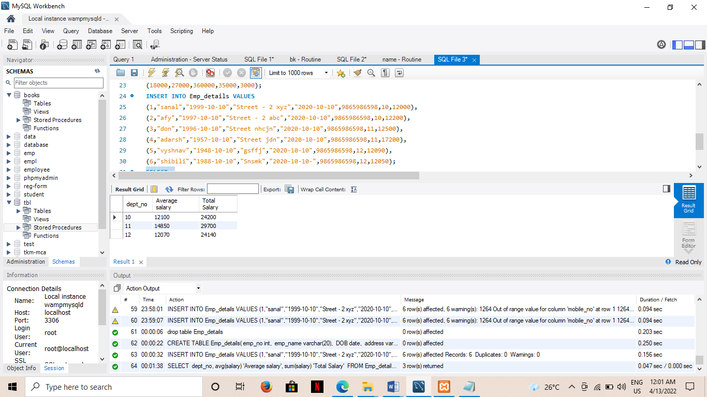

**b)** SELECT

sum(salary) 'SUM OF SALARY'

FROM Emp_details;

**OUTPUT**

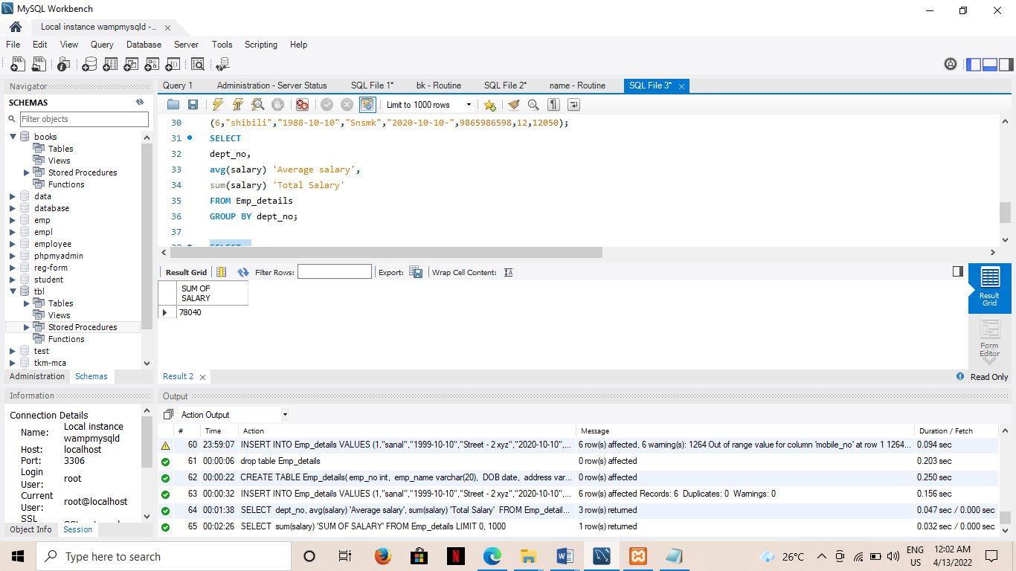

**c)**

//FUCTION//

CREATE DEFINER=`root`@`localhost` FUNCTION `fund_total`() RETURNS double

BEGIN

DECLARE f DOUBLE;

DECLARE i DOUBLE;

SELECT SUM(fund_amount)

FROM Admins;

RETURN f;

END

//FUNCTION CALL//

SELECT fund_total() from Admins LIMIT 1;

**OUTPUT**

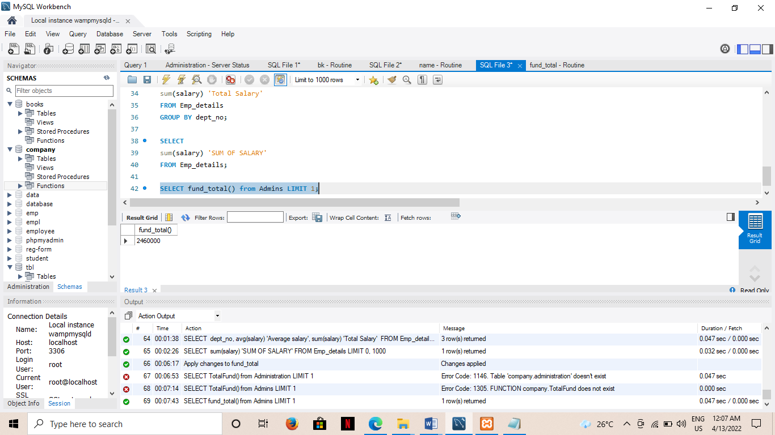

**PROGRAM-6**

**AIM:** To write a program to implement trigger

**CODE:**

create database employees;

use employees;

create table employee(emp_id int,emp_name varchar(10),department_name varchar(15));

insert into employee values(101,"Coen","mca");

insert into employee values(102,"aloe","mca");

insert into employee values(103,"Raimi","btech");

insert into employee values(104,"Ras","mca");

create table dpt_mca(dept_id int,dept_name varchar(20), dept_emp varchar(15));

create table dpt_cs(dept_id int,dept_name varchar(20), dept_emp varchar(15));

select * from employee;

insert into employee values(105,"Anu","mca");

select * from dpt_mca;

insert into employee values(106,"R0se","CS");

select * from dpt_cs;

///TRIGGER///

CREATE DEFINER=`root`@`localhost` TRIGGER `employees`.`employee_BEFORE_INSERT` BEFORE INSERT ON `employee` FOR EACH ROW

BEGIN

if new.department_name="mca" then

INSERT INTO dpt_mca set dept_id=new.emp_id,dept_name=new.emp_name,dept_emp="Asst.proff fill";

end if;

if new.department_name="cs" then

INSERT INTO dpt_cs set dept_id=new.emp_id,dept_name=new.emp_name,dept_emp="Asst.proff fill";

end if;

END

**OUTPUT**:

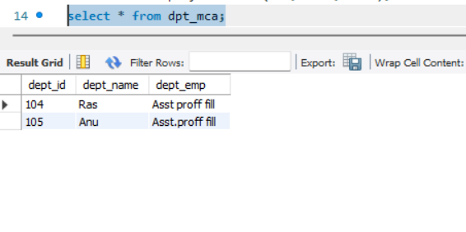

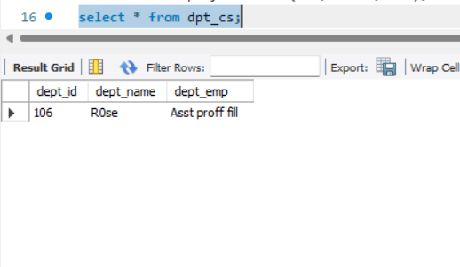

**PROGRAM-7**

**AIM:** . To create a student record database in which student marks assessment is recorded.In such schema,create a trigger so that the total and average of specified marks is automatically inserted whenever a record is inserted.

**CODE:**

create database students;

use students;

create table student(rollno varchar(10) primary key,studname varchar(10),sub1 varchar(10),sub2 varchar(10),sub3 varchar(10));

create table result(rollno varchar(10),studname varchar(10),total_marks varchar(10),percentage varchar(10));

insert into student values("1","abhi","35","55","85"),

("2","adarsh","15","60","10"),

("3","anu","96","99","94");

insert into student values(8,"jain",67,90,76);

insert into student values(10,"bini",60,96,50);

select * from student;

select * from result;

///TRIGGER///

CREATE DEFINER=`root`@`localhost` TRIGGER `students`.`student_AFTER_INSERT` AFTER INSERT ON `student` FOR EACH ROW

BEGIN

declare total varchar(10);

declare perc varchar(10);

set total=new.sub1+new.sub2+new.sub3;

set perc=((total/300)*100);

insert into result values(new.rollno,new.studname,total,perc);

END

**OUTPUT**:

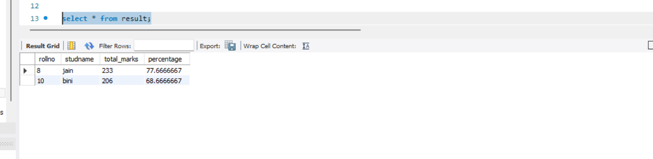

**PROGRAM-8**

**AIM:** To write a program to implement cursors

**CODE:**

create database college1;

use college1;

create table library (shelf_no int(10),category varchar(10),book_name varchar(20));

insert into library values(11,'science','algebra');

insert into library values(12,'science','Data Mining');

insert into library values(21,'comic','New Avengers');

insert into library values(22,'comic','Spiderman');

insert into library values(31,'drama','romeo and juliet');

insert into library values(32,'drama','hamlet');

create table book_by_order(book_shelf int (10),book_category varchar(20),bookname varchar(20));

select * from library;

call book_details();

select * from book_by_order;

///CURSOR///

CREATE DEFINER=`root`@`localhost` PROCEDURE `book_details`()

BEGIN

declare book_shelf int;

declare bookname varchar(20);

declare book_category varchar(10);

declare C_finished integer default 0;

declare C1 cursor for select shelf_no,category,book_name from library;

declare continue handler for not found set C_finished = 1;

open C1;

book_details:loop

if C_finished=1 then

leave book_details;

end if;

if C_finished = 0 then

Fetch from C1 into book_shelf,book_category,bookname;

if book_category = 'comic' then

insert into book_by_order values(book_shelf,bookname,book_category);

end if;

end if;

end loop;

close C1;

END

**OUTPUT** :

