

**Group Members**

ONLINE PROPERTY MANAGEMENT SYSTEM

Ade Eshwar Nayak 202051009

Ankit Kumar Mishra 202051028

Deshmukh Devashish Anil 202051061

Ghiya Jay Manishbhai 202051073

Hariom Kaushal 202051080

* **INTRODUCTION :**

Real estate is a type of business for selling, buying, renting land, buildings and offices. Real estate agencies duties include, to give the property on rent or else to sell the property. Properties like building, retail sites, flats, houses, bungalows etc. Many people search for property for many purposes like residence, offices, faculty and etc. Every individual wants his house to be in the best location with best facilities. Offices should be near market area in order to increase sales and productivity. The manual real estate agency follows a lengthy and hectic process. People need to meet the agent in person, for checking the Property details and also needs to visit the location. it takes long time to look for the desired location and desired type of property.

So, to tackle all of the above problems we came up with **Online Property Management System (OPMS)**.

Main Target group or we can say clients/users of our system are Buyer and Seller

* **SAILENT FEATURES OF OUR SYSTEM:**
* Seller can list his property along with its property details.
* Buyer can see all the property
* Buyer can also buy the property from the listed properties
* Buyer can also comment on the listed property
* Admin can also view all listed clients and property
* Admin can manage listed property, comments
* **TECHNOLOGIES USED:**
* Mysql
* Javafx
* **STEPS TO RUN SOFTWARE**
* To create database schema.

To do this, you have to run the sql script which is present in project file.

* To run the software.

You have to execute the “main.java” file

* **USER GUIDE:**

When you run the software First we see is Welcome page that consists of Client Login , Admin Login, Client Registration

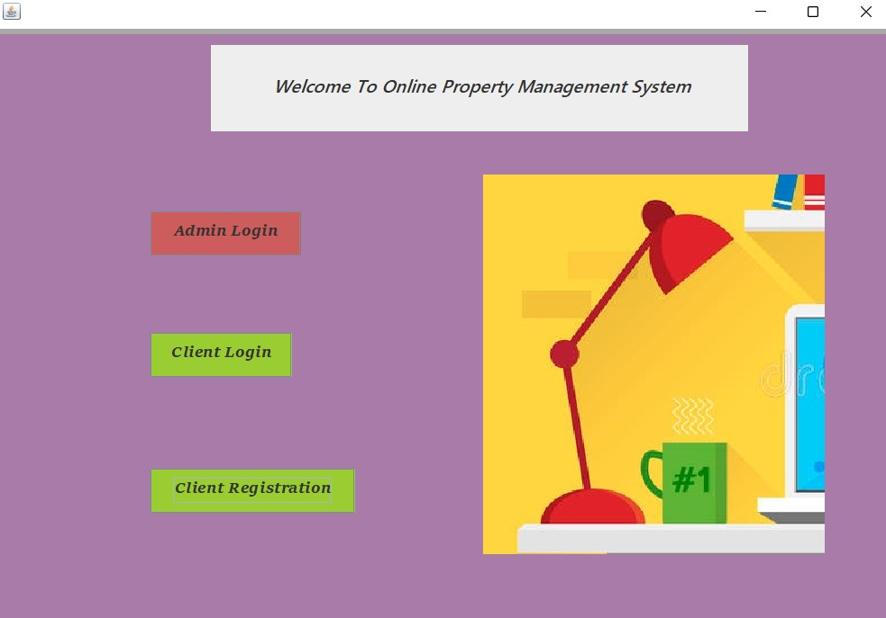

1. **If “Client Login” is chosen:**

Now the client has login by entering his login credentials.

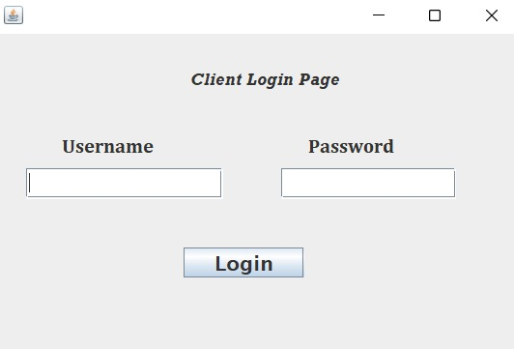

Now if the client is buyer different user interface is opened and if its seller different user interface is opened

**BUYER SECTION**

Then, the buyer has to choose one option from Comments, Buy a property in order to proceed further

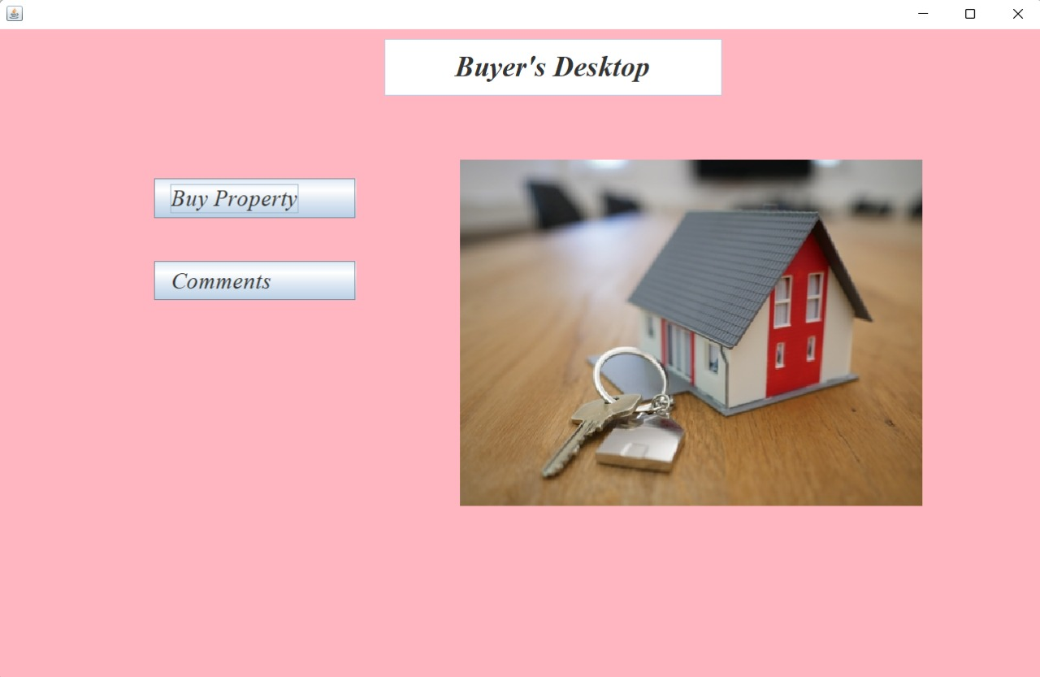

1. If “Comments” is chosen:

Here all comments are shown

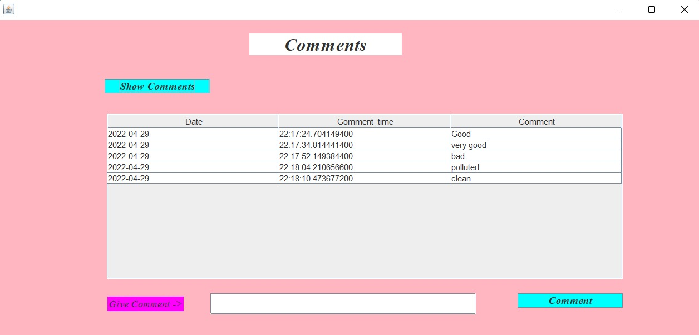

Here buyer can add comment also

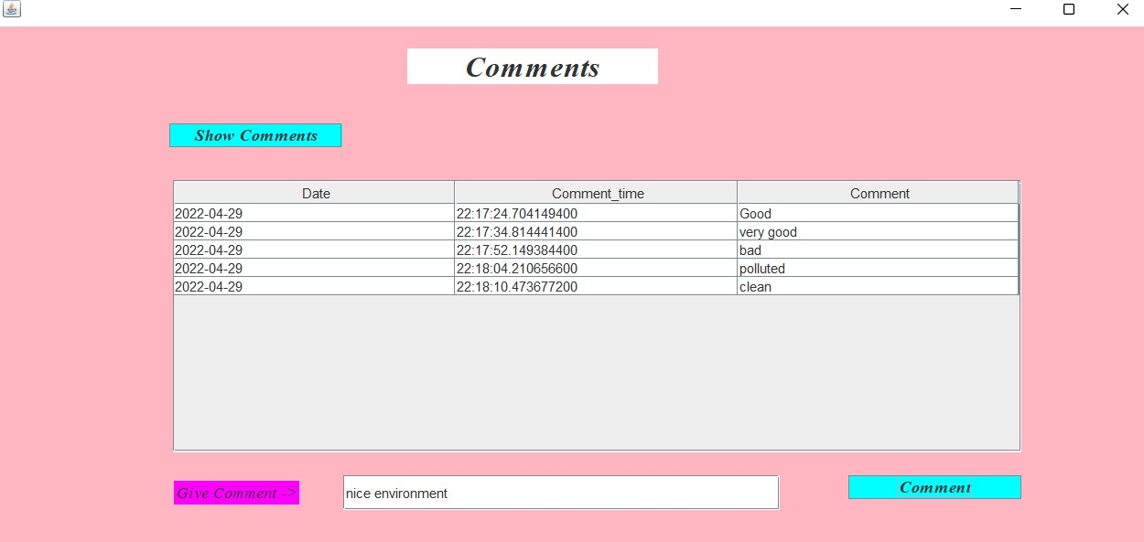

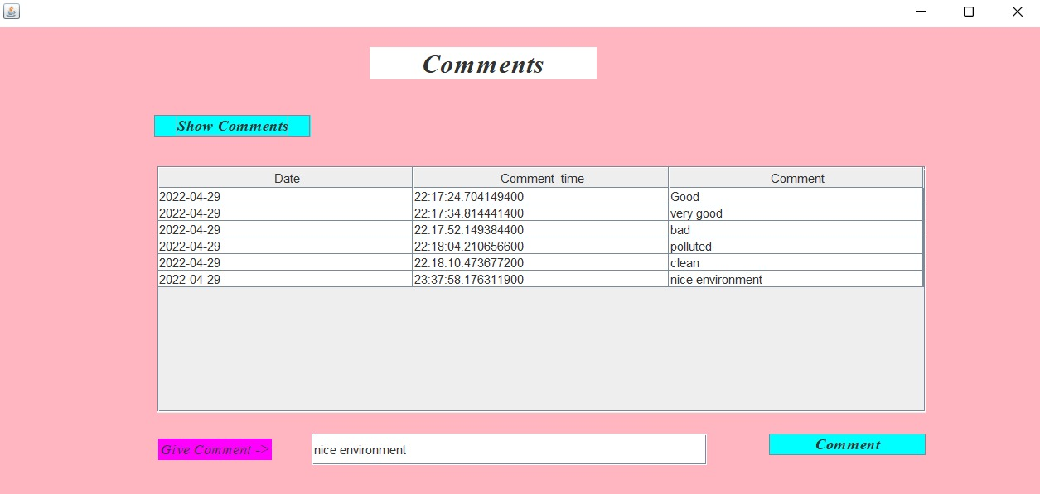

1. If “Buy a property” is chosen:

Here all properties listed are shown and you can buy any property

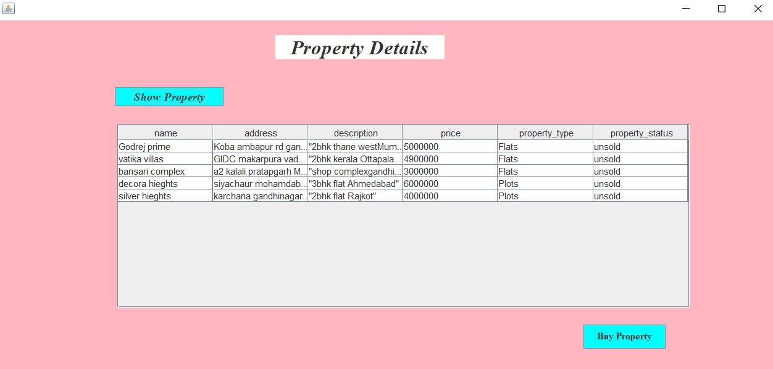

You have to enter property no to buy property

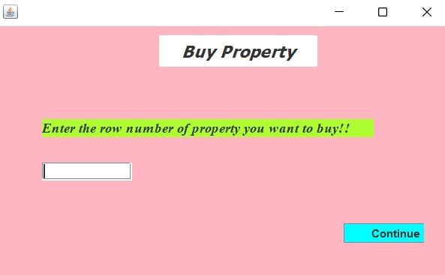

Enter payment details :

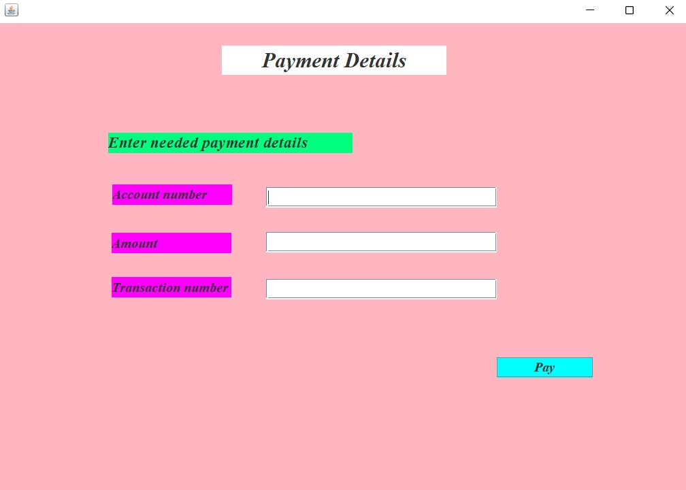

**SELLER SECTION**

Then, the Seller has to choose one option from Property Details, Comments, Add property in order to proceed further

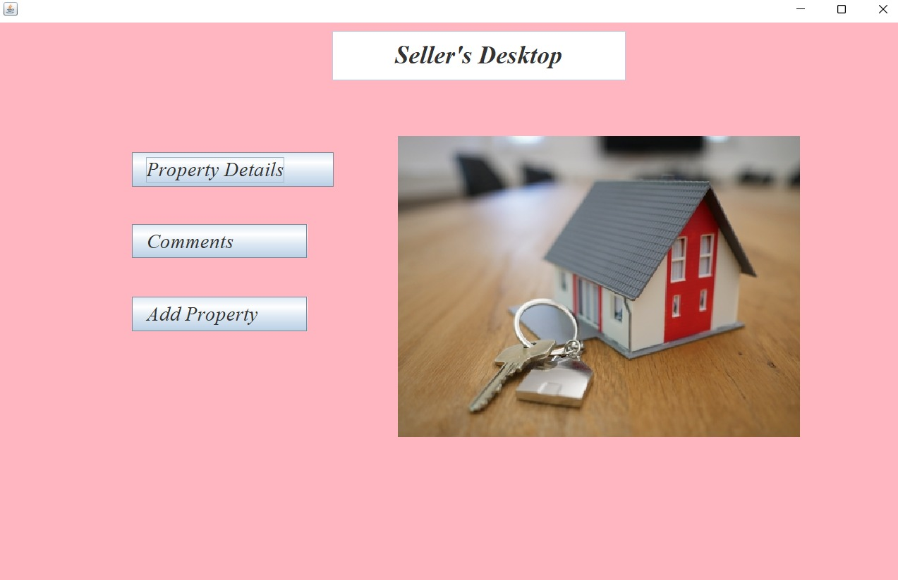

1. If “Property Details” is chosen:

Here details the of all listed property are shown

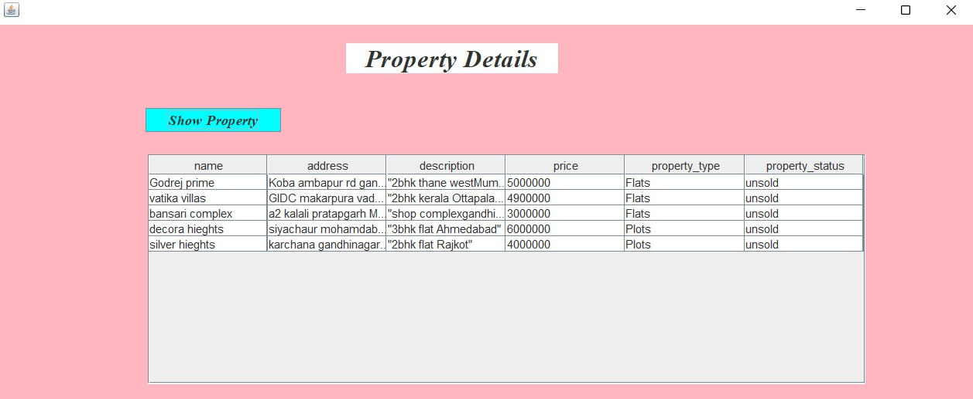

1. If “Comments” is chosen:

Here all comments are shown



Here Seller can add comment also





1. If “Add a property” is chosen:

Here enter property details to add property,

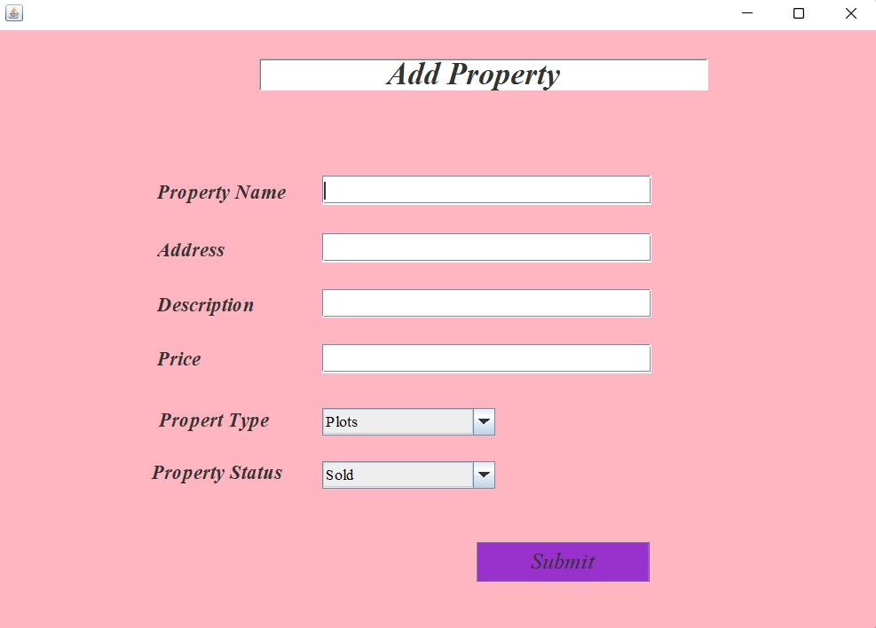

1. **If “Client Registration” is chosen:**

First user/client has to register himself. They have to provide their Name, Address, Email, Username, Password, select client one type from seller and buyer. This data will be stored in database.

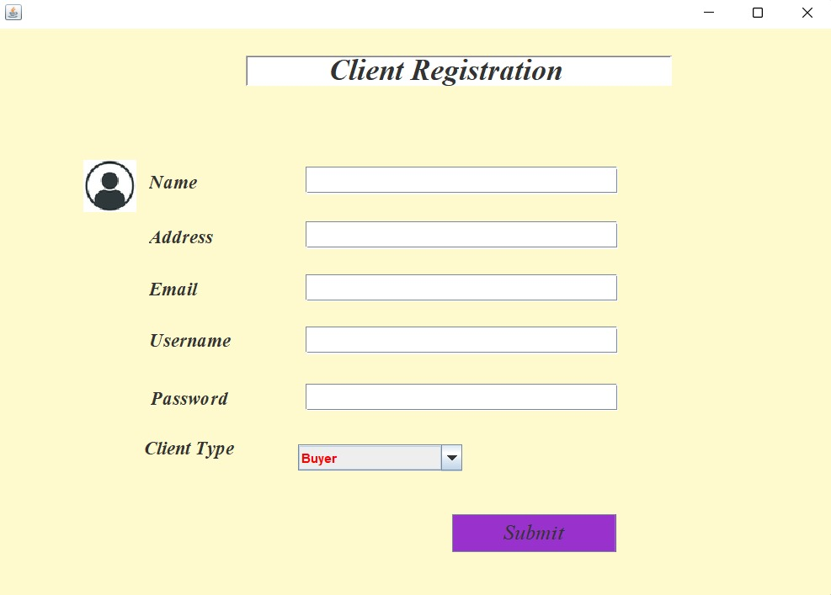

1. **If “Admin Login” is chosen:**

Now the Admin can login by entering his login credentials.

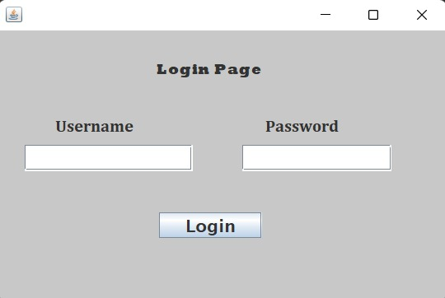

Note : In our database, you cannot add new admins . So only previously listed admins can getaccess to the admin section

Now “Admin workspace” is opened. Now to proceed Admin has to choose one option from Manage Property, Manage Comments, Manage Payments, Client details.

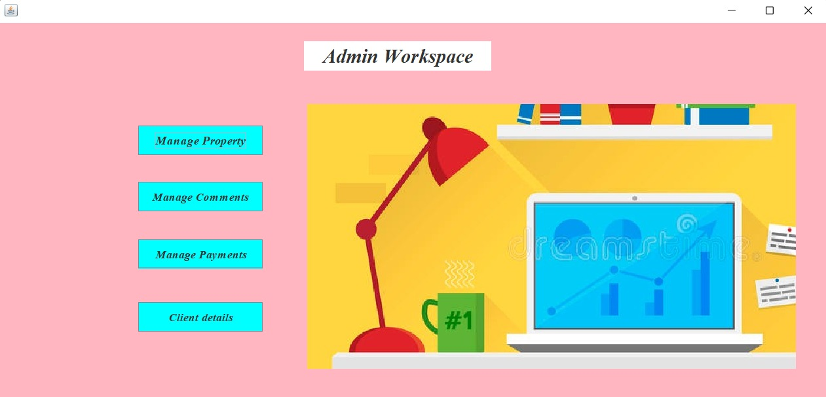

1. If “Manage Property” is chosen:

Here details the of all listed property are shown

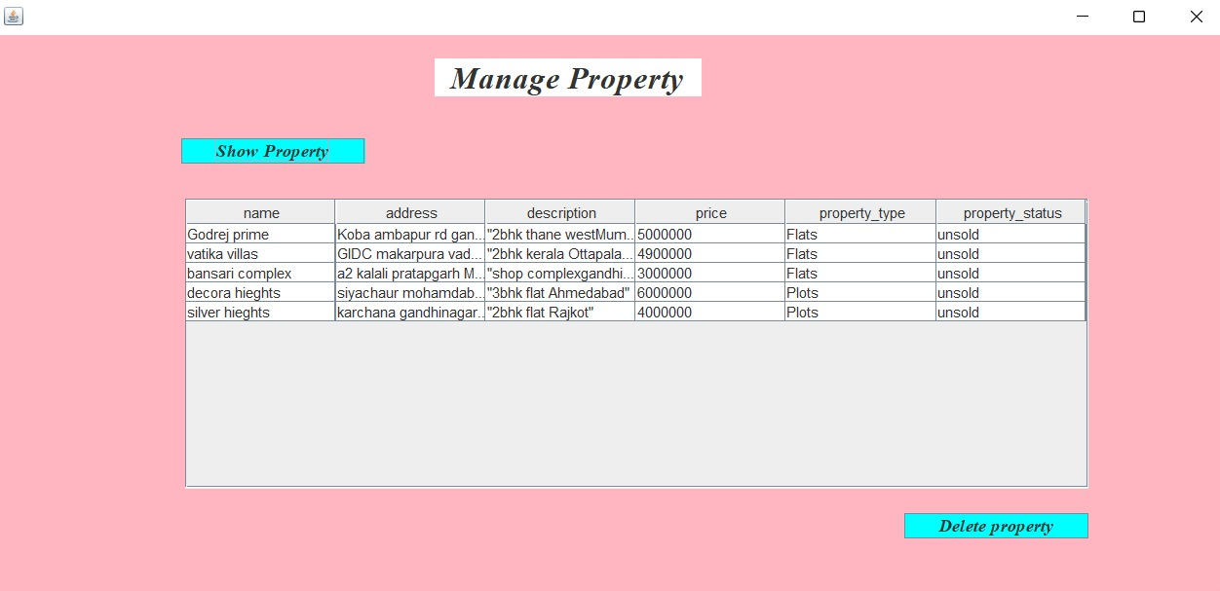

Here admin can delete any property

By entering the row no of property, admin wants to delete

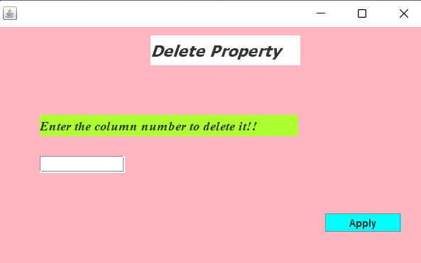

1. If “Manage Comment” is chosen:

Here all comments are shown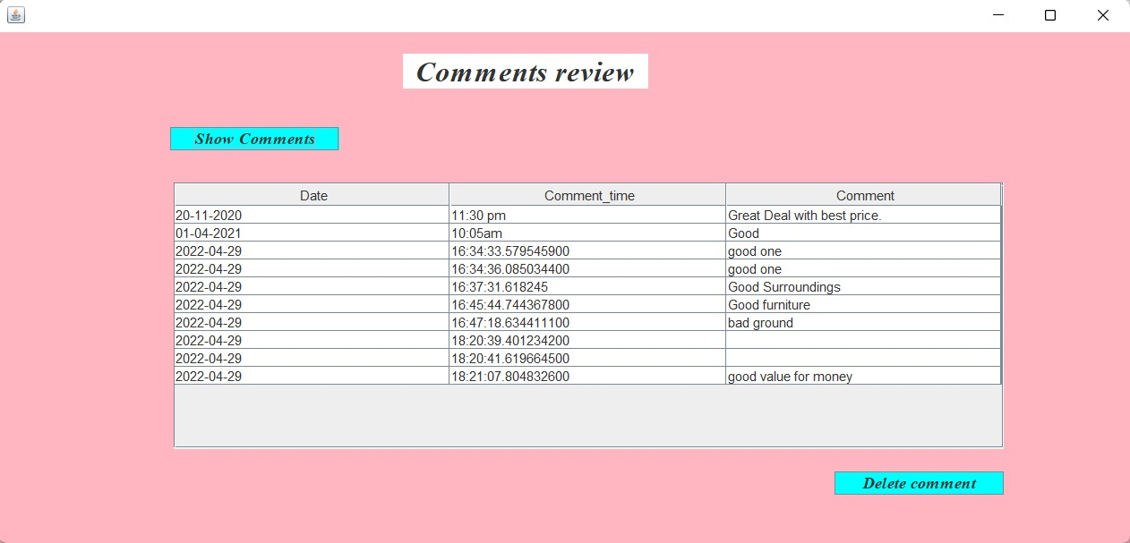

Here admin can delete any comment

By entering the row no of comment, admin wants to delete

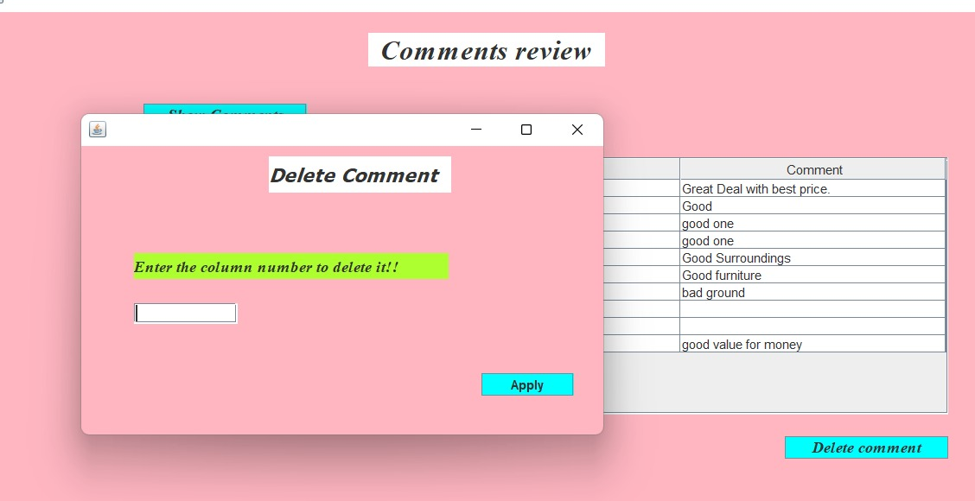

1. If “Manage Payments” is chosen:

Here all payments are shown

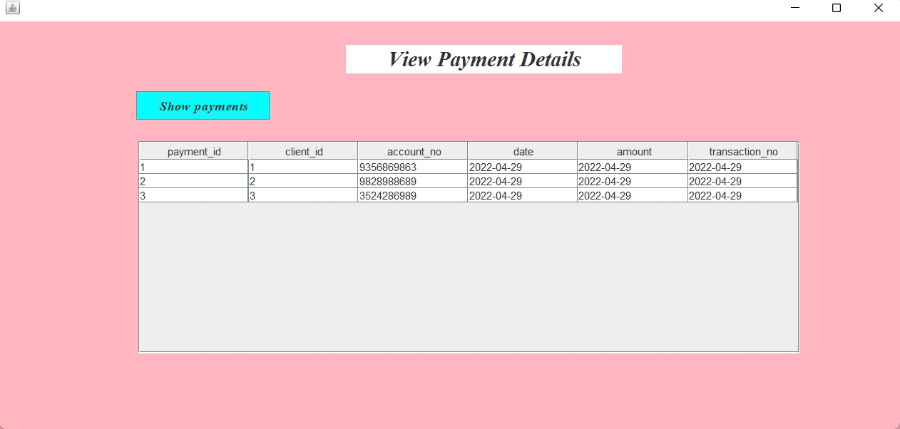

1. If “Client details” is chosen:

Here all Client details are shown



