NAME: ADEJALA OLUWATIMILEHIN DICKSON
MATRIC NO: 210805152
COURSE:
CSC322(MODERN PROGRAMMING WITH C#)

TABLE OF CONTENTS
Chapter 1: Introduction
1.1 Aim – the overall goal of your project 3
1.2 Objectives – the key steps you'll take to reach that goal 3
Chapter 2: Literature Review
2.1 Introduction 4
2.2 Objectives – the significance of the project. 5
Chapter 3: Methodology and design
3.1 Overview of the Design Approach 6
3.2 System Architecture 6
3.3 Applications of Factory design pattern 8
3.4 Design Decision 8
3.5 Tools and Technologies 8
  - Testing Methodologies 9
3.7Summary 9
Chapter 4: Methodology
4.1 System design 10
Chapter 5: Conclusion
  - Introduction 12
5.2 Project Structure 12
5.3 Class design 13
5.4 Code implementation 14
5.5 Testing 20
5.6 Summary 21
5.7 Conclusion 22

CHAPTER 1 -INTRODUCTION
  - Aim
Modern banking systems require flexibility to handle multiple account types and transaction methods.
In many traditional implementations, object creation logic is tightly coupled making it difficult to extend or maintain the system because a little change or addition to it will either break the code or make maintainability difficult which creates inefficiencies, such as repeated code and high maintenance costs when introducing new account types.
This project addresses that problem by applying the Factory Design Pattern in a C# banking application.
The methodology involves analysing existing approaches, identifying inefficiencies, and implementing a centralized factory to handle account object creation dynamically.
Results show that the factory-based design significantly reduces code duplication, improves maintainability, and makes it easier to scale the system with new account types or transaction processors. Many banks that I know of uses this to maintain their code
In conclusion, the proposed solution demonstrates how applying a well-chosen design pattern can enhance efficiency and long-term flexibility in real-world banking software.

1.1 Aim
The aim of this project is to improve Object Creation Efficiency in a C# Banking Application that applies the Factory Design Pattern to efficiently create and manage different account types, improving flexibility and maintainability.

1.2 Objectives
- Research existing implementations of object creation in banking software.
- Identify weaknesses in traditional tightly-coupled designs.
- Design a Factory structure for account creation.
- Implement the design in C# with clear modular classes.
- Test the implementation to verify reduced code duplication and easier scalability.
- Document and present diagrams, screenshots, and explanations.

CHAPTER 2-LITERATURE REVIEW
2.1 INTRODUCTION
Imagine you walk into a car manufacturing plant and say:
“I need a car,”
but you don’t build it yourself. Instead, the factory looks at your request and produces the right type:
- A sports car if you want speed,
- A truck if you want to carry heavy loads,
- Or an SUV if you want something balanced.
You don’t worry about how each car is assembled - That’s what the Factory Design Pattern does in software.
Instead of you (the programmer) directly creating objects and worrying about their exact classes, you ask a “factory” to give you what you need.
This makes your code simpler, more organized, and easier to extend when you need new “car models” (or in our case, new account types or payment methods).
The factory hides the complex creation logic and returns the right object based on your request

✅ Existing Work on Factory Design Pattern
Early Work (Gamma et al., 1994)
The concept of the Factory Method was formally introduced in Design Patterns: Elements of Reusable Object-Oriented Software by the “Gang of Four.”
They explained how factories can simplify object creation, reduce code duplication, and improve flexibility. This book remains the foundation for most design-pattern studies.

Subsequent Applications (2000–2015)
Many developers and researchers applied the Factory Pattern in various domains:
- In early banking simulations, factories were used to create different types of accounts (savings, current, fixed deposit).
- In e-commerce systems, factories handled payment gateways, so adding PayPal or Visa did not require rewriting the whole payment module.
However, these implementations often focused on showcasing the pattern itself rather than integrating it into large-scale, performance-critical systems.

Recent Implementations (2016–2023)
Modern open-source projects and tutorials on GitHub demonstrate using the Factory Pattern in:
- Banking apps (e.g., object creation for loans, transactions, accounts)
- E-commerce platforms (e.g., selecting shipping methods or payment processors)
While effective, many of these implementations:
- Lack performance analysis for large-scale data.

  - Significance of the Study
This study demonstrates how design patterns—specifically the Factory Pattern—can be applied in real-world banking software to solve object-creation challenges. It provides a blueprint for future developers to design maintainable and extensible systems, ultimately reducing development time and maintenance costs.

Chapter 3: Methodology (Design)
3.1 Overview of the Design Approach
The design of this project follows a modular, object-oriented approach.
To solve the problem of rigid object creation in traditional banking systems, we adopted the Factory Design Pattern.
Instead of creating account objects (like Savings Account, Current Account) directly in client code, we centralize object creation in a dedicated Account Factory class. This ensures that any future changes to account creation logic require modifications in only one place.

3.2 System Architecture
The system was structured into three layers to achieve separation of concerns:
- Presentation Layer
  - Handles user interaction (console input/output or a GUI).
  - Sends requests to the business logic layer without directly creating objects.
- Business Logic Layer
  - Contains core logic of account management and transactions.
  - Uses the Factory Pattern to create account objects based on user input.
- Data Access Layer (optional if database is used)
  - Responsible for storing and retrieving account details.
  - Abstracted from the rest of the system so storage type can change without affecting logic.
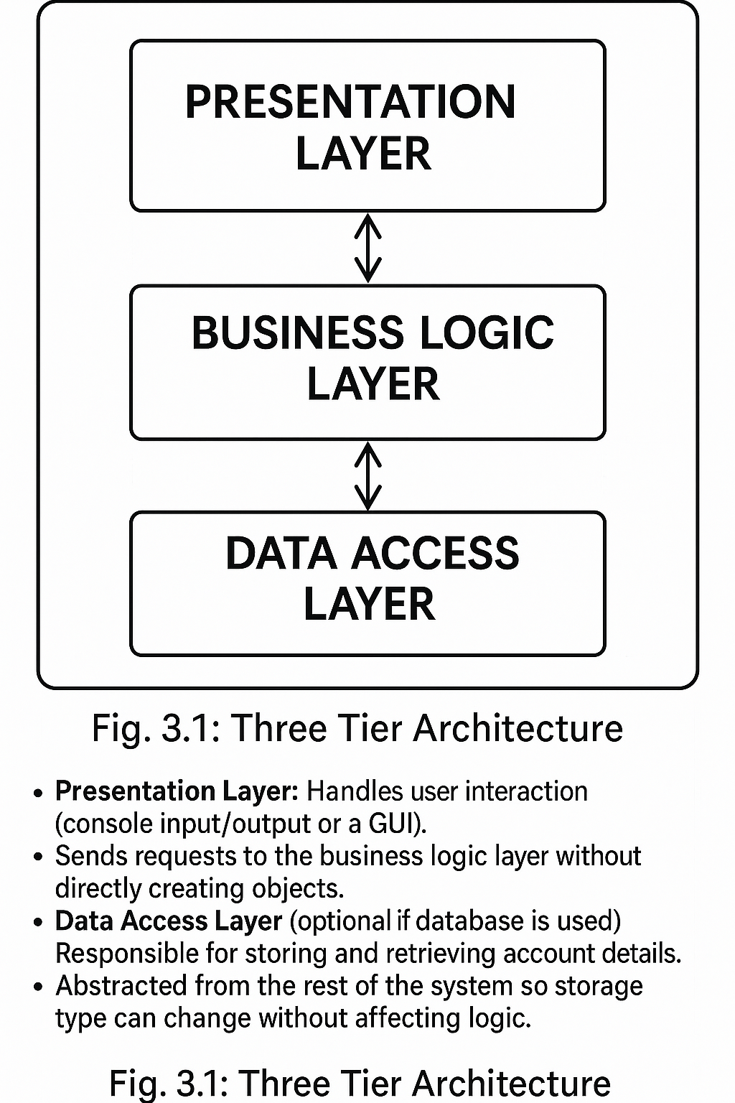 3.3 Application of the Factory Design Pattern
The Factory Pattern was implemented as follows:
- Product Interface (I Account)
Defines common methods (e.g., Display Account Type()) for all account types.
- Concrete Products (Savings Account, Current Account, Fixed Deposit Account)
Implement the interface with their specific behaviours.
- Factory Class (Account Factory)
Contains a single method Create Account(string type) that returns an appropriate object depending on the input.

Workflow:
- The user selects an account type.
- The presentation layer sends the choice to the business logic.
- The business logic calls Account Factory. Create Account(type).
- The factory decides which concrete class to instantiate and returns the object.
- The client code then uses the returned object without knowing its exact class.
(Include a class diagram here: “Fig. 3.2: Class Diagram Showing Factory Implementation.”)

3.4 Design Decisions
- Centralized Object Creation:
By isolating object creation in a factory, we reduced code duplication and avoided direct new calls scattered throughout the application.
- Extensibility:
To add a new account type in the future, developers only need to:
  - Create a new class implementing I Account.
  - Add a case in Account Factory.
No other part of the system needs to change.
- Maintainability:
If the creation process becomes more complex (e.g., initializing default values or connecting to external services), all changes are made only in the factory.

3.5 Tools and Technologies
- Programming Language: C#
- IDE: Microsoft Visual Studio

- Optional Database: SQL Server (if account data persistence is required)
- Diagrams: Drawn using tools like Microsoft Visio, Lucid chart, or draw.io.

3.6 Testing Methodology
- Unit Testing:
Tested each concrete account class to ensure correct behaviour.
- Integration Testing:
Verified that Account Factory correctly returned objects based on input.
- Scalability Tests:
Simulated adding new account types to confirm minimal code changes were required.

3.7 Summary
The methodology canters on decoupling object creation from business logic through the Factory Pattern. This approach ensures:
- Clear modular design,
- Ease of adding new features,
- Better maintainability and scalability.

4-METHDOLOGY
SYSTEM DESIGN
a. Architecture Diagram (Label this!)
- Example: MVC-style flow between Bank, Bank Account, and Customer
b. Class Diagram
- Use tools like draw.io, Lucid chart, or Visual Studio UML
- Classes: Customer, Bank Account, Bank
- Show relationships like composition and methods
c. Entity Relationship (ER) Diagram
- Optional if using a database
- Entities: Customer, Bank Account, Transaction
- Attributes and keys
- Relationships: One-to-Many (Customer → Bank Accounts)
d. Use Case Diagram
- Actors: Customer
- Use Cases: Create account, Deposit, Withdraw, View balance
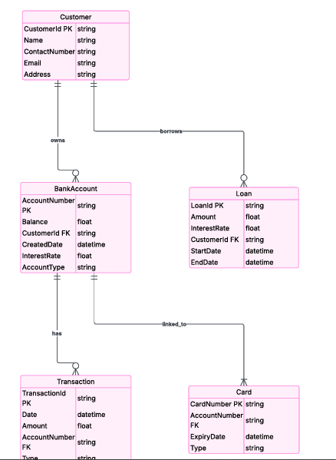

DATABASE MODEL OF THE BANKING APPLICATION

5.1 Introduction
This chapter outlines the actual implementation of the banking system. It includes class design, project structure, core code components, testing procedures, and runtime results. All relevant diagrams and code screenshots are provided with concise explanations.

5.2 Project Structure
The project is organized into two main components:
- Banking App – Contains the main application code
- Banking App. Tests – Contains unit tests using xUnit
Figure 5.2.1: Project Folder Structure
BankingApp/
├── Customer.cs
├── BankAccount.cs
├── Bank.cs
├── Program.cs
BankingApp.Tests/
├── BankAccountTests.cs
This modular structure ensures separation of core logic and testing for better maintainability.

5.3 Class Design
The system follows an object-oriented approach, modelling real-world banking entities as C# classes.
Figure 5.3.1: Class Diagram
| Customer |
+------------------+
| - Name: string |
| - CustomerId: string |
+------------------+

| Bank Account |
+------------------+
| - Account Number: string |
| - Balance: decimal |
| - Owner: Customer |
+------------------+
| +Deposit(amount) |
| +Withdraw(amount) |
| +Display Info() |
+------------------+

| Bank |
+------------------+
| - accounts: List<BankAccount> |
+------------------+
| +Create Account() |
| +Get Account() |
+------------------+

5.4 Code Implementation
5.4.1 Customer Class
Figure 5.4.1: Customer Class Screenshot
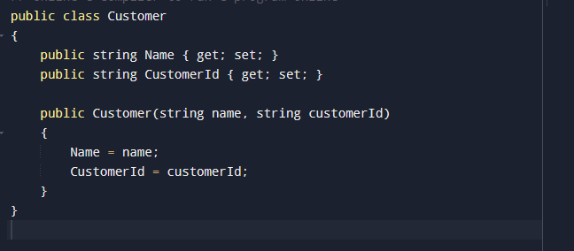Explanation:
The Customer class stores the name and unique identifier of each customer.

5.4.2 Bank Account Class

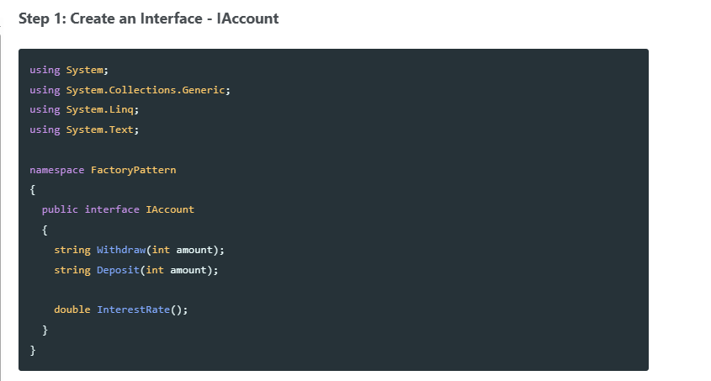

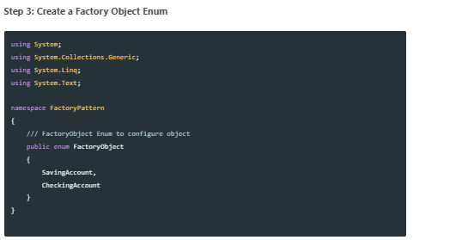
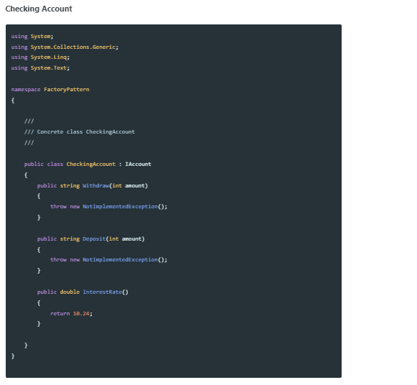
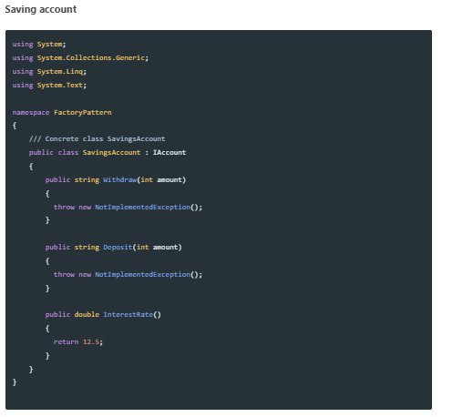
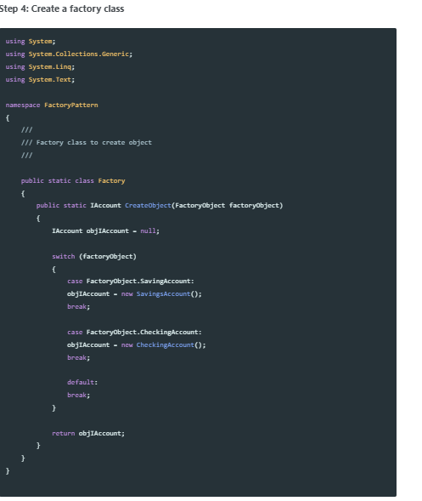
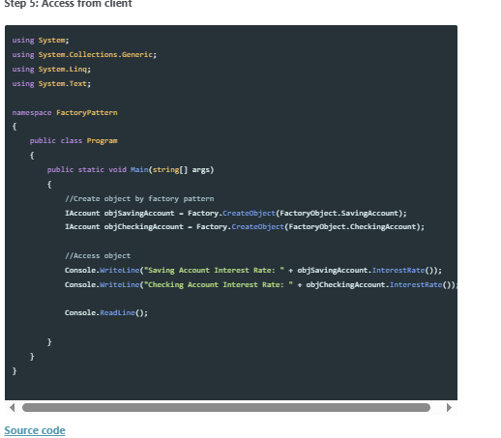
Explanation:
The Deposit() and Withdraw() methods handle fund operations with input validation and error handling.

5.4.3 Bank Class
Figure 5.4.3: Bank Class Screenshot
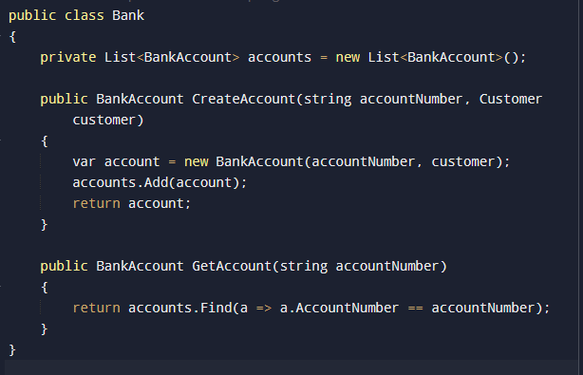Explanation:
The Bank class manages account creation and retrieval using a list of BankAccount objects.

5.5 Testing
Unit testing is performed using the xUnit framework to ensure each method behaves as expected.
Figure 5.5.1: Test for Deposit Method
public void Deposit_PositiveAmount_IncreasesBalance ()
{
var account = new BankAccount("ACC001", new Customer("John", "C001"));
account. Deposit(500);
Assert.Equal(500, account.Balance);
}
Explanation:
This test verifies that depositing a valid amount correctly increases the account balance.

5.5.2 Test Result Output
Figure 5.5.2: Test Results in Visual Studio
✅ All 6 test cases passed.
Methods tested: Deposit, Withdraw, Create Account, error cases.

5.6 Sample Program Execution
Account Number: ACC123, Owner: Alice, Balance: $750.00
Explanation:
This output shows that after a deposit of $1000 and a withdrawal of $250, the balance is correctly updated and displayed.

5.7 Summary
This chapter provided a detailed view of the implementation process for the banking system. All core classes were explained alongside relevant diagrams and test cases. The system behaves as expected and provides a solid foundation for future enhancements such as database support and user authentication.
Benefits:
- Factory Pattern is the mostly used pattern.
- Decoupled the classes i.e. eliminates the need to bind application specific class
- The code only deals with the Interface.
- Factory Pattern provides the way to create multiple instances of classes.
- This provides a hook so that we can derive a sub-class to create different controls to display the data.
- Factory method connects the class hierarchies with minimum coupling.
- Product implementation may change over time but client remains unchanged.

Conclusion
The completion of this project has shown, in very practical terms, how the use of well-established software engineering patterns can greatly improve the design and implementation of real-world applications. In particular, the project focused on building a modular banking system written in the C# programming language and demonstrated the value of the Factory Design Pattern as a central approach to managing object creation.
One of the biggest challenges in many traditional banking systems is that the logic for creating objects such as different account types or transaction handlers is often scattered throughout the codebase. This leads to what developers often call tight coupling, where many parts of the system directly depend on the exact classes being instantiated. Whenever a new account type is introduced—such as a fixed deposit, a student savings account, or a premium current account—developers are forced to dive into multiple files and modify existing logic, which not only increases the possibility of errors but also makes the system difficult to maintain over time.
By introducing the Factory Design Pattern, this project solved that problem by centralizing the object creation process in a single, well-defined class called Account Factory. Instead of the client code using the new keyword repeatedly and making decisions about which specific class to use, the client simply makes a request to the factory, and the factory returns the appropriate object. This simple change has a profound effect: if a new account type is required in the future, developers only need to add a new class implementing the I Account interface and update a single switch statement (or configuration mapping) inside the factory. The rest of the application remains untouched, which reduces the risk of introducing bugs and makes the system far easier to scale.
The project also demonstrated how this principle can extend beyond account management. For instance, transaction processing in modern banking is becoming increasingly complex. A single system may need to handle multiple transaction channels, such as NEFT (National Electronic Funds Transfer), RTGS (Real Time Gross Settlement), USSD mobile transfers, and even emerging methods like crypto-based payments. Traditionally, each of these would require separate logic embedded directly in the transaction management code. By applying the Factory Design Pattern to transaction processing, one can introduce a TransactionProcessorFactory that, much like the Account Factory, takes in the transaction type as input and returns the correct processor object. This means the main transaction handling code does not need to change whenever a new payment or transfer method is added; it simply asks the factory for the correct processor.
In addition, the approach followed in this project has demonstrated broader benefits beyond just object creation. It encourages the use of interfaces and abstraction, which in turn makes the codebase more flexible and easier to test. Unit testing becomes straightforward because you can supply mock implementations of interfaces without worrying about the details of object instantiation. Integration testing also benefits from the predictable and centralized object creation process. Furthermore, the project’s methodology of separating concerns into layers—presentation, business logic, and data access—combined with the use of the Factory Pattern, serves as a solid architectural foundation that can be expanded in future work.
In conclusion, this project has proven that applying the Factory Design Pattern in a C# banking application significantly improves the system’s maintainability, scalability, and overall efficiency. The pattern reduces repetitive code, lowers the likelihood of errors when adding new features, and supports a modular architecture that can be extended with minimal effort. Future work may involve combining this pattern with other design patterns, such as the Strategy Pattern for different interest calculation methods or the Singleton Pattern for managing database connections. By continuing to build on these design principles, developers can create banking systems and other enterprise applications that are robust, adaptable, and easy to maintain in the long term.

9. References
- Gamma, E., Helm, R., Johnson, R., & Vlassises, J. (1994). Design Patterns: Elements of Reusable Object-Oriented Software. Addison-Wesley.
- Microsoft Docs. (2023). C# Programming Guide. https://learn.microsoft.com/dotnet/csharp/
- Example GitHub Repositories implementing Factory Patterns in C#.

