Figures

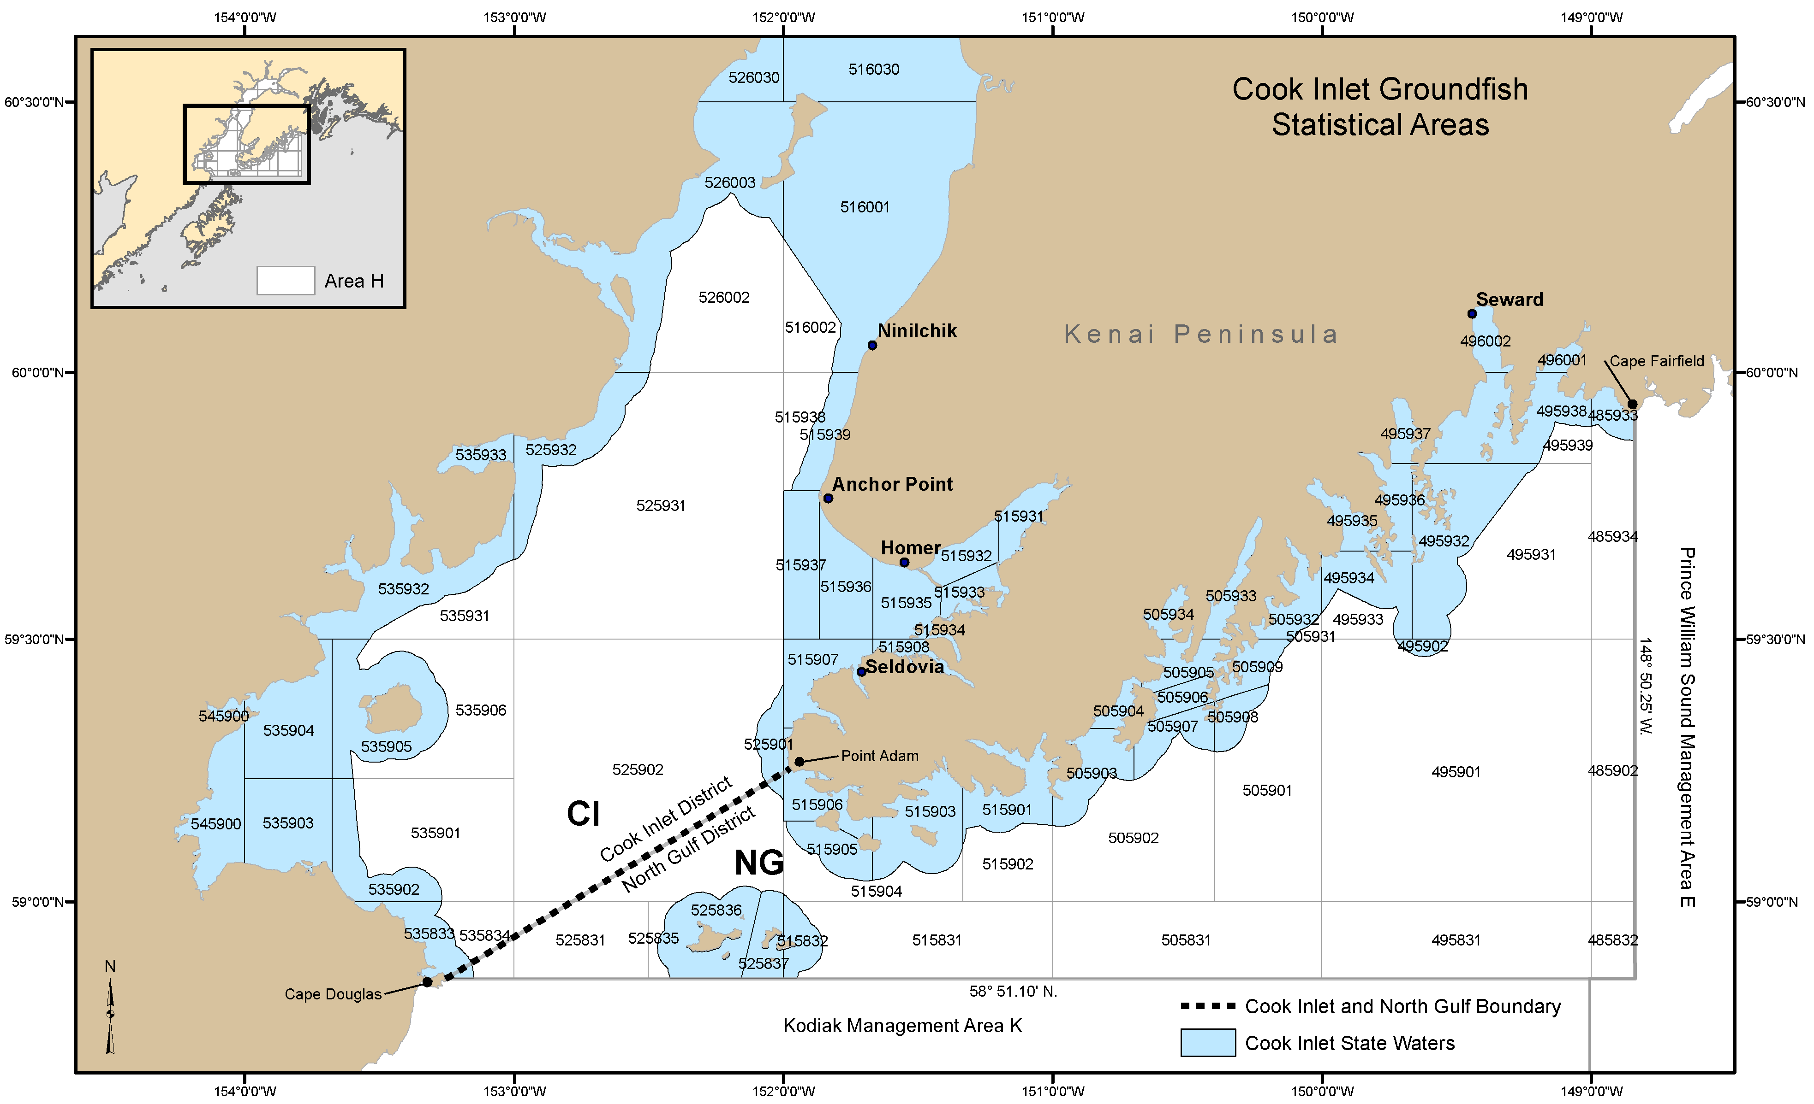
Figure 1. Cook Inlet rockfish commercial fishery management units: North Gulf District (NG) and Cook Inlet District (CI).

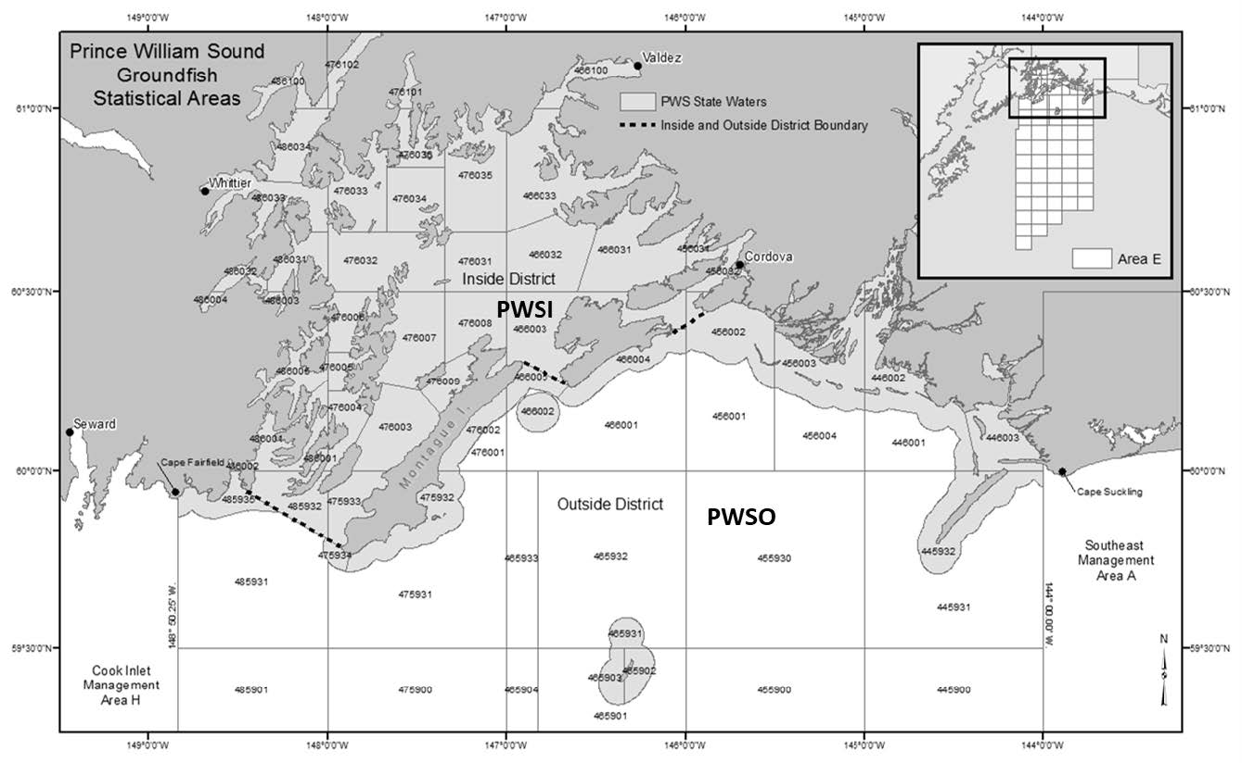
Figure 2. Prince William Sound rockfish commercial fishery management units: Prince William Sound Inside District (PWSI) and Prince William Sound Outside District (PWSO).

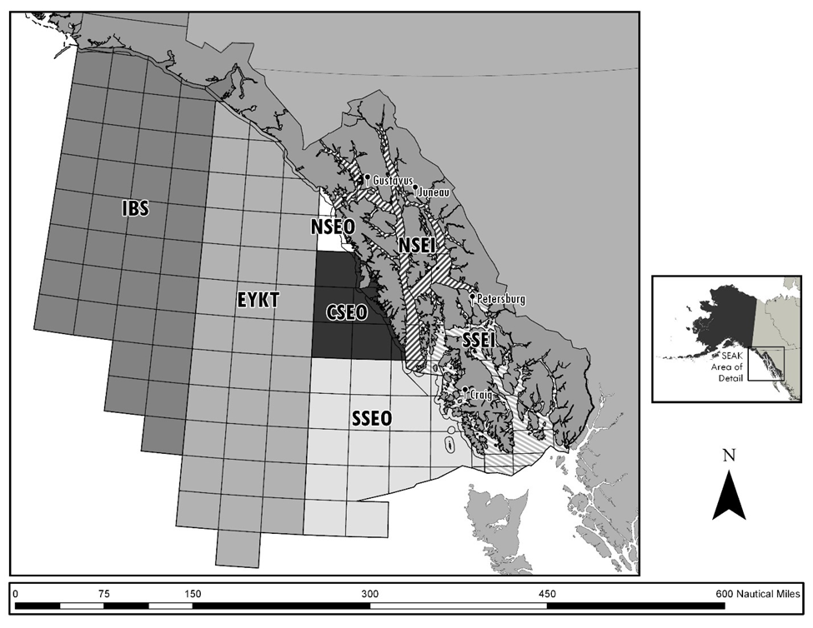
Figure 3. Southeast Alaska rockfish commercial fishery management units: Icy Bay Subdistrict (IBS), East Yakutat Section (EYKT), Northern Southeast Outside Section (NSEO), Central Southeast Outside Section (CSEO), Southern Southeast Outside Section (SSEO), Northern Southeast Inside Subdistrict (NSEI), and Southern Southeast Inside Subdistrict (SSEI).

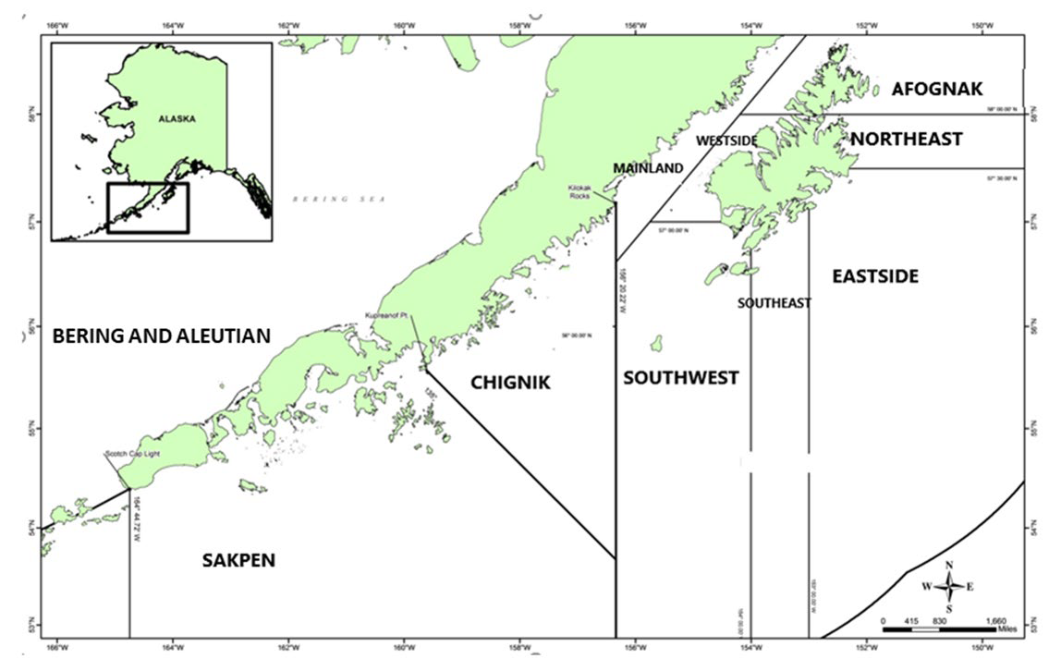
Figure 4. Kodiak, Chignik, and the South Alaska Peninsula (SAKPEN) rockfish commercial fishery management units. The Bering Sea–Aleutian Islands Area includes all waters west of the South Alaska Peninsula Area border at Scotch Cap Light, and north into the Bering Sea. Kodiak management units include Afognak, Northeast, Eastside, Southeast, Southwest, Westside, and Mainland Districts.

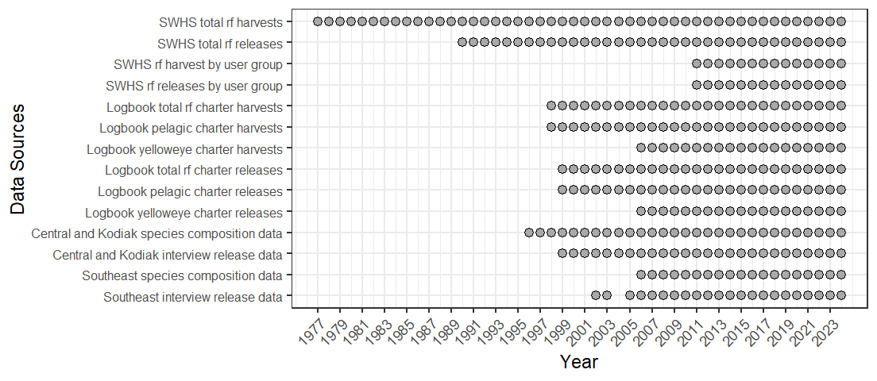
Figure 5.- Data sources for estimating rockfish harvests and releases in ADF&G commercial fisheries management units. Note that initial rockfish harvest estimates were not differentiated into species assemblage or species until 1998 when logbooks began differentiating by pelagic and non-pelagic. Logbooks began to collect data on yelloweye beginning in 2006. Port sampling programs to gather data on species composition of harvests began in 1996 in Southcentral and Kodiak and in 2006 in Southeast.

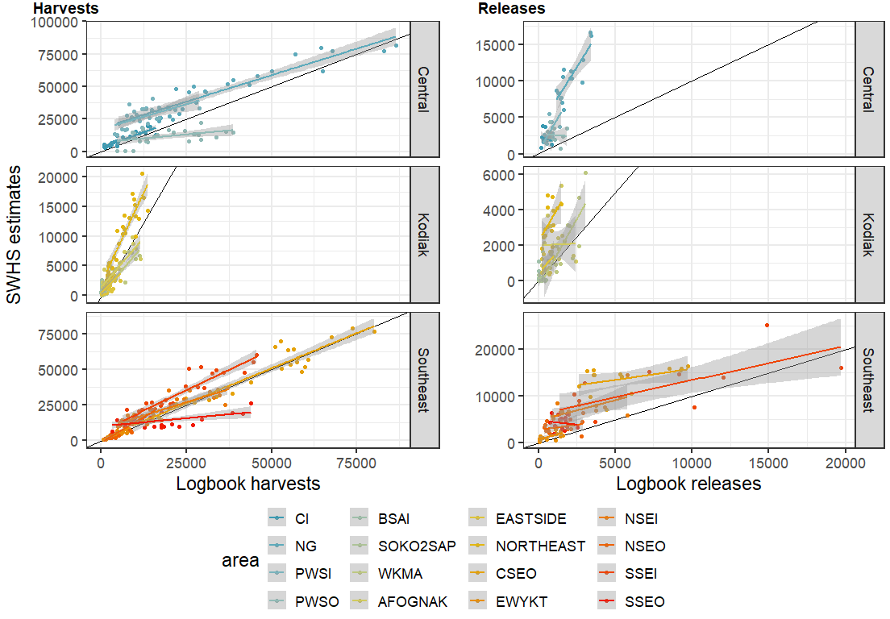
Figure 6.- SWHS harvest (left) and release (right) estimates from guided trips (x-axis) versus repoted harvests from charter logbooks (y-axis).

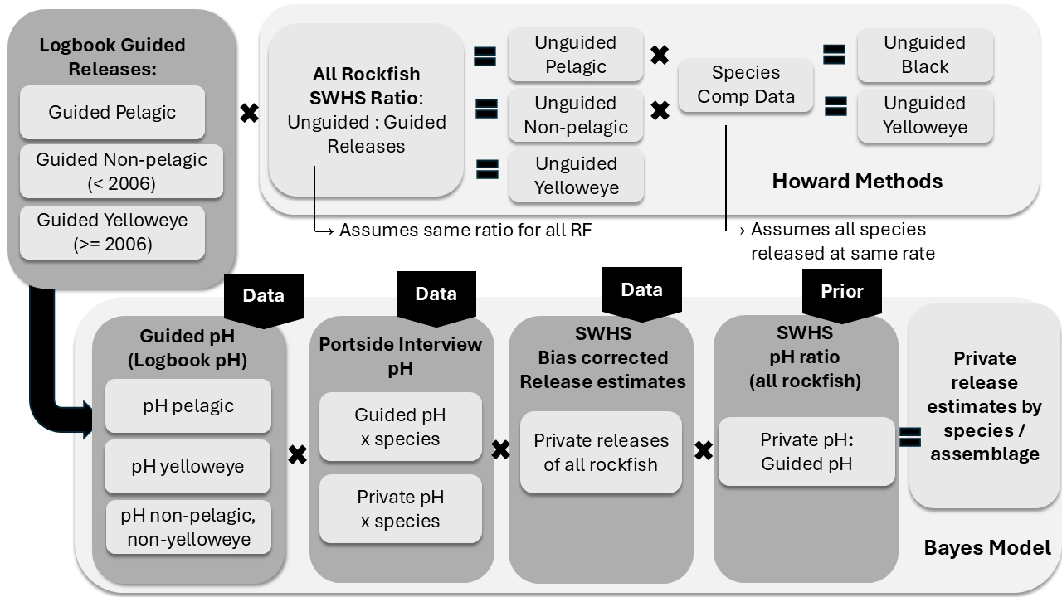
Figure 7. Schematic illustrating the difference processes used by Howard et al. (2020) and the Bayesian model to estimate releases of rockfish by unguided anglers in Alaska waters. The Howard methods assume that the ratio of unguided:guided releases for all rockfish in the SWHS apply equally to all rockfish species and complexes. The Bayesian approach estimates retention probabilities separately by species assemblage based on the retention probabilities of anglers evident in the logbook data, portside interview data, and bias corrected SWHS data with an informative prior derived from the SWHS data informing the model on the relative retention probability of a generic rockfish landed by guided and unguided anglers.

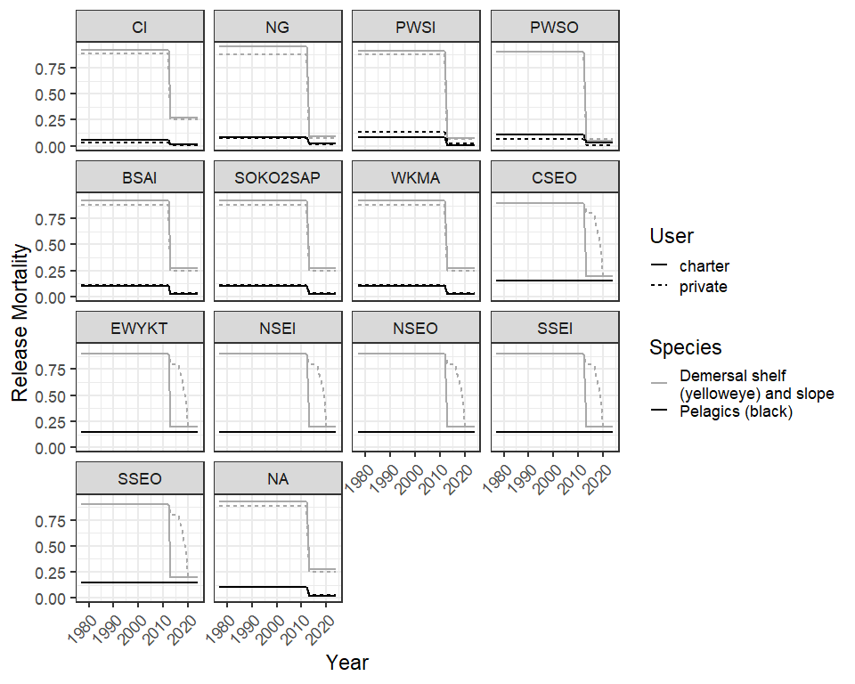
Figure 8. Release mortality rates for 16 commercial fisheries management units used to calculate the number of released rockfish assumed to have died. The change in mortality rates in 2013 reflect the deep water release (DWR) requirements that were adopted in that year.

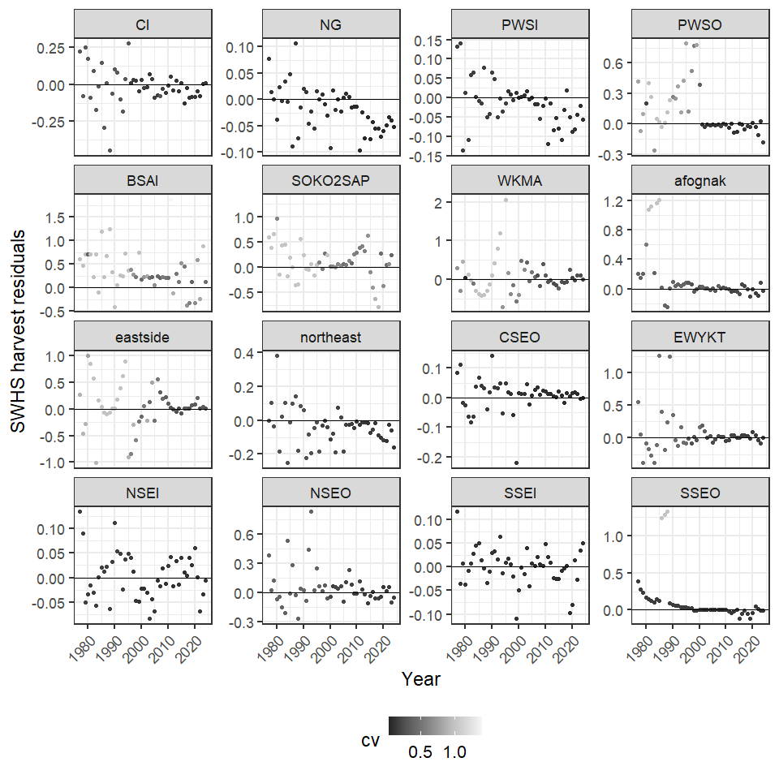
Figure 9.- Residuals from SWHS harvests for 16 commercial fisheries management units 1977-2024 showing the difference between model estimates with the bias correction removed and observed values in the SWHS. The CV of the SWHS data is indicated by the grey scale.

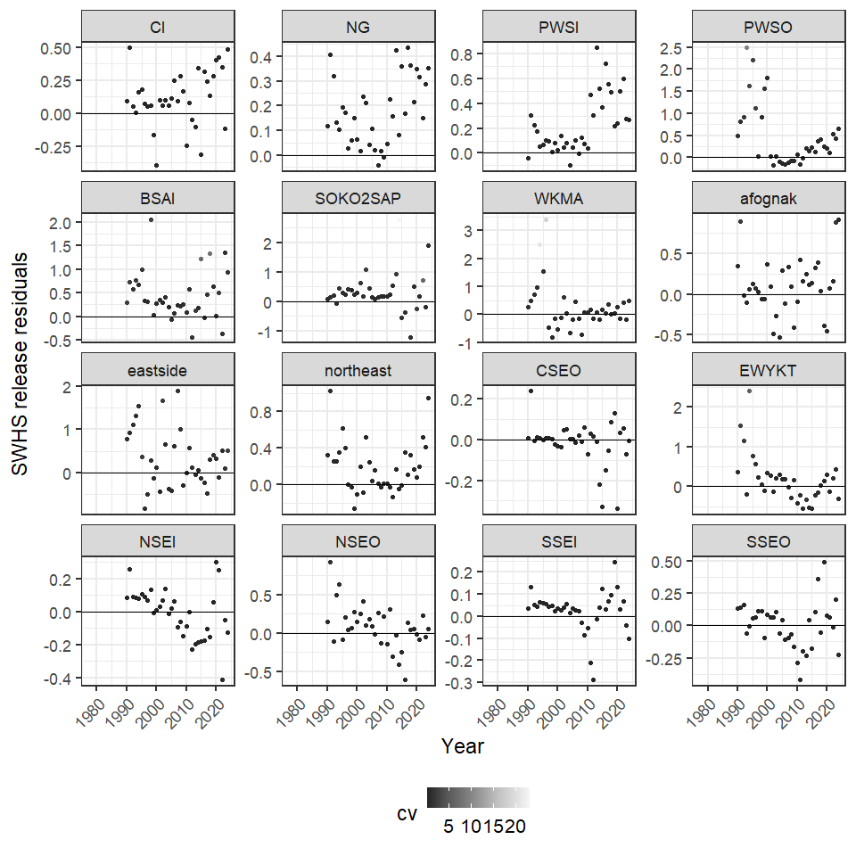
Figure 10.- Residual of SWHS releases for 16 commercial fisheries management units 1977-2024 showing the difference between model estimates with the bias correction removed and observed values in the SWHS. The CV of the SWHS data is indicated by the grey scale.

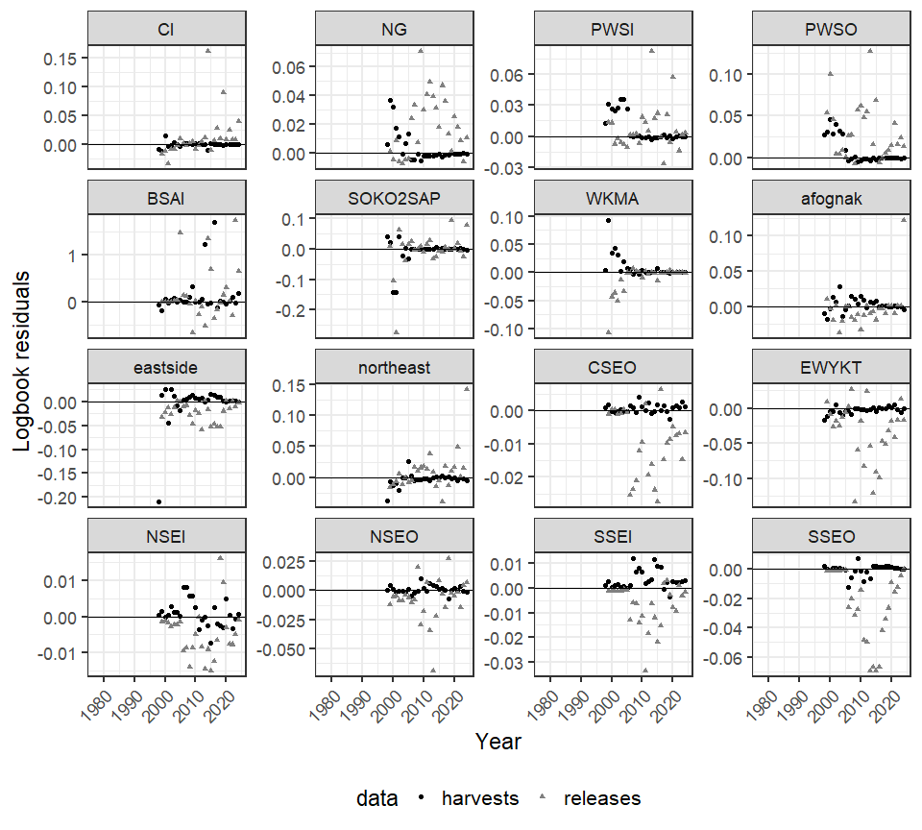
Figure 11.- Residuals from logbook harvests and releases for 16 commercial fisheries management units 1977-2024 with residuals shown proportional to the magnitude of the harvest and release data.

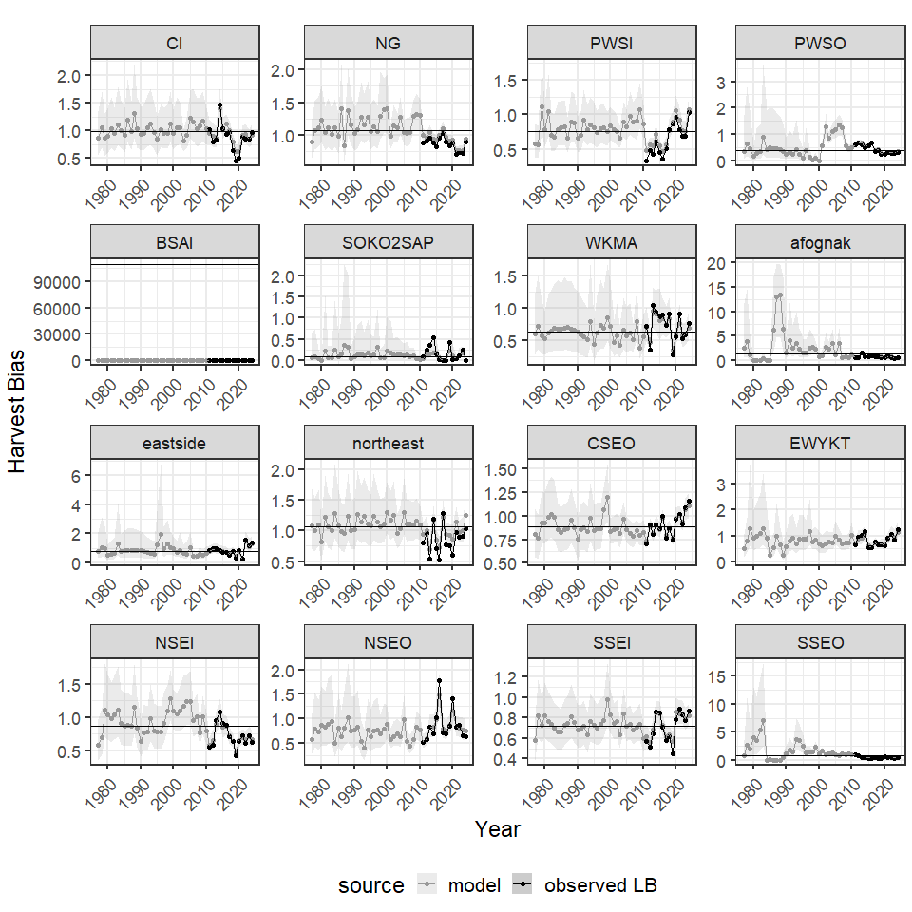
Figure 12.- Annual estimates of SWHS bias in harvests for 16 commercial fishing managment units, 1977-2024. Note that a bias < 1 indicates that the SWHS underestimates the true value and bias > 1 indicates the survey overestimates the true value.

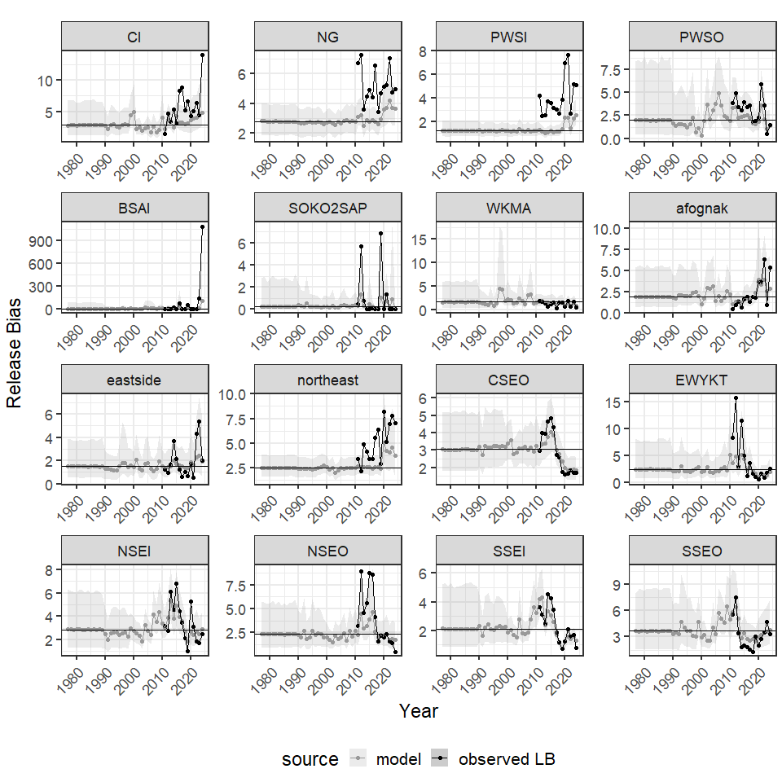
Figure 13.- Annual estimates of SWHS bias in releases for 16 commercial fishing manamgent units, 1977-2024. Note that a bias < 1 indicates that the SWHS underestimates the true value and bias > 1 indicates the survey overestimates the true value.

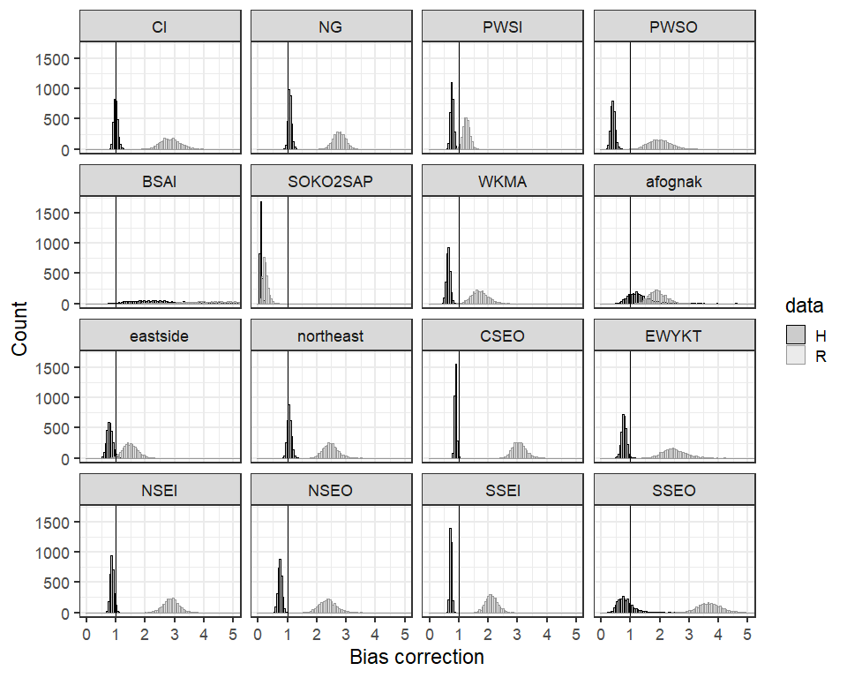
Figure 14.- Mean SWHS bias for harvests and catches for 16 commercial fisheries management units. Note that a bias < 1 indicates that the SWHS underestimates the true value and bias > 1 indicates the survey overestimates the true value.

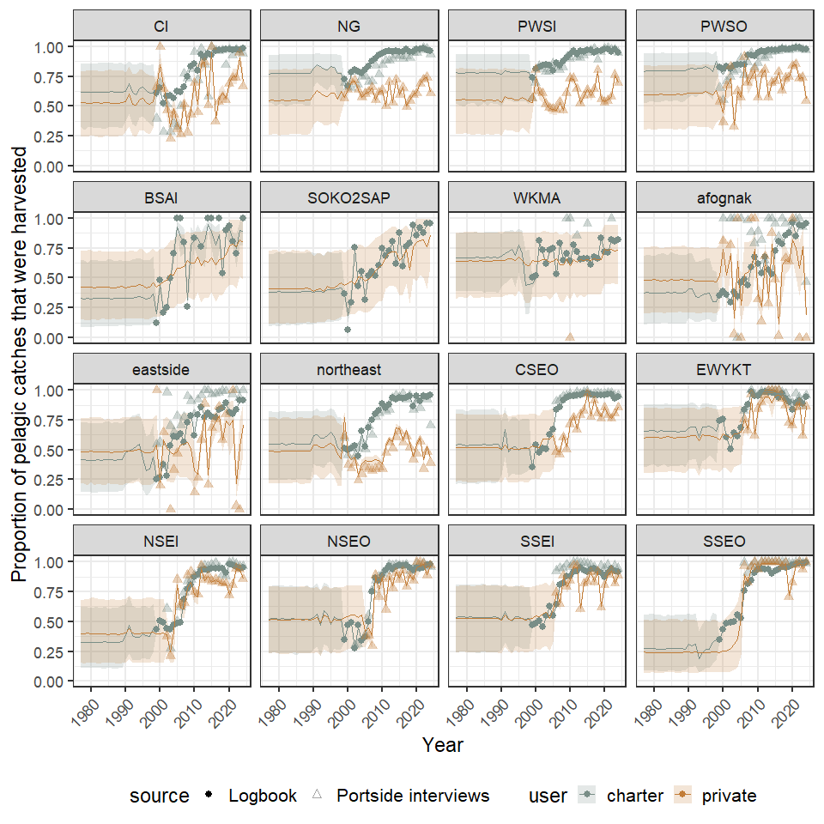
Figure 15.- Annual proportion of pelagic rockfish catch that was harvested by guided and unguided anglers in 16 commercial fishing management units, 1977-2024 as estimated by the model (line) and evident in the logbook (solid circles) and portside interview data (triangles). The shaded areas represent the 95% credibility intervals of the Bayesian model estimates.

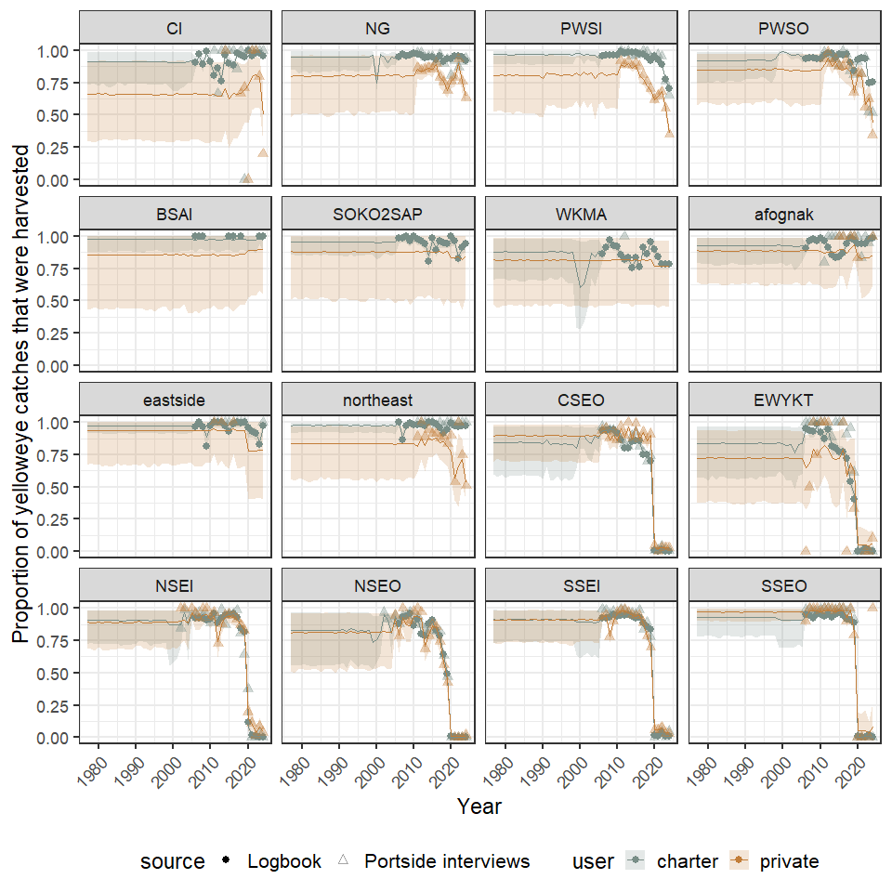
Figure 16.- Annual proportion of yelloweye rockfish catch that was harvested by guided and unguided anglers in 16 commercial fishing management units, 1977-2024 as estimated by the model (line) and evident in the logbook (solid circles) and portside interview data (triangles). The shaded areas represent the 95% credibility intervals of the Bayesian model estimates.

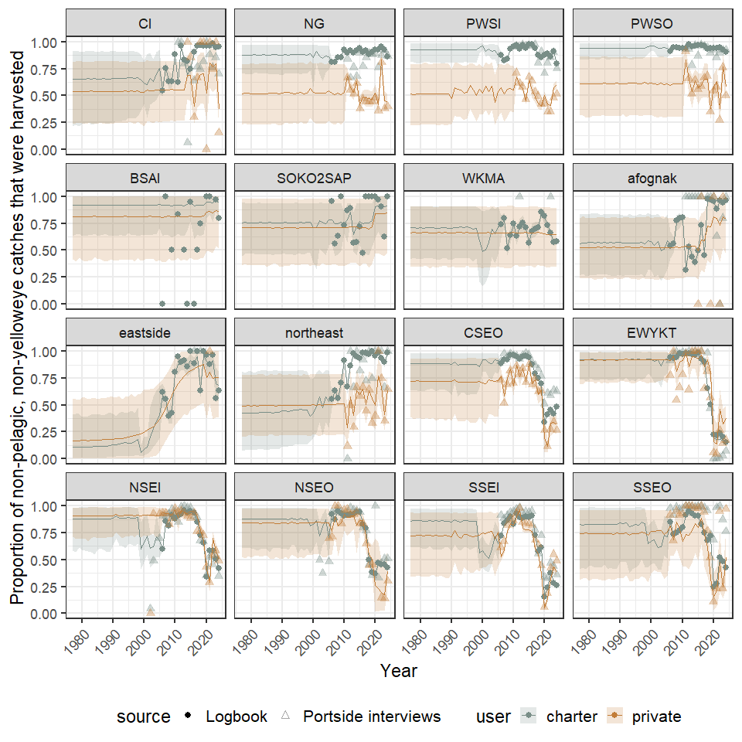
Figure 17.- Annual proportion of other (non-pelagic, non-yelloweye) rockfish catch that was harvested by guided and unguided anglers in 16 commercial fishing management units, 1977-2024 as estimated by the model (line) and evident in the logbook (solid circles) and portside interview data (triangles). The shaded areas represent the 95% credibility intervals of the Bayesian model estimates.

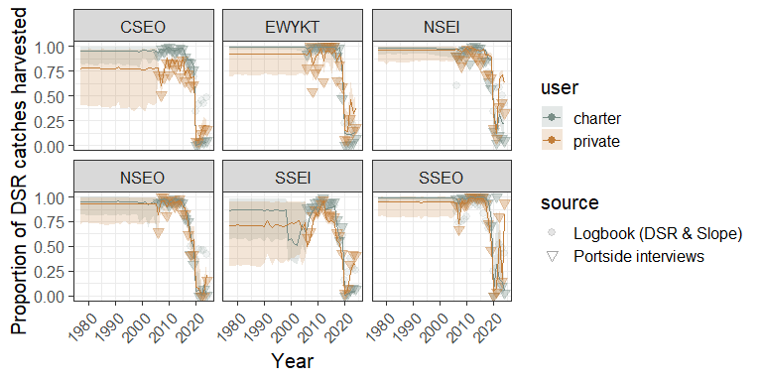
Figure 18.- Annual proportion of demersal shelf rockfish catch that was harvested by guided and unguided anglers in 6 Southeast commercial fishing management units, 1977-2024 as estimated by the model (line) and evident in portside interview data (triangles). The shaded areas represent the 95% credibility intervals of the Bayesian model estimates.

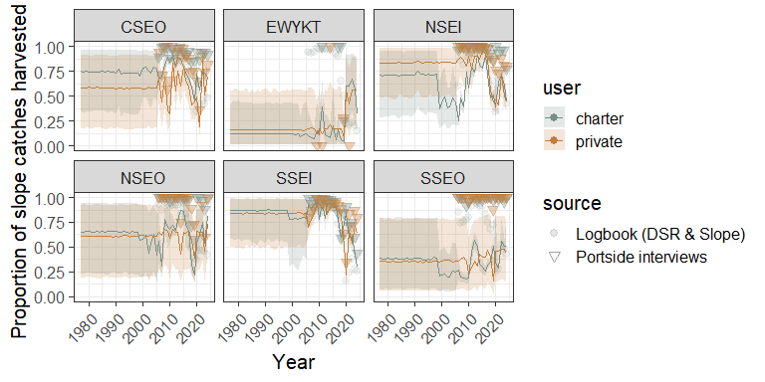
Figure 19.- Annual proportion of slope rockfish catch that was harvested by guided and unguided anglers in 6 Southeast commercial fishing management units, 1977-2024 as estimated by the model (line) and evident in portside interview data (triangles). The shaded areas represent the 95% credibility intervals of the Bayesian model estimates.

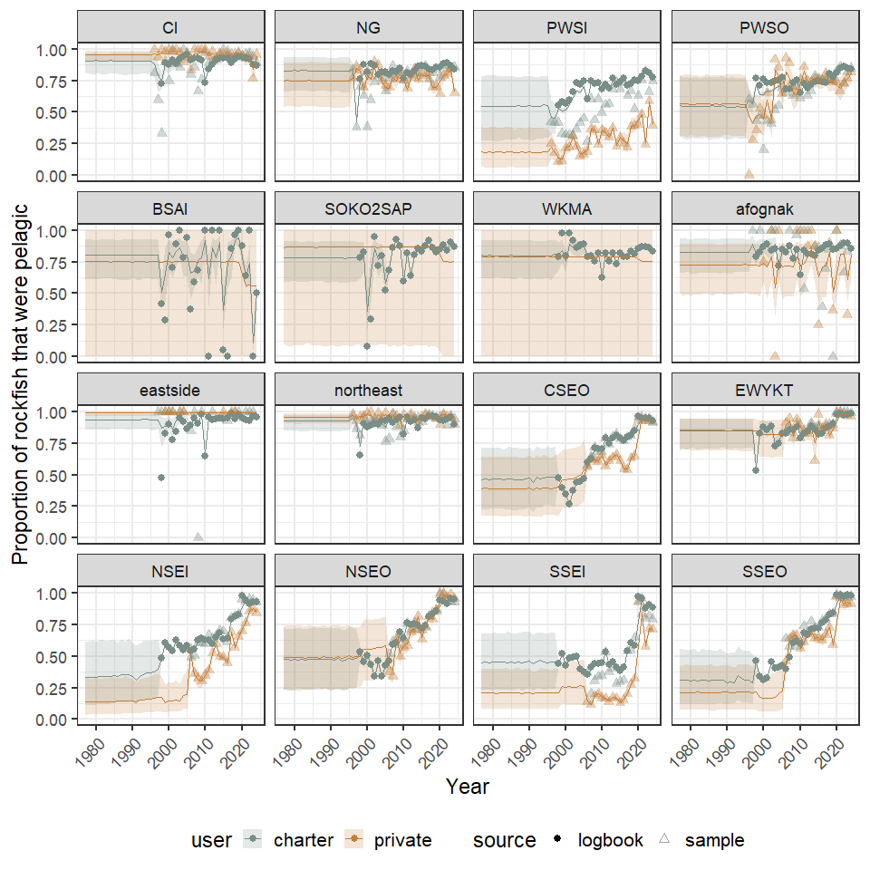
Figure 20.- Annual estimates of the percent of the sport harvest that was pelagic rockfish for guided and unguided anglers in 16 commercial fishery management units, 1977-2024 as estimated by the model (line) and evident in the logbook (solid circles) and portside sampling (triangles). The shaded areas represent the 95% credibility intervals of the Bayesian model estimates.

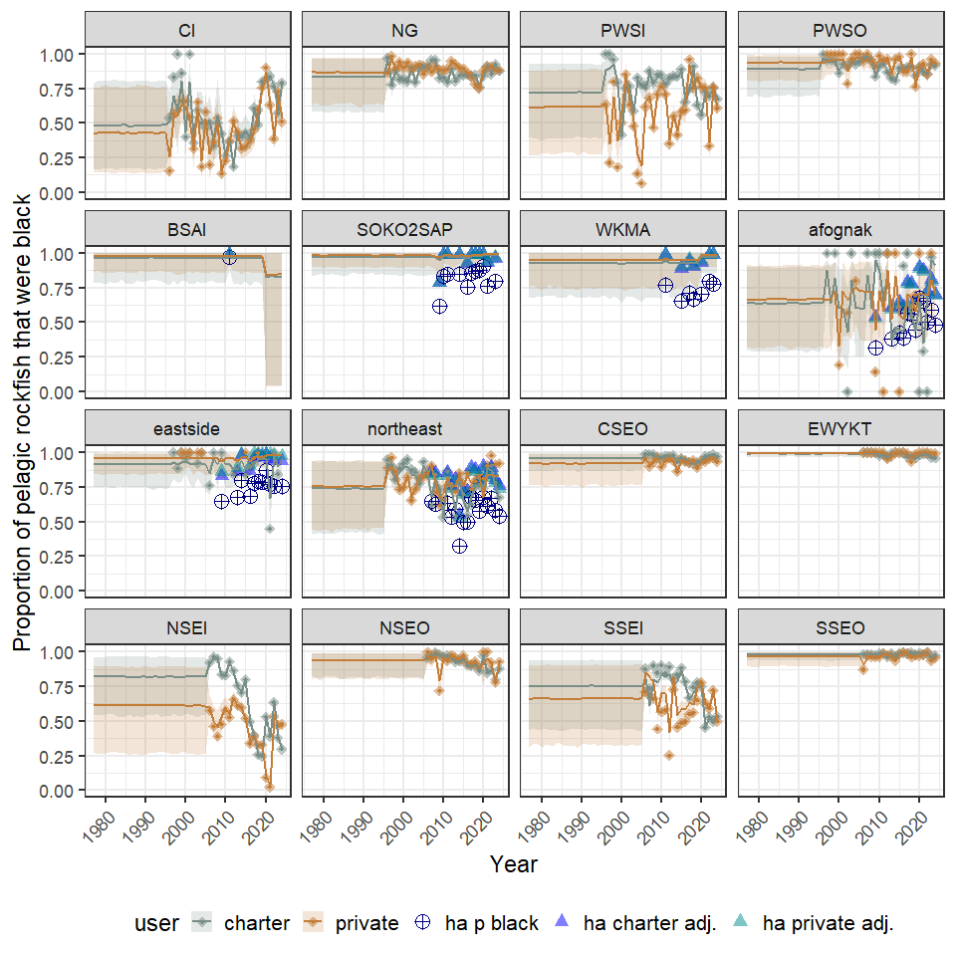
Figure 21.- Annual estimates of the percent of the sport harvest of pelagic rockfish that were black rockfish for guided and unguided anglers in 16 commercial fishing management units, 1977-2024 as estimated by the model (line) and evident in portside sampling (triangles). The shaded areas represent the 95% credibility intervals of the Bayesian model estimates. Kodiak panels include data from a hydroacoustic survey and the proportion of pelagic rockfish that are black in those areas (navy blue) and the adjusted proportions based on obseved harvests for charter (blue) and private (cyan) users.

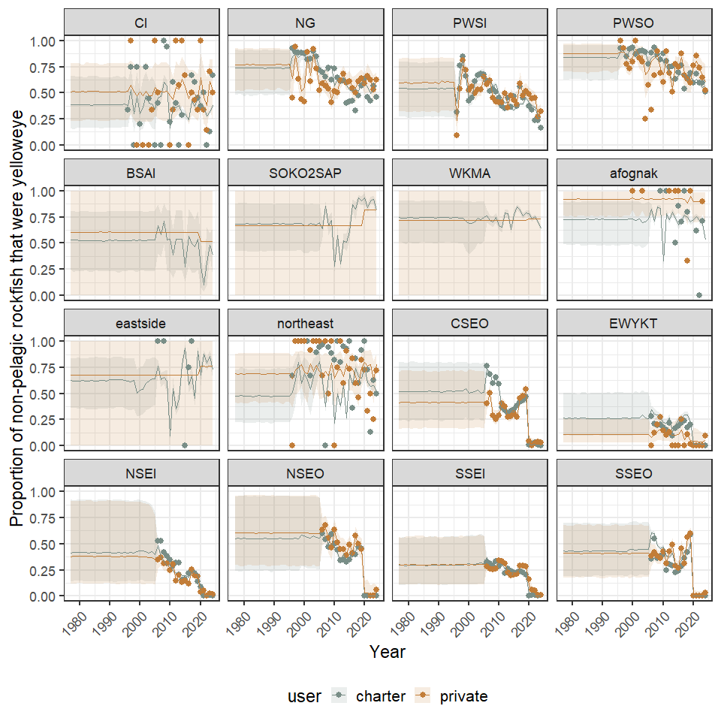
Figure 22.- Annual estimates of the percent of the sport harvest of non-pelagic rockfish that were yelloweye rockfish for guided and unguided anglers in 16 commercial fishing management units, 1977-2024 as estimated by the model (line) and evident in portside sampling (circles). The shaded areas represent the 95% credibility intervals of the Bayesian model estimates.

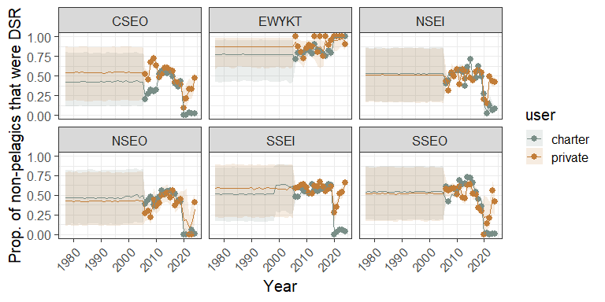
Figure 23.- Annual estimates of the percent of the sport harvest of non-pelagic rockfish that were non-yelloweye DSR rockfish for guided and unguided anglers in 6 Southeast commercial fishing management units, 1977-2024 as estimated by the model (line) and evident in portside sampling (dots). The shaded areas represent the 95% credibility intervals of the Bayesian model estimates.

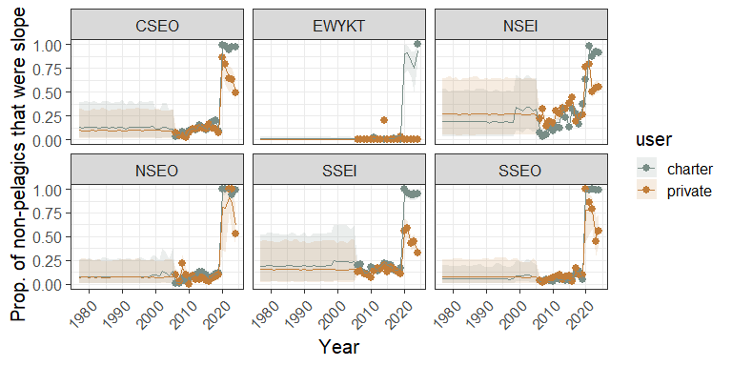
Figure 24.- Annual estimates of the percent of the sport harvest of non-pelagic rockfish that were slope rockfish guided and unguided anglers in 6 Southeast commercial fishing management units, 1977-2024 as estimated by the model (line) and evident in portside sampling (dots). The shaded areas represent the 95% credibility intervals of the Bayesian model estimates.

## NULL

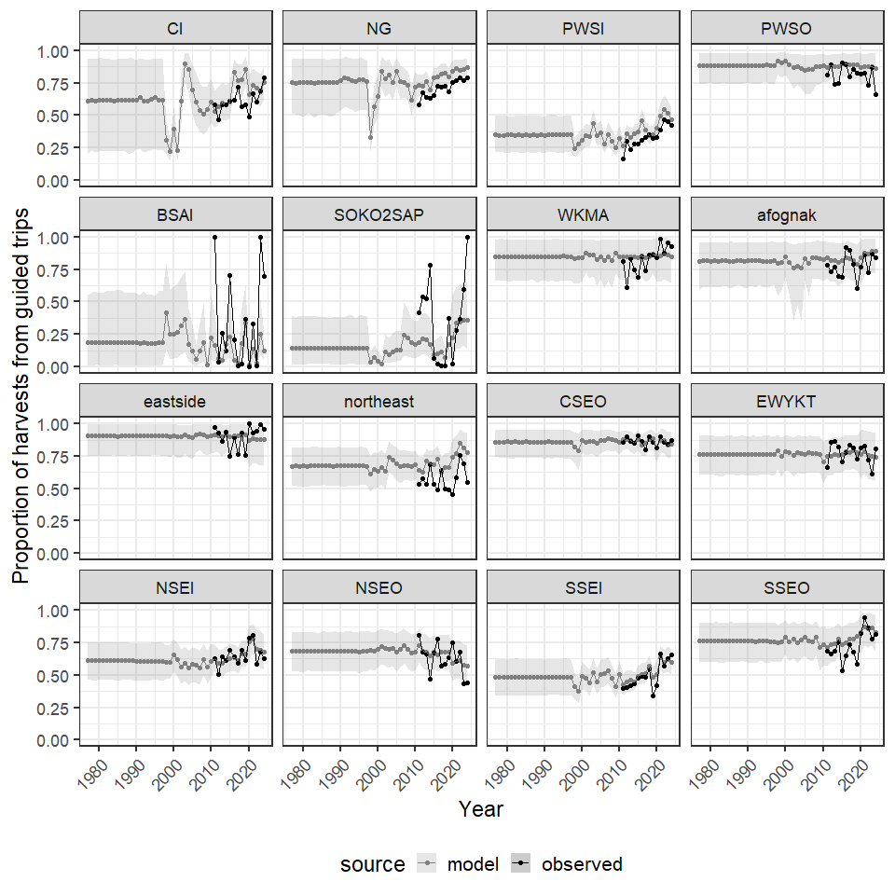
Figure 25.- Annual estimates of the proportion of total sport fish harvest taken by charter anglers for 16 commercial fishing management units, 1977-2024 as observed in the SWHS and estimated in the model.

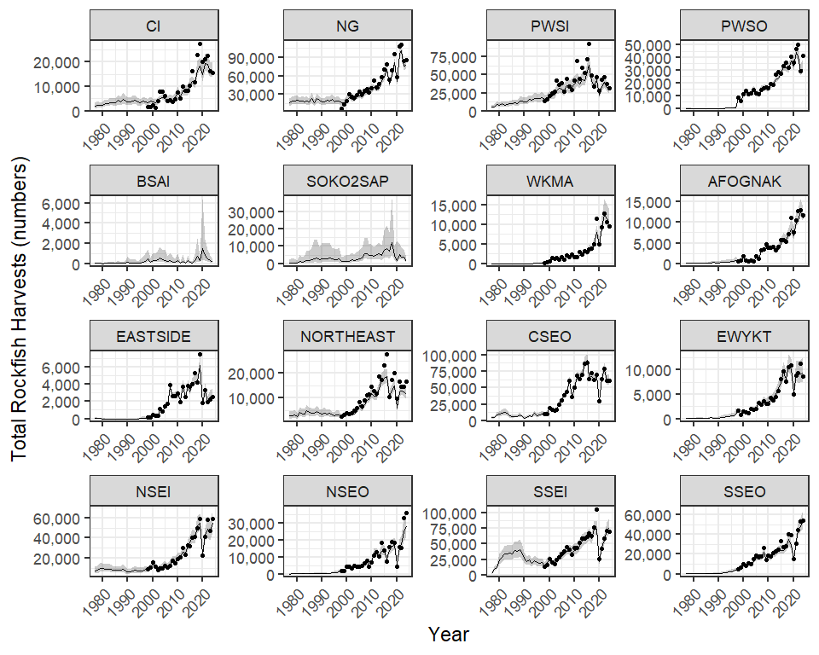
Figure 26.- Total rockfish harvests for 16 commercial fisheries management units 1977-2024. Lines and error polygons represent model estimates and 95% credibility intervals, respectively, and points represent Howard et al. (2020) estimates.

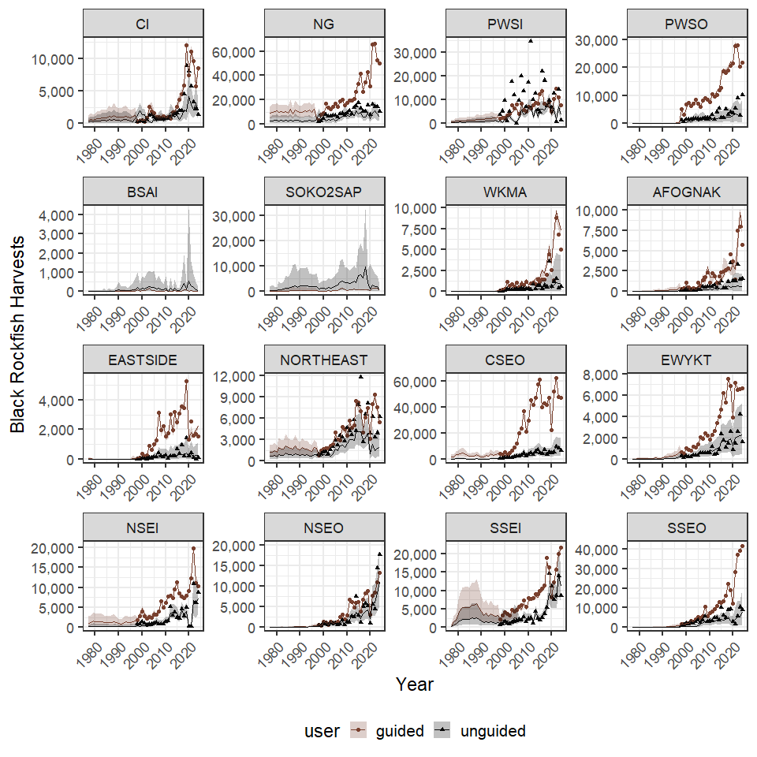
Figure 27.- Black rockfish harvests for 16 commercial fisheries management units 1977-2024. Lines and error polygons represent model estimates and 95% credibility intervals, respectively, and points represent Howard et al. (2020) estimates.

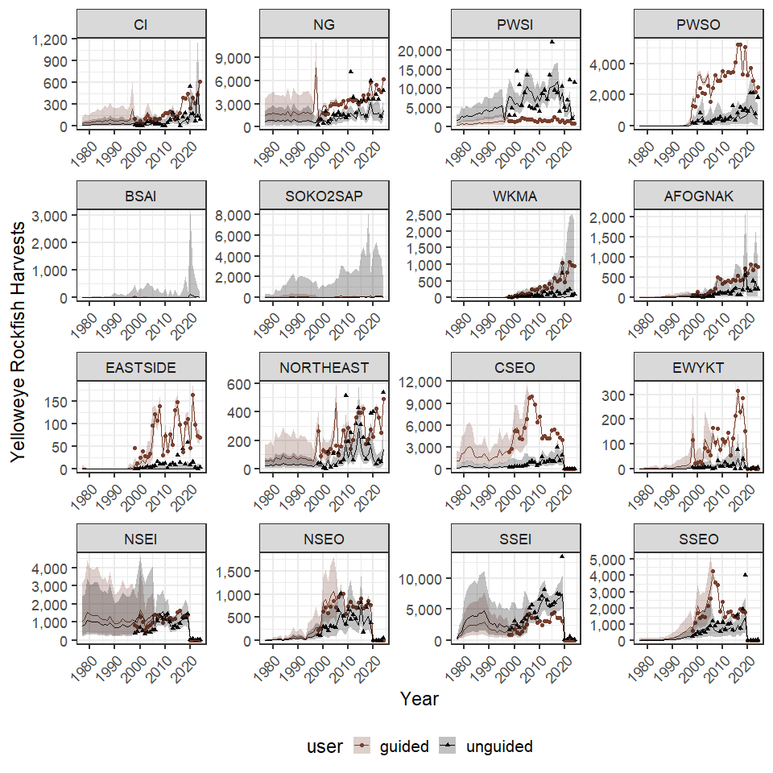
Figure 28.- Yellow rockfish harvests for 16 commercial fisheries management units 1977-2024. Lines and error polygons represent model estimates and 95% credibility intervals, respectively, and points represent Howard et al. (2020) estimates.

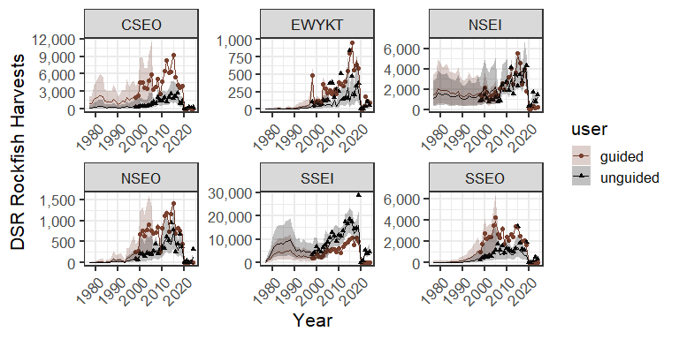
Figure 29.- Non-yelloweye DSR rockfish harvests for 6 Southeast Alaska commercial fisheries management units in Southeast Alaska 1977–2024. Lines and error polygons represent model estimates and 95% credibility intervals, respectively, and points represent Howard et al. (2020) estimates.

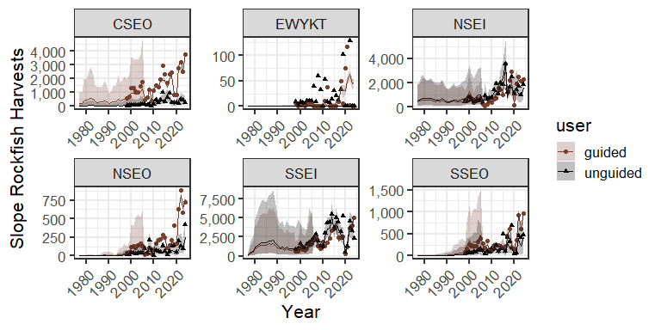
Figure 30.- Slope rockfish harvests for 6 Southeast Alaska commercial fisheries management units in Southeast Alaska 1977–2024. Lines and error polygons represent model estimates and 95% credibility intervals, respectively, and points represent Howard et al. (2020) estimates.

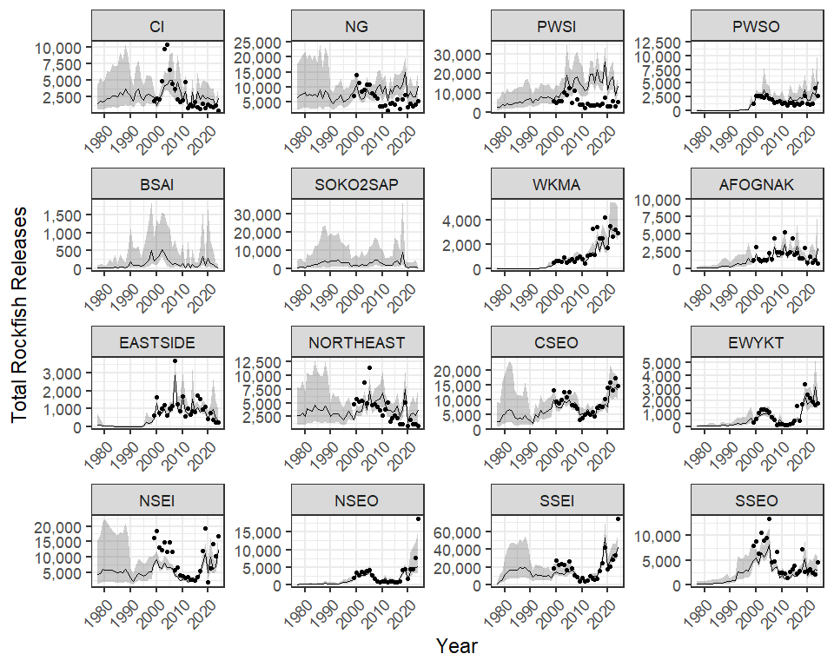
Figure 31.- Total rockfish releases for 16 commercial fisheries management units 1977–2024. Lines and error polygons represent model estimates and 95% credibility intervals, respectively, and points represent Howard et al. (2020) estimates.

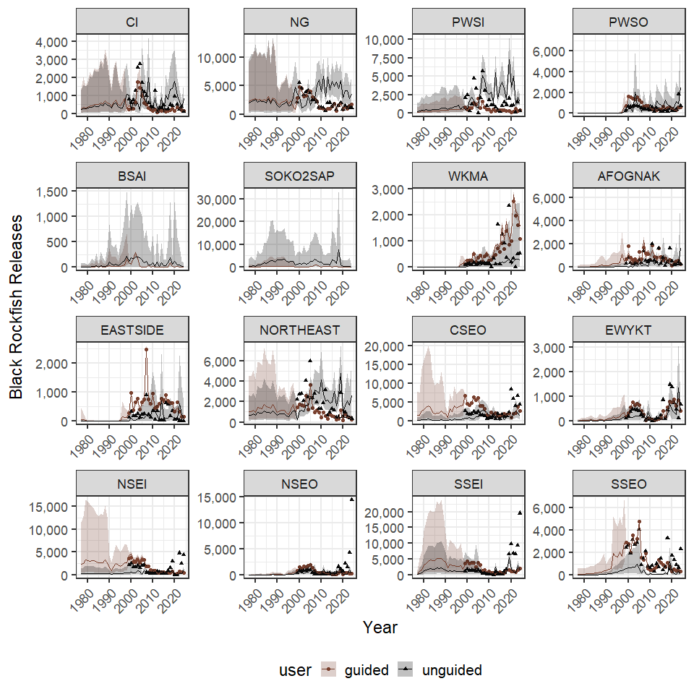
Figure 32.- Black rockfish releases for 16 commercial fisheries management units 1977–2024. Lines and error polygons represent model estimates and 95% credibility intervals, respectively, and points represent Howard et al. (2020) estimates.

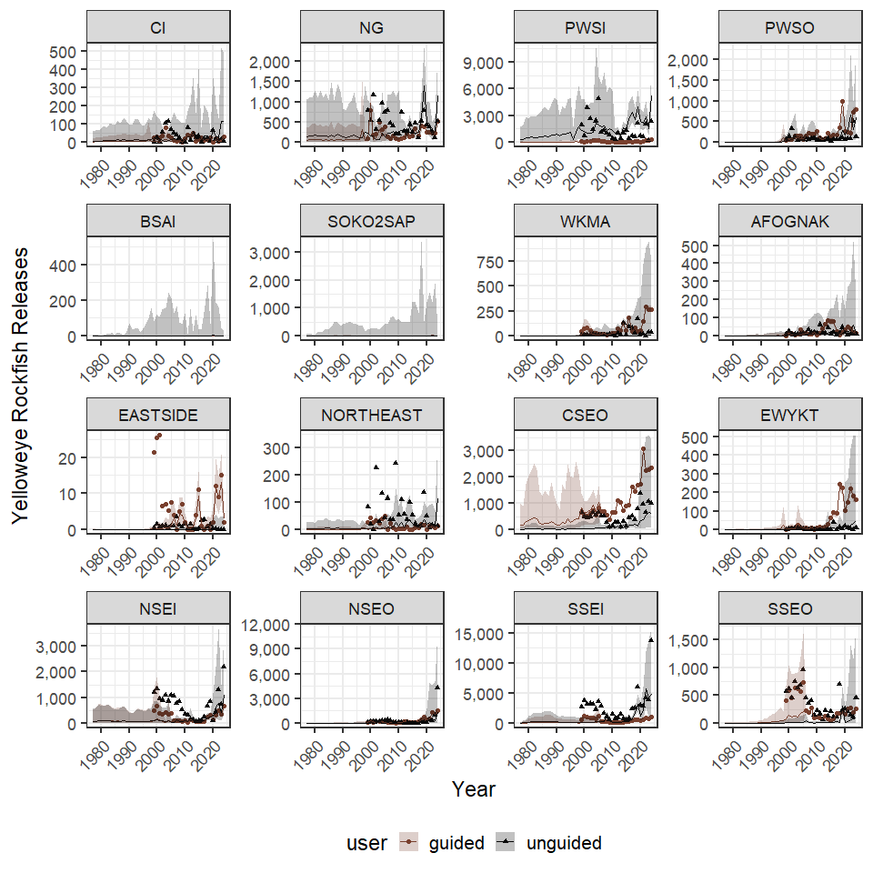
Figure 33.- Yellow rockfish releases for 16 commercial fisheries management units 1977–2024. Lines and error polygons represent model estimates and 95% credibility intervals, respectively, and points represent Howard et al. (2020) estimates.

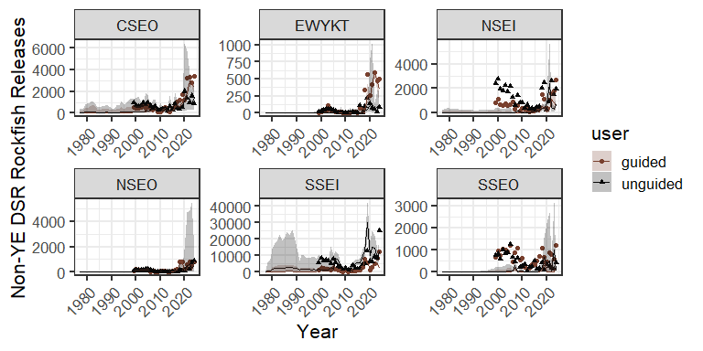
Figure 34.- Non-yelloweye DSR rockfish releases for 6 Southeast Alaska commercial fisheries management units 1977–2024. Lines and error polygons represent model estimates and 95% credibility intervals, respectively, and points represent Howard et al. (2020) estimates.

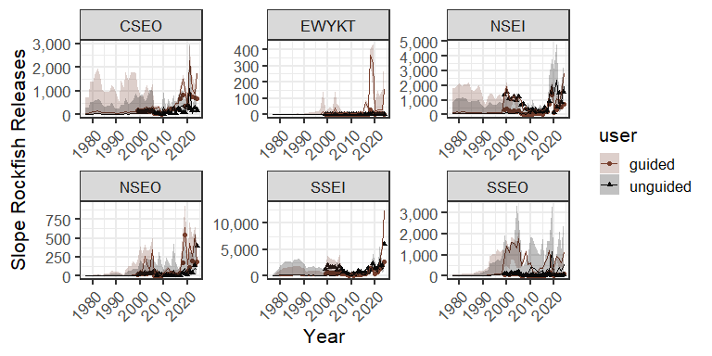
Figure 35.- Slope rockfish releases for 6 Southeast Alaska commercial fisheries management units 1977–2024. Lines and error polygons represent model estimates and 95% credibility intervals, respectively, and points represent Howard et al. (2020) estimates.

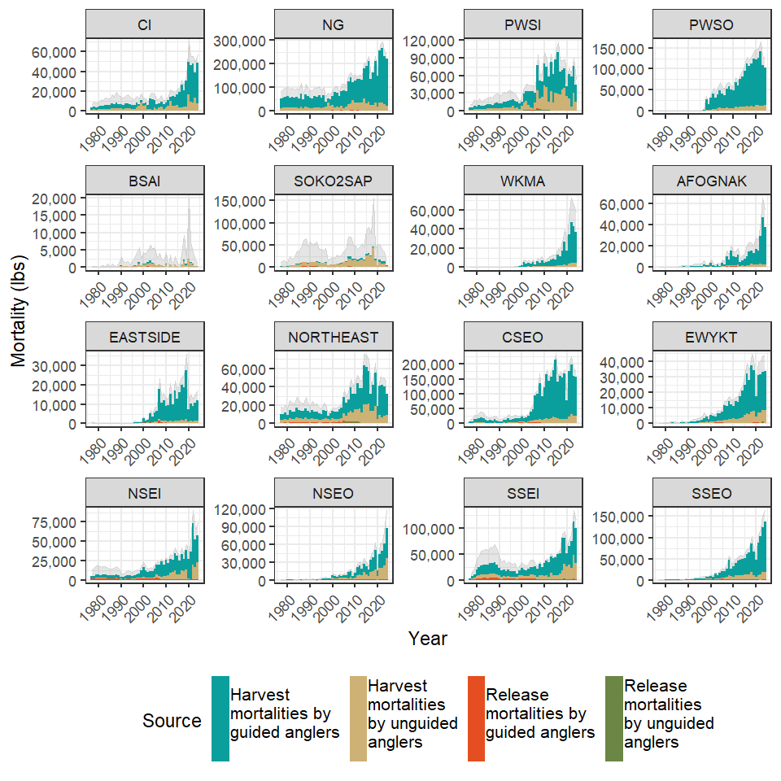
Figure 36.- Total removals of black rockfish by guided and unguided anglers in 16 Alaska commercial fishery management units as dervided from harvests and release mortalities 1977-2024. The grey polygon in the backround represents 95% credibility intervals of the total removals. Southeast Alaska (CSEO, EWYKT, NSEI, NSEO, SSEI, SSEO) biomass estimates prior to ",SE4stageyear1," do not use mean weights generated from the 4-stage sampling design (Richards et al. 2025) that has been used since ", SE4stageyear1, "and as such are considered preliminary. Finalized biomass estimates for pre-“SE4stageyear1, “ estimates are not expected to change significantly when 4-stage estimates are generated for those year.

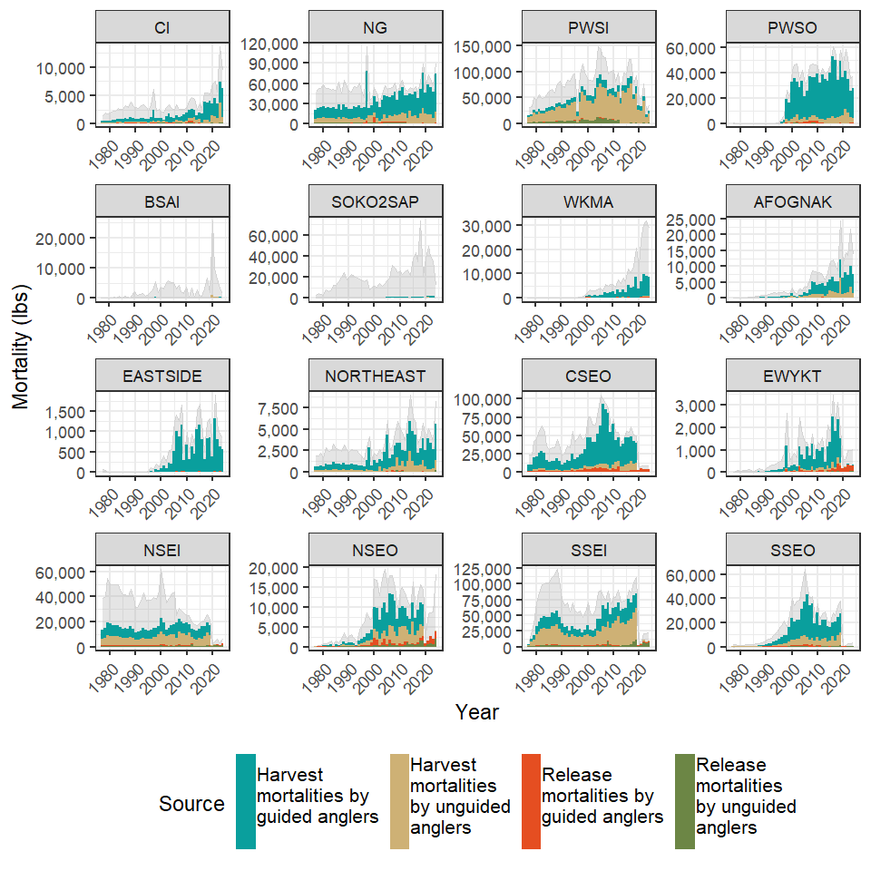
Figure 37.- Total removals of yelloweye rockfish by guided and unguided anglers in Alaska commercial fishery management units as dervided from harvests and release mortalities 1977-2024. The grey polygon in the backround represents 95% credibility intervals of the total removals.

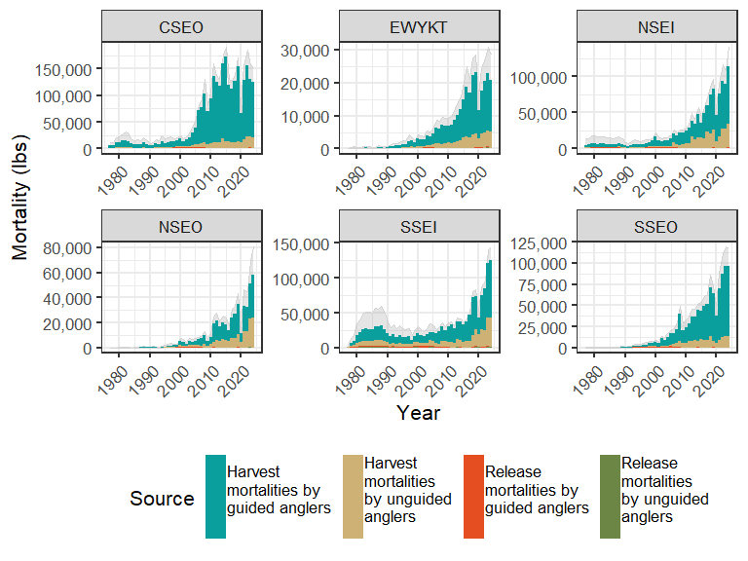
Figure 38.- Total removals of non-black pelagic rockfish by guided and unguided anglers in Southeast Alaska commercial fishery management units as dervided from harvests and release mortalities 1977-2024. The grey polygon in the backround represents 95% credibility intervals of the total removals.

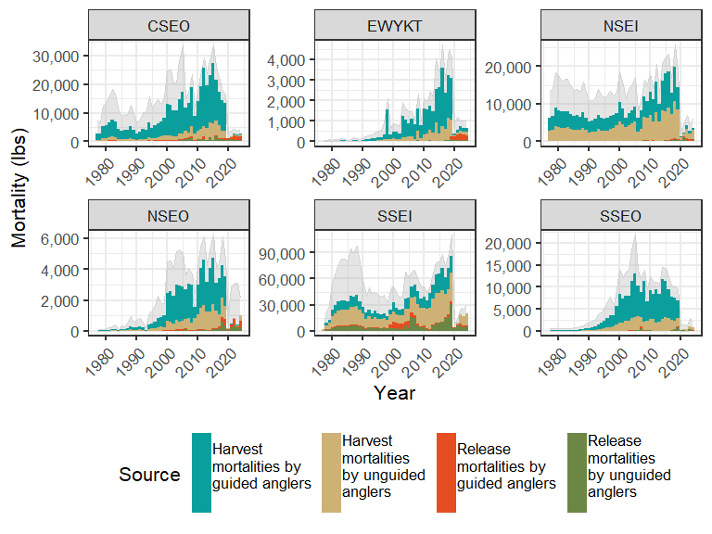
Figure 39.- Total removals of non-yelloweye demersal shelf rockfish by guided and unguided anglers in southeast Alaska commercial fishery management units as dervided from harvests and release mortalities 1977-2024. The grey polygon in the backround represents 95% credibility intervals of the total removals.

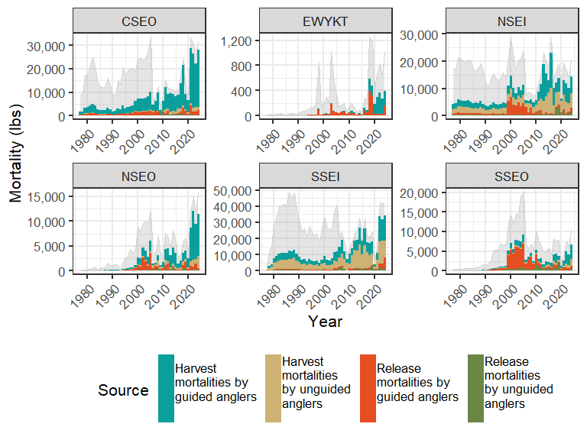
Figure 40.- Total removals of slope rockfish by guided and unguided anglers in Southeast Alaska commercial fishery management units as dervided from harvests and release mortalities 1977-2024. The grey polygon in the backround represents 95% credibility intervals of the total removals.

