Figures
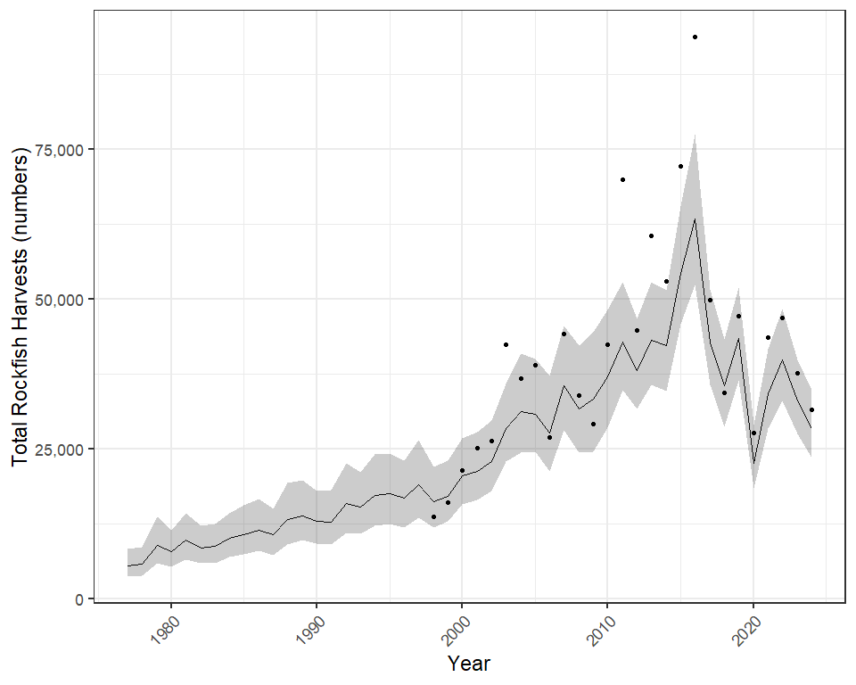
Figure 1.- Total rockfish harvests for 16 commercial fisheries management units 1977-2024. Lines and error polygons represent model estimates and 95% credibility intervals, respectively, and points represent Howard et al. (2020) estimates.

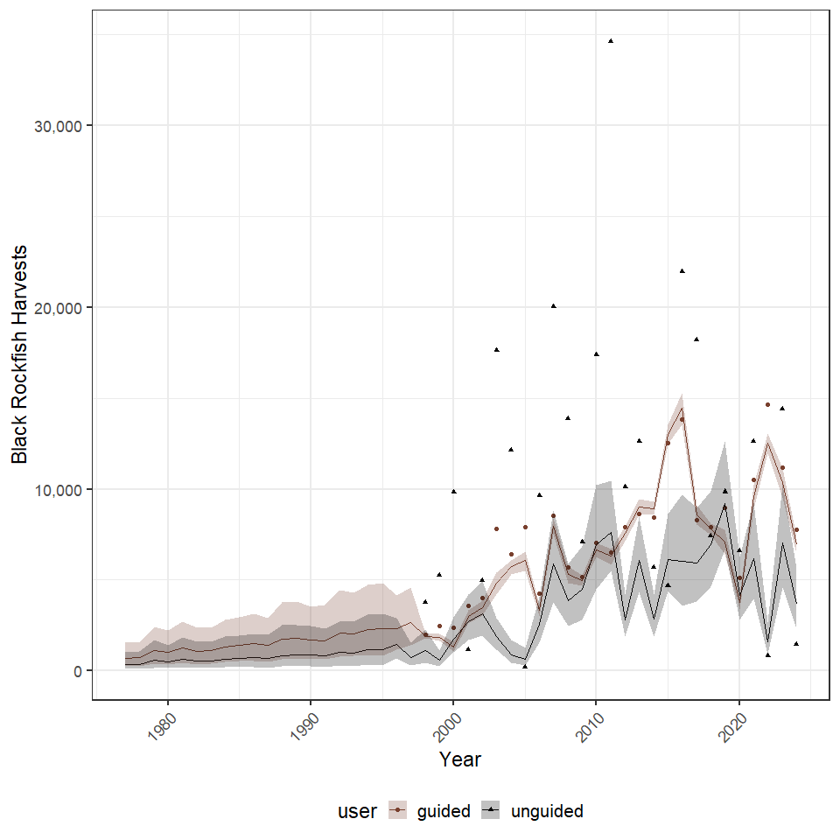
Figure 2.- Black rockfish harvests for 16 commercial fisheries management units 1977-2024. Lines and error polygons represent model estimates and 95% credibility intervals, respectively, and points represent Howard et al. (2020) estimates.

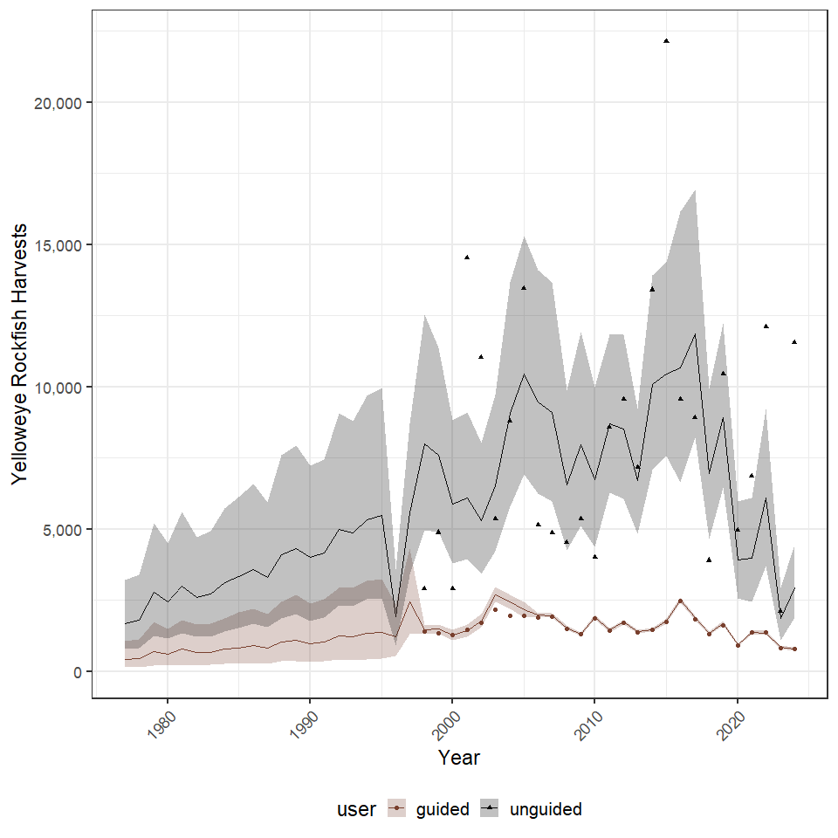
Figure 3.- Yellow rockfish harvests for 16 commercial fisheries management units 1977-2024. Lines and error polygons represent model estimates and 95% credibility intervals, respectively, and points represent Howard et al. (2020) estimates.

## NULL

## NULL

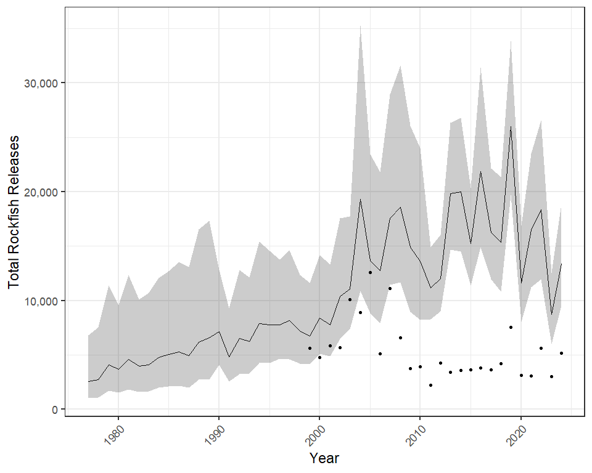
Figure 4.- Total rockfish releases for 16 commercial fisheries management units 1977–2024. Lines and error polygons represent model estimates and 95% credibility intervals, respectively, and points represent Howard et al. (2020) estimates.

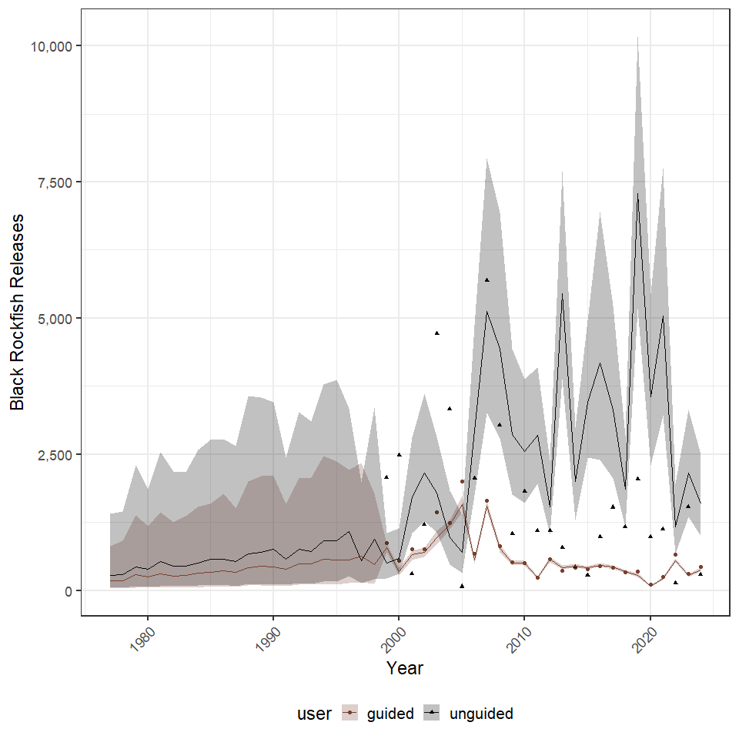
Figure 5.- Black rockfish releases for 16 commercial fisheries management units 1977–2024. Lines and error polygons represent model estimates and 95% credibility intervals, respectively, and points represent Howard et al. (2020) estimates.

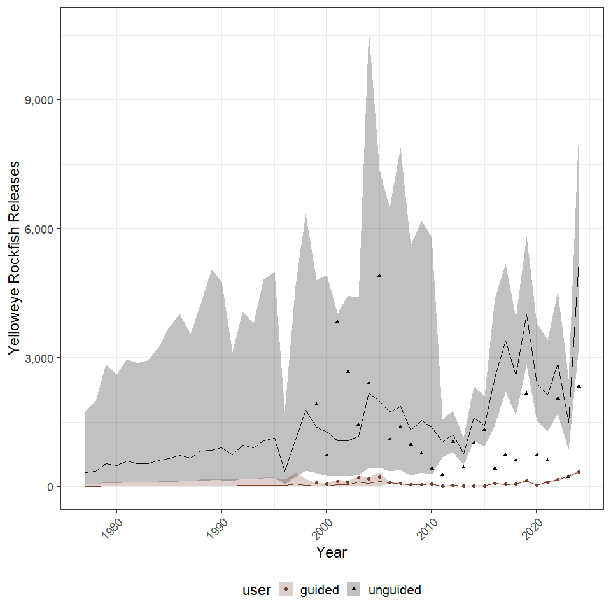
Figure 6.- Yellow rockfish releases for 16 commercial fisheries management units 1977–2024. Lines and error polygons represent model estimates and 95% credibility intervals, respectively, and points represent Howard et al. (2020) estimates.

## NULL

## NULL

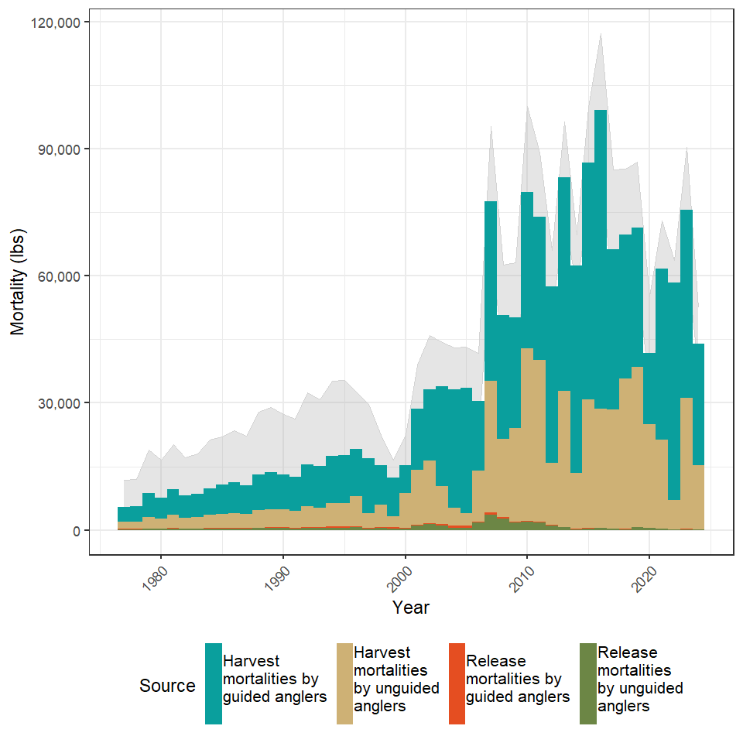
Figure 7.- Total removals of black rockfish by guided and unguided anglers in 16 Alaska commercial fishery management units as dervided from harvests and release mortalities 1977-2024. The grey polygon in the backround represents 95% credibility intervals of the total removals.

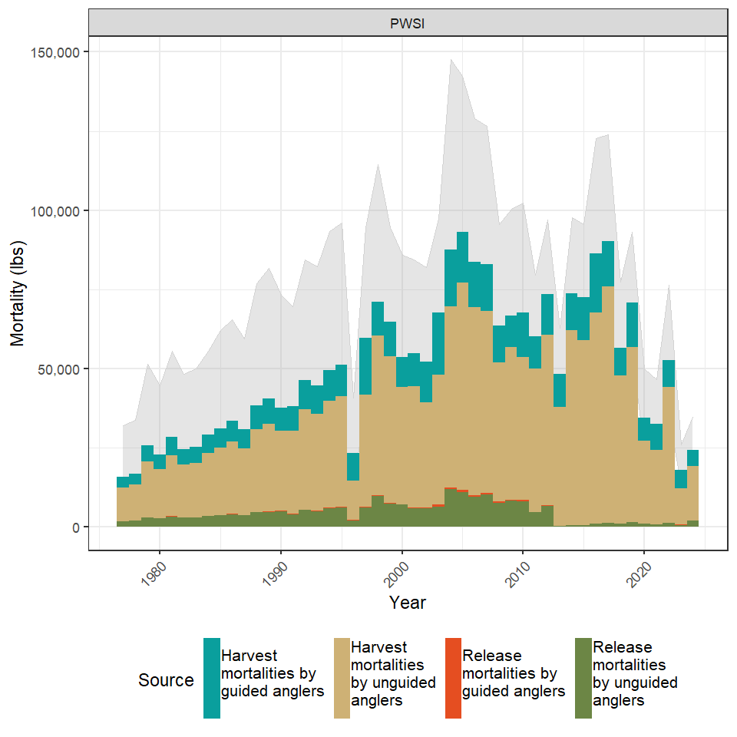
Figure 8.- Total removals of yelloweye rockfish by guided and unguided anglers in Alaska commercial fishery management units as dervided from harvests and release mortalities 1977-2024. The grey polygon in the backround represents 95% credibility intervals of the total removals.

## NULL

## NULL

