Fishery Manuscript No. YY-XX
Rockfish Removals in Alaska Sport Fisheries 1977 - 2025
by
Philip J. Joy,
Clay McKean,
Christine Hinds, and
Diana Tersteeg

Month year
Alaska Department of Fish and Game Divisions of Sport Fish and Commercial Fisheries

Symbols and Abbreviations
The following symbols and abbreviations, and others approved for the Système International d'Unités (SI), are used without definition in the following reports by the Divisions of Sport Fish and of Commercial Fisheries: Fishery Manuscripts, Fishery Data Series Reports, Fishery Management Reports, and Special Publications. All others, including deviations from definitions listed below, are noted in the text at first mention, as well as in the titles or footnotes of tables, and in figure or figure captions.

Weights and measures (metric)
centimeter cm
deciliter dL
gram g
hectare ha
kilogram kg
kilometer km
liter L
meter m
milliliter mL
millimeter mm

Weights and measures (English)
cubic feet per second ft³/s
foot ft
gallon gal
inch in
mile mi
nautical mile nmi
ounce oz
pound lb
quart qt
yard yd

Time and temperature
day d
degrees Celsius °C
degrees Fahrenheit °F
degrees kelvin K
hour h
minute min
second s

Physics and chemistry
all atomic symbols
alternating current AC
ampere A
calorie cal
direct current DC
hertz Hz
horsepower hp
hydrogen ion activity pH
(negative log of)
parts per million ppm
parts per thousand ppt,
‰
volts V
watts W
General
Alaska Administrative
Code AAC
all commonly accepted
abbreviations e.g., Mr., Mrs., AM, PM, etc.
all commonly accepted
professional titles e.g., Dr., Ph.D.,
R.N., etc.
at @
compass directions:
east E
north N
south S
west W
copyright ©
corporate suffixes:
Company Co.
Corporation Corp.
Incorporated Inc.
Limited Ltd.
District of Columbia D.C.
et alii (and others) et al.
et cetera (and so forth) etc.
exempli gratia
(for example) e.g.
Federal Information
Code FIC
id est (that is) i.e.
latitude or longitude lat or long
monetary symbols
(U.S.) $, ¢
months (tables and
figures): first three
letters Jan,...,Dec
registered trademark ®
trademark ™
United States
(adjective) U.S.
United States of
America (noun) USA
U.S.C. United States Code
U.S. state use two-letter abbreviations (e.g., AK, WA)
Mathematics, statistics
all standard mathematical
signs, symbols and
abbreviations
alternate hypothesis H_{A}
base of natural logarithm e
catch per unit effort CPUE
coefficient of variation CV
common test statistics (F, t, χ², etc.)
confidence interval CI
correlation coefficient
(multiple) R
correlation coefficient
(simple) r
covariance cov
degree (angular) °
degrees of freedom df
expected value E
greater than >
greater than or equal to ≥
harvest per unit effort HPUE
less than <
less than or equal to ≤
logarithm (natural) ln
logarithm (base 10) log
logarithm (specify base) log_{2,} etc.
minute (angular) ′
not significant NS
null hypothesis H_{O}
percent %
probability P
probability of a type I error
(rejection of the null
hypothesis when true) α
probability of a type II error
(acceptance of the null
hypothesis when false) β
second (angular) ″
standard deviation SD
standard error SE
variance
population Var
sample var

fishery manuscript no. YY-XX
Rockfish Removals in Alaska Sport Fisheries 1977 - 2025

by
Philip J. Joy
Alaska Department of Fish and Game, Division of Sport Fish, Juneau,
Clay McKean
Alaska Department of Fish and Game, Division of Sport Fish, Anchorage,
Christine Hinds
Alaska Department of Fish and Game, Division of Sport Fish, Douglas
and
Diana Tersteeg
Alaska Department of Fish and Game, Division of Sport Fish, Douglas

Alaska Department of Fish and Game
Division of Sport Fish, Research and Technical Services
333 Raspberry Road, Anchorage, Alaska, 99518-1565
Month Year

Delete funding block if not applicable: This investigation was partially financed by the Federal Aid in Sport Fish Restoration Act (16 U.S.C.777-777K) under Project F-10-XX, Job No. X-X.
The Fishery Manuscript Series was established in 1987 by the Division of Sport Fish for the publication of technically oriented results of several years’ work undertaken on a project to address common objectives, provide an overview of work undertaken through multiple projects to address specific research or management goal(s), or new and/or highly technical methods, and became a joint divisional series in 2004 with the Division of Commercial Fisheries. Fishery Manuscripts are intended for fishery and other technical professionals. Fishery Manuscripts are available through the Alaska State Library and on the Internet: http://www.adfg.alaska.gov/sf/publications/. This publication has undergone editorial and peer review.
Product names used in this publication are included for completeness and do not constitute product endorsement. The Alaska Department of Fish and Game does not endorse or recommend any specific company or their products.

Philip J. Joy,
Alaska Department of Fish and Game, Division of Sport Fish,
Headquarters, 1255 W 8th St. Juneau, AK 99801,
Mailing: PO Box 115526, Juneau, AK 99811
Clay McKean,
Alaska Department of Fish and Game, Division of Sport Fish
333 Raspberry Rd., Anchorage, AK 99518-1565,
Christine Hinds,
Alaska Department of Fish and Game, Division of Sport Fish
802 3rd St., Douglas, AK 99824
and
Diana Tersteeg
Alaska Department of Fish and Game, Division of Sport Fish,
802 3rd St., Douglas, AK 99824

This document should be cited as follows:
Joy, P. J., C. McKean, C. Hinds and D. Tersteeg. Year. Rockfish Removals in Alaska Sport Fisheries 1977 - 2025. Alaska Department of Fish and Game, Fishery Manuscript No. YY-XX, Anchorage.
The Alaska Department of Fish and Game (ADF&G) administers all programs and activities free from discrimination based on race, color, national origin, age, sex, religion, marital status, pregnancy, parenthood, or disability. The department administers all programs and activities in compliance with Title VI of the Civil Rights Act of 1964, Section 504 of the Rehabilitation Act of 1973, Title II of the Americans with Disabilities Act (ADA) of 1990, the Age Discrimination Act of 1975, and Title IX of the Education Amendments of 1972.
If you believe you have been discriminated against in any program, activity, or facility please write:
ADF&G ADA Coordinator, P.O. Box 115526, Juneau, AK 99811-5526
U.S. Fish and Wildlife Service, 4401 N. Fairfax Drive, MS 2042, Arlington, VA 22203
Office of Equal Opportunity, U.S. Department of the Interior, 1849 C Street NW MS 5230, Washington DC 20240
The department’s ADA Coordinator can be reached via phone at the following numbers:
(VOICE) 907-465-6077, (Statewide Telecommunication Device for the Deaf) 1-800-478-3648,
(Juneau TDD) 907-465-3646, or (FAX) 907-465-6078
For information on alternative formats and questions on this publication, please contact:
ADF&G, Division of Sport Fish, Research and Technical Services, 333 Raspberry Rd, Anchorage AK 99518 (907) 267-2517

TABLE OF CONTENTS
Page
LIST OF TABLES ii
LIST OF FIGURES ii
LIST OF APPENDICES iv
abstract 1
Introduction 2
Objectives 4
Methods 5
Study Area 5
Data 5
Logbook Data 5
Statewide Harvest Survey Data 5
Port Sampling Data 6
Release Mortality Estimates 6
Weight Data and Estimates 7
Kodiak Hydroacoustic Camera Data 8
Model Structure 8
Process Equations 8
Harvests 9
Species Apportionment 9
Releases 12
Total mortality 16
Biomass conversions 16
Observation Equations 17
Harvests 17
Species Compositions (Port Sampling) 17
Releases 18
Weights 19
Kodiak Hydroacoustic Species Apportionment 20
Model Platforms and Diagnostics 21
Results 21
Residual Patterns 22
Bias Estimation 23
Proportion Harvested 23
Species Composition 24
Proportion guided 25
Weight 25
Harvest, Release and Total Removal Estimates 26
Harvests 26
Releases 27
Total Removals in Biomass 28
Discussion 28
Conclusions and Recommendations 31
Acknowledgments 32
References Cited 33
TABLES 35
FIGURES 43
Appendix A: Length and age sample sizes for compositional data 87
Appendix B: Model fit to length composition data by year, sex and fleet 91
Appendix C: One-step-ahead (osa) residuals of length composition data 97
Appendix D: Fit of conditional age-at-length data by year, sex and fleet 103
Appendix E: Fit of age data to model predictions by year, sex and fleet 109
Appendix F: model estimated time series of biomass, spawning output, depletion, recruitment and exploitation 115

LIST OF TABLES
Table Page
1. Biological reference points from the base assessment model, including estimates of maximum sustained yield, stock status, exploitation rates corresponding MSY values, and 95% confidence intervals. 48
2. Removals by year and fleet and total combined. 49
3. Summary of management measures taken in relation to black rockfish harvests managed by the state of Alaska. 52
4. AIC scores of models examined for standardizing the black rockfish commercial jig fishery CPUE index in the Cook Inlet Area. 53
5. Structure and assumptions of the base statistical-catch-at-age model used in this assessment. 54
6. List of parameters used in the base model, including estimated and fixed values and standard deviations, estimation phase, and prior type information. 55
7. Black rockfish natural mortality values considered in model development phase and in evaluating alternative models. 56
8. Likelihood components in the base model by source. 57
9. Model estimated LVB parameter estimates compared to those estimated outside the model. 58
Table Page
10. AIC scores, likelihood components, parameter estimates and biological reference points from models that tested the sensitivity of model output to natural mortality, M. 59
11. AIC scores, likelihood components, parameter estimates and biological reference points from models that tested the sensitivity of model output to priors used for male and female growth LVB parameters. 60
12. AIC scores, likelihood components, parameter estimates and biological reference points from models that tested the sensitivity of model output to steepness, maturity, pooling commercial fleets and indices. 61
13. AIC scores, likelihood components, parameter estimates and biological reference points from models that tested the sensitivity of model output to $σR$. 62
14. AIC scores, likelihood components, parameter estimates and biological reference points from models that tested the sensitivity of model output to time varying selectivity in the sport fisheries. 63
15. Biological reference points from models that that are considered viable alternatives to the base model. 64

LIST OF FIGURES
Figure Page
1. The Cook Inlet Area comprised of the Lower Cook Inlet Management Area and North Gulf Coast Management Area that defines the geographic boundaries of the North Gulf Coast black rockfish stock. 66
2. Summary plot showing removals by fleet in the bars. 67
3. The mean lengths of black rockfish sampled from the commercial mechanical jig fishery, commercial hand jig fishery, commercial longline fishery, guided sport fishery, and unguided sport fisheries with 95% confidence intervals for males and females with the model estimated mean length in blue. 68
4. Age composition of raw data for black rockfish in the Cook Inlet Area for males and females pooled across all fisheries. Bar colors track cohorts over time. 69
5. Time series of model estimates of fishing intensity, relative spawning output, age-0 recruits, and total biomass. 70
6. The Alaska Department of Fish and Game commercial fisheries regions bordering the Gulf Coast of Alaska. 71
7. The proportion of sampled North Gulf Coast black rockfish that are female as a function of age. 72
8. Length ~ weight allometry and length-at-age of black rockfish samples in the Cook Inlet Area, Kodiak area, and Prince William Sound inside and outside waters. 73
9. Data inputs to the assessment model, including catch by fleet, abundance indices, length data and age data. 74
10. Length composition of raw data for black rockfish in the Cook Inlet Area for males and females in commercial and sport fisheries. 75
11. Standardized and nominal CPUE estimates of black rockfish in the commercial jig fishery in the Cook Inlet Area of Alaska. 76
12. The age compositional data from all sampled black rockfish for males and females. 77
13. Likelihood profiles of male and female natural mortality M from the base model. 78
14. Length at age relationships for sampled male and female black rockfish in the Cook Inlet Area for each year of available data. 79
15. Estimated maturity at length for female black rockfish sampled off Kodiak Island, Alaska in 2003–2006 and 2019–2021. 80
16. The fit of model estimated length compositions for males and females to observed data across all years for the commercial mechanical jig, commercial hand jig, commercial longline, sport guided, and sport unguided fisheries. 81
17. Pearson’s residual plots of the fit of length compositional data by year to model estimates for male and female black rockfish in the commercial mechanical jig, commercial hand jig, commercial longline, sport guided, and sport unguided fisheries. 82

LIST OF FIGURES (Continued)
Figure Page
18. Mean length residuals by year for the commercial mechanical jig, commercial hand jig, commercial longline, sport guided, and sport unguided fisheries length data and the residuals of the fit of the commercial jig fishery CPUE index to the base model estimates. 83
19. The mean conditional age-at-length of black rockfish sampled from the commercial mechanical jig, commercial hand jig, guided sport, and unguided sport fisheries with 95% confidence intervals for males and females and the model estimated mean length in blue. 84
20. The standardized CPUE of black rockfish in the commercial jig fishery in the Cook Inlet Area between 2012 and 2022. 85
21. Growth curves displaying length at age for male and female black rockfish showing the curve fit to the data outside of the SCAA model and the curves estimated within the SCAA model using priors centered around the parameters estimated outside the model and standard deviations ranging from the values estimated outside the model to values 5 times the external estimates. 86
22. Estimated selectivity for the commercial mechanical jig, commercial hand jig, commercial longline, guided sport, and unguided sport fisheries of black rockfish in the Cook Inlet Area in the base model. 87
23. Phase plane diagram that tracks fishing intensity on the y-axis and relative spawning output on the x-axis. 88
24. Sensitivity plots showing the variation in relative spawning output as a function of different natural mortality values for females and males. 89
25. Sensitivity plots showing the variation in relative spawning output as a function of different levels of precision in the LVB parameter priors in the model for females and males. 90
26. Sensitivity plots showing the variation in relative spawning output as a function of steepness in the Beverton-Holt productivity curve and different maturity estimates. 91
27. Sensitivity plots showing the variation in relative spawning output as a function of $σR$ values and time varying selectivity for the sport fleets using time blocks and random walk functions in the terminal years of the assessment. 92
28. Sensitivity plots showing the variation in relative spawning output as a function of potential bias in sport fish removal estimates and uncertainty in the actual estimates. 93
29. Ten-year retrospective plots demonstrating the estimates of fraction unfished, spawning output, and age-0 recruits when terminal years are sequentially removed and thus showing how these estimates change with the successive addition of data. 94

LIST OF APPENDICES
Appendix Page
A1. Number of black rockfish lengths and ages sampled and the number of landings sampled from the sport fishery by year, fleet, and sex in the Cook Inlet Area. 96
A2. Number of black rockfish lengths and ages sampled and the number of landings sampled from the sport fishery by year, fleet, and sex in the Cook Inlet Area. 98
B1. Fit of base model predictions to commercial mechanical jig fishery length data across all sampled years. Individual panels show effective and adjusted sample sizes. 100
B2. Fit of base model predictions to commercial hand jig fishery length data across all sampled years. Individual panels show effective and adjusted sample sizes. 101
B3. Fit of base model predictions to commercial longline fishery length data across all sampled years. Individual panels show effective and adjusted sample sizes. 102
B4. Fit of base model predictions to guided sport fisheries length data across all sampled years. Individual panels show effective and adjusted sample sizes. 103
B5. Fit of base model predictions to unguided sport fisheries length data across all sampled years. Individual panels show effective and adjusted sample sizes. 104
C1. One-step-ahead residuals and quantile-quantile plots of length composition data in the commercial mechanical jig fleet. 106

LIST OF APPENDICES (Continued)
Appendix Page
C2. One-step-ahead residuals and quantile-quantile plots of length composition data in the commercial hand jig fleet. 107
C3. One-step-ahead residuals and quantile-quantile plots of length composition data in the commercial longline fleet. 108
C4. One-step-ahead residuals and quantile-quantile plots of length composition data in the guided sport fleet. 109
C5. One-step-ahead residuals and quantile-quantile plots of length composition data in the unguided sport fleet. 110
D1. Fit of base model predictions to commercial mechanical jig fishery length at age data across all sampled years for males and females. 112
D2. Fit of base model predictions to pooled commercial hand jig fishery length at age data across all sampled years for males and females. 113
D3. Fit of base model predictions to commercial longline fishery length at age data across all sampled years for males and females. 114
D4. Fit of base model predictions to guided sport fisheries length at age data across all sampled years for males and females. 115
D5. Fit of base model predictions to unguided sport fisheries length at age data across all sampled years for males and females. 116
E1. Fit of base model predictions to commercial mechanical jig age data across all sampled years. 118
E2. Fit of base model predictions to commercial hand jig age data across all sampled years. 119
E3. Fit of base model predictions to commercial longline age data across all sampled years.. 120
E4. Fit of base model predictions to guided sport fisheries age data across all sampled years. 121
E5. Fit of base model predictions to unguided sport fisheries age data across all sampled years. 122
F1. Time series estimates of total stock biomass in metric tons, spawning output, relative depletion, age-0 recruitment, fishing intensity, and exploitation rate from the base model from 1959 until 2025. 124

abstract
Fishery stock assessments require defensible estimates of total extractions (commercial, sport, subsistence, personal use, and bycatch) throughout the history of exploitation and at appropriate spatial scales for management. This study provides updated methods and estimates of total sport harvest and releases for black (Sebastes melanops) and yelloweye rockfishes (S. ruberrimus) as well as demersal shelf (DSR), slope, and non–black pelagic rockfish complexes in Southeast Alaska, in geographic units consistent with commercial fishery management units (CFMUs) and incorporates release mortalities and fish weights to estimate total fishing mortality in pounds. The new methods build on the foundational work of Howard et al. (2020) that developed the spatial relationship between sport and commercial fishery management units and provided estimates between 1999 and today. The Bayesian methods used here allow for estimation from 1977 through today, corrects some flawed assumptions that were necessary in the original Howard methodology, incorporates portside interview data, and provides a unified, reproducible and hierarchical approach to estimating sport fishing mortalities. Guide logbooks have provided a census of guided sport harvest and releases beginning in 1998 and the Alaska Sport Fishing Survey (referred to as the statewide harvest survey or SWHS) has provided estimates of rockfish harvests since 1977. Port sampling data has provided biological data on length, weight, sex and age compositions of the harvest, estimates of species composition in the harvest, and interview data on angler retention behavior. The Bayesian model calculates harvests very similar to the methods used in Howard et al. (2020) but differs in its approach to estimating unguided harvest and release numbers. Bias in the SWHS harvest and release numbers are quantified and corrected, and the model applies a hierarchical approach to share information across areas within regions. Assumptions about key parameters and estimates before data collection began are made using logistic curves to estimate trends. Harvest estimates from the Bayesian model are very similar to the Howard et al. (2020) estimates but release estimates differ considerably as a result of bias correction and more informed estimates of release probability by species and species assemblage informed by logbook and portside interview data. The new model provides a unified approach to quantifying rockfish removals going forward and these methods are recommended for use in stock assessments.
Keywords: sport fish, harvest, release, fishing mortality, black rockfish, yelloweye rockfish, demersal shelf rockfish, slope rockfish, pelagic rockfish, Gulf of Alaska, Sebastes, Sebastes melanops, Sebastes ruberrimus, rockfish

Introduction
Rockfish (Sebastes spp) harvests in Alaskan waters have become an increasing concern as restrictions on halibut and salmon have led to increased pressure on rockfish stocks. In response to this pressure, the Alaska Department of Fish and Game (ADF&G) initiated an interdivisional, inter–regional strategic plan to develop long-term management and stock assessment strategies for black rockfish (S. melanops) and yelloweye rockfish (S. ruberrimus) across the Gulf of Alaska (GOA) (Howard et al. 2019a). The first step in assessing any fish stock is to have an accurate and complete history of fishery removals from the stock. While commercial fisheries rely on a fish ticketing system that censuses the harvest, Alaska sport fisheries rely on a number of programs, phased in over time, to account for rockfish removals in the sport fishery.
Sport fishery harvests are differentiated between guided (chartered) and unguided (private) anglers and are measured through a variety of programs, primarily the Alaska Sport Fishing Survey (commonly known as the statewide harvest survey or SWHS), the saltwater guide logbook program, and sampling programs at primary ports (Table 1). With some exceptions, rockfish harvests and removals are necessarily estimated quantities subject to statistical assumptions and calculations. Mandatory logbook reporting provides a census of harvests and releases as reported by charter captains, but rockfish data is only available for limited taxonomic categories with estimation required to estimate removals at finer taxonomic scales. For unguided anglers there is even greater uncertainty given that reporting for this sector is not mandatory and data sources are less precise than those available for the charter sector.
The SWHS is the longest running program and was initiated in 1977 as an annual mail–out survey (Romberg et al. 2018). Response to this survey is voluntary and the survey design provides estimates of statewide harvest and catch (since 1990) in numbers of fish for rockfish (all species combined) and effort in saltwater angler days (for all marine species combined) by unguided and guided anglers (since 2011) by predefined geographical strata. SWHS strata are not geographically consistent with either sport rockfish fishery management areas or commercial fisheries management units (CFMUs) but have been assigned as specified in Howard et al. (2020).
The guided logbook program was established in 1998 to acquire information on guided industry harvests and releases by species and effort (Powers 2015). In addition to other species such as salmon and halibut, this mandatory program provides a census of harvest and release in numbers of pelagic and nonpelagic rockfish species assemblages and, since 2006, yelloweye rockfishes. The logbook program also provides information on the statistical area where fishing occurred (Table 1).
Sport harvest port sampling programs provide information on biological characteristics of the harvest, including species composition and angler retention behavior (McKean and Ford 2025; Richards et al. 2025). Port sampling programs vary regionally in their design, history, and information collected (Table 1). Port sampling data is used to apportion harvests and releases by species in guided and unguided trips and provide length and weight data in addition to collecting other biological data including sex and age sampling.
Stock assessments also require estimates of total mortalities in weight units. Rockfish can experience high levels of release mortality as a result of barotrauma (Jarvis and Lowe 2008; Hochhalter and Reed 2011), particularly before the mandating of deep–water release mechanism (DRM) devices in recent years. This requires an accounting of rockfish releases and reliable estimates of mortality. Converting fish numbers to biomass also requires weight data by species and species complex from port sampling programs.
As stand–alone data sources the SWHS, charter logbook and port sampling programs cannot produce estimates of rockfish removals at the species, or even species assemblage, level and it is necessary to integrate all data sources to generate estimates of removals (Table 1). As a result of the interdivisional strategic plan (Howard et al. 2019a) yelloweye and black rockfish removal estimation methods were originally developed by Howard et al. (2020; hereafter referred to as the Howard methods), which included spatial partitioning of the data, identifying bias in the SWHS survey estimates relative to the logbook census of guided anglers, and estimating unguided harvests and releases by expanding logbook catch and release data using the proportions of guided:unguided harvests and releases from SWHS estimates. This approach was both novel and critical in providing harvest and release estimates for managers to understand the magnitude of the catch and provide for accurate stock assessments.
While the Howard methods provide the baseline for understanding and reconstructing rockfish harvests in Alaska, the methods had several shortcomings and recommendations for reevaluation as more data and improved methodologies became available. The Howard methods were limited to the period beginning with the inception of the logbook program in 1998 even though rockfish have been harvested by sport anglers since at least the 1960s. The Howard methods also rely on a “decision tree” approach to deal with missing data and inadequate sample sizes by using long term averages or proxy values from neighboring management areas or user groups. Furthermore, while the Howard methods address bias in the SWHS data, it is not implicitly estimated or corrected. In particular, the estimation of unguided harvests and releases relies on an expansion of logbook data based on the guided:unguided ratio in the SWHS estimates for all rockfish combined, regardless of species or species complex.
The methods presented here build on the foundational Howard methods by applying an integrated Bayesian approach to expand the harvest and release time series back to 1977 when the SWHS was first implemented. The Bayesian model also makes improvements on the Howard methods by estimating and correcting bias in the SWHS harvest and release data, incorporating portside interview data, allowing release probabilities to vary by species / species assemblage, and replaces the decision tree approach with a hierarchical model that more accurately, consistently, and efficiently shares information between areas within regions and over time (Table 2 HOWARD_VS_BAYES).
The Bayesian harvest estimation method for guided anglers is nearly identical to the Howard method in that both methods rely on apportioning logbook harvest estimates using logbook data and port sampling data (Figure 1 HARV METHODS). Unguided harvest estimation methods differ such that the bias in the SWHS is estimated by comparing the logbook harvests and SWHS estimates of guided removals and then correcting the bias when calculating unguided harvests from the SWHS estimates. Species compositional data from the port sampling programs are then used to apportion harvest estimates to finer taxonomic levels (Table 1, Figure 1 HARV METHODS).
The Bayesian release estimates derived here rely on a different approach from the Howard methods, including the incorporation of port sampling interview data to better estimate fish releases and a more process driven approach that recognizes differing retention probabilities by time and taxonomic group. (Table 1 and 2, Figure RELEASE METHODS). Guided release estimates remain reliant on the releases reported in the logbook but are further informed by portside interview data on release behavior. Unguided release estimates are poorly informed by any single data source given large uncertainty and bias in the SWHS release estimates. These estimates thus rely on integrating several data sources including estimates of all rockfish released by unguided anglers from the SWHS, species–specific retention probabilities of guided anglers as estimated from logbook data, and portside interview data of release behavior by guided and unguided anglers. Additionally, the proportion of landed rockfish that are harvested by unguided and guided anglers in the SWHS provides an indication of whether unguided anglers were more, or less, inclined to retain a generic rockfish and was incorporated into the estimation procedure (Figure 2 RELEASE METHODS).
The Bayesian methods also provide the ability to reconstruct sport fish removals back to the advent of the SWHS in 1977. To generate estimates prior to 1999 the Bayesian model estimates trends in species proportions and harvest/release probability to project backwards in time. Furthermore, the model’s hierarchical structure allows information on these trends, as well as overall harvest trends, to be shared among management areas within the three main regions (Southeast, Southcentral and Kodiak) without reliance on proxy values while more effectively propagating error throughout the process. The model incorporates fish weight and release mortality probabilities (Jarvis and Lowe 2008; Hochhalter and Reed 2011; Blain and Sutton 2016; Blain–Roth and Sutton 2019) directly into the model so that previously unpublished biomass–based estimates can also be produced consistently with proper documentation.
These methods provide a more streamlined and reproducible approach to deriving rockfish removal estimates than has been previously available to the department. Previously, staff with Research and Technical Services (RTS) produced estimates of harvests and releases in numbers using the Howard methods after which those numbers were passed to regional staff for calculating release mortality and biomass estimates. This process has been inefficient, inconsistent between regions, lacked proper documentation and introduced opportunities for human error. This new approach provides the opportunity to produce these calculations in a consistent, published, and reproducible format.

Objectives
- Estimate annual sport harvests, releases and total removals in biomass of rockfishes in Gulf of Alaska CFMUs from 1977 – 2025. Estimates are for the following species / complexes in the following regions:
  - black rockfish (all regions)
  - yelloweye rockfish (all regions)
  - non–black pelagic rockfish (dark S. ciliates, dusky S. variabilis, widow entomelas, yellowtail S. flavidus, and blue S. mystinus rockfish); Southeast only,
  - non–yelloweye demersal shelf (DSR) rockfish (canary S. pinniger, quillback S. maliger, china S. nebulosus, copper S. caurinus, rosethorn S. helvomaculatus and tiger S. nigrocinctus rockfish); Southeast only, and,
  - slope rockfish (redbanded S. babcocki , rougheye S. aleutianus, silvergray S. brevispinis, shortraker S. borealis, vermillion S. miniatus, and bocaccio S. pauciscpinis rockfish); Southeast only.

Methods

Study Area
Harvest reconstructions were developed for CFMUs across the Gulf of Alaska, from Kodiak Island east to Southeast Alaska. CFMUs were divided into the Southeast, Southcentral and Kodiak regions. The Southcentral region contained Cook Inlet (CI), the North Gulf Coast (NG) (Figure 3 CING_CFMUs) and Prince William Sound Inside (PWSI) and Outside (PWSO) CFMU’s (Figure 4 PWS_CFMUs) and Southeast region was comprised of the Central Southeast Outside (CSEO), North Southeast Outside (NSEO), South Southeast Outside (SSEO), North Southeast Inside (NSEI), South Southeast Inside (SSEI) and a sixth area that pooled the Icy Bay subdistrict (IBS) and East Yakutat section (EYKT) to comprise the East–West Yakutat management area (EWYKT) (Figure 5 SE_CFMUs).
Several of the westward and Kodiak subdistricts have little data and necessitated pooling for this analysis (Figure 6 KOD_CFMUs). In addition to the Afognak, Eastside and Northeast CFMUs which contained adequate data, the Westside and Mainland districts were pooled to form the Western Kodiak management area (WKMA) while the Southeast, Southwest, Chignik and South Alaska Peninsula (SAKPEN) districts were pooled into a CFMU called SOKO2PEN. Lastly the Aleutian and Bering Sea CFMUs were pooled into the BSAI CFMU and included in the Kodiak region.

Data

Logbook Data
The department’s charter logbook program provides data on guided sport fishing in state waters in a similar manner to how fish tickets are used in commercial fisheries. Sport fishing guides have been required to report their harvest of rockfish since 1998 and releases since 1999 as part of the charter logbook program. Reported harvest and releases are also available by assemblage (pelagic vs. non–pelagic) for the entirety of the program while harvest and release of yelloweye and “other” (non–pelagic, non–yelloweye) rockfish have been reported separately since 2006. Logbook data is treated as a census of the true catch and release of rockfish in these categories.

Statewide Harvest Survey Data
Statewide harvest survey estimates of total rockfish (all species combined) catch and harvest have been available since 1996 for all users and have been broken down by guided and unguided trips since 2011 (Figure 7 DATA_SOURCES). Additionally, there are overall harvest estimates from 1977 – 1995 and release estimates from 1990 – 1995 that required partitioning into current management areas. Harvest and release estimates in unknown areas from this early period were apportioned based on harvest proportions in 1996. Variance estimates are not available for pre–1996 data and as such, the maximum observed coefficient of variation (cv) in each commercial fisheries management unit was applied to the pre–1996 values.
SWHS Rockfish release estimates are inferred from the difference between catch and harvest estimates. SWHS release estimates were assumed equal to the total catch minus the harvest and the standard deviation of the releases was derived from the standard deviation of the harvest and catch estimates such that
 | $$σ_{SWHS_{R}} = \sqrt{σ_{SWHS_{H}}^{2}+σ_{SWHS_{C}}^{2}}$$ | (1)
SWHS estimates of harvests and releases are assumed to be biased based on the disagreement between SWHS estimates of guided trips and matching logbook totals of guided harvests and releases (Figure 8 DATA BIAS; Howard et al. 2020). Additionally, the bias in harvests and releases varies considerably in both direction and magnitude (Figure 8 DATA BIAS). The model treats the logbook data as a census with minimal uncertainty and thus SWHS bias estimation is a product of the difference between the survey and the logbook data in combination with other data sources, including portside interview data.

Port Sampling Data
The department’s port sampling program provides data on the species composition of the catch, biological data on individual fish that includes length, weight, sex, and otolith samples (for aging), and interview data on the relative number of fish harvested and released, all stratified by user group (unguided/private or guided/charter). In Southcentral and Kodiak regions port sampling also collects data on the depth of capture and release and weather a deepwater release mechanism (DRM) was used. The location of capture for biological and interview data is reported by ADF&G groundfish statistical areas. Port sampling data exists from Southcentral and Kodiak areas since 1996 and from Southeast Alaska areas since 2006 (McKean and Ford 2025; Richards et al. 2025; Jaenicke et al. 2019; Failor 2016). Port sampling data in Southcentral and Kodiak areas is subdivided by the number of total rockfish, pelagic and non–pelagic rockfish, black rockfish and yelloweye rockfish. In the Southeast region, species data is further subdivided into demersal shelf (DSR, of which yelloweye rockfish are one species) and slope rockfish. In Southcentral, rockfish data were collected from ports in 3 CFMU areas: Deep Creek, Anchor Point, and Homer in the Cook Inlet management area; Seward in the North Gulf Coast management area (Figure 3); and Valdez and Whittier in the Prince William Sound Inside and Outside management areas (Figure 4). Whittier was sampled starting in August 1998, but 1999 was the first full season of sampling. Rockfish sampled in the Kodiak area were collected in the port of Kodiak out of the Coast Guard base and Saint Paul and Saint Herman harbors. These areas were the only Kodiak ports sampled due to the difficulties of sampling in the more remote areas in the Kodiak management unit. Sampling in Southeast Alaska occurs from late April to early September from the ports of Ketchikan, Craig, Klawock, Petersburg, Wrangell, Sitka, Juneau, Gustavus, Elfin Cove, and Yakutat. In Southcentral and Kodiak regions sampling is conducted from mid–May through the end of August each year. Fishing for rockfish occurs year–round but is primarily conducted in the summer months, with the sampled time period capturing the majority of the harvest.

Release Mortality Estimates
Estimating total removals from the population includes accounting for the number of fish that are expected to die after release. Release mortality increases with depth of capture for both surface and DRM release types although DRM release mortality is significantly lower. Yelloweye rockfish show considerably higher mortality when released at the surface compared to black rockfish and lower mortality when released at depth. Release mortality estimates prior to 2013, the year DRM devices were mandated in the charter fleet, assume that all fish were released on the surface and apply published mortality estimates (Hannah et al. 2008; Hochhalter et al. 2011; Hannah et a. 2012; Hochhalter et al. 2012) for pelagic and non–pelagic species (Figure 9 RELEASE MORT). DRM became mandatory gear for charter vessels in 2013 and have been required for all fishing vessels (private or chartered) since 2020. After 2013, release mortality rates assume the use of DWR devices and mortality rates commensurate with the literature.
Southeast mortality rates do not account for the depth of released fish but assume a phased–in effect of the DRM devices for private users reflecting the adoption of the devices between the mandate for charter vessels in 2013 and the mandate for all vessels in 2020 (Figure 9 RELEASE MORT). Sport fish mortality rates are estimated from the literature and preliminary research conducted by commercial fisheries (unpublished data and Hannah et al. 2008; Jarvis and Lowe 2008; Hochhalter and Reed 2011; Hochhalter et al. 2011; Hannah et a. 2012; Hochhalter et al. 2012; Blain and Sutton 2016; Blain–Roth and Sutton 2019).
Southcentral and Kodiak mortality rates factor in the depth–at–capture information and release practices from portside interviews and calculate mortality rates based on the depth–of–capture and whether a DRM device was used. Capture depth is collected to the nearest foot in interview data then categorized into four depth strata: 0–59, 60–119, 120–179, and 180+ feet. Capture depth is assumed to be the release depth for deep water releases. This data is not sufficient for annual estimates but is instead pooled across years to provide an average depth profile of releases for each species assemblage and area. For each Southcentral and Kodiak area, user group and species assemblage has pre– and post–DRM release mortality estimates calculated by averaging the mortality estimates from the different depth strata weighted by the estimated proportion released within each depth strata (Figure 9 RELEASE MORT, Appendix A).

Weight Data and Estimates
Port sampling programs also provide the data necessary to convert fish numbers to biomass. All rockfish are sampled for length and in Southcentral Alaska a subsample are weighed. All measured fish that were not individually weighed have weights estimated using a weight ~ length regression. In southcentral and Kodiak regions the weight ~ length relationship for black and yelloweye rockfish is estimated from samples with recorded weights collected between 1996 and 2021 such that the predicted weight is related to the measured length, L such that
 | $$W_{pred}=α{\text{L}}^{β}$$ | (2)
where $α$ and $β$ are estimated using least square methods (McKean and Ford 2025; Schuster et al. 2025). Southeast rockfish weights are also estimated from weight length regressions but rely on published values (Richards et al. 2025).
Converting the number of fish harvested or released into biomass was done by multiplying the average weight of the species or species complex by the estimated number. For each year and CFMU the average weight of each species or species complex is calculated from fish both directly weighed fish and fish with weights predicted from lengths. For Southcentral and Kodiak regions a minimum sample size of 10 fish from 4 unique vessels was used as cutoff to include in the model. Although this is a small sample size, the hierarchical nature of the model means that annual estimates would regress towards the long term mean when sample sizes are small or absent in any given year.
The variance of the mean weight used in the model uses the bootstrap estimate of the standard deviation of the mean. Because the model uses the mean weight to convert from numbers to biomass it is the uncertainty in the estimate of the true mean that is relevant and not the range of the individual fish weights that constitute a yearly sample. As such, the bootstrapped estimate of the mean’s standard deviation is applied rather than the standard deviation of the individual fish weights.
Sampling in Southeast Alaska is not proportional to the distribution of the catch and as such uses a 4–stage weighted average procedure to estimate mean weights (Richards et al. 2025). The 4–stage approach is detailed in Richards et al. (2025) but as of this writing historical weight estimates prior to 2025 are being reevaluated and are unavailable. As such weight estimates prior to 2025 use bootstrapped mean weights similar to Southcentral methods but are to be considered preliminary estimates that will be revised as needed. Updated weight estimates will be important for accuracy but are expected to result in only minor differences in biomass estimates that should not significantly impact stock assessments. This report provides removal estimates in numbers as well as biomass and updated weight estimates for past years can easily be applied to the posterior estimates from the model.

Kodiak Hydroacoustic Camera Data
An auxiliary data set was used to further inform the species composition in Kodiak samples. Port sampling for outlying areas in Kodiak are unavailable to inform species compositions and thus are largely reliant on the hierarchical structure of the model to derive estimates from the sampled areas. However, ADF&G commercial fisheries division has a robust hydroacoustic survey around the island to estimate black rockfish abundance and as part of that survey stereoscopic cameras are used to estimates species compositions of the surveyed pelagic rockfish communities (Tschersich et al. 2023). The species apportionment data from those cameras was used as supplemental data in this model to further inform the species composition in the Kodiak CFMUs.

Model Structure
The model is constructed over two time periods that are divided into the historical reconstruction between 1977 and 2019, and modern estimates which begin in 2020. The historical reconstruction relies on hindcasting estimates of the species composition and the retention probability by species in the periods before port sampling programs and logbook programs were available. Doing so required relying on long term means when the data revealed no temporal trends or, alternatively, logistic curves to account for trends in the data when evident. Management action taken by the department was relatively light prior to 2020 and harvest and release trends can be assumed to follow a mostly organic process as these fisheries developed over time. Beginning in 2020 the department began taking stronger management actions to curtail rockfish harvests, including fishery closures and more severe bag limit reductions (Arthur et al 2024; Blain–Roth et al. 2024; Polum et al. 2025). These regulatory changes altered angler behavior with regard to retention probabilities and species composition of the harvest and thus angler behavior during the modern period would not be informative to angler behavior in the past. While the process remains consistent throughout the entire time series, long term means and logistic extrapolations in the hindcasting process rely only on data through 2019.

Process Equations
The model process is based around the guided logbook and SWHS estimates of total rockfish harvest by year and CFMU. Guided and unguided harvests are proportionally related to total harvests ($P_{user}$) while species specific harvests are related to the total harvest based on the proportions evident in the port sampling and logbook data ($P_{comp}$) where comp refers to the species or species complex). Release estimates are based on the proportion of total catches that were harvested by user group, area, year and species/species complex, also referred to as the retention probability or the proportion–harvested, pH. Numbers of fish are converted to biomass based on mean annual weights and total sport fish mortality is the sum of the harvest weights plus the proportion of releases that are expected to die based on release mortality rates (Jarvis and Lowe 2008; Hochhalter and Reed 2011; Blain and Sutton 2016; Blain–Roth and Sutton 2019). The equations describing this process are as follows.

Harvests
The true harvest $H_{ay}$ of rockfish for area $a$ during year $y$ is assumed to follow a temporal trend defined by a penalized spline:
 | $$\text{log}\left(H_{ay}\right) ∼ \text{Normal}\left(f\left(a,y\right),σ_{Ha}\right)$$ | (3)
where $f\left(a,y\right)$ is a p–spline basis with 7 components (knots) and a second–degree penalty (Eiler and Marx 1996; Ruppert et al. 2003; Lang and Brezger 2004; Appendix B) and $σ_{Ha}$ is the variance (Table 3 PRIORS). The spline was modeled hierarchically within regions (Table 3 PRIORS, Appendix B).
Harvests were apportioned by user groups such that charter and private harvest $H_{ayu}$ (where u = 1 for charter anglers and u = 2 for private anglers) is a fraction of total annual harvest in each area:
 | $$H_{ay1} = H_{ay}P_{\left(user\right)ay1}$$ | (4)
 | $$H_{ay2} = H_{ay}\left(1-P_{\left(user\right)ay1}\right)$$ | (5)
where $P_{\left(user\right)ay1}$ is the fraction of the annual harvest in each area taken by charter anglers. $P_{\left(user\right)ay1}$ was modeled hierarchically across years as:
 | $$P_{\left(user\right)ay1} ∼ \text{beta}\left(λ1_{a},λ2_{a}\right)$$ | (6)
with non–informative priors on both parameters (Table 3 PRIORS).

Species Apportionment
The total harvest of rockfish is apportioned to species and species complexes beginning with a partition into pelagic and non–pelagic categories such that
 | $$H_{\left(pelagic\right)ayu} = H_{ayu}*P_{\left(pelagic\right)ayu}$$ | (7)
and
 | $$H_{\left(non-pelagic\right)ayu} = H_{ayu}-H_{\left(pelagic\right)ayu}$$ | (8)
where $P_{\left(pelagic\right)ayu}$ is the fraction of the annual harvest for each area and user group that was pelagic rockfish. Black rockfish are a subset of the pelagic assemblage and as such annual black rockfish harvest $H_{\left(black\right)ayu}$ for each area and user group is:
 | $$H_{\left(black\right)ayu} = H_{ayu}*P_{\left(pelagic\right)ayu}*P_{\left(black|pelagic\right)ayu}$$ | (9)
where $P_{\left(black|pelagic\right)ayu}$ is the fraction of the annual harvest of pelagic rockfish for each area and user group that was black rockfish.
Yelloweye rockfish comprise a component of the non–pelagic assemblage such that the harvest of yelloweye
 | $$H_{\left(yelloweye\right)ayu} = H_{ayu}*\left(1-P_{\left(pelagic\right)ayu}\right)*P_{\left(yelloweye|non-pelagic\right)ayu}$$ | (10)
where $P_{\left(yellow|non-pelagic\right)ayu}$ is the fraction of the annual harvest of non–pelagic rockfish for each area and user group that was yelloweye rockfish.
The Southeast region tracks two other non–pelagic rockfish assemblages, demersal shelf rockfish (DSR, which technically includes yelloweye) and slope rockfish that are also components of the non–pelagic species assemblage such that
 | $$H_{\left(DSR\right)ayu} = H_{ayu}*\left(1-P_{\left(pelagic\right)ayu}\right)*P_{\left(DSR|non-pelagic\right)ayu}$$ | (11)
 | $$H_{\left(slope\right)ayu} = H_{ayu}*\left(1-P_{\left(pelagic\right)ayu}\right)*P_{\left(slope|non-pelagic\right)ayu}$$ | (12)
where $P_{\left(DSR|non-pelagic\right)ayu}$ and $P_{\left(slope|non-pelagic\right)ayu}$ are the fractions of the annual harvest of non–pelagic rockfish for each area and user group that were DSR and slope rockfish, respectively. Although yelloweye rockfish are technically part of the DSR assemblage, in this analysis DSR do not include yelloweye rockfish.
During the modern period beginning in 2020 the species composition was modeled as deviations about a mean value using a logit function to facilitate fitting linear models to probabilities such that
 | $$\text{logit}\left(P_{\left(comp\right)ayu}\right) = β0_{\left(comp\right)a}+β4_{\left(comp\right)a}*I\left(u=private\right)+re_{\left(comp\right)ayu}$$ | (13)
where the $β$ parameters define the intercept ($β0$), and private angler effect ($β4$), respectively, $y$ is the year index, $I\left(u=private\right)$ is an index variable which is 1 when the user groups is private and 0 otherwise, and $re_{\left(comp\right)ayu}$ is a random effect describing the deviation from the mean.
Note that the underlying means described by the $β0_{\left(comp\right)a}$ parameter may require a time–block approach when there are major shifts in management as was the case in Southeast Alaska in 2025. Between 2020 and 2024 Southeast Alaska was closed to the retention of yelloweye rockfish for both guided and unguided anglers but opened again in 2025. This closure has obvious and large effects on the species composition, including the ratio of pelagic:non–pelagic rockfish and, within the non–pelagic group, between slope and non–yelloweye DSR. As such the $β0_{\left(comp\right)a}$ parameter for Southeast Alaska encompasses the years between 2020 and 2024 as a time block and then a separate parameter estimates a new $β0_{\left(comp\right)a}$ beginning in 2025.
For the historical reconstruction through 2019, species composition data is not available for the entire time series and as such it was necessary to assume some trend in the data to project backwards in time. To do so, we fit a logistic curve to the species composition data that would account for shifts in the species composition during the observed time period but would not extrapolate beyond the limits of the observed data when hindcasting. The logistic curve was fit to data through 2019 and ignored data after that point. Thus, the composition parameters $P_{\left(comp\right)ayu}$, were modeled using a logistic curve such that:
 | $$\text{logit}\left(P_{\left(comp\right)ayu}\right) = β0_{\left(comp\right)a}+\frac{β1_{\left(comp\right)a}}{\left(1+exp\left(β2_{\left(comp\right)a}*\left(y-β3_{\left(comp\right)a}\right)\right)\right)}+β4_{\left(comp\right)a}*I\left(u=private\right)+re_{\left(comp\right)ayu}$$ | (14)

where the $β$ parameters define the intercept ($β0$), scaling factor ($β1$), slope ($β2$), inflection point ($β3$) and private angler effect ($β4$), respectively, $y$ is the year index, and $I\left(u=private\right)$ is an index variable which is 1 when the user groups is private and 0 otherwise.
The regional $β0$ and $β4$ terms were readily estimated and required only vague priors where
 | $$β0_{\left(comp\right)a} ∼ β4_{\left(comp\right)a} ∼ \text{Normal}\left(0,10\right)$$ | (15)
The scaler ($β1$) and slope ($β2$) terms required more informed priors to fit the logistic curves. The $β1$ and $β2$ parameters interact such that when both have the same sign (positive or negative), the realized slope of the curve is positive and when the two terms have different signs, the realized slope is negative. To stabilize the model a lognormal prior was applied to the $β1$ term to maintain a positive value so that only the sign of the $β2$ term determined the direction of the slope. If the slope of the curve was clearly positive or negative the $β2$ term was sometimes provided a prior that reflected the direction of the curve to speed convergence. Thus, $β1$ priors were
 | $$β1_{\left(pelagic\right)a} ∼ β1_{\left(black\right)a} ∼ \text{LogNormal}\left(log\left(0.1\right),10\right)$$ | (16)
 | $$β1_{\left(yelloweye\right)a} ∼ \text{LogNormal}\left(log\left(0.0001\right),10\right)$$ | (17)
and the $β2$ priors were
 | $$β2_{\left(comp\right)a} ∼ \text{Normal}\left(0,10\right)$$ | (18)
for all areas and species assemblages other than Southeast pelagics which were given a prior of
 | $$β2_{\left(pelagics\right)a_{SE}} ∼ \text{Normal}\left(0.1,10\right)$$ | (19)
to speed convergence. A uniform prior was applied to the inflection point parameters ($β3$) bracketed by the time period during which data was available.
The $β$ parameters were generally slow to converge given the combinations of values that can fit plausible curves to the data. To speed convergence the $β$ parameters were truncated during model development based on examination of posteriors and traceplots.
The $re_{\left(comp\right)ayu}$ term in equation 13 and 14 is a random effect describing the deviation from the fitted line. The random effect terms were forced to sum to zero for discrete periods that align with the available data and the period used to inform the hindcasting portion of the model. Thus, for each time period between year $y_{1}$ and $y_{2}$ the random effect term for each area, user group and species was
 | $$re_{\left(comp\right)ayu}=ϵ_{\left(comp\right)au}-\frac{1}{y_{2}-y_{1}}\sum_{y=y_{1}}^{y_{2}}{ϵ_{\left(comp\right)ayu}}$$ | (20)
where
 | $$ϵ_{\left(comp\right)ayu} ∼ \text{Normal}\left(0,σ_{comp}\right)$$ | (21)
 | $$σ_{comp} ∼ \text{Uniform}\left(0,10\right)$$ | (22)
It was necessary to describe three time periods around which the random effects were divided. The first period started in 1977 ($y_{1}$) and went through the period that lacked species composition data ($y_{2}$), which varied by region (Figure 7 DATA). The second period consisted of the data informed time series through 2019. The third period consisted of 2020 through the present. It was necessary to divide the time series in this manner to ensure that the fit curves were forced through the data. The recent time period was separated to stay consistent with the rest of the model and ensure that the recent period that included management measures did not affect hindcasting. The pre–2020 period necessitated separating the random effects between the periods with and without data to prevent the model from fitting a line that resulted in all of the random effects in the data period being positive or negative and balanced out by the reverse estimates in the pre–data period. Note that the time–blocking that is used for the $β0_{\left(comp\right)a}$ parameter to address the change in management in Southeast Alaska in 2025 carries forth to the random effects as well. Thus for Southeast Alaska, the third period extends from 2020 through 2024 with a fourth period beginning in 2025.
When there was no discernible change in composition over the observed time period $β$ parameters became inestimable. As such, $β1$ (scaling factor) and $β2$ (slope) were fixed to 0, $β3$ (inflection point) was fixed to an arbitrary number and thus equation 14 resolves to equation 13 so that the long term mean value was used for hindcasting. Pelagic rockfish in the CI, NG, EWYKT and all Kodiak areas, all black rockfish other than in the NSEI, yelloweye in CI, EWYKT, SSEO and all Kodiak areas, and all DSR and slope $P_{\left(comp\right)ayu}$ assumed a long–term mean.
A regional hierarchical approach was considered for modelling species compositions over time, but it was decided that species composition likely reflected local habitat and broad, regional–scale patterns would have minimal information in estimating these values. However, because there is a lack of port sampling in most Kodiak CFMU’s the species $β$ logistic terms for the Kodiak CFMU’s were modelled hierarchically around a mean and standard deviation such that
 | $$β0_{\left(comp\right)a_{Kod}} ∼ \text{Normal}\left(β0_{\left(comp\right)Kodiak},σ_{\left(comp\right)Kodiak}^{β0}\right)$$ | (23)
 | $$β4_{\left(comp\right)a_{Kod}} ∼ \text{Normal}\left(β4_{\left(comp\right)Kodiak},σ_{\left(comp\right)Kodiak}^{β4}\right)$$ | (24)
where
 | $$β0_{\left(comp\right)Kodiak} ∼ β4_{\left(comp\right)Kodiak} ∼ \text{Normal}\left(0,10\right)$$ | (25)
 | $$σ_{\left(comp\right)Kodiak}^{β0} ∼ \text{Uniform}\left(0.1,5\right)$$ | (26)
 | $$σ_{\left(comp\right)Kodiak}^{β4} ∼ \text{Uniform}\left(0.1,10\right)$$ | (27)
Note that Kodiak species compositions were all modelled with long term means so $β1$, $β2$ and $β3$ were fixed.

Releases
The procedure for estimating releases differs from the Howard methods in that it relies on a process driven approach in contrast to the estimation methods employed in Howard et al. (2020; Figure 10 REL_SCHEMATICS) and further incorporates all sources of data, including SWHS estimates and port sampling interview data. Rather than making the assumption that the guided:unguided ratio of total rockfish releases in the SWHS data is an appropriate way to derive unguided releases of each species complex from the logbook record of releases, this approach models releases based on the harvests and the probability that a landed fish is retained separately for each of the regional species assemblages while estimating and accounting for the bias in SWHS release estimates. Thus, the true number of released rockfish $R_{ayu}$ was based on the proportion of the total catch harvested (also referred to as retention probability), $pH_{\left(comp\right)ayu}$, by area, year, user group and species grouping.
Release data from the SWHS is for all rockfish combined and the release data from logbooks is subdivided into pelagics, yelloweye and “other” (non–pelagic, non–yelloweye) rockfish. Port sampling data in Southcentral and Kodiak is available for the same categories as the logbook data, and as such $pH_{\left(comp\right)ayu}$ and release estimates are only calculated for those categories. It was assumed that $pH_{\left(black\right)ayu}$ was equal to $pH_{\left(pelagic\right)ayu}$ given the dominance of that species within the assemblage. In Southeast Alaska port sampling programs also record harvest and release data for DSR and slope rockfish and allow $pH_{\left(comp\right)ayu}$ and release estimates for those groups, with the assumption that $R_{\left(DSR\right)ayu}$ and $R_{\left(slope\right)ayu}$ sum to $R_{\left(other\right)ayu}$.
Releases are related to total catch, $C_{\left(comp\right)ayu}$, and harvest, $H_{\left(comp\right)ayu}$, by user group, area and year such that
 | $$R_{\left(comp\right)ayu} = C_{\left(comp\right)ayu}-H_{\left(comp\right)ayu} = \frac{H_{\left(comp\right)ayu}}{pH_{\left(comp\right)ayu}}-H_{\left(comp\right)ayu}$$ | (28)
with total releases equal to the sum of the compositional releases.
For the modern period beginning in 2020 the proportion harvested, pH, was modeled as deviations about a mean such that
 | $$\text{logit}\left(pH_{\left(comp\right)ayu}\right) = β0_{\left(pH\right)\left(comp\right)a}*\left(1+\left(I\left(u=private\right)-1\right)*\left(β4_{\left(pH\right)\left(comp\right)a}-1\right)\right)+re_{\left(pH\right)\left(comp\right)ayu}$$ | (29)
where the $β$ parameters define the intercept ($β0$) and private angler effect ($β4$), $y$ is the year index, $I\left(u=private\right)$ is an index variable which is 1 when the user groups is private and 0 otherwise, and $re_{\left(pH\right)ayu}$ is a random effect with a non–informative prior that estimates deviation from the fit line.
A time block approach is also necessary to deal with the $β0_{\left(pH\right)\left(comp\right)a}$ parameter for the same reasons it was necessary for the $β0_{\left(comp\right)a}$ parameter described above. Because Southeast Alaska was closed to the retention of yelloweye rockfish between 2020 and 2024 the probability of retaining a yelloweye rockfish would be substantially different from when they were reopened to a limited harvest in 2025. This has the knock–on effect of potentially altering angler behavior with regard to other rockfish species as well. As such the $β0_{\left(pH\right)\left(comp\right)a}$ parameter for Southeast Alaska encompasses the years between 2020 and 2024 as a time block and then a separate parameter estimates a new mean beginning in 2025.
For the historical reconstruction prior to 2020, the proportion harvest parameters for $pH_{\left(comp\right)ayu}$ were modeled using a logistic curve that would allow hindcasting based on trends in the data without extrapolating beyond the range of observed values such that
 | $$\text{logit}\left(pH_{\left(comp\right)ayu}\right) = \left(β0_{\left(pH\right)\left(comp\right)a}+\frac{β1_{\left(pH\right)\left(comp\right)a}}{\left(1+exp\left(β2_{\left(pH\right)\left(comp\right)a}*\left(y-β3_{\left(pH\right)\left(comp\right)a}\right)\right)\right)}\right)*\left(1+\left(I\left(u=private\right)-1\right)*\left(β4_{\left(pH\right)\left(comp\right)a}-1\right)\right)+re_{\left(pH\right)\left(comp\right)ayu}$$ | (30)
where the $β$ parameters define the intercept ($β0$), scaling factor ($β1$), slope ($β2$), inflection point ($β3$) and private angler effect ($β4$), $y$ is the year index, $I\left(u=private\right)$ is an index variable which is 1 when the user groups is private and 0 otherwise and $re_{\left(pH\right)ayu}$ is a random effect with a non–informative prior that estimates deviation from the fit line. The random effect term allowed estimation during the historical period when data is available, but the curve defined by the above equation determined release estimates between 1977 and whenever data became available (Figure 7 DATA). Similar to the species composition logistic curve, it was only fit to data through 2019 to avoid changes in harvest proportions that resulted from regulatory changes that began to take place in 2020. Random effect terms were also forced to sum to zero for each area, user group, species and time period in an identical manner to that described in equation 20 for species compositions.
Unlike the compositional trends, pH $β$ parameters were modeled hierarchically by region such that area specific $β0$, $β1$, and $β2$ parameters were centered around region–specific hyperpriors such that
 | $$β0_{\left(pH\right)\left(comp\right)a} ∼ \text{Normal}\left(β0_{\left(pH\right)\left(comp\right)region},σ_{\left(pH\right)\left(comp\right)region}^{β0}\right)$$ | (31)
 | $$β1_{\left(pH\right)\left(comp\right)a} ∼ \text{LogNormal}\left(β1_{\left(pH\right)\left(comp\right)region},{σ^{2}}_{\left(pH\right)\left(comp\right)region}^{β1}\right)$$ | (32)
 | $$β2_{\left(pH\right)\left(comp\right)a} ∼ \text{Normal}\left(β2_{\left(pH\right)\left(comp\right)region},σ_{\left(pH\right)\left(comp\right)region}^{β2}\right)$$ | (33)
where
 | $$β0_{\left(pH\right)\left(comp\right)region} ∼ β2_{\left(pH\right)\left(comp\right)region} ∼ \text{Normal}\left(0,10\right)$$ | (34)
 | $$β1_{\left(pH\right)\left(comp\right)region} ∼ \text{LogNormal}\left(log\left(0.00001\right),10\right)$$ | (35)
 | $$σ_{\left(pH\right)\left(comp\right)region}^{β0} ∼ σ_{\left(pH\right)\left(comp\right)region}^{β1} ∼ \text{Uniform}\left(0.1,10\right)$$ | (36)
 | $${σ^{2}}_{\left(pH\right)\left(comp\right)region}^{β2} ∼ \text{Uniform}\left(0.1,5\right)$$ | (37)
where region refers to Kodiak, Southcentral and Southeast. Similar to the species composition logistic curve, a uniform prior was applied to the inflection point $β3$ bracketed by the time period during which data was available and did not use a hyper prior. $β_{pH}$ parameters were also truncated as necessary during model development to speed convergence and based on examination of traceplots and posterior distributions.
When $β$ parameters were inestimable as a result of no discernible change in harvest probability over the observed time period, $β1$ (scaling factor) and $β2$ (slope) were fixed to 0 and $β3$ (inflection point) was fixed to an arbitrary value so that equation 30 resolves to equation 29 and the long term mean value was used for hindcasting. Long term means were fit for WKMA pelagics, all yelloweye, CI, BSAI, SOKO2SAP, and WKMA “other” rockfish, and SE slope rockfish assemblages.
The $β4_{\left(pH\right)\left(comp\right)ayu}$ term describing the offset of the pH logistic curve (or long–term average) for unguided anglers used a prior developed from the SWHS data that indicated whether private anglers were more or less likely to harvest a landed rockfish. The SWHS provides information on the relative number of total rockfish caught, retained and released for each user group and was used to derive an informative prior on retention probabilities, pH. Because the proportion harvested is known for guided anglers via logbook data, the difference in the proportion harvested for each user group in the SWHS data suggests whether private anglers are more or less likely to retain a generic rockfish relative to guided anglers. The same relationship was used in the Howard methods to directly calculate unguided releases whereas this approach treats it as a prior that interacts with other relevant data sources to provide a more data and process driven estimate of releases (Figure 10).
As such the SWHS data was used to develop a prior to inform the $β4_{\left(pH\right)\left(comp\right)ayu}$ terms. The $β4_{\left(pH\right)\left(comp\right)ayu}$ term was given a prior informed by the ratio of the proportion harvested by private anglers, as estimated by the SWHS ($pH_{unguided}^{SWHS}$), to the proportion harvested by guided anglers, as estimated by the SWHS ($pH_{guided}^{SWHS}$), such that unguided:guided SWHS pH ratio in area a and year y, $pH_{ay}^{ung:gui}$ is defined as
 | $$pH_{ay}^{ung:gui}=\frac{pH_{unguided_{ay}}^{SWHS}}{pH_{guided_{ay}}^{SWHS}}$$ | (38)
such that the proportion harvested for each user group, u, is
 | $$pH_{ayu}^{SWHS}=\frac{{\hat{H}}_{ayu}^{SWHS}}{{\hat{H}}_{ayu}^{SWHS}+{\hat{R}}_{ayu}^{SWHS}}$$ | (39)
where ${\hat{H}}_{ayu}^{SWHS}$ and ${\hat{R}}_{ayu}^{SWHS}$ are the SWHS estimates of harvests and releases, respectively, and the standard error is
 | $$se_{pHayu}=\sqrt{se_{H_{ay}}^{2}{{\hat{R}}_{ayu}^{SWHS}}^{2}+se_{R_{ay}}^{2}{{\hat{H}}_{ayu}^{SWHS}}^{2}-2*{\hat{R}}_{ayu}^{SWHS}*{\hat{H}}_{ayu}^{SWHS}*cov*se_{H_{ay}}*se_{R_{ay}}}$$ | (40)
For each area the area specific mean of the $pH_{ay}^{ung:gui}$ ratios was used as a prior on $β4_{\left(pH\right)\left(comp\right)ay}$ with the annual associated error of the $pH_{ay}^{ung:gui}$ estimates propagated through the prior such that
 | $$β4_{\left(pH\right)\left(comp\right)ay} ∼ \text{LogNormal}\left(log\left(μ_{a}^{β4}\right),\frac{1}{τ_{\overline{pH}a}}\right)$$ | (41)
where modeled ${\hat{pH}}_{ay}^{ung:gui}$ assumes a lognormal distribution relative to observed $pH_{ay}^{ung:gui}$ such that
 | $$pH_{ay}^{ung:gui} ∼ \text{LogNormal}\left(log\left({\hat{pH}}_{ay}^{ung:gui}\right),se_{pHayu}^{2}\right)$$ | (42)
and
 | $$\text{log}\left({\hat{pH}}_{ay}^{ung:gui}\right) ∼ \text{Normal}\left(\text{log}\left(μ_{a}^{β4}\right),\frac{1}{τ_{\overline{pH}a}}\right)$$ | (43)
where $μ_{a}^{β4}$ and $τ_{\overline{pH}a}$ assumed vague priors
 | $$\text{log}\left(μ_{a}^{β4}\right) ∼ \text{Normal}\left(0,32\right)$$ | (44)
 | $$τ_{\overline{pH}a} ∼ \text{Gamma}\left(0.1,0.1\right)$$ | (45)
These priors were weakly informative given the large variances associated with SWHS release estimates and propagation of that uncertainty through the derivation of the priors (FIGURE 11 pH Priors). Given the other sources of data informing pH estimates it was not clear that these vague priors would be necessary. However, sensitivity testing during model development demonstrated that the priors significantly aided model convergence and provided stability during the early years in the time series when other data sources about unguided angler harvest probabilities were not available.

Total mortality
Release mortality (i.e., the number of released rockfish expected to die) was calculated assuming fixed mortality rates developed in each of the regions (FIGURE 9 REL_MORT). Deep–water release mechanism (DRM) devices were mandated for charter fleets in 2013 and release mortality rates were reduced since then to match research results (Jarvis and Lowe 2008; Hochhalter and Reed 2011; Blain and Sutton 2016; Blain–Roth and Sutton 2019). Southeast applies basic rates estimated in these studies while Southcentral and Kodiak rates were derived by using historical depth–of–release data to adjust the rates based on area and user group.
The total number of mortalities by year, area, user and species/species assemblage in numbers was calculated by summing harvests and release mortality such that
 | $$M_{\left(comp\right)ayu} = H_{\left(comp\right)ayu}+m_{R-\left(comp\right)ayu}*R_{\left(comp\right)ayu}$$ | (46)
where $m_{R-\left(comp\right)ayu}$ is the release mortality rate by year, area, user and species (Figure 9 REL_MORT).

Biomass conversions
Total removals in numbers of fish were converted to biomass in pounds using the average weight of fish as estimated from port sampling. Weights were modeled hierarchically to estimate weights in years when data was missing. The total biomass of removals by year, area, user and species was thus
 | $$B_{\left(comp\right)ayu} = {\overline{wt}}_{\left(comp\right)ayu}*M_{\left(comp\right)ayu}$$ | (47)
where ${\overline{wt}}_{\left(comp\right)ayu}$ is the mean weight by species, area, user and year.

Observation Equations

Harvests
The modeled process described above was fit to the SWHS, logbook and port sampling data using the following equations. SWHS estimates of annual rockfish harvest ${\hat{H}}_{ay}^{SWHS}$ were assumed to index true harvest:
 | $${\hat{H}}_{ay}^{SWHS} ∼ \text{LogNormal}\left(\text{log}\left(H_{ay}b_{H}ay\right),σ_{SWHSHay}^{2}\right)$$ | (48)
where bias in the SWHS harvest estimates, $b_{H}ay$, is modeled hierarchically across years as:
 | $$b_{H}ay ∼ \text{Normal}\left(μ_{H}\left(b\right)a,σ_{H}\left(b\right)a\right)$$ | (49)
with non–informative priors on both parameters (Table 3 PRIORS). SWHS estimates of guided angler harvest ${\hat{H}}_{ay1}^{SWHS}$ are thus related to total guided harvest by:
 | $${\hat{H}}_{ay1}^{SWHS} ∼ \text{LogNormal}\left(\text{log}\left(H_{ay1}b_{ay}\right),σ_{SWHS_{ay1}}^{2}\right)$$ | (50)
Reported guide logbook harvests ${\hat{H}}_{ay}^{LB}$ are considered a census and are related to true harvest as:
 | $${\hat{H}}_{ay}^{LB} ∼ \text{Poisson}\left(H_{ay1}\right)$$ | (51)
 | $${\hat{H}}_{\left(pelagic\right)ay}^{LB} ∼ \text{Poisson}\left(H_{ay1}P_{\left(pelagic\right)ay1}\right)$$ | (52)
 | $${\hat{H}}_{\left(yelloweye\right)ay}^{LB} ∼ \text{Poisson}\left(H_{\left(yelloweye\right)ay1}\right)$$ | (53)
 | $${\hat{H}}_{\left(non-pel,non-ye\right)ay}^{LB} ∼ \text{Poisson}\left(H_{\left(non-pel,non-ye\right)ay1}\right)$$ | (54)
Note that for Southcentral and Kodiak areas $H_{\left(non-pel,non-ye\right)ay1}$ is equal to the total harvest minus pelagic and yelloweye harvests. For Southeast areas $H_{\left(non-pel,non-ye\right)ay1}$ is also equal to the sum of the non–yelloweye DSR and slope harvests. Although yelloweye rockfish are technically part of the DSR complex, the DSR estimates in this report do not include yelloweye rockfish.

Species Compositions (Port Sampling)
The number of pelagic rockfish sampled in port sampling programs $x_{\left(pelagic\right)ayu}$ follow a binomial distribution relative to the true proportion of the harvest comprised of pelagic rockfish, $P_{\left(pelagic\right)ayu}$ in area a, year y by user group u, such that:
 | $$x_{\left(pelagic\right)ayu} ∼ \text{Binomial}\left(P_{\left(pelagic\right)ayu},N_{ayu}\right)$$ | (55)
where $N_{ayu}$ is the total number of rockfish sampled in area $a$ during year $y$ from user group $u$. The number of black rockfish sampled in harvest sampling programs was thus a proportion of the pelagic harvests
 | $$x_{\left(black\right)ayu} ∼ \text{Binomial}\left(P_{\left(black\right)ayu},N_{ayu}^{pel}\right)$$ | (56)
where $N_{ayu}^{pel}$ is the total number of pelagic rockfish. Yelloweye rockfish were modeled similarly as a proportion of the total number of non–pelagics such that
 | $$x_{\left(yellow_{R2}\right)ayu} ∼ \text{Binomial}\left(P_{\left(yellow\right)ayu},N_{ayu}^{nonpel}\right)$$ | (57)
Southeast areas have two other non–pelagic groupings such that non–yelloweye DSR and slope rockfish are a proportion of non–pelagics such that
 | $$x_{\left(DSR\right)ayu} ∼ \text{Binomial}\left(P_{\left(DSR\right)ayu},N_{ayu}^{nonpel}\right)$$ | (58)
and
 | $$x_{\left(slope\right)ayu} ∼ \text{Binomial}\left(P_{\left(slope\right)ayu},N_{ayu}^{nonpel}\right)$$ | (59)

Releases
SWHS estimates of annual rockfish releases ${\hat{R}}_{ay}^{SWHS}$ were assumed to index true releases similarly to harvests and were modeled such that
 | $${\hat{R}}_{ay}^{SWHS} ∼ \text{LogNormal}\left(\text{log}\left(R_{ay}b_{R}ay\right),σ_{SWHS_{R}ay}^{2}\right)$$ | (60)
SWHS estimates of guided angler releases assumed an independent bias from that of the harvests such that
 | $$b_{R}ay ∼ \text{Normal}\left(μ_{R}\left(b\right)a,σ_{R}\left(b\right)a\right)$$ | (61)
where bias in the SWHS release estimates, $b_{R}ay$, is modeled hierarchically across years with non–informative priors on both parameters (Table 3 PRIORS).
Reported guide logbook releases ${\hat{R}}_{ay}^{LB}$ are considered a census of the true releases and are related to true releases as:
 | $${\hat{R}}_{ay}^{LB} ∼ \text{Poisson}\left(R_{ay1}\right)$$ | (62)
 | $${\hat{R}}_{\left(pelagic\right)ay}^{LB} ∼ \text{Poisson}\left(R_{ay1}P_{\left(pelagic\right)ay1}\right)$$ | (63)
 | $${\hat{R}}_{\left(yelloweye\right)ay}^{LB} ∼ \text{Poisson}\left(R_{\left(yelloweye\right)ay1}\right)$$ | (64)
 | $${\hat{R}}_{\left(non-pel,non-ye\right)ay}^{LB} ∼ \text{Poisson}\left(R_{\left(non-pel,non-ye\right)ay1}\right)$$ | (65)
Releases are also related to harvests through the $pH_{\left(comp\right)ayu}$ quantity describing the proportion of landed fish that are retained and harvested by species, area, year and user. This quantity is informed by portside sampling and interviews where $x_{\left(comp\right)ayu}$ is the number of harvested rockfish of species comp sampled dockside in area a in year y by user group u, and assumes a binomial distribution in relation to $pH_{\left(comp\right)ayu}$ such that
 | $$x_{\left(comp\right)ayu} ∼ \text{Binomial}\left(pH_{\left(comp\right)ayu},x_{\left(comp\right)ayu}+r_{\left(comp\right)ayu}\right)$$ | (66)
where $r_{\left(comp\right)ayu}$ is the corresponding number of rockfish reported as released in portside angler interviews and when summed with $x_{\left(comp\right)ayu}$ represents the total number landed of that species assemblage.
Angler interview data in Southeast showed discrepancies in the number of “other” rockfish released relative to the numbers reported in charter logbooks. Southeast “other” rockfish are comprised of slope and DSR assemblages, both of which may contribute to these discrepancies. To accommodate apparent overdispersion in the angler interview data for the slope and DSR assemblages a logistic–normal random effect was used to inflate the variance (Molenberghs et al. 2010; Kassahun et al. 2012) such that the observed probability of being harvested in the interview data, $pH_{\left(DSR/slope\right)ayu}^{int}$, relates to the true underlying probability of being harvested, $pH_{\left(DSR/slope\right)ayu}$, with area–specific overdispersion such that
 | $$\text{logit}\left(pH_{\left(DSR/slope\right)ayu}^{int}\right) = \text{logit}\left(pH_{\left(DSR/slope\right)ayu}\right)+η_{\left(DSR/slope\right)a}$$ | (67)
where $η_{\left(DSR/slope\right)a}$ is an area–specific random effect that compensates for overdisperion
 | $$η_{\left(DSR/slope\right)a} ∼ \text{Normal}\left(0,σ_{η\left(DSR/slope\right)a}\right)$$ | (68)
and $σ_{η\left(DSR/slope\right)a}$ was modelled with a uniform prior between 0 and 6, resulting in an adjusted binomial likelihood that accommodates the overdispersed probability as
 | $$x_{\left(DSR/slope\right)ayu} ∼ \text{Binomial}\left(pH_{\left(DSR/slope\right)ayu}^{int},x_{\left(DSR/slope\right)ayu}+r_{\left(DSR/slope\right)ayu}\right)$$ | (69)
Release estimates interact such that the model estimates of species–specific releases must sum to the bias corrected SWHS estimate of releases for both user groups such that
 | $$R_{ayu}=R_{\left(pelagic\right)ayu}+R_{\left(yelloweye\right)ayu}+R_{\left(non-pelagic,non-yelloweye\right)ayu}$$ | (70)
and for Southeast areas
 | $$R_{\left(non-pelagic,non-yelloweye\right)ayu}=R_{\left(DSR\right)ayu}+R_{\left(slope\right)ayu}$$ | (71)
Unguided release estimates by species thus reflect a balance of several information sources that include, 1) an estimate of all rockfish released by unguided anglers, ${\hat{R}}_{ay}^{SWHS}$, 2) species specific estimates of unguided angler harvests, $H_{\left(comp\right)ayu}$, 3) species–specific retention probabilities of guided anglers as estimated from logbook data, $pH_{\left(comp\right)ay1}$, 4) portside sampling estimates of $pH_{\left(comp\right)ayu}$ for both user groups, and 5) the $pH_{ay}^{ung:gui}$ ratios from the SWHS indicating unguided angler predilection for releasing fish relative to guided anglers. The portside interview data is the primary driver of unguided release estimates, but the other data sources and modelled interactions provide further information where interview data is limited or absent.

Weights
The average weight of rockfish by species, user, area and year was modeled hierarchically at several levels within regions such that the average weight by species, area, year and user group $wt_{\left(comp\right)ayu}$ is related to the average weight by area $wt_{\left(comp\right)a}$, which is related to the average weight by region $wt_{\left(comp\right)region}$, which is related to the average weight by species assemblage $wt_{\left(comp\right)}$ such that
 | $$wt_{\left(comp\right)ayu} ∼ \text{Normal}\left(wt_{\left(comp\right)a}+I*δ_{\left(comp\right)a},σ_{wt_{\left(comp\right)}}\right) ∼ \text{Normal}\left(wt_{\left(comp\right)region},σ_{wt_{\left(comp\right)}}\right) ∼ \text{Normal}\left(wt_{\left(comp\right)},σ_{wt_{\left(comp\right)}}\right)$$ | (72)
where region refers to Kodiak, Southcentral and Southeast, $σ_{wt_{\left(comp\right)}}$ is the variance of the weight for each species assemblage, $δ_{\left(comp\right)a}$ is an offset defining the difference in mean weights between user groups in each area and I is an index variable which is 1 when the user group is private and 0 when it is guided. The prior for the species mean weight was centered on the mean of the data and corresponding variance and standard deviation.
The $δ_{\left(comp\right)a}$ was modeled hierarchically at the regional level such that
 | $$δ_{\left(comp\right)a} ∼ \text{Normal}\left(δ_{\left(comp\right)region},σ_{δ_{\left(comp\right)region}}\right)$$ | (73)
where $δ_{\left(comp\right)region}$ was given a weak prior centered around 0 and $σ_{δ_{\left(comp\right)region}}$ was given an uninformative uniform prior between 0 and 5. Because the Kodiak region only has weight data from the Northeast CFMU $δ_{\left(comp\right)region}$ was used in lieu of $δ_{\left(comp\right)a}$ in equation XX above.
Observed mean weights assume a normal distribution such that
 | $${\overline{wt}}_{\left(comp\right)ayu} ∼ \text{Normal}\left(wt_{\left(comp\right)ayu},σ_{{\overline{wt}}_{\left(comp\right)ayu}}\right)$$ | (74)
where $σ_{{\overline{wt}}_{\left(comp\right)ayu}}$ is the bootstrapped variance of the mean in Southcentral and Kodiak regions or the 4–stage estimate used in the Southeast region.

Kodiak Hydroacoustic Species Apportionment
Kodiak has limited port sampling beyond the main harbors but has a robust hydroacoustic survey that is used to quantify black rockfish abundance across the management area and uses stereocameras to define the species compositions of the hydroacoustic–based fish counts (Tscherisch et al. 2023). This data was used as supplementary data to further inform the model on the proportion of pelagic rockfish that are black in Kodiak areas. Where angler landing data is available, they demonstrate a higher proportion of black rockfish relative to the hydroacoustic survey and thus the predicted proportion of black rockfish in the harvest ($P_{\left(black|pelagic\right)ayu}$) related to the observed proportion in the hydroacoustic data (${\hat{P}}_{\left(black|pelagic\right)ayu}^{ha}$) such that
 | $${\hat{P}}_{\left(black|pelagic\right)ayu}^{ha} = P_{\left(black|pelagic\right)ayu}+ψ_{au}$$ | (75)
where $ψ_{au}$ is the angler effect for each area and user group modeled hierarchically around a mean of 0 such that
 | $$ψ_{au} ∼ LogNormal\left(μ_{ψ},σ_{ψ}\right)$$ | (76)
where
 | $$μ_{ψ} ∼ Normal\left(0,0.1\right)$$ | (77)
and $σ_{ψ}$ was given a uniform prior between 0 and 5. The predicted proportion in the hydroacoustic data, $P_{\left(black|pelagic\right)ayu}^{ha}$, assumed a beta distribution such that
 | $$P_{\left(black|pelagic\right)ayu}^{ha} ∼ beta\left(α^{ha},β^{ha}\right)$$ | (78)
where $α^{ha}$ and $β^{ha}$ relate to the observed hydroacoustic proportion ${\hat{P}}_{\left(black|pelagic\right)ayu}^{ha}$ such that
 | $$α^{ha} = {\left({\hat{P}}_{\left(black|pelagic\right)ayu}^{ha}\right)}^{2}*\frac{1-{\hat{P}}_{\left(black|pelagic\right)ayu}^{ha}}{\frac{var_{{\hat{P}}_{ha}}-1}{{\hat{P}}_{\left(black|pelagic\right)ayu}^{ha}}},$$ | (79)
 | $$β^{ha} = \left(α^{ha}\right)*\frac{1}{{\hat{P}}_{\left(black|pelagic\right)ayu}^{ha}-1},$$ | (80)
 | $$var_{{\hat{P}}^{ha}} = {\left({\hat{P}}_{\left(black|pelagic\right)ayu}^{ha}*cv{\hat{P}}_{\left(black|pelagic\right)ayu}^{ha}\right)}^{2}$$ | (81)
and $cv{\hat{P}}_{\left(black|pelagic\right)ayu}^{ha}$ is the coefficient of variation for the observed hydroacoustic proportions
 | $$cv{\hat{P}}_{\left(black|pelagic\right)ayu}^{ha} = \frac{\sqrt{var{\hat{P}}_{\left(black|pelagic\right)ayu}^{ha}}}{{\hat{P}}_{\left(black|pelagic\right)ayu}^{ha}}$$ | (82)
The variance is approximated using the delta method (Casella and Berger 2002) as
 | $$var{\hat{P}}_{\left(black|pelagic\right)ayu}^{ha} = {\left(\frac{1}{n_{pel}}\right)}^{2}*varN_{black}^{ha}+{\left(\frac{n_{black}}{n_{pel}^{2}}\right)}^{2}*varN_{pel}^{ha}$$ | (83)
where $varN_{black}^{ha}$ and $varN_{pelagic}^{ha}$ are the variance of the estimated number of black and pelagic rockfish in the hydroacoustic survey, respectively (Tscherisch et al. 2023). The covariance term was omitted as it was at or near 0.

Model Platforms and Diagnostics
The model was run using JAGS version 4.3.1 using the jagsUI and rjags packages (Plummer et al. 2006, Lunn et al. 2009, Plummer 2024) on the statistical R Statistical Software (v4.4.3;R Core Team 2021). Note that in the JAGS code normal and lognormal distributions take $τ$ values that are related to true standard deviations such that
 | $$τ ∼ \frac{1}{σ^{2}}$$ | (84)
The historical (1977–2019) and contemporary (2020–2025) models were run with 3 MCMC chains. The historical model used 2,500,000 iterations with a burn–in of 250,000 iterations and a thinning rate of 2,250 iterations while the contemporary model used 1,000,000 iterations with a burn–in of 250,000 iterations and a thinning rate of 750 iterations. Model convergence was judged by examining traceplots and ensuring that $\hat{R}$ values were below 1.1 (Gelman and Rubin 1992).

Results
The estimation model was able to estimate harvests, releases and total removals (harvests plus release mortalities) with near complete convergence of model parameters. Harvest estimates were very similar to Howard et al. (2020) estimates but differed more in areas where private anglers were the dominant user group. Release estimates were also very similar to guided estimates from the Howard estimates as expected given that both methods rely on the census derived from the logbook program. However, estimates of unguided releases differed substantially from the Howard estimates, particularly in recent years that include portside interview data on release and retention behavior. The large difference is unsurprising given the bias correction undertaken in the Bayesian model, the use of the proportion harvested data from the logbook program, and the integration of the portside interview data.
Of the true parameters in the model, 94 (1.43%) failed to converge to an $\hat{R}$ of 1.01 but only 1 of those had $\hat{R}$ values above 1.1 (Table 4). The $β$ parameters used in the logistic curve were generally slow to converge given the combination of values that could describe plausible curves fit to the data. However, parameters with $\hat{R}$ values between 1.01 and 1.1 demonstrated trace plots with occasional extreme values and skewed distributions that would likely converge with longer runs. The lone true parameter that failed to converge was $σ_{\left(pH\right)\left(other\right)Kodiak}^{β2}$ that estimated the uncertainty in the hyperprior $β2_{\left(pH\right)\left(other\right)Kodiak}$ describing the slope of the proportion of “other” rockfish harvested in Kodiak. Traceplots showed a shewed distribution with occasional spikes but a well–defined posterior space that would likely converge with longer runs.
Derived quantities in the model can be divided into primary and secondarily derived quantities. Primary derived quantities are those derived directly from parameter estimates and included harvest $H_{\left(comp\right)ayu}$ and release $R_{\left(comp\right)ayu}$ estimates by user group, year and area as well as the species composition proportion values $P_{\left(comp\right)ayu}$. Secondarily derived quantities are those values derived from the primary derived quantities and their lack of convergence is directly tied to that of the primary quantities. Although 73 (1.24%) of the $P_{\left(comp\right)ayu}$ estimates failed to converge to an $\hat{R}$ of 1.01, all were below 1.1.
$H_{\left(comp\right)ayu}$ estimates were generally well converged with 583 demonstrating $\hat{R}$ values (4.28%) above 1.01 and 20 (0.15%) demonstrating values above 1.1 (Table 5). Unconverged estimates all demonstrated highly skewed posteriors where the bulk of the posterior distributions were near zero. Of the 20 estimates with $\hat{R}$ in excess of 1.1, 16 estimates (80%) had medians less than 1 and all had medians less than 10.
$R_{\left(comp\right)ayu}$ estimates were less well converged relative to $H_{\left(comp\right)ayu}$ estimates with 2,032 demonstrating $\hat{R}$ values (15.03%) above 1.01 and 104 (0.769%) demonstrating values above 1.1 (Table 6). Unconverged estimates demonstrated highly skewed posteriors where the bulk of the posterior distributions were near zero. Of the 104 estimates with $\hat{R}$ in excess of 1.1, 66 estimates (63%) had medians less than 1, 95 (91%) had medians less than 10, 100 (96%) had medians less than 50, and 103 (99%) had medians less than 100. The lone unconverged $R_{\left(comp\right)ayu}$ estimate with a median value greater than 100 came from pre–1999 years and had an $\hat{R}$ value of 1.128 (Table 6).

Residual Patterns
Residual patterns of the fit of the data to the SWHS data were generally satisfactory, with a few exceptions. Large harvest residuals (Figure 12 SWHS_H_RESIDS) were often associated with poor precision in the SWHS estimates in all regions. PWSO demonstrated odd residual patterns associated with large uncertainty prior to 2000 with the model predicting higher harvests than demonstrated in the SWHS. Kodiak areas demonstrated some strange residual patterns in the WKMA and eastside CFMU’s, but were generally associated with poor precision in the estimates. Southeast harvests showed generally satisfactory residual patterns, although SSEO model results were consistently higher than survey estimates prior to 1992.
Residual patterns for the SWHS release data showed much larger residuals as would be expected from the less precise release estimates (Figure 13 SWHS_R_RESIDS). Overall, the release residuals tended to be more positive than negative. PWSO releases demonstrated the same pattern as that of the harvests.
Residual patterns of the fit to the logbook data show some patterns but are minor with respect to the overall number of fish being estimated (Figure 14 LB_RESIDS). Logbook data is fit with a poisson distribution which assumes a very small error and thus the model estimates are usually within 1% of the logbook value for both harvests and releases. There were some odd patterns in the North Gulf and both Prince William Sound CFMUs where the model predicted less harvests than logbook entries in the early years of the program and across all of southcentral and Kodiak CFMU’s the residuals are larger during that time period. These instances mirror the residual patterns in the SWHS and are the result of the model balancing the various data sources.

Bias Estimation
Observed bias in the SWHS refers to the difference between SWHS guided harvest and release estimates and that reported in charter logbooks (Figure 8 BIAS). Model predicted bias in SWHS harvest data tracked the observed bias well across years and CFMUs (Figure 15 YEARAREA_BIAS) but there was more discrepancies in the release data (Figure 16 YEARAREA_BIAS). Results demonstrated that SWHS estimates were generally biased low while release estimates were biased high (Figure 17 MEAN_BIAS). Observed and estimated harvest bias were very consistent with the exception of the very data poor BSAI CFMU (Figure 15 YEARAREA_BIAS).
Model estimated bias in SWHS release estimates differed more dramatically from the “observed” bias (Figure 16 YEARAREA_BIAS) and is the result of incorporating portside interview release data into the model. Release bias for the Southcentral areas and northeast Kodiak was much lower in the model relative to that observed when comparing logbook and SWHS data (Figure 16 YEARAREA_BIAS). When the portside interview data is omitted, the model estimated bias matches the observed similarly to that of the other regions. The reduced bias estimated with the inclusion of the interview data suggests that private anglers are providing less biased responses to the SWHS than guided anglers and/or logbook records of releases in this region are perhaps less accurate than would be assumed.

Proportion Harvested
Estimates of the proportion harvested (pH) for guided pelagic rockfish accurately tracked the logbook and portside interview data and the logistic curve fit to that data demonstrated reasonable patterns and uncertainty for hindcasting (Figure 18 pH_PEL). Logbook data and portside interviews of guided anglers provided similar estimates and demonstrated similar trends in pH in most cases and the model favored the logbook estimates owing to the Poisson distribution applied to the logbook data. Retention probabilities by private anglers followed the trends in the portside interview data and were stabilized by their association with guided estimates, through the $pH_{ay}^{ung:gui}$ prior on angler effects.The $pH_{ay}^{ung:gui}$ priors suggested that unguided anglers were more likely to release rockfish in most areas and time periods although confidence intervals around those values often included values above 1 where unguided anglers would be more likely to release a generic rockfish (Figure 11).
All CFMUs demonstrated a similar pattern where retention of pelagic rockfish has increased since the logbook program began in 1998, with very few pelagic rockfish being released by guided anglers in recent years and an increasing, but more variable trend in private anglers. Logbooks and portside interview data were in alignment for this assemblage. Private anglers were more likely to release pelagic rockfish in most regions with the difference most pronounced in Southcentral and with little difference in Southeast.
The proportion harvested of yelloweye rockfish demonstrated a very different pattern from pelagic rockfish whereby anglers have retained almost all landed fish until recent years when management restrictions came into effect (Figure 19 pH_YE). This is most obvious in the Southeast CFMU’s where yelloweye retention was prohibited beginning in 2020 and to a lesser degree in Prince William Sound (CFMU PWSI and PWSO) where milder restrictions were enacted. Logbook and portside interviews data were mostly in agreement with regard to yelloweye retention. The model tracked the data well and the hindcasting applied a long term mean because the lack of appreciable change in the data since 2006.
For non–pelagic / non–yelloweye rockfish ($pH_{other}$) the proportion harvested demonstrated variable patterns across regions (Figure 20 pH_OTHER). Central regions demonstrated a static pattern with the exception of Cook Inlet where retention probabilities increased over the observed time period. Kodiak demonstrated increasing retention probabilities with the exception of the WKMA CFMUs which were static. For these two regions, the portside interview data tracked logbook records to various degrees but demonstrated greater differences relative to the other species assemblages.
Southeast CFMU’s show a pattern similar to that of yelloweye rockfish with high retention prior to management restrictions enacted in recent years, but with greater discrepancies between the logbook and portside interview data. The model tracked the logbook data for guided anglers and estimates of unguided releases showed considerable uncertainty even in recent years as a result of high overdispersion in the interview data that is evident from the disparity between logbook and interview data (Figure 20 pH_OTHER). The “other” rockfish in Southeast Alaska are comprised of slope rockfish and non–yelloweye DSR rockfish, which further informs the model but introduces more tension as the likelihoods compete over the contradictory data. The retention probability of non–yelloweye DSR (Figure 21 pH_DSR) and slope rockfish (Figure 22 pH_SLOPE) are fit using the portside interview data while the sum of those releases must be equal to the release of the “other” rockfish fit to the logbook data. The resolution of these sometimes contradictory signals resulted in pH estimates for DSR that follow the data (Figure 21 pH_DSR), but pH estimates for slope rockfish in the SSEO that are substantially less than that reported in portside interviews (Figure 22 pH_SLOPE). Sample sizes for slope rockfish are generally smaller than for DSR, particularly in the SSEO and thus the model resolves the conflicting data signals in favor of the DSR data relative to the slope rockfish data.

Species Composition
The species composition of the harvests tracked the observed data well and produced reasonable logistic curves for hindcasting. The pelagic proportion demonstrated either an increasing trend in the harvests (Southeast and Prince William Sound) or a static trend (Kodiak, Cook Inlet and North Gulf) (Figure 23 P_PEL). Model estimates tracked the observed data well and fell towards the trend line when sample sizes were small or absent. The logistic hindcasting curve appeared to match the trends in the data and encompassed the uncertainty derived from the random effect estimates. The prior applied to the $β4_{\left(P_{comp}\right)ayuc}$ term was less informative than that applied to $β4_{\left(pH\right)ayuc}$ terms but nevertheless resulted in fairly minor differences between guided and unguided anglers with the exception of PWSI and, to a lesser extent, SSEI.
The parameters associated with $P_{\left(pelagic\right)}$ were generally well converged with the exception of the Prince William Sound areas and the NSEI in Southeast, which were slow to converge. In these areas the port sampling data and the logbook data differ significantly and the model struggled to fit both of these data sources (Figure 23 P_PEL). Port sampling programs in this region are not proportional to the effort and thus the proportions are weighted to account for that issue (Howard et al. 2020). However, even with the data weighting the adjusted values do not align with the logbook data and thus remains an outstanding issue. As it stands, the model favors the logbook data over the port sampling data due to the nature of the relative likelihoods (Figure 23 P_Pel).
The proportion of pelagic rockfish that were black proved to be static, with the exception of Cook Inlet, which showed an increase, and NSEI, which showed a decrease (Figure 24 P_BLACK). The model tracked observed values well and applied the uncertainty derived from the random effects in the hindcast values. Applying the hydroacoustic survey data to Kodiak $P_{\left(black\right)ayu}$ proved to be both informative and useful in estimating those values. Without that data the estimates tended toward the hyperprior values as informed by the Northeast data and resulted in credibility intervals that stretched from 0 to 1. The hydroacoustic data demonstrates higher black rockfish proportions in these other areas and the model was able to generate more precise and realistic estimates of these parameters.
The yelloweye rockfish proportion demonstrated a static portion of the harvest in Kodiak, a subtle decline in Southcentral areas and a precipitous drop in Southeast when retention was prohibited between 2020 and 2024, but allowed in 2025 (Figure 25 P_YE). Southcentral data is noisy, but the fitted logistic curve appeared to capture the change in species composition during the observed time period and provided acceptable values for hindcasting with the appropriate level of uncertainty. Kodiak yelloweye trends were poorly informed due to a lack of data associated with consistently low harvests of yelloweye in this region. Southeast yelloweye proportions (relative to the DSR assemblage) were also somewhat noisy, but the trends in the data were adequately captured by the fitted logistic curve.
The proportion of the Southeast harvest that were DSR and slope rockfish also appeared to track the data well and provide reasonable predictions for hindcasting (Figure P_DSR 26, P_SLOPE 27). The trends in these two assemblages indicate that prior to restrictions being placed on yelloweye and DSR, the vast bulk of the non–pelagic harvests in Southeast were DSR species with slope species comprising only a minor proportion. However, with the closure of yelloweye and restrictions on DSR the proportion of the harvest that were slope rose steeply in recent years.

Proportion guided
Data on the proportion of total rockfish catches that were guided is lacking and there was no trend estimated for hindcasting these parameters. The model captured the observed estimates within the credibility intervals but tended to smooth the observed estimates (Figure 28 pG). Difference between the observed pG and that estimated by the model are the result of bias correction in SWHS estimates and more informed estimates of unguided angler harvests. Without modelling a trend in the same manner as for pH and $P_{comp}$, the model relies on a long–term average defined by the estimated beta distribution of the $P_{user}$ parameters to hindcast the guided proportion in the model. Credibility in the hindcasted values reflect the variability occuring during the observed time period.

Weight
The model estimated weights matched the observations as would be expected and tended to the hyperprior means when data was absent or sample sizes were small (Appendix C).

Harvest, Release and Total Removal Estimates

Harvests
Total rockfish harvests demonstrated a generally increasing trend across the time series with some plateauing in recent years as a result of management restrictions (Figure 29 H_ALL; Appendix D1). Prior to 1998 when the logbook program went into effect, there is greater uncertainty in estimates and harvests were generally low. Some areas such as Cook Inlet (CI), North Gulf (NG), Northeast Kodiak and many of the Southeast CFMUs demonstrate consistent harvests during that time period. Harvest estimates from the Bayesian model are very consistent with Howard method estimates with some exceptions. There are some differences in the 1998–2001 period when the Howard methods made assumptions to deal with data limitations that were more appropriately handled with the hierarchical approach in the Bayesian model. There are also differences in some of the Kodiak areas where the Howard methods borrowed values from the most data rich Kodiak CFMUs whereas the Bayesian model applies a hierarchical approach to leverage all of the available data.
Black rockfish harvests demonstrate an increasing trend over the time series that is dominated by guided anglers with the exception of PWSI (Figure 30 H_BLACK, Appendix D2). Harvests prior to 1998 are generally low, but the North Gulf (NG), Northeast Kodiak, and the SSEI, NSEI and CSEO CFMU’s in Southeast had significant harvests during that time period. Guided estimates are very precise since the logbook program went into effect and port sampling programs provide robust samples for understanding the black rockfish proportion of the pelagic harvest. Unguided harvests are more uncertain as would be expected given their reliance on the SWHS estimates. Unguided estimates are similar to the Howard estimates and where they differ the credibility intervals of the Bayesian estimates include Howard estimates in most cases. They differ significantly in the PWSI where unguided harvests are the same magnitude as guided harvests and thus bias corrections made in the Bayesian model have a larger effect on those estimates.
Yelloweye rockfish harvests also demonstrate increasing trends but with reductions in recent years that reflect management actions taken by the department (Figure 31 H_YE, Appendix D3). The Bayesian model demonstrates consistent and steady harvests in many CFMU’s prior to 1998 with the Southeast SSEI and CSEO demonstrating appreciable harvests. As with black rockfish, yelloweye rockfish guided harvests estimates agree with Howard estimates. Unguided yelloweye harvests were also similar to Howard estimates with the exception of the PWSI CFMU. This is the only area where private harvests are significantly greater than guided harvests and thus the effect of bias correction in the model is more pronounced. Variability in those harvests is significantly dampened in the Bayesian estimates while the overall magnitude of the harvests remains the same.
Yelloweye rockfish harvests in the BSAI and SOKO2SAP areas of Kodiak have extremely large credibility intervals owing to a lack of area–specific data for these areas. Yelloweye harvests are generally low in the Kodiak region and portside samples are lacking, even for the most heavily fished Northeast and Afognak units. As such, the proportion of non–yelloweye harvests that are yelloweye have credibility intervals for 4 of the 6 Kodiak units ranging from 0 to 1 (Figure 25 YE_COMP) with this uncertainty propagated through the harvest and release calculations. Harvest and total removal point estimates for these regions are very low (Figure 31 YE_HARV) and even the upper end of the credibility intervals are relatively low. Although imprecise, these estimates provide managers with information on the scale and trend of harvests in these areas.
Non–yelloweye DSR harvests in Southeast show very similar patterns to yelloweye and strong agreement with Howard estimates (Figure 32 H_DSR and Appendix D4) and slope rockfish harvests show an increasing trend that is less pronounced than the other species and complexes (Figure 33 H_SLOPE and Appendix D5). Although slope pH increased dramatically in recent years, overall harvests did not as overall non–pelagic harvests fell during recent years in Southeast. The slope estimates show some differences from Howard estimates in EWKT CFMU because the Howard methods borrowed values from other areas whereas the Bayesian model uses hierarchical modelling to deal with low or absent samples.

Releases
The release estimates for all rockfish are substantially less than harvests and demonstrate variable trends over the course of the time series with substantial uncertainty in the estimates (Figure 34 R_ALL and Appendix D1). Estimates from the pre–1998 period were sometimes similar to the low end of the post–1998 period or demonstrated an increase as the fishery in that CFMU developed. The trends in the Bayesian model diverge from the Howard estimates more than the harvest estimates due to changes in methodology, including the integration of the portside interview data. Portside interview data in Southcentral and the Northeast Kodiak CFMUs showed much lower retention probabilities for private anglers which greatly increased the release estimates in this region relative to the Howard estimates. In the Southeast region the release estimates are generally in line with the Howard estimates but are significantly lower in the early 2000s when the Howard methods relied on assumptions and long–term averages to compensate for the lack of logbook data on yelloweye releases (Figure 7 DATA).
Releases of black rockfish demonstrate a relatively steady trend with an increase for guided anglers in the early 2000s as anglers began to target the species and then a decline as guided angler retention increased (Figure 35 R_BLACK, Figure 18 PEL_pH, Appendix D2). Unguided anglers show a gradual increase in releases that mirrors the overall increased participation in the fishery. Estimates of guided releases are very precise since 1998 owing to logbook records and adequate sampling in the port sampling program. Prior to 1998, guided release estimates demonstrate significant uncertainty. Owing to less informative data estimates of unguided releases have substantial uncertainty as a result of data specific to unguided release numbers and the reliance on the pH demonstrated by guided anglers. Unguided black rockfish release estimates were substantially higher than the Howard estimates in Southcentral and Kodiak regions as a result of integrating the portside interview data. In contrast, that same data resulted in lower release estimates in Southeast.
Yelloweye release estimates demonstrated steady trends with pronounced uncertainty around the unguided estimates (Figure 36 R_YE and Appendix D3). Retention of yelloweye rockfish has historically been high (Figure 19 YE_pH) and the overall release estimates are generally low. Unguided release estimates also differ substantially from the Howard estimates but, unlike black rockfish, are sometime higher and sometimes lower. In almost all cases the credibility intervals from the Bayesian model include the Howard estimates.
Non–yelloweye DSR and slope rockfish demonstrated the most uncertainty in release estimates owing to conflicting information on the proportion harvested, pH, coming from the portside interview and logbook data (Figure 20, 21 and 22). Nevertheless, release estimates for both species assemblages are relatively small in all areas except the SSEI. Non–yelloweye DSR demonstrated similar release patterns to yelloweye rockfish and lower unguided estimates than Howard (Figure R_DSR 37 and Appendix D4) while slope rockfish show very low release numbers for most of the time series and a large, uptick in recent years with substantial uncertainty (R_SLOPE 38 and Appendix D5). While the DSR estimates track the Howard estimates to a fair degree, the slope rockfish estimates are substantially higher in the SSEO and, to a lesser degree, the NSEI and EWYKT, although the overall number is still low and not likely to be a management concern.

Total Removals in Biomass
After factoring in release mortalities and converting to biomass total removals of rockfish in sport fisheries were calculated (Appendix D), keeping in mind that biomass estimates for Southeast Alaska before 2025 may be revised when updated weight estimates are made available. The release mortality rate for pelagic and black rockfish is relatively low even before the introduction of DWRs and coupled with high retention in recent years, release mortalities represent a trivial component of overall fishery removals (Figure 39 BRF_M, 40 PEL_M). DSR (including yelloweye) and slope rockfish assemblages experienced high release mortality prior to DRM requirements and even with DWR experience appreciable mortality rates (Figure 9 REL_M). As such, release mortalities comprised a modest but appreciable contribution to overall mortalities for these species (Figure 41, 42 and 43 YE_M, DRS_M and SLOPE_M).

Discussion
The Bayesian approach to reconstructing historical rockfish removals and calculating current rockfish removals build and improve on the foundation established by Howard et al. (2020). This new approach offers unified methods that encompasses all of the necessary steps to go from the SWHS, logbook and port sampling data to produce estimates of harvests, releases and total biomass removal estimates necessary to conduct stock assessments. These methods are reproducible and offer the first documentation of the biomass and mortality calculations that have been used since the Howard methods were first adopted. This will provide greater consistency and transparency in accounting for rockfish removals in Alaska waters. These methods improve on the Howard methodology by accurately addressing bias in the SWHS data, models the release data in a more realistic process, uses hierarchical modelling to deal with low or absent samples, and generates a time series back to 1977 by utilizing all available data.
Harvest estimates produced with these methods are generally consistent with the Howard estimates and differ only where the Bayesian methods offer improvements on a key, but flawed, assumption about the use of SWHS data. The Howard methods rely on the SWHS ratio of guided:unguided harvests to expand guided logbook harvests to generate unguided estimates thus making the assumption that the guided:unguided ratio applies equally to all species and species complexes. Most CFMUs have considerably higher harvests by guided users and thus this flaw is less significant as the Bayesian estimates of unguided harvests align well with Howard estimates. However, where guided anglers are in the minority (i.e., PWSI) we see larger differences in the unguided harvests demonstrating the limitations of the Howard methods.
The Bayesian approach to estimating releases produces noticeably different estimates from the Howard approach, particularly for the unguided sector. The Howard approach uses the same methods for estimating unguided releases as for harvests by applying the SWHS ratio of guided:unguided release of all rockfish to the logbook release data. However, the Howard methods do not address bias in those estimates, assumes the ratio is equal for all species, and do not make use of the portside interview data. In contrast to SWHS harvest estimates, SWHS release estimates are biased high (i.e., anglers over–report their releases relative to logbook data) with a much larger magnitude in the bias relative to harvests. Rather than multiplying the logbook release estimates by the unguided:guided ratio of releases in the SWHS data, the Bayesian model corrects the SWHS release estimates and ensures that releases of the three logbook categories sum to that value, ensuring a more process and data driven estimation procedure. In many cases the Howard method results in unguided release estimates that are at or above guided release estimates even when the harvest of unguided anglers is substantially less (Figures 30 H_BLACK and 35 R_BLACK). This would imply that unguided anglers are discarding fish at a far higher rate than guided anglers.
The flaw in the Howard methods is apparent when examining release estimates of rockfish in Southeast CFMU’s since 2020 when yelloweye retention was prohibited and DSR retention restricted. During these years the logbook data demonstrated almost 100% retention of black rockfish while regulations reduced yelloweye retention to zero and limited DSR retention to 1 per day. In most of Southeast guided harvests are significantly higher than unguided harvests but the SWHS unguided:guided release ratio suggests more releases by unguided anglers. Thus, the Howard methods expand the guided release estimates to derive unguided estimates, resulting in estimates of unguided black rockfish releases far above the guided estimates while the harvest estimates display the opposite pattern. The CSEO is particularly indicative of this inconsistency where guided harvests of black rockfish are over 4 times that of the unguided anglers while the Howard methods generate unguided release estimates 2 to 3 times that of guided anglers. Because the SWHS data is for all rockfish combined it does not address the different retention probabilities among species complexes which are particularly divergent in Southeast since 2000 due to management action.
A major impetus for this project was to provide a fuller time series of rockfish removals for use in stock assessments and results from this project appear to produce reasonable and data driven values in most cases, with certain exceptions. Howard estimates provided harvest and release estimates back to 1999 and assessments typically relied on linear or logistic interpolation to make assumptions about removals prior to that. This report provides estimates back to 1977 when the SWHS was first implemented by leveraging data in more recent years to make assumptions about species compositions, retention probability and user groups. As would be expected, there is considerable uncertainty around the early estimates, but the trends follow the data and fisheries researchers can incorporate that uncertainty in their assessments. In many cases the older estimates differ minimally from a linear taper back to zero, however in other areas the model predicts steady catches at a low rate or even substantial catches.
The pre–1999 estimates are nevertheless still limited by available data and the lack of early data for certain areas limited the approach. In particular estimates from PWSO are negligible prior to 1999 but escalate rapidly once the modern data period begins (Figure 29–31). SWHS estimates broken down by CFMU were available beginning in 1996 but prior to that the SWHS estimates required apportionment based on the 1996 data. The PWSI and PWSO CFMUs are separated by Hitchenbrook and Montague Islands (among others) and it is possible, or even likely, that some of the harvests and releases assigned to PWSI around those islands may have occurred on the outside of those islands in the PWSO. Stock assessment authors may want to consider a linear ramp for the PWSO area in evaluations of those stocks.
The Bayesian approach is not without flaws and required making an assumption that retention probabilities have followed similar trends in both user groups. Projecting release estimates back in time required relating releases to the harvest data and necessitated estimating retention probability (pH). However, initial efforts to maintain consistency with the Howard methods and model pH for all rockfish proved to be untenable given the underlying inconsistency in retention probabilities of pelagic, yelloweye and “other” rockfish in the logbook data. As such, the approach was altered to estimating pH by species complex. This worked well for guided anglers because of the logbook data but was challenging for unguided angler estimates.
Estimating unguided releases thus required an assumption that retention probabilities for unguided anglers followed similar trends to that of unguided anglers but was informed by the integration of the portside interview data. All release estimates are based on the assumption that charter captains accurately report the number of fish they release and under–reported releases in logbook data would have the effect of inflating the model estimates of release bias in the SWHS. While law enforcement provides incentives for the accurate recording of harvests, enforcement of release reporting is near impossible. Apparent bias of SWHS release estimates is very high, suggesting that anglers overestimate the number of fish released by a factor of 2 or more while underestimating the number of fish harvested. Recall bias, which may be worse with released fish relative to harvests, may partially explain these results but it cannot be ruled out that release estimates from the logbook data are not entirely accurate. Models were explored to loosen the assumption that logbook releases act as a census, but thus far no viable model has been developed that produces reasonable release estimates. The SWHS is currently undergoing a modernization project that may shed more light on how to resolve some of these issues in the future.
One key parameter in the model that is poorly informed prior to 2011 is the proportion guided, $P_{user}$. There is limited data on this parameter and was thus modeled as a long–term average using a beta distribution (Figure 26 pG). Ideally, this would be estimated as a trend similar to how retention probability and species proportions were handled in the model, however the available data did not suggest obvious trends that would support that approach. If $P_{user}$ has changed significantly it would affect the estimates in the model and thus remains a question mark in the approach. If data were to become available the model could be updated to produce more accurate estimates, but in the absence of that data it is hoped that credibility intervals capture the true values.
Species composition data on the pelagic / non–pelagic ratio ($P_{\left(pelagic\right)}$) were generally consistent between port samples and logbook data in all areas except Prince William Sound where port samples suggest a lower proportion than the logbook data (Figure 23 P_PEL). Howard et al. (2020) identified issues with the representativeness of the port samples in relation to the harvests. Consequently, that data has been weighted according to their methods although the issue remains even with the adjusted data. The discrepancy between the logbook and port sampling data may be a byproduct of the proportion of fish that are cleaned at sea and not brought to port where they can be sampled. The proportion of rockfish cleaned at sea in Prince William Sound can be as high as 73% based on interviews in the Whittier port and if pelagic rockfish (which have historically had a higher bag limit that non–pelagic species) are more likely to be cleaned at sea than non–pelagic rockfish the lower $P_{\left(pelagic\right)}$ seen in port samples relative to logbook data would align with this explanation. The model favors logbook data as a result of model construction that treats the logbook data as a census and estimates adhere more closely to the logbook estimates of $P_{\left(pelagic\right)}$ while the logistic curve appears to capture the uncertainty in pre–logbook estimates. However, the cause of the discrepancy remains unclear although lessened in recent years. Improving port sampling procedures and regulations may help to better understand these discrepancies.
Release estimates of DSR and slope rockfish in Southeast Alaska diverge from the raw data and should be viewed with caution. There is significant discrepancy in the release of non–yelloweye DSR and slope rockfish in the SSEO and NSEI between the portside sampling and logbook data . In particular, logbooks record low retention of “other” rockfish while portside interviews indicate high retention. The model makes estimates based on the data and associated sample sizes but cannot resolve which data source is more reliable. Area biologists should investigate this data discrepancy to determine if species identification or systematic under– or overreporting in logbooks is contributing to the contradictory data.
This report provides the first harvest, release and mortality estimates for the BSAI and SOKO2SAP Kodiak CFMU’s but estimates for unguided anglers lack precise and unbiased estimates from the SWHS as well as species composition and interview data specific to those areas. As such, these estimates are dependent on the association with guided anglers in the region and relationships estimated from other areas in the Kodiak region and thus sensitive to underlying model structure. This is particularly evident in the $P_{\left(pelagic\right)}$ estimates (Figure 23 P_PELAGIC) where there is a noticeable drop in the estimate between the historical model (1977–2019) and the contemporary portion of the model (2020–2025) that overlap in credibility intervals. Sensitivity testing during model development showed that this had minimal effect on estimates of black rockfish harvests because those estimates were underpinned by more informative data. However, the knock–on effect was that it affected estimates of yelloweye removals because there was minimal data on yelloweye from the logbook and port sampling data while SWHS estimates for these regions lack precision. These estimates are likely to shift as data is added each year and will require monitoring as annual estimates are generated going forward. Nevertheless, trace plots show consistent exploration of the parameter space and estimates include large credibility intervals that reflect the lack of data from these areas. This is true even for the $P_{\left(pelagic\right)}$ estimates where despite differences in point estimates, both the historical and contemporary point estimates are well within the broad credibility intervals of both. The hierarchical nature of the model allows inferences to be made based on data from the rest of the Kodiak region and these estimates provide managers with reasonable, if imprecise, information about the scale and trend of rockfish harvests in these areas.

Conclusions and Recommendations
Managers understandably prefer harvest estimates to remain static once published yet removals occurring in sport fisheries are estimated quantities that can change with improved science reflecting our understanding of the system. Adopting new harvest and release estimates is ultimately at the discretion of regional staff and managers. These revisions were made to address shortcomings in the original Howard methods which provided the first steps in estimating rockfish harvests from the various data sources used to monitor sport harvests in Alaska. The new estimates represent a more uniform and reproducible approach to generating removal estimates, extend the time series back to 1977 and furthermore provide a robust and streamlined approach to generating estimates going forward.
With regard to contemporary estimates, the model readily converges and this model provides a single, unified method for calculating annual harvests and removals from all available data sources. Estimates should remain stable provided that sampling programs remain in place, but the model’s built–in use of long term means in the recent time period will provide reasonable estimates when samples sizes are low or absent. Biomass estimates may shift to a minute degree as weight data is added annually but should not cause concern.
One caveat to moving forward with these methods is the possibility of gaps occurring in the port sampling programs and large changes in management. The modern period of the model calculates the pH and $p_{comp}$ parameters as deviations around a mean and those values could be substantially changed as a result of management action. When that to occurs it may be necessary to introduce a new time–block as was done for the Southeast region between 2024 and 2025. The closure of yelloweye rockfish retention between 2020 and 2024 followed by reopening in 2025 significantly altered the species composition in port sampling data as well as angler behavior with regard to releasing and retaining fish. With adequate data there would be no need to timeblock the $β0$ parameters, however the imperfect data informing the DSR and slope species complexes resulted in model instability in pH and $P_{comp}$ estimates for those groups that was only resolved when the $β0_{\left(pH\right)\left(comp\right)a}$ and $β0_{\left(comp\right)a}$ parameters (and associated random effect parameters) were estimated separately for the 2020–2024 and 2025+ time periods. Small changes in management and adequate port sampling should mitigate the need for introducing timeblocks, but care should be taken when large management changes occur and the data is imperfect. Similarly, if there were gaps in the port sampling programs the model can inform those periods through the long–term means but care should be taken in considering how those means are estimated.
In conclusion, these new estimates of rockfish harvest, release and removals offer an improved and more reproducible approach to catch accounting for this increasingly targeted and vulnerable group of fish. These methods build on the location accounting system built by Howard et al. (2020) as well as the validation of the port sampling representativeness. In addition to extending the time series, the new methods more accurately reflect the angling process, better capture uncertainty in the data, more appropriately share information within regions, and provide a unified and centralized approach to calculating, reporting and archiving rockfish harvests, releases and removals in Alaska waters.

Acknowledgments
Sport harvest reconstructions provided in this document were made possible by the devoted time and effort of many people administering the data collection projects used in these analyses. First and foremost, it needs to be acknowledged that although this report may seem critical of the Howard methods, this effort does not exist without the foundational work undertaken by Katie Howard and her coauthors in developing these methods, establishing and validating the relevancy of the data, and developing a system of accurately assigning data to appropriate CFMUs that are now available annually from the SWHS and logbook programs. Similarly, those overseeing and running those programs deserve special thanks for the high–quality work and products produced including Nick Smith and Jacob Bozzini from the SWHS program and Ben Jevons and Kyla Buster from the Saltwater Guide Logbook program. This project also highlights the high value of the port sampling programs with particular thanks going to Marian Ford, Corey Litwiniak, Adam Lake, and a virtual army of technicians. We would also like to thank Tyler Polum and Philip Tschersich for the Kodiak hydroacoustic data and advice. We would like to thank Adam Reimer for developing the initial approach to this model and Hamachan Hamazaki for his review of this work.

References Cited
Arthur, D. E., B. J. Blain–Roth, and B. Bowman. 2024. Area management report for the sport fisheries of the North Gulf Coast, 2019–2021. Alaska Department of Fish and Game, Fishery Management Report No. 24–17, Anchorage.
Blain–Roth, B. J., D. E. Arthur, and C. McKean. 2024. Sport fisheries in the Prince William Sound Management Area in 2023 to inform the Alaska Board of Fisheries in 2024. Alaska Department of Fish and Game, Fishery Management Report No. 24–27, Anchorage.
Blain, B. J. and T. M. Sutton. 2016. Reproductive status and blood–plasma indicators of sex and gonad maturation status for yelloweye rockfish following barotrauma and recompression events. Transactions of the American Fisheries Socociety 145: 1234–1240.
Blain–Roth, B. J., and T. M. Sutton. 2019. Effects of barotrauma and recompression events on subsequent embryo condition of yelloweye rockfish. Fisheries Research 211: 212–216.
Casella, G., & Berger, R. L. (2002). Statistical Inference (2nd ed.). Duxbury.
Eilers, Paul H. C., and Brian D. Marx. 1996. “Flexible Smoothing with B–Splines and Penalties.” Statistical Science 11: 89–121.
Failor, B. 2016. Operational plan: Assessment of Pacific halibut and groundfish sport harvest in Southcentral Alaska, 2016–2018. Alaska Department of Fish and Game, Regional Operational Plan ROP.SF.2A.2016.20, Anchorage.
Gelman, A.. Prior distributions for variance parameters in hierarchical models. Bayesian Analysis, 1:515–533, 2006.
Gelman, A. and D. Rubin. Inference from iterative simulation using multiple sequences. Statistical Science 7:457–511, 1992.
Hannah, R. W., P. S. Rankin, and M. T. O. Blume. 2012. Use of a novel cage system to measure postrecompression survival of northeast Pacific rockfish. Marine and Coastal Fisheries: Dynamics, Management, and Ecosystem Science, 4:1, 46–56.
Hannah, R. W., S. J. Parker, and K. M. Matteson. 2008. Escaping the surface: the effect of capture depth on submergence success of surface–released Pacific rockfish. North American Journal of Fisheries Management, 28:694–700.
Hochhalter, S. J. 2012. Modeling submergence success of discarded yelloweye rockfish (Sebastes ruberrimus) and quillback rockfish (Sebastes maliger): Towards improved estimation of total fishery removals: Fisheries Research 127–128.
Hochhalter, S. J., and D. J. Reed. 2011. The effectiveness of deepwater release at improving the survival of discarded yelloweye rockfish. North American Journal of Fisheries Management 31: 852–860.
Howard, K. G., S. Campen, F. R. Bowers, R. E. Chadwick, J. W. Erickson, J. J. Hasbrouck, T. R. McKinley, J. Nichols, N. Nichols, A. Olson, J. Rumble, T. T. Taube, and B. Williams. 2019a. ADF&G Statewide Rockfish Initiative: Strategic plan 2017–2020. Alaska Department of Fish and Game, Division of Commercial Fisheries, Regional Information Report 5J19–05, Anchorage.
Howard, K. G., D. Evans, and A. St. Saviour. 2020. Reconstructed sport harvests and releases of black and yelloweye rockfishes in the Gulf of Alaska, 1998–2018. Alaska Department of Fish and Game, Fishery Data Series No. 20–25, Anchorage.
Jaenicke, M., D. Tersteeg, and J. Huang. 2019. Operational Plan: Southeast Alaska marine boat sport fishery harvest studies, 2019. Alaska Department of Fish and Game, Regional Operational Plan SF.1J.2019.05, Anchorage.
Jarvis, E. T. and C. G. Lowe. 2008. The effects of barotrauma on the catch–and–release survival of southern California nearshore and shelf rockfish (Scorpaenidae, Sebastes spp.). Canadian Journal of Fisheries and Aquatic Science 65: 1286–1296.
Kassahun, W., Neyens, T., Molenberghs, G. et al. 2012. Modeling overdispersed longitudinal binary data using a combined beta and normal random–effects model. Arch Public Health 70, 7. https://doi.org/10.1186/0778-7367-70-7
REFERENCES CITED (Continued)
Lang, Stefan, and Andreas Brezger. 2004. “Bayesian P–Splines.” Journal of Computational and Graphical Statistics 13 (1): 183–212.
Lunn D, Spiegelhalter D, Thomas A, Best N. 2009. The BUGS project: Evolution, critique and future directions. Statistics in Medicine, 28:3049–67.
McKean, C., and M. Ford. 2025. Operational plan: Assessment of Pacific halibut and groundfish sport harvest in Southcentral Alaska, 2025–2027. Alaska Department of Fish and Game, Division of Sport Fish, Regional Operational Plan No. ROP.SF.2A.2025.07, Anchorage.
Molenberghs, G., Verbeke, G., Demétrio, C. G. B., & Vieira, A. M. C. 2010. A Family of Generalized Linear Models for Repeated Measures with Normal and Conjugate Random Effects. Statistical Science, 25(3), 325–347. http://www.jstor.org/stable/41058951
Plummer M (2024). rjags: Bayesian Graphical Models using MCMC. R package version 4–16, https://CRAN.R-project.org/package=rjags.
Plummer M, Best N, Cowles K, Vines K 2006. CODA: Convergence Diagnosis and Output Analysis for MCMC, R News, 6:7–11.
Polum, T., M. Witteveen, and B. Woolever. 2025. Report on selected sport fisheries of the Alaska Peninsula–Aleutian Islands Management Area, 2015–2025. Alaska Department of Fish and Game, Fishery Management Report No. 25–36, Anchorage.
Powers, B. 2015. Alaska Department of Fish and Game statewide saltwater guided sport fishing logbook reporting program, 2015–2017. Alaska Department of Fish and Game, Division of Sport Fish, Regional Operational Plan ROP.SF.4A.2015.02, Anchorage.
R Core Team (2021). R: A language and environment for statistical computing. R Foundation for Statistical Computing, Vienna, Austria. URL https://www.R-project.org/.
Richards, P., D. Tersteeg, C. M. Hinds, A. Lake, and J. Huang. 2025. Operational plan: Southeast Alaska marine boat sport fishery harvest studies, 2025. Alaska Department of Fish and Game, Division of Sport Fish, Regional Operational Plan No. ROP.SF.1J.2025.05, Anchorage.
Romberg, W. J., I. Rafferty, and M. Martz. 2018. Alaska Statewide Sport Fish Harvest Survey, 2018. Alaska Department of Fish and Game, Division of Sport Fish, Regional Operational Plan ROP.SF.4A.2018.07, Anchorage.
Ruppert, David, Matt P. Wand, and Raymond J. Carroll. 2003. Semiparametric Regression. Cambridge University Press.
Schuster, M. D., A. B. St. Saviour, A. Reimer, C. McKean, and S. C. Meyer. 2025. Characteristics of the sport harvest of rockfishes Sebastes in Southcentral Alaska, 1996–2019. Alaska Department of Fish and Game, Fishery Data Series No. 25–40, Anchorage.
Tschersich, P., J. Dissen, and W. Gaeuman. 2023. Westward Region hydroacoustic survey for black rockfish Sebastes melanops abundance, 2007–2022. Alaska Department of Fish and Game, Fishery Data Series No. 23–31, Anchorage.
REFERENCES CITED (Continued)
REFERENCES CITED (Continued)

TABLES

Table 1.– Summary of ADF&G programs used to quantify rockfish removals in Alaska sport fisheries.
Program | User groups | Species resolution | Data generated | Years
Statewide harvest survey (SWHS) | All anglers combined | All rockfish combined | Estimates of total harvest. | 1977 - present
Statewide harvest survey (SWHS) | All anglers combined | All rockfish combined | Estimates of total catch and harvest with releases equal to the catch minus the harvest. | 1990 - present
Statewide harvest survey (SWHS) | Guided (charter) and unguided | All rockfish combined |  | 2011 - present
Charter logbooks | Guided (charter) | Pelagic and non-pelagic rockfish | Census of reported harvest. | 1998 - present
Charter logbooks | Guided (charter) | Pelagic and non-pelagic rockfish | Census of reported releases. | 1999 - present
Charter logbooks | Guided (charter) | Pelagic/non-pelagic, yelloweye, and other (non-pelagic, non-yelloweye) | Census of reported harvests and releases. | 2006 - present
Port sampling programs | Guided (charter) and unguided | Species level | Species composition of the rockfish harvest. | 1996 - present (Southcentral and Kodiak)
 |  |  |  | 2006 - present (Southeast)
Port sampling programs | Guided (charter) and unguided | Species level | Release data from interviews. | 1999 - present (Southcentral and Kodiak)
 |  |  |  | 2002 - present (Southcentral and Kodiak)

Table 2.– Summary of key improvements in reconstructing sport fish removals of rockfish using the Bayesian model as compared to the Howard et al. (2020) methods.
Issue | Howard | Bayesian
Time series | 1999 - present | 1977 - present
Bias in SWHS | Not explicitly accounted for. Relies on logbook data and ratios of guided/unguided from SWHS data to estimate unguided releases and harvests. | Explicitly estimates bias in SWHS harvest and release estimates based on logbook data.
Unguided harvest estimation | Derived by multiplying guided harvests (as censused in logbooks) by the ratio of guided:unguided generic rockfish harvest estimates, irrespective of species being evaluated. | Estimated bias in the SWHS is applied to the SWHS unguided total rockfish estimates and species/assemblage estimates derived by applying species composition data from port side sampling.
Species composition of releases | Assumes that species composition of releases is equal to that of the harvest, which is not evident in the logbook and port sampling data. | Recognizes different release probabilities by species / species assemblage and estimates it from logbook, portside interview, and bias corrected SWHS data
Sample size limitations | Uses sample size thresholds such that when areas fall below those thresholds values are borrowed from nearby areas or user groups. | Uses a hierarchical modelling approach that shares information between areas in the same region, reduces assumptions, and maximizes the use of all available data, even with small sample sizes.
Error propagation | Error is propagated when variance estimates are available, but there is uncertainty associated with borrowing values from nearby areas, or the assumption of species compositions being identical in harvest and releases. | Uncertainty in release estimates is more reflective of the fishery because these methods do not assume species composition is the same between harvests and releases. The hierarchical approach more accurately captures uncertainty within and between areas within a region.

Table 3.– Model priors for parameters associated with species composition, retention probability, the harvest trend spline, statewide harvest survey (SWHS) bias and proportion guided.
Model Component | Parameter | Strata | Distribution | 1st  term | 2nd  term
Species Composition | σ_{comp} | by species complex | uniform | 0 | 10
Proportion Harvested (pH) | σ_{pH} | by species complex | uniform | 0 | 5
Harvest trend spline | μ_{λ} | by region | normal | 1 | 0.1
 | σ_{λ} | by region | uniform | 0 | 20
 | σ_{Ha} | by area | normal | 0.2 | 1
 | β_{0H} | by area | normal | 0 | 1e-06
SWHS harvest bias | μ_{Hb} | by area | normal | 0 | 0.001
 | σ_{Hb} | by area | gamma | 2 | 2
SWHS release bias | μ_{Rb} | by area | normal | 0 | 0.001
 | σ_{Rb} | by area | gamma | 2 | 2
Proportion Guided | λ1_{a} | by area | uniform | 1 | 50
 | λ2_{a} | by area | uniform | 1 | 50

Table 4.– Table summarizing true parameters that failed to converge to an $\hat{R}$ value less than 1.1
Parameter | Region | Species | Mean | Median | Lower CI | Upper CI | Rhat | SD | Skew | Model
1 / (σ_{pH}^{β2})² | Kodiak | non-YE, non-pelagic | 0.211 | 0.086 | 0.041 | 1.107 | 1.235 | 0.963 | 0.13 | historical

Table 5.– Table summarizing the mean, median, standard deviation (SD), skew and $\hat{R}$ of the posterior harvest estimates that failed to converge to an $\hat{R}$ value less than 1.1 and had medians greater than 1.
Region | Area | Year | Species | Users | Mean(s) | Median(s) | SD(s) | Skew(s) | Rhat(s)
Kodiak | BSAI | 1979 | all | unguided | 11.06 | 5.74 | 23.74 | 0.22 | 1.12
Kodiak | SOKO2SAP | 1977 | non-YE, non-pelagic | total | 42.58 | 5.53 | 195.52 | 0.19 | 1.14
Kodiak | SOKO2SAP | 1978 | non-YE, non-pelagic | total | 54.91 | 7.05 | 267.4 | 0.18 | 1.16
Kodiak | SOKO2SAP | 1979 | non-YE, non-pelagic | total | 48.63 | 7.11 | 192.85 | 0.22 | 1.12

Table 6.– Table summarizing the mean, median, standard deviation (SD), skew and $\hat{R}$ of the posterior release estimates that failed to converge to an $\hat{R}$ value less than 1.1 and had medians greater than 1. Where more than one user group faild to converge for a psecies in a given year, the mean, median, SD, skew and $\hat{R}$ columns present the range of values for that group.
Region | Area | Year | Species | Users | Mean(s) | Median(s) | SD(s) | Skew(s) | Rhat(s)
Central | CI | 1987 | yelloweye | guided | 9.05 | 5.1 | 15.29 | 0.26 | 1.11
Kodiak | Afognak | 1988 | yelloweye | guided | 2.27 | 1.32 | 4.54 | 0.21 | 1.13
Kodiak | Afognak | 2013 | yelloweye | total & unguided | 13.5-75.19 | 6.74-70.19 | 30.07-31.28 | 0.16-0.22 | 1.11-1.12
Kodiak | BSAI | 1983 | all | unguided | 23.31 | 11.28 | 51.33 | 0.23 | 1.11
Kodiak | BSAI | 1983 | black | unguided | 20.91 | 9.6 | 49.64 | 0.23 | 1.11
Kodiak | BSAI | 1983 | pelagic | unguided | 21.35 | 9.83 | 50.91 | 0.23 | 1.11
Kodiak | BSAI | 1985 | all | unguided | 16.55 | 8.21 | 40.63 | 0.2 | 1.11
Kodiak | BSAI | 1985 | black | unguided | 14.97 | 6.94 | 39.92 | 0.2 | 1.12
Kodiak | BSAI | 1985 | pelagic | unguided | 15.26 | 7.1 | 40.23 | 0.2 | 1.11
Kodiak | SOKO2SAP | 1978 | non-YE, non-pelagic | total | 29.69 | 2.19 | 158.19 | 0.17 | 1.11
Kodiak | SOKO2SAP | 1979 | non-YE, non-pelagic | total | 25.47 | 2.23 | 126.13 | 0.18 | 1.15
Kodiak | SOKO2SAP | 1981 | non-YE, non-pelagic | total | 48.83 | 4.99 | 204.22 | 0.22 | 1.11
Kodiak | SOKO2SAP | 1982 | yelloweye | total | 18.35 | 1.56 | 105.68 | 0.16 | 1.1
Kodiak | SOKO2SAP | 1986 | yelloweye | total | 41.23 | 3.49 | 257.77 | 0.15 | 1.12
Kodiak | SOKO2SAP | 1988 | yelloweye | total | 65.41 | 4.92 | 425.15 | 0.14 | 1.19
Kodiak | SOKO2SAP | 1989 | non-YE, non-pelagic | guided | 10.91 | 4.46 | 26.07 | 0.25 | 1.1
Kodiak | SOKO2SAP | 1991 | non-YE, non-pelagic | total & unguided | 147.58-160.34 | 1.05-12.85 | 1072.11-1075.64 | 0.14-0.14 | 1.15-1.15
Kodiak | SOKO2SAP | 1992 | yelloweye | guided | 3.9 | 1.66 | 10.15 | 0.22 | 1.12
Kodiak | SOKO2SAP | 1993 | yelloweye | total | 61.77 | 5.07 | 348.19 | 0.16 | 1.1
Kodiak | SOKO2SAP | 1994 | non-YE, non-pelagic | total | 130.5 | 12.22 | 659.45 | 0.18 | 1.12
Kodiak | SOKO2SAP | 1994 | yelloweye | guided | 3.45 | 1.51 | 9.59 | 0.2 | 1.16
Kodiak | SOKO2SAP | 1999 | yelloweye | total | 24.62 | 1.28 | 124.45 | 0.19 | 1.1
Kodiak | SOKO2SAP | 2006 | yelloweye | total | 51.73 | 3.43 | 249.2 | 0.19 | 1.1
Kodiak | WKMA | 1997 | yelloweye | total | 4.46 | 2.26 | 17.26 | 0.13 | 1.22
Southeast | EWYKT | 2005 | dsr | total & unguided | 7.86-9.4 | 4.03-5.62 | 16.46-16.6 | 0.23-0.23 | 1.12-1.13
Southeast | EWYKT | 2005 | non-YE, non-pelagic | unguided | 7.97 | 4.12 | 16.48 | 0.23 | 1.13
Southeast | EWYKT | 2021 | yelloweye | unguided | 3.25 | 1.24 | 11.58 | 0.17 | 1.17
Southeast | NSEI | 1977 | slope | unguided | 159.67 | 75.61 | 339.19 | 0.25 | 1.1
Southeast | NSEI | 1981 | dsr | total & unguided | 68.68-108.72 | 35.87-71.18 | 275.39-283.44 | 0.12-0.13 | 1.24-1.26
Southeast | NSEI | 1990 | dsr | guided | 27.67 | 14.84 | 50.74 | 0.25 | 1.12
Southeast | NSEO | 1987 | yelloweye | unguided | 8.35 | 4.92 | 13.21 | 0.26 | 1.11
Southeast | SSEI | 1980 | slope | guided | 221.9 | 100.92 | 664.65 | 0.18 | 1.13
Southeast | SSEO | 1981 | non-YE, non-pelagic | guided | 15.97 | 6.85 | 39.28 | 0.23 | 1.11
Southeast | SSEO | 1981 | slope | guided | 15.36 | 6.24 | 39.05 | 0.23 | 1.11

FIGURES

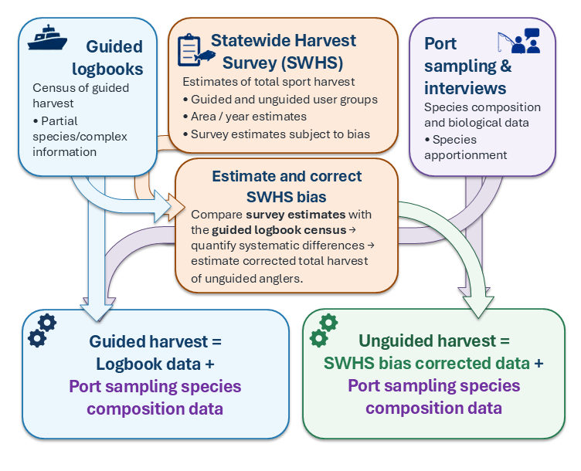
Figure 1.– Flow chart depicting data sources and conceptual use of the data to generate guided and unguided sport harvest estimates in the Bayesian model.

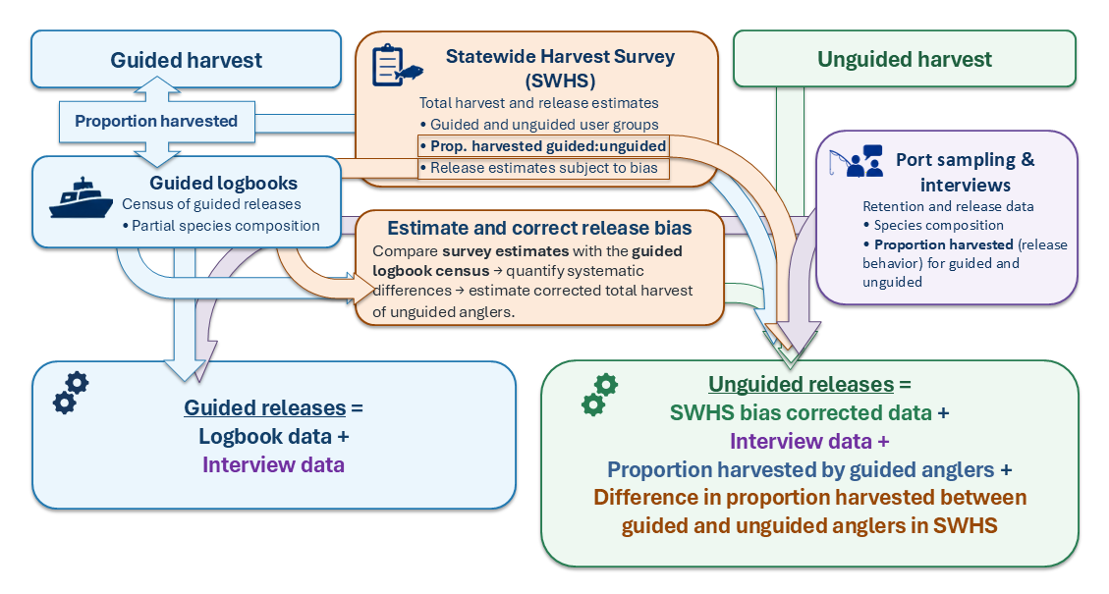
Figure 2.– Flow chart depicting data sources and conceptual use of the data to generate guided and unguided sport release estimates in the Bayesian model.

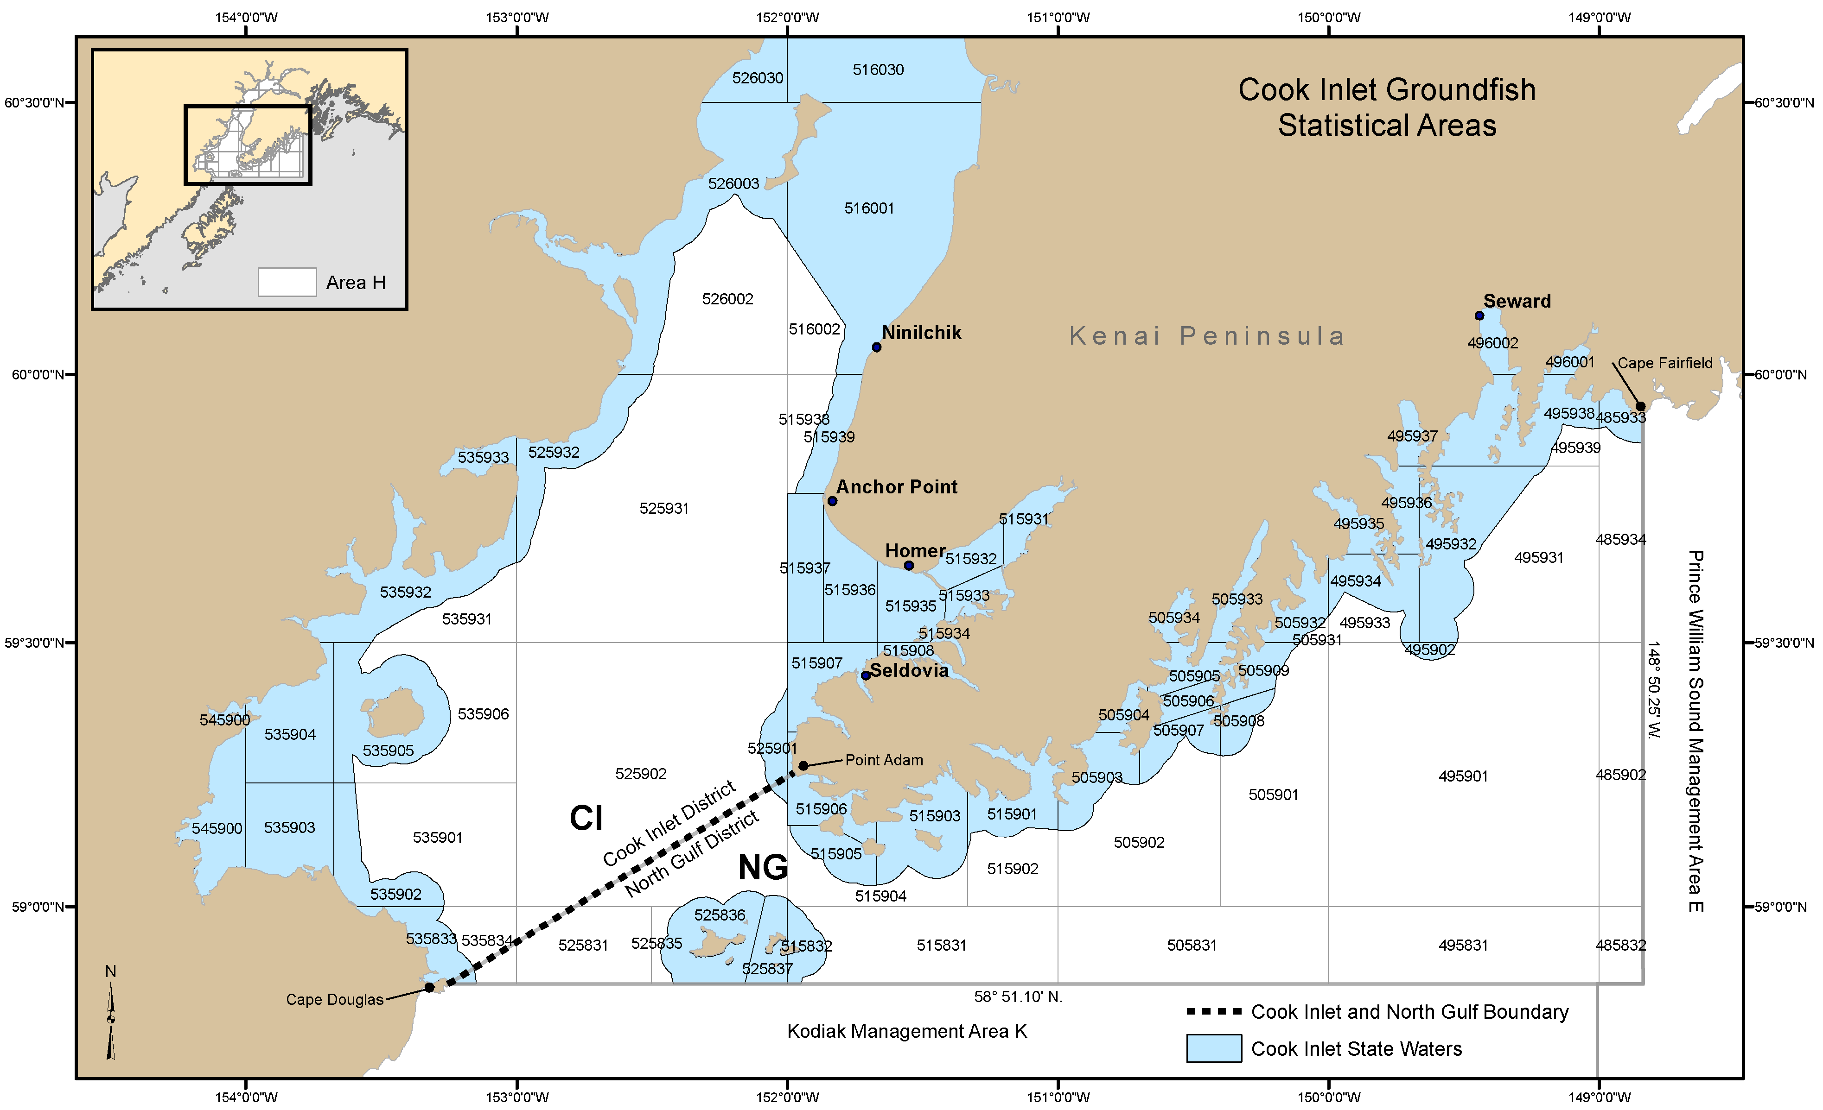
Figure 3.– Cook Inlet rockfish commercial fishery management units: North Gulf District (NG) and Cook Inlet District (CI).

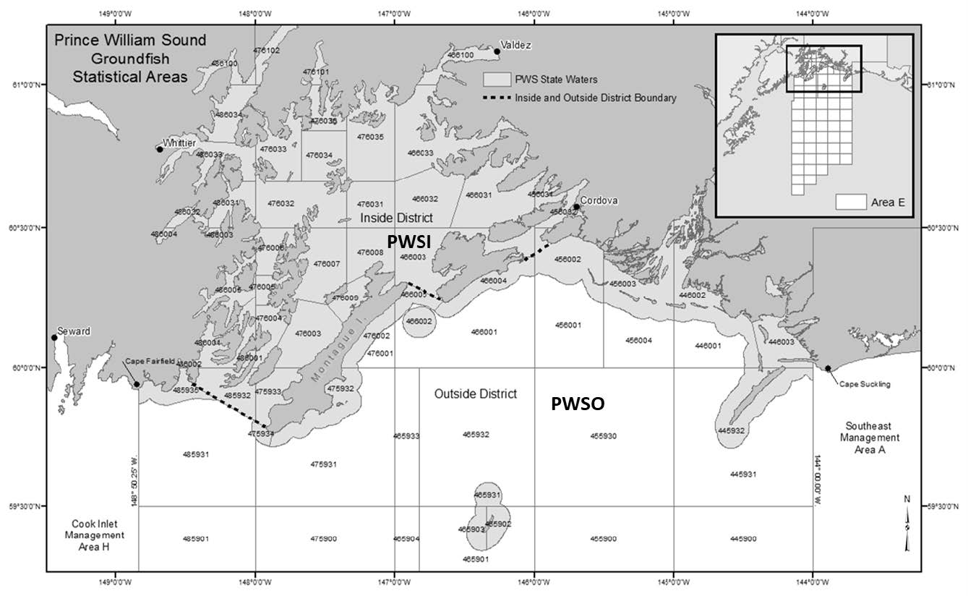
Figure 4.– Prince William Sound rockfish commercial fishery management units: Prince William Sound Inside District (PWSI) and Prince William Sound Outside District (PWSO).

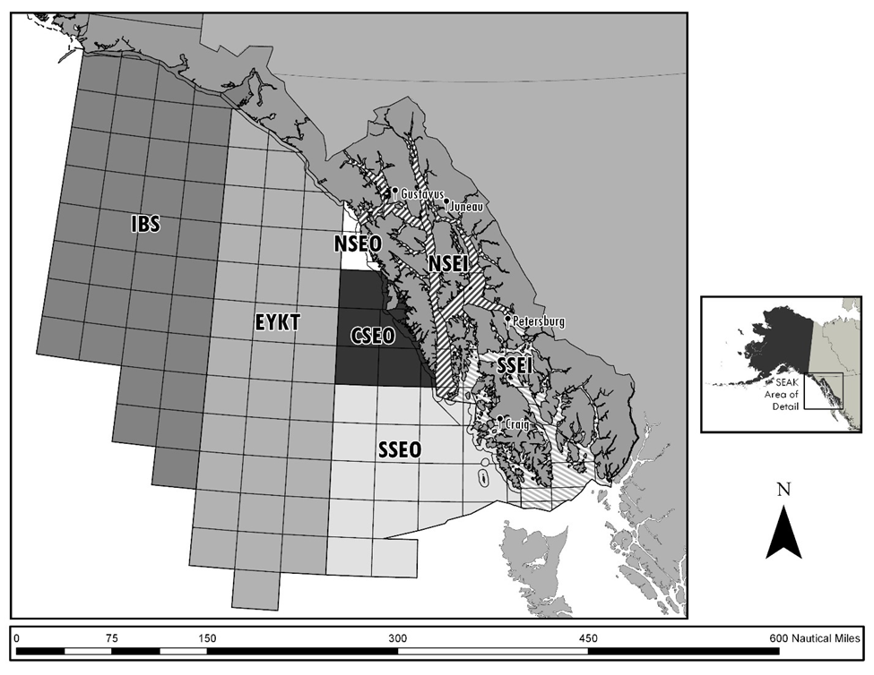
Figure 5.– Southeast Alaska rockfish commercial fishery management units: Icy Bay Subdistrict (IBS), East Yakutat Section (EYKT), Northern Southeast Outside Section (NSEO), Central Southeast Outside Section (CSEO), Southern Southeast Outside Section (SSEO), Northern Southeast Inside Subdistrict (NSEI), and Southern Southeast Inside Subdistrict (SSEI).

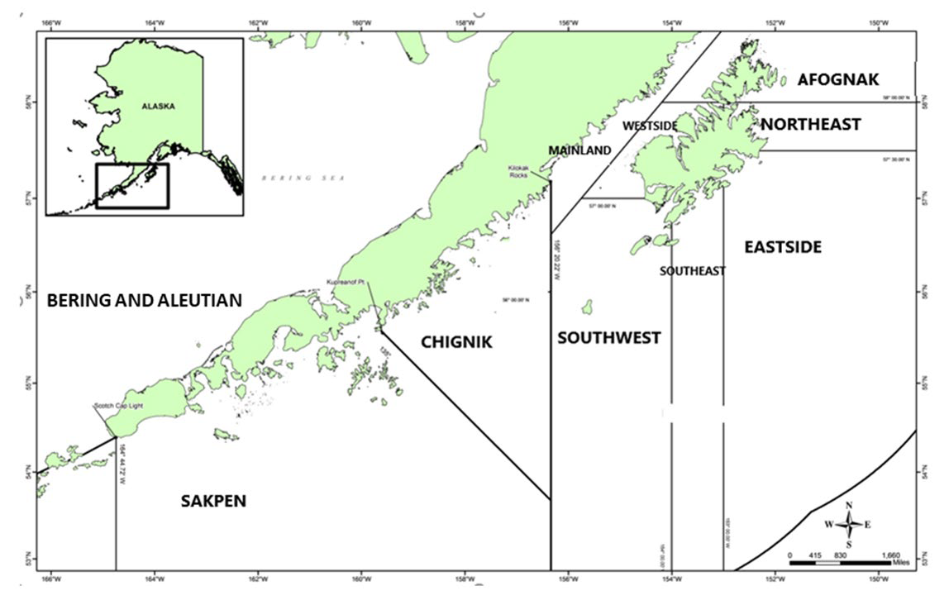
Figure 6.– Kodiak, Chignik, and the South Alaska Peninsula (SAKPEN) rockfish commercial fishery management units. The Bering Sea–Aleutian Islands Area includes all waters west of the South Alaska Peninsula Area border at Scotch Cap Light, and north into the Bering Sea. Kodiak management units include Afognak, Northeast, Eastside, Southeast, Southwest, Westside, and Mainland Districts.

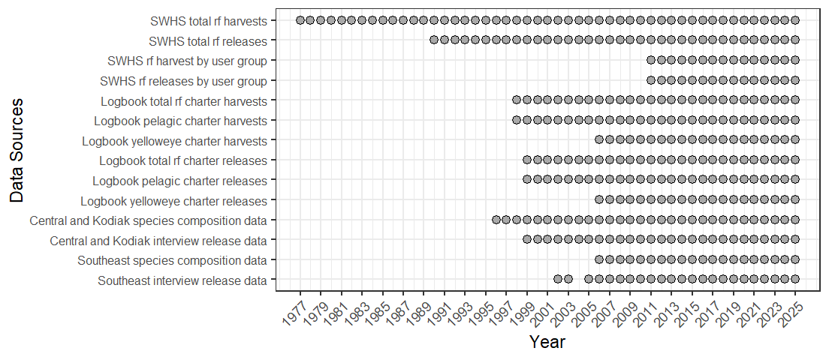
Figure 7.– Data sources for estimating rockfish harvests and releases in ADF&G commercial fisheries management units. Note that initial rockfish harvest estimates were not differentiated into species assemblage or species until 1998 when logbooks began differentiating by pelagic and non-pelagic. Logbooks began to collect data on yelloweye beginning in 2006. Port sampling programs to gather data on species composition of harvests began in 1996 in Southcentral and Kodiak and in 2006 in Southeast.

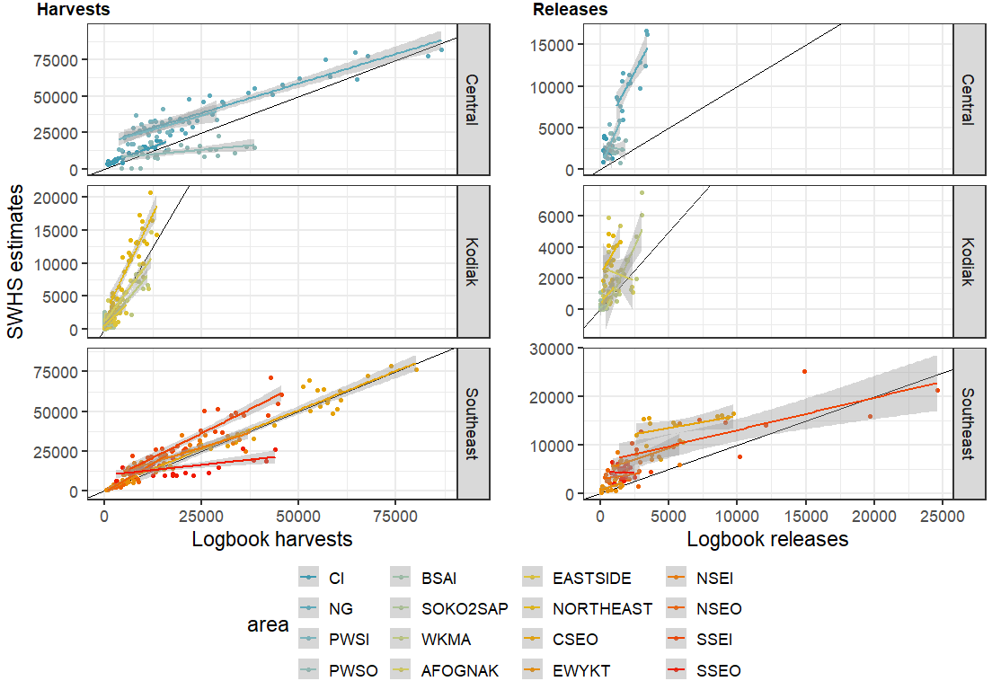
Figure 8.– Statewide harvest survey (SWHS) harvest (left) and release (right) estimates (y-axis) from guided trips versus repoted harvests from charter logbooks (x-axis). The diagnol black line represents a one-to-one relationship and perfect agreement between the two data sources. Values above the line indicate that estimates from the SWHS are higher than that recorded in logbooks while values below the diagnol line indicate that estimates from the SWHS are lower than that recorded in logbooks.

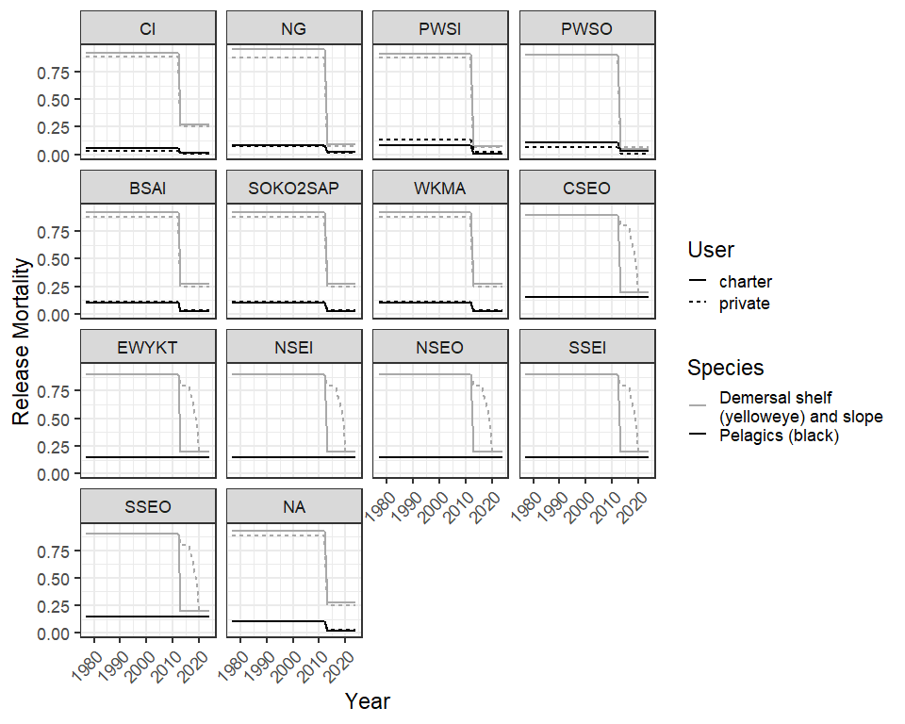
Figure 9.– Release mortality rates for 16 commercial fisheries management units used to calculate the number of released rockfish assumed to have died. The change in mortality rates in 2013 reflect the deep water release (DWR) requirements that were adopted in that year.

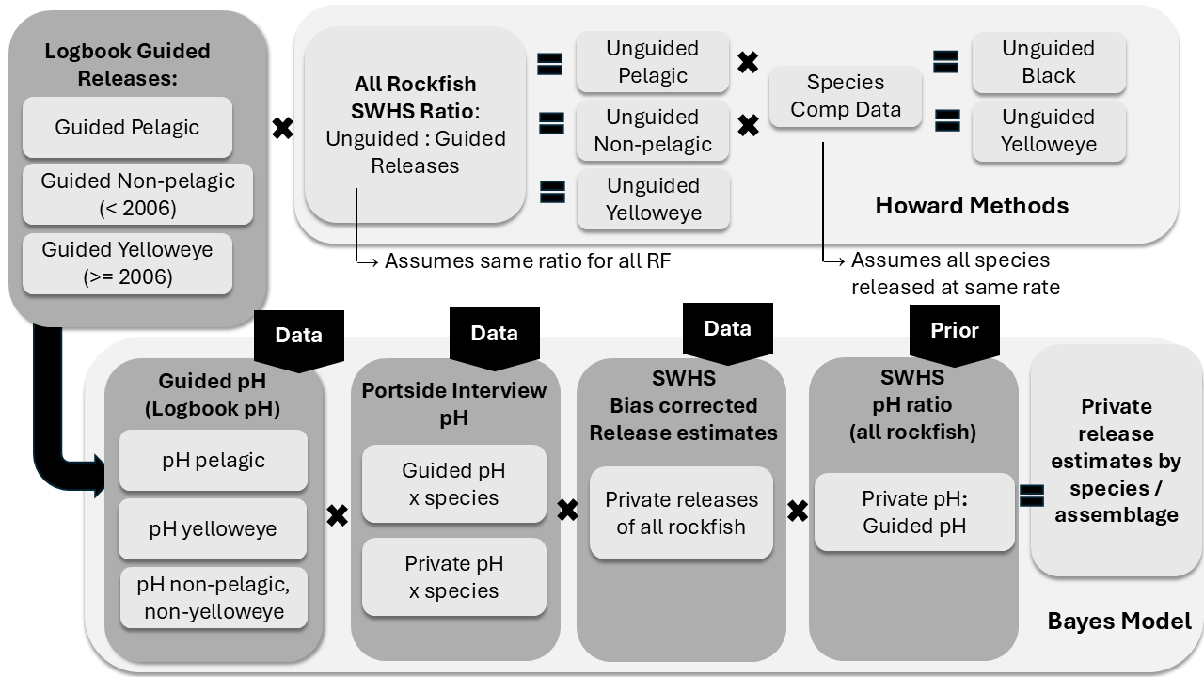
Figure 10.– Schematic illustrating the difference processes used by Howard et al. (2020) and the Bayesian model to estimate releases of rockfish by unguided anglers in Alaska waters. The Howard methods assume that the ratio of unguided:guided releases for all rockfish in the SWHS apply equally to all rockfish species and complexes. The Bayesian approach estimates retention probabilities separately by species assemblage based on the retention probabilities of anglers evident in the logbook data, portside interview data, and bias corrected SWHS data with an informative prior derived from the SWHS data descrbing whether an unguided angler is more or less likely to harvest a generic landed rockfish. The pH term describes the probability that a landed rockfish was harvested.

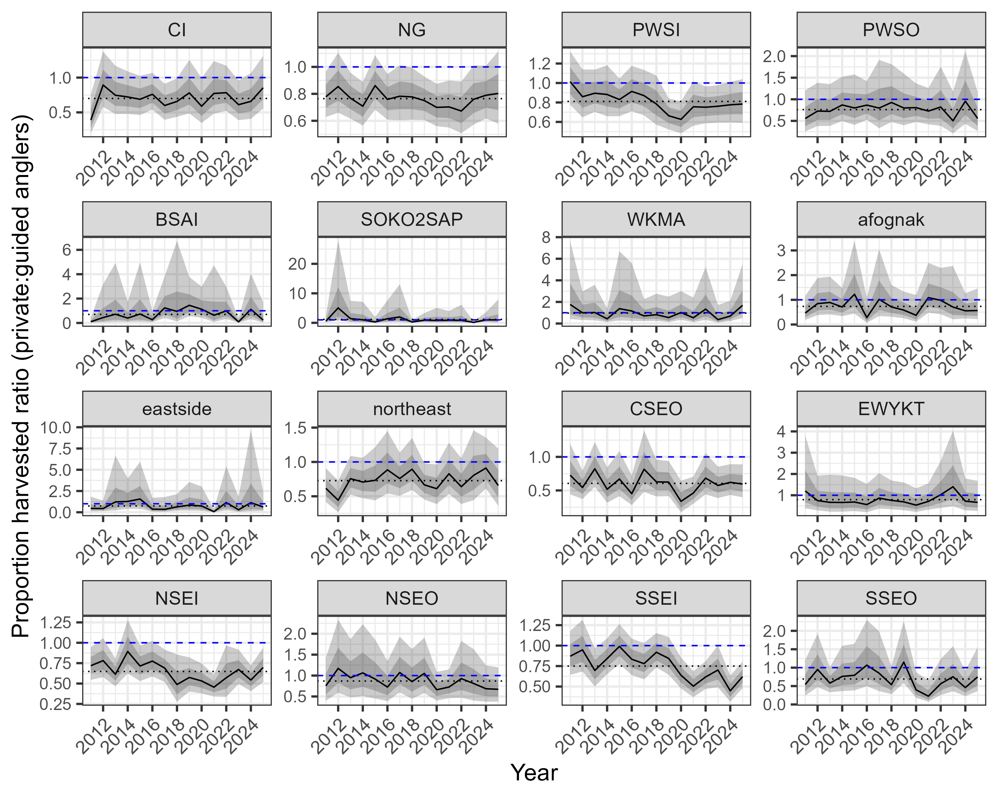
Figure 11.– Plots showing the ratio of the proportion of rockfish harvested (pH) by private anglers ($pH_{unguided}^{SWHS}$) to the proportion of rockfish harvested by guided anglers ($pH_{guided}^{SWHS}$) as derived from the statewide harvest survey (SWHS) between 2011 and 2025. This ratio, $pH_{ay}^{ung:gui}$, describes whether unguided anglers are more (values above 1) or less (values less than 1) likely to harvest a generic rockfish and is used as a prior to inform the $β4_{\left(pH\right)\left(comp\right)ayu}$ parameter describing the offset of the pH logistic curve (or long-term average) for unguided anglers in the model. The horizontal dotted black line represents the mean across all years and the dashed blue line highlights a value of 1. The dark grey and light grey polygons represent the 50 and 95% confidence intervals for the prior values as calculated from SWHS data.

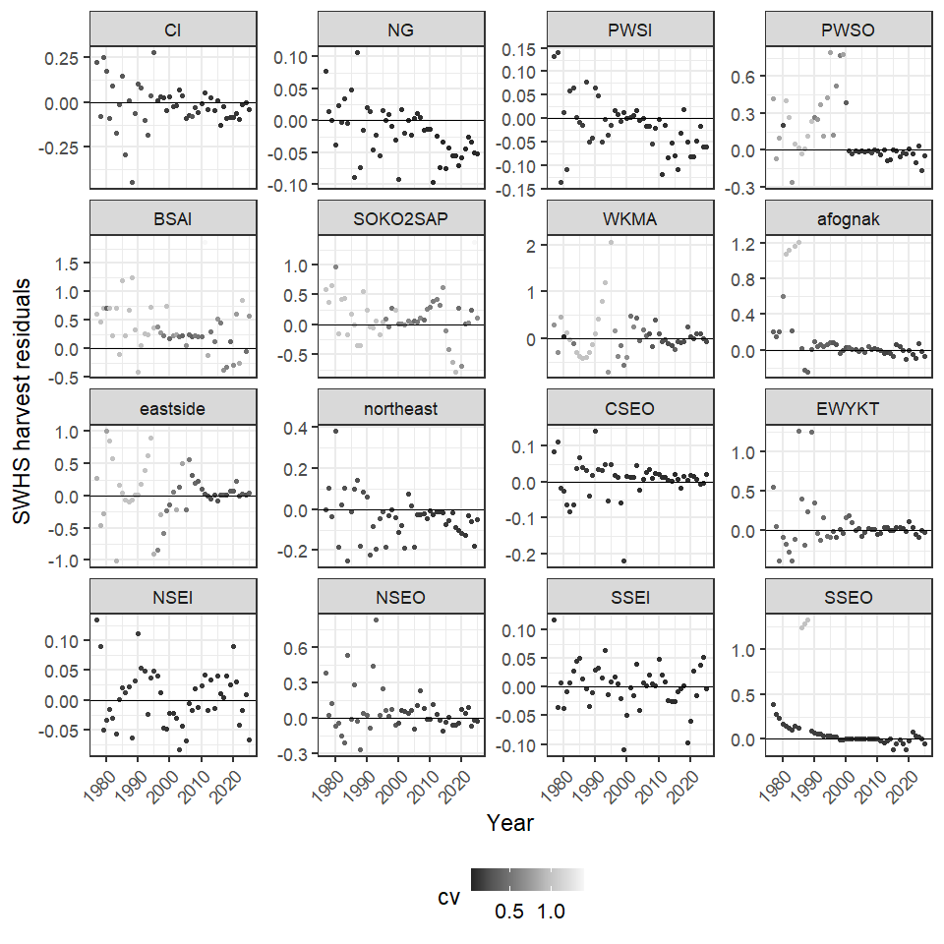
Figure 12.– Residuals from statewide harvest survey (SWHS) harvests for 16 commercial fisheries management units 1977-2025 showing the difference between model estimates with the bias correction removed and observed values in the SWHS. The CV of the SWHS data is indicated by the grey scale.
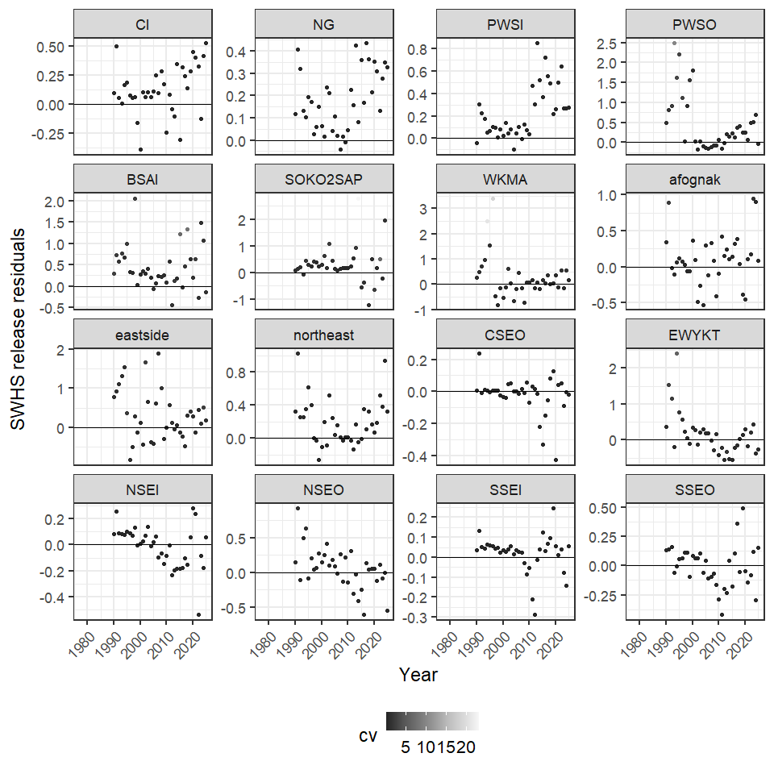
Figure 13.– Residuals from statewide harvest survey (SWHS) releases for 16 commercial fisheries management units 1977-2025 showing the difference between model estimates with the bias correction removed and observed values in the SWHS. The CV of the SWHS data is indicated by the grey scale.
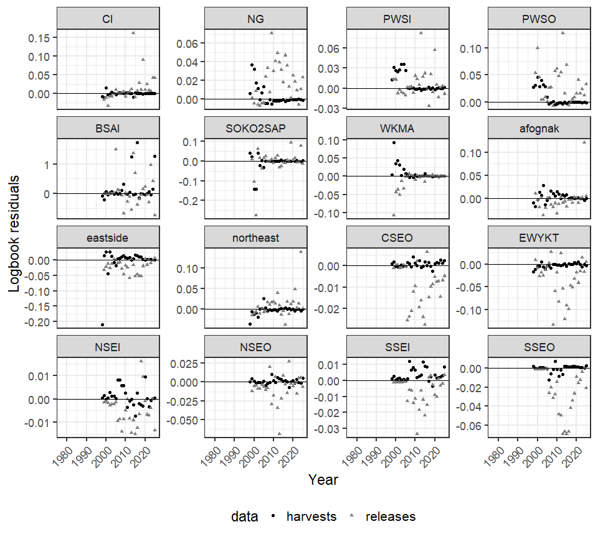
Figure 14.– Residuals from logbook harvests and releases for 16 commercial fisheries management units 1977-2025 with residuals shown proportional to the magnitude of the harvest and release data.

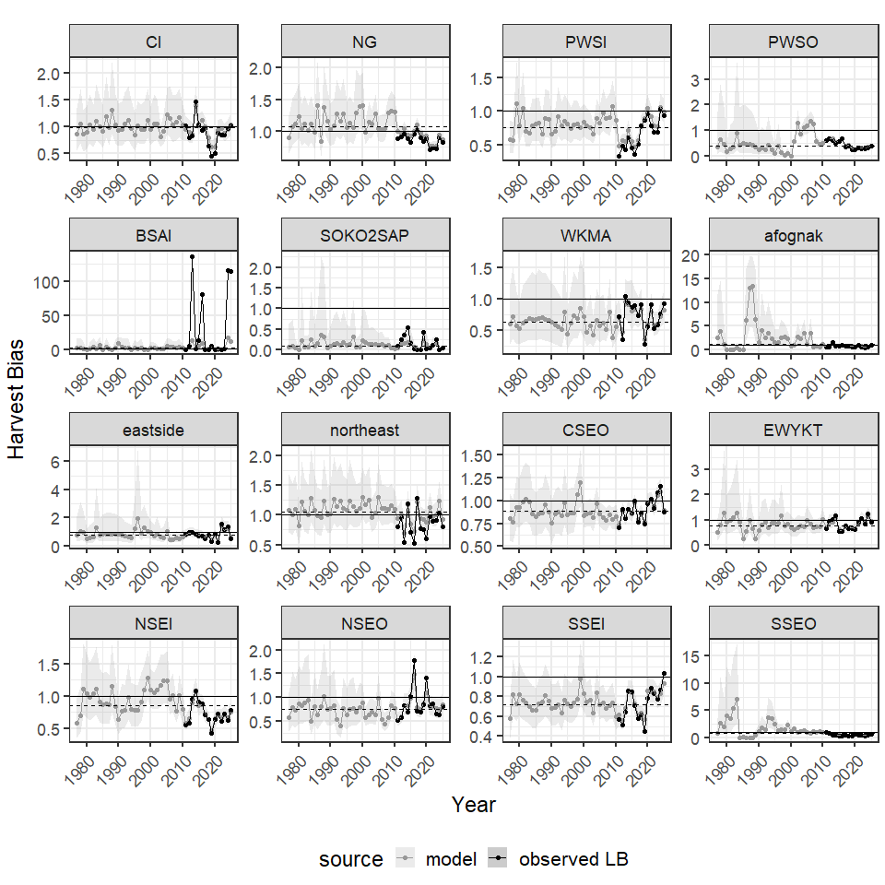
Figure 15.– Annual estimates of statewide harvest survey (SWHS) bias in harvests for 16 commercial fishing managment units, 1977-2025. Note that a bias < 1 indicates that the SWHS underestimates the true value and bias > 1 indicates the survey overestimates the true value. The solid black line represents no bias (bias = 1) and the dashed black line represents the median bias for each area throughout the time series.

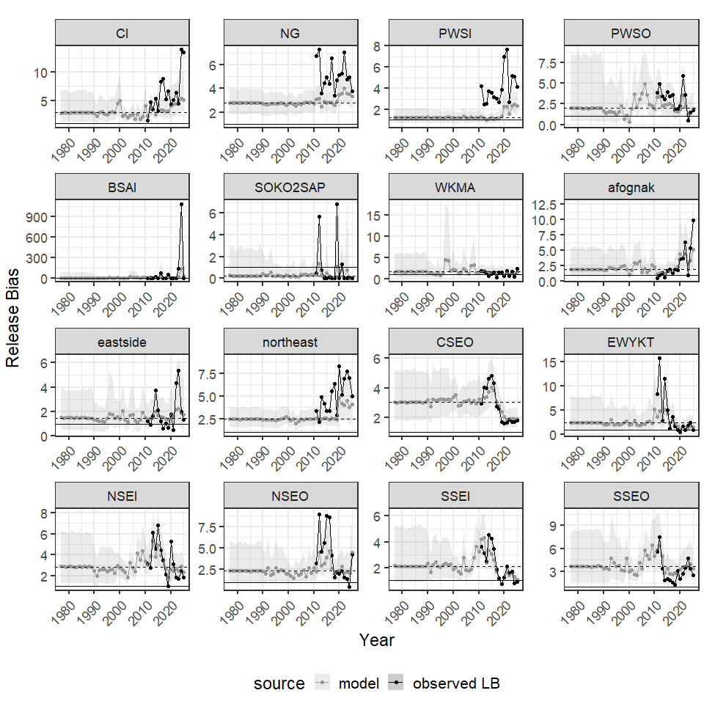
Figure 16.– Annual estimates of SWHS bias in releases for 16 commercial fishing manamgent units, 1977-2025. Note that a bias < 1 indicates that the SWHS underestimates the true value and bias > 1 indicates the survey overestimates the true value. The solid black line represents no bias (bias = 1) and the dashed black line represents the median bias for each area throughout the time series.

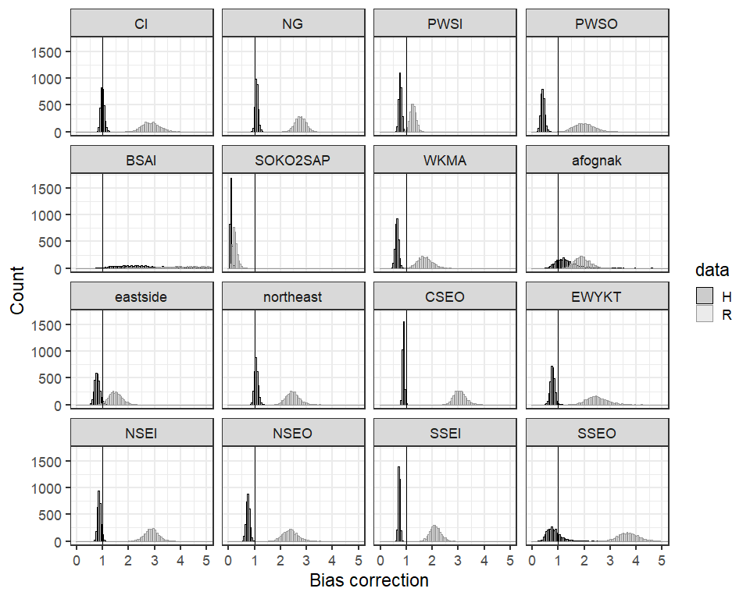
Figure 17.– Mean statewide harvest survey (SWHS) bias for harvests (H) and releases (R) for 16 commercial fisheries management units. Note that a bias < 1 indicates that the SWHS underestimates the true value and bias > 1 indicates the survey overestimates the true value.

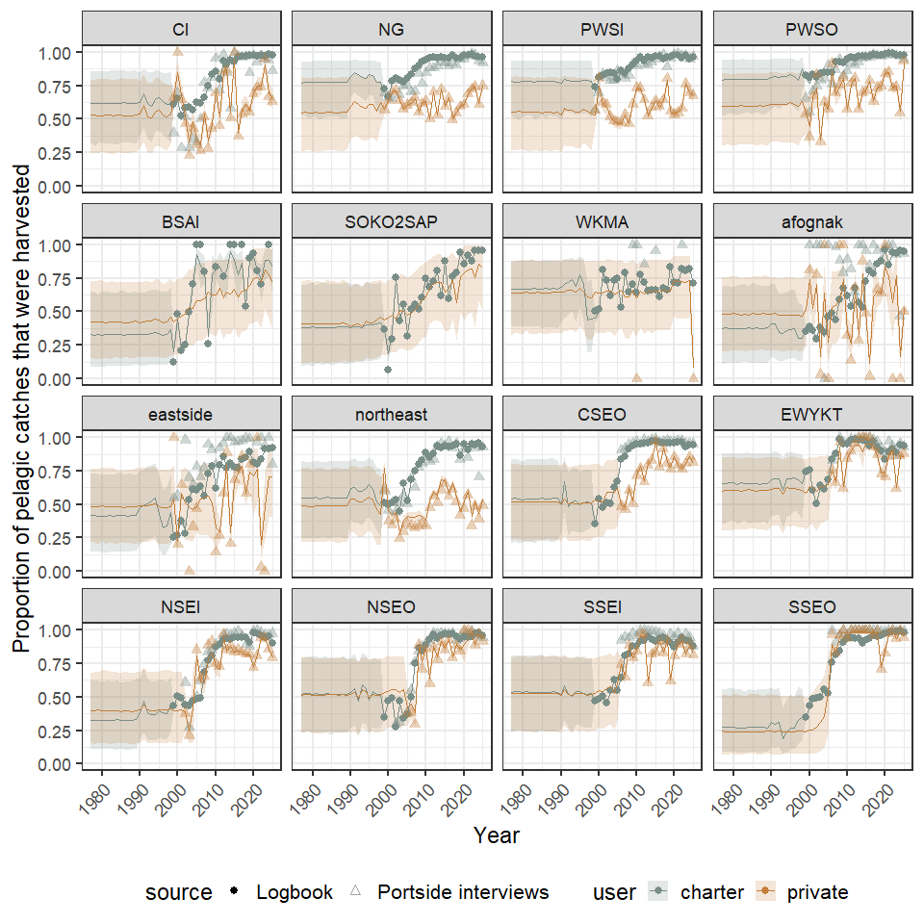
Figure 18.– Annual proportion of pelagic rockfish catch that was harvested by guided and unguided anglers in 16 commercial fishing management units, 1977-2025 as estimated by the model (line) and evident in the logbook (solid circles) and portside interview data (triangles). The shaded areas represent the 95% credibility intervals of the Bayesian model estimates.

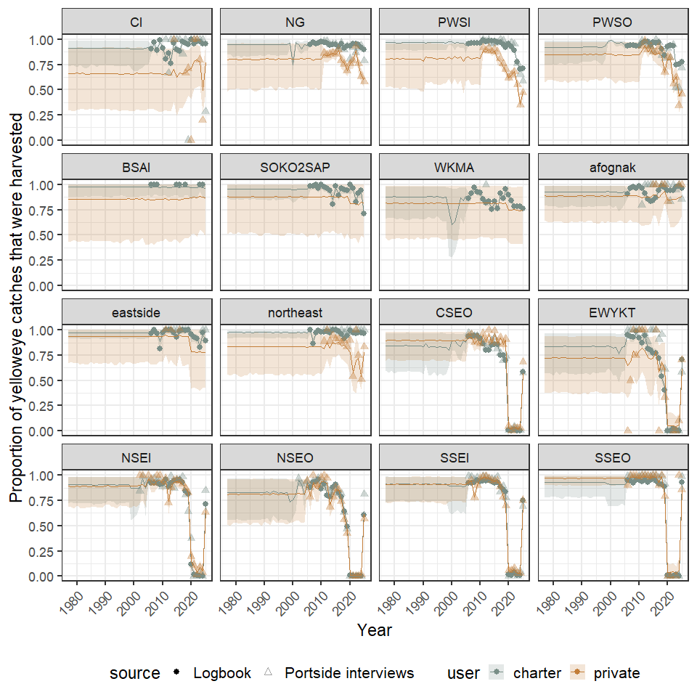
Figure 19.– Annual proportion of yelloweye rockfish catch that was harvested by guided and unguided anglers in 16 commercial fishing management units, 1977-2025 as estimated by the model (line) and evident in the logbook (solid circles) and portside interview data (triangles). The shaded areas represent the 95% credibility intervals of the Bayesian model estimates.

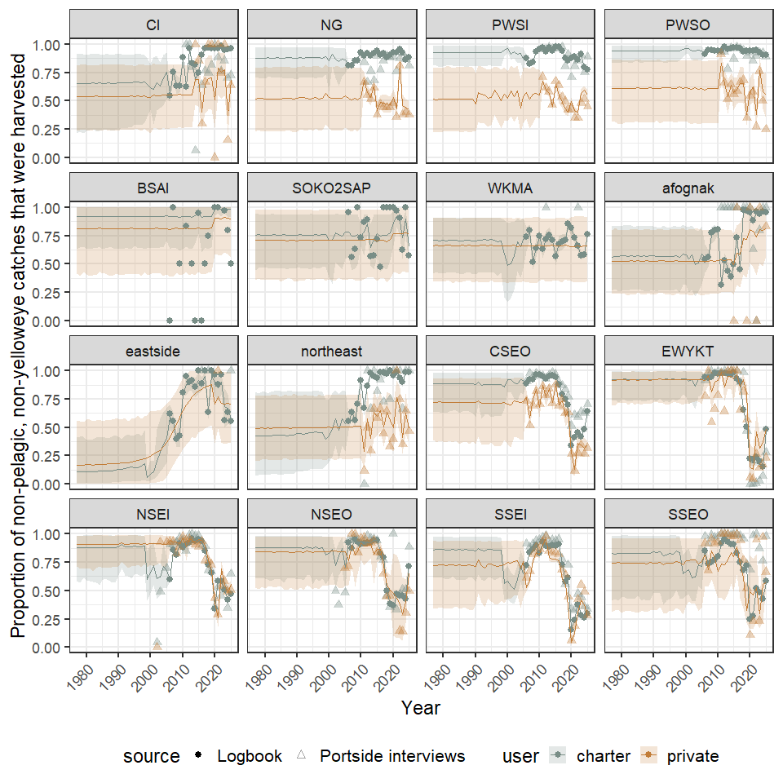
Figure 20.– Annual proportion of other (non-pelagic, non-yelloweye) rockfish catch that was harvested by guided and unguided anglers in 16 commercial fishing management units, 1977-2025 as estimated by the model (line) and evident in the logbook (solid circles) and portside interview data (triangles). The shaded areas represent the 95% credibility intervals of the Bayesian model estimates.

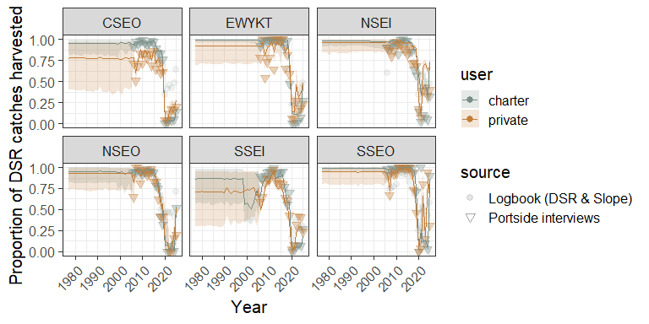
Figure 21.– Annual proportion of demersal shelf rockfish catch that was harvested by guided and unguided anglers in 6 Southeast commercial fishing management units, 1977-2025 as estimated by the model (line) and evident in portside interview data (triangles). The shaded areas represent the 95% credibility intervals of the Bayesian model estimates.

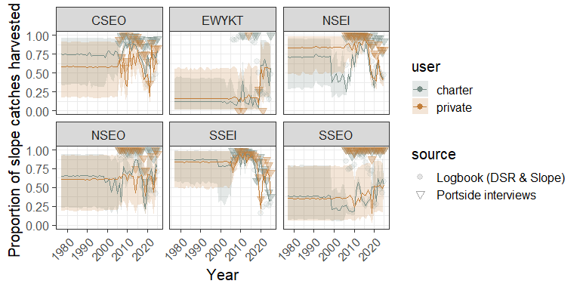
Figure 22.– Annual proportion of slope rockfish catch that was harvested by guided and unguided anglers in 6 Southeast commercial fishing management units, 1977-2025 as estimated by the model (line) and evident in portside interview data (triangles). The shaded areas represent the 95% credibility intervals of the Bayesian model estimates.

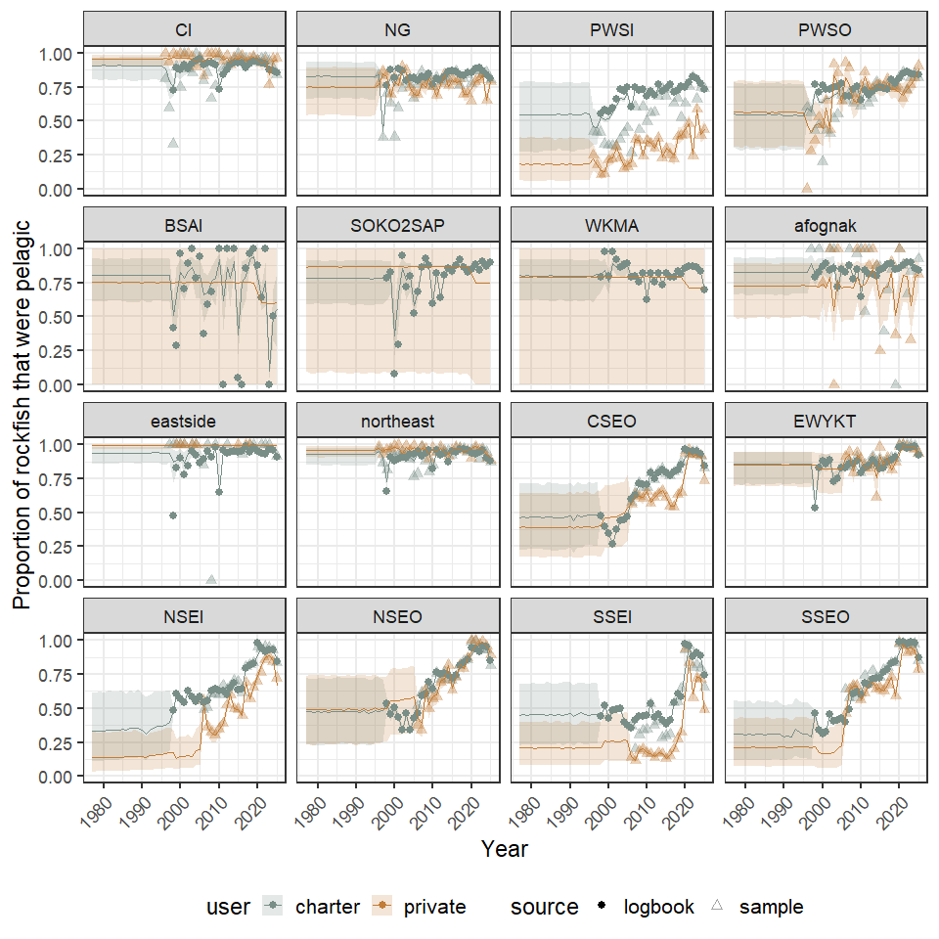
Figure 23.– Annual estimates of the proportion of the sport harvest that was pelagic rockfish for guided and unguided anglers in 16 commercial fishery management units, 1977-2025 as estimated by the model (line) and evident in the logbook (solid circles) and portside sampling (triangles). The shaded areas represent the 95% credibility intervals of the Bayesian model estimates.

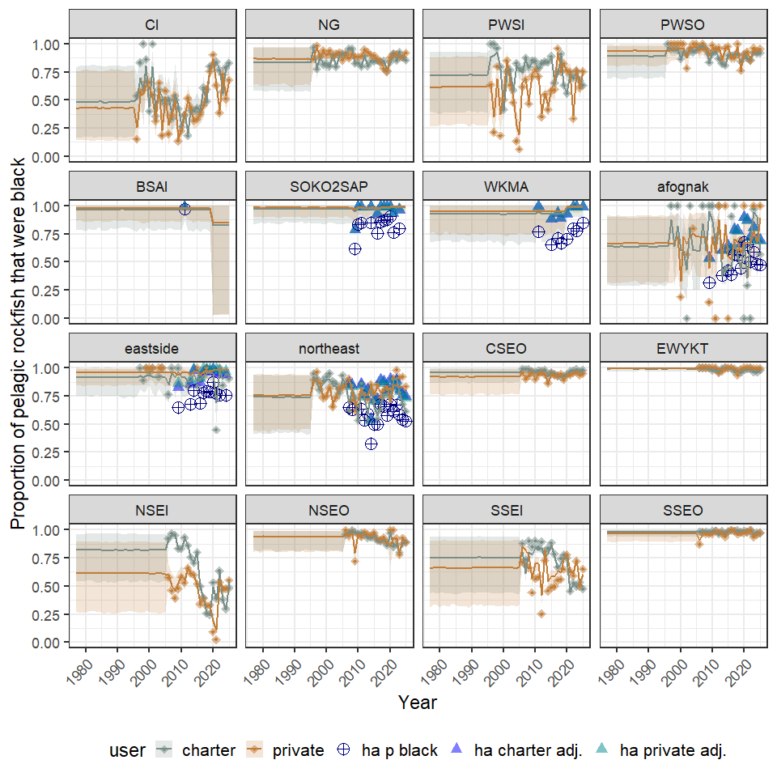
Figure 24.– Annual estimates of the proportion of the sport harvest of pelagic rockfish that were black rockfish for guided and unguided anglers in 16 commercial fishing management units, 1977-2025 as estimated by the model (line) and evident in portside sampling (triangles). The shaded areas represent the 95% credibility intervals of the Bayesian model estimates. Kodiak panels include data from a hydroacoustic survey and the proportion of pelagic rockfish that are black in those areas (navy blue) and the adjusted proportions based on obseved harvests for charter (blue) and private (cyan) users.

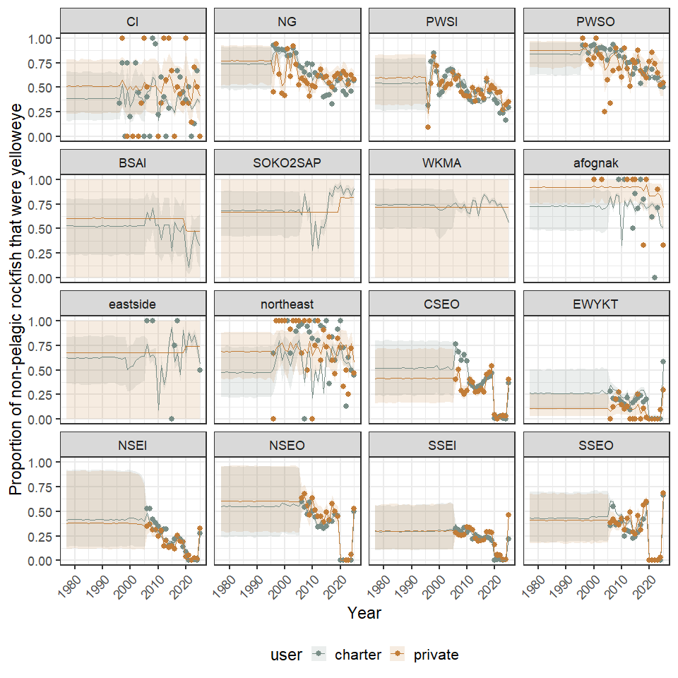
Figure 25.– Annual estimates of the proportion of the sport harvest of non-pelagic rockfish that were yelloweye rockfish for guided and unguided anglers in 16 commercial fishing management units, 1977-2025 as estimated by the model (line) and evident in portside sampling (circles). The shaded areas represent the 95% credibility intervals of the Bayesian model estimates.

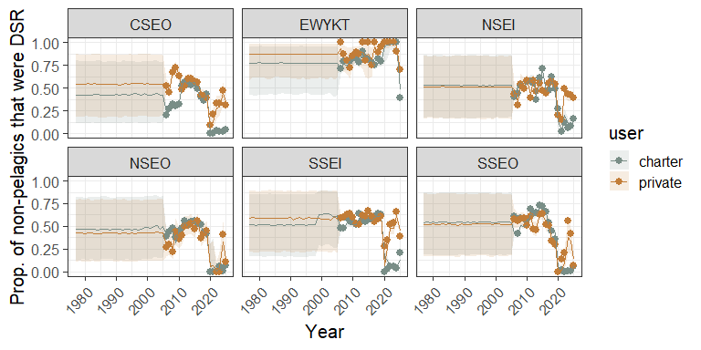
Figure 26.– Annual estimates of the proportion of the sport harvest of non-pelagic rockfish that were non-yelloweye DSR rockfish for guided and unguided anglers in 6 Southeast commercial fishing management units, 1977-2025 as estimated by the model (line) and evident in portside sampling (dots). The shaded areas represent the 95% credibility intervals of the Bayesian model estimates.

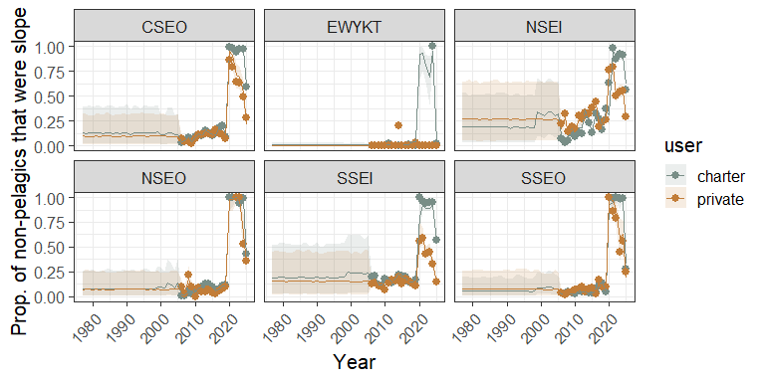
Figure 27.– Annual estimates of the proportion of the sport harvest of non-pelagic rockfish that were slope rockfish guided and unguided anglers in 6 Southeast commercial fishing management units, 1977-2025 as estimated by the model (line) and evident in portside sampling (dots). The shaded areas represent the 95% credibility intervals of the Bayesian model estimates.

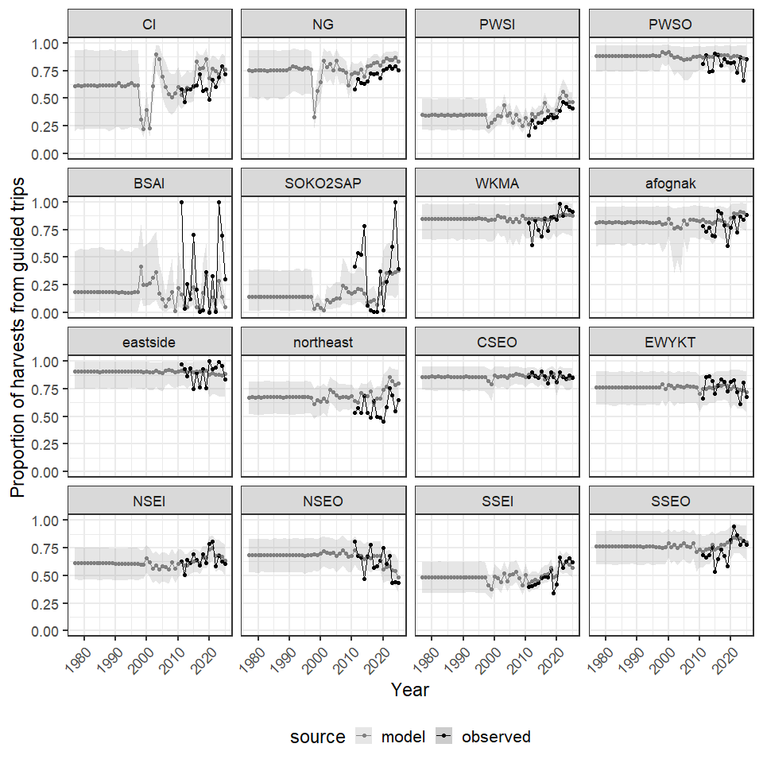
Figure 28.– Annual estimates of the proportion of total sport fish harvest taken by charter anglers for 16 commercial fishing management units, 1977-2025 as observed in the SWHS and estimated in the model.

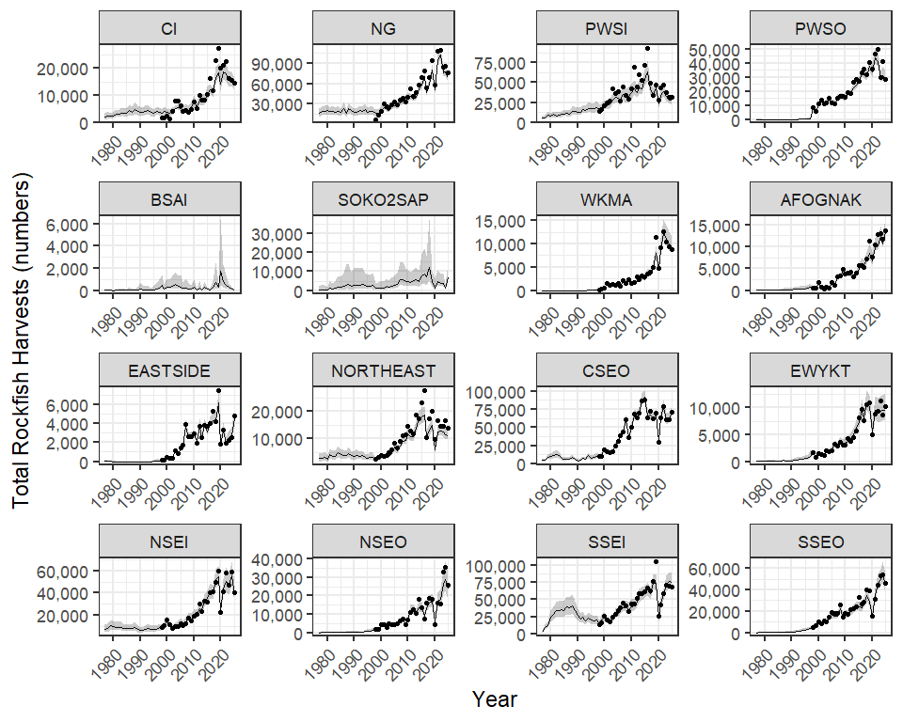
Figure 29.– Total rockfish harvests for 16 commercial fisheries management units 1977-2025. Lines and error polygons represent model estimates and 95% credibility intervals, respectively, and points represent Howard et al. (2020) estimates.
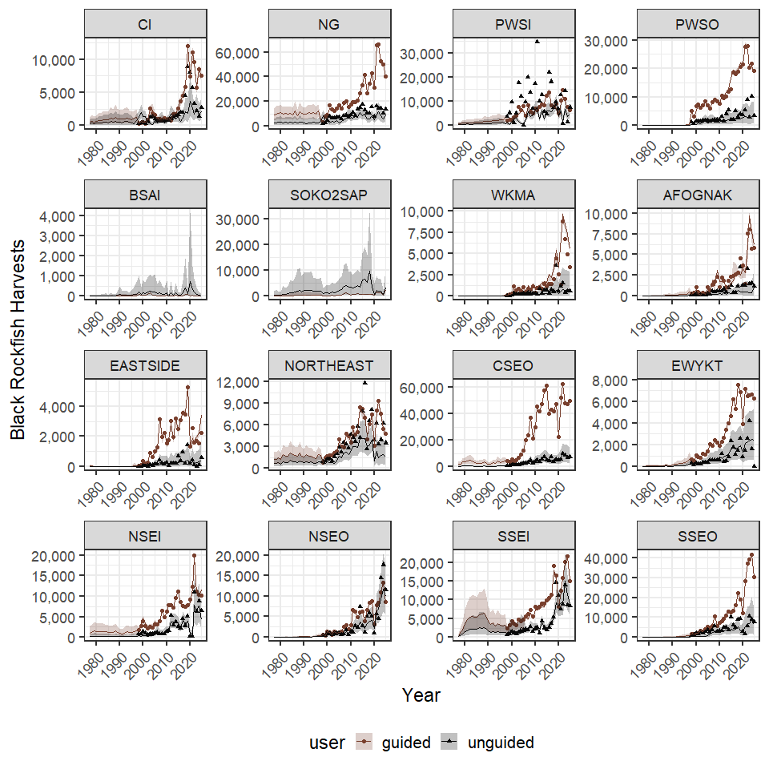
Figure 30.– Black rockfish harvests for 16 commercial fisheries management units 1977-2025. Lines and error polygons represent model estimates and 95% credibility intervals, respectively, and points represent Howard et al. (2020) estimates.

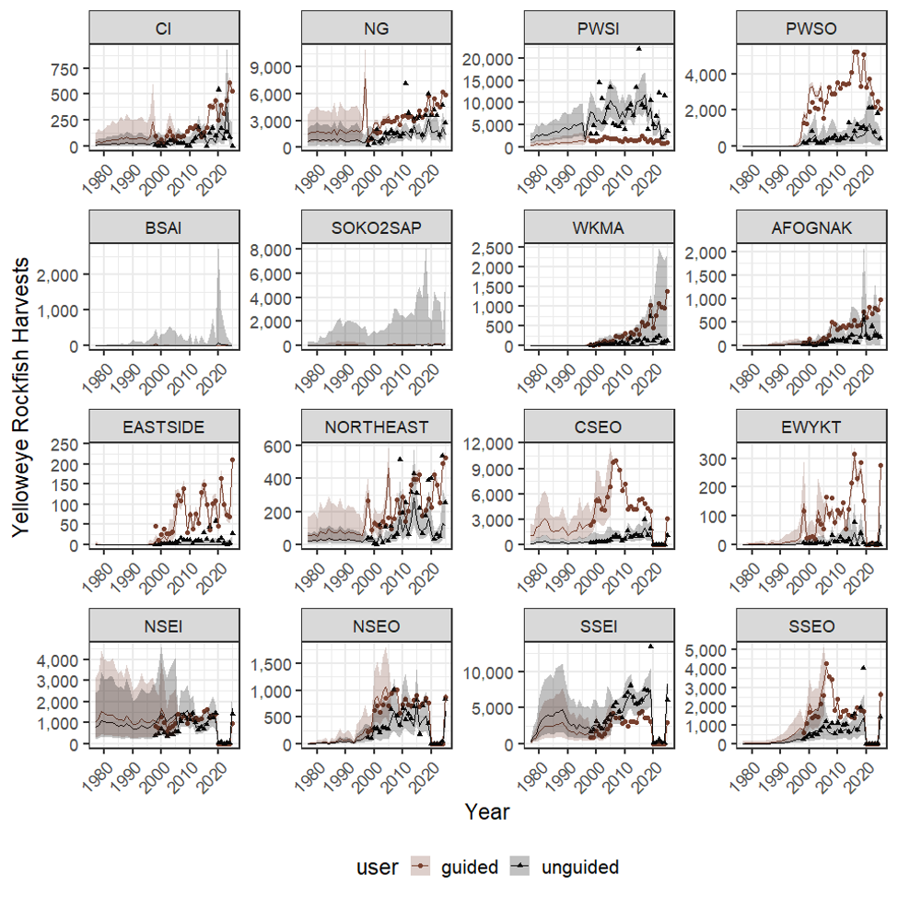
Figure 31.– Black rockfish harvests for 16 commercial fisheries management units 1977-2025. Lines and error polygons represent model estimates and 95% credibility intervals, respectively, and points represent Howard et al. (2020) estimates.

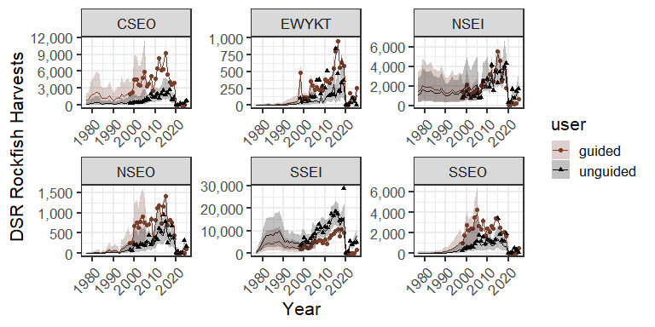
Figure 32.– Non-yelloweye DSR rockfish harvests for 6 Southeast Alaska commercial fisheries management units in Southeast Alaska 1977–2025. Lines and error polygons represent model estimates and 95% credibility intervals, respectively, and points represent Howard et al. (2020) estimates.

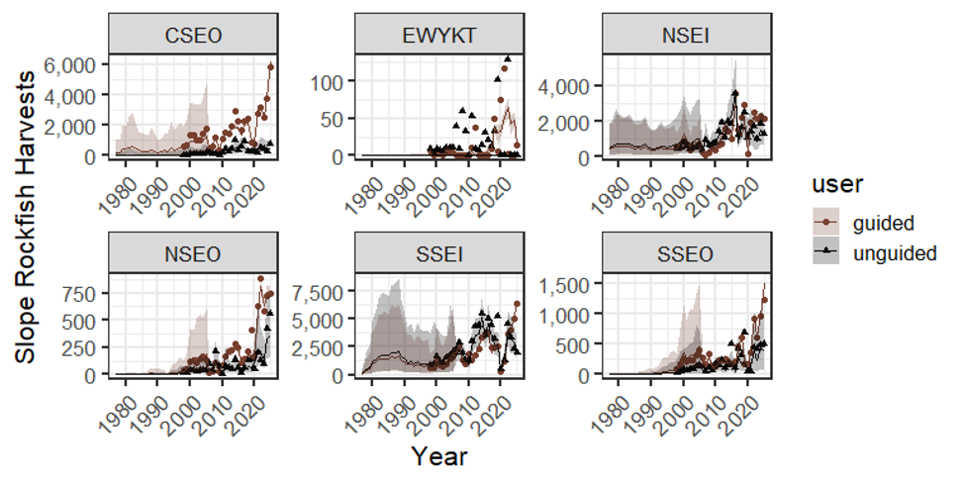
Figure 33.– Slope rockfish harvests for 6 Southeast Alaska commercial fisheries management units in Southeast Alaska 1977–2025. Lines and error polygons represent model estimates and 95% credibility intervals, respectively, and points represent Howard et al. (2020) estimates.

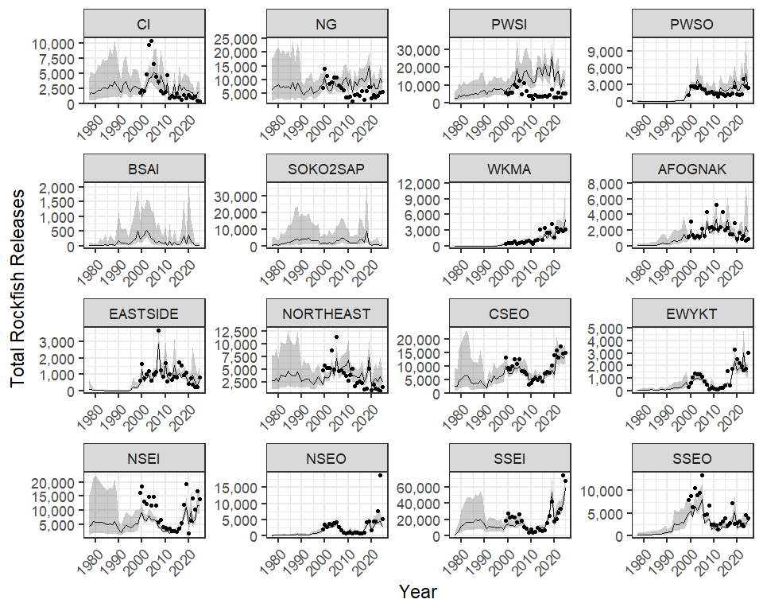
Figure 34.– Total rockfish releases for 16 commercial fisheries management units 1977–2025. Lines and error polygons represent model estimates and 95% credibility intervals, respectively, and points represent Howard et al. (2020) estimates.

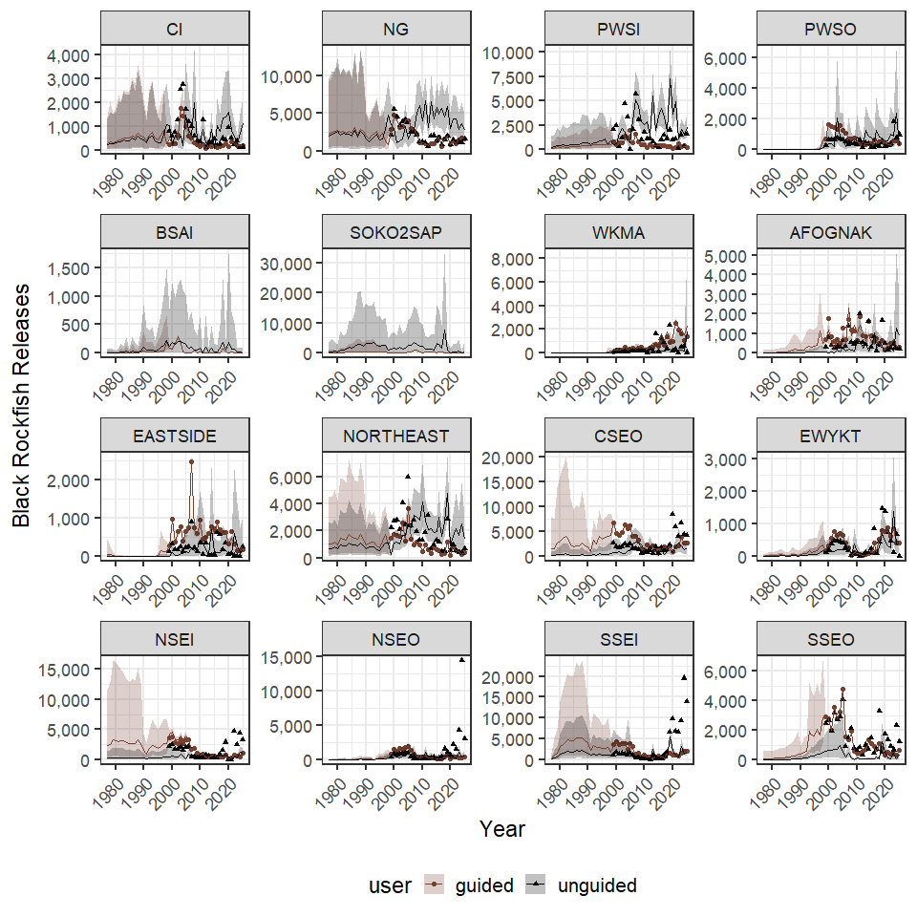
Figure 35.– Total rockfish releases for 16 commercial fisheries management units 1977–2025. Lines and error polygons represent model estimates and 95% credibility intervals, respectively, and points represent Howard et al. (2020) estimates.

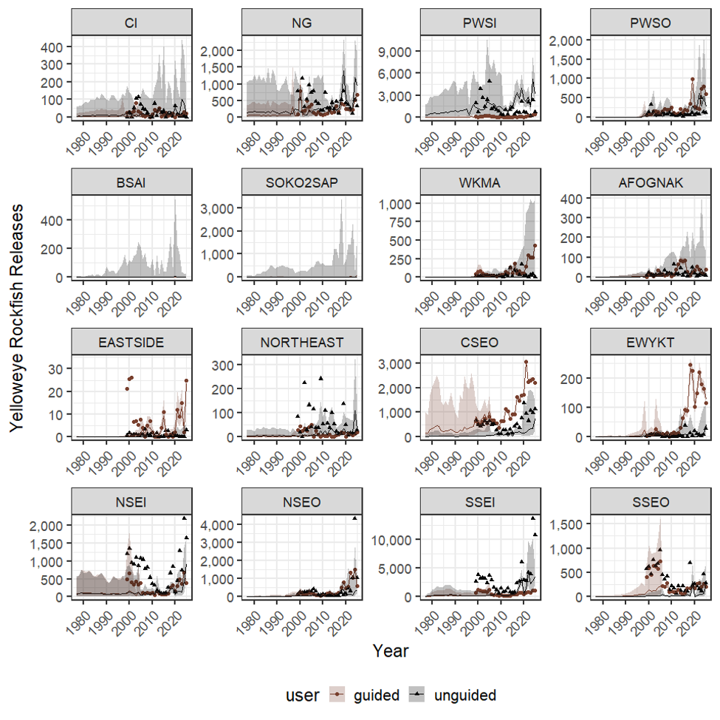
Figure 36.– Yellow rockfish releases for 16 commercial fisheries management units 1977–2025. Lines and error polygons represent model estimates and 95% credibility intervals, respectively, and points represent Howard et al. (2020) estimates.

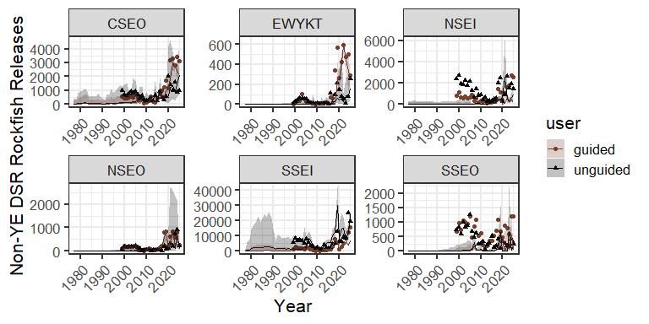
Figure 37.– Non-yelloweye DSR rockfish releases for 6 Southeast Alaska commercial fisheries management units 1977–2025. Lines and error polygons represent model estimates and 95% credibility intervals, respectively, and points represent Howard et al. (2020) estimates.

Figure 38.– Slope rockfish releases for 6 Southeast Alaska commercial fisheries management units 1977–2025. Lines and error polygons represent model estimates and 95% credibility intervals, respectively, and points represent Howard et al. (2020) estimates.

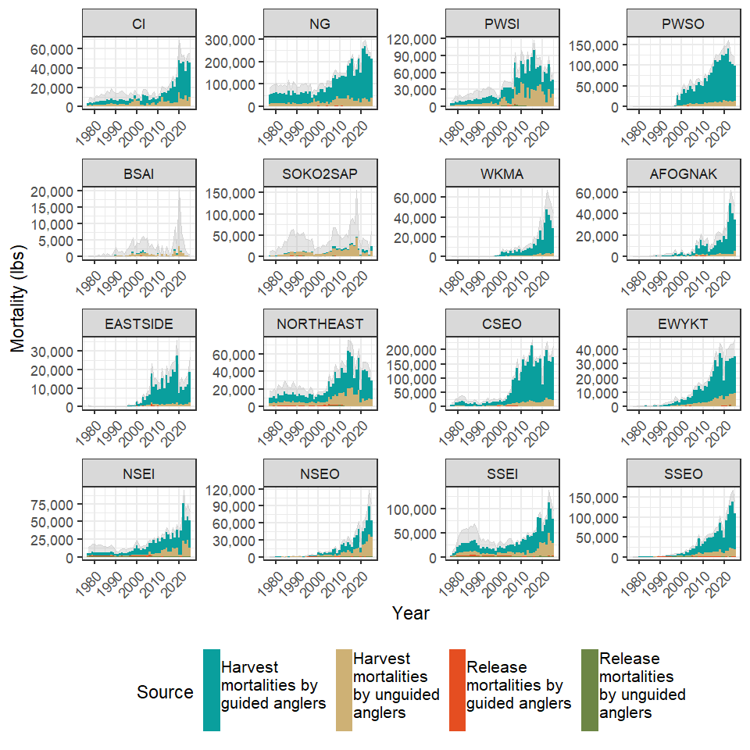
Figure 39.– Total removals of black rockfish by guided and unguided anglers in 16 Alaska commercial fishery management units as derived from harvests and release mortalities 1977-2025. The grey polygon in the background represents 95% credibility intervals of the total removals. Southeast Alaska (CSEO, EWYKT, NSEI, NSEO, SSEI, SSEO) biomass estimates prior to 2025 do not use mean weights generated from the 4-stage sampling design (Richards et al. 2025) that has been used since 2025 and as such are considered preliminary. Finalized biomass estimates for pre-2025 estimates are not expected to change significantly when 4-stage estimates are generated for those years.

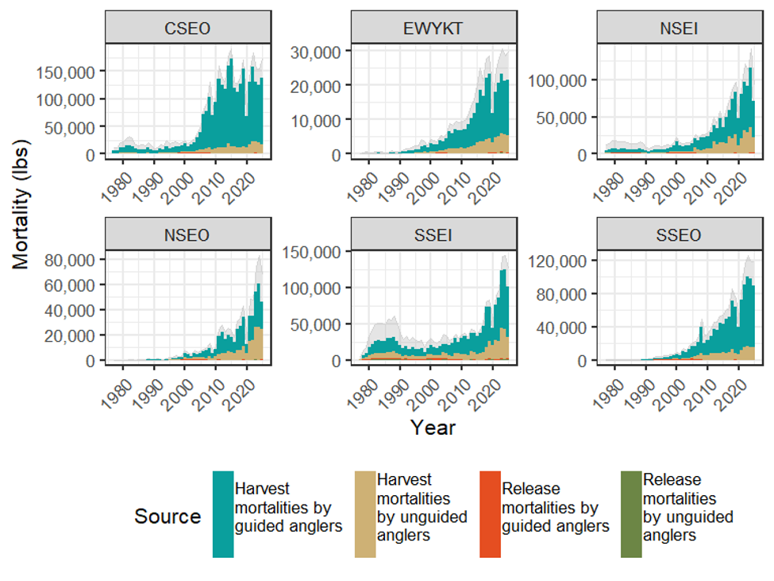
Figure 40.– Total removals of black rockfish by guided and unguided anglers in 16 Alaska commercial fishery management units as derived from harvests and release mortalities 1977-2025. The grey polygon in the background represents 95% credibility intervals of the total removals. Southeast Alaska (CSEO, EWYKT, NSEI, NSEO, SSEI, SSEO) biomass estimates prior to 2025 do not use mean weights generated from the 4-stage sampling design (Richards et al. 2025) that has been used since 2025 and as such are considered preliminary. Finalized biomass estimates for pre-2025 estimates are not expected to change significantly when 4-stage estimates are generated for those years.

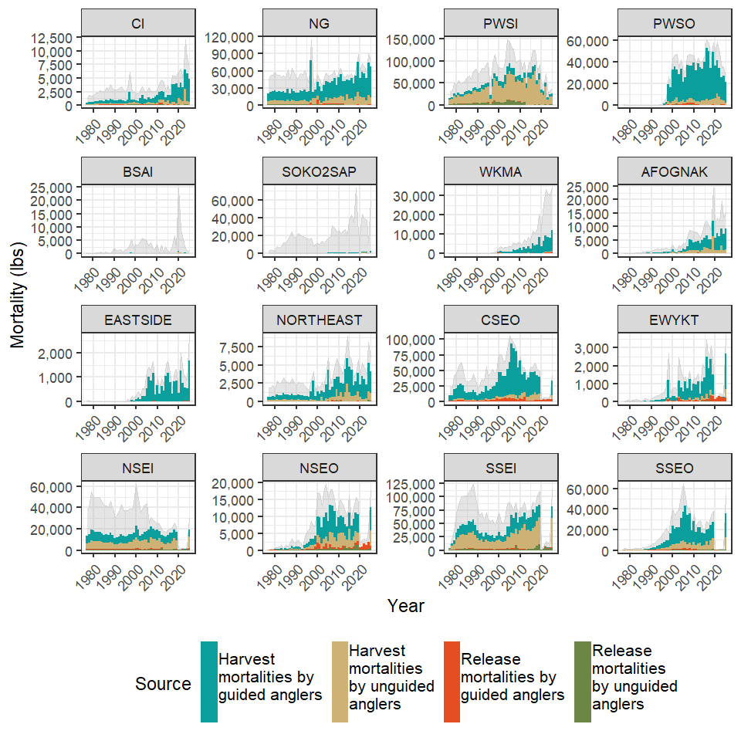
Figure 41.– Total removals of yelloweye rockfish by guided and unguided anglers in Alaska commercial fishery management units as derived from harvests and release mortalities 1977-2025. The grey polygon in the background represents 95% credibility intervals of the total removals. Southeast Alaska (CSEO, EWYKT, NSEI, NSEO, SSEI, SSEO) biomass estimates prior to 2025 do not use mean weights generated from the 4-stage sampling design (Richards et al. 2025) that has been used since 2025 and as such are considered preliminary. Finalized biomass estimates for pre-2025 estimates are not expected to change significantly when 4-stage estimates are generated for those years.

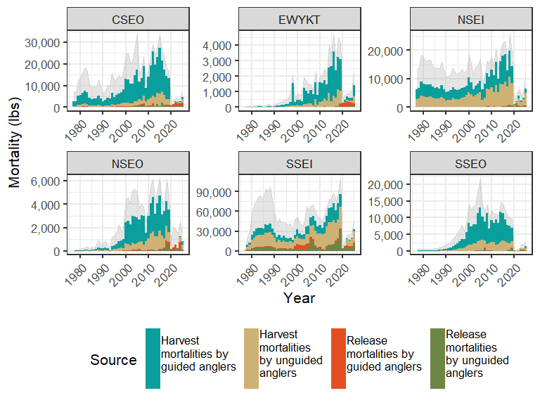
Figure 42.– Total removals of non-yelloweye demersal shelf rockfish by guided and unguided anglers in southeast Alaska commercial fishery management units as derived from harvests and release mortalities 1977-2025. The grey polygon in the background represents 95% credibility intervals of the total removals. Biomass estimates prior to 2025 do not use mean weights generated from the 4-stage sampling design (Richards et al. 2025) that has been used since 2025 and as such are considered preliminary. Finalized biomass estimates for pre-2025 estimates are not expected to change significantly when 4-stage estimates are generated for those years.

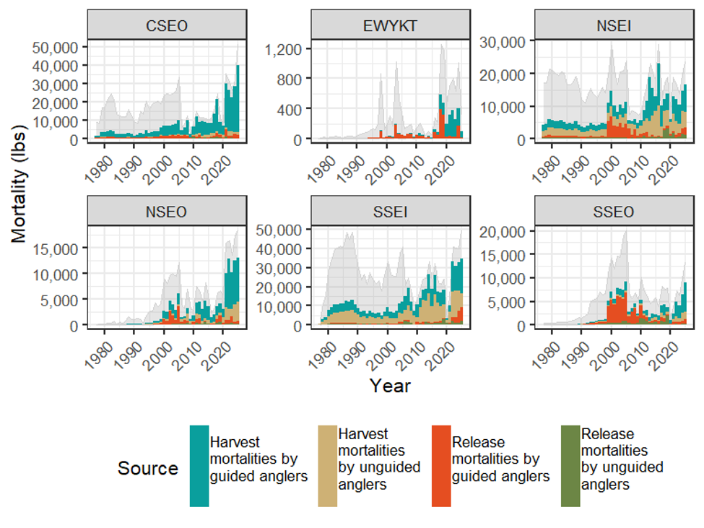
Figure 43.– Total removals of slope rockfish by guided and unguided anglers in Southeast Alaska commercial fishery management units as derived from harvests and release mortalities 1977-2025. The grey polygon in the background represents 95% credibility intervals of the total removals. Biomass estimates prior to 2025 do not use mean weights generated from the 4-stage sampling design (Richards et al. 2025) that has been used since 2025 and as such are considered preliminary. Finalized biomass estimates for pre-2025 estimates are not expected to change significantly when 4-stage estimates are generated for those years.

Appendix A: Release mortality at depth used in Southcentral and Kodiak regions

Appendix A1.– Estimated release mortality rates by depth and species used in estimating release mortality in Southcentral and Kodiak regions. DRM release methods denote the use of deepwater release mechanisms.
 |  | Capture depth (feet)
Species | Release method | 0-59' | 60-119' | 120-179' | 180'+ | Source
Black Rockfish | Surface | 0.00 | 0.12 | 0.35 | 0.8 | Hannah et al. 2008
Black Rockfish | DRM | 0.00 | 0.04 | 0.31 | 0.4 | Hannah et al. 2012
Yelloweye Rockfish | Surface | 0.00 | 0.70 | 0.94 | 1.0 | Hochhalter 2012
Yelloweye Rockfish | DRM | 0.01 | 0.01 | 0.01 | 0.2 | Hochhalter and Reed 2011

Appendix B: Spline fomulae

The following formulas were used to fit the penalized spline to the harvest trend in the model. In region R parameters $α_{λ_{R}}$ and $β_{λ_{R}}$ were calculated as
 | $$α_{λ_{R}} = \frac{μ_{λ_{R}}^{2}}{σ_{λ_{R}}^{2}}$$ | (B1)
 | $$β_{λ_{R}} = \frac{μ_{λ_{R}}}{σ_{λ_{R}}^{2}}$$ | (B2)
where $μ_{λ_{R}}$ and $σ_{λ_{R}}$ were derived from priors (Table 1).
The harvest trend spline by area, a, was modeled such that $λ_{a}$ was derived from the regional $α_{λ_{R}}$ and $β_{λ_{R}}$ parameters based on a gamma distribution such that
 | $$λ_{a} ∼ gamma\left(α_{λ_{R}},β_{λ_{R}}\right)$$ | (B3)
Area specific $β_{a,1:C}$ matrices with a by C dimensions where C is equal to the number of knots in the spline were derived from a multivariate normal distribution such that
 | $$β_{a,1:C} ∼ mnorm\left(zero_{1:C}+β0_{a},λ_{a}*Q_{1:C,1:C}\right)$$ | (B4)
where $beta0_{a}$ was derived from a prior (Table PRIORS1), $zero_{1:C}$ is a vector of zeros and $Q_{1:C,1:C}$ is a matrix derived from the number of knots (see https://bragqut.github.io/2016/05/24/samclifford-splines/ for original formulation and the model code in https://github.com/ADFG-DSF/RockfishSportMort/tree/main/models).
The true harvest in area a and year y, $H_{ay}$, was fit to the spline trend line such that
 | $$log\left(H_{ay}\right) ∼ norm\left(H_{ay}^{trend},τ_{a}\right)$$ | (B5)
where
 | $$τ_{a} = \frac{1}{σ_{Ha}}$$ | (B6)
and $σ_{Ha}$ was derived from a prior distribution (Table PRIORS1). The spine trend $H_{ay}^{trend}$ was calculated as
 | $$H_{ay}^{trend} = Z_{y}*β_{a,1:C}$$ | (B7)
where $Z_{y}$ is a matrix derived from the number of knots and the number of years in the time series (see https://bragqut.github.io/2016/05/24/samclifford-splines/ for original formulation and the model code in https://github.com/ADFG-DSF/RockfishSportMort/tree/main/models).

Appendix C: Model fit to weight data.

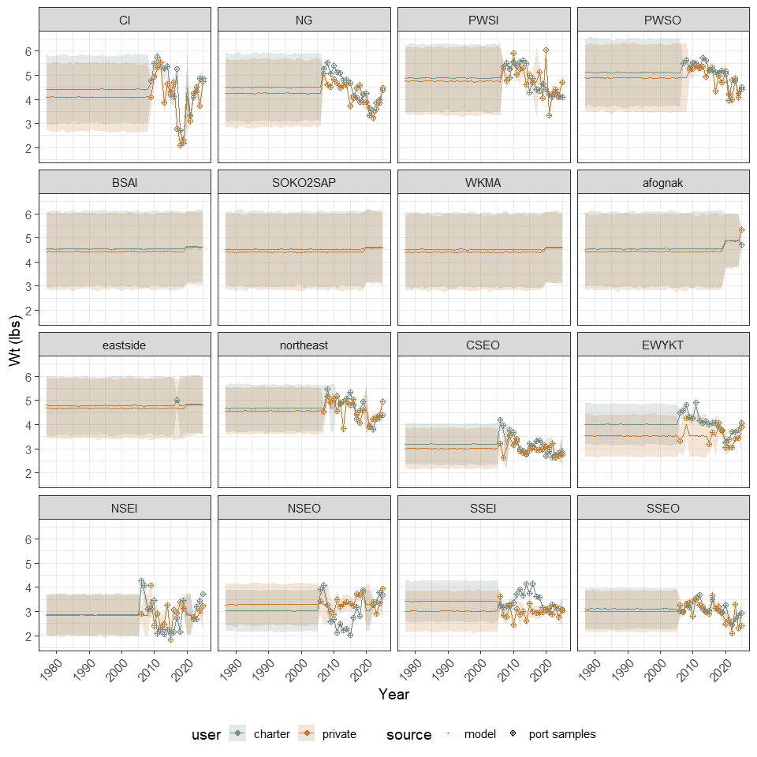
Appendix C1.– Mean weights of black rockfish used to estimate biomass from harvest and release mortality estimates in numbers of fish.

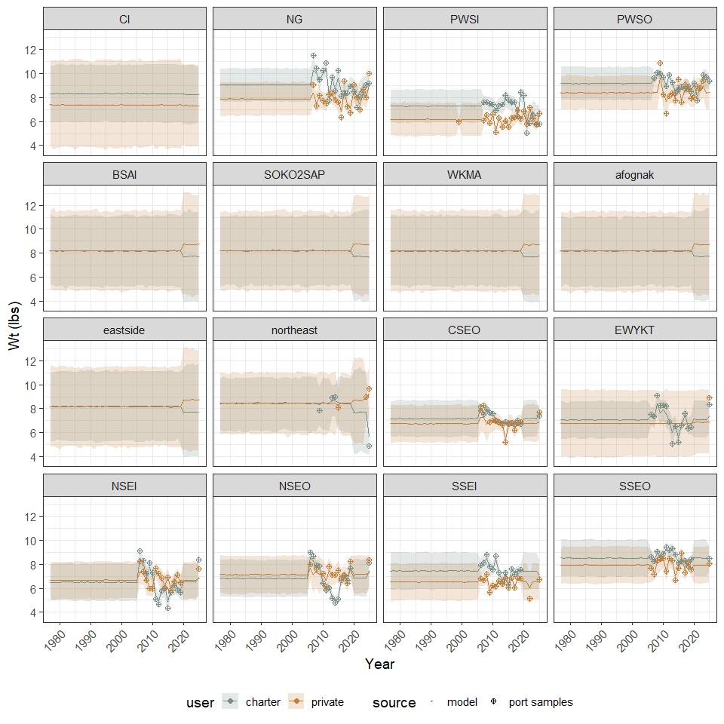
Appendix C2.– Mean weights of yelloweye rockfish used to estimate biomass from harvest and release mortality estimates in numbers of fish.

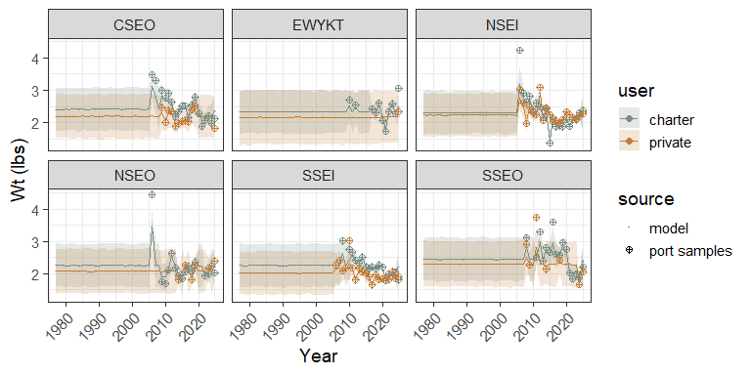
Appendix C3.– Mean weights of non-black, pelagic rockfish used to estimate biomass from harvest and release mortality estimates in numbers of fish.

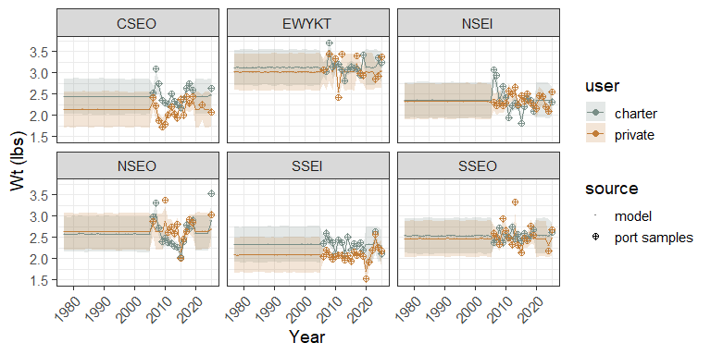
Appendix C4.– Mean weights of non-yelloweye, demersal shelf rockfish used to estimate biomass from harvest and release mortality estimates in numbers of fish.

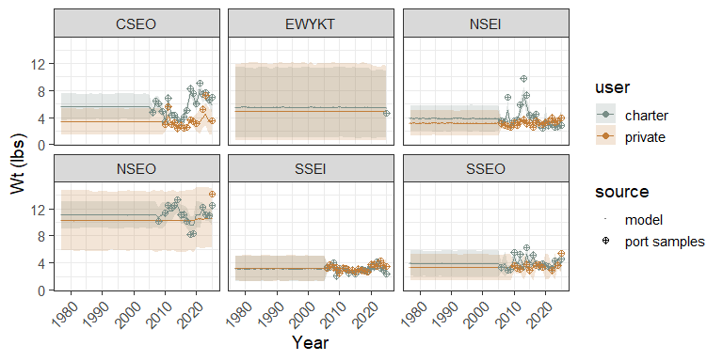
Appendix C5.– Mean weights of slope rockfish used to estimate biomass from harvest and release mortality estimates in numbers of fish.

Appendix D: Model output harvest, release, release mortality and total removal estimates

Appendix D1.– Black rockfish harvest, release, release mortality, weight, and total mortality estimates by year and user group for Cook Inlet Commercial Fisheries Management Unit 1977 - 2025. User “gui” indicates guided trips while “pri” indicates unguided trips. Harvest, release and release mortalities are estimated in numbers of fish.

