# Figures

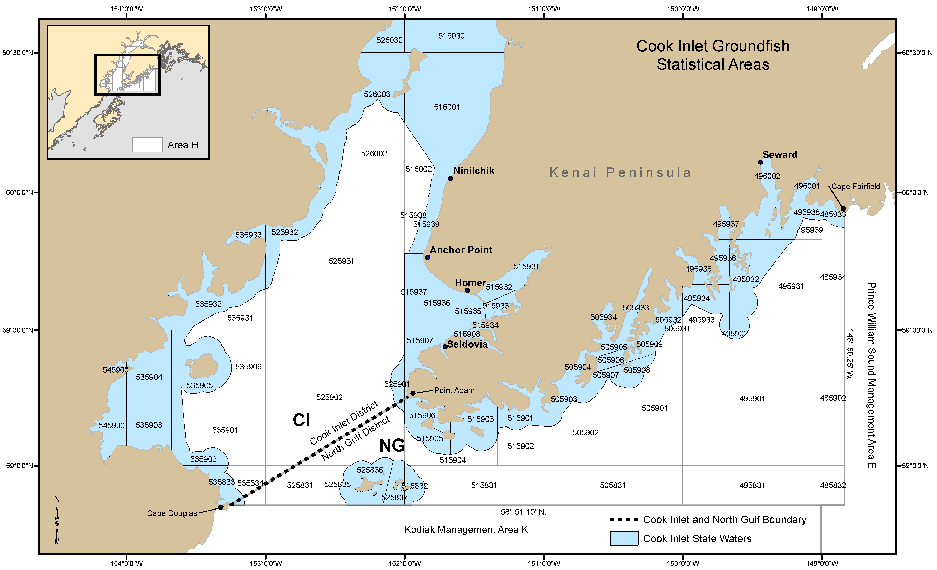

**Figure 1.** Cook Inlet rockfish commercial fishery management units: North Gulf District (NG) and Cook Inlet District (CI).

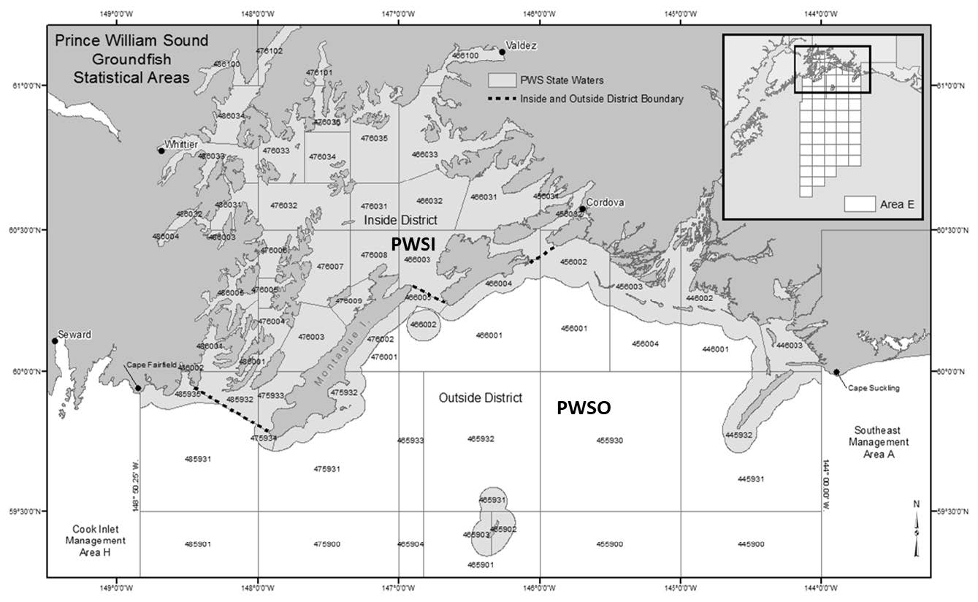

**Figure 2.** Prince William Sound rockfish commercial fishery management units: Prince William Sound Inside District (PWSI) and Prince William Sound Outside District (PWSO).

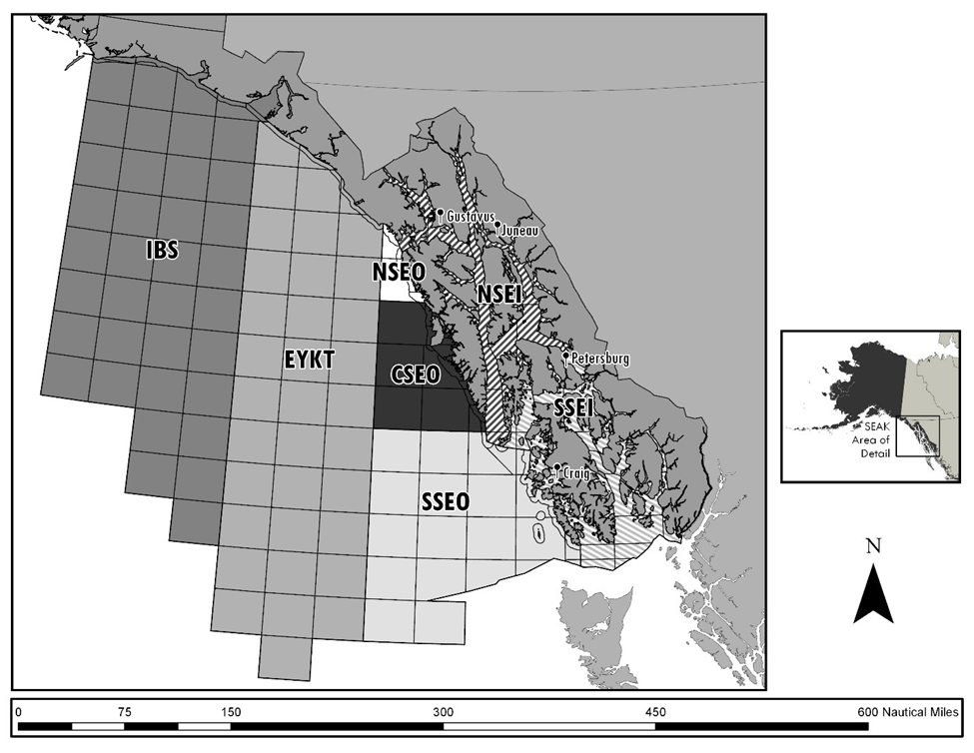

**Figure 3.** Southeast Alaska rockfish commercial fishery management units: Icy Bay Subdistrict (IBS), East Yakutat Section (EYKT), Northern Southeast Outside Section (NSEO), Central Southeast Outside Section (CSEO), Southern Southeast Outside Section (SSEO), Northern Southeast Inside Subdistrict (NSEI), and Southern Southeast Inside Subdistrict (SSEI).

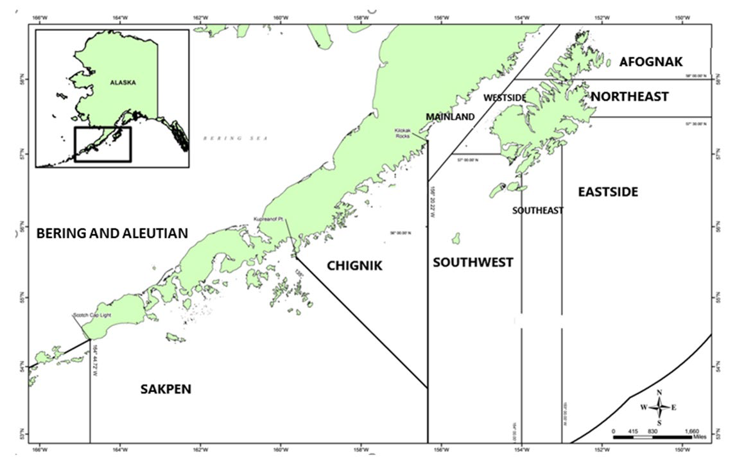

**Figure 4.** Kodiak, Chignik, and the South Alaska Peninsula (SAKPEN) rockfish commercial fishery management units. The Bering Sea–Aleutian Islands Area includes all waters west of the South Alaska Peninsula Area border at Scotch Cap Light, and north into the Bering Sea. Kodiak management units include Afognak, Northeast, Eastside, Southeast, Southwest, Westside, and Mainland Districts.

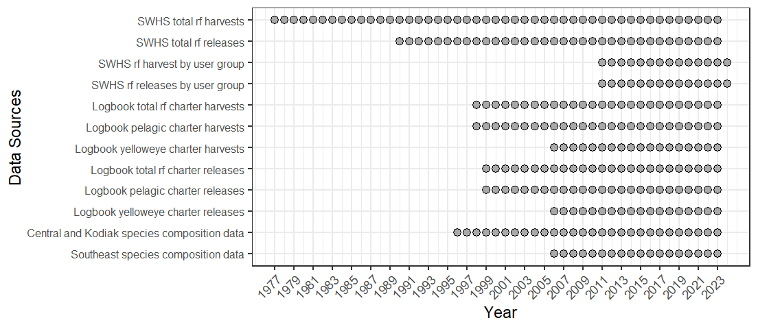

**Figure 5.**- Data sources for estimating rockfish harvests and releases in ADF&G commercial fisheries management units. Note that initial rockfish harvest estimates were not differentiated into species assemblage or species until 1998 when logbooks began differentiating by pelagic and non-pelagic. Logbooks began to collect data on yelloweye beginning in 2006. Port sampling programs to gather data on species composition of harvests began in 1996 in Southcentral and Kodiak and in 2006 in Southeast.

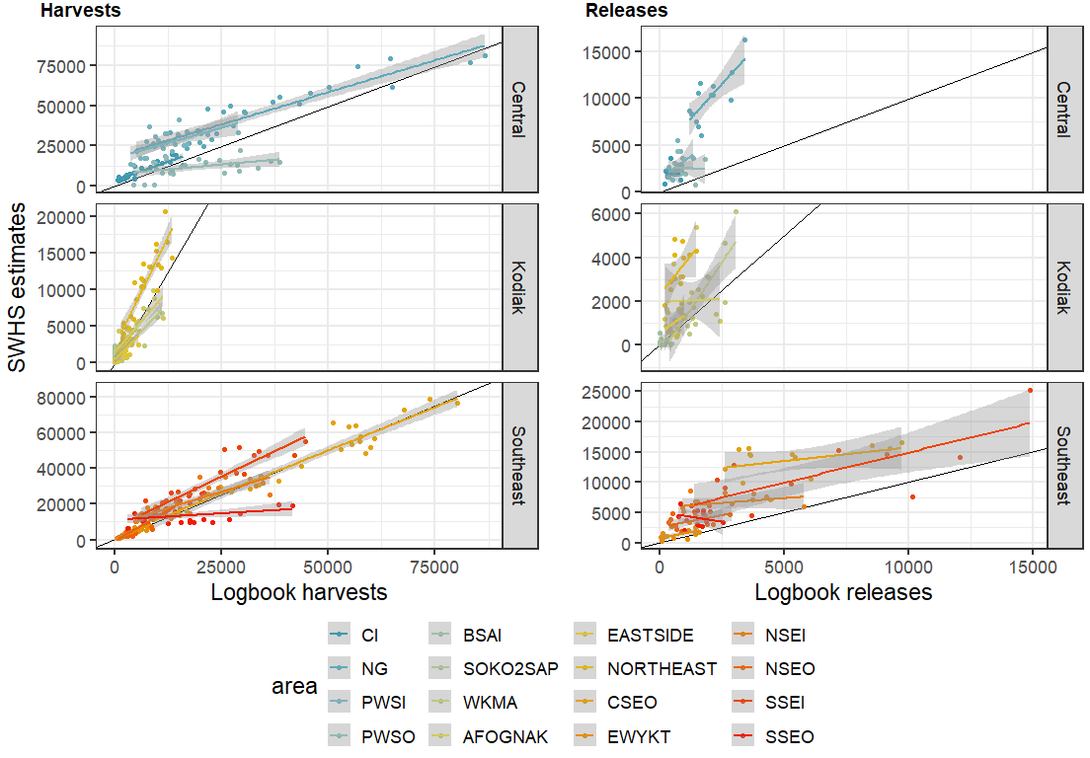

**Figure 6.**- SWHS harvest (left) and release (right) estimates from guided trips (x-axis) versus repoted harvests from charter logbooks (y-axis).

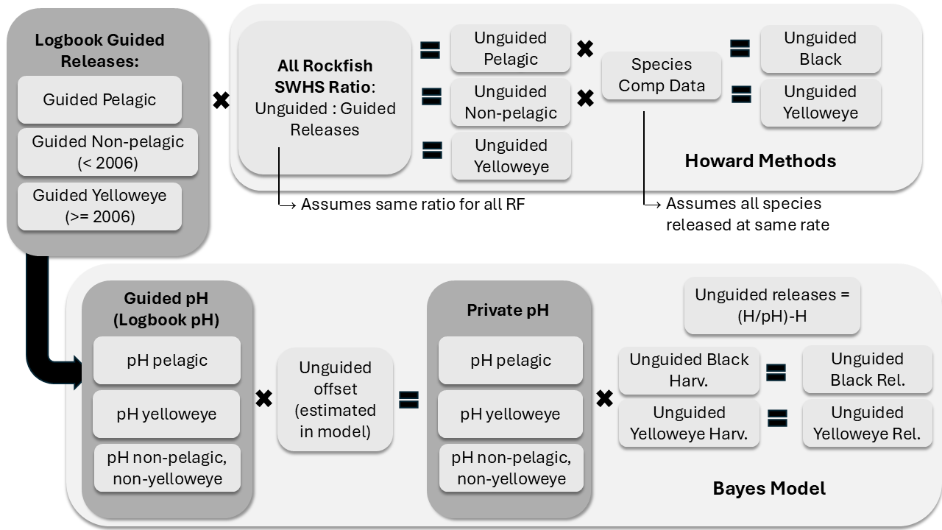

**Figure 7.** Schematics illustrating the difference in processes used by Howard et al. (2020) and the Bayesian model to estimates releases of rockfish by unguided anglers in Alaska waters. The Howard methods assume that the ratio of unguided:guided releases for all rockfish in the SWHS apply equally to all rockfish species and complexes. The Bayesian approach estimates retention probabilities separately for the three categories of rockfish in the logbook data (pelagics, yelloweye, and *other*) based on the retention probabilities of guided anglers evident in the logbook data.

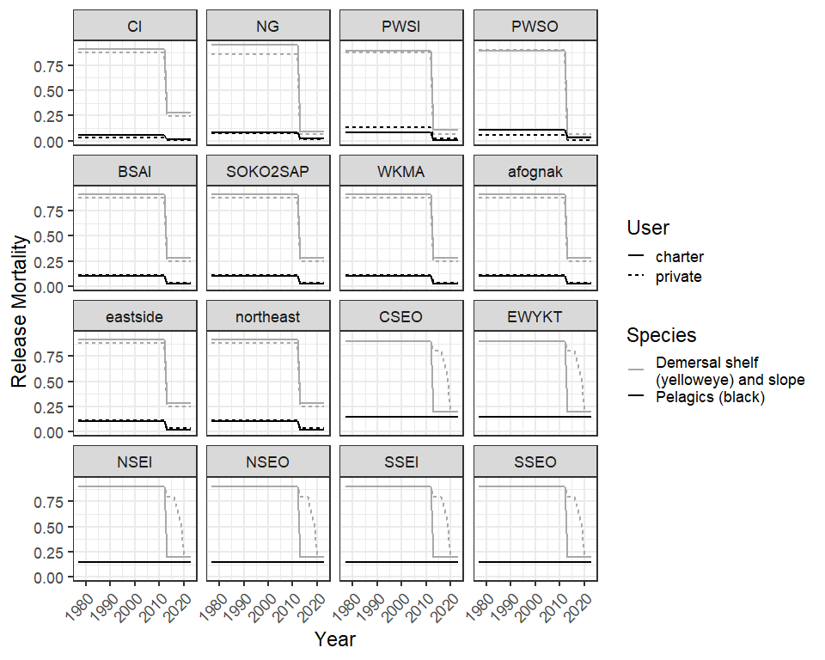

**Figure 8.** Release mortality rates used to calculate the number of released rockfish assumed to have died. The change in mortality rates in 2013 reflect the deep water release (DWR) requirements that were adopted in that year.

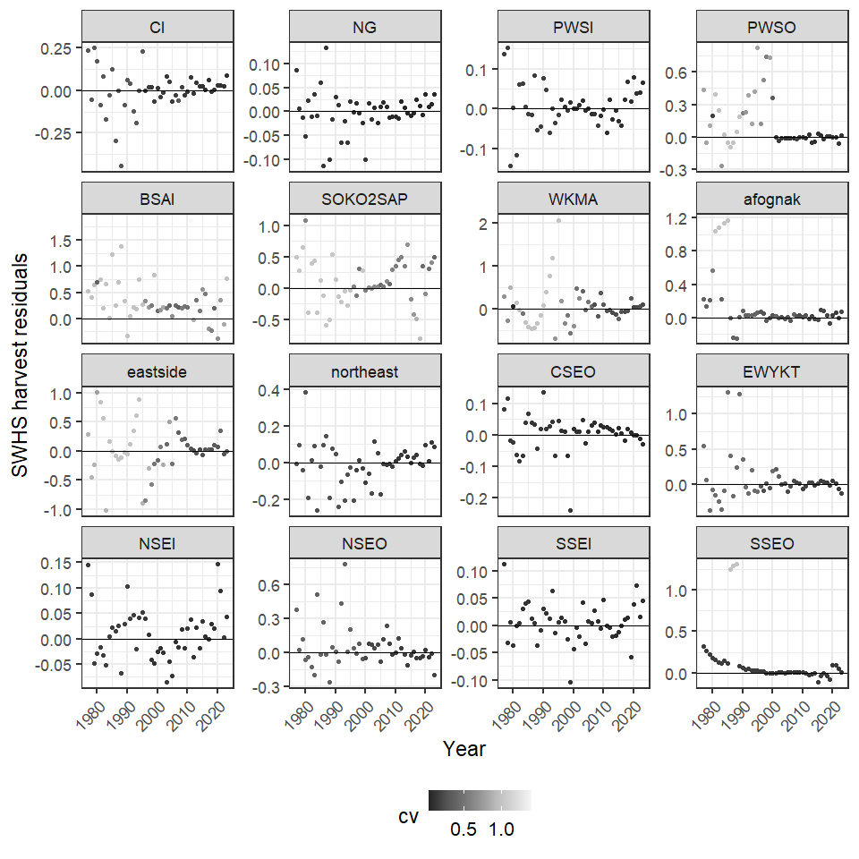

**Figure 9.**- Residuals from SWHS harvests showing the difference between model estimates with the bias correction removed and observed values in the SWHS. The CV of the SWHS data is indicated by the grey scale.

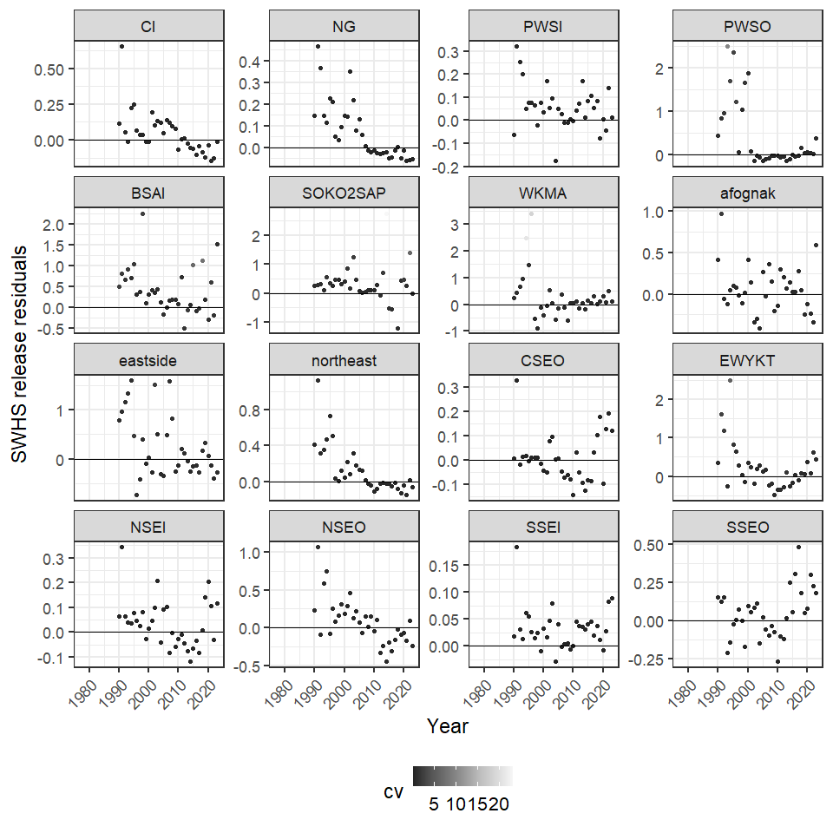

**Figure 10.**- Residual of SWHS releases showing the difference between model estimates with the bias correction removed and observed values in the SWHS. The CV of the SWHS data is indicated by the grey scale.

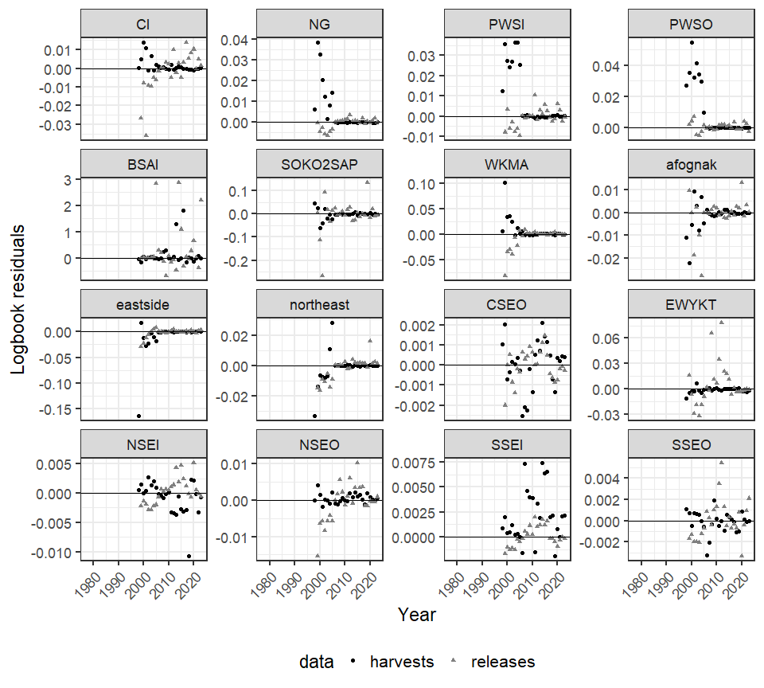

**Figure 11.**- Residuals from logbook harvests and releases with residuals shown proportional to the magnitude of the harvest and release data.

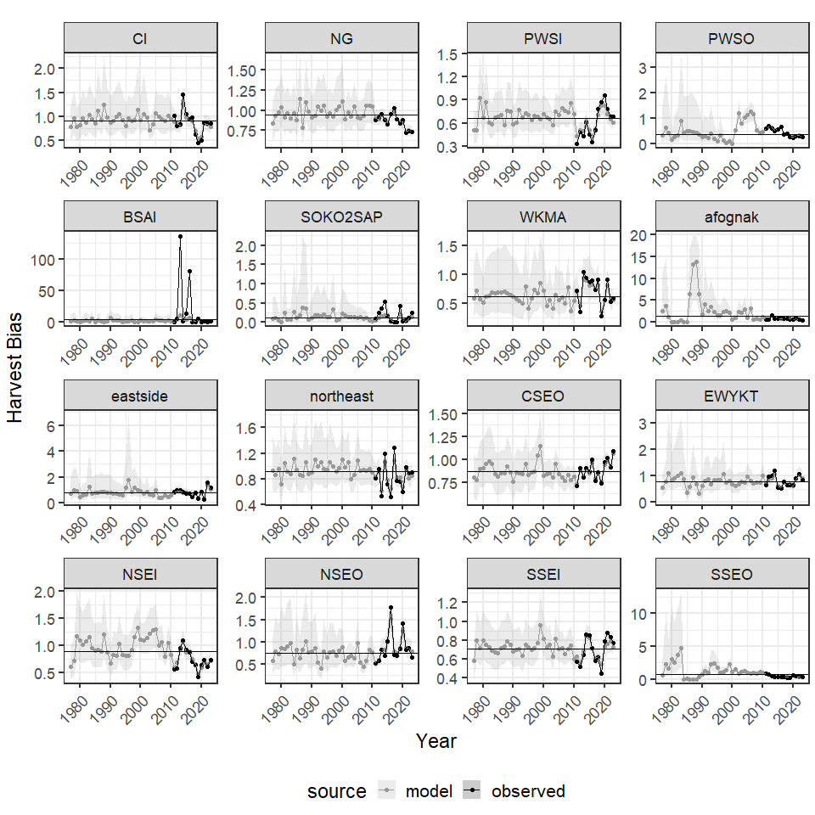

**Figure 12.**- Annual estimates of SWHS bias in harvests for 16 commerical fishing manamgent areas, 1996-2023. Note that a bias < 1 indicates that the SWHS *underestimates* the true value and bias > 1 indicates the survey *overestimates* the true value.

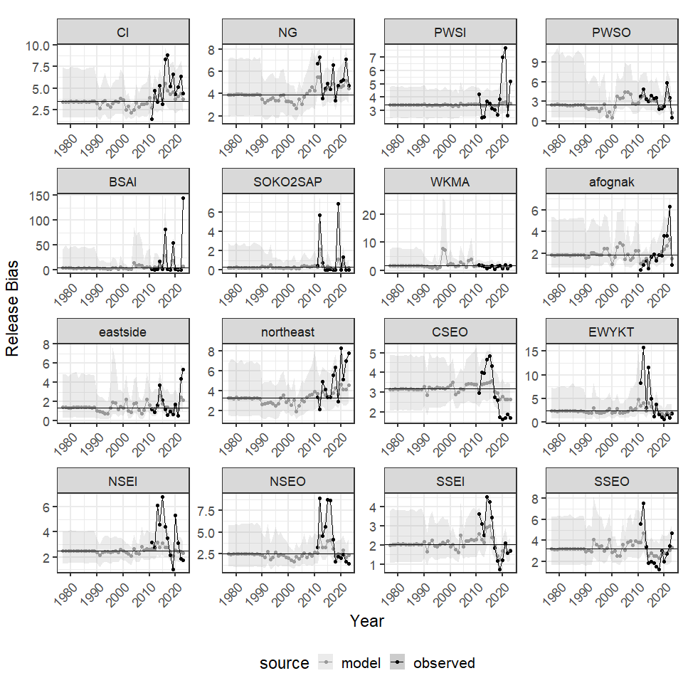

**Figure 13.**- Annual estimates of SWHS bias in releases for 16 commerical fishing manamgent areas, 1996-2023. Note that a bias < 1 indicates that the SWHS *underestimates* the true value and bias > 1 indicates the survey *overestimates* the true value.

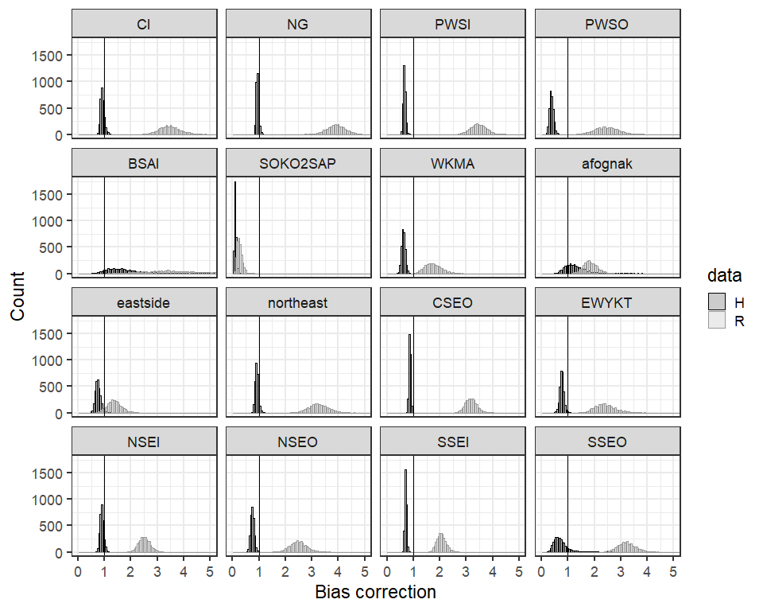

**Figure 14.**- Mean SWHS bias for harvests and catches. Note that a bias < 1 indicates that the SWHS *underestimates* the true value and bias > 1 indicates the survey *overestimates* the true value.

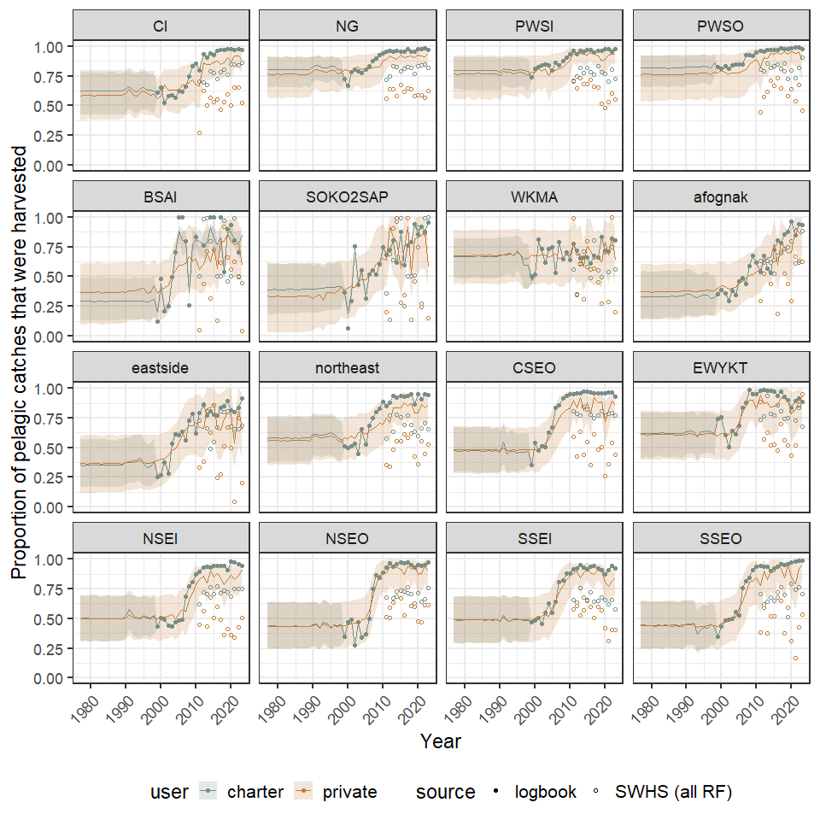

**Figure 15.**- Annual proportion of pelagic rockfish catch that was harvested. Note that pre-1990 estimates are used to estimate catch in these years when catch estimates are not available.

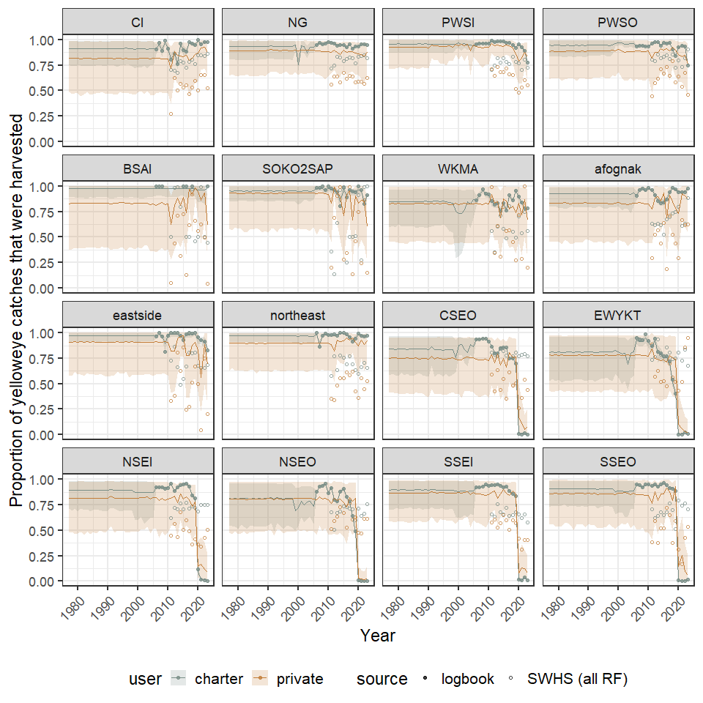

**Figure 16.**- Annual proportion of yelloweye rockfish catch that was harvested. Note that pre-1990 estimates are used to estimate catch in these years when catch estimates are not available.

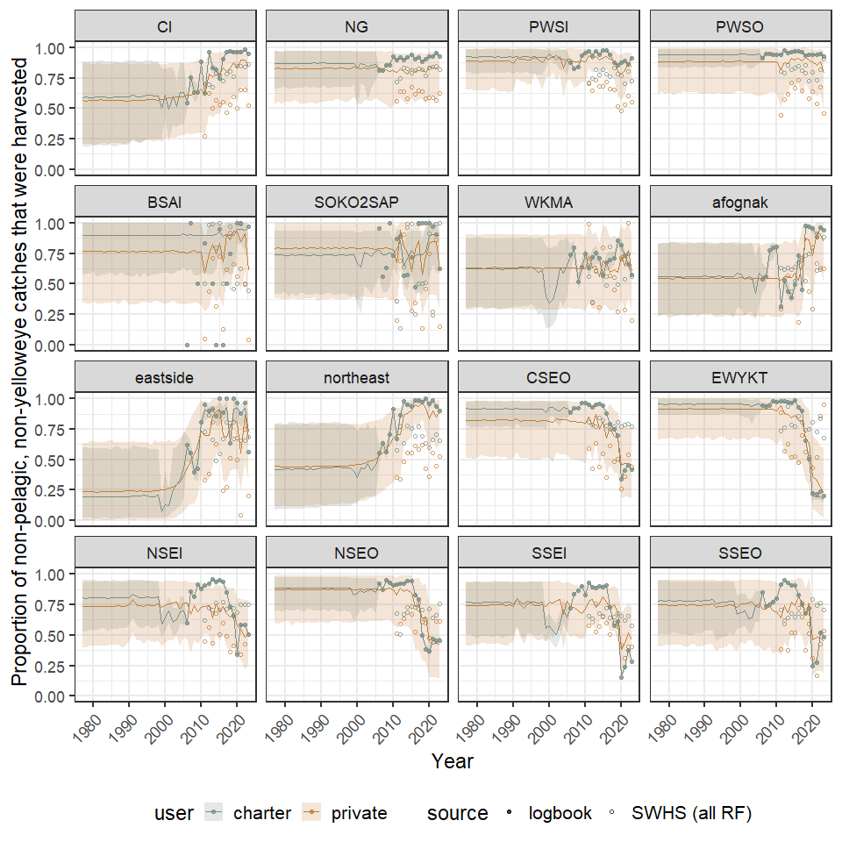

**Figure 17.**- Annual proportion of *other* (non-pelagic, non-yelloweye) rockfish catch that was harvested. Note that pre-1990 estimates are used to estimate catch in these years when catch estimates are not available. Note, that this is not estimated for Southeast areas because non=pelagics are divided between DSR (including yelloweye) and Slope species.

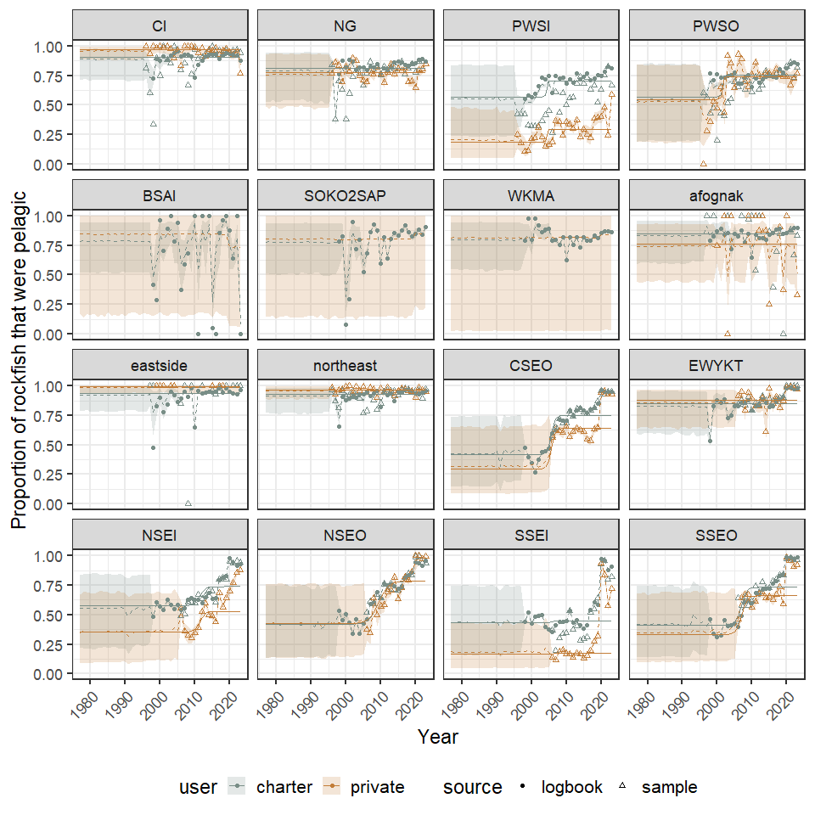

**Figure 18.**- Annual estimates of the percent of the sport harvest that was pelagic rockfish for 16 commerical fishing manamgent areas, 1996-2023.

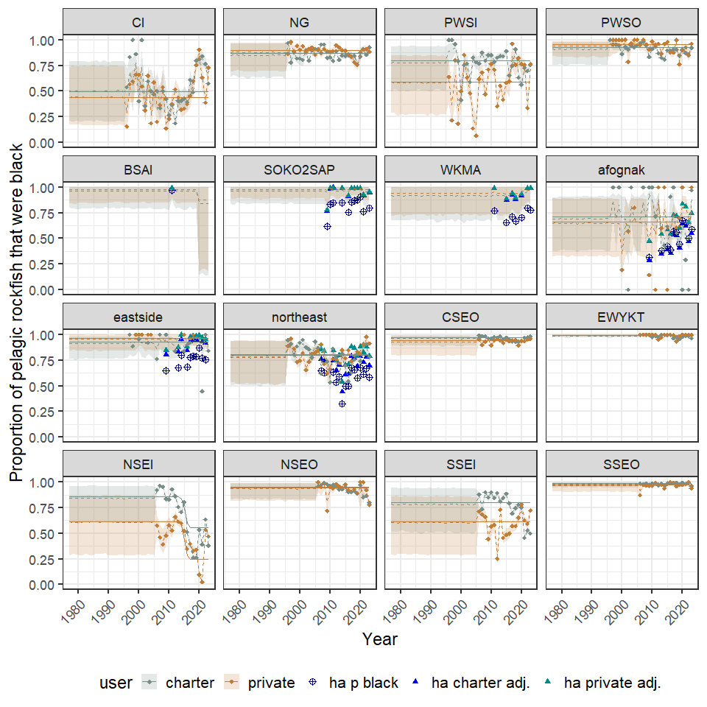

**Figure 19.**- Annual estimates of the percent of the sport harvest of pelagic rockfish that were black rockfish for 16 commerical fishing manamgent areas, 1996-2023. Kodiak panels include data from a hydroacoustic survey and the proportion of pelagic rockfish that are black in those areas (navy blue) and the adjusted proportions based on obseved harvests for charter (blue) and private (cyan) users.

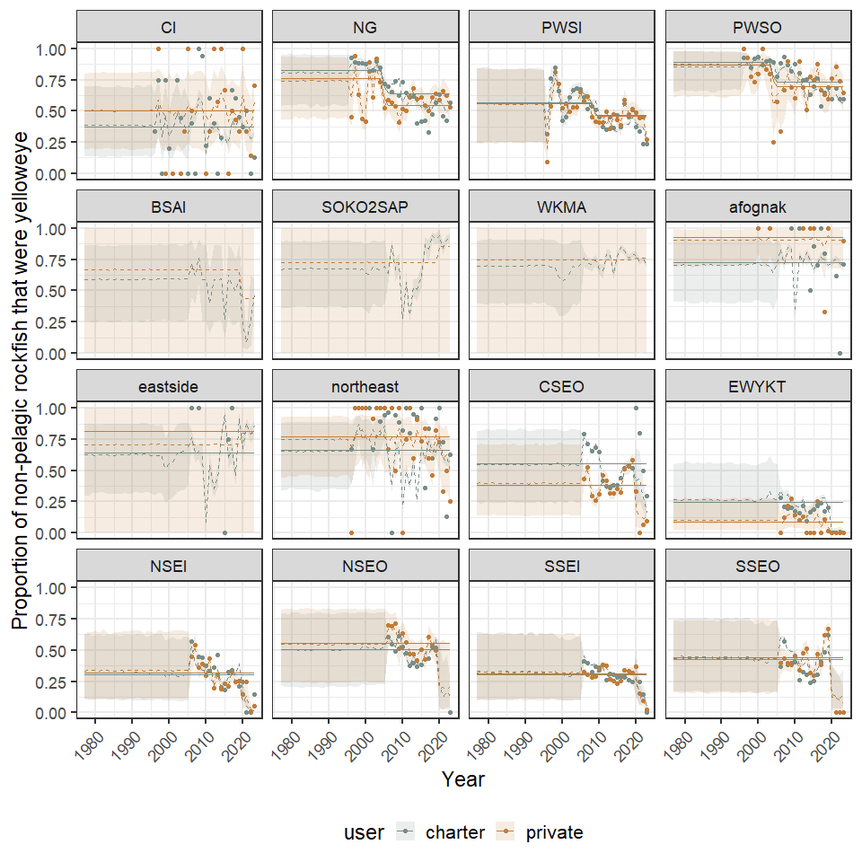

**Figure 20.**- Annual estimates of the percent of the sport harvest of non-pelagic rockfish that were yelloweye rockfish for 16 commerical fishing manamgent areas, 1996-2023. Note that P(yelloweye) is the the proportion relative to non-pelagics for Central and Kodiak areas but is relative to DSR for Southeast areas.

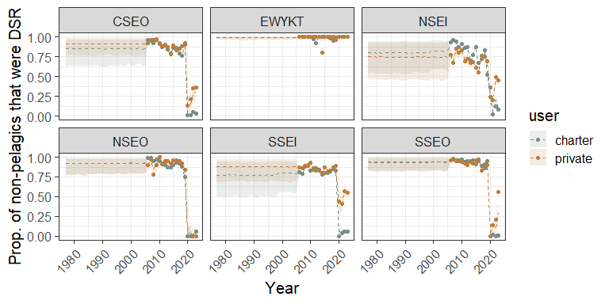

**Figure 21.**- Annual estimates of the percent of the sport harvest of non-pelagic rockfish that were DSR rockfish for 6 Southeast commerical fishing manamgent areas, 1996-2023.

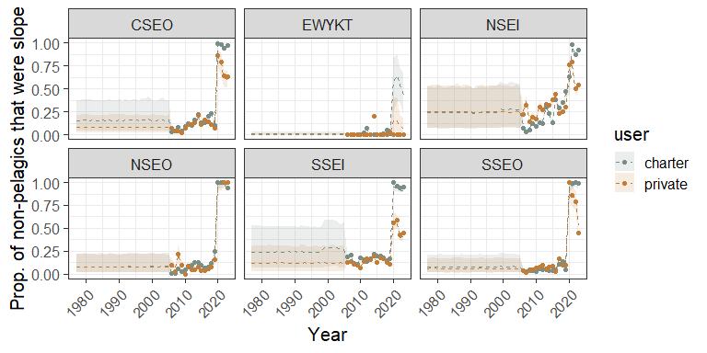

**Figure 22.**- Annual estimates of the percent of the sport harvest of non-pelagic rockfish that were slope rockfish for 6 southeast commerical fishing manamgent areas, 1996-2023. Note that P(yelloweye) is the the proportion relative to non-pelagics for Central and Kodiak areas but is relative to DSR for Southeast areas.

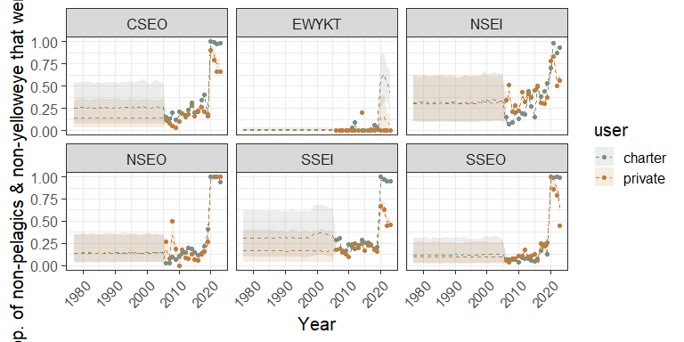

**Figure 23.**- Annual estimates of the percent of the sport non-pelagic, non-yelloweye releases that were slope rockfish for 6 southeast commerical fishing manamgent areas, 1996-2023.

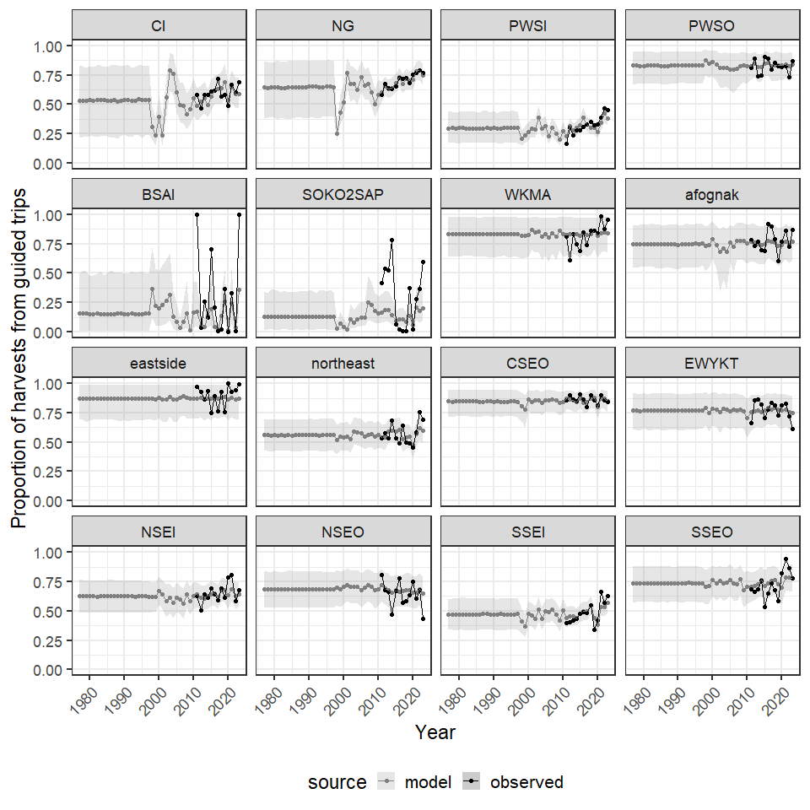

**Figure 24.**- Annual estimates of the percent of harvest by charter anglers for 16 commerical fishing manamgent areas, 1996-2023.

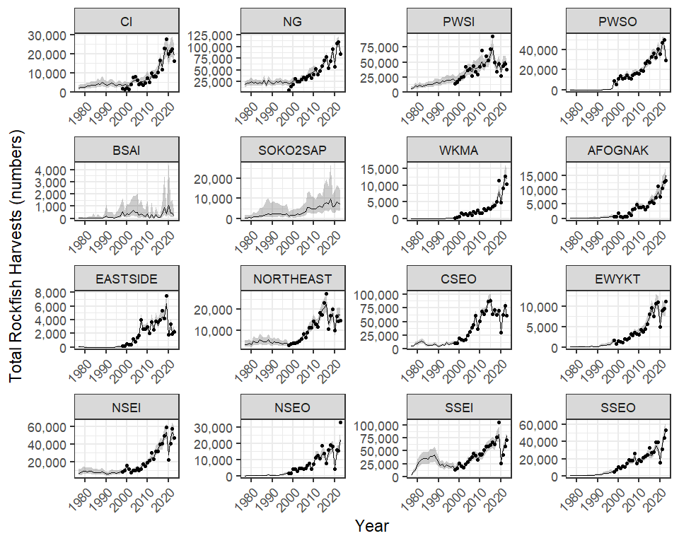

**Figure 25.**- Total rockfish harvests 1996-2023. Lines and error polygons represent model estimates and points represent Howard et al estimates.

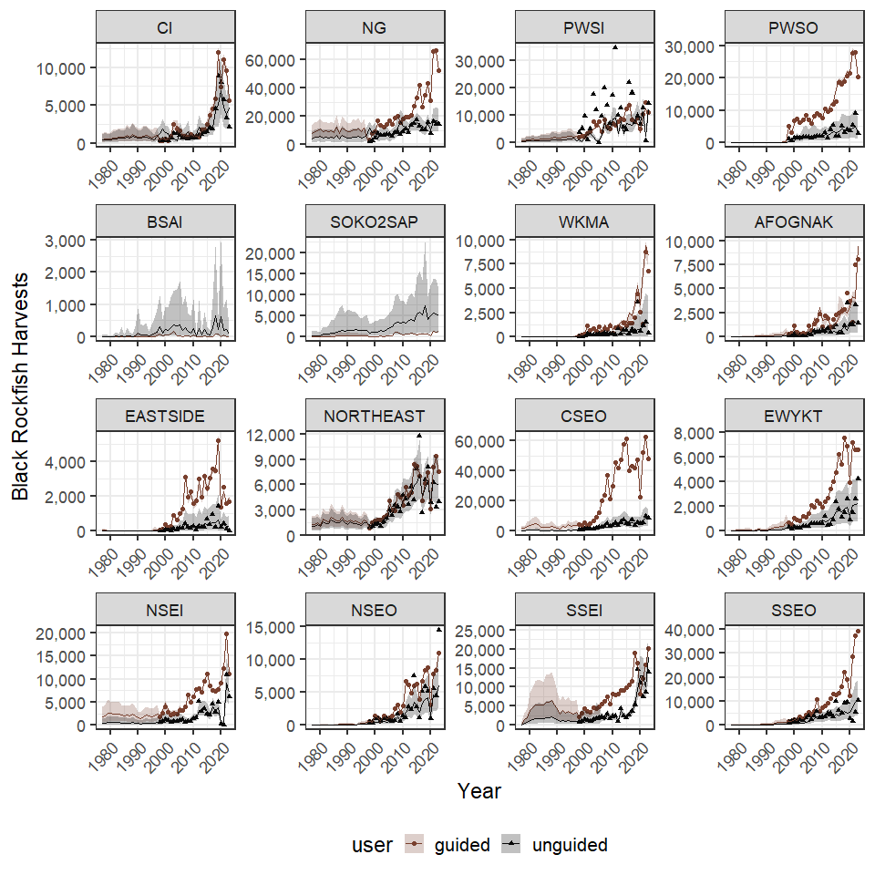

**Figure 26.**- Black rockfish harvests 1996–2023. Lines and error polygons represent model estimates and points represent Howard et al estimates.

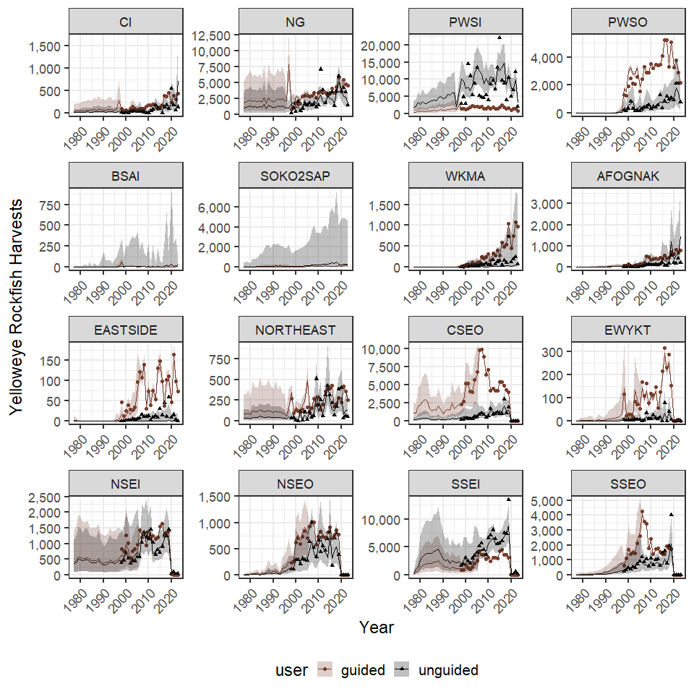

**Figure 27.**- Yellow rockfish harvests 1996–2023. Lines and error polygons represent model estimates and points represent Howard et al estimates.

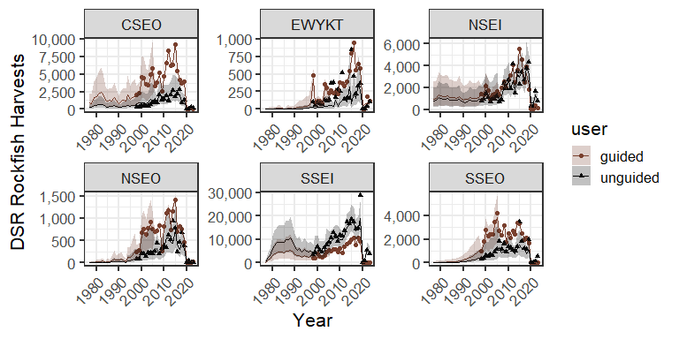

**Figure 28.**- DSR rockfish (excluding yelloweye) harvests 1996–2023. Lines and error polygons represent model estimates and points represent Howard et al estimates.

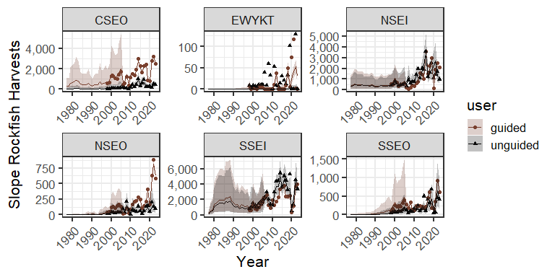

**Figure 29.**- Slope rockfish harvests 1996-2023. Lines and error polygons represent model estimates and points represent Howard et al estimates.

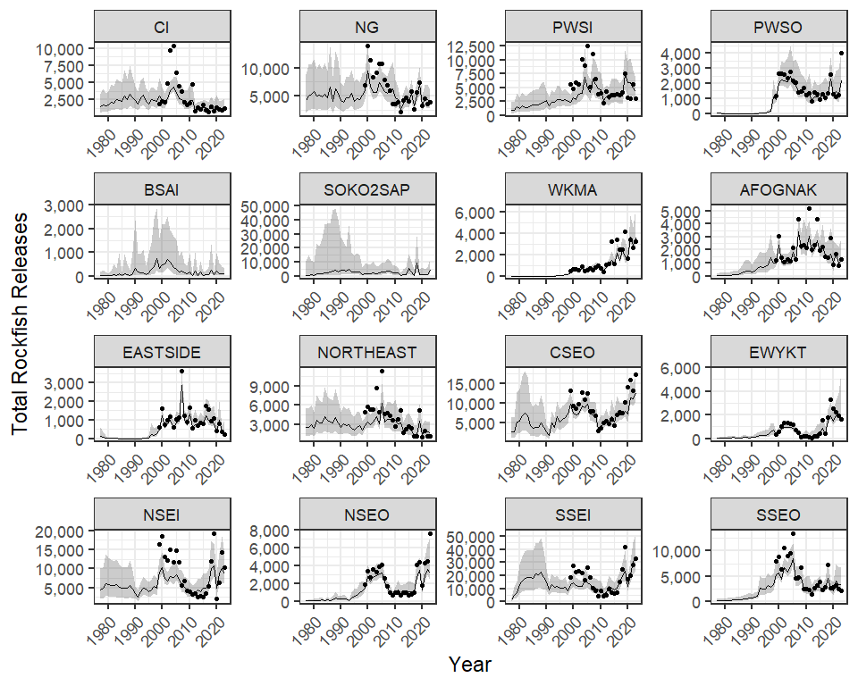

**Figure 30.**- Total rockfish releases 1996–2023. Lines and error polygons represent model estimates and points represent Howard et al estimates.

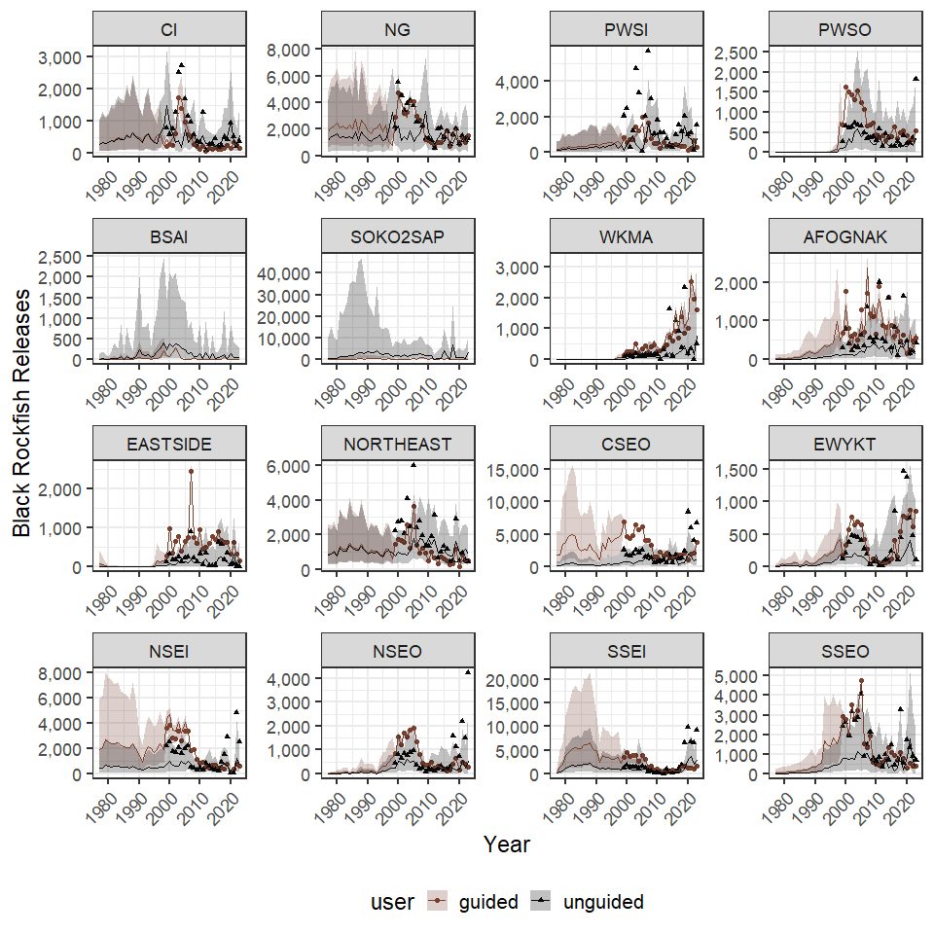

**Figure 31.**- Black rockfish releases 1996–2023. Lines and error polygons represent model estimates and points represent Howard et al estimates.

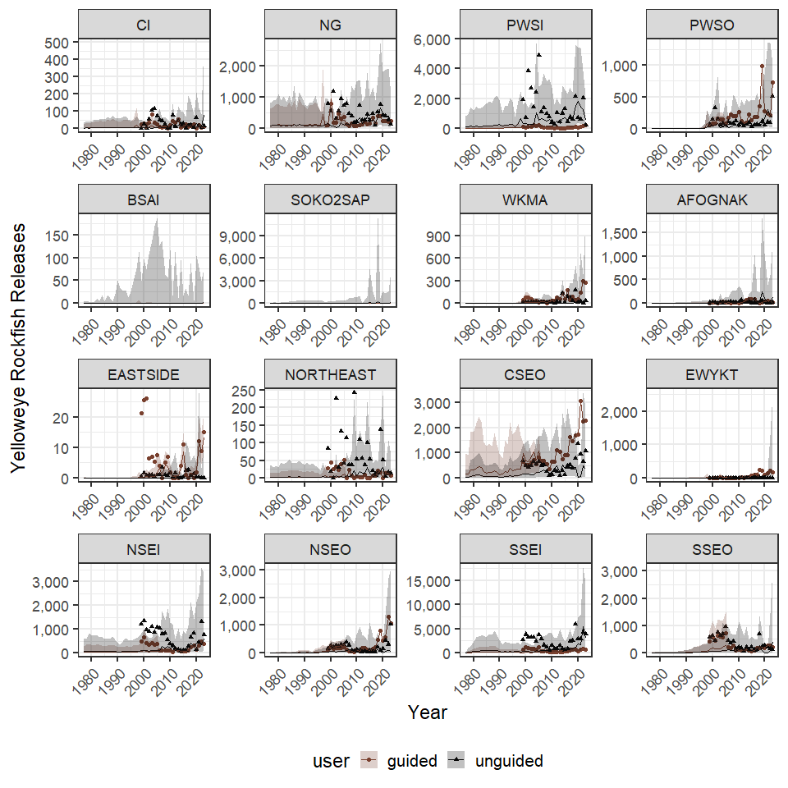

**Figure 32.**- Yellow rockfish releases 1996–2023. Lines and error polygons represent model estimates and points represent Howard et al estimates.

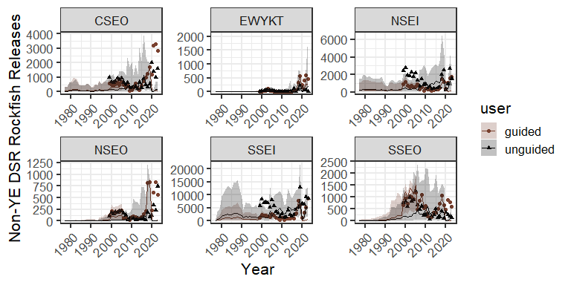

**Figure 33.**- DSR rockfish releases (including yelloweye) 1996–2023. Lines and error polygons represent model estimates and points represent Howard et al estimates.

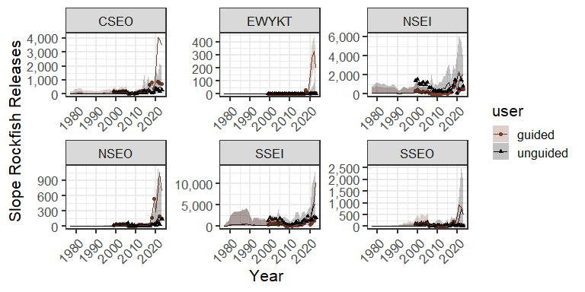

**Figure 34.**- Slope rockfish releases 1996–2023. Lines and error polygons represent model estimates and points represent Howard et al estimates.

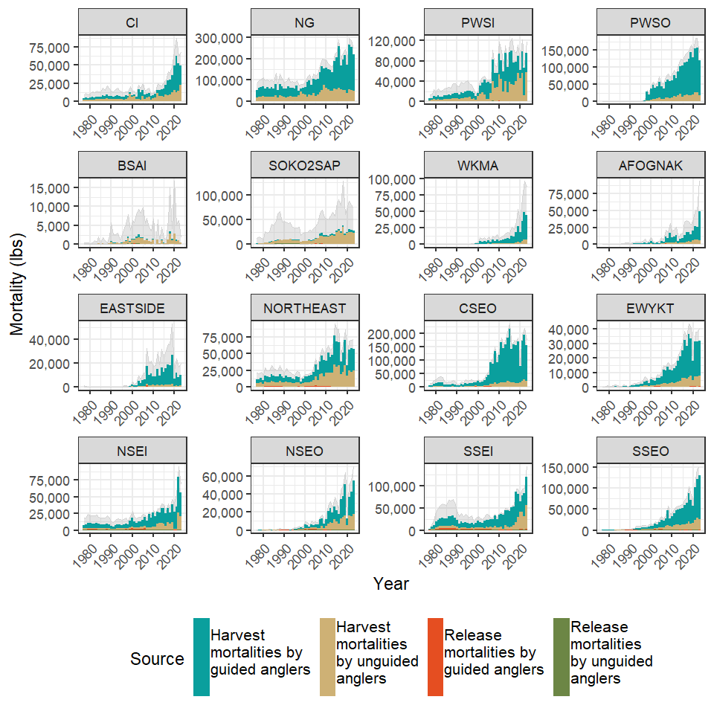

**Figure 35.**- Total removals of black rockfish by guided and unguided anlgers in Alaska commercial fishery management units as dervided from harvests and release mortalities. The grey polygon in the backround represents 95% credibility intervals of the total removals.

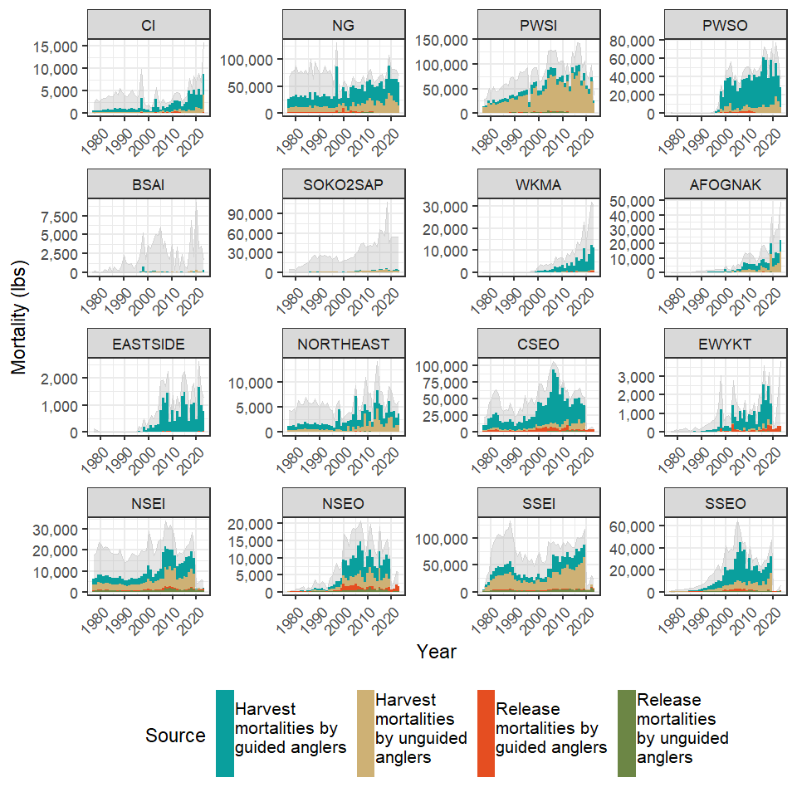

**Figure 36.**- Total removals of yelloweye rockfish by guided and unguided anlgers in Alaska commercial fishery management units as dervided from harvests and release mortalities. The grey polygon in the backround represents 95% credibility intervals of the total removals.

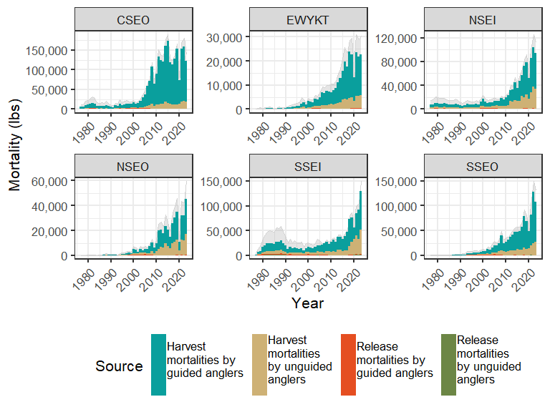

**Figure 37.**- Total removals of non-black pelagic rockfish by guided and unguided anlgers in southeast Alaska commercial fishery management units as dervided from harvests and release mortalities. The grey polygon in the backround represents 95% credibility intervals of the total removals.

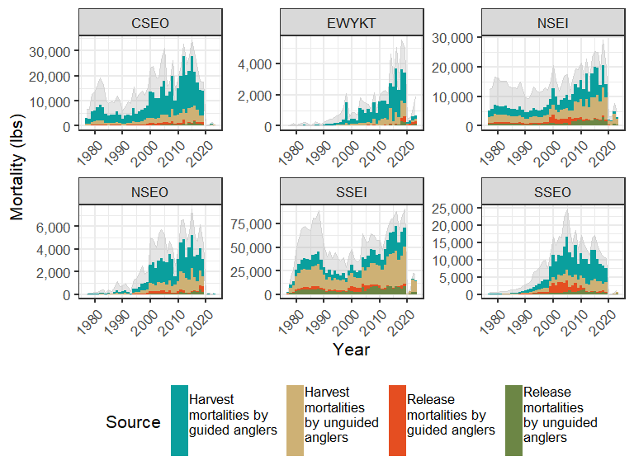

**Figure 38.**- Total removals of non-yelloweye demersal shelf rockfish by guided and unguided anlgers in southeast Alaska commercial fishery management units as dervided from harvests and release mortalities. The grey polygon in the backround represents 95% credibility intervals of the total removals.

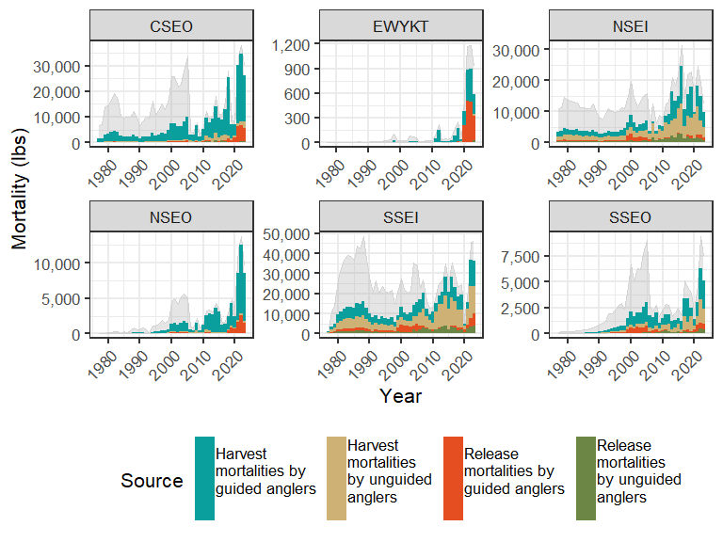

**Figure 39.**- Total removals of slope rockfish by guided and unguided anlgers in southeast Alaska commercial fishery management units as dervided from harvests and release mortalities. The grey polygon in the backround represents 95% credibility intervals of the total removals.