DisasterSense
A Comparative Study of CNN, Patch-Based CNN and Vision Transformer
for Disaster Image Classification and Automated Alert Generation
Machine Learning Theory — Project Report
Section A1
Submitted to
Sir Tariq Mahmood
Submitted by
Muhammad Taha Masaud — F2023376266
Meerub Sohail — F2023376374
Adhab Ahmad — F2023376027

Table of Contents
Abstract 3
1. Introduction 3
1.1 Research Challenges 3
1.2 Novel Contributions 4
2. Background Knowledge Based on Deep Learning Methods 4
3. Proposed Methodology 5
3.1 Dataset 5
3.2 Image Preprocessing Methods 6
3.3 Loss Function 6
3.4 Model Architectures 6
3.5 Multi-Class Disaster Classification and Alert Generation Module 7
3.6 Performance Evaluation Metrics 7
4. Experimental Results and Analysis 8
4.1 Experimental Setup and Evaluation Metrics 8
4.2 Analysis of Experimental Results 8
4.3 Training Hyperparameter Experiments 11
4.4 Comparison of the Proposed Methods 11
4.5 Comparison with State-of-the-Art Research 12
4.6 Experimental Visualization Analysis 13
5. Conclusion 14
6. System Architecture 14
7. Limitations 15
8. Future Work 15
9. Ethical and Practical Considerations 15
10. Technology Stack 16
Appendix A: Model Training Code 16
Appendix B: Testing on Sample Images 23

Abstract
Natural disasters such as earthquakes, floods and wildfires demand rapid identification from visual data so that emergency teams can prioritise their response. This project, DisasterSense, presents a controlled deep learning study that classifies disaster images into three categories — Earthquakes, Floods and Wildfires — and converts each prediction into a severity-graded textual alert. Rather than training a single model, the project isolates exactly what makes modern vision models work by comparing three architectures under identical conditions: (1) a ResNet50 Convolutional Neural Network that sees the whole image, (2) the same ResNet50 applied to 16 separate image patches that are only averaged together (patches without attention), and (3) a Vision Transformer (ViT-Base/16) that splits the image into 196 patches and connects them through self-attention. All three models were trained on a 300-image Kaggle dataset (240 training, 60 test images, stratified 80/20 split) for up to 30 epochs with Adam (learning rate 1e-4), Cross-Entropy Loss, batch size 16 and early stopping. The Vision Transformer achieved the best result with 98.33% test accuracy, 0.9841 precision and a 0.9833 weighted F1-score (only 1 error out of 60 images), compared with 93.33% for the CNN and 90.00% for the patch-based CNN. The experiment shows that splitting an image into patches on its own reduces accuracy by 3.33 points, while adding self-attention on top of the patches raises it by 8.33 points — demonstrating that attention, not patching, is the key ingredient.

1. Introduction
Disaster response teams depend heavily on rapid situational assessment to prioritise resources effectively. Manually reviewing images from drones, satellites, social media or field reports is slow and error-prone during emergencies. This project automates that triage step by training deep learning image classifiers that recognise the type of disaster in a photograph and by attaching an automated alerting module that produces a readable, actionable message.
The project has three core components:
- Computer Vision (CV) Module — three image classifiers (CNN, CNN with patches, and Vision Transformer) that classify disaster images into Earthquakes, Floods or Wildfires.
- Machine Learning Evaluation Module — accuracy, precision, recall, F1-score and confusion matrices computed with scikit-learn, used to compare the three models fairly on the same held-out test set.
- Alert Generation Module — a rule-based component that converts the predicted class and its softmax confidence into a severity-graded alert (CRITICAL, HIGH, MODERATE or VERIFY).
The project deliberately blends classical Machine Learning concepts — stratified data splitting, precision/recall/F1 evaluation and confusion-matrix analysis — with modern Deep Learning concepts — convolutional feature learning, transfer learning, patch embeddings and multi-head self-attention — inside a single, reproducible notebook pipeline.

1.1 Research Challenges
- Real-time constraint: disaster response decisions are time-critical, so the classifier must be accurate and fast enough to give near-instant feedback.
- Visual ambiguity between classes: earthquake rubble, flood debris and smoke-covered landscapes can share colours and textures (mud, broken structures, grey skies), which makes single-label classification genuinely hard.
- Limited data: only 300 labelled images were available (100 per class). Training deep networks on such a small dataset risks severe overfitting — our first attempt with a simple ResNet trained from scratch, without transfer learning, produced results that were too weak to be useful.
- Understanding why a model works: Vision Transformers differ from CNNs in two ways at once (they use patches and they use attention), so a direct CNN-vs-ViT comparison cannot tell which of the two changes is responsible for any improvement.
- Bridging model output and human action: a raw class label and probability are not directly actionable for a responder and must be converted into a clear message.

1.2 Novel Contributions
- A three-way controlled comparison that introduces an intermediate model — a ResNet50 applied to 16 image patches with no attention — so that the effect of patching and the effect of self-attention are measured separately.
- Evidence that patches alone hurt performance (−3.33 points) while self-attention over patches improves it (+8.33 points), giving the Vision Transformer the best overall accuracy of 98.33%.
- A fair training protocol: one shared training function, the same optimizer, learning rate, loss, batch size, data split and early-stopping rule for all three models, trained for up to 30 epochs.
- A lightweight, fully interpretable rule-based alert module (generate_alert()) that turns predictions into severity-aware alerts without the hallucination risk of a generative language model.

2. Background Knowledge Based on Deep Learning Methods
Image classification has evolved through three broad eras. Classical Machine Learning approaches relied on hand-crafted features (edges, colour histograms, texture descriptors) paired with shallow classifiers such as Support Vector Machines or Decision Trees. These required manual feature engineering and generalised poorly to unseen visual conditions.
Convolutional Neural Networks (CNNs) replaced hand-crafted features with learned, hierarchical convolutional filters, and transfer learning made it practical to reuse networks pretrained on large datasets such as ImageNet. Several CNN families are commonly used as transfer-learning backbones:
- AlexNet — one of the earliest deep CNNs, using stacked convolution and max-pooling layers with ReLU activations; strong on coarse features but shallow by modern standards.
- VGG — deeper, very uniform 3×3 convolutional blocks; simple to fine-tune but parameter-heavy.
- ResNet — introduces residual (skip) connections that allow much deeper networks to train without vanishing gradients. ResNet50 (23.5M parameters) is used as the CNN backbone in this project.
- MobileNet — depthwise-separable convolutions designed for a much smaller parameter and compute footprint, suited to mobile and edge deployment.
All of the above share a common limitation: convolution is inherently local, so each layer only sees a small receptive field, and long-range dependencies across an image are only captured after many stacked layers.
The Vision Transformer (ViT) addresses this by splitting an image into fixed-size patches, linearly embedding each patch, and processing the resulting sequence with a standard Transformer encoder and multi-head self-attention — the same mechanism used in large language models. Because self-attention compares every patch with every other patch, ViT can model global relationships (for example, smoke in one corner of a wildfire image and flames in another) from the very first layer. The backbone used here, google/vit-base-patch16-224, has 12 encoder layers, 12 attention heads, a hidden size of 768 and 85.8M parameters.
A ViT therefore changes two things compared to a CNN: it works on patches and it combines them with attention. The central idea of this project is to separate these two ingredients by adding a middle model that uses patches but no attention.

3. Proposed Methodology

3.1 Dataset
The dataset is the Kaggle Disaster Dataset (2024–2026), stored on Google Drive in folder format with one sub-folder per class (earthquakes, floods, wildfires). It contains 300 RGB images, 100 per class. The images were divided with scikit-learn’s train_test_split using an 80/20 ratio, stratified by label and a fixed random seed (42) for reproducibility, giving 240 training images (15 batches) and 60 test images (4 batches).
Class | Total Images | Training Split (80%) | Test Split (20%)
Earthquakes | 100 | 80 | 20
Floods | 100 | 80 | 20
Wildfires | 100 | 80 | 20
Total | 300 | 240 | 60

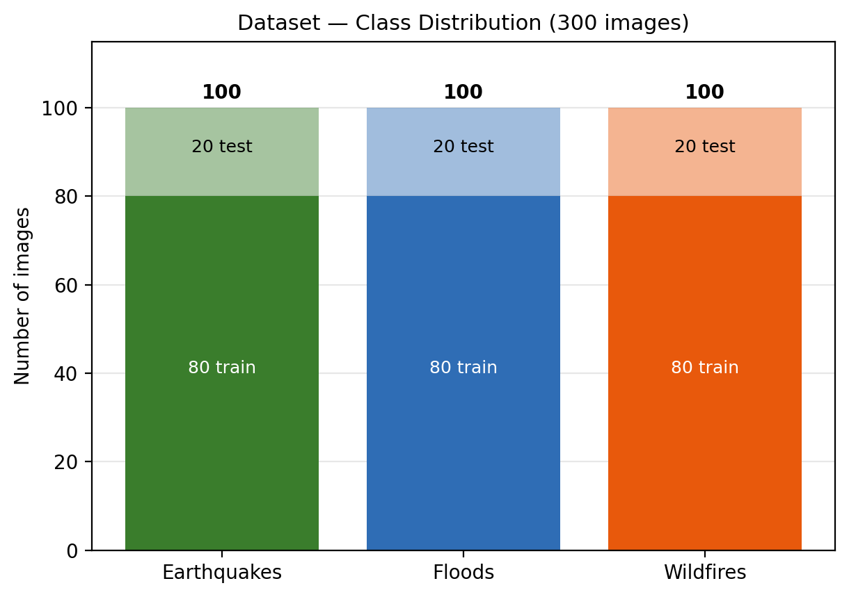
Figure 1: Class distribution of the dataset with the stratified 80/20 train/test split.
The three classes are perfectly balanced (100 images each), and stratification keeps this balance in both splits (80 training and 20 test images per class). This means plain accuracy is a reliable headline metric, and it directly informed the choice of a standard (unweighted) loss function in Section 3.3.

3.2 Image Preprocessing Methods
All images are preprocessed with torchvision transforms before being fed to the models. The test set uses only the deterministic steps, while the training set additionally uses data augmentation:
- Resize — every image is resized to 224 × 224 pixels, the input resolution expected by both ResNet50 and ViT-Base/16.
- Data augmentation (training only) — random rotation of ±15°, random horizontal flip, random affine translation of up to 10%, and colour jitter (brightness and contrast ±0.2). This artificially enlarges the small 240-image training set and reduces overfitting.
- Tensor conversion — pixel values are converted from the [0, 255] range to [0, 1].
- Normalize — each channel is normalized with mean 0.5 and standard deviation 0.5, mapping pixel values into the [−1, 1] range.
For the patch-based CNN, each normalized 224×224 image is further split inside the model into a 4×4 grid of 16 non-overlapping 56×56 patches. For the Vision Transformer, the patch-embedding layer splits the same image into a 14×14 grid of 196 patches of 16×16 pixels.

3.3 Loss Function
All three models are trained with the standard multi-class Cross-Entropy Loss (nn.CrossEntropyLoss), which applies a softmax over the three class logits and penalises the negative log-probability of the correct class. Because the dataset is perfectly balanced (Section 3.1), class-weighted or Focal Loss formulations — typically used to counter class imbalance — were not required. Using the same loss function for every model keeps the comparison fair.

3.4 Model Architectures
Three architectures were implemented in PyTorch. They were designed so that each step changes only one ingredient: Model 1 → Model 2 adds patches, and Model 2 → Model 3 replaces averaging with self-attention.
Model | Sees the image as… | Combines information via… | Parameters
CNN (No Patches) | One whole 224×224 image | Convolution + global pooling over the full grid | 23.5M
CNN (With Patches) | 16 separate 56×56 patches (shared ResNet50) | Simple average pooling of patch features — no attention | 23.5M
ViT (Patches + Attention) | 196 separate 16×16 patches | Multi-head self-attention across all patches | 85.8M

Model 1: CNN — ResNet50 without Patches
- ResNet50 backbone initialised with ImageNet pre-trained weights (transfer learning).
- The original 1000-class fully connected layer is replaced with a new linear layer with 3 outputs (Earthquakes, Floods, Wildfires).
- The network processes the full 224×224 image at once; all layers are fine-tuned end-to-end.

Model 2: CNN — ResNet50 with Patches, No Attention
- Uses the exact same pre-trained ResNet50 backbone (all layers up to global average pooling).
- A patchify() function uses tensor unfolding to split each image into 16 non-overlapping 56×56 patches; all patches pass through the shared backbone as one batch.
- The 16 resulting 2048-dimensional feature vectors are simply averaged and passed to a 3-class linear classifier. Patches never “look at” each other.

Model 3: Vision Transformer — Patches with Self-Attention
- google/vit-base-patch16-224 loaded through Hugging Face ViTForImageClassification with num_labels=3; the 1000-class head is discarded and re-initialised (ignore_mismatched_sizes=True).
- Patch size 16×16 over a 224×224 input, giving 196 patch tokens plus a classification token, each embedded in 768 dimensions.
- 12 Transformer encoder layers with 12 self-attention heads let every patch attend to every other patch; all layers are fine-tuned.
First attempt (baseline without transfer learning). Before this final design, a simple CNN/ResNet was trained from scratch with randomly initialised weights. With only 240 training images, the network could not learn robust features and its results were too weak. This motivated the use of ImageNet pre-trained weights for all three final models, so that the comparison reflects the architectures rather than the lack of data.

3.5 Multi-Class Disaster Classification and Alert Generation Module
Once a model produces logits for an image, a softmax converts them into a probability distribution over the three disaster categories. The top predicted class and its confidence score are passed to the rule-based function generate_alert(), which assigns one of four severity levels:
Confidence | Severity Level | Recommended Action
> 95% | CRITICAL | Immediate response prioritisation recommended.
85% – 95% | HIGH | Dispatch response teams; confirm with field reports.
75% – 85% | MODERATE | Further verification advised before dispatching teams.
≤ 75% | VERIFY | Manual review of the image is strongly recommended.

The final alert string has the form “[SEVERITY] DISASTER_TYPE DETECTED – Confidence: xx.x%”. For example, on a sample earthquake image all three models produced “[CRITICAL] EARTHQUAKES DETECTED”, with confidences of 100.0% (CNN), 99.6% (CNN with patches) and 100.0% (ViT). Because the module is fully deterministic and template-based, its behaviour is 100% predictable and auditable — an important property for a safety-critical alerting tool.

3.6 Performance Evaluation Metrics
Model performance is assessed on the 60-image held-out test set using standard classical Machine Learning classification metrics from scikit-learn:
- Accuracy — overall proportion of correctly classified images.
- Precision, Recall and F1-score — computed per class and as a weighted average, to check whether performance is uniform across Earthquakes, Floods and Wildfires.
- Confusion Matrix — a class-by-class breakdown of correct predictions versus misclassifications, used in Section 4.6 to analyse specific failure cases.
- Error count — the number of misclassified test images out of 60, which gives an intuitive view of the gap between models.

4. Experimental Results and Analysis

4.1 Experimental Setup and Evaluation Metrics
Parameter | Value
Models | ResNet50 CNN, ResNet50 CNN with 16 patches, ViT-Base/16
Number of classes | 3 (Earthquakes, Floods, Wildfires)
Optimizer | Adam
Learning rate | 1e-4
Batch size | 16
Maximum epochs | 30
Early stopping | Patience = 3 epochs on test accuracy
Loss function | Cross-Entropy Loss
Train / Test split | 240 / 60 images (80% / 20%, stratified, seed 42)
Random seeds | torch.manual_seed(42), np.random.seed(42)
Hardware | Google Colab (PyTorch 2.11)

4.2 Analysis of Experimental Results
Each model was allowed to train for up to 30 epochs, with early stopping halting training once test accuracy had not improved for 3 consecutive epochs. The tables below report the actual training logs recorded in the notebook.

Model 1: CNN (No Patches) — stopped at epoch 6
Epoch | Train Loss | Train Accuracy | Test Loss | Test Accuracy
1 | 0.5142 | 83.33% | 0.1444 | 93.33%
2 | 0.0797 | 98.75% | 0.1142 | 93.33%
3 | 0.0694 | 97.92% | 0.0975 | 96.67%
4 | 0.0480 | 97.50% | 0.1353 | 93.33%
5 | 0.0613 | 97.08% | 0.1951 | 91.67%
6 | 0.0362 | 98.75% | 0.1503 | 93.33%

Model 2: CNN (With Patches, No Attention) — stopped at epoch 5
Epoch | Train Loss | Train Accuracy | Test Loss | Test Accuracy
1 | 0.5536 | 82.92% | 0.2879 | 91.67%
2 | 0.1534 | 94.17% | 0.1172 | 95.00%
3 | 0.0776 | 98.75% | 0.3012 | 93.33%
4 | 0.1201 | 94.58% | 0.3040 | 86.67%
5 | 0.0699 | 98.33% | 0.2808 | 90.00%

Model 3: Vision Transformer (Patches + Attention) — stopped at epoch 4
Epoch | Train Loss | Train Accuracy | Test Loss | Test Accuracy
1 | 0.2997 | 91.25% | 0.1141 | 98.33%
2 | 0.0267 | 99.17% | 0.0996 | 96.67%
3 | 0.0479 | 98.75% | 0.0574 | 98.33%
4 | 0.0189 | 99.17% | 0.1001 | 98.33%

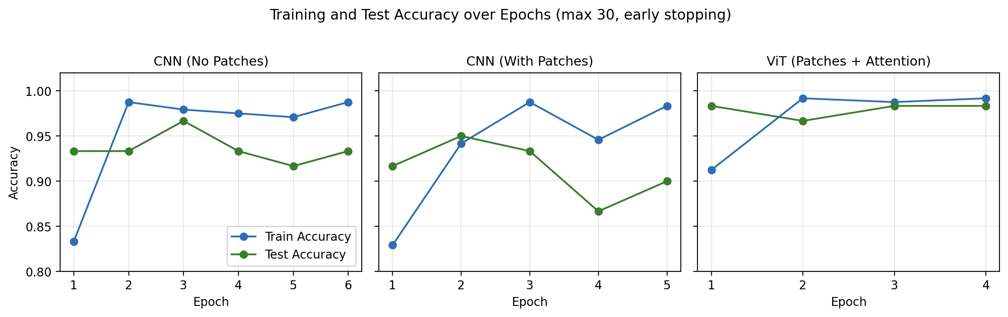
Figure 2: Training and test accuracy over epochs for the three models.
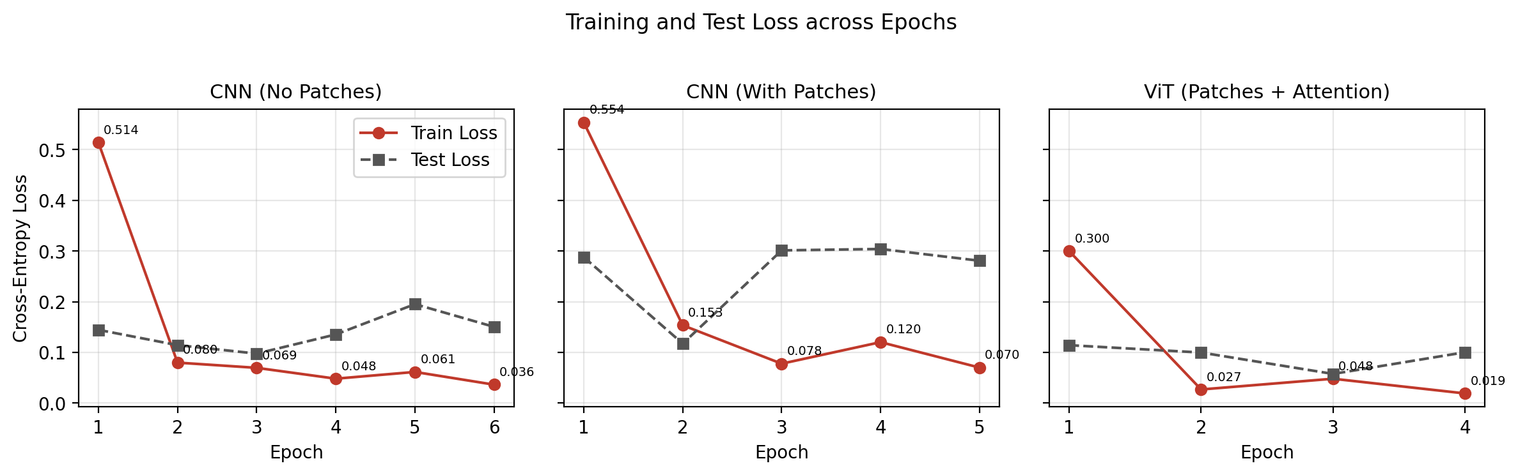
Figure 3: Training and test loss across epochs for the three models.
The Vision Transformer reached 98.33% test accuracy after its very first epoch and kept that level, with the lowest test loss of all models (0.0574 at epoch 3). The CNN improved steadily and peaked at 96.67% in epoch 3 before settling at 93.33%. The patch-based CNN was the least stable: its test loss rose from 0.1172 to over 0.30 and its test accuracy dropped to 86.67% at epoch 4, even though its training accuracy stayed above 94% — a clear sign that it memorised the training patches without learning how they fit together. The final test-set results were:
Metric | CNN (No Patches) | CNN (With Patches) | ViT (Patches + Attn)
Test Accuracy | 0.9333 | 0.9000 | 0.9833
Precision (weighted) | 0.9399 | 0.9103 | 0.9841
Recall (weighted) | 0.9333 | 0.9000 | 0.9833
F1-score (weighted) | 0.9331 | 0.8998 | 0.9833
Errors on test set | 4 / 60 | 6 / 60 | 1 / 60
Epochs trained | 6 | 5 | 4
Parameters | 23.5M | 23.5M | 85.8M

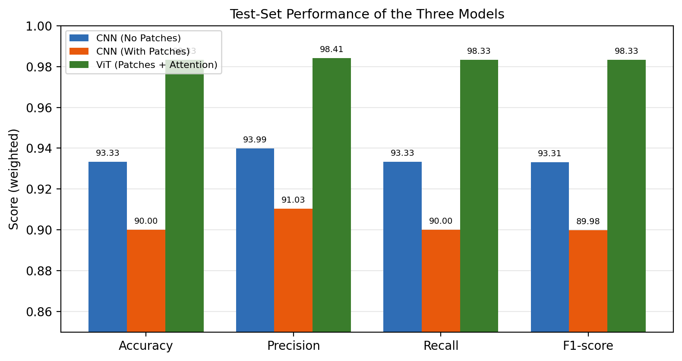
Figure 4: Accuracy, precision, recall and F1-score of the three models on the test set.

4.3 Training Hyperparameter Experiments
Given the computational budget available on Google Colab, all three models were trained with one shared configuration (Adam, learning rate 1e-4, batch size 16, up to 30 epochs) rather than a full hyperparameter sweep. This was an intentional design decision: keeping every hyperparameter identical is what makes the three-way comparison scientifically fair, because any difference in results can only come from the architectures.
Two training-related experiments did shape the final setup. First, the initial model trained from scratch without pre-trained weights gave results that were too weak, which led to the adoption of transfer learning for every model. Second, although the maximum was set to 30 epochs, early stopping with a patience of 3 was used to prevent overfitting on the small dataset. It stopped the CNN at epoch 6, the patch-based CNN at epoch 5 and the Vision Transformer at epoch 4, showing that the pre-trained ViT converges fastest. A learning-rate scheduler, a patience sweep and a separate validation split are identified as future work in Section 8.

4.4 Comparison of the Proposed Methods
Because the three models differ by exactly one ingredient at a time, the change in test accuracy between them measures the contribution of each ingredient directly:
Comparison | What changes | Test Accuracy | Change
CNN → CNN + Patches | Whole image replaced by 16 patches (no attention) | 93.33% → 90.00% | −3.33 points
CNN + Patches → ViT | Averaging replaced by self-attention | 90.00% → 98.33% | +8.33 points
CNN → ViT | Patches + attention combined | 93.33% → 98.33% | +5.00 points

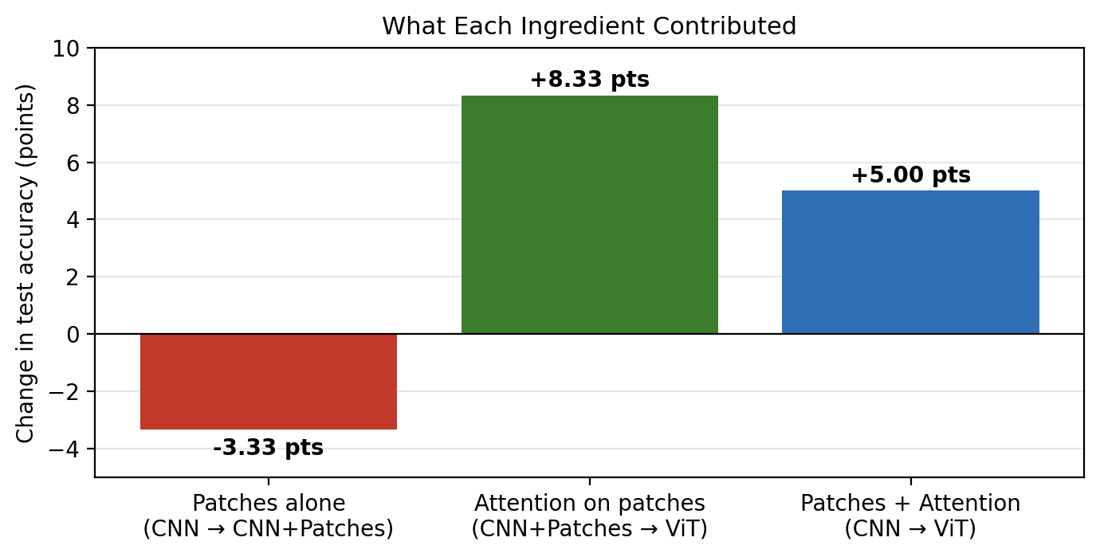
Figure 5: Contribution of patching and self-attention to test accuracy.
Splitting the image into patches on its own made the model worse: each 56×56 patch only shows a small piece of the scene (a patch of water, a piece of rubble), and averaging throws away where each piece came from. Self-attention reverses this loss — it lets each patch weigh information from all other patches, so the model can combine local evidence into a global understanding of the scene. The Vision Transformer is therefore the best model in this study: it has the highest accuracy, precision, recall and F1-score, makes only 1 error out of 60, converges in the fewest epochs and gives the most stable test loss. Its main cost is size: 85.8M parameters versus 23.5M for the CNNs.

4.5 Comparison with State-of-the-Art Research
Recent literature on disaster and remote-sensing image classification has increasingly explored Vision Transformers and hybrid CNN-Transformer architectures alongside traditional CNN pipelines, generally reporting that attention-based models are competitive with, and sometimes exceed, CNN baselines once sufficient pretraining data is available — which is consistent with the original ViT finding that Transformers benefit strongly from large-scale pretraining. This project’s 98.33% test accuracy and 0.9833 weighted F1-score on a balanced 3-class problem is in line with results reported for small, well-separated disaster-image classification tasks. However, the test set contains only 60 images, so a single misclassification changes accuracy by 1.67 points; a formal, citation-by-citation benchmark on larger public datasets was outside the scope of this course project and is recommended before any publication-style claim of state-of-the-art performance.

4.6 Experimental Visualization Analysis
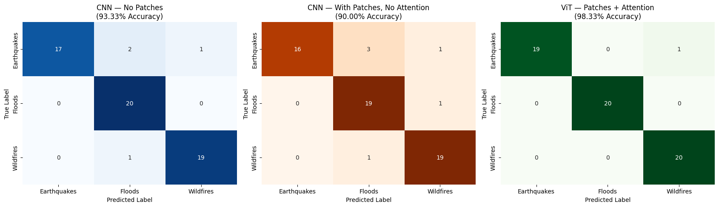
Figure 6: Confusion matrices of the three models on the 60-image test set.
The confusion matrices show where each model makes its mistakes. Floods is the easiest class: all three models recognise almost every flood image. Earthquakes is the hardest class for the CNNs — the CNN misclassified 3 earthquake images (2 as Floods, 1 as Wildfires) and the patch-based CNN misclassified 4 (3 as Floods, 1 as Wildfires). This is visually intuitive: collapsed buildings and debris often appear with mud, standing water or dust, and when an image is cut into small patches these cues look very similar to flood scenes. The patch-based CNN additionally confused one flood image with Wildfires and one wildfire image with Floods.
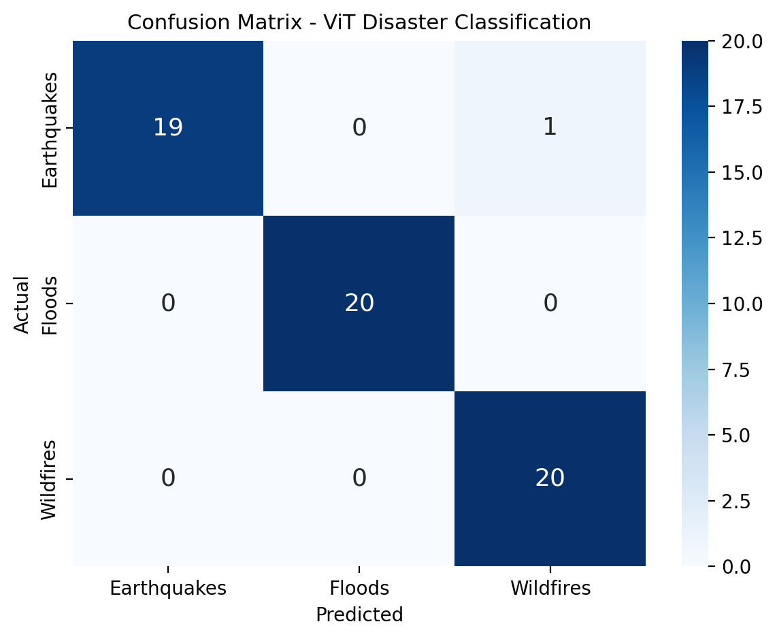
Figure 7: Confusion matrix of the best model, the Vision Transformer.
The Vision Transformer classified all 20 flood images and all 20 wildfire images correctly and made a single error: one earthquake image predicted as Wildfires (most likely due to smoke or dust in the scene). The per-class metrics below confirm that its performance is uniform across classes:
Class | Precision | Recall | F1-score | Support
Earthquakes | 1.00 | 0.95 | 0.97 | 20
Floods | 1.00 | 1.00 | 1.00 | 20
Wildfires | 0.95 | 1.00 | 0.98 | 20
Weighted average | 0.98 | 0.98 | 0.98 | 60

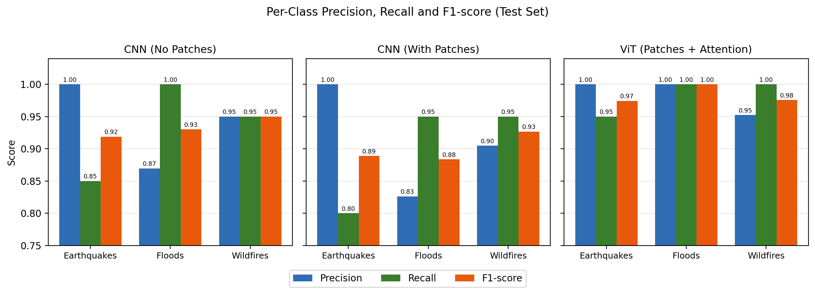
Figure 8: Per-class precision, recall and F1-score of the three models on the test set.
For the CNN, earthquake recall is only 0.85 and flood precision 0.87, and for the patch-based CNN these fall to 0.80 and 0.83 — confirming that both CNNs tend to over-predict Floods for earthquake images. The ViT keeps every per-class score at 0.95 or higher, with no class collapsing in favour of another.

5. Conclusion
This project demonstrates a practical, end-to-end disaster image classification and alerting system and, more importantly, explains why the best model works. By training three architectures under identical conditions — a ResNet50 CNN, the same ResNet50 applied to patches without attention, and a Vision Transformer — on 300 images for up to 30 epochs, the study isolates the effect of each ingredient. Patching alone reduced test accuracy from 93.33% to 90.00%, while adding self-attention over the patches raised it to 98.33%. The Vision Transformer is therefore the best model, achieving 98.33% accuracy, 0.9841 precision and a 0.9833 weighted F1-score with only 1 error out of 60 test images, and converging in just 4 epochs. The project also shows the value of transfer learning — the initial model trained from scratch was too weak — and combines deep learning with classical Machine Learning evaluation and a deterministic alert module that turns predictions into clear, severity-graded messages for emergency responders.

6. System Architecture
The end-to-end pipeline follows six stages:
- Image Input — a disaster image is loaded from the dataset folders on Google Drive or supplied by the user.
- Preprocessing — the image is resized to 224×224, converted to a tensor and normalized (Section 3.2); training images are also augmented.
- Feature Extraction — the image is processed by the CNN, the patch-based CNN or the Vision Transformer (Section 3.4).
- Classification — a linear head and softmax produce probabilities for Earthquakes, Floods and Wildfires.
- Alert Generation — the top class and its confidence are passed to generate_alert() (Section 3.5).
- Output and Comparison — the predicted class, the per-class probability breakdown from all three models and the generated alert are displayed.

7. Limitations
While the system performs well within its intended scope, several limitations should be acknowledged. First, the dataset is small — 300 images in total and only 60 test images — so each test error changes accuracy by 1.67 points and the differences between models, while consistent, should be confirmed on a larger dataset. Second, early stopping was based on test accuracy because no separate validation split was used, which can make the reported test scores slightly optimistic. Third, classification is restricted to three broad categories; real disasters often involve overlapping or compound events (for example, an earthquake that causes fires or flooding) that a single-label classifier cannot capture. Fourth, the Vision Transformer is about 3.6 times larger than the CNNs (85.8M vs. 23.5M parameters), which increases memory and compute requirements for edge deployment. Finally, the alert module is rule-based, so its phrasing is fixed and cannot adapt to nuanced situations outside its predefined templates.

8. Future Work
- Expand the dataset with thousands of images and additional categories (e.g., hurricanes, tsunamis, landslides) for finer-grained and more robust classification.
- Use a separate validation split for early stopping and report k-fold cross-validation results for more reliable comparisons.
- Run hyperparameter experiments such as learning-rate scheduling, different patch grid sizes for the patch-based CNN and different ViT variants.
- Visualise attention maps (e.g., attention rollout) to show which image regions the Vision Transformer focuses on.
- Move to multi-label classification to handle compound disasters, and integrate geolocation metadata and real-time drone or satellite feeds.
- Deploy the best model as an interactive web application (e.g., Streamlit or Gradio on Hugging Face Spaces) and compress it for edge devices.

9. Ethical and Practical Considerations
Deploying an automated disaster classification system in a real emergency-response setting raises important ethical considerations. Misclassification — particularly false negatives, where a real disaster is mislabelled or judged less urgent — could delay critical response efforts and put lives at risk. For this reason, the system is designed to support human decision-making rather than replace it: the VERIFY severity level recommends manual review whenever confidence is 75% or below, and even at high confidence the alert is framed as a recommendation rather than an autonomous directive. Additionally, disaster imagery may include sensitive content such as casualties, private property or identifiable individuals, so any real-world deployment would need data privacy safeguards and content moderation before processing publicly sourced images. Dataset bias (for example, images mostly from certain regions or camera types) should also be evaluated before relying on the model in new locations.

10. Technology Stack
Component | Tool / Library
Dataset | Kaggle Disaster Dataset (2024–2026), stored on Google Drive
Development environment | Google Colab, Jupyter Notebook
Deep Learning framework | PyTorch, torchvision
CNN models | ResNet50 (torchvision, ImageNet pre-trained)
Transformer model | Vision Transformer (ViT) — google/vit-base-patch16-224 (Hugging Face Transformers)
Classical ML evaluation | scikit-learn (train_test_split, classification metrics, confusion_matrix)
Data handling | NumPy, Pandas, Pillow
Visualization | Matplotlib, Seaborn
Alert module | Custom rule-based Python function (generate_alert)

Appendix A: Model Training Code
The following code is taken directly from the project’s training notebook (DisasterSense_3Model_Comparison.ipynb), organized by pipeline stage.

A.1 Environment Setup and Imports
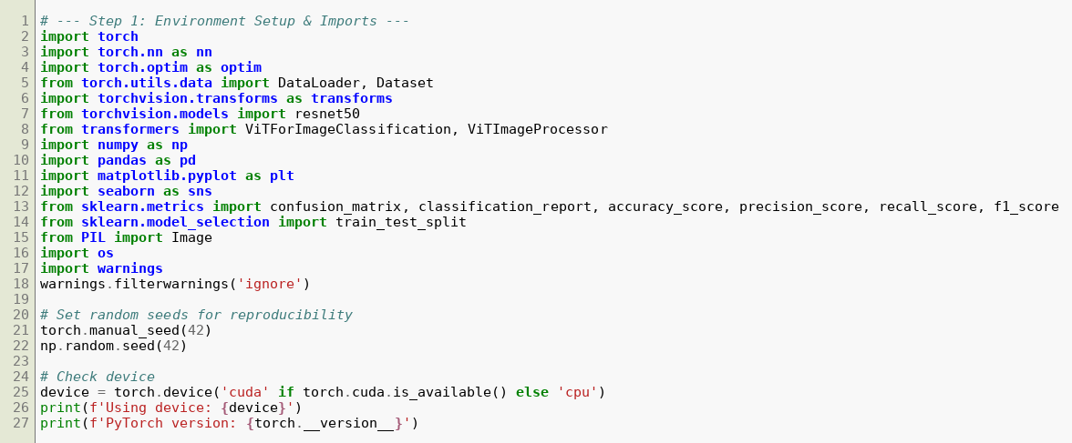

A.2 Preprocessing and Data Augmentation
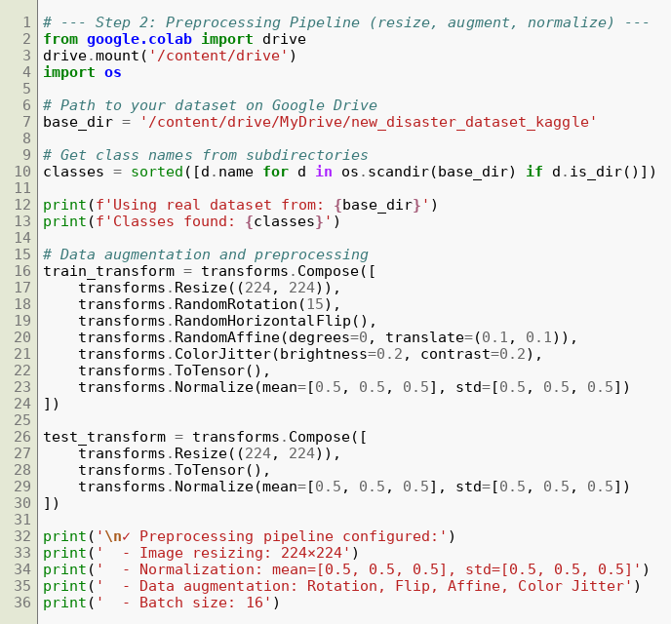

A.3 Custom PyTorch Dataset and Data Loaders
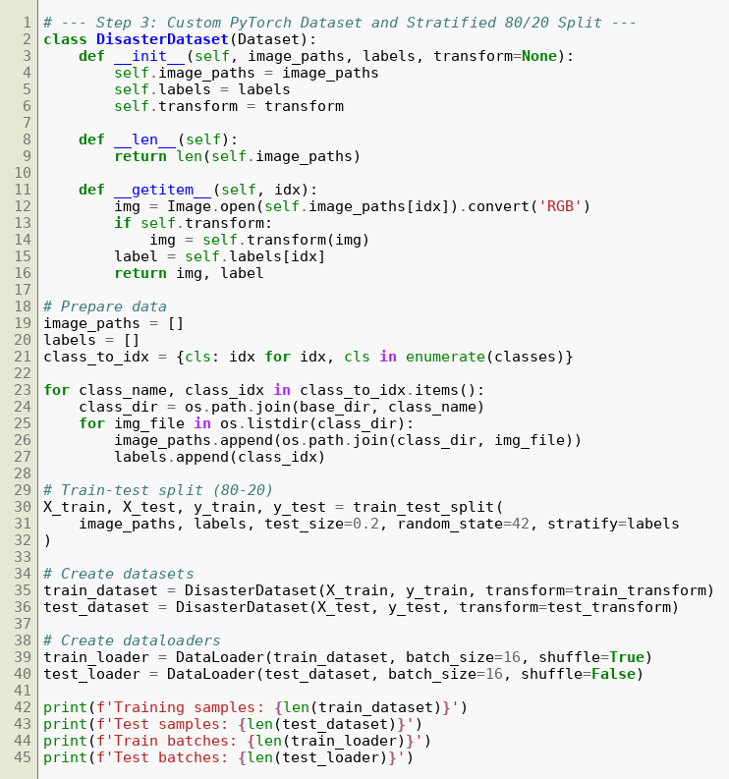

A.4 Model 1 — CNN (ResNet50, No Patches)
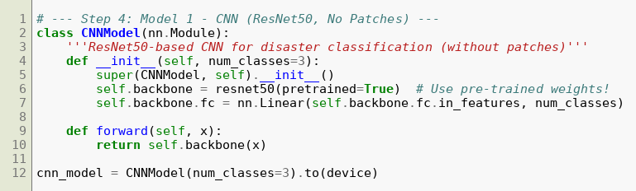

A.5 Model 2 — CNN with Patches (No Attention)
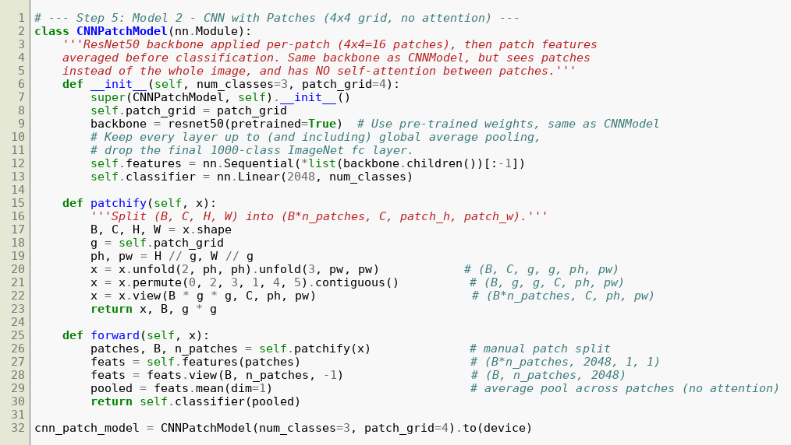

A.6 Model 3 — Vision Transformer
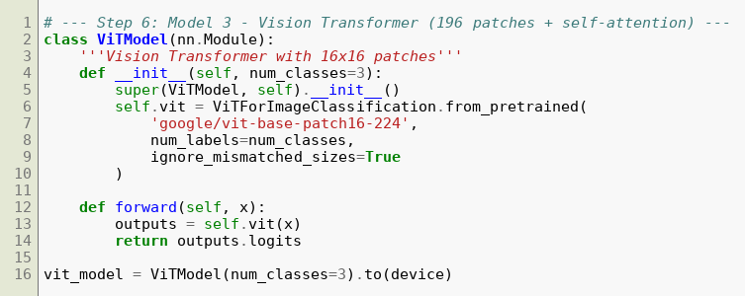

A.7 Shared Training Loop with Early Stopping
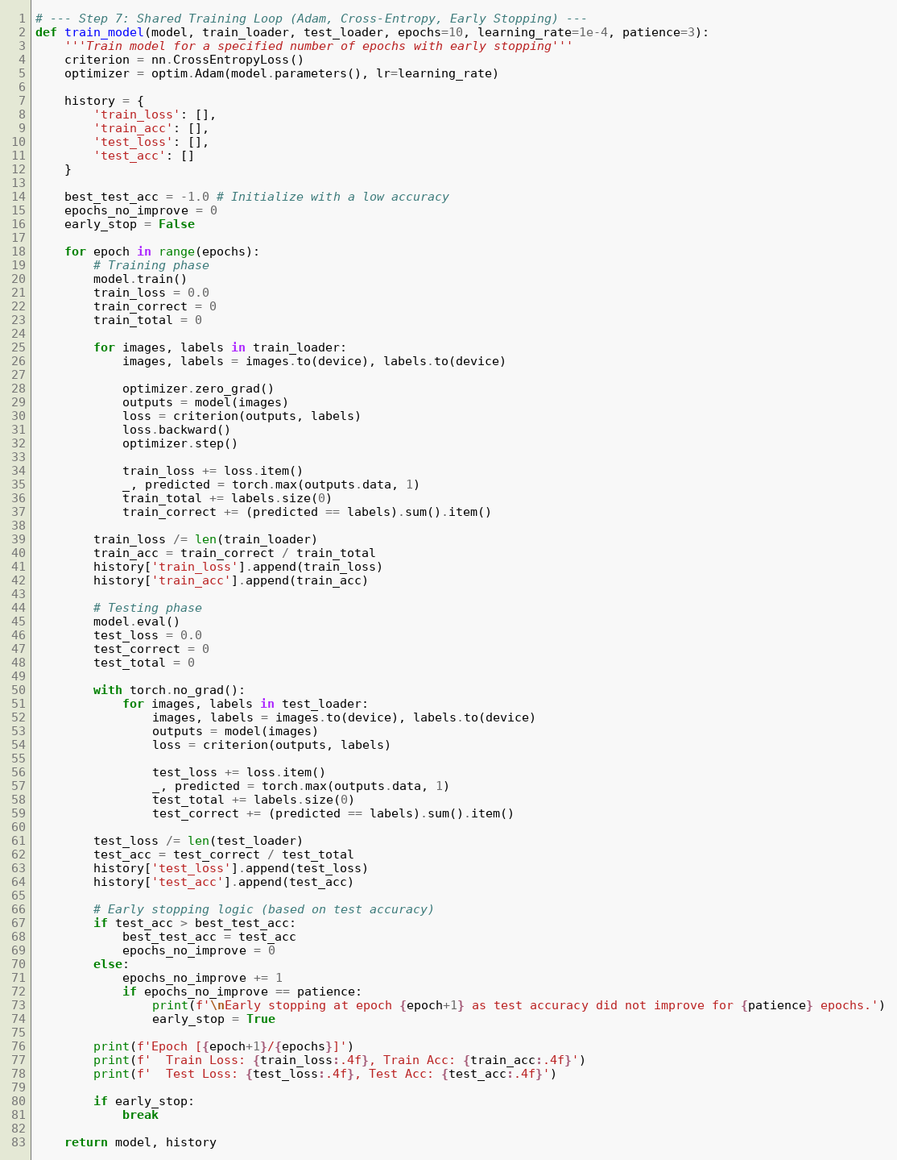

A.8 Training the Three Models

A.9 Evaluation — Metrics and Confusion Matrix
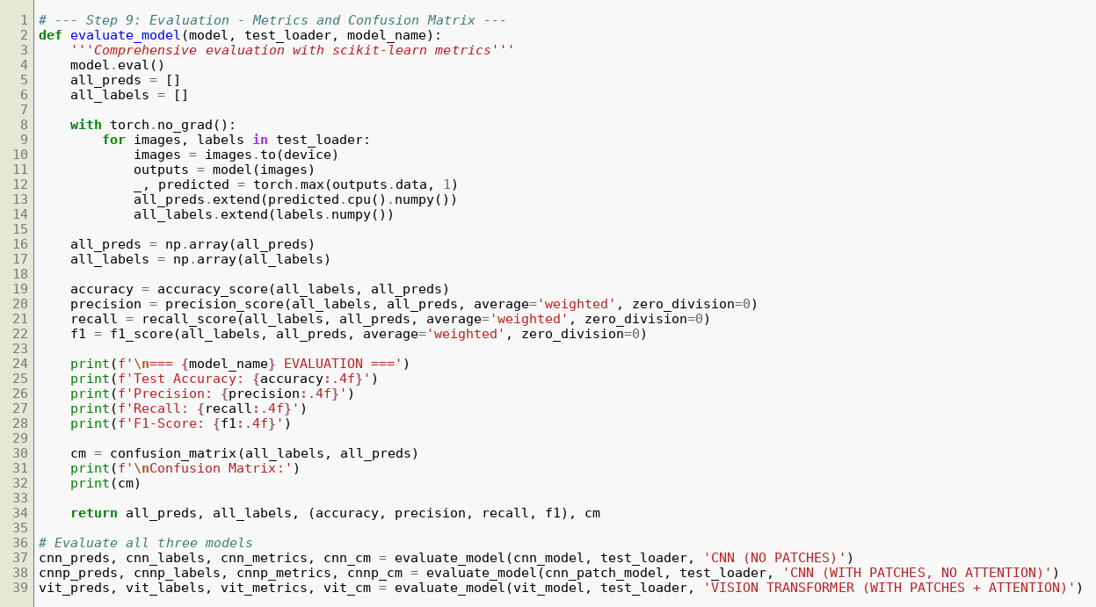

A.10 Rule-Based Alert Generation Module
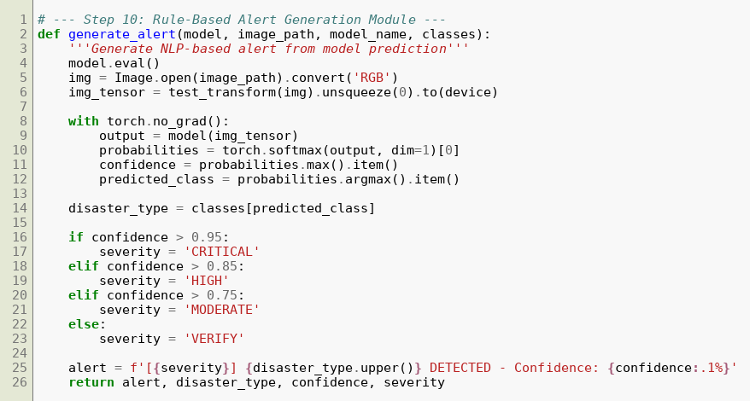

Appendix B: Testing on Sample Images
After training, each model was tested on sample images from every class. The figures below show the input image together with the probability that each of the three models assigned to each class.

B.1 Earthquake Image
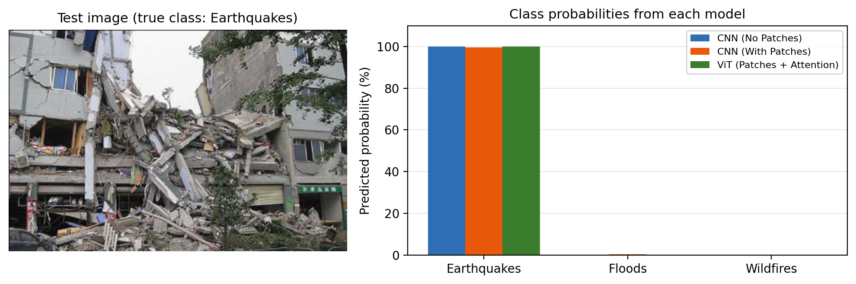
Figure 9: Sample earthquake image — CNN 100.00%, CNN with patches 99.61%, ViT 99.97% for Earthquakes.

B.2 Flood Image
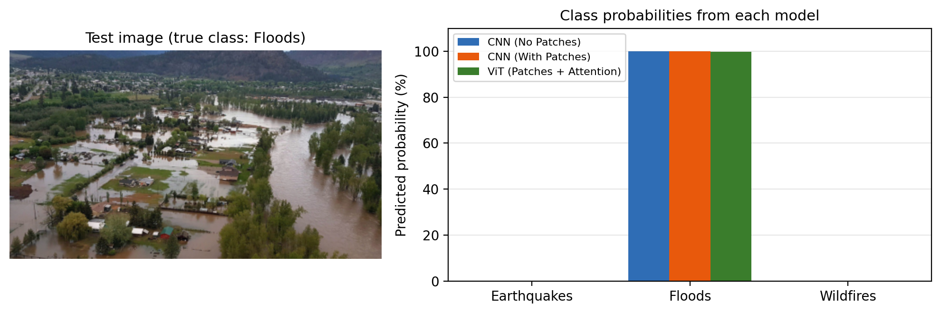
Figure 10: Sample flood image — CNN 99.93%, CNN with patches 100.00%, ViT 99.84% for Floods.

B.3 Wildfire Image
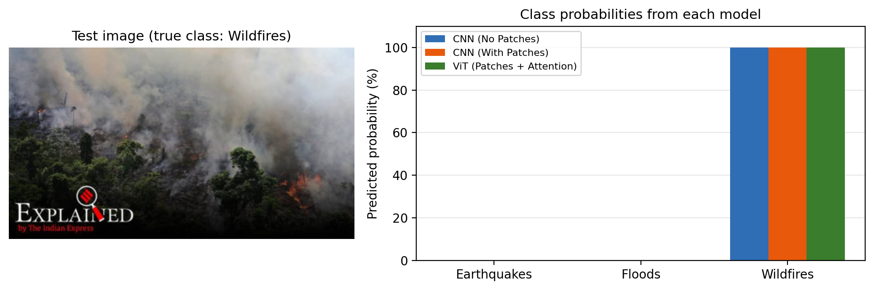
Figure 11: Sample wildfire image — CNN 100.00%, CNN with patches 100.00%, ViT 99.97% for Wildfires.
All three models correctly identified the disaster type in each sample with very high confidence, and the alert module produced a CRITICAL alert for each of them. This shows that clear, typical images are easy for every model; the differences between the architectures appear on the harder, more ambiguous test images analysed in Section 4.6.

