EXPERIMENT 1
ARDUINO UNO-BASED SMART HOME SAFETY AND OCCUPANCY MONITORING SYSTEM USING GAS, PIR AND ULTRASONIC SENSORS

Source Code
const int gasSensor = A0;
const int pirSensor = 2;
const int trigPin = 8;
const int echoPin = 9;
const int buzzer = 10;
const int led = 11;
long duration;
int distance;
int gasValue;
int motionState;
void setup() {
pinMode(pirSensor, INPUT);
pinMode(trigPin, OUTPUT);
pinMode(echoPin, INPUT);
pinMode(buzzer, OUTPUT);
pinMode(led, OUTPUT);
Serial.begin(9600);
}
void loop() {
gasValue = analogRead(gasSensor);
motionState = digitalRead(pirSensor);
digitalWrite(trigPin, LOW);
delayMicroseconds(2);
digitalWrite(trigPin, HIGH);
delayMicroseconds(10);
digitalWrite(trigPin, LOW);
duration = pulseIn(echoPin, HIGH);
distance = duration * 0.034 / 2;
if (gasValue > 500) {
digitalWrite(buzzer, HIGH);
digitalWrite(led, HIGH);
Serial.println("GAS ALERT!");
} else {
digitalWrite(buzzer, LOW);
digitalWrite(led, LOW);
Serial.println("SYSTEM SAFE");
}
if (motionState == HIGH) {
Serial.println("OCCUPANCY DETECTED");
}
Serial.print("Gas Level: ");
Serial.println(gasValue);
Serial.print("Distance: ");
Serial.print(distance);
Serial.println(" cm");
delay(1000);
}

Prototype Output – Arduino / Proteus Simulation
The screenshot below shows the prototype simulation and virtual terminal output supplied for this experiment.
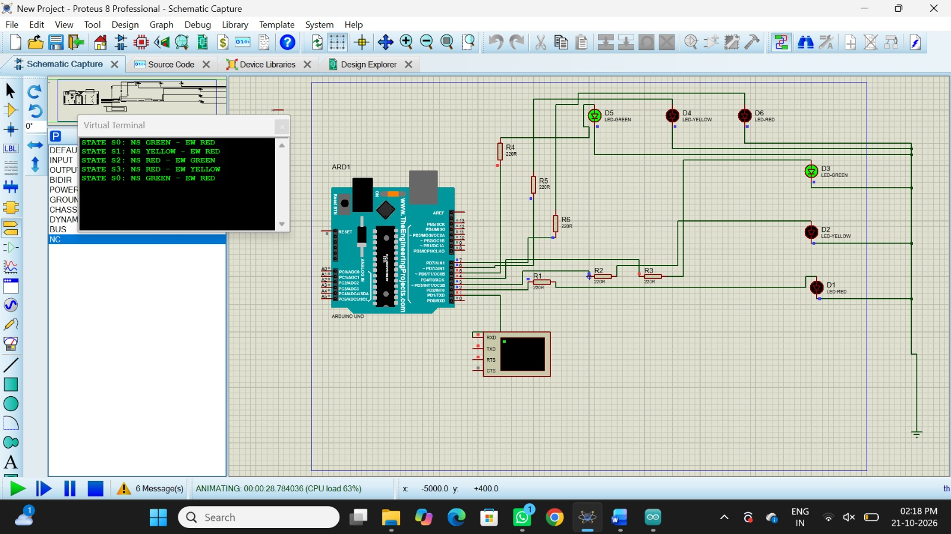
Figure 1: Arduino Uno prototype with LED indicators and virtual terminal status messages.

Reflection
This experiment demonstrates how an Arduino Uno can monitor gas levels, motion, and distance using connected sensors. The virtual terminal displays system status messages, while the LEDs and buzzer provide visual and audible alerts.

