[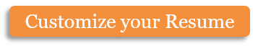](https://www.myperfectresume.com/membership/RegisterGuestUser.aspx?wizard=true&productid=17&utm_source=hloom-com&utm_medium=referral&utm_campaign=word-template)

Address:

Skype

Website:

(Name)

(Position)

Contant Info

Work

|  |
| --- |
|  |

Education

|  |
| --- |
|  |

Reference

Skills

|  |  |
| --- | --- |
|  |  |