**PORTABLE SELF-ASSESSMENT AUDIOMETER USING RASPBERRY PI**

**19ECPN6401**

**MINI PROJECT REPORT**

***Submitted by***

**ADHIL.M 727622BEC114**

**PRANESH .S 727622BEC018**

**NAVEEN.S 727622BEC110**

*In partial fulfillment for the requirement for the award of the degree of*

## BACHELOR OF ENGINEERING

### In

ELECTRONICS AND COMMUNICATION ENGINEERING

**Dr. MAHALINGAM COLLEGE OF**

**ENGINEERING AND TECHNOLOGY**

**An Autonomous Institution**

**Affiliated to ANNA UNIVERSITY**

**CHENNAI – 600 025**

## MAY-2024.

Dr. MAHALINGAM COLLEGE OF ENGINEERING AND TECHNOLOGY, POLLACHI -642 003

### (An Autonomous Institution Affiliated to Anna University, Chennai - 600 025)

**BONAFIDE CERTIFICATE**

Certified that this Mini project report titled **“PORTABLE SELF-ASSESSMENT AUDIOMETER USING RASPBERRY PI”** is the bonafide work of

**ADHIL.M 727622BEC114**

**PRANESH .S 727622BEC018**

**NAVEEN.S 727622BEC110**

who carried out the mini project under my supervision.

|  |  |
| --- | --- |
| **Dr.R.Sudhakar,M.E.,Ph.D**  **HEAD OF THE DEPARTMENT**  Department of ECE  Dr. Mahalingam College of Engineering and Technology Pollachi- 642003 | **Mr.A.Shafeek M.E., Assistant Professor (SS)**  **SUPERVISOR**  Department of ECE  Dr. Mahalingam College of Engineering and Technology Pollachi- 642003 |

Submitted for the Autonomous End Semester Mini Project Examination held on 22/05/2024.

|  |  |
| --- | --- |
| **INTERNAL EXAMINER** | **EXTERNAL EXAMINER** |

Dr. MAHALINGAM COLLEGE OF ENGINEERING AND TECHNOLOGY, POLLACHI -642 003

### (An Autonomous Institution Affiliated to Anna University, Chennai - 600 025)

**TECHNOLOGY READINESS LEVEL (TRL) CERTIFICATE**

**Project Title:** Portable Self-Assessment Audiometer Using

Raspberry Pi

**Course Code:** 19ECPN6401- Mini Project

**ADHIL.M 727622BEC114 PRANESH .S 727622BEC018 NAVEEN.S 727622BEC110**

**Guide Name:** Mr.A.Shafeek M.E., AP(SS)/ECE

### Technology Readiness Level* (TRL) of this Project: TRL 06

**Prototype System Verified** (System/process prototype demonstration in an operational environment)

**SIGNATURE OF THE GUIDE HOD**

**INTERNAL EXAMINER EXTERNAL EXAMINER**

**ABSTRACT**

People with hearing impairments often face irreversible damage. To determine the extent of hearing loss across different frequencies in each ear, a hearing screening test is used. However, traditional audiometers require an audiologist to conduct the test, which can be time- consuming and expensive for the individual. This study aims to create a new portable audiometer for self-assessment of hearing.

The portable audiometer consists of a computer, Raspberry Pi 3 B+, patient response button, and headphones. Sound signals are delivered to the patient through the headphones, and the patient responds using the left mouse button. Based on the patient's responses, an automatic audiogram is generated, showing the relationship between frequency and intensity, which indicates the volume of sound pressure.

The results, including the audiogram and raw data, are saved in CSV files named with the time and date of the test. The efficient Hughson Westlake procedure, which is less time- consuming, is implemented in Python, a popular open-source programming language, to obtain the audiogram. Using Python helps reduce software development cos

## ACKNOWLEDGEMENT

We wish to express our sincere thanks to all who have contributed to do this project through their support, encouragement and guidance.

We extend our gratitude to our management for having provided us with all facilities to build my project successfully. We express our sincere thanks to our honourable Secretary, **Dr.C.Ramaswamy, M.E., Ph.D., F.I.V.,** for providing the required amenities.

We take this opportunity to express our deepest gratitude to our principal **Dr.P.Govindhasamy, M.Tech., Ph.D.,** who provide suitable environment to carry out the project.

We express our extreme gratefulness to **Dr.R.Sudhakar, M.E., Ph.D.,** Professor and Head of the department of Electronics and Communication Engineering, for his constant support and encouragement.

We wish to express our deep sense of gratitude and thankfulness to my project guide **Mr.A.Shafeek,M.E.,** for the valuable suggestion and guidance offered during the course of the project.

Finally, we are committed to place our heartfelt thanks to all those who had contributed directly and indirectly towards the success of the completion of this project.

**TABLE OF CONTENTS**

|  |  |  |
| --- | --- | --- |
| **S.NO** | **CHAPTER** | **PG.NO** |
|  | **ABSTRACT** | **I** |
|  | **ACKNOWLEDGEMENT** | **II** |
|  | **TABLE OF CONTENT** | **III** |
|  | **LIST OF FIGURES** | **V** |
|  | **LIST OF TABLES** | **VII** |
|  | **LIST OF ABBRIVATIONS** | **VIII** |
| **1** | **INTRODUCTION** | **1** |
|  | 1.1 INTRODUCTION | 1 |
|  | 1.2. MOTIVATION | 2 |
|  | 1.3 OVERVIEW | 2 |
| **2** | **LITERATURE REVIEW** | **3** |
| **3** | **PROBLEM STATEMENT** | **5** |
|  | 3.1. BENEFITS OF THE PROJECT | 5 |
| 4. | **OBJECTIVE OF THE PROJECT** | **6** |
|  | 4.1. PURPOSE OF PURE TONE AUDIOMETER | 6 |
| **5** | **SELF-ASSESSMENT AUDIOMETER** | **7** |
|  | 5.1 INTRODUCTION | 7 |
|  | 5.2. PORTABLE AUDIOMETER UTILIZING RASPBERRY PI | 7 |
|  | 5.3. AUDIOGRAM | 7 |
|  | 5.4. STAGES OF HEARING LOSS | 8 |
|  | 5.5. APPLICATION | 8 |
| 6. | **EXISTING VS PROPOSED SELF-ASSESSMENT AUDIOMETERS** | **9** |
|  | 6.1 PORTABLE AUDIOMETER VS AUDIOMETER | 9 |
|  | 6.2. PORTABLE AUDIOMETER VS MOBILE HEARING TEST | 10 |
|  | 6.3. FEATURES | 11 |
| **7** | **BLOCK DIAGRAM** | **12** |
| **8** | **IMPLEMENTATION OF HARWARE MODULES** | **15** |
|  | 8.1 INTRODUCTION | 15 |
|  | 8.2. RASPBERRY PI | 15 |
|  | 8.2.1. FEATURES OF RASPBERRY PI | 16 |
|  | 8.2.2. RASPBERRY PI GPIO’S PIN | 16 |
|  | 8.3. RASPBERRY PI CASE | 17 |

|  |  |  |
| --- | --- | --- |
|  | 8.4. MOUSE | 17 |
| 8.5. HEADPHONE | 17 |
| 8.5.1. TDH 49 HEADPHONE CHARACTERISTICS | 18 |
| 8.6. ETHERNET CABLE | 19 |
| 8.7. POWER SUPPLY | 19 |
| **9** | **SOFTWARE IMPLEMENTATION** | **20** |
|  | 9.1 INTRODUCTION | 20 |
|  | 9.2. RASPBERRY PI OS (RASPBIAN) | 20 |
|  | 9.3. VNC: REMOTE ACCESS A RASPBERRY PI | 21 |
| **10.** | **VALIDATION AND FEEDBACK: MEETING WITH ENT DOCTOR** | **22** |
|  | 10.1. INTRODUCTION | 22 |
|  | 10.2. CONSULTING WITH THE DOCTOR | 22 |
|  | 10.3 TESTING SELF-ASSEMBLED PURE TONE AUDIOMETER | 23 |
|  | 10.4 FEEDBACK AND CONCLUSION | 23 |
| **11.** | **MEETING WITH AUDIOLOGIST BALACHANDRAN** | **24** |
|  | 11.1. INTRODUCTION | 24 |
|  | 11.2. MEETING WITH AUDIOLOGIST BALACHANDRAN | 24 |
|  | 11.3 KEY FEEDBACK FROM AUDIOLOGIST | 25 |
|  | 11.4. EXPLORATION AND FUTURE SCOPE | 26 |
| **12** | **RESULTS** | **27** |
|  | 12.1 INTRODUCTION | 27 |
|  | 12.2 TESTING OF FINAL WORKING MODEL | 27 |
|  | 12.3 RESULT ANALYSIS | 27 |
| **13** | **CONCLUSION & FUTURE SCOPE** | **30** |
| **14** | **BIBLIOGRAPHY** | **31** |
| **15** | **APPENDIX** | **32** |
|  | **PLAGIARISM REPORT** | **36** |

**LIST OF FIGURES**

|  |  |  |  |
| --- | --- | --- | --- |
| **S NO** | **FIGURES** | **TOPIC** | **PAGE NO** |
| 1. | 1.1 | PURE TONE AUDIOMETRY (PTA) | 2 |
| 2. | 5.3 | STAGES OF HEARING LOSS | 8 |
| 3. | 5.4 | AUDIOGRAM | 8 |
| 4. | 6.1.1 | PORTABLE AUDIOMETER | 9 |
| 5. | 6.1.2 | AUDIOMETER | 9 |
| 6. | 6.2.1 | PORTABLE SELF ASSESSMENT AUDIOMETER | 10 |
| 7. | 6.2.2 | MOBILE HEARING TEST | 10 |
| 8. | 7.1 | Block Diagram | 12 |
| 9. | 8.2 | RASPBERRY PI | 15 |
| 10.. | 8.2.1 | PIN DESCRIPTION OF RASPBERRY PI | 16 |
| 11. | 8.2.2 | RASPBERRY PI GPIO’S PIN LAYOUT | 16 |
| 12 | 8.3 | RASPBERRY PI CASE | 17 |
| 13 | 8.4 | MOUSE | 17 |
| 14. | 8.5 | HEADPHONE | 18 |
| 15. | 8.5.1 | TDH 49=Headphone | 18 |
| 16. | 8.6 | ETHERNET CABLE: | 19 |

|  |  |  |  |
| --- | --- | --- | --- |
| 17 | 8.7 | POWER ADAPTER | 19 |
| 18. | 9.2 | INSTALLING RASPBIAN. | 20 |
| 19. | 9.2.1 | THE RASPBERRY PI DESKTOP. | 21 |
| 20. | 9.3 | VNC: REMOTE ACCESS TO A RASPBERRY | 21 |
| 21. | 10.2 | CONSULTING WITH THE DOCTOR | 22 |
| 22. | 11.2 | CONSULTING WITH THE AUDIOLOGIST | 24 |
| 23. | 11.3 | AUDIOMETRY TEST | 25 |
| 24. | 12.2 | OVERALL INITIALIZATION PURE TONE AUDIOMETER | 27 |
| 25. | 12.3.1 | PYTHON CODE IN THONNY IDE | 28 |
| 26. | 12.3.2 | INSTRUCTION OF THE PROJECT | 28 |
| 27. | 12.3.3 | PATIENT RESPONSE OF THE AUDIOMETER | 28 |
| 28. | 12.3.4 | OUTPUT OF THE AUDIOGRAM CHART | 29 |
| 29. | 12.3.5 | PORTABLE SELF ASSESSMENT AUDIOMETER | 29 |
| 30. | 16 | PLAGIARISM REPORT | 36 |

**LIST OF TABLES**

|  |  |  |  |
| --- | --- | --- | --- |
| **S NO** | **TABLE** | **TOPIC** | **PAGE NO** |
| 1. | 6.1 | Existing vs proposed self-assessment audiometers | **9** |
| 2. | 6.2. | Portable Audiometer (Raspberry Pi) Vs Mobile Hearing Test | **10** |
| 3. | 12.3 | Result analysis | **29** |

**LIST OF ABBRIVATIONS**

1. HA - Hearing aid
2. SNHL - Sensorineural hearing loss
3. WNL - Within normal limits
4. AU - Both sides (ears)
5. AS - Left
6. AD - Right
7. BC - Bone conduction
8. AC - Air conduction
9. PTA - Pure-tone average
10. UCL - Uncomfortable loudness level
11. MCL - Most comfortable loudness level
12. HFA - High frequency average
13. HL - Hearing level
14. SRT - Speech reception threshold
15. SAT - Speech awareness threshold

**CHAPTER - 1 INTRODUCTION**

## INTRODUCTION

Hearing impairment is a widespread chronic condition affecting adults globally, especially as they age, particularly at frequencies exceeding 2000 Hz. According to the World Health Organization (WHO), approximately 466 million people worldwide are affected by hearing loss, with 75% residing in developing nations. Factors such as prolonged exposure to loud noises, aging, tumors, illnesses, and ototoxic medications contribute to hearing loss, which may occur alone or alongside tinnitus. Though not fatal, hearing loss can lead to depression, communication difficulties, decreased functional abilities, and social isolation. Detecting and treating hearing loss early is crucial to enhance the quality of life for older adults dealing with hearing impairment.

Research conducted in the United Kingdom found that individuals who identified their hearing loss early and consistently used hearing aids experienced greater benefits compared to those who delayed using hearing aids until later stages of the condition. Therefore, it is essential to conduct hearing screening tests in the early stages to minimize the impact of hearing loss on individuals' lives. Hearing levels are typically evaluated across frequency ranges centered at 125Hz, 250 Hz, 500 Hz, 1 kHz, 2 kHz, 4 kHz, and 8 kHz. Although the human hearing range is commonly stated as 20 to 20,000 Hz, variations can occur, especially at higher frequencies.

Audiometers are instruments used to assess hearing capacity, often employing pure tone audiometry (PTA) testing, where individuals respond to presented pure tones. Traditionally, audiologists administer these tests in soundproof booths, necessitating patient visits to clinics, which may be inconvenient, especially for elderly individuals with mobility issues. During the test, patients wear sound-isolating headphones, and tones ranging from 125 Hz to 8 kHz are played at different intensities to determine hearing thresholds. The intensity level is adjusted to reach the patient's threshold, following the Hughson Westlake ascending method. While traditional audiometers are precise, they are costly and time-consuming.

## MOTIVATION

The motivation for developing the portable self-assessment audiometer arises from the need to overcome limitations of traditional testing methods. This includes improving accessibility, reducing costs, and enhancing convenience, especially for those in remote areas. By leveraging technology and affordability, the project aims to democratize hearing healthcare, empowering individuals to monitor their hearing health easily and effectively. The device's user-friendly design and data storage capabilities further support its role in facilitating early detection and intervention, ultimately improving outcomes and quality of life for individuals with hearing impairments.

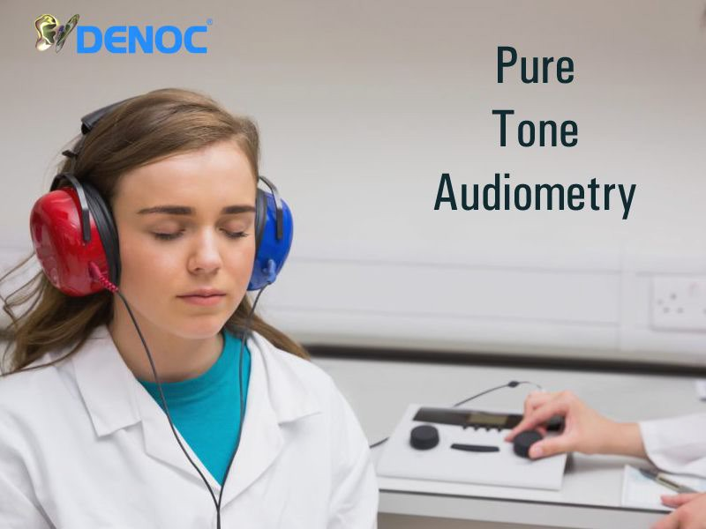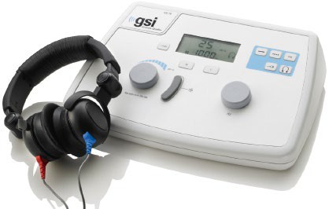

**Fig 1.1** Pure Tone Audiometry (PTA)

## 1.3. OVERVIEW

The project aims to develop a Portable Audiometer for Hearing Self-Assessment, addressing the limitations of traditional audiometry in terms of accessibility, cost, and time. Utilizing a Raspberry Pi 3 B+, Python, and audio hardware, the audiometer allows individuals to independently assess their hearing in a cost-effective and user-friendly manner.

The hardware includes a Raspberry Pi 3 B+, a mouse for user interaction, and headphones for audio output. The Raspberry Pi generates pure tone signals at various frequencies and intensity levels. The Python software manages signal generation, user interaction, response recording, and data analysis.

The audiometer tests both ears by playing pure tone signals at different frequencies and intensity levels, with users responding via mouse clicks. It employs the modified Hughson Westlake procedure to adjust signal intensity based on user responses.

**CHAPTER -2 LITERATURE REVIEW**

## 2.1 INTRODUCTION

This research addresses the need for accessible hearing assessments. Traditional audiometry is costly and inaccessible for many. To overcome this, we developed a portable self-assessment audiometer using Raspberry Pi technology. This innovation empowers individuals, especially in underserved communities, to monitor their hearing health independently. Rigorous testing aims to prove its effectiveness in enhancing accessibility and inclusivity in hearing healthcare.

## 2.2. METHODOLOGY

1. **“A NOVEL RASPBERRY PI-3 BASED PURE TONE AUDIOMETER AND VERIFICATION OF CALIBRATION WITH STANDARD SYSTEM”**

M. Dharani Kumar Chowdhary, Dr. C. Nagaraja, Dr. C. Sandeep Kumar Reddy, and Dr. Srinivasarao Udara developed "A Novel Raspberry Pi-3 Based Pure Tone Audiometer and Verification of Calibration with Standard System." This device uses a sound card and headphones to generate tones at various frequencies and intensities, similar to traditional audiometers, with users indicating when they hear the tones. Calibration verification against standard audiometers is crucial to ensure accuracy.This portable and cost-effective audiometer could improve access to hearing screenings in resource-limited areas and help individuals monitor their hearing health at home, though professional diagnosis is still necessary.

## “DEVELOPMENT OF HEARING SELF-ASSESSMENT PURE TONE AUDIOMETER”

Marwa Gargouri, Mondher Chaoui, and Patrice Wira present a study on the "Development of Hearing Self-Assessment Pure Tone Audiometer." They address the global impact of hearing loss with an innovative, cost-effective, and accessible solution. Their portable audiometer uses Raspberry Pi technology, a computer, a patient response button, and headphones for self-administered tests. Implementing the Hughson Westlake procedure in

Python, it automatically generates audiograms. This method reduces the time and cost of traditional audiometry, benefiting the elderly and underserved populations. The study highlights the importance of early detection and intervention in hearing impairment, enhancing accessibility through innovative technology and open-source software.

1. **HEARTHAT? - AN APP FOR DIAGNOSING HEARING LOSS**

Silvia Figueira, Kevin Nguyen, and Shweta Panditrao's project, "HearThat? - An App for Diagnosing Hearing Loss," highlights the potential of smartphone applications in healthcare. Their work parallels our project by leveraging technology to improve accessibility and efficiency in diagnosing hearing loss. The app exemplifies innovative mobile health solutions, emphasizing the importance of accessible and user-friendly tools in healthcare. Their insights contribute to the broader effort to use technology to empower individuals and enhance healthcare outcomes.

1. **"PORTABLE AUDIOMETER FOR DETECTING HEARING DISORDER AT AN EARLY STAGE FOR CANCER PATIENTS**

In their work presented at the 2016 International Conference on Automatic Control and Dynamic Optimization Techniques, Ritu Rani and H.T. Patil introduced a "Portable audiometer for detecting hearing disorder at an early stage for cancer patients." This innovative device signifies a multifaceted approach to healthcare, emphasizing the significance of early detection in managing health conditions. By focusing on cancer patients, the research addresses the often- overlooked aspect of hearing impairment resulting from cancer treatments or related complications. The development of a portable audiometer tailored to this specific demographic underscores the importance of personalized medical solutions and the integration of technology into healthcare delivery. This project likely involved the design and validation of a specialized diagnostic tool capable of early detection, thereby highlighting the intersection of medical research, technology, and patient care.

**CHAPTER – 3 PROBLEM STATEMENT**

Traditional audiometric testing methods present barriers to individuals seeking to assess their hearing health, including limited accessibility, high costs, and inconvenience. Particularly challenging for those in remote areas, these methods often result in delays in diagnosis and intervention. To address these issues, there is a pressing need for a portable self-assessment audiometer. This device must be affordable, user-friendly, and capable of providing accurate assessments without professional oversight.

Additionally, it should offer convenient data storage and analysis for collaboration with healthcare professionals. The challenge is to design and implement a portable audiometer that democratizes access to hearing healthcare, empowering individuals to monitor and manage their hearing health effectively. It must be cost-effective, portable, easy to use, and capable of delivering accurate results, ultimately improving outcomes for individuals with hearing impairments.

## BENEFITS OF THE PROJECT

Developing a portable self-assessment audiometer offers several benefits:

* + 1. **Accessibility:** Provides easy access to hearing assessments, especially in remote areas.
    2. **Cost-Effectiveness:** Utilizes affordable components and open-source software, reducing costs.
    3. **Convenience**: Allows users to conduct tests at their convenience, avoiding clinic visits.
    4. **Early Detection**: Facilitates early detection of hearing issues for timely intervention.
    5. **Empowerment**: Enables individuals to monitor and manage their hearing health regularly.
    6. **Portability:** Allows testing in various settings, including homes, schools, workplaces, and community centers.

**CHAPTER – 4 OBJECTIVE OF THE PROJECT**

The project endeavors to create a Portable Audiometer for Hearing Self-Assessment, leveraging Raspberry Pi, Python programming, and audio hardware. Its goal is to address the drawbacks of traditional audiometry by providing a budget-friendly, easy-to-use solution for self-directed hearing evaluation. By producing pure tone signals and integrating a modified version of the Hughson Westlake procedure, individuals can react to audible tones by clicking the mouse.

The gathered data will undergo analysis to ascertain hearing thresholds and produce audiograms, visually depicting hearing levels. Ultimately, the aim is to improve the accessibility of hearing screening, facilitating early identification and management of hearing impairment

## PURPOSE OF PURE TONE AUDIOMETER

* + 1. Assess hearing abilities accurately.
    2. Diagnose various types and degrees of hearing loss.
    3. Plan appropriate treatments, such as hearing aids or surgery.
    4. Monitor changes in hearing sensitivity over time.
    5. Screen for occupational and clinical hearing health.
    6. Contribute to research and education in audiology

**CHAPTER – 5**

**SELF-ASSESSMENT AUDIOMETER**

## 5.1 INTRODUCTION

The self-assessment audiometer project aims to revolutionize hearing screening with a user-friendly solution. Traditional audiometry is often time-consuming and costly, requiring audiologists. This project develops an innovative audiometer that allows individuals to independently monitor their hearing health, eliminating the need for specialized professionals.

## PORTABLE AUDIOMETER UTILIZING RASPBERRY PI

Central to the project is the development of a portable audiometer powered by Raspberry Pi technology. The Raspberry Pi serves as the core computing platform, offering a versatile and cost-effective solution for audiometric testing. Leveraging its computational capabilities, the audiometer can generate pure tones across various frequency ranges and deliver them to the patient via headphones. The portability of the device ensures flexibility in conducting assessments in diverse settings, from clinical environments to remote or home- based settings.

## AUDIOGRAM

An audiogram serves as a visual representation depicting an individual's hearing capacity across different frequencies and levels of intensity. It holds significant importance in audiology for evaluating and diagnosing hearing impairments. Typically, the graph illustrates frequencies ranging from low to high along the horizontal axis (x-axis), measured in Hertz (Hz), and sound intensity or volume along the vertical axis (y-axis), measured in decibels (dB).

The results of audiograms are derived from a series of tests wherein the individual responds to various tones or sounds. The audiologist documents the faintest sound audible to the person at each frequency, forming a profile of hearing thresholds. Offering insights into the type, severity, and pattern of hearing loss, the audiogram assists audiologists in devising appropriate interventions, such as recommending hearing aids or other necessary measures.

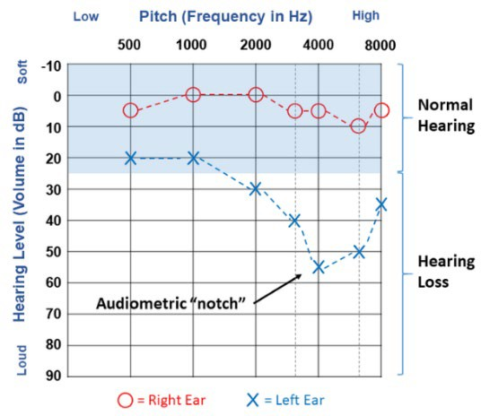 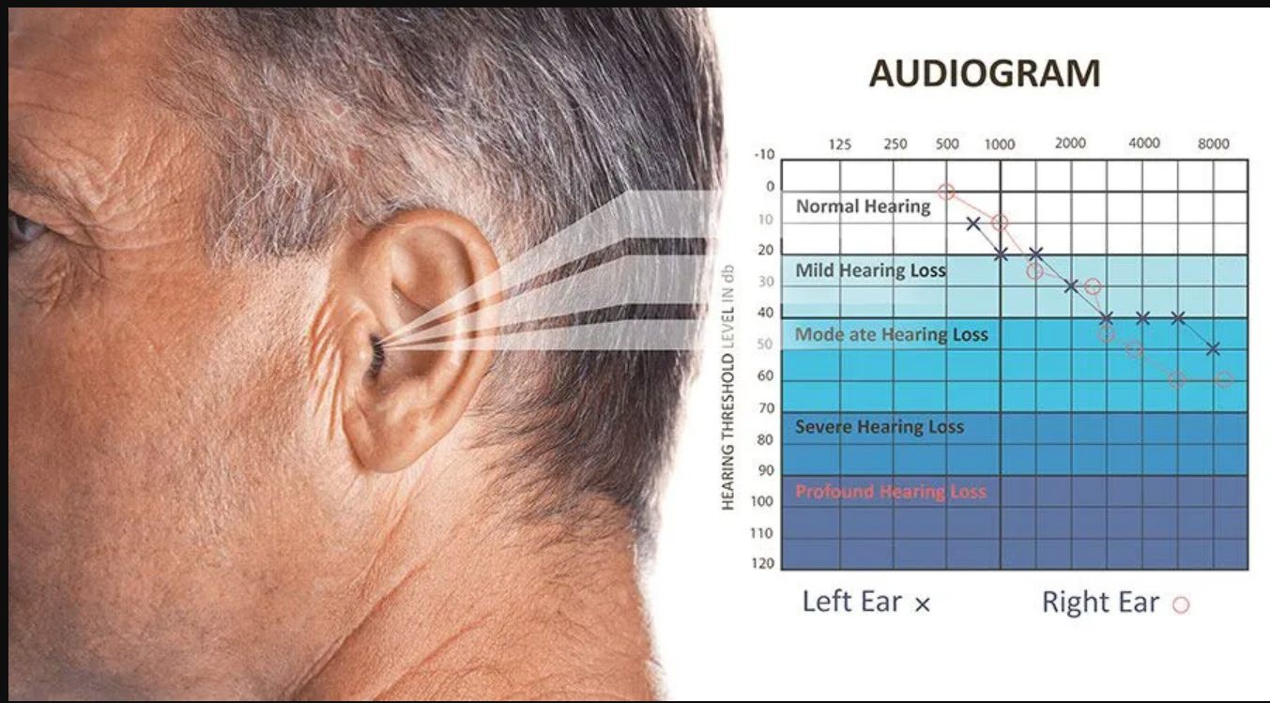

Fig 5.3. Audiogram Fig 5.4. Stages of hearing loss

## STAGES OF HEARING LOSS

* + 1. **Normal (0-25 dB):** Can perceive faint sounds, whispers, and speech clearly.
    2. **Mild (26-40 dB):** Difficulty hearing soft or distant speech, especially in noise.
    3. **Moderate (41-55 dB):** Effort needed to understand conversation, especially in noise.
    4. **Moderately Severe (56-70 dB):** Struggles with speech without assistance like hearing aids.
    5. **Severe (71-90 dB):** Limited ability to understand speech without amplification; may rely on sign language.
    6. **Profound (>90 dB):** Very limited or no hearing without aids or implants; heavily reliant on visual cues.

## APPLICATION

* + 1. **Hearing Assessment**: They accurately assess hearing sensitivity, aiding in diagnosis and classification of hearing loss.
    2. **Treatment Monitoring**: Audiometers help monitor treatment effectiveness, such as hearing aid usage.
    3. **Screening**: They're used for occupational and clinical hearing screenings.
    4. **Research and Education**: Audiometers support research and education in audiology

**CHAPTER - 6**

**EXISTING VS PROPOSED SELF-ASSESSMENT AUDIOMETERS**

* 1. **EXISTING VS PROPOSED SELF-ASSESSMENT AUDIOMETERS**

|  |  |  |
| --- | --- | --- |
| **FEATURE** | **PORTABLE SELF-ASSESSMENT AUDIOMETER** | **TRADITIONAL AUDIOMETER** |
| **PICTURE** | Fig 6.1.1 PORTABLE AUDIOMETER | What is an audiometer? - Quora  Fig 6.1.2. AUDIOMETER |
| **CALIBRATION LEVEL** | Calibrated to a specific sound pressure level (SPL) | Requires professional calibration to maintain accuracy |
| **TONE USED** | Pure tones across various frequencies | Pure tones across various frequencies |
| **BENEFITS** | Cost-effective, convenient, and user- friendly | Highly accurate with professional oversight |
| **CROSS-EAR LEVELS** | Managed by software algorithms to minimize cross-hearing | Audiologist adjusts to prevent cross- hearing |
| **OPERATION** | Automated testing procedure with patient-controlled responses | Audiologist conducts and adjusts the test manually |
| **PORTABILITY** | Highly portable; consists of Raspberry Pi, headphones, button | Generally stationary, housed in clinics or hospitals |
| **COST** | Lower cost due to use of affordable components and open-source software | Higher cost due to sophisticated equipment and professional fees |

|  |  |  |
| --- | --- | --- |
| **ACCESSIBILITY** | Accessible at home or in remote locations | Accessible primarily in medical or audiology facilities |
| **FLEXIBILITY** | Flexible; can be used in various settings and by different users | Limited to clinical settings and use by trained personnel |
| **DATA STORAGE** | Results saved automatically as CSV files with date/time stamps | Data typically recorded manually or through clinic software |
| **TECHNOLOGY** | Uses Raspberry Pi 3 B+, Python for software implementation | Utilizes advanced audiometric equipment and specialized software |

**TABLE 2: EXISTING VS PROPOSED SELF-ASSESSMENT AUDIOMETERS**

* 1. **PORTABLE AUDIOMETER (RASPBERRY PI) VS MOBILE HEARING TEST**

|  |  |  |
| --- | --- | --- |
| **FEATURES** | **PORTABLE AUDIOMETER (RASPBERRY PI)** | **MOBILE HEARING TEST** |
| **PICTURE** | Fig 6.2.1 PORTABLE AUDIOMETER | IT ForYou „ Hearing Test  Fig 6.2.2. MOBILE HEARING TEST |
| **CALIBRATION LEVEL** | Utilizes precise calibration of sound pressure levels (SPL) | Varies widely, dependent on the quality and calibration of mobile devices |
| **TONE USED** | Pure tones of varying frequencies | Pure tones or speech signals depending on the app |

|  |  |  |
| --- | --- | --- |
| **BENEFITS** | Provides accurate and reliable results, customizable, integrates with various software | Highly accessible, convenient, and easy to use |
| **CROSS-EAR LEVELS** | Allows for detailed measurement of interaural attenuation (cross-hearing) | Limited capability to assess cross- ear hearing accurately |
| **OPERATION** | Requires basic technical knowledge for setup and operation | User-friendly apps, minimal technical knowledge required |
| **PORTABILITY** | Highly portable, but requires several components (Raspberry Pi, headphones, etc.) | Extremely portable, just requires a smartphone and headphones |
| **COST** | Moderate initial cost for hardware components | Low cost, often just the price of the app or free |
| **FLEXIBILITY** | High, can be customized for various audiometric tests | Moderate, depends on app features |
| **DATA STORAGE** | Saves results in CSV files, easy to manage and analyze | Saves results within the app or cloud storage, varies by app |
| **TECHNOLOGY** | Uses Raspberry Pi 3 B+, Python programming for automation | Utilizes smartphone technology and app-based interfaces |

**Table 2: Portable Audiometer (Raspberry Pi) Vs Mobile Hearing Test**

## FEATURES

* + 1. **Wide Frequency Range:** Covers low to high frequencies.
    2. **Intensity Control:** Allows precise sound level adjustment.
    3. **Masking Capabilities:** Ensures accuracy, especially for asymmetric hearing loss.
    4. **Data Management**: Provides storage and connectivity for patient records.
    5. **Ear Configurations**: Accommodates different testing methods, including air and bone conduction.

**CHAPTER - 7 BLOCK DIAGRAM**

* 1. **INTRODUCTION**

Hearing impairments often result in irreversible damage, necessitating accurate assessment tools to determine the extent of hearing loss across different frequencies in each ear. Traditional audiometers require the presence of an audiologist, making the process time- consuming and costly. This study focuses on the development of a portable audiometer, allowing individuals to conduct self-assessment hearing tests efficiently and affordably.

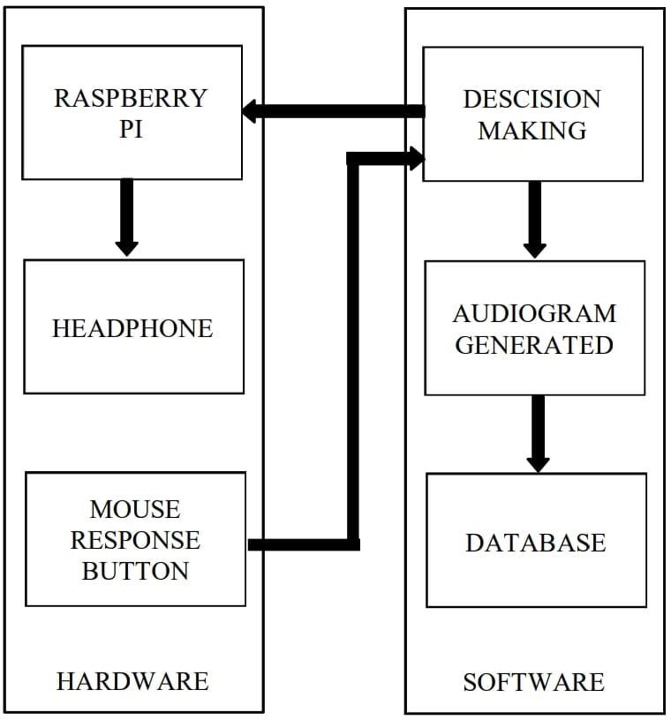

Fig 7.1. Block Diagram

### Components of the Portable Audiometer

1. **Computer**: Acts as the primary interface for processing data and generating audiograms.
2. **Raspberry Pi 3 B+**: Serves as the main processing unit, managing sound delivery and data collection.
3. **Patient Response Button**: A simple interface, usually the left mouse button, for patients to indicate their responses.
4. **Headphones**: Deliver sound signals directly to the patient during the test.

### Operational Mechanism

1. **Sound Signal Delivery**: The Raspberry Pi generates specific sound signals at various frequencies and intensities, which are delivered to the patient through the headphones.
2. **Patient Response**: Patients respond to the sounds they hear by pressing the left mouse button.
3. **Data Collection**: Responses are collected and processed by the Raspberry Pi.
4. **Audiogram Generation**: Based on the responses, an automatic audiogram is created, illustrating the relationship between frequency and sound intensity.

### Data Storage and Analysis

The results from each test, including the audiogram and raw response data, are saved in CSV format. Each file is named according to the date and time of the test, facilitating easy retrieval and analysis.

### Block Diagram Explanation

The block diagram of the system illustrates the flow of operations:

1. **Raspberry Pi to Headphones**: The Raspberry Pi sends sound signals to the headphones.
2. **Headphones to Patient**: The patient listens to the sounds through the headphones.
3. **Patient to Response Button**: The patient presses the response button (left mouse button) when a sound is heard.
4. **Response Button to Decision-Making Module**: The patient's responses are sent to the decision-making module.
5. **Decision-Making to Database**: The decision-making module processes the responses and stores the data in a database.
6. **Database to Audiogram Generation**: The stored data is used to generate an audiogram.

### Conclusion

This portable audiometer offers a cost-effective and efficient solution for self- assessment of hearing loss. By leveraging the capabilities of the Raspberry Pi and Python, the device provides a user-friendly and accurate method for individuals to monitor their hearing health without the need for frequent visits to an audiologist.

**CHAPTER - 8 IMPLEMENTATION OF HARDWARE MODULES**

## 8.1 INTRODUCTION

The portable pure tone audiometer uses a Raspberry Pi 3 B+, a mouse, and headphones. The Raspberry Pi runs on Raspbian OS with a 64-bit 1.2GHz quad-core processor and essential ports. Programmed in Python, it allows for easy script development. Using the Raspberry Pi's ALSA sound card, the audiometer produces pure tones from 125 Hz to 8 kHz. These tones are delivered to HP102BK headphones via a 3.5mm audio jack.

## COMPONENT DESCRIPTION

* 1. **RASPBERRY P**

The Raspberry Pi, a line of compact single-board computers (SBCs), was developed by the Raspberry Pi Foundation in partnership with Broadcom in the United Kingdom. Initially designed to enrich fundamental computer science education in educational institutions, Raspberry Pi quickly expanded beyond its educational role, attracting a broad spectrum of users from enthusiasts to industrial pioneers.

The establishment of Raspberry Pi (Trading) Ltd, led by visionary Eben Upton, marked a pivotal moment in the evolution of the Raspberry Pi ecosystem. While maintaining its commitment to education, the Foundation pivoted towards commercial endeavors, ensuring the widespread availability of Raspberry Pi devices through manufacturing facilities in Wales, China, and Japan.

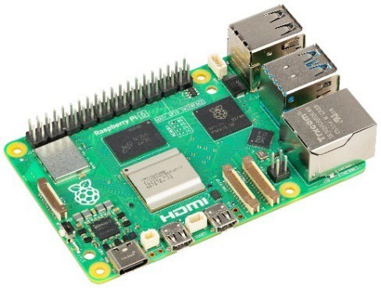

**Fig 8.2.** Raspberry Pi

## FEATURES OF RASPBERRY PI:

The general features of this board are as follows:

* + - * **Affordability**: Raspberry Pi offers a low-cost computing solution.
      * **Versatility**: It suits a wide range of projects, from simple electronics to complex IoT applications.
      * **GPIO Pins**: GPIO pins enable interaction with external components.
      * **Community Support**: A large and active community provides ample resources and assistance.
      * **Education**: Raspberry Pi promotes learning programming and electronics, originally designed for educational purposes.

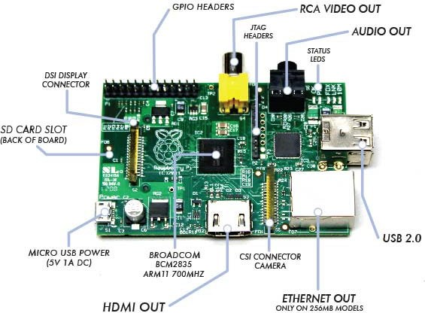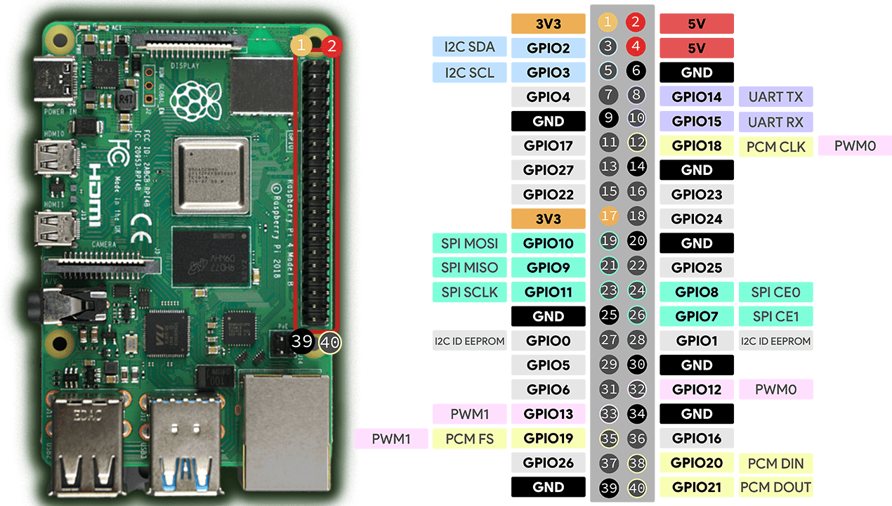

Fig 8.2.1 Pin Description of Raspberry Pi Fig 8.2.2 Raspberry Pi GPIO’s Pin Layout

* + 1. **RASPBERRY PI GPIO’S PIN**
       - GPIO (General Purpose Input/Output) pins enable interaction with external components. They act as programmable switches for controlling (output) or reading from (input) devices.
       - These pins are grouped into sets for specific purposes like power, ground, digital I/O, and analog input.
       - Raspberry Pi models offer varying numbers and configurations of GPIO pins, typically in a row of 40 (some models feature 26).
       - GPIO pins facilitate a wide range of projects by allowing users to interface with sensors, LEDs, motors, and other peripherals.

## RASPBERRY PI CASE:

A protective enclosure designed to house and shield the Raspberry Pi 3 B+ from physical damage and environmental hazards.

**Features**: Secure enclosure to safeguard the Raspberry Pi components, Accessible openings for ports, GPIO pins, and camera/display connectors.

### Specifications:

* Material: Plastic or aluminum
* Design: Ventilation holes for heat dissipation, mounting holes for stability.

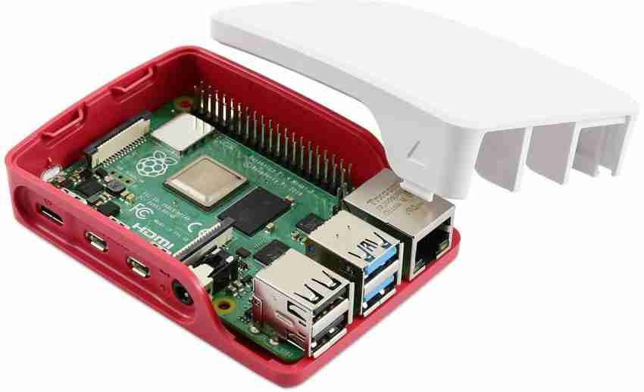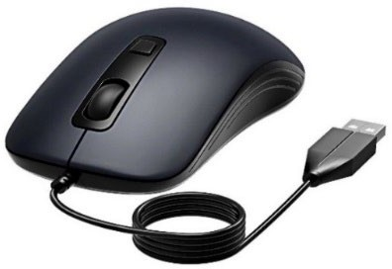

Fig 8.3. Raspberry Pi Case Fig 8.4. Mouse

## MOUSE

The mouse is an input device used for interacting with graphical user interfaces on computers.

**Features**: Ergonomic design for comfortable use, Responsive optical or laser sensor for precise cursor movement.

## HEADPHONE:

The headphone delivers audio output to the user for listening to sound from the Raspberry Pi.

**Features**: High-quality audio reproduction for immersive sound experience, Comfortable design for extended wear.

### Specifications:

* Connectivity: Wired (3.5mm audio jack) or wireless (Bluetooth)
* Frequency Response: Typically ranges from 20Hz to 20kHz

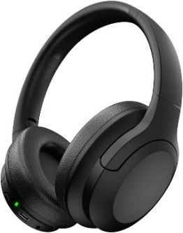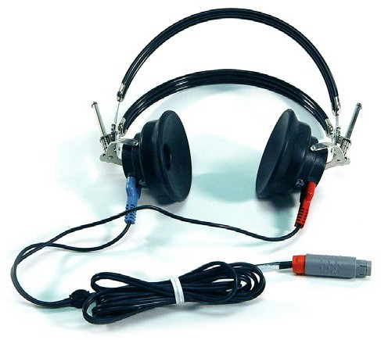

Fig 8.5. Headphone Fig 8.5.1. TDH -49 Headphone

## TDH 49 HEADPHONE CHARACTERISTICS AND USAGE

### Tone Used

* + Pure tones across various frequencies for audiometric testing.

### Positive Characteristics

* + Reliable and consistent in delivering precise sound stimuli.
  + Closed design attenuates ambient noise for accurate testing.

### Negative Characteristics

* + Bulky size and weight may cause discomfort during prolonged use.
  + Closed design can lead to heat and moisture buildup, causing discomfort.

### Cross Ear Level

* + Designed to minimize cross-hearing with good acoustic isolation.
  + Proper positioning crucial for minimal sound leakage and accurate results.

### Crossover

* + Potential feature for consistent sound quality across frequencies.

## ETHERNET CABLE:

The Ethernet cable establishes a wired network connection between devices for high- speed data transfer.

**Features**: Secure and stable network connectivity, Twisted pair construction for reduced interference.

### Specifications:

* Cable Category: Cat5e, Cat6, Cat6a
* Length: Various lengths available
* Speed: Typically up to 1Gbps

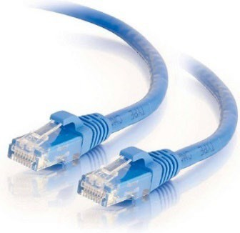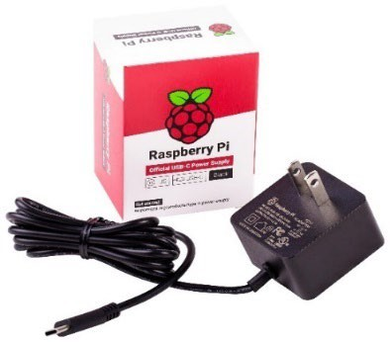

Fig 8.6. Ethernet Cable: Fig 8.7. Power Adapter

### Power Supply

The power source delivers essential electrical energy to the Raspberry Pi and accompanying components of the audiometer, ensuring steady and dependable functionality of the system.

1. **Characteristics:** Provides consistent output voltage for reliable performance, Equipped with safety measures like overload and short-circuit protection.

### Specifications:

* + Input: AC 100-240V, 50/60Hz
  + Output: DC 5V, 2.5A
  + Connector Type: Micro USB

**CHAPTER – 9 SOFTWARE IMPLEMENTATION**

## 9.1 INTRODUCTION

In Technology, the word implementation of software is used to describe the software tools implemented in this project.

## 9.2. RASPBERRY PI OS (RASPBIAN)

Installing Raspberry Pi OS involves preparing a microSD card and setting up your Raspberry Pi. Here's a quick overview

Installing Raspberry Pi OS via Raspberry Pi Imager offers a swift and straightforward method to set up the operating system on a microSD card, making it compatible with your Raspberry Pi for immediate use. [**https://downloads.raspberrypi.org/imager/imager_latest.exe**](https://downloads.raspberrypi.org/imager/imager_latest.exe)

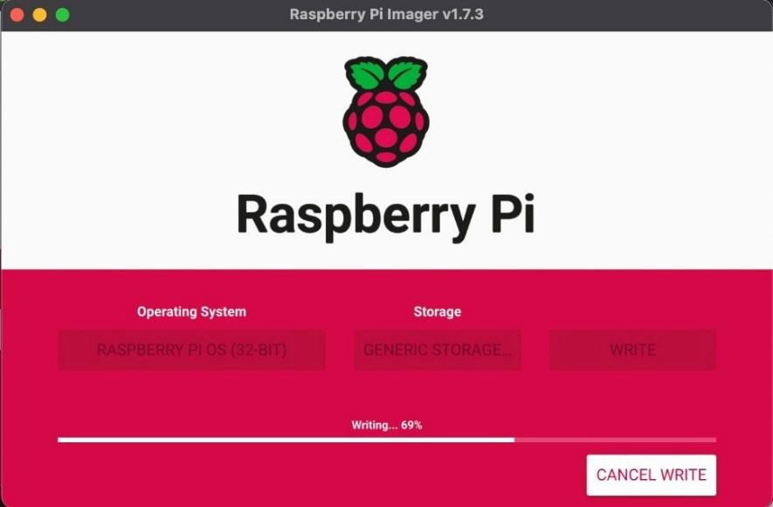

Fig 9.2 Installing Raspbian.

1. **Download Raspberry Pi Imager:** This tool writes the OS to your SD card. Get it from the Raspberry Pi website.
2. **Prepare microSD card:** Use a minimum 8GB class 10 card. The imager will erase it during setup.
3. **Flash OS to SD card:** Use the imager to select Raspberry Pi OS (formerly Raspbian) and your SD card. The imager will write the OS to the card.
4. **Setup Raspberry Pi:** Insert the SD card, connect a monitor, keyboard, mouse, and power supply to your Pi. You can also connect to Wi-Fi during initial setup.

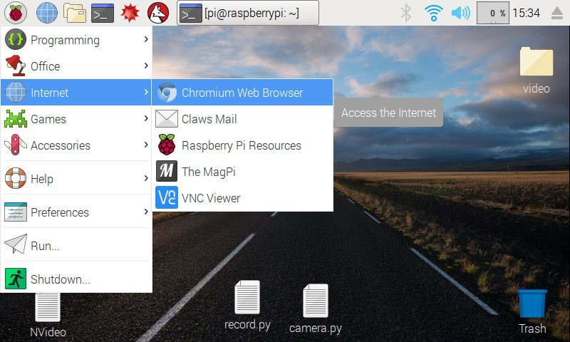

Fig 9.2.1 The Raspberry Pi desktop.

### 9.3. VNC: Remote access a Raspberry Pi

To install VNC Viewer on your computer and connect to your Raspberry Pi:

1. **Download VNC Viewer**: Visit the RealVNC website and download the VNC Viewer application for your operating system.
2. **Install VNC Viewer**: Follow the on-screen instructions to install VNC Viewer on your computer.
3. **Configure Raspberry Pi**: On your Raspberry Pi, enable VNC Server. You can do this by opening a terminal and running **sudo raspi-config**, navigating to **Interfacing Options**, and enabling VNC.
4. **Find Raspberry Pi IP Address**: Use **ifconfig** on the Raspberry Pi terminal to find its IP address.
5. **Connect with VNC Viewer**: Open VNC Viewer on your computer and enter the Raspberry Pi's IP address. Click connect and enter the username and password for your Raspberry Pi when prompted.
6. **Access Raspberry Pi Desktop**: You should now be connected to your Raspberry Pi's desktop environment using VNC Viewer.

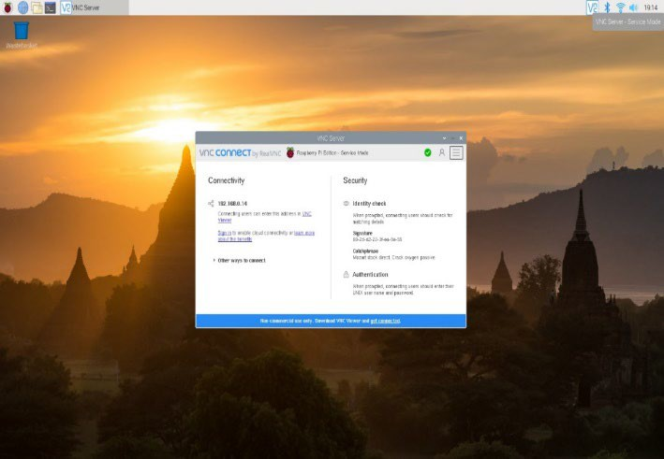

Fig 9.3 VNC: Remote Access to a Raspberry Pi

**CHAPTER – 10**

**VALIDATION AND FEEDBACK: MEETING WITH ENT DOCTOR**

**Consultation with Dr. B. Harsha Vardhan, M.S. ENT (Otolaryngology)**

* 1. **INTRODUCTION**

To develop a portable audiometer for self-assessment of hearing loss, we sought input from Dr. B. Harsha Vardhan, an ENT expert, to gather practical insights and evaluate the device's effectiveness. Dr. Vardhan provided valuable guidance and feedback on the project.

* 1. **CONSULTATION WITH DR. B. HARSHA VARDHAN, M.S. ENT (OTOLARYNGOLOGY)**

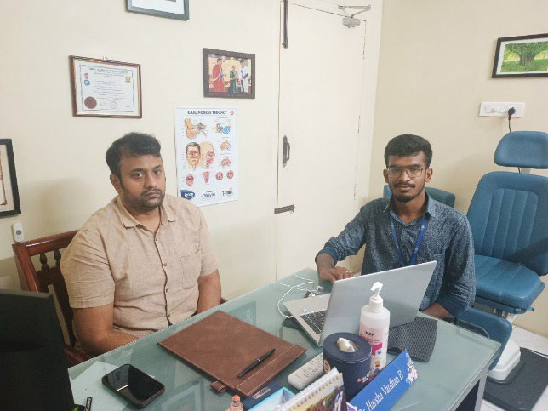

# Fig 10.2. Consulting with the Doctor

* + - We met Dr. B. Harsha Vardhan, an ENT specialist based in Mahalingapuram, Pollachi.
    - During the meeting, we discussed the project and demonstrated the functionality of the pure tone audiometer.
    - Dr. Vardhan praised the project, considering it highly promising.
    - He expressed interest in purchasing the pure tone audiometer once it is completed.

# Discussion with the ENT Doctor:

* + - We spoke with the audiologist and discussed the project in detail.
    - We learned that the market value of a commercial pure tone audiometer is approximately 1.50 lakhs.
    - The audiologist advised us to test the self-assembled pure tone audiometer with individuals who are hearing impaired for further validation.
    - Feedback was given on making minor adjustments to the audiogram's x and y-axis for improved accuracy.

# Testing the Self-Assembled Pure Tone Audiometer:

* + - We met with an audiologist in Pollachi who had access to a commercial pure tone audiometer.
    - Comparative tests were conducted between the self-assembled audiometer and the commercial device.
    - The results indicated that the self-assembled device performed well, with only slight variations in audio tones

# Feedback and Conclusion:

* + - Dr. Vardhan appreciated the innovative project and participated in testing the audiometer.
    - The project received positive feedback overall, with suggestions for minor adjustments to enhance accuracy.
    - Collaboration with medical professionals validated the effectiveness of the self- assembled pure tone audiometer, reinforcing its potential utility.

**CHAPTER - 11**

**MEETING WITH AUDIOLOGIST BALACHANDRAN, ASLP**

# Consultation with Dr. P. Balachandran, ASLP

## INTRODUCTION:

I had the opportunity to meet with Audiologist Balachandran, ASLP. We engaged in an in-depth discussion about audiometric equipment and testing procedures for over an hour.

## MEETING WITH AUDIOLOGIST BALACHANDRAN ASLP IN POLLACHI

In Pollachi, I met with Audiologist Balachandran, ASLP, for an enlightening conversation lasting over an hour. He introduced me to essential audiology testing equipment, including the Auditivio Audiometer (Endeavour), an Indian product priced at ₹50,000, and the imported Flute Inventis Tympanometer, which costs ₹4.50 lakhs

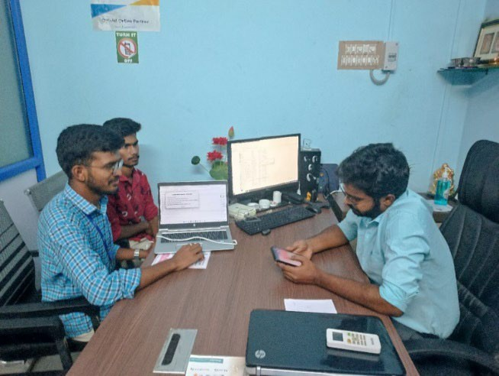

Fig 11.2. Meeting with Audiologist

## PROJECT DISCUSSION AND RECOMMENDATIONS

Balachandran provided valuable insights and suggestions for enhancing our project. He emphasized the importance of including a bone conduction test to accurately plot the audiogram and describe hearing loss. He also recommended replacing the standard headphones with TDH49, which are specifically designed for audiometry tests. Furthermore, he suggested printing the audiogram sheet for proper documentation**.**

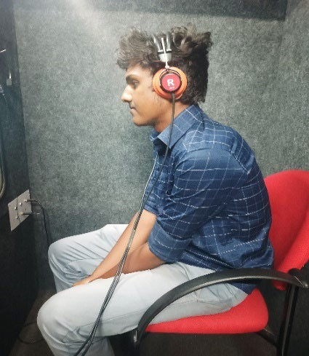 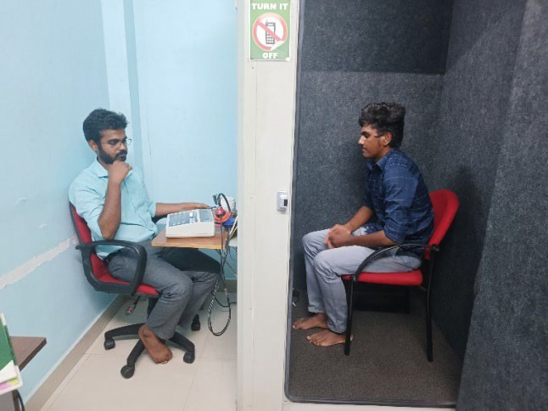

Fig 11.3. Audiometry Test

## KEY FEEDBACK FROM AUDIOLOGIST BALACHANDRAN

* + 1. **Bone Conduction Tests:** Essential for accurate audiogram plotting and describing hearing loss.
    2. **TDH49 Headphones:** Recommended replacing standard headphones with TDH49 for audiometry tests.
    3. **Printed Audiogram Sheets**: Necessary for proper documentation.
    4. **Calibration Levels:** Explore and implement sound pressure level calibration for accuracy.
    5. **Intensity and Time Delay Adjustments:** Needed for better test accuracy.
    6. **Maximum Frequency Intensity**: Research the maximum frequency intensity levels.
    7. **TDH49 Headphone Characteristics:** Study crossover and ear level responses.
    8. **Cost-Effectiveness:** Compare the project’s cost-effectiveness with pure tone audiometers.
    9. **Mackenzie Audiometry Test**: Consider incorporating or adapting principles from this test
    10. **High-Frequency Audiometry Tests:** Extend capabilities to include high-frequency audiometry tests.
    11. **Detailed Documentation and User Manual:** Develop comprehensive documentation and a user manual.
    12. **Enhanced User Interface**: Improve user interface for better usability.
    13. **Real-Time Data Analysis and Feedback:** Integrate real-time data analysis and feedback features for immediate results.

## GUIDANCE AND LEARNING

Balachandran recommended the book "Auditory Diagnosis" by Robert and requested a hard copy of our project documentation. We provided him with detailed study material. He also explained the Mackenzie audiometry test, highlighting its significance.

## EXPLORATION AND FUTURE SCOPE

Balachandran educated us on high-frequency audiometry tests and provided guidance for further development of our project. He offered detailed insights into masking tests, cross- level intensity, and various types of audiometry, and explained the concept of hearing loss.

## CONCLUSION

The meeting with Balachandran was incredibly enlightening. We gained valuable insights into potential improvements and future prospects for our project. His expertise in audiometry testing and his recommendations were instrumental in enhancing our understanding and guiding our project's direction.

**CHAPTER – 12 RESULTS**

## 12.1 INTRODUCTION

This chapter explains the testing of the working of hardware, software, raspberry pi (Pure Tone Audiometry) of the project.

## 12.2. TESTING OF FINAL WORKING MODEL:

### Components:

Raspberry Pi 3 B+, computer, patient response button, and headphones.

### Sound Signal Delivery:

Headphones deliver sound signals of varying frequencies and volumes.

### Patient Response:

Patients respond using a mouse button, providing feedback for recording.

### Data Processing:

Real-time processing captures frequency, volume, and reaction time data.

### Output:

Generates audiograms and visualizations for easy interpretation of hearing levels.

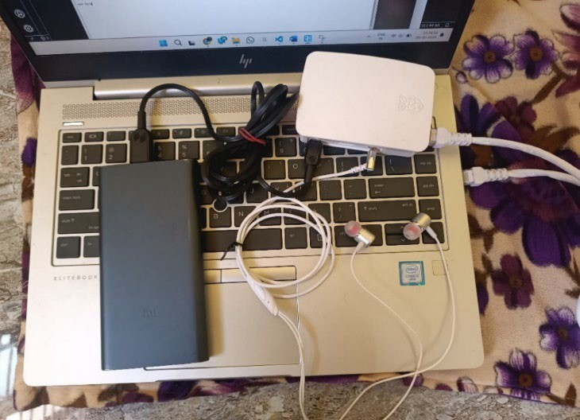

Fig 12.2 Overall Initialization Pure Tone Audiometer

**12.3. RESULT ANALYSIS:**

Using the data stored in the CSV file, the audiogram was produced to illustrate the hearing thresholds for both the right and left ears. The graph displayed the frequency,

measured in Hertz, along the X-axis, and the sound intensity, measured in decibels (dB), along the Y-axis.

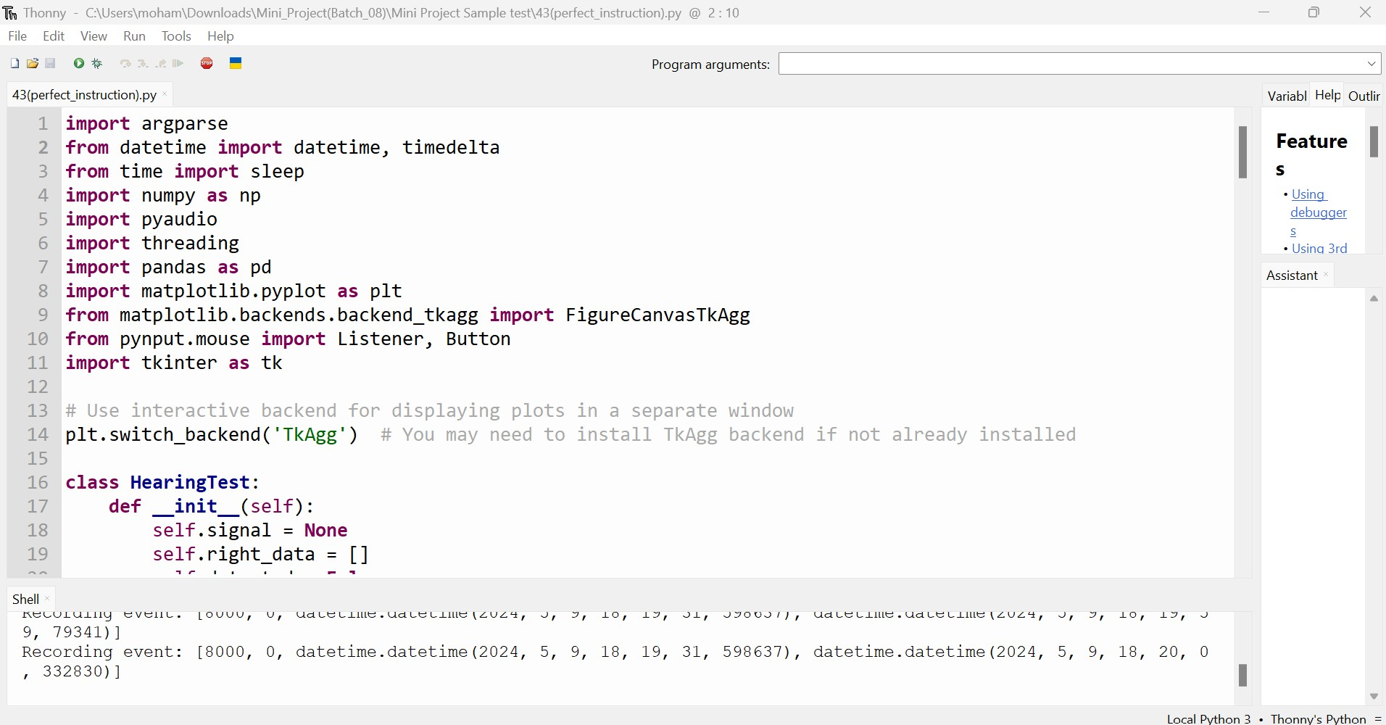

Fig 12.3.1. Python Code in Thonny Ide

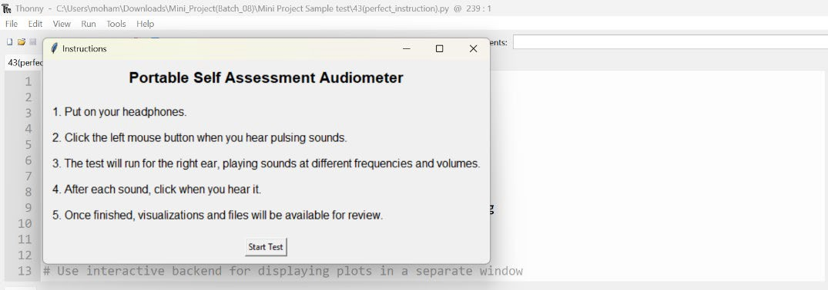

Fig 12.3.2. Instruction of the project

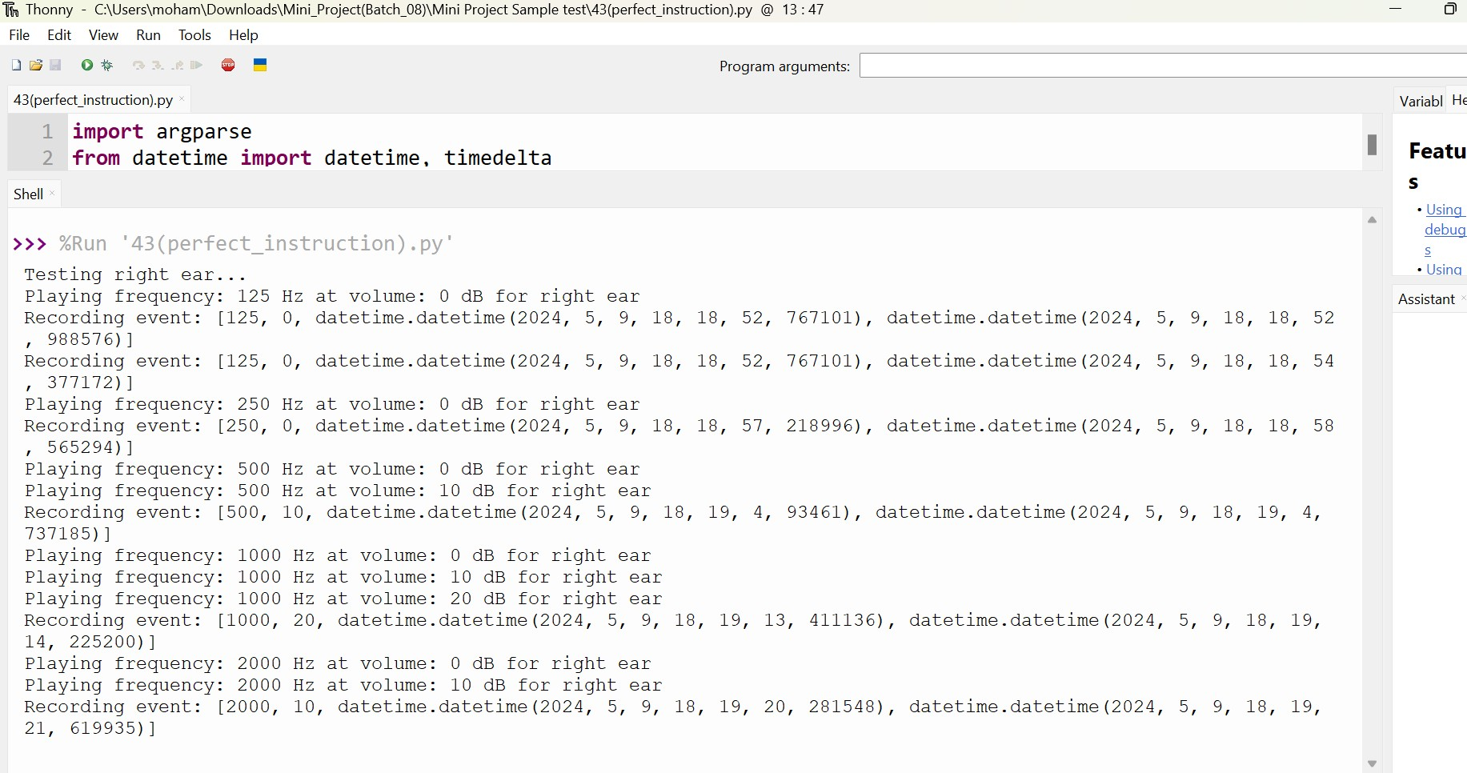

Fig 12.3.3. Patient Response of the Audiometer

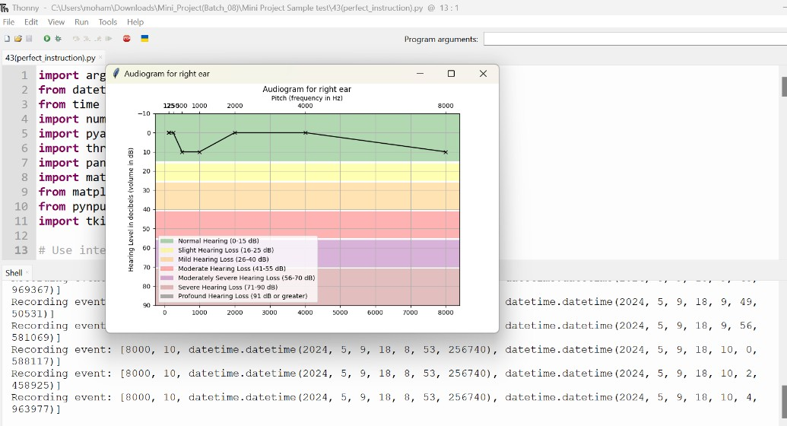

Fig 12.3.4. Output of the Audiogram Chart

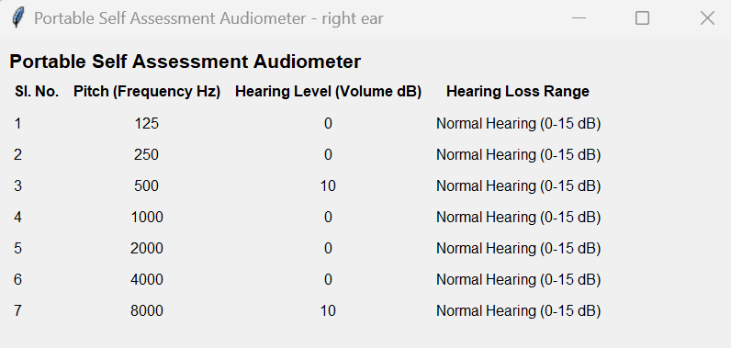

Table 4: Result Analysis

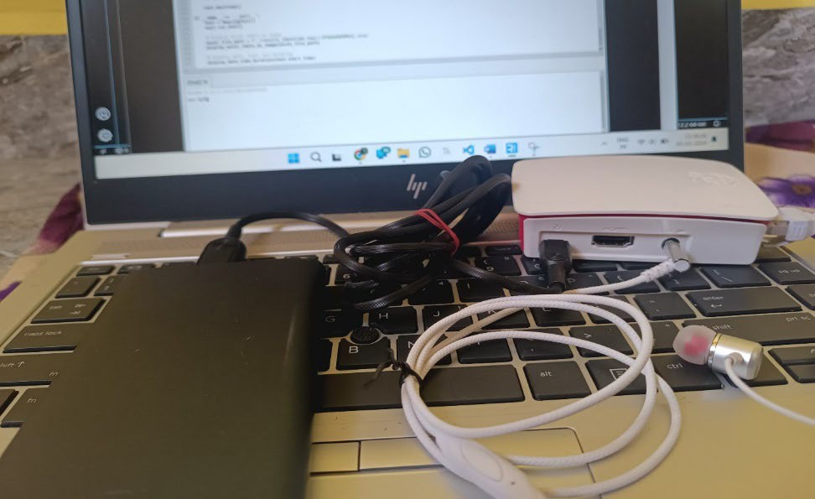

Fig 12.3.5. Portable Self Assessment Audiometer

**CHAPTER – 13 CONCLUSION & FUTURE SCOPE**

The project has resulted in a significant achievement: the development of a portable audiometer capable of autonomously and repeatedly diagnosing hearing loss. What distinguishes this portable device is its innovative incorporation of information technology into audiology equipment.

By utilizing the widely-adopted Python programming language, the system is accessible even to individuals without specialized expertise, and Python's user-friendly nature facilitates smooth integration with other devices.

The implementation of automated screening procedures in Python not only cuts down on operational expenses but also enhances the portability of the hearing screening tool. Furthermore, the created audiometer functions as a self-assessment system for hearing, eliminating the requirement for expert operation.

* 1. **FUTURE SCOPE:**
     1. **User Interface Enhancement:** Develop user-friendly interfaces, including voice commands or touch-screen options, for individuals with varying levels of technological proficiency.
     2. **Mobile App Integration:** Create a mobile app companion for tracking hearing health, receiving reminders, and accessing educational resources.
     3. **Real-Time Feedback:** Implement algorithms for immediate feedback during tests, showing visualizations and recommendations.
     4. **Customized Testing:** Allow users to tailor tests based on their needs, adjusting frequency range, intensity, or duration.
     5. **Telemedicine Integration:** Explore integration with telemedicine for remote monitoring and consultation.
     6. **Continued Development:** Collaborate for hardware and software improvements, conducting validation studies for effectiveness.

**CHAPTER – 14 BIBLIOGRAPHY**

1. [”Ritu Rani](https://ieeexplore.ieee.org/author/37086157994); [H.T. Patil](https://ieeexplore.ieee.org/author/37085472348)”, “Portable audiometer for detecting hearing disorder at an early stage for cancer patient”, “2016 International Conference on Automatic Control and Dynamic Optimization Techniques”.
2. [“Marwa](https://ieeexplore.ieee.org/author/37086545038) [Gargouri](https://ieeexplore.ieee.org/author/37086545038);, Mondher Chaoui” ,“Development of hearing self-assessment pure tone audiometer, [“2020 IEEE International Conference on Design & Test of Integrated](https://ieeexplore.ieee.org/xpl/conhome/9188339/proceeding) [Micro & Nano-Systems (DTS)](https://ieeexplore.ieee.org/xpl/conhome/9188339/proceeding)”
3. “M.Dharani kumar Chowdhary, Dr. C. Nagaraja ”,” A novel raspberry pi-3 based pure tone audiometer and verification of calibration with standard system, “Journal of Data Acquisition and Processing(2020)”.
4. [“Silvia](https://ieeexplore.ieee.org/author/37284736800) [Figueira](https://ieeexplore.ieee.org/author/37284736800); [Kevin Nguyen](https://ieeexplore.ieee.org/author/37085564668); [Shweta](https://ieeexplore.ieee.org/author/37085565142) [Panditrao](https://ieeexplore.ieee.org/author/37085565142)”, “HearThat? - An app for diagnosing hearing loss”, [“IEEE Global Humanitarian Technology Conference (GHTC](https://ieeexplore.ieee.org/xpl/conhome/6958780/proceeding) [2019)](https://ieeexplore.ieee.org/xpl/conhome/6958780/proceeding)”.
5. Zeit K. Collaborating with clients & the media to improve public awareness. Adult hearing screening. 2007. [http://www.asha.org/Events/convention/handouts/2007/0413_Zeit_Kat rina_3/ Accessed](http://www.asha.org/Events/convention/handouts/2007/0413_Zeit_Kat%20rina_3/%20Accessed%209%20January%202012) [9 January 2012](http://www.asha.org/Events/convention/handouts/2007/0413_Zeit_Kat%20rina_3/%20Accessed%209%20January%202012).
6. “Deafness and hearing loss,” World Health Organization, Mar. 20, 2019.[Online]. Available: <http://www.who.int/en/news-room/factsheets/detail/deafness-and-hearing-loss>
7. American Speech-Language-Hearing Association. Causes of hearing loss in adults 2012. <http://www.asha.org/public/hearing/disorders/causes_adults.htm> Accessed 3 January
8. N. Nakamura, “Development of mobileaudiometer for screening using mobile phones,” in Proc. 26th Annu. Int. Conf. IEEE Eng. Medicine Biol. Soc., Sep. 1–5, 2004.
9. P. G. Jacobs et al., “Development and evaluation of a portable audiometer for high- frequency screening of hearing loss from ototoxicity in homes/clinics,” IEEE Trans. Biomed. Eng., vol. 59, no. 11, pp. 3097–3103, Jul. 2012.

**CHAPTER 15** **APPENDIX**

**11.1. SOURCE CODE (PYTHON CODE):**

### import argparse

**from datetime import** datetime, timedelta

### from time import sleep import numpy as np import pyaudio import threading import pandas as pd

**import matplotlib.pyplot as plt**

**from matplotlib.backends.backend_tkagg import** FigureCanvasTkAgg

**from pynput.mouse import** Listener, Button

### import tkinter as tk

# Use interactive backend for displaying plots in a separate window plt.switch_backend('TkAgg') # You may need to install TkAgg backend if not already installed **class HearingTest**:

**def init** (self):

self.signal = None self.right_data = [] self.detected = False self.start_time = None

**def display_instructions**(self):

"""Display instructions in a new window""" instructions_window = tk.Tk() instructions_window.title("Instructions")

instructions_label = tk.Label(instructions_window, text="Portable Self Assessment Audiometer", font=("Arial", **16**, "bold"))

instructions_label.pack(padx=**10**, pady=**10**)

instructions_text = "1. Put on your headphones.**\n\n**2. Click the left mouse button when you hear pulsing sounds.**\n\n**3. The test will run for the right ear, playing sounds at different frequencies and volumes.

instructions_text_label = tk.Label(instructions_window, text=instructions_text, font=("Arial",

**12**), justify=tk.LEFT) instructions_text_label.pack(padx=**10**, pady=**10**)

start_button = tk.Button(instructions_window, text="Start Test", command=self.start_test) start_button.pack(padx=**10**, pady=**10**)

instructions_window.mainloop()

**def start_test**(self):

"""Start the hearing test""" self.display_instructions() self.run_test()

**def player**(self, p, repeat=**1**, ear='right'):

"""Plays sounds with different frequencies and volume levels"""

volumes = [**0**, **10**, **20**, **30**, **40**, **50**, **60**, **70**, **80**, **90**] # Adjusted volume levels in dB

frequencies = [**125**, **250**, **500**, **1000**, **2000**, **4000**, **8000**] # Adjusted frequencies in Hz # Repeat each frequency based on the provided argument

frequencies = np.repeat(frequencies, repeat) stream = p.open(format=pyaudio.paFloat32, channels=**1**,

rate=**44100**, output=True) sleep(**0.1**)

**for** freq **in** frequencies:

self.detected = False

**for** vol **in** volumes:

**print**(f"Playing frequency: {freq} Hz at volume: {vol} dB for {ear} ear") self.signal = [freq, vol, datetime.now()]

audio_data = (np.sin(**2** * np.pi * np.arange(**44100** * **0.5**) * freq / **44100**)).astype(np.float32) audio_data = audio_data * **10**\*\*(vol / **20**)

stream.write(audio_data.tobytes())

sleep(**2**) # Adding 2-second pause after playing each volume level

**if** self.detected:

### break

sleep(**2**) # Adding 2-second pause after playing each frequency stream.stop_stream()

stream.close()

**def on_click**(self, x, y, button, pressed):

"""Callback function for mouse clicks"""

**if** button == Button.left **and** pressed:

**if** self.signal:

d = self.signal + [datetime.now()] **print**(f'Recording event: {d}') self.right_data.append(d) self.detected = True

**def listener**(self):

"""Listens to mouse clicks"""

**with** Listener(on_click=self.on_click) **as** listener:

listener.join()

**def analyse_results**(self, data, ear):

"""Stores and visualizes results"""

now = datetime.now() # Load data to DataFrame

df = pd.DataFrame(data, columns=['frequency', 'volume', 'played', 'heard']) df['reaction_time'] = (df['heard'] - df['played']).dt.microseconds // **1000**

# Create audiogram chart audiogram_fig = plt.figure()

ax1 = audiogram_fig.add_subplot(**111**)

ax1.plot(df['frequency'], df['volume'], marker='x', linestyle='-', color='black') ax1.set(title=f"Audiogram for {ear} ear", ylim=[**90**, -**10**], yticks=[**90**, **80**, **70**, **60**, **50**, **40**, **30**,

**20**, **10**, **0**, -**10**])

ax1.grid(True)

ax1.set_ylabel('Hearing Level in decibels (volume in dB)') # Add x-axis ticks and labels chart ax2 = ax1.twiny()

ax2.set_xlim(ax1.get_xlim())

ax2.set_xticks(df['frequency']) ax2.set_xticklabels(df['frequency']) ax2.set_xlabel('Pitch (frequency in Hz)')

ax2.xaxis.tick_top() # Add colored rows for different hearing loss stages ax1.axhspan(-**10**, **15**, facecolor='green', alpha=**0.3**, label='Normal Hearing (0-15 dB)')

ax1.axhspan(**16**, **25**, facecolor='yellow', alpha=**0.3**, label='Slight Hearing Loss (16-25 dB)') ax1.axhspan(**26**, **40**, facecolor='orange', alpha=**0.3**, label='Mild Hearing Loss (26-40 dB)') ax1.axhspan(**41**, **55**, facecolor='red', alpha=**0.3**, label='Moderate Hearing Loss (41-55 dB)') ax1.axhspan(**56**, **70**, facecolor='purple', alpha=**0.3**, label='Moderately Severe Hearing Loss (56-70 dB)')

ax1.axhspan(**71**, **90**, facecolor='brown', alpha=**0.3**, label='Severe Hearing Loss (71-90 dB)') ax1.axhspan(**91**, **120**, facecolor='black', alpha=**0.3**, label='Profound Hearing Loss (91 dB or greater)')ax1.legend() # Save audiogram chart as image audiogram_fig.savefig(f'./results_{ear}_{now:%Y%m%d%H%M%S}_audiogram.png')

# Display audiogram chart in a new window audiogram_window = tk.Tk() audiogram_window.title(f"Audiogram for {ear} ear")

canvas = FigureCanvasTkAgg(audiogram_fig, master=audiogram_window) canvas.draw()

canvas.get_tk_widget().pack(side=tk.TOP, fill=tk.BOTH, expand=**1**) # Display Excel table in a new window

excel_window = tk.Tk()

excel_window.title(f"Portable Self Assessment Audiometer - {ear} ear") excel_table = tk.Frame(excel_window)

excel_table.grid(row=**0**, column=**0**, padx=**10**, pady=**10**)

table_label = tk.Label(excel_table, text="Portable Self Assessment Audiometer", font=("Arial", **16**, "bold"))

table_label.grid(row=**0**, columnspan=**5**, sticky="w")

headers = ['Sl. No.', 'Pitch (Frequency Hz)', 'Hearing Level (Volume dB)', 'Hearing Loss Range']

**for** i, header **in** enumerate(headers):

col_label = tk.Label(excel_table, text=header, font=("Arial", **12**, "bold")) col_label.grid(row=**1**, column=i, padx=**5**, pady=**5**)

**for** i, row **in** df.iterrows():

sl_no = tk.Label(excel_table, text=i+**1**, font=("Arial", **12**)) sl_no.grid(row=i + **2**, column=**0**, padx=**5**, pady=**5**, sticky="w")

freq_label = tk.Label(excel_table, text=row['frequency'], font=("Arial", **12**)) freq_label.grid(row=i + **2**, column=**1**, padx=**5**, pady=**5**)

vol_label = tk.Label(excel_table, text=row['volume'], font=("Arial", **12**)) vol_label.grid(row=i + **2**, column=**2**, padx=**5**, pady=**5**)

range_label = tk.Label(excel_table, text=self.get_hearing_loss_range(row['volume']), font=("Arial", **12**))

range_label.grid(row=i + **2**, column=**3**, padx=**5**, pady=**5**) excel_window.mainloop() # Create CSV file

df.to_csv(f'./results_{ear}_{now:%Y%m%d%H%M%S}.csv', index=None) # Create Excel df_excel = pd.DataFrame(data, columns=['Sl. No.', 'Pitch (Frequency Hz)', 'Hearing Level (Volume dB)', 'Hearing Loss Range'])

df_excel['Hearing Loss Range'] = df_excel['Hearing Level (Volume dB)'].apply(self.get_hearing_loss_range) df_excel.to_excel(f'./results_{ear}_{now:%Y%m%d%H%M%S}.xlsx', index=None)

**print**("Audiogram chart, CSV file, and Excel sheet created successfully.")

**return** df

**def get_hearing_loss_range**(self, volume):

"""Determines the hearing loss range based on volume level"""

**if** volume <= **15**:

**return** 'Normal Hearing (0-15 dB)'

**elif** volume <= **25**:

**return** 'Slight Hearing Loss (16-25 dB)'

**elif** volume <= **40**:

**return** 'Mild Hearing Loss (26-40 dB)'

**elif** volume <= **55**:

**return** 'Moderate Hearing Loss (41-55 dB)'

**elif** volume <= **70**:

**return** 'Moderately Severe Hearing Loss (56-70 dB)'

**elif** volume <= **90**:

**return** 'Severe Hearing Loss (71-90 dB)'

### else:

**return** 'Profound Hearing Loss (91 dB or greater)'

**def run_test**(self):

parser = argparse.ArgumentParser()

parser.add_argument('-r', '--repeat', help='Number of times each frequency is repeated', type=int, default=**1**) # Change default value to 1

args = parser.parse_args() self.start_time = datetime.now()

p = pyaudio.PyAudio() # Start listener

p2 = threading.Thread(target=self.listener, daemon=True) p2.start() # Run test for the right ear

**print**('Testing right ear...')

self.player(p, repeat=args.repeat, ear='right') # Analyse and visualize results for the right ear right_df = self.analyse_results(self.right_data, 'right')

self.right_data = []

**print**('Test is finished. Please check visualizations and files.') self.display_date_time_duration()

### def display_date_time_duration(self):

now = datetime.now()

duration = now - self.start_time # Display test information in a new window info_window = tk.Tk()

info_window.title("Test Information")

date_label = tk.Label(info_window, text=f"Date: {self.start_time.strftime('%Y-%m-%d')}", font=("Arial", **12**))

date_label.pack()

start_time_label = tk.Label(info_window, text=f"Start Time:

{self.start_time.strftime('%H:%M:%S')}", font=("Arial", **12**)) start_time_label.pack()

duration_label = tk.Label(info_window, text=f"Duration: {duration}", font=("Arial", **12**)) duration_label.pack()

info_window.mainloop()

**if**  name == ' main ': test = HearingTest() test.start_test()

**PLAGIARISM REPORT**

My project contains 5% plagiarism, and I verified it using the Turnitin plagiarism checker in the MCET library.

