**DATA VISUALISATION PROJECT REPORT**

(Project Semester August – December 2024)

# ECOMMERCE SALES DASHBOARD

# LPU Logo DesIgn | Figma

Submitted by

**AMARAGONDA ADHITHYA**

**REG.NO: 12212304**

Programme and Section: B. Tech (CSE), K22MK

Course Code: INT233

**Under the Guidance of**

**Aashima: 28968**

**Discipline of CSE/IT**

**Lovely School of Computer Science**

**Lovely Professional University, Phagwara.**

**CERTIFICATE**

This is to certify that M. Sathwik Reddy bearing Registration no. 12212304 has completed the INT 233 project titled, **“ECOMMERCE SALES DASHBOARD”** under my guidance and supervision. To the best of my knowledge, the present work results from his/her original development, effort, and study.

**Aashima (28968)**

**School of Computer Science**

Lovely Professional University

Phagwara, Punjab.

Date: 15 -11- 2024

**DECLARATION**

I, AMARAGONDA ADHITHYA, student of B. Tech under CSE/IT Discipline at, Lovely Professional University, Punjab, hereby declare that all the information furnished in this project report is based on my own intensive work and is genuine.

Date: 15- 11- 2024 Signature: A.ADHITHYA

Registration No. 12212304 A.ADHITHYA

**TABLE OF CONTENTS**

|  |  |
| --- | --- |
| **1** | INTRODUCTION |
| **2** | OBJECTIVES OF THE DASHBOARD |
| **3** | DATA SOURCE |
| **4** | DASHBOARD DESIGN AND FEATURES |
| **5** | TRENDS AND PATTERNS OBSERVED |
| **6** | FUTURE SCOPE OF THIS PROJECT |
| **7** | CONCLUSION |
| **8** | REFERENCE |

1. **INTRODUCTION**

This project presents a comprehensive dashboard for analyzing eCommerce sales trends, customer demographics, and product performance, leveraging Tableau for data visualization. eCommerce businesses require efficient tools to analyze sales data, customer behavior, and market trends to optimize operations, enhance customer satisfaction, and drive revenue growth.

The primary objective of this dashboard is to provide an interactive and visually intuitive way to explore various eCommerce metrics, including sales revenue, customer demographics, product categories, order trends, and regional performance. The insights generated can aid in understanding customer preferences, identifying high-performing products, and uncovering areas for improvement in sales strategies. Additionally, the dashboard allows stakeholders to analyze seasonal trends, explore customer purchasing patterns, and make data-driven decisions to boost profitability and market competitiveness.

This report details the data sources, methods of visualization, and key findings drawn from the dashboard, offering a structured analysis of eCommerce sales data to enhance strategic planning and operational efficiency.

1. **OBJECTIVES OF THE DASHBOARD**

The objective of this project is to develop a comprehensive Tableau dashboard to provide key insights into the ECOMMERCE SALES workforce, enabling data-driven decision-making and strategic planning. This dashboard focuses on delivering clear, interactive visualizations and analytics related to employee demographics, performance, and organizational trends. Specifically, the goals are as follows:

* **Gender Diversity Analysis**
  + To assess and visualize the gender ratio across the organization, promoting diversity and inclusion initiatives.
* **Workforce Size Monitoring**
  + To track the total number of employees, providing a clear snapshot of workforce size and its evolution over time.
* **Demographic Insights by Department**
  + To analyse the average age of employees within each department, identifying potential generational gaps and informing succession planning.
* **Compensation Benchmarking**
  + To display average monthly salaries by department, enabling comparisons that highlight potential disparities and help ensure equitable compensation.
* **Marital Status Demographics**
  + To explore marital status data of employees, offering insights into employee needs and potential customization of benefits.
* **Career Path Analysis**
  + To analyse the number of companies employees have worked for prior to joining, providing context on experience levels and potential implications for retention and engagement.
* **Educational Background Assessment**
  + To visualize the distribution of employees by education field, identifying key areas of expertise and supporting workforce development initiatives.

By meeting these objectives, this dashboard aims to provide HR professionals and stakeholders with actionable insights to support strategic decisions in areas such as diversity, compensation, workforce distribution, and recruitment planning.

1. **DATA SOURCE**

The dataset used for this project originates from KAGGLE FOR ECOMMERCE DASHBOARD, providing detailed information on various employee demographics and job-related attributes. This data was obtained through Kaggle, a popular platform for datasets and data science resources. The IBM dataset on Kaggle includes information on employee gender, marital status, job roles, average monthly income, education fields, and other relevant variables, which serve as the foundation for the insights and visualizations in this dashboard.

1. **DASHBOARD DESIGN AND FEATURES**

The IBM Employees Dashboard is designed to provide an intuitive and engaging user experience while maximizing the use of visual space within a **1700 x 900-pixel** layout. This design ensures accessibility across multiple screen sizes and offers a comprehensive view of employee data and metrics. Key features and design elements include:

* **Responsive Layout:** The dashboard is optimized to display critical metrics and visualizations without clutter, ensuring a balanced presentation of content across the available space.
* **Navigation Pane:** An easy-to-use sidebar or top navigation bar allows users to quickly access different sections of the dashboard, such as demographics, compensation, attrition, and performance metrics.
* **Interactive Filters and Drill-Down Options:** Users can apply filters for department, role, gender, age group, etc., to customize the data views and gain deeper insights.
* **Key Metric Cards:** Prominently placed at the top of the dashboard, key metric cards provide an at-a-glance summary of core metrics such as total employees, average age by department, gender ratio, and average monthly salary.
* **Demographic Charts and Graphs:** Pie charts, bar graphs, and heatmaps are used to visualize gender diversity, marital status, and education field distributions effectively.
* **Trend and Comparative Analysis Sections:** Line graphs and comparison charts are employed to display trends in employee metrics over time, facilitating a deeper understanding of workforce changes.
* **Customizable Tooltips and Annotations:** Each visualization includes tooltips that provide detailed data when hovering over elements, enhancing user interaction and data exploration capabilities.
* **Color-Coded Visuals:** A consistent and thoughtful colour scheme is applied to differentiate departments, highlight trends, and emphasize key insights, making the data easier to interpret.

This design approach ensures that users can interactively explore and analyse key employee data, empowering stakeholders with actionable insights to make informed decisions about workforce management and strategy.

**DASHBOARD DESIGN**

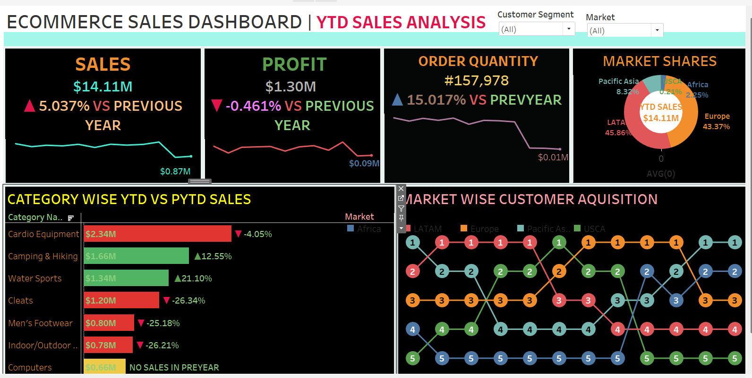

**OBJECTIVES VISUALISATION**

**5.TRENDS AND PATTERNS OBSERVED**

In this section, we explore key trends and patterns in the IBM employee data that reveal important insights about workforce dynamics, organizational performance, and potential areas for improvement. By analysing these trends, we can uncover significant shifts in the workforce and identify actionable opportunities for strategic planning.

* **Employee Attrition and Retention Trends:** We observe fluctuations in employee turnover rates over time, identifying periods of increased attrition. This could highlight the impact of internal factors such as changes in leadership, organizational restructuring, or external market conditions. Identifying these trends helps pinpoint retention challenges and suggests areas for improvement in employee engagement and satisfaction.
* **Gender Diversity Evolution:** Gender distribution trends over time provide valuable insights into the company’s progress in fostering a diverse workforce. Analyzing patterns in the gender ratio across different departments and roles can show if diversity goals are being met and where there may be gaps, helping inform diversity and inclusion initiatives.
* **Age Distribution by Department:** Patterns in the average age of employees across various departments can reveal generational trends within the workforce. For example, younger employees may dominate certain departments, indicating a need for mentorship and succession planning, while older employees may represent critical institutional knowledge.
* **Compensation Trends and Pay Equity:** The average monthly salary trend by department highlights areas where compensation may be competitive or lagging. Identifying patterns in pay over time can help assess the effectiveness of salary reviews, identify departments facing salary disparities, and support fair pay practices.
* **Employee Experience and Career Paths:** Trends in the number of companies employees have worked for prior to joining IBM can provide insights into the level of experience entering the company. For example, if most employees have worked for multiple companies, it may indicate that the company is attracting seasoned professionals or that the employee base is highly mobile.
* **Education Field and Skillset Trends:** By analysing the total number of employees within each educational field, we can identify trends in the educational background of the workforce. This can help the company assess the alignment between employees' skills and the company’s evolving needs, informing future hiring strategies.
* **Marital Status Patterns and Workforce Needs:** Understanding the distribution of marital status within the workforce can uncover trends related to employee needs, benefits preferences, and work-life balance. For instance, employees with families might require more flexible work arrangements, which could influence retention and job satisfaction.
* **Performance Trends by Department:** By analysing performance metrics across departments, we can identify patterns of high or low performance. This data can be used to optimize team structure, resource allocation, and identify areas for professional development or improvement.

**5.FUTURE SCOPE OF THIS PROJECT**

The **ECOMMERCE SALES DASHBOARD**  project provides valuable insights into workforce dynamics, but there are several opportunities for further enhancement and expansion. As organizational needs evolve and new technologies emerge, the following areas represent potential directions for extending the dashboard’s capabilities:

* **Advanced Predictive Analytics:**
  + Future iterations could incorporate **predictive models** to forecast key employee metrics, such as attrition, performance trends, and career progression. Machine learning algorithms could be employed to identify patterns in historical data, helping the organization proactively address retention challenges and talent management.
* **Employee Engagement Insights:**
  + Adding features that analyze **employee engagement data** (e.g., survey results, feedback) could provide deeper insights into factors influencing job satisfaction, productivity, and morale. Interactive visualizations could explore correlations between engagement scores and performance, attrition, or departmental success.
* **Real-Time Data Integration:**
  + Integrating **real-time data** feeds into the dashboard could enhance its usefulness by reflecting the most up-to-date employee information. This would help HR teams quickly respond to emerging trends, such as spikes in attrition or shifts in compensation requirements.
* **Customizable Dashboards for Different Stakeholders:**
  + The ability to **customize dashboards** for different user groups (e.g., HR, department heads, senior leadership) could be explored. Each group could have tailored views and metrics relevant to their needs, such as detailed compensation breakdowns for finance or employee engagement data for HR.
* **Employee Career Development Insights:**
  + Adding features that analyse **career development paths**, such as internal promotions, lateral moves, and skill development, could help IBM identify top talent and support succession planning efforts.

By expanding the scope of the IBM Employee Dashboard in these areas, the platform can become a more powerful tool for strategic workforce planning, employee engagement, and organizational development, allowing IBM to continue attracting, developing, and retaining top talent in an increasingly competitive environment.

1. **CONCLUSION**

This report details the data sources, methods of visualization, and key findings drawn from the dashboard, offering a structured analysis of eCommerce sales data to enhance strategic planning and operational efficiency. The insights provided empower businesses to make data-driven decisions, improve customer engagement, and optimize sales performance in a competitive marketplace.

1. **REFERENCES**

**ECOMMERCE SALES DASHBOARD**

* A popular dataset on Kaggle that contains information on employee attrition, demographics, performance, and more—ideal for your dashboard project on IBM employees.