Applying Filters to SQL Queries

Material & instructions developed by: Google Cybersecurity Professional Certificate Course

Completed by: Alexander Herman on 01/26/24

**Table of Contents:**

Scenario (Provided): ______________________________________________________________**2**

Step-By-Step Instructions (Provided): _______________________________________________**2**

Instruction Output (My Work): __________________________________________________**2-6**

Summary (My Work): ______________________________________________________________**7**

**Scenario**

You are a security professional at a large organization. Part of your job is to investigate security issues to help keep the system secure. You recently discovered some potential security issues that involve login attempts and employee machines.

Your task is to examine the organization’s data in their **employees** and **log_in_attempts** tables. You’ll need to use SQL filters to retrieve records from different datasets and investigate the potential security issues.

**Step-By-Step Instructions**

1. Retrieve after hours failed login attempts
2. Retrieve login attempts on specific dates
3. Retrieve login attempts outside of Mexico
4. Retrieve employees in Marketing
5. Retrieve employees in Finance or Sales
6. Retrieve all employees not in IT

**Instruction Output**

1. **Retrieve after hours failed login attempts:** (after hours starts at 18:00)

1. **Retrieve login attempts on specific dates:** 5/8/22 & 5/9/22

1. **Retrieve login attempts outside of Mexico**

1. **Retrieve employees in Marketing:** (and in East Building)

1. **Retrieve employees in Finance or Sales**

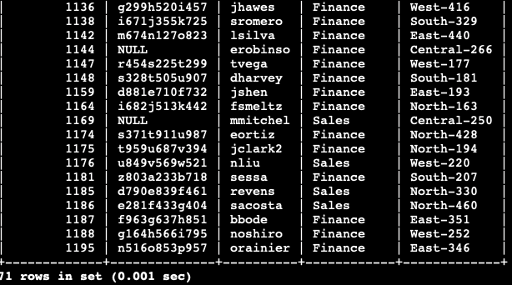

1. **Retrieve all employees not in IT**

**Summary**

Using SQL Queries one can quickly sift through databases for important information relating to employees, devices, departments, etc… In the activity above, I used basic query commands to return valuable information about company logs and employees. I drilled down into these specific tables using filters to return specific records I was interested in. I like SQL because there are multiple ways to write a query that can return the same records so one can utilize shortcuts.