**Q1) What is MongoDB?**

**Ans.** MongoDB is a cross platform, open source document database and a NoSQL database. It provides high performance, high availability, and easy scalability( Horizontal scaling – dividing into multiple servers). It works on the concept of collection and document. Here the data used is in the form of JSON.

Structure:

DB -> Collection -> Document

**Q2) Difference between SQL & NoSQL.**

**Ans.**

|  |  |
| --- | --- |
| **SQL** | **NoSQL** |
| 1. Relational Database. | 1. Non-relational Database. |
| 1. Vertically scaled. | 1. Horizontally scaled. |
| 1. Language used is SQL. (Structured Query Language). | 1. Language used is unstructured, with dynamic schema. (JSON in case of MongoDB) |
| 1. Structure:   Database->Table->Row->Column | 1. Structure:   Database->Collection->Document |

**Q3) How to install MongoDB & start MongoDB on system.**

**Ans.** Installation of MongoDB:

1. <https://www.mongodb.com/download-center/community>
2. Download Community server.

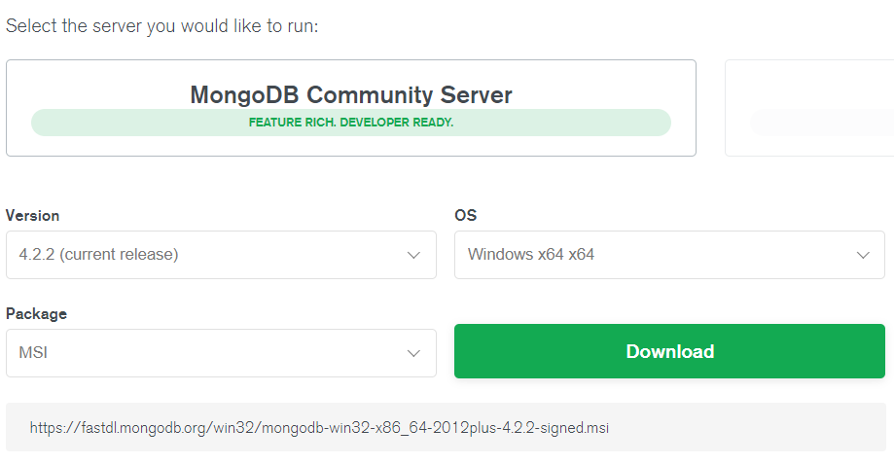

1. Install the MongoDB community server.
2. Set path to **C:\Program Files\MongoDB\Server\4.2\bin** in environment variables.

Start MongoDB:

1. Open Command Prompt, => mongod (opens the server)
2. Open Command Prompt => mongo (to run commands)

OR

Install Robo3T and run commands.

**Q4) Write a command to import JSON file in MongoDB.**

**Ans.** To import any json file containing certain number of records

* mongoimport json_file.json -d=db_name -c=collection_name jsonArray

**Q5) How to use current DB?**

**Ans.** There are many available databases, in order to switch to any database or use any database:

* use db_name

**Q6) How to delete DB and collection?**

**Ans.** We can delete/ drop any database or collection by:

* db.dropDatabase() - will drop current database.
* db.collection_name.drop()

**Q7) Different ways to create documents in MongoDB.**

**Ans.** Ways to create documents in MongoDB:

* db.collection_name.insert() -direct method
* db.createCollection(‘collection_name’) -indirect method

db.collection_name.insert()

**Q8) How to find second record?**

**Ans.** Second record of collection:

* db.collection_name. find().skip(1).limit(1)

**Q9) How to find record with multiple conditions?**

**Ans.** => db.collection_name.find([{condition1},{condition2}])

**Q10) How to search array of objects in MongoDB?**

**Ans.**

**Q11) What is object ID and size of it?**

**Ans.** object id is in the form of BJSON(Binary).

BJSON - 12 Byte

4Byte 4Byte 4Byte

Timestamp Server ID/ random number

(Current Time/ Process ID

Date)

//site: medium

4Byte 3Byte 2Byte

Timestamp Server ID

**Q12) Explain different data models in MongoDB?**

**Ans.**

**Q13) What is Aggregation in MongoDB?**

**Ans.** Aggregation in MongoDB is an operation to process the data that returns computed data.

eg . count().

Syntax:

* db.collection_name.aggregate( AGGREGATE OPERTION)

**Q14) How to sort by field?**

**Ans.** To sort records (ascending/ descending order):

* db.collection_name.find().sort({condition})

-1 => decending order, 1=> ascending order

**Q15) What is projection in MongoDB?**

**Ans.** Projection sets the preference of field of a record to be displayed.

0 – not to be displayed.

1 – to be displayed.