**Name:** Aditya Kotkar **Roll no:** 27 **Class:** D10 **Batch:** B

**Q1. Write a program to add Fibonacci series.**

**Code:** 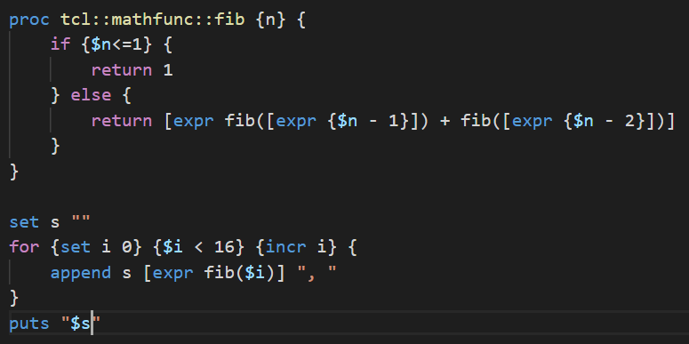

**Output:**

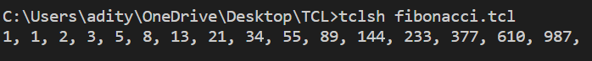

**Q2. Write a program to find factorial of a number.**

**Code:**

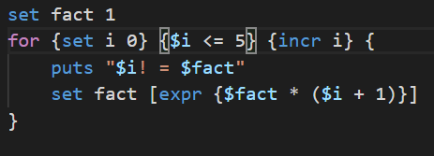

**Output:**

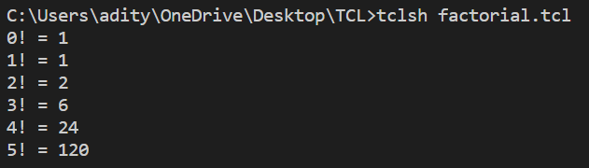

**Q3. Write a program to check even numbers.**

**Code:**

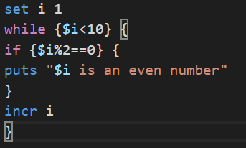

**Output:**

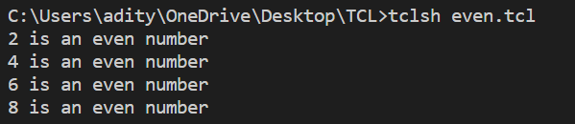

**Q4. Write a program to check whether one is adult or not.**

**Code:**

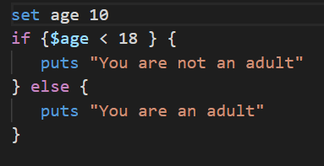

**Output:**



**Q5. Write a program to make a simple calculator.**

**Code:** 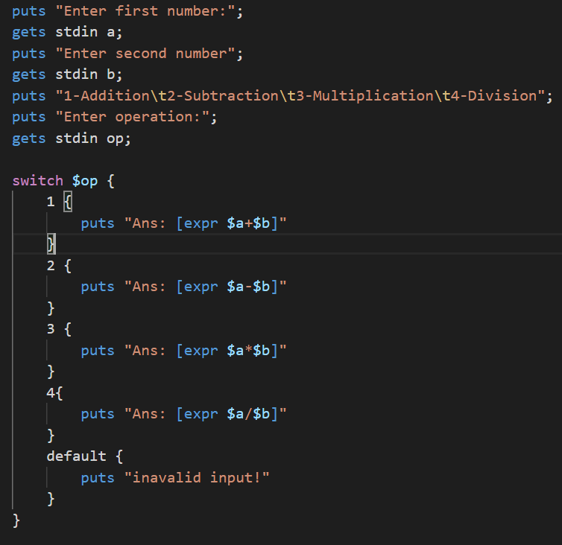

**Output:** 