Safety-Shielded Hierarchical Reinforcement Learning for Formula 1: A Move-Level Racing Driver and a Lap-Level PPO Race Strategist Trained on Real Circuits and Real Overtakes
Member 1 · Member 2 · Member 3

Abstract
Formula 1 racing couples two sequential decision problems on different clocks: a driver who must overtake and defend at the grip limit without contact, and a strategist who chooses pit laps, tyres and push levels under safety cars, rain and incidents. Rule-based plans cannot react to such events, and end-to-end RL drivers learn slowly and lack hard safety. We build a seeded Gymnasium simulator on 25 real circuits and train a two-level PPO hierarchy. Its novelty lies in (i) a driver that selects temporally extended race-craft moves executed by a limit-pace path planner and filtered by a bilateral predictive safety shield, (ii) a curriculum seeded with real 2021-2025 overtakes used as start states rather than imitation targets, and (iii) a strategist trained on a profile measured from the learned driver. Against rule-based baselines on five unseen circuits, the driver records zero contacts in 1,174 real situations and holds 273 of 460 defences versus 264, while pure soft actor-critic plateaued 17-20% off the limit lap. The strategist’s learning curve passes the rule-based plan within 0.4 million laps; on held-out races it wins 96% versus 91% when clean and 29% versus 4.5% after a spin.
Keywords: reinforcement learning, hierarchical control, PPO, safe RL, shielding, autonomous racing, race strategy, curriculum learning, Formula 1.

1.1 Background and Context
Reinforcement learning (RL) studies how an agent should act in an environment to maximise long-run reward [1]. At each step $t$ the agent observes a state $s_{t}$, draws an action $a_{t}$ from its policy $π_{θ}\left(a∣s\right)$, and the environment returns a scalar reward $r_{t}$ and a new state $s_{t+1}$. The problem is usually written as a Markov decision process $\left(S,A,P,R,γ\right)$, and the goal is a policy that maximises the discounted return Gt=k≥0​γkrt+k. Because the agent learns from consequences rather than labelled answers, RL suits problems in which an early choice only pays off (or fails) many steps later. Deep networks made it practical for large state spaces: deep Q-networks learned Atari games from pixels [2], search plus policy networks mastered Go [3], and multi-agent RL reached grandmaster level in StarCraft II [4]. The same tools now appear in robot control [5], automated driving [6], drone racing [7] and planning problems where a model of the future is cheap to simulate but hard to solve analytically.
Motorsport is a natural but demanding test bed for these methods. A racing car is driven at the edge of tyre grip, where a small error ends the lap, and the reward for a good braking point is felt seconds later. Racing against others adds interaction: the car ahead shapes your air flow, your line and your options, and a collision is costly for both. Above the driver sits a slower layer of decisions - when to pit, which compound to fit, how hard to push - whose consequences unfold over a whole race and depend on what rivals do and on random events such as safety cars and showers. The key domain challenges are therefore (a) long horizons with delayed reward, (b) hard safety constraints, (c) other agents whose behaviour changes the problem, (d) two decision rates that differ by two orders of magnitude, and (e) scarce real data: public F1 telemetry has no steering signal and positions are sampled at only a few hertz.

1.2 Problem Statement
We address the following sequential decision problem. Given a circuit, a car model with a friction-ellipse grip limit and tyre wear, and a field of rival cars, learn (1) a Driver Agent policy that every 0.5 s chooses a race-craft move (follow the racing line, pull out of the slipstream, take a lane beside the car ahead, cover, take the inside, feint and similar) so that the car laps near the physical limit, completes clean overtakes, and defends its position with zero contacts; and (2) a Strategy Agent policy that once per lap chooses whether to pit, which compound to fit, and a push level, so that the car finishes a full Grand Prix as early as possible and ideally wins, under safety-car, virtual safety-car, rain, spin and puncture events. Both policies must generalise to circuits never seen in training.

1.3 Motivation
Race engineering still leans on hand-written rules and Monte-Carlo race simulation [8], [27]. A fixed plan such as “start on mediums, change to hards at 45% race distance” is easy to explain but ignores the state of the race: it does not bring a stop forward under a safety car, it cannot react to a spin, and it never undercuts deliberately. Supervised learning can copy what teams did [10], but the labels encode those teams’ cars, rivals and risk preferences, and there is no label for “the decision that would have been better”. On the driving side, optimal control computes excellent single-car laps [11], [12] but becomes hard to solve once another car’s intent is unknown; end-to-end RL can learn superhuman lap times in a high-fidelity game [13], [14], yet the published systems needed large compute budgets and still had to be taught etiquette through carefully weighted penalties.
RL is attractive here because the simulator gives unlimited, cheap experience, the objective (finish first, cleanly) is easy to state as reward, and the learned policy reacts to whatever state it finds itself in. The remaining gaps that motivate this work are: how to make RL learn clean wheel-to-wheel racing without an industrial compute budget, how to use real race data that lacks control signals, and how to make a strategist’s decisions consistent with what its own driver can actually do.

1.4 Objectives
- Build a fast, seeded Gymnasium simulator on real circuit geometry with a friction-ellipse car, tyre wear, slipstream, dirty air and aerodynamic drag.
- Design a Driver Agent whose actions are race-craft moves rather than raw pedals, so that exploration happens at the level of tactics.
- Create reward functions that pay for progress and for overtakes that stick, and that charge for contact, unsafe proximity and lost places.
- Keep learning stable and safe with a predictive safety shield, behaviour-cloned warm starts and real-race start states.
- Beat rule-based baselines: a scripted tactician and line-holding defender for the driver, and a fixed one-stop plan for the strategist.
- Approach the best achievable result: the optimal-line limit lap for pace and a 100% win rate for the strategist where the car allows it.

1.5 Contributions
- A move-level driver policy on top of a physics-aware path planner. The PPO driver chooses among 17 temporally extended options (racing line, pull-out, four lane offsets with normal or late braking, cover, inside, feint, switchback and others); a planner then drives the chosen path at the grip limit. This turns a continuous control problem in which pure soft actor-critic plateaued 17-20% off the limit lap into a tactical choice made on top of a planner that, driving alone, laps within 1.1% of the limit.
- A bilateral predictive safety shield. Every candidate command of every car is accepted only if both cars could still fall back on a rule-of-the-road manoeuvre (the car behind brakes, the car ahead keeps its lane) without touching; otherwise the least intrusive safe command replaces it. Contacts on 424 held-out real starts fall from 20 to 0, and the trained driver keeps zero contacts on all 1,174 held-out real starts.
- A real-incident curriculum without imitation. Passes and defences from real 2021-2025 races (FastF1 and OpenF1 timing) are mapped onto the simulator’s circuits and used as episode start states and as a held-out test set, which avoids behaviour-cloning targets that the data cannot support.
- Driver-aware strategy learning. The Strategy Agent is trained against a statistical profile measured from the learned driver itself - its pace gap and logistic pass and defend curves - so the strategist values track position as much as the real driver’s overtaking ability warrants.
- A composite race-time-plus-win objective with a stay-out prior. A sparse win-only reward does not learn from a random start (a random policy pits on three laps out of four and never wins); biasing the initial policy towards staying out, and adding a dense race-time term, makes the win objective learnable and gives a policy that wins 200 of 200 held-out races when the car is quickest.

1.6 Functionality Diagram
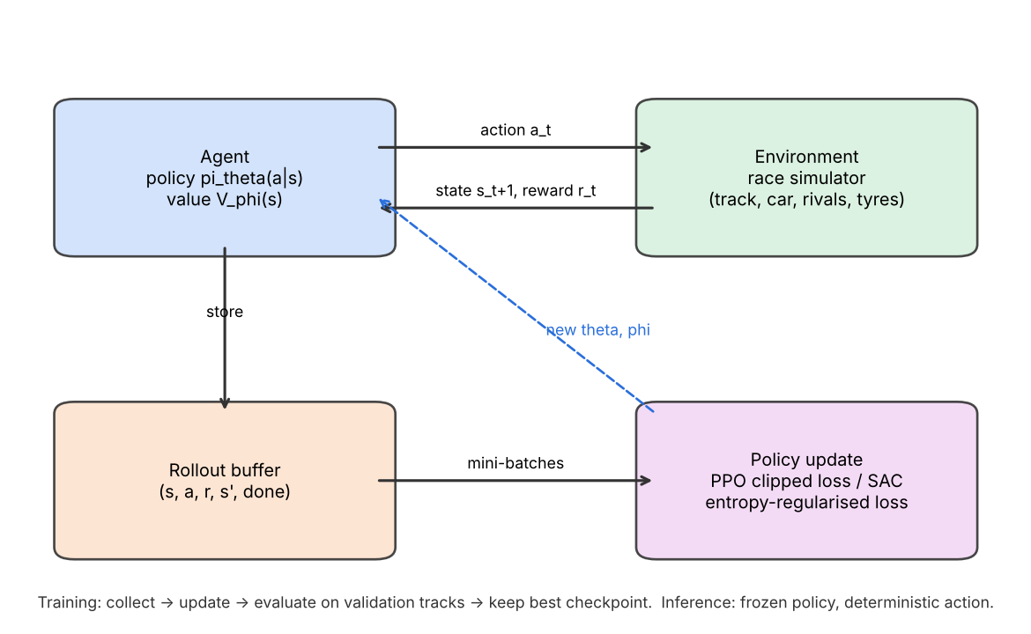
Conceptual RL loop used by both agents.
Fig. 1. The RL interaction and update loop. During training the agent’s actions are sampled from the stochastic policy, transitions are stored, PPO (or SAC for the pure-control baseline) updates the networks, and a periodic evaluation on validation circuits keeps the best checkpoint. At inference the frozen policy acts deterministically.

2. Literature Review / Related Work
Optimal control for racing. The classic way to drive fast is to compute a trajectory and track it. Liniger et al. used model predictive contouring control to race 1:43 cars [11], and Heilmeier et al. computed minimum-curvature racing lines and controllers for a full-size autonomous race car [12]; the TUM racetrack database released with that work provides the circuit geometry we use. Game- theoretic extensions add an opponent [15]. These methods give near-optimal laps and clear guarantees, but they need an accurate model, they are expensive to solve with interacting agents, and tactics such as a feint or a late lunge must be hand-specified. A survey of autonomous racing summarises these trade-offs [9].
End-to-end RL drivers. Early work learned lane following on a real car within a day [16], trained steering and throttle from images in a rally game [17], and ran open competitions in the TORCS simulator [18]. Fuchs et al. reached super-human lap times in Gran Turismo Sport with soft actor-critic [13], and Song et al. added overtaking through a three-stage curriculum [19]. GT Sophy [14] beat champion human drivers head-to-head; it used a distance-based passing reward, penalties for any collision, a mix of training scenarios and a population of opponents, trained on many consoles for days. These results show RL can find both speed and tactics, but they rely on large compute and on high-fidelity simulators, and their low-level policies have no explicit safety layer.
Hierarchical and multi-agent racing. Thakkar et al. split head-to-head racing into a high-level discrete game planner and a low-level controller learned with multi-agent RL, and won over 90% of races while obeying overtaking rules better than end-to-end MARL [20]. The general idea of temporally extended actions comes from the options framework [21] and later learned hierarchies such as option-critic [22], FeUdal networks [23] and HIRO [24]. In our design the options are hand-built race-craft manoeuvres and the hierarchy also spans the strategy layer.
Safe RL and shielding. García and Fernández surveyed ways to keep RL inside safe states [25]; Alshiekh et al. introduced shields that override unsafe actions of a learning agent [26]. Racing work usually relies on reward penalties instead [14]. Our shield is predictive and symmetric: it checks a short horizon for both cars and assumes each falls back on a rule-of-the-road manoeuvre.
Race strategy. Heilmeier et al. built a Monte-Carlo race simulation for circuit motorsport [8] and a “virtual strategy engineer” whose neural networks were trained on past decisions [10]. Thomas et al. trained an RL strategist (RSRL) for F1 and reported an average finish of P5.33 against P5.63 for the best baseline on the 2023 Bahrain Grand Prix [27]. Fieni et al. trained multi-agent strategists with self-play that manage energy, tyres and pit stops [28]. These works model the driver as a fixed lap-time function; none connects the strategist to the measured ability of a learned driver, and few test robustness to safety cars, rain and incidents at the same time.
Curriculum and data use. Curriculum learning orders tasks from easy to hard [29]; reward shaping changes the learning signal without changing the optimal policy when it is potential-based [30]. Behaviour cloning [31] provides warm starts but needs action labels, which public F1 data lacks.
Gap and positioning. Existing work either drives one car very well without an explicit safety guarantee, plans strategy with a fixed driver model, or needs large compute. Our approach is different in three ways: the driver acts at the level of manoeuvres on a planner that already laps near the limit, a shield enforces zero contact for every car including scripted opponents, and the strategist is trained on numbers measured from that same driver. This combination is necessary because, as our experiments show, a flat continuous-control agent did not reach competitive pace on our compute budget, and a strategist that assumes better overtaking than its driver has would choose plans the driver cannot execute.

3. Solution Approach / Methodology
The pipeline has two learning levels that share one simulator family. At the lower level, RaceEnv integrates a car in the Frenet frame of a real circuit at 50 Hz; TacticalEnv wraps it so that the Driver Agent picks a manoeuvre every 0.5 s, a PathDriver turns the manoeuvre into a speed and lateral-offset plan, and the safety shield checks every car’s command before the physics step. At the upper level, StrategyEnv simulates a full Grand Prix lap by lap for ten cars, using a lap-time table and pass/defend probabilities measured from the trained driver. Both agents are trained with PPO in Stable-Baselines3, evaluated on validation circuits during training, and scored once at the end on held-out circuits. The novelty sits in the move-level action space, the shield, the real-start curriculum and the measured driver profile that links the two levels.

3.1 Block Diagram
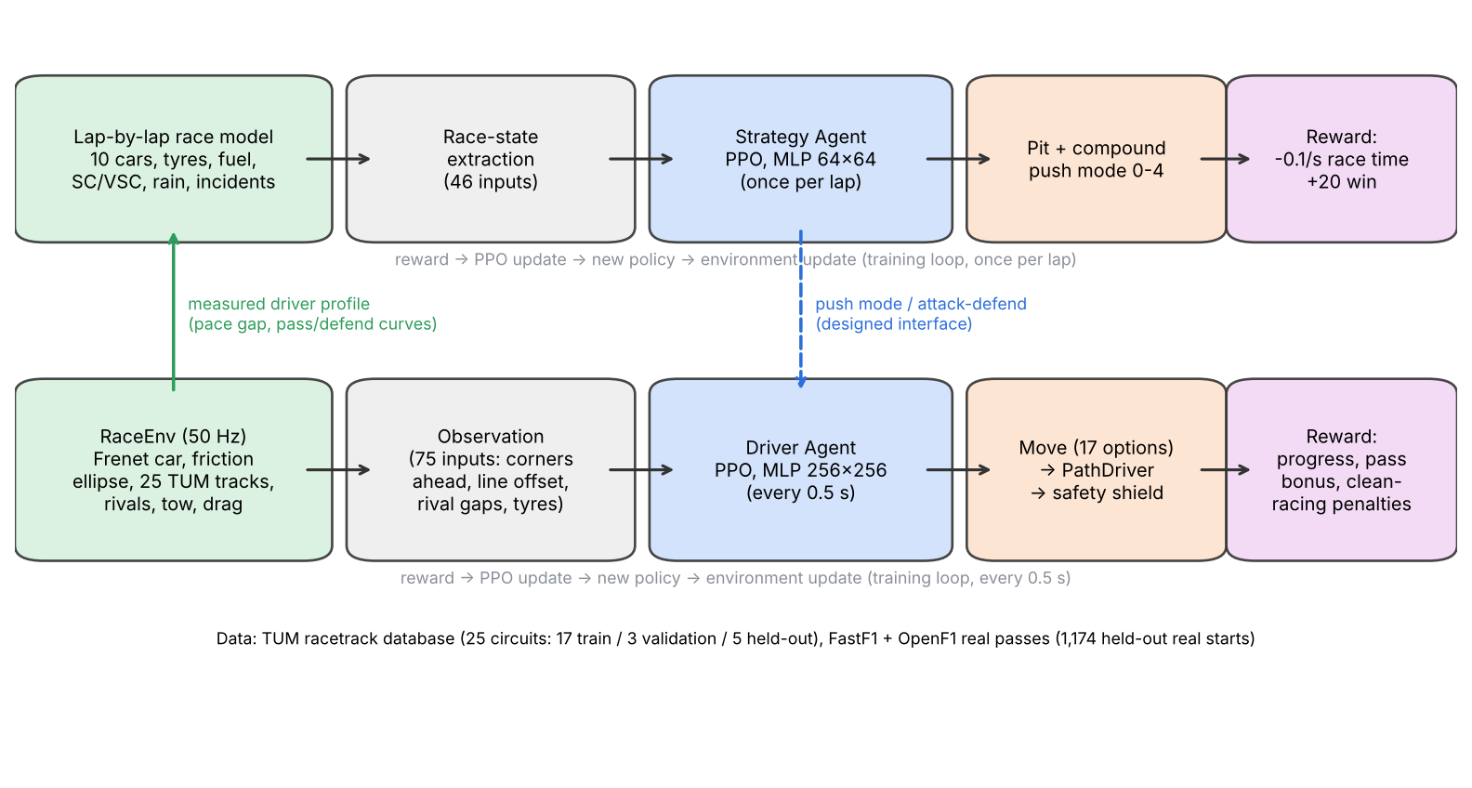
Full pipeline of the hierarchical system.
Fig. 2. Environment → state extraction → agent → policy/value network → action → environment update → reward → training loop, shown for both levels. The green arrow is the measured driver profile that parameterises the strategy level; the dashed blue arrow is the push-mode interface from strategist to driver (designed, with the mode currently applied as a lap-time scaling in the strategy simulator).

3.2 Environment Design

3.2.1 Track, car and physics
Circuits. Twenty-five real circuits from the TUM racetrack database [12] give centre lines and track widths. They are split once: 17 for training, 3 for model selection (Montreal, Hockenheim, Catalunya) and 5 for the final test only (Suzuka, Spa, Sao Paulo, Silverstone, Yas Marina). A minimum-curvature racing line and a g-g (friction-ellipse) lap simulation give each track’s limit lap, which serves as the pace reference.
Car. The car is a point mass with heading in the Frenet frame (arc length $s$, lateral offset $n$, heading error $ψ$). Longitudinal and lateral accelerations share one friction ellipse, ${\left(a_{x}/a_{x,max}\right)}^{2}+{\left(a_{y}/a_{y,max}\right)}^{2}≤μ^{2}$, with $a_{y,max}=5g$, braking $5g$, traction $1.5g$, top speed 97 m/s and an optional drag term chosen so that full throttle exactly holds top speed. Grip $μ$ falls with tyre wear, which grows with tyre load and time.
Interaction effects. A car within a short distance behind another gets a slipstream (12% less drag and a higher speed cap) but loses 4% grip in dirty air; all these values are design choices labelled as such in the configuration rather than claimed F1 figures.
Opponents. Scripted kinds include backmarker, slow, equal, defender, attacker and the “guard” defenders that make one legal move to the inside before a braking zone; RL-trained defenders and frozen copies of our own driver are also used.

3.2.2 State space
Driver Agent (75 inputs, all scaled to roughly $\left[−1,1\right]$). Speed, lateral offset and heading; the corner speed limits in 12 look-ahead windows from 10 m to 250 m; the optimal line’s offset and speed ahead (reference features); tyre wear and push level; gap, relative speed and lateral offset of the nearest car ahead and behind; the one-hot code of the move currently running; the corner after next and the metres left in the battle; and how the car ahead moved over the last second.
Strategy Agent (46 inputs). Race progress and laps left, place and gaps to the cars around, own compound, wear and fuel, whether the two-compound rule is met, the lap-time delta of each fresh compound against the current tyres, tyre life left against laps to go, the pit window per compound, where a stop would rejoin, rivals’ compounds and tyre ages, safety-car and VSC flags, and incident flags (spun, punctured, time lost, must stop).

3.2.3 Action space
Driver. Discrete(17): line, outside, divebomb, dummy, switchback, cover, inside, pull_in, pull_out, and eight lane moves (left/right of the car ahead at 3.0 m or 4.2 m centre-to-centre, each with normal or late braking). Once chosen, a lane move runs until the other car is cleared or 30 m behind (a committed option), which makes the problem a semi-MDP.
Strategist. MultiDiscrete([4, 5]): pit choice (stay out, soft, medium, hard) and push level (five modes from 92% to 95% of grip, with tyre wear from 0.58× to 1.73× of normal). The first action picks the starting tyre for free.

3.2.4 Transition dynamics
The driver environment integrates all cars with a 0.02 s step; each agent decision repeats for five physics steps (0.1 s) and a move is reconsidered every 0.5 s. Before each step the shield simulates a 2.5-3.0 s horizon for each pair of cars and replaces any command that cannot be followed by a safe fallback. Episodes end on leaving the track, driving the wrong way, falling below 3 m/s, a 90 s time limit, or at the end of a section battle.
The strategy environment advances one lap per step. Each car’s lap time is the measured lap for its grip level and fuel load, plus wear, push and dirty-air terms, plus pit loss when stopping (22 s; 12-14 s under SC/VSC). When a quicker car meets a slower one, a pass happens with a probability given by a logistic curve of the pace difference, fitted to the driver’s measured battles; otherwise the quicker car follows 0.3 s behind. Rivals run seeded variants of the rule-based plan.

3.2.5 Reward shaping
Driver. Per decision,
$$\begin{matrix}r_{t}=​ & \frac{Δs}{d_{p}}−c_{\text{fail}} 1\left[\text{off/stall}\right] \\ & +B \left(1\left[\text{pass held}\right]−1\left[\text{place lost}\right]\right) \\ & +w_{g} Δg 1\left[\text{near}\right]−c_{d} n_{\text{dirty}}−c_{i} n_{\text{shield}} \\ & −c_{w}\left(1−p\right) Δw±r_{\text{section}},\end{matrix}$$
with progress scale $d_{p}=50$ m, failure penalty $c_{\text{fail}}=50$, overtake bonus $B=100$ paid only once a new order has held for 600 m (so passing and being re-passed earns nothing), a GT Sophy-style gap term $w_{g}=1$ per metre gained on a nearby car [14], a penalty $c_{d}=1$ per physics step of “dirty” driving (less than 0.5 m of air side by side, chopping across a car’s nose, tailgating), a penalty for each step the shield had to intervene, a tyre-wear cost scaled by push level, and $±30$ at the end of a section battle.
Strategist. $r=−0.1 \left(T_{\text{lap}}−T_{\text{ref}}\right)$ per lap, summing to minus 0.1 times total race time, plus $+20$ for a legal win at the flag and $−50$ if the car never used two dry compounds.

3.3 RL Algorithm
We use Proximal Policy Optimization (PPO) [32] for both agents. PPO suits the discrete and multi-discrete action spaces, it is stable with many parallel environments, and its on-policy updates tolerate the non-stationarity caused by opponents and by changing scenario mixes better than replay-based methods. For the pure continuous-control baseline we used Soft Actor-Critic (SAC) [33], which is the standard choice for continuous throttle and steering [13].
PPO maximises the clipped surrogate
$$\begin{matrix}L^{\text{CLIP}}\left(θ\right) & =E_{t}\left[min\left(ρ_{t}\left(θ\right){\hat{A}}_{t}, clip\left(ρ_{t}\left(θ\right),1−ϵ,1+ϵ\right){\hat{A}}_{t}\right)\right], \\ ρ_{t} & =\frac{π_{θ}\left(a_{t}∣s_{t}\right)}{π_{θ_{\text{old}}}\left(a_{t}∣s_{t}\right)},\end{matrix}$$
with advantages from generalised advantage estimation [34] At=l≥0​γλlδt+l, $δ_{t}=r_{t}+γV_{ϕ}\left(s_{t+1}\right)−V_{ϕ}\left(s_{t}\right)$. The full loss is
$$\begin{matrix}L=​ & −L^{\text{CLIP}}+c_{v} E_{t}\left[{\left(V_{ϕ}\left(s_{t}\right)−{\hat{G}}_{t}\right)}^{2}\right] \\ & −c_{e} E_{t}\left[H\left(π_{θ}\left(⋅∣s_{t}\right)\right)\right],\end{matrix}$$
minimised with Adam for several epochs over mini-batches of each rollout; $ϵ=0.2$. SAC instead maximises Et​rt+αHπ⋅∣st with twin Q-critics, a target network updated with rate $τ$, and an automatically tuned temperature $α$.

3.4 Novel Components
Options on a planner (hierarchical action space). Rather than learning to steer, the driver chooses what to do and the PathDriver handles how: it plans corner speeds and braking points on the path it will actually drive, so every option is executed at the grip limit. Scripted with no sideways move, this planner laps 24 usable circuits at +1.1% (worst +1.5%) off the limit lap.
Bilateral predictive shield. For each pair of cars the shield simulates the proposed commands over the horizon and accepts them only if both cars could still fall back on the rules of the road. Otherwise it searches candidates in order of intrusiveness - lift before braking, then brake and/or move away - and never picks one that leaves the road unless nothing else is clear. Four successive fixes were needed: treating the fallback itself as a candidate, preventing brake-tests, rejecting off-road swerves beside a car, and widening steering authority and horizon.
Real-start curriculum. About 1,200 real passes and defences (FastF1 for 2021- 2022, OpenF1 for 2023 onwards) are converted to start states 400 m before the real pass location; 40% of training episodes begin from one. The held-out circuits’ real starts form the final test.
Behaviour-cloned warm start. Before PPO, the driver is trained by supervised learning to copy the scripted tactician’s choices (60k decisions, 95.9% agreement in one run; 40k defence decisions at 91.1% in the defend run), so exploration starts from competent play.
Driver profile and stay-out prior. The trained driver is measured on all 25 circuits (225 solo laps and 1,512 one-lap battles) to fit its pace gap and logistic pass and defend curves; the strategy simulator uses these numbers. When the win reward is sparse, the pit head’s “stay out” logit is raised by 5 at initialisation.

3.5 Algorithm Description
Algorithm 1: Hierarchical training of the Driver and Strategy Agents
Input: circuits split C_train / C_val / C_test; real-start library D; seeds
1: // ---------- Driver level ----------
2: init policy pi_theta, value V_phi (MLP 256x256); set seed
3: pi_theta <- behaviour-clone(scripted tactician on C_train) # warm start
4: repeat until N_driver decisions:
5: for each of K parallel envs:
6: reset: pick circuit c ~ C_train; with prob 0.4 start from d ~ D(c),
else random section battle vs opponent from the mix
7: observe s_t (75 features)
8: a_t ~ pi_theta(.|s_t) # move choice
9: for each 0.1 s sub-step of the 0.5 s decision:
10: u_i <- PathDriver(move_i) for every car i
11: u_i <- Shield(u_i, others) # zero-contact filter
12: integrate physics (dt = 0.02 s)
13: r_t <- progress + held-pass bonus + gap term - dirty - shield - wear
14: store (s_t, a_t, r_t, s_{t+1}, done)
15: compute GAE advantages; for E epochs over mini-batches: Adam step on PPO loss
16: every M decisions: evaluate on C_val; keep checkpoint if best and contact-free
17: measure driver on all circuits -> profile P (pace gap, pass/defend logistic fits)
18: // ---------- Strategy level ----------
19: init pi_psi (MLP 64x64); add stay-out prior to pit logits
20: repeat until N_strategy laps:
21: reset race: circuit ~ C_train, grid slot, rivals' plans, random SC/VSC/
spin/puncture/rain draws (seeded)
22: each lap: observe race state (46 features); (pit, push) ~ pi_psi
23: simulate one lap for 10 cars using P; r <- -0.1 * lap time delta
24: at the flag: r += 20 * win - 50 * illegal
25: PPO update as in lines 15-16, selecting checkpoints by validation wins
26: return pi_theta*, pi_psi*
Stopping: fixed decision/lap budget; best checkpoint chosen on C_val only;
C_test is touched once, at the end.

4. Experimental Results

4.1 Experimental Setup
Data. No offline RL dataset is used. Circuit geometry comes from the TUM racetrack database (25 circuits, pinned commit). Real overtaking situations come from FastF1 timing for 2021-2022 and from the OpenF1 API for 2023-2025; 2018-2020 were skipped because they now require a paid login. The held-out library contains 1,174 real starts on the five test circuits.
Environment. As in Section 3.2. Driver: 50 Hz physics, 10 Hz control, a move decision every 0.5 s, 90 s battles or 600-800 m sections spanning two corners. Strategy: full Grand Prix length (fewest laps covering 305 km), ten cars, our car starting tenth.
Hardware. All driver training ran on a laptop CPU (AMD Ryzen 7 7840HS, 8 cores / 16 threads, no GPU). Strategy runs ran on that laptop or on a 4-vCPU cloud container, also without a GPU.
Software. Python 3.12, Gymnasium [35], Stable-Baselines3 2.9 [36], PyTorch 2.14, NumPy, FastF1 3.8 and the OpenF1 REST API, with uv for reproducible environments. Every run writes its resolved configuration, seed and git commit next to its checkpoints.
Hyperparameters.
Setting | SAC driver (baseline) | PPO driver (defend run 2) | PPO driver (real starts) | PPO strategist
Learning rate | 3e-4 → 3e-5 (linear) | 1e-4 | 3e-4 | 3e-4
Discount $γ$ | 0.995 | 0.97 | 0.99 | 0.995
GAE $λ$ / SAC $τ$ | $τ$ = 0.005 | 0.95 | 0.95 | 0.95
Batch size | 256 | 256 | 512 | 256
Rollout / buffer | 1M replay | 128 steps × 12 envs | 256 × 8 envs | 512 × 4 envs
Epochs per update | 4 gradient steps / vec-step | 8 | 6 | 10
Exploration | auto entropy temperature | entropy coef. 0.01 + BC warm start | entropy coef. 0.03 + BC | entropy coef. 0.01 + stay-out prior
Network | 256×256 ReLU | 256×256 ReLU | 256×256 ReLU | 64×64 tanh (SB3 default)
Training budget | 2.0M decisions | 0.5M decisions | 1.5M decisions | 1.5-3M laps (≈25k-50k races)
Effect of each setting (observed in our runs).
- Discount factor. In an early lap-time driver, $γ=0.98$ (a 5 s horizon at 10 Hz) learned to stop before a chicane because it could not see the value of the rest of the lap; $γ=0.995$ fixed this. For the move-level driver, whose decisions last 0.5 s or a whole manoeuvre, 0.97-0.99 was enough.
- Control rate. At 50 Hz the early driver never discovered braking; 10 Hz worked; a 25 Hz SAC variant completed no lap after 250k decisions.
- Reward scale and learning rate. Multiplying all driver rewards by 10 sped up early SAC learning (+18% off the limit at 300k vs +26%), but linear learning-rate decay did not remove the final plateau. A smaller PPO learning rate (1e-4) in the defend run kept the attacking skill from being overwritten.
- Entropy and exploration. After behaviour cloning, entropy collapsed and the driver stopped attempting passes; raising the entropy coefficient from 0.01 to 0.03 together with a larger pass bonus restored them (Section 4.5). In self-play pilots the policy entropy still collapsed to about 0.3 nats.
- Batch size and epochs. Not swept systematically; values follow common PPO defaults scaled to the number of environments.
- Seeds. All earlier runs used seed 0. To measure seed sensitivity we retrained the main strategy configuration with three seeds (Section 4.2.5).

4.2 Performance Evaluation

4.2.1 Mean evaluation return and learning curves
Because the reward weights differ between runs, we report the task-level quantity each evaluation measured rather than raw return: lap-time gap for pure driving, success rate for battles, and win rate for strategy.
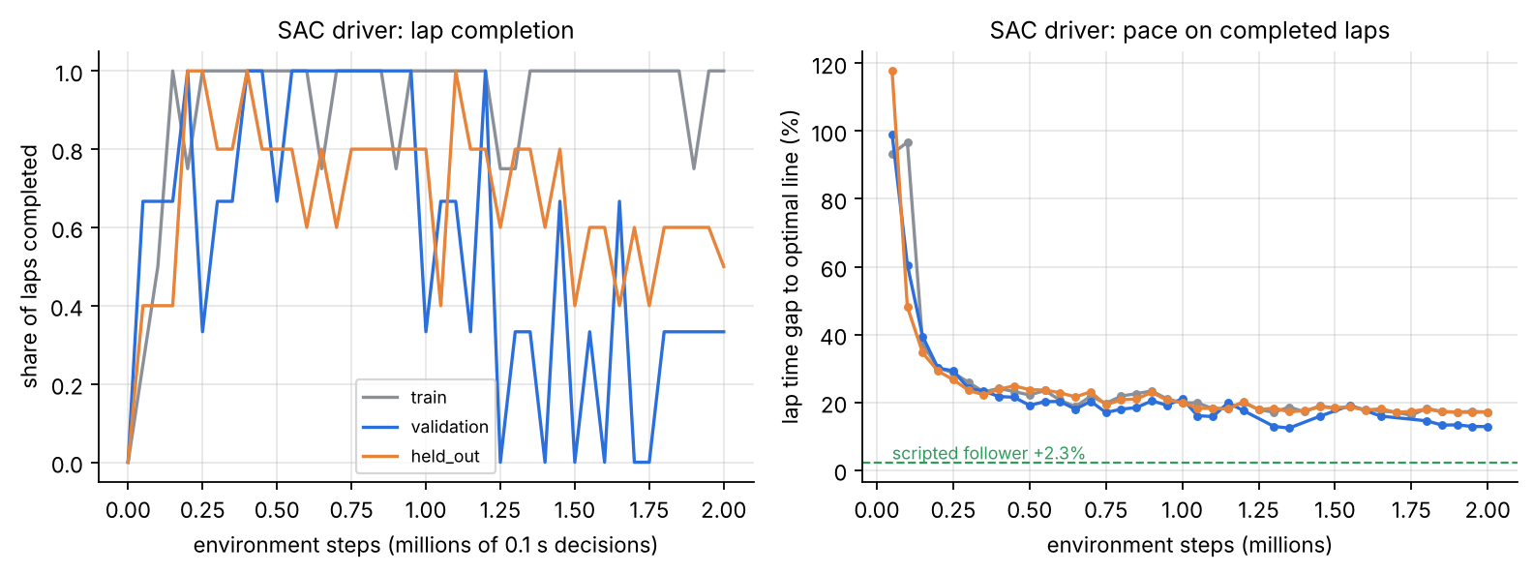
SAC learning curve.
Fig. 3. Pure-RL SAC driver (seed 0). Left: share of evaluation laps completed; right: mean gap to the optimal-line lap on completed laps. Pace improves quickly from +100% to about +25% within 0.3M decisions, then flattens at +13% to +20%; the scripted planner sits at +2.3%.
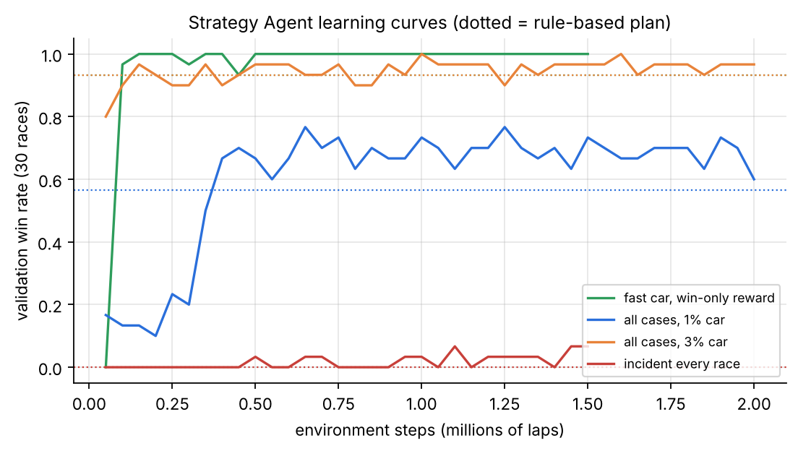
Strategy learning curves.
Fig. 4. Strategy Agent validation win rate (30 races per point) for four scenario configurations. Dotted lines are the rule-based plan on the same races.
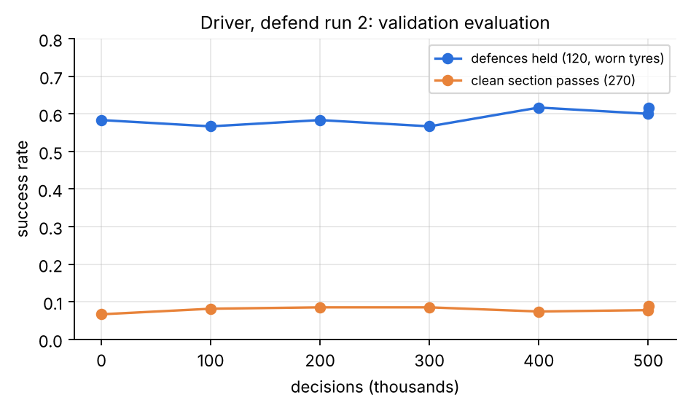
Defend run learning curve.
Fig. 5. Driver defend run 2: validation defences held (120, worn tyres) and clean section passes (270) over 0.5M decisions. Both curves are nearly flat: the behaviour-cloned start already sits close to what these moves allow.

4.2.2 Success rate
Success is defined per task. A pass succeeds when our car is ahead at the end of the battle, the new order has held for 600 m (1 km in later re-scoring), and there was no contact, no off-track and no dirty step. A defence succeeds when the car is still ahead and clean. A race succeeds when the car wins legally.
Task (held-out circuits) | Proposed | Best baseline
Defences held, worn tyres (460) | 273 (59.3%) | 264 (57.4%) line-holding
Clean section passes vs slow + guard cars (350) | 49 (14.0%) | 29 (8.3%) starting policy
Attack vs equal-pace defender, real starts (495)* | 434 (87.7%) | 168 (33.9%) scripted tactician
Race wins, clean, 1% faster car (200, 3 seeds) | 96.7% | 91% rule-based plan
Race wins after a spin (200, 3 seeds) | 29.8% | 4.5%
Race wins, safety car (200, 3 seeds) | 78.0% | 89.5%
*Later found to be inflated by place-swapping; see Section 4.3.

4.2.3 Cumulative regret
We define regret against the best available reference policy.
Driving (cost minimisation). Per lap, $\text{regret}=T_{π}−T_{\text{opt}}$, the time lost to the optimal-line limit lap in the same physics. Summed over the four held-out circuits that the SAC agent finished, cumulative regret is 57.9 s for SAC, 46.5 s for the v1 cautious baseline, and 6.8 s for the scripted path follower; Yas Marina is excluded because SAC did not finish it (scripted: 2.5 s there).
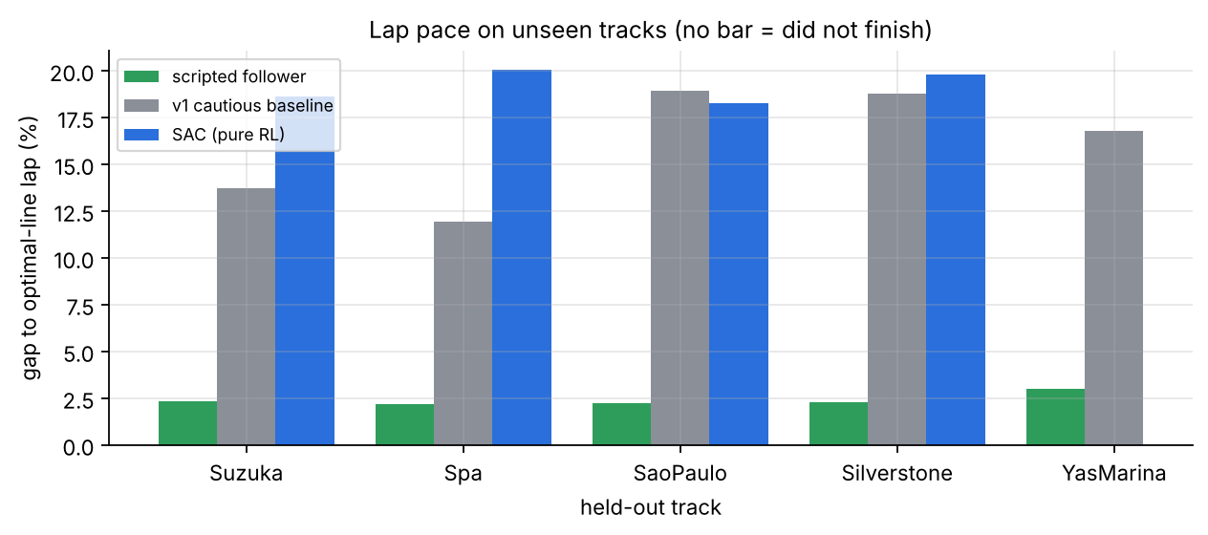
Lap gaps on held-out circuits.
Fig. 6. Gap to the optimal lap on each held-out circuit.
Strategy (reward maximisation). Per race, place regret is $\text{place}−1$ (distance from the best possible result). In the fastest-car, win-only scenario the agent’s cumulative place regret over 200 held-out races is 0 (200/200 wins) against 22 for the rule-based plan (mean place 1.11). For race time we define regret per race as the time lost to the faster of the two policies on that seeded race. Over 200 clean held-out races the three seeds accumulate 44 s, 173 s and 26 s of race-time regret, against 1,125 s for the rule-based plan (measured against seed 2): the agent is the faster policy in almost every race.

4.2.4 Convergence speed and sample efficiency
We measure the number of environment steps until the validation win rate first exceeds the rule-based plan’s, and until it reaches 90% of its own best.
Strategy configuration | Baseline win rate | Steps to beat baseline | Steps to 90% of best | Best win rate
Fast car, win-only reward | 93% | 100k laps (≈1.7k races) | 100k | 100%
All cases, 3% faster car | 93% | 150k | 100k | 100%
All cases, 1% faster car | 57% | 400k (≈6.7k races) | 450k | 77%
Incident every race (wins) | 0% | 500k | 1.1M | 7%
The driver is far less sample-efficient: SAC needed about 0.3M decisions (8 h of simulated driving) just to finish laps reliably, and never matched the scripted planner within 2M decisions. The move-level PPO driver starts from a behaviour-cloned policy, so its first evaluation is already competent; the real- start run reached its attack plateau within 0.2M decisions (Fig. 8).

4.2.5 Stability across seeds
We retrained the main strategy configuration (strategy_all.yaml: 1% faster car, races with spins, punctures, SC and VSC) with three seeds (0, 1, 2) for 1M laps each, using identical code, and scored each seed’s best checkpoint on the same 200 held-out races per case. These runs use the current configuration, which includes the minimum-stint rule (no new stop within five laps of the last).
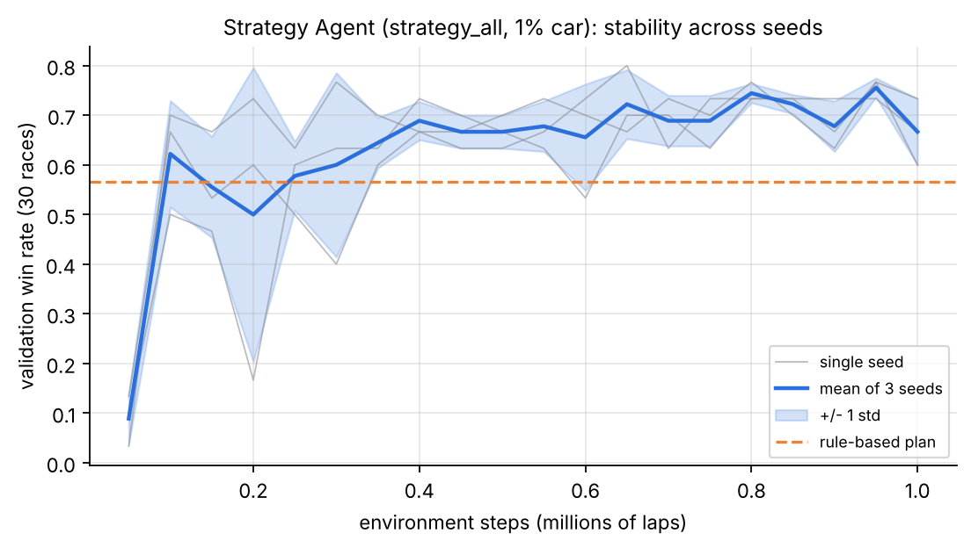
Seed stability.
Fig. 7. Validation win rate for three seeds: individual runs (grey), mean (blue) and one standard deviation (band). All three seeds pass the rule-based plan’s 57% within 0.1-0.25M laps and settle at 60-80%.
Held-out case (200 races) | Seed 0 | Seed 1 | Seed 2 | Mean ± s.d. | 95% CI | Rule-based
Clean race wins | 97.0% | 95.0% | 98.0% | 96.7 ± 1.5% | ±3.8 | 91.0%
After a spin | 33.5% | 25.5% | 30.5% | 29.8 ± 4.0% | ±10.0 | 4.5%
After a puncture | 0% | 0% | 0% | 0% | - | 0%
Safety car | 81.0% | 78.0% | 75.0% | 78.0 ± 3.0% | ±7.5 | 89.5%
VSC | 93.5% | 82.5% | 86.0% | 87.3 ± 5.6% | ±14.0 | 89.0%
Mean race time vs rule-based, clean | -5.0 s | -3.4 s | -5.5 s | -4.6 ± 1.1 s |  | 0
Steps to first beat the rule-based plan on validation: 100k, 250k and 100k laps; best validation win rate 77%, 77% and 80%. The clean-race and after-spin advantages hold for every seed and their confidence intervals exclude the baseline. The safety-car result does not: every seed wins fewer SC races than the rule-based plan (78% vs 89.5%), although its mean race time is still 0.5-1.4 s shorter. The agent optimises race time, not position, and under the minimum-stint rule it makes extra stops under the safety car (1.4-1.6 stops against 1.0) that save time on average but sometimes cost the lead. The earlier single-seed agent trained without the minimum-stint rule won 94.5% of SC races, so this rule and the time-based reward interact; a position-aware term under neutralised running is the obvious fix. Seed 1 is the weakest in every case, which shows why a single seed should not be reported alone.

4.2.6 Computational efficiency
Item | Value
SAC driver training (2.0M decisions) | 3 h 29 min, laptop CPU, ≈165 decisions/s shared
PPO real-start driver (1.5M decisions) | 3 h 31 min, ≈117 decisions/s with the shield on
PPO defend run 2 (0.5M decisions) | 1 h 19 min, ≈104 decisions/s
PPO strategist (2M laps) | 1M laps in about 15 min per run (three runs sharing 4 vCPUs, one thread each); ≈1.1k laps/s
Safety shield cost | ≈35% lower environment throughput
Parameters | driver 175,122; strategist 14,986
Inference latency (CPU, batch 1) | driver 0.06 ms per decision, strategist 0.15 ms per decision (policy only)
Total logged training time | > 20 h CPU across all runs; no GPU used
A strategy training run used about 0.8 GB of resident memory in its main process; memory of the driver runs and energy use were not measured.

4.2.7 Problem-specific metrics
For racing we report: gap to optimal lap (%), contacts, off-tracks, dirty steps (unsafe proximity), shield interventions, clean passes held, defences held, and tyre wear per lap. For strategy: win rate, podium rate, mean finishing place, race time, legality (two-compound rule), stops per race, undercuts made and suffered, and on-track passes per race. Generalisation is always reported on the five unseen circuits; robustness to opponents is reported against scripted, RL-trained and frozen-self opponents.

4.3 Results and Discussion
Result 1 - pure end-to-end RL plateaued. What happened: every SAC recipe (different look-ahead, reward scales, control rates, demonstrations, optimal-line features) plateaued at 17-20% slower than the limit lap; the best checkpoint finished four of five held-out circuits at +19.2%. Why: the agent found a cautious optimum - it failed only 2-5% of training episodes but averaged about 60 m/s against 70 m/s on the optimal line; one off-track costs 50 reward units, more than the time gained by braking later in many corners. Expected? Partly; published superhuman SAC drivers trained for far longer on richer signals [13]. Stability: completion on validation swung between 0/3 and 3/3 at the same average pace, so checkpoint selection was partly luck. Unseen tracks: held-out pace matched training pace, so the plateau was not over-fitting. This result motivated the move-level design.
Result 2 - the shield removed contacts at small cost. With the scripted tactician on 424 held-out real starts, contacts fell from 20 to 0; off-tracks rose from 18 to 30 because the shield’s swerves left the planner less margin, which later fixes reduced to zero on 284 validation starts with random moves. Every trained driver since then recorded zero contacts on held-out circuits except two, both caused by a scripted attacker at the same Silverstone corner. Component: the symmetric fallback check; reward penalties alone had left 1-4 contacts per evaluation.
Result 3 - reward exploitation in attacking, and its fix. With an overtake bonus of 100 the real-start driver beat the scripted tactician by a wide margin (434/495 vs 168/495 attacks). Watching replays revealed that the agent swapped places back and forth: it was paid for a pass that did not last. When passes had to hold 1 km over 150 s battles, the same model succeeded in only 7 of 49 attacks. We then (a) paid the bonus only once a new order held for 600 m and charged equally for re-passes, (b) added dirty-driving penalties, and (c) scored battles strictly. Under these rules the learned driver roughly matches but does not beat the scripted tactician on attacks (56 vs 65 of 525 held-out battles), while the defend-trained driver improves both defence (273 vs 264) and attack (49 vs 29 of 350). Where it failed: a brute-force oracle over the same moves found only 38 of 180 validation battles winnable within one section, so the ceiling, not the learner, limits overtaking at small pace gaps.
Result 4 - the strategist learned undercuts and event responses. Trained against rivals that all run the rule-based plan, the agent discovered a race-long undercut: a medium-to-hard stop at 36-42% of the race, earlier than every rival, then inheriting the lead as they stop later on older tyres. With our measured driver (which needs a large pace edge to pass) it won 72% of held-out races against 10% for the rule-based plan, and finished on the podium in 95% against 33%. In the rain it pitted about a lap earlier than rivals by reading the forecast (68% wins against 0%). After a spin it pits next lap for fresh tyres and attacks (29% wins vs 4.5%). Which component: the race-state features (tyre delta, pit window, rejoin position) and the race-time reward; the win-only reward did not learn without the stay-out prior. Where it failed: a puncture costs 40-50 s, which a 0.3 s/lap edge cannot recover (0% for both policies); VSC wins were level (88.5% vs 89%).
Result 5 - generalisation. Every number above is on circuits never used for training or model selection. Strategy performance on held-out circuits was lower than on validation in the first pilot (place 4.20 vs 2.75), and similar in later runs; driver results transferred with no visible gap.

4.4 Comparison with Existing / Benchmark Methods
Driver.
Method | Gap to optimal ↓ | Clean passes (350) ↑ | Defences held (460) ↑ | Contacts ↓ | Unseen circuits | Train time ↓
v1 cautious rule-based driver | +11.9% to +18.9% | - | - | - | 5/5 finished | none
SAC end-to-end [33] | +18.3% to +20.1% | - | - | - | 4/5 finished | 3.5 h
Scripted path follower (no moves) | +1.1% (25 circuits) | 0 | 264 | 0 | 5/5 | none
Scripted tactician (rule-based moves) | +1.1% | 65 / 525† | 257 | 0 | 5/5 | none
PPO move-level driver + shield (proposed) | +1.1% planner‡ | 49 (start 29) | 273 | 2 | 5/5 | 1.3 h (+ earlier stages)
†Different battle set (two-corner battles against slow, guard and RL defenders). ‡Lap pace comes from the planner; under the full tactical layer the solo lap was +3.1%.
Strategist (held-out races, 1% faster car, starting tenth).
Method | Win rate ↑ | Mean place ↓ | Legal ↑ | Unseen circuits | Decision time
Random policy | 0% | 10.0 | 95% | yes | -
Rule-based M→H one-stop at 45% | 91% clean / 4.5% after spin | 1.11 (win-only scenario) | 100% | yes | negligible
RSRL [27] (reported, different simulator) | - | P5.33 vs P5.63 baseline | - | Bahrain 2023 | -
PPO strategist (proposed, 3 seeds) | 96.7% clean / 29.8% after spin / 78% SC | 1.00 (win-only scenario) | 100% | yes | 0.15 ms
Results from other papers use different simulators and fields, so they are listed for context, not as a direct numerical comparison.

4.5 Ablation Study
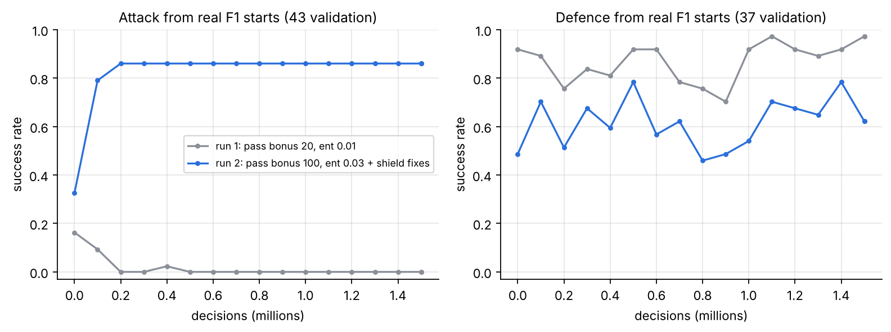
Reward ablation for the attacking driver.
Fig. 8. Real-start driver, run 1 (overtake bonus 20, entropy coefficient 0.01) vs run 2 (bonus 100, entropy 0.03, plus shield fixes). Run 1 stops attacking within 0.2M decisions; run 2 attacks on 37/43 starts but defends worse.
Component removed or changed | Effect (validation unless noted)
Overtake bonus 100 → 20, entropy 0.03 → 0.01 | attack success 37/43 → 0/43 after 0.2M decisions (passive policy)
Pass must hold 600 m / 1 km | without it, reported attacks 434/495 fell to 7/49 under strict scoring
Safety shield | contacts 0 → 20 on 424 held-out real starts (scripted driver)
Shield fixes 1-3 (fallback as candidate, no brake-test, no off-road beside car) | random-move contacts 2 → 1, off-tracks 26 → 3 on 284 starts
Shield fix 4 (steer 0.4 → 0.8, horizon 1.5 → 2.5 s) | 18 contacts → 0 in 150 validation defences
Move-level actions → raw continuous control (SAC) | gap to limit +1.1% (planner) → +17-20%
Optimal-line features added to SAC | no gain (+19-21% vs +19.2%)
Air drag + two-corner battles | scripted passes 13 → 23 of 180; off-tracks 18 → 9
Dirty air removed (diagnostic) | scripted passes 23 → 36 of 180
Stay-out prior removed (win-only reward) | no learning: random policy pits 3 laps in 4, never wins
Dense race-time reward vs win-only (incident races) | win-only: P10, pitting every lap; dense: P6.9 vs 8.1 baseline
Driver profile: strategist trained on rain mix used in dry races | dry wins 25% vs 72% for dry-trained agent

4.6 Robustness, Sensitivity and Generalization
Robustness (environment changes). Opponent change: the defending driver was tested against four attacker types, including a frozen copy of itself; the overtaking driver against slow, guard and RL-trained defenders. Across all of these opponents the shielded driver recorded two contacts in 810 held-out battles, both caused by the same scripted attacker at one corner. Against the RL-trained defender the learned attacker passed 14 of 175 times against 15 for the scripted tactician, so a stronger opponent lowers the success rate of both drivers alike. Failures and events: the strategist was evaluated separately on clean races, spins, punctures, safety cars and VSCs (Fig. 9). With a 3% faster car it won 99.5-100% in every case except punctures (56% vs 44% for the rule-based plan). Forecast error: the rain agent reads a noisy 3- and 6-lap forecast and still pitted about one lap before rivals. Sensor error: not tested; observations are exact.
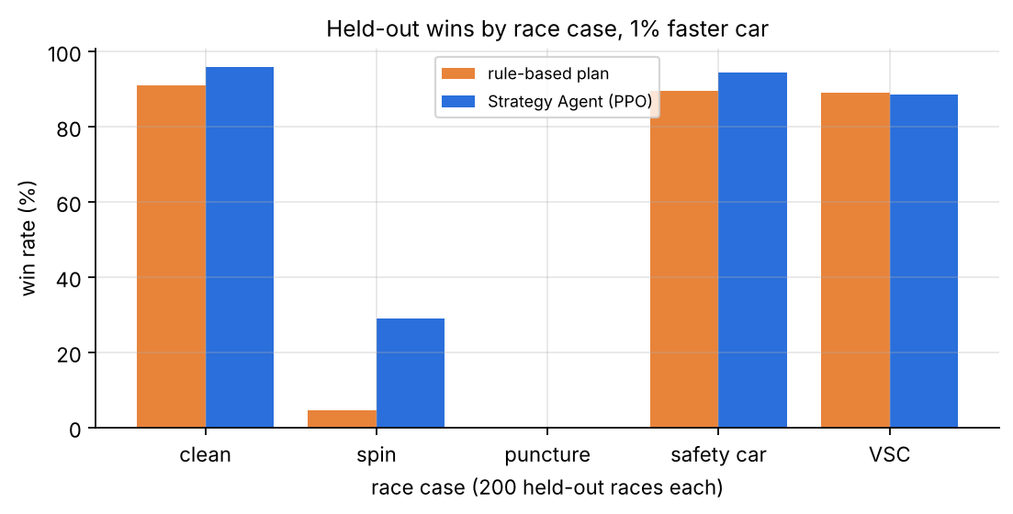
Held-out wins by race case.
Fig. 9. Held-out wins by race case, 200 races each, 1% faster car (the single-seed model trained without the minimum-stint rule; the three-seed results with the rule are in Section 4.2.5).
Sensitivity (parameter changes). With car pace edges of 0.5%, 1% and 3%, the agent’s advantage over the rule-based plan is largest where the race is close (1%: 96% vs 91% clean, 29% vs 4.5% after a spin) and vanishes when the car is so fast that any sensible plan wins (3%). With a stronger overtaker (pass at a 1.5 s/lap edge) the agent switched from a clean-air plan to racing through traffic (11.4 vs 7.8 passes per race). Grip-to-lap-time sensitivity: 1% grip ≈ 0.3 s per lap.
Generalisation. Driver and strategist were selected on three validation circuits and tested once on five unseen circuits that differ in layout (Spa’s long straights, Suzuka’s esses, Sao Paulo’s short lap). The held-out library of real starts adds unseen situations drawn from real races.

5. Limitations
- Simulator fidelity. The car is a point mass with a friction ellipse, no load transfer, no tyre temperature and simplified aerodynamics. Slipstream, dirty air, tyre compounds, pit loss, safety-car and weather effects are design values, not calibrated F1 figures; a one-race FastF1 tyre fit was not identifiable because tyre age and fuel burn are collinear.
- Data limitations. Public data has no steering or pedal signals and only ~4 Hz positions; 2018-2020 sessions now need a paid login; OpenF1 races have no pass locations yet, so only their defences are used.
- Overtaking ceiling. At realistic pace gaps (0.4-1.2 s per lap) clean passes remain rare for both the learned and the scripted driver; the learned driver does not yet beat the scripted tactician on strict attacking.
- Reward exploitation. The place-swapping episode shows the reward can be gamed; the strict scoring fixes the known case but cannot rule out others.
- Loose coupling of the hierarchy. The strategist uses a statistical profile of the driver; the driver does not yet receive the push mode as an input, and the two levels are not fine-tuned jointly.
- Rival behaviour. Strategy rivals follow seeded rule-based plans and never react to an undercut, which flatters early stops; there is no cold-tyre out-lap.
- Statistical scope. Apart from the three-seed strategy study, results come from one seed per configuration; the seed study itself found a safety-car weakness (78% vs 89.5% wins) that one seed alone had hidden; evaluation sets of 30-40 races give wide confidence intervals.
- Computational cost. Driver training runs at 100-170 decisions per second on a laptop CPU, and the shield costs about a third of that, which limited the number of driver experiments and seeds.
- Unresolved failures. Punctures cannot be recovered with a small pace edge; the defend scenario on held-out circuits succeeded 2/5; lap pace under the full tactical layer is +3.1% instead of the 1% target.

6. Conclusion and Future Work
We studied racing as a two-timescale decision problem in which an F1 car must be driven fast and cleanly while a strategist manages tyres and pit stops through unpredictable events. The gap we targeted is that end-to-end RL drivers need large compute and lack hard safety, while RL strategists are trained on fixed lap-time models unrelated to any real driver. Our system combines a PPO driver that selects race-craft options on a near-limit path planner, a bilateral predictive shield that enforces zero contact, a curriculum seeded with real F1 passes, and a PPO strategist trained on the measured profile of that driver. The experiments establish four things: flat continuous control (SAC) plateaued at 17-20% off the limit while the planner-based hierarchy laps within 1.1-3.1%; the shield eliminated contacts across more than a thousand real held-out situations; the defending driver improved held-out defences (273 vs 264) and passes (49 vs 29); and the strategist learned undercuts and event responses that beat a rule-based plan on unseen circuits (96% vs 91% clean wins, 29% vs 4.5% after a spin, 200/200 when quickest), reaching baseline level within 0.1-0.4 million laps. Across three seeds the clean-race and after-spin gains are stable (96.7 ± 1.5% and 29.8 ± 4.0% wins), while safety-car races expose a weakness of the race-time reward under the minimum-stint rule (78% vs 89.5%).
Future work follows from the limitations: calibrate tyre and pit constants from multi-race FastF1 stints; give the driver the push mode and attack/defend orders as inputs and fine-tune both levels jointly; replace scripted rivals with a league of learned opponents and reactive strategists, as in population-based self-play [4], [14]; add defensive late braking and holding the inside through a corner, which the oracle analysis identifies as the missing moves; add ERS deployment, cold-tyre out-laps and lapped traffic; and repeat every driver experiment over several seeds with confidence intervals [37], [38].

References
[1] R. S. Sutton and A. G. Barto, Reinforcement Learning: An Introduction, 2nd ed. Cambridge, MA, USA: MIT Press, 2018.
[2] V. Mnih et al., “Human-level control through deep reinforcement learning,” Nature, vol. 518, no. 7540, pp. 529–533, 2015.
[3] D. Silver et al., “Mastering the game of Go with deep neural networks and tree search,” Nature, vol. 529, no. 7587, pp. 484–489, 2016.
[4] O. Vinyals et al., “Grandmaster level in StarCraft II using multi-agent reinforcement learning,” Nature, vol. 575, no. 7782, pp. 350–354, 2019.
[5] J. Kober, J. A. Bagnell, and J. Peters, “Reinforcement learning in robotics: A survey,” Int. J. Robot. Res., vol. 32, no. 11, pp. 1238–1274, 2013.
[6] B. R. Kiran et al., “Deep reinforcement learning for autonomous driving: A survey,” IEEE Trans. Intell. Transp. Syst., vol. 23, no. 6, pp. 4909–4926, 2022.
[7] E. Kaufmann, L. Bauersfeld, A. Loquercio, M. Müller, V. Koltun, and D. Scaramuzza, “Champion-level drone racing using deep reinforcement learning,” Nature, vol. 620, no. 7976, pp. 982–987, 2023.
[8] A. Heilmeier, M. Graf, J. Betz, and M. Lienkamp, “Application of Monte Carlo methods to consider probabilistic effects in a race simulation for circuit motorsport,” Appl. Sci., vol. 10, no. 12, Art. no. 4229, 2020.
[9] J. Betz et al., “Autonomous vehicles on the edge: A survey on autonomous vehicle racing,” IEEE Open J. Intell. Transp. Syst., vol. 3, pp. 458–488, 2022.
[10] A. Heilmeier, A. Thomaser, M. Graf, and J. Betz, “Virtual strategy engineer: Using artificial neural networks for making race strategy decisions in circuit motorsport,” Appl. Sci., vol. 10, no. 21, Art. no. 7805, 2020.
[11] A. Liniger, A. Domahidi, and M. Morari, “Optimization-based autonomous racing of 1:43 scale RC cars,” Optim. Control Appl. Methods, vol. 36, no. 5, pp. 628–647, 2015.
[12] A. Heilmeier, A. Wischnewski, L. Hermansdorfer, J. Betz, M. Lienkamp, and B. Lohmann, “Minimum curvature trajectory planning and control for an autonomous race car,” Veh. Syst. Dyn., vol. 58, no. 10, pp. 1497–1527, 2020.
[13] F. Fuchs, Y. Song, E. Kaufmann, D. Scaramuzza, and P. Dürr, “Super-human performance in Gran Turismo Sport using deep reinforcement learning,” IEEE Robot. Autom. Lett., vol. 6, no. 3, pp. 4257–4264, 2021.
[14] P. R. Wurman et al., “Outracing champion Gran Turismo drivers with deep reinforcement learning,” Nature, vol. 602, no. 7896, pp. 223–228, 2022.
[15] A. Liniger and J. Lygeros, “A noncooperative game approach to autonomous racing,” IEEE Trans. Control Syst. Technol., vol. 28, no. 3, pp. 884–897, 2020.
[16] A. Kendall et al., “Learning to drive in a day,” in Proc. IEEE Int. Conf. Robot. Autom. (ICRA), 2019, pp. 8248–8254.
[17] M. Jaritz, R. de Charette, M. Toromanoff, E. Perot, and F. Nashashibi, “End-to-end race driving with deep reinforcement learning,” in Proc. IEEE Int. Conf. Robot. Autom. (ICRA), 2018, pp. 2070–2075.
[18] D. Loiacono et al., “The 2009 simulated car racing championship,” IEEE Trans. Comput. Intell. AI Games, vol. 2, no. 2, pp. 131–147, 2010.
[19] Y. Song, H. Lin, E. Kaufmann, P. Dürr, and D. Scaramuzza, “Autonomous overtaking in Gran Turismo Sport using curriculum reinforcement learning,” in Proc. IEEE Int. Conf. Robot. Autom. (ICRA), 2021, pp. 9403–9409.
[20] R. S. Thakkar, A. S. Samyal, D. Fridovich-Keil, Z. Xu, and U. Topcu, “Hierarchical control for head-to-head autonomous racing,” Field Robot., vol. 4, pp. 46–69, 2024.
[21] R. S. Sutton, D. Precup, and S. Singh, “Between MDPs and semi-MDPs: A framework for temporal abstraction in reinforcement learning,” Artif. Intell., vol. 112, no. 1–2, pp. 181–211, 1999.
[22] P.-L. Bacon, J. Harb, and D. Precup, “The option-critic architecture,” in Proc. AAAI Conf. Artif. Intell., 2017, pp. 1726–1734.
[23] A. S. Vezhnevets et al., “FeUdal networks for hierarchical reinforcement learning,” in Proc. Int. Conf. Mach. Learn. (ICML), 2017, pp. 3540–3549.
[24] O. Nachum, S. Gu, H. Lee, and S. Levine, “Data-efficient hierarchical reinforcement learning,” in Adv. Neural Inf. Process. Syst. (NeurIPS), 2018, pp. 3303–3313.
[25] J. García and F. Fernández, “A comprehensive survey on safe reinforcement learning,” J. Mach. Learn. Res., vol. 16, pp. 1437–1480, 2015.
[26] M. Alshiekh, R. Bloem, R. Ehlers, B. Könighofer, S. Niekum, and U. Topcu, “Safe reinforcement learning via shielding,” in Proc. AAAI Conf. Artif. Intell., 2018, pp. 2669–2678.
[27] D. Thomas et al., “Explainable reinforcement learning for Formula One race strategy,” in Proc. ACM/SIGAPP Symp. Appl. Comput. (SAC), 2025, doi: 10.1145/3672608.3707766.
[28] G. Fieni, J. Wüthrich, M.-P. Neumann, and C. H. Onder, “Learning-based multi-agent race strategies in Formula 1,” arXiv:2602.23056, 2026.
[29] Y. Bengio, J. Louradour, R. Collobert, and J. Weston, “Curriculum learning,” in Proc. Int. Conf. Mach. Learn. (ICML), 2009, pp. 41–48.
[30] A. Y. Ng, D. Harada, and S. Russell, “Policy invariance under reward transformations: Theory and application to reward shaping,” in Proc. Int. Conf. Mach. Learn. (ICML), 1999, pp. 278–287.
[31] D. A. Pomerleau, “ALVINN: An autonomous land vehicle in a neural network,” in Adv. Neural Inf. Process. Syst. (NIPS), 1989, pp. 305–313.
[32] J. Schulman, F. Wolski, P. Dhariwal, A. Radford, and O. Klimov, “Proximal policy optimization algorithms,” arXiv:1707.06347, 2017.
[33] T. Haarnoja, A. Zhou, P. Abbeel, and S. Levine, “Soft actor-critic: Off-policy maximum entropy deep reinforcement learning with a stochastic actor,” in Proc. Int. Conf. Mach. Learn. (ICML), 2018, pp. 1861–1870.
[34] J. Schulman, P. Moritz, S. Levine, M. Jordan, and P. Abbeel, “High-dimensional continuous control using generalized advantage estimation,” in Proc. Int. Conf. Learn. Represent. (ICLR), 2016.
[35] M. Towers et al., “Gymnasium: A standard interface for reinforcement learning environments,” arXiv:2407.17032, 2024.
[36] A. Raffin, A. Hill, A. Gleave, A. Kanervisto, M. Ernestus, and N. Dormann, “Stable-Baselines3: Reliable reinforcement learning implementations,” J. Mach. Learn. Res., vol. 22, no. 268, pp. 1–8, 2021.
[37] P. Henderson, R. Islam, P. Bachman, J. Pineau, D. Precup, and D. Meger, “Deep reinforcement learning that matters,” in Proc. AAAI Conf. Artif. Intell., 2018, pp. 3207–3214.
[38] R. Agarwal, M. Schwarzer, P. S. Castro, A. Courville, and M. G. Bellemare, “Deep reinforcement learning at the edge of the statistical precipice,” in Adv. Neural Inf. Process. Syst. (NeurIPS), 2021, pp. 29304–29320.

