Assignment — Implement Authentication & Authorization
Event Management Web App
ASP.NET Core 8 MVC · Entity Framework Core · ASP.NET Core Identity
Name: Arjun Vashishtha
Application No.: IN26014275
July 2026

Overview
The existing EventManagementWebApp has been enhanced with Authentication, Authorization, and Role-Based Navigation using ASP.NET Core Identity (Individual Accounts).
Roles: Admin (manages events, views all participants) and User (views events, registers for one event, manages own profile). Every new registration is automatically assigned the User role.
Administrator account (seeded at startup): admin@eventapp.com / Admin@123
Users create their own accounts via the Register page.
Security: [Authorize(Roles = ...)] attributes protect all restricted actions; typing a restricted URL directly redirects to Login (anonymous) or the Access Denied page (wrong role). The navigation menu adapts to the visitor's role, and the logged-in user's email is always displayed in the navigation bar.

Part A — Screenshots

1. Administrator Navigation
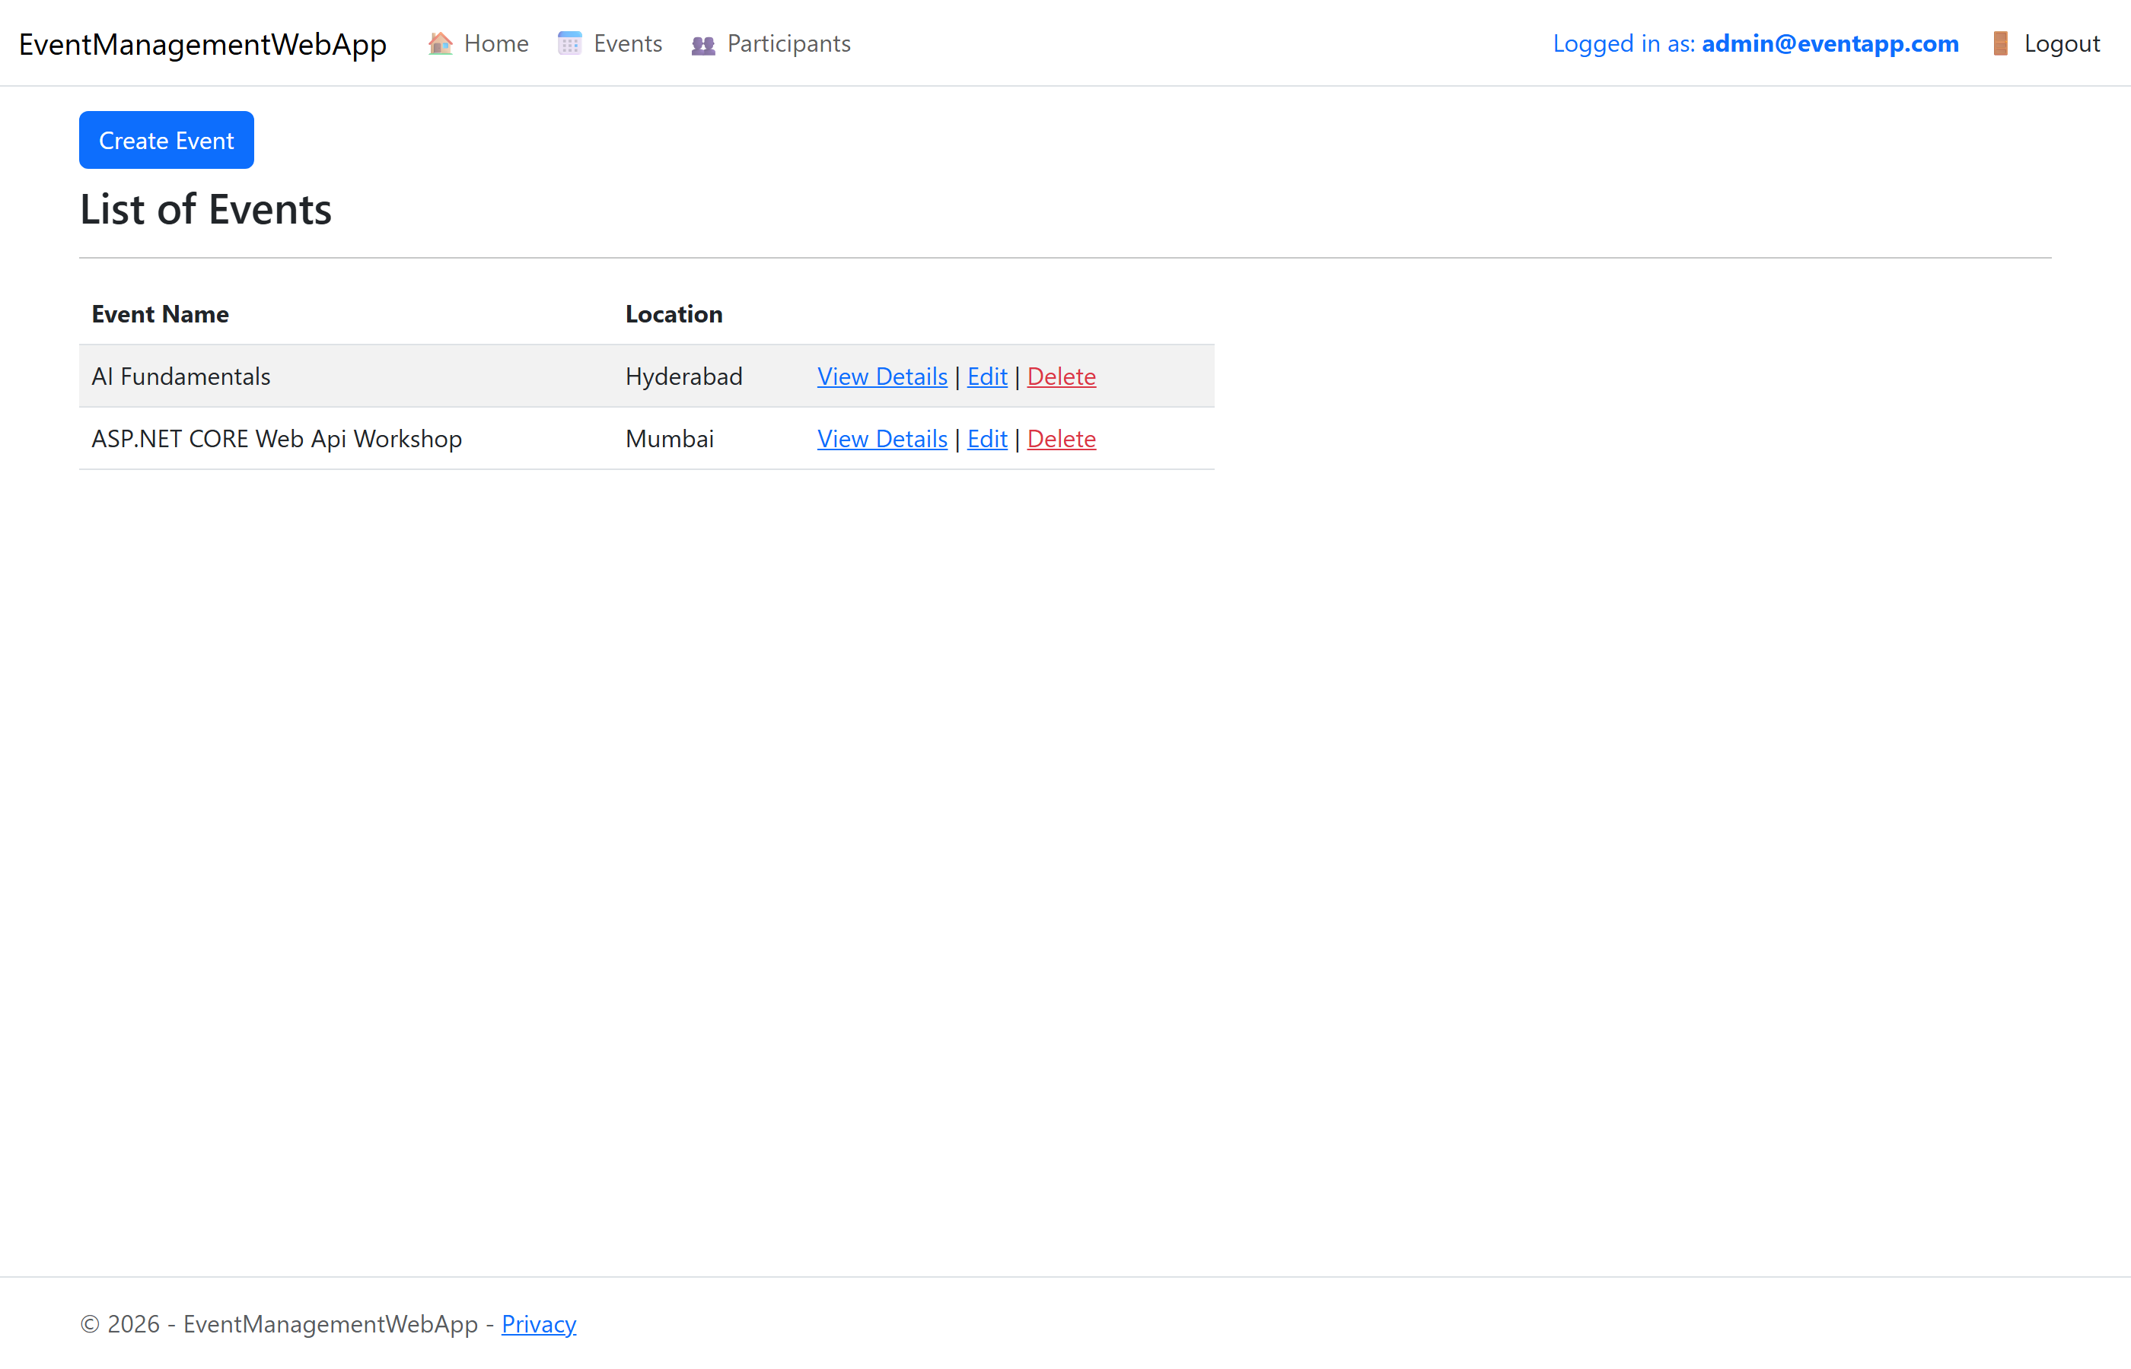
Admin sees: Home, Events, Participants, Logout — with the admin email displayed in the navigation bar. Create/Edit/Delete links are visible on the Events list.

2. User Navigation
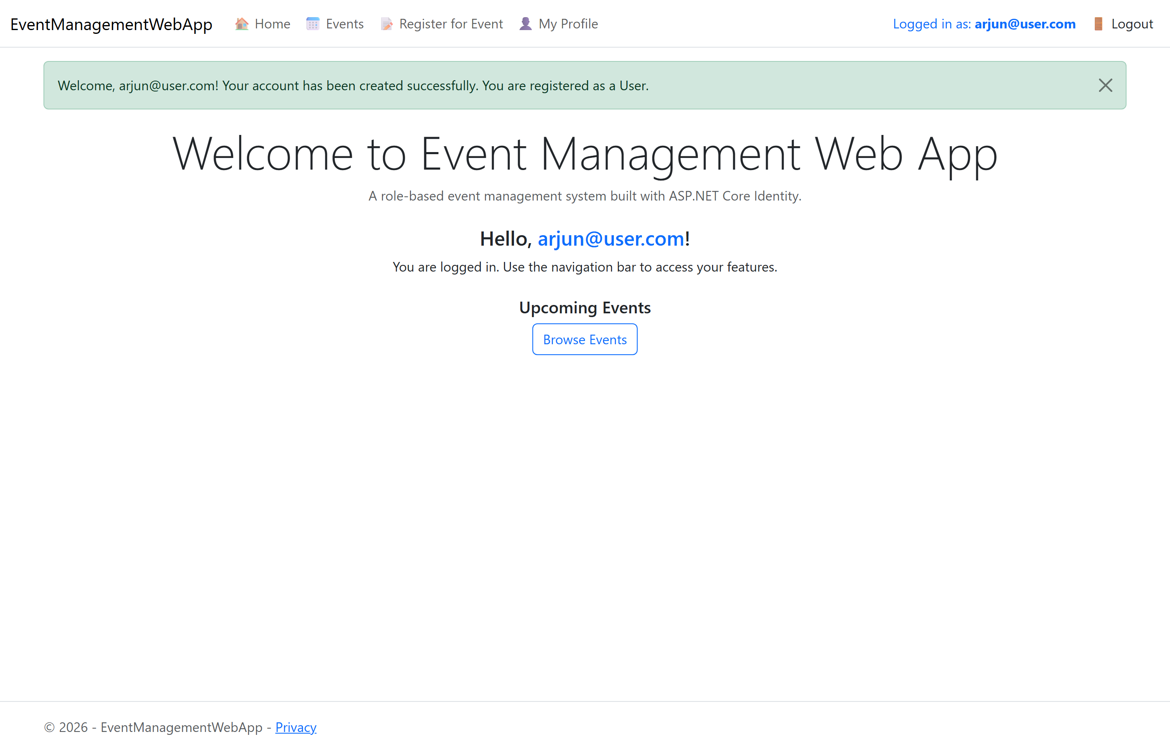
A newly registered user is automatically assigned the User role and sees: Home, Events, Register for Event, My Profile, Logout — with their email in the navigation bar. The welcome message confirms successful registration.

3. Anonymous Navigation
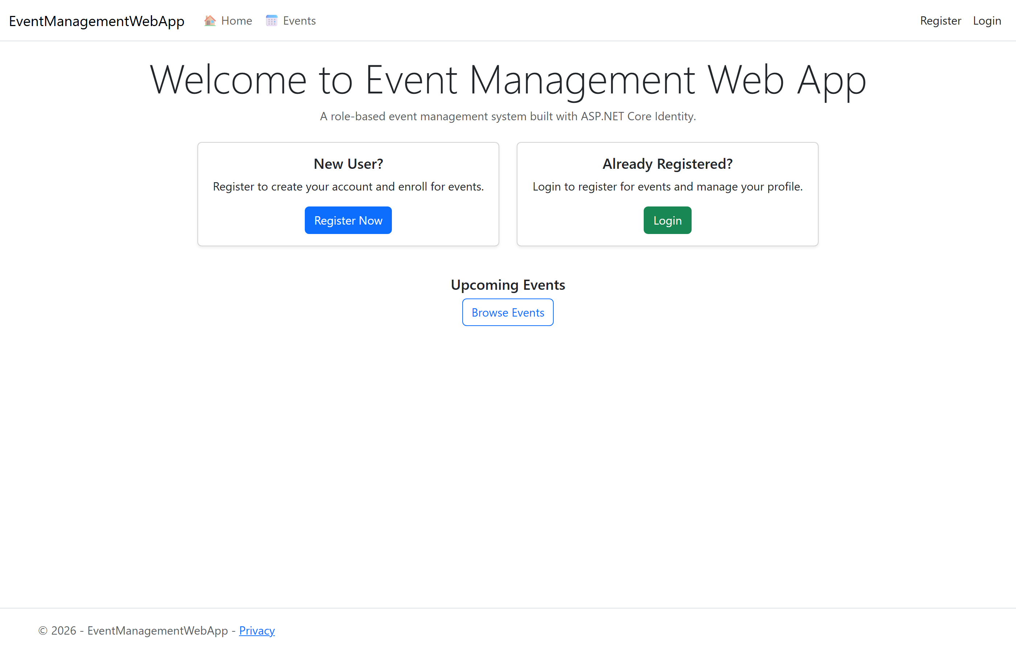
Anonymous visitors see only: Home, Events, Register, Login.

4. Successful Login
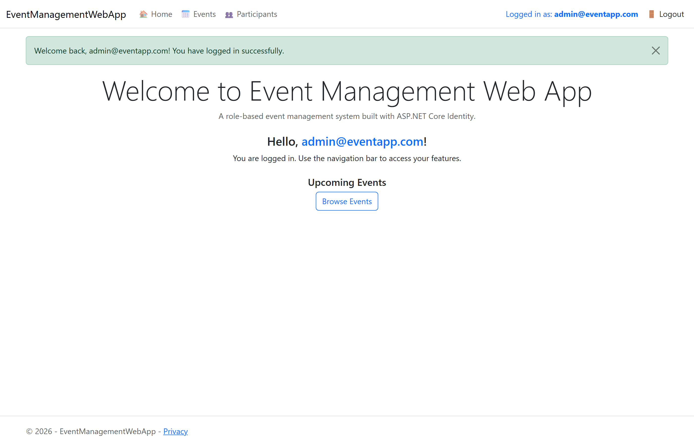
Welcome message displayed after a successful login, with the logged-in email shown in the navigation bar.

5. Successful Event Registration
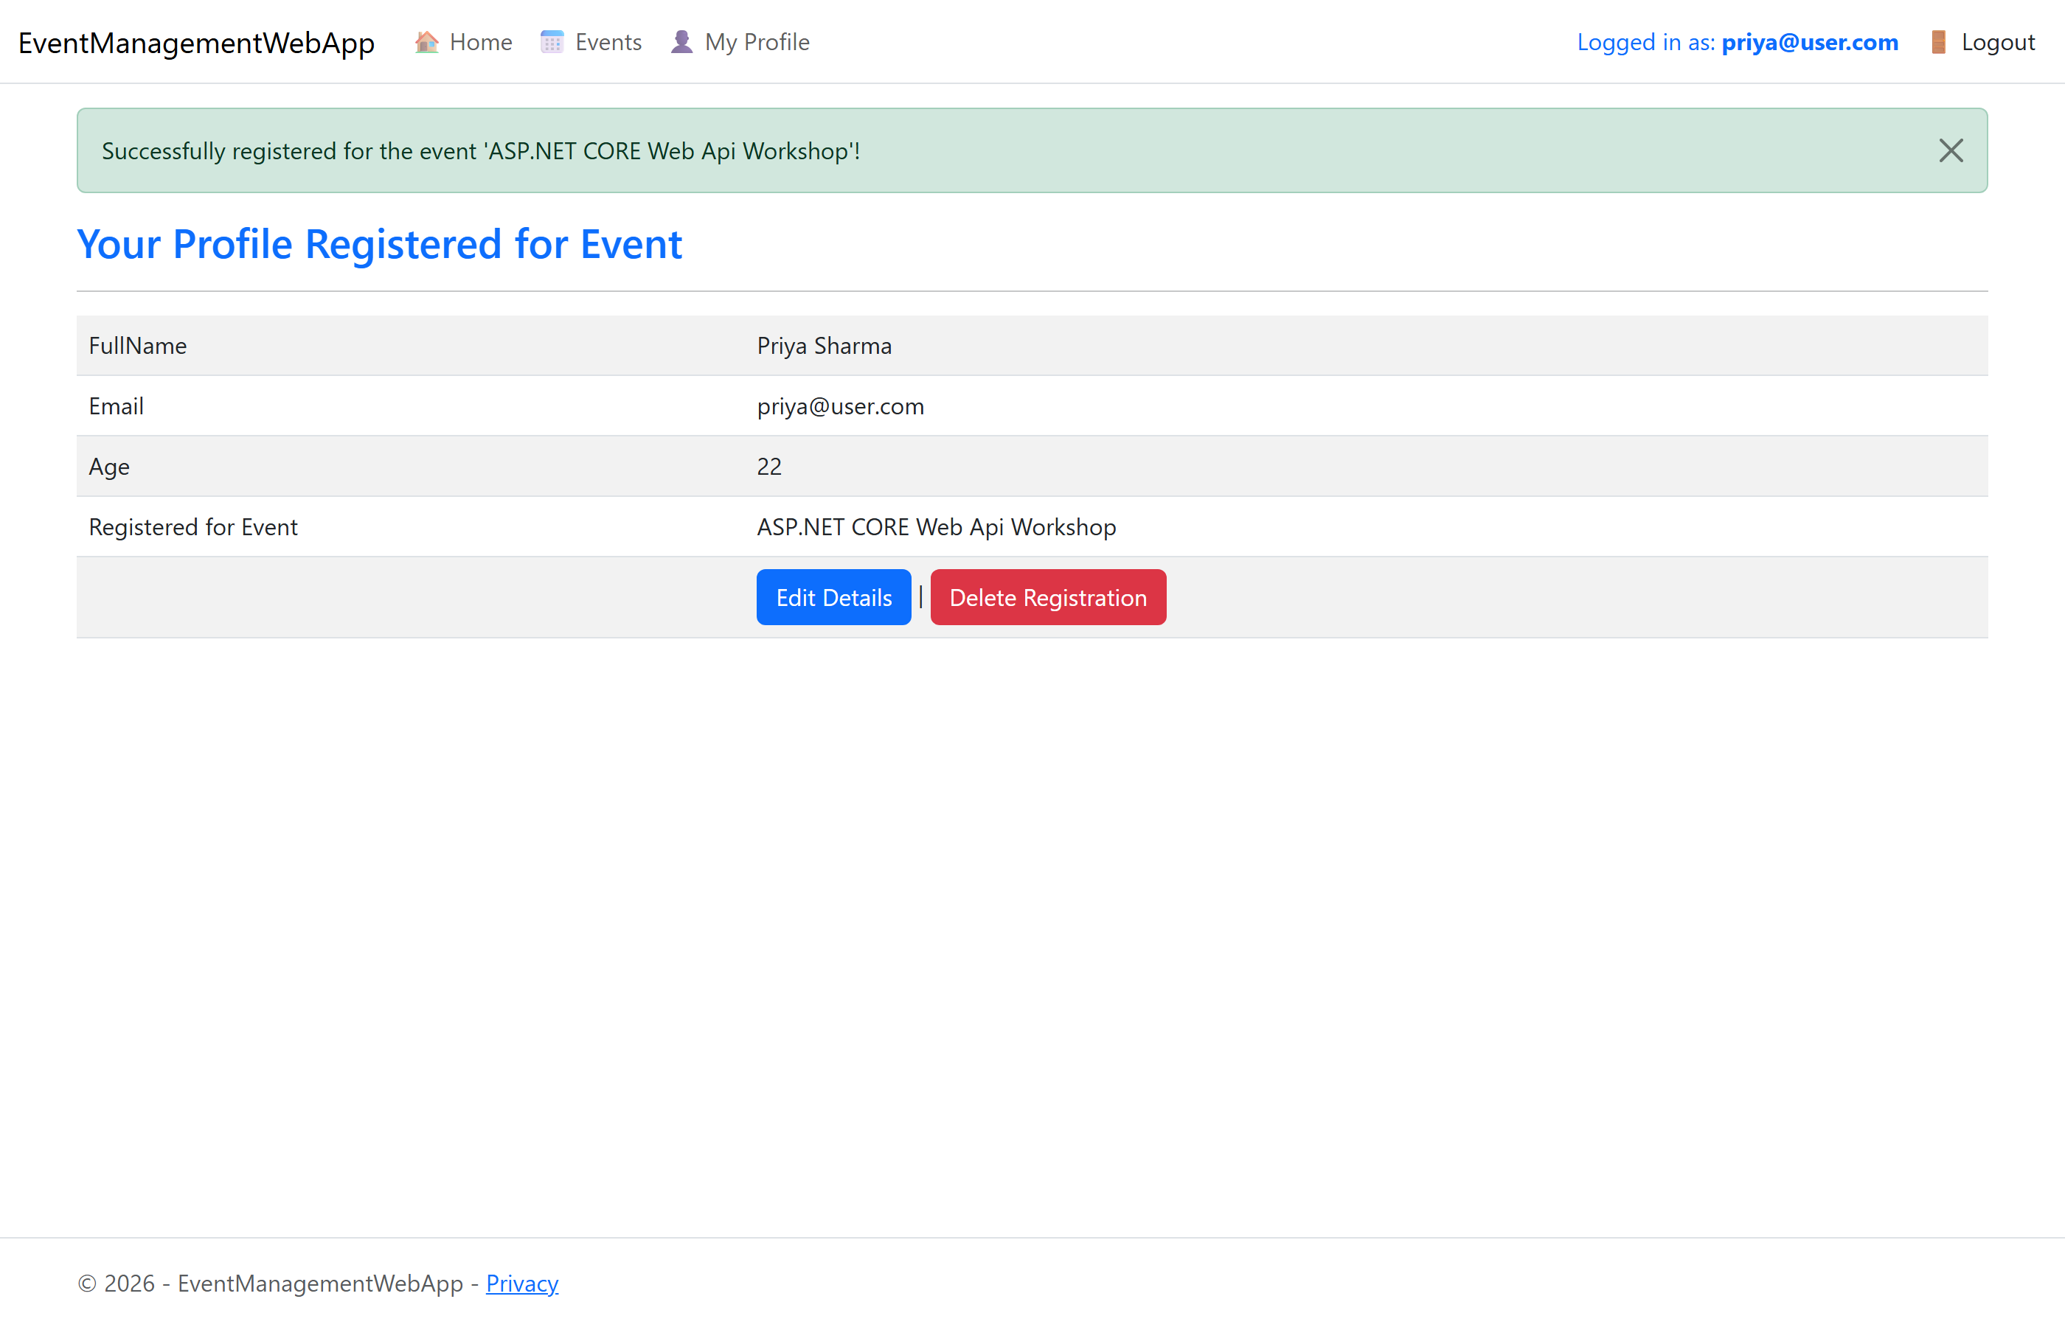
Success message after a user registers for an event. Note the 'Register for Event' link is no longer displayed in the navigation bar because the user has already registered.

6. Access Denied Page
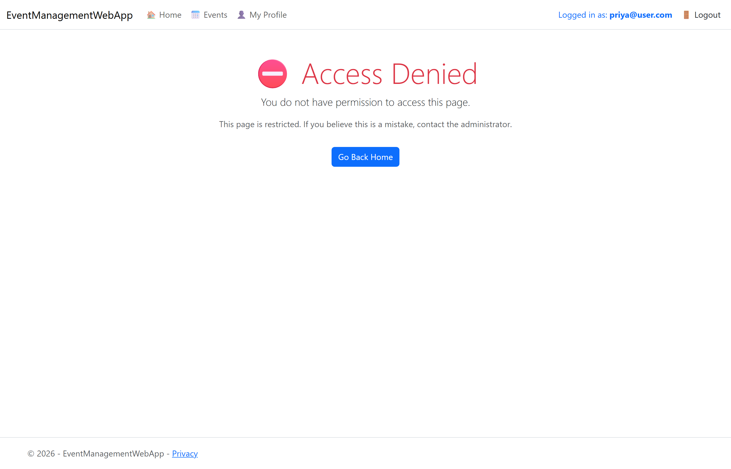
A logged-in User typed the admin-only URL /Participant/Index directly and was redirected to the Access Denied page.

7. User Profile Page
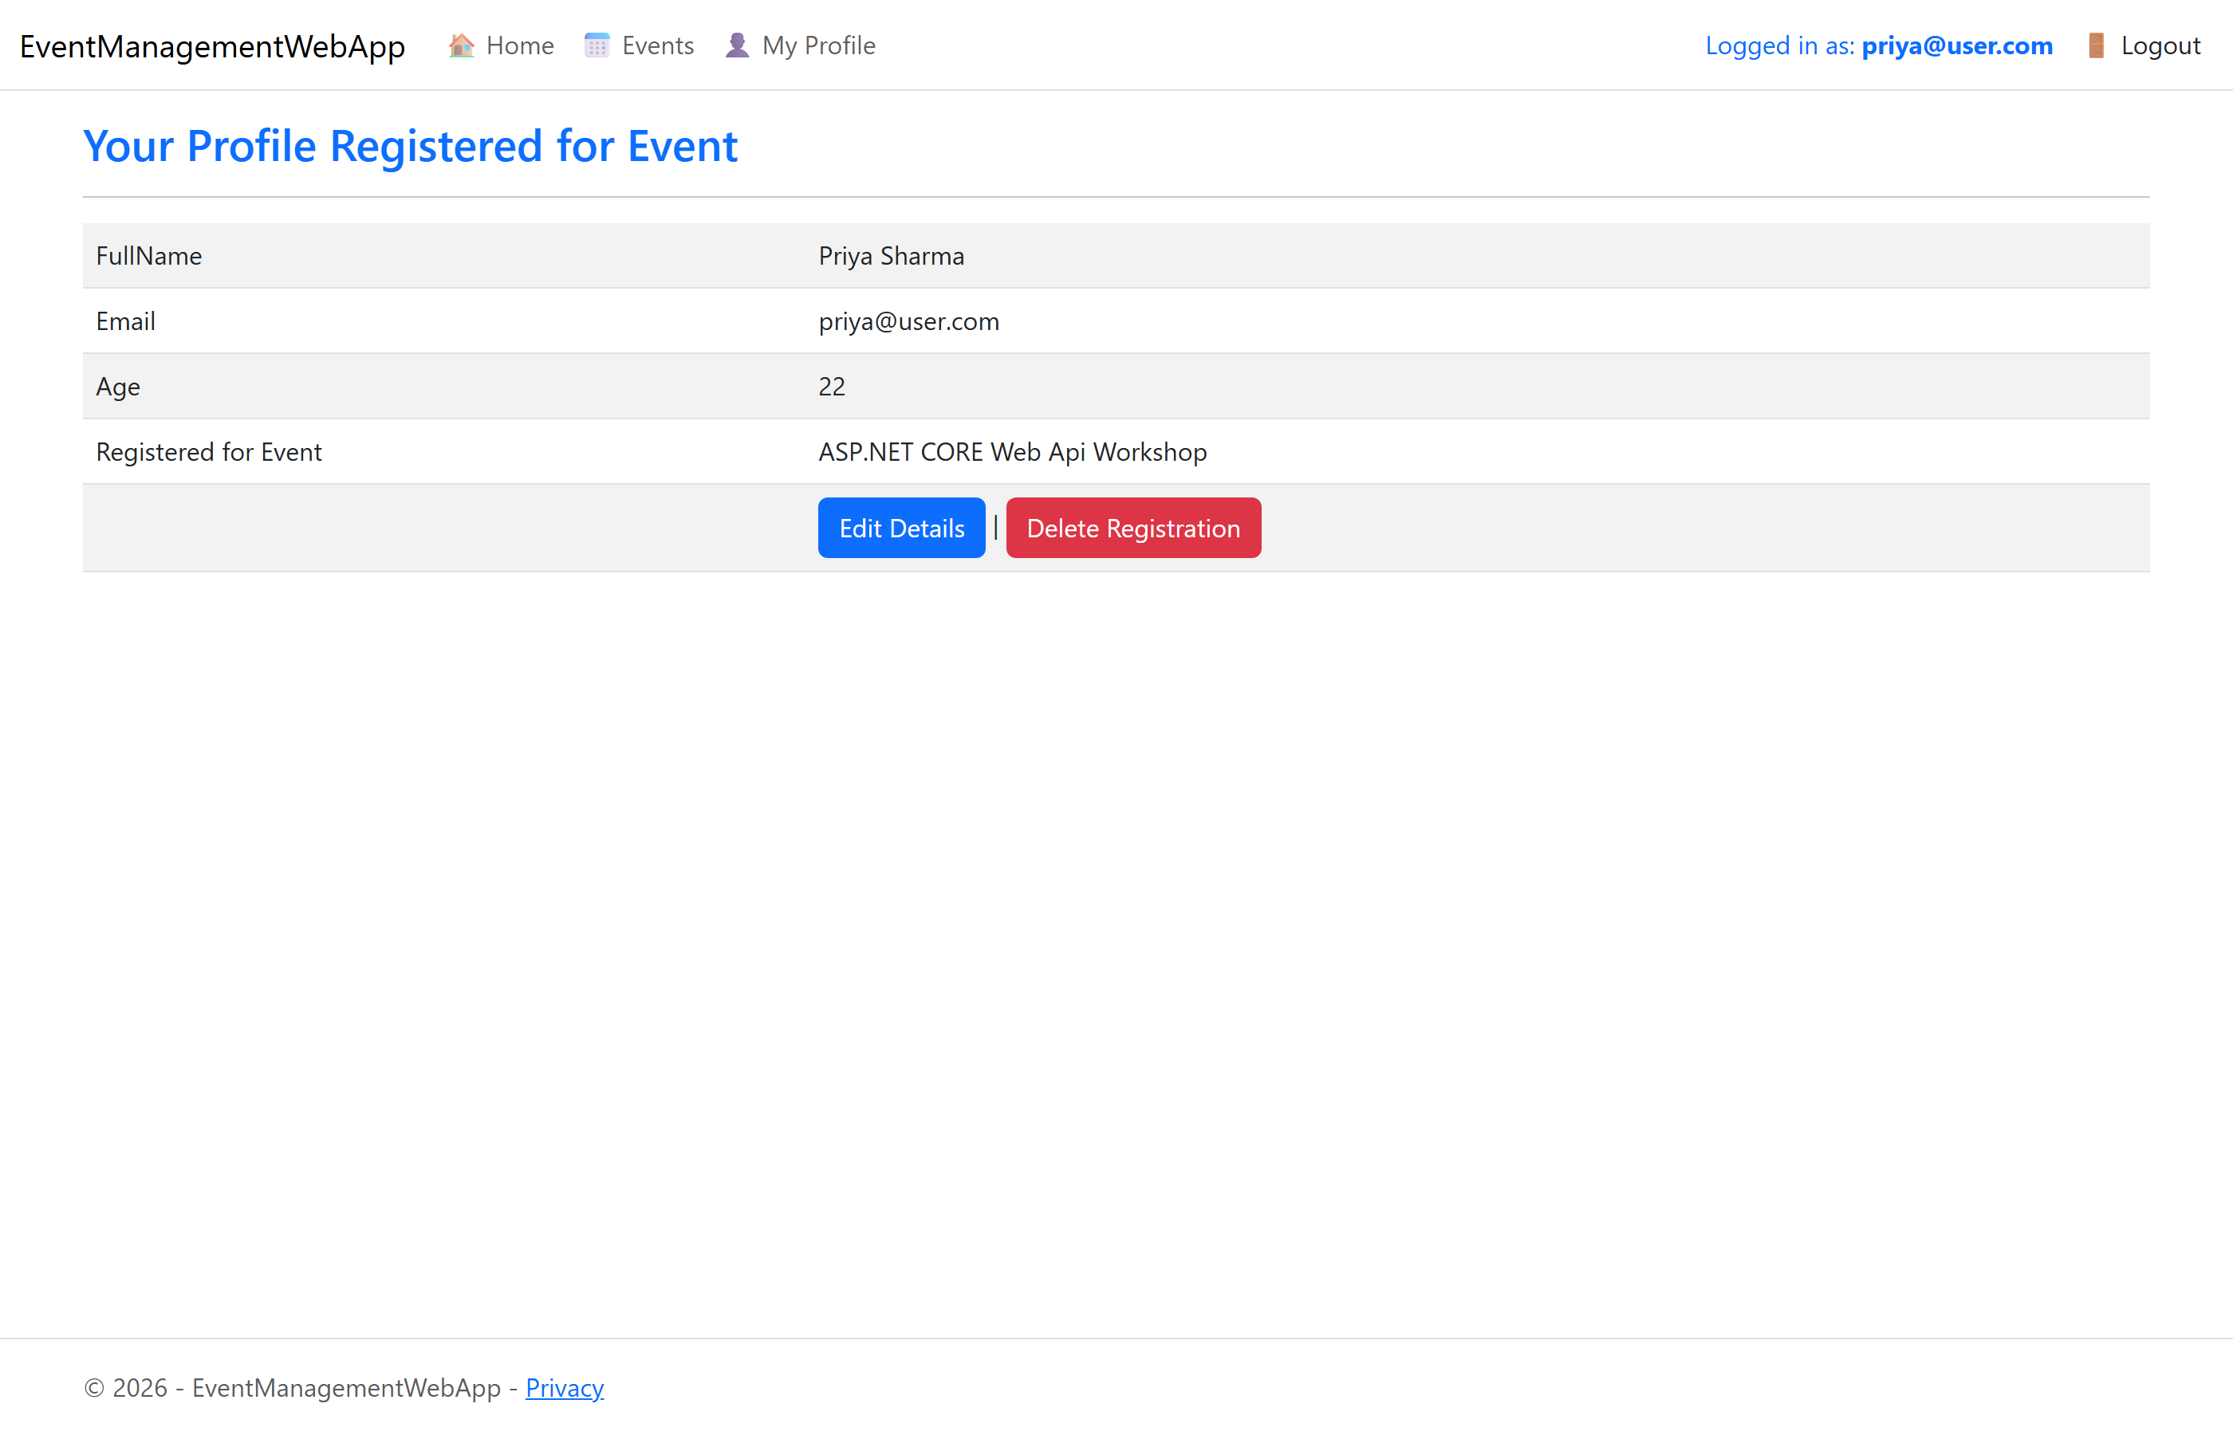
My Profile page showing the user's registration details and the event they registered for.

8. Administrator — List of Participants
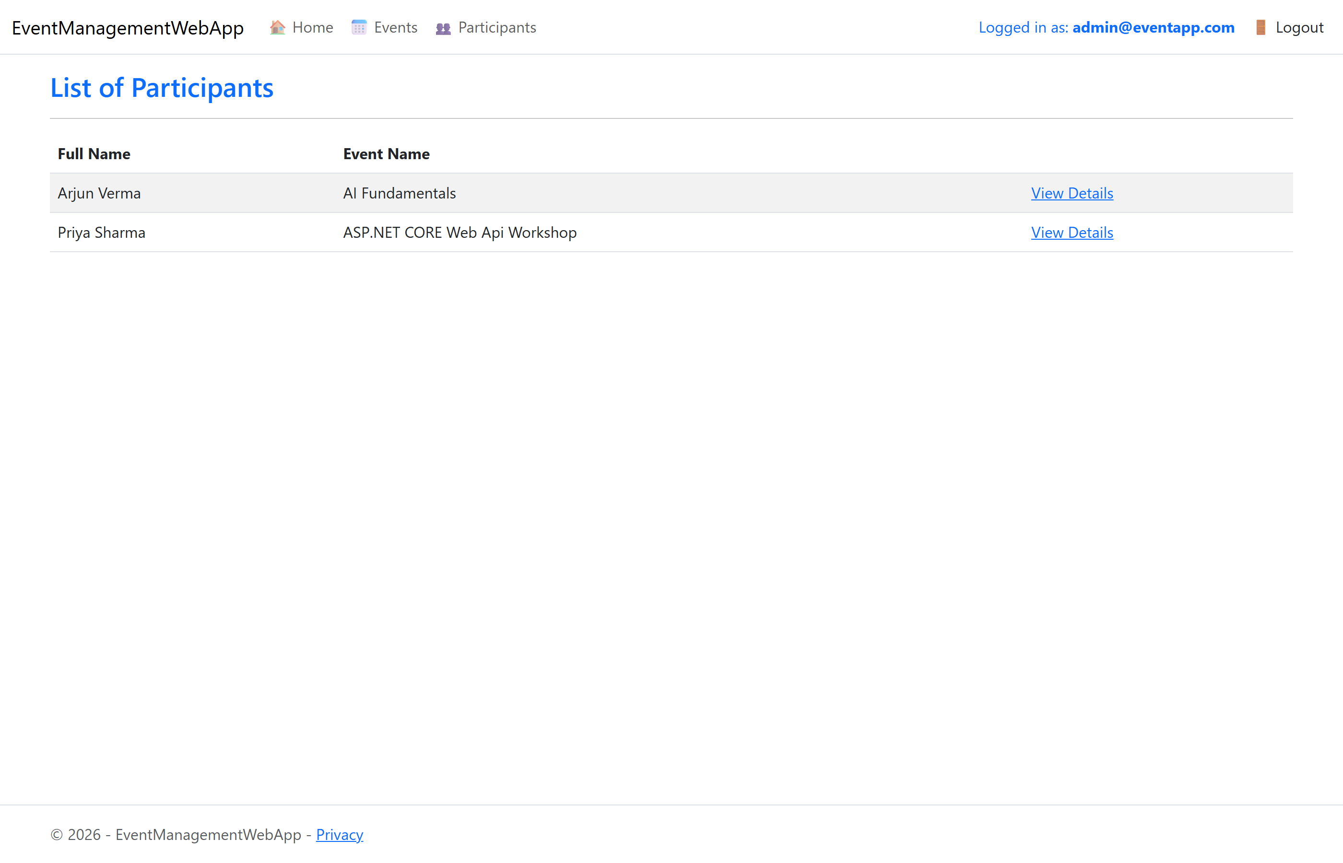
Admin-only view listing all registered participants with their events.

9. SQL Server Database — Identity and Application Tables
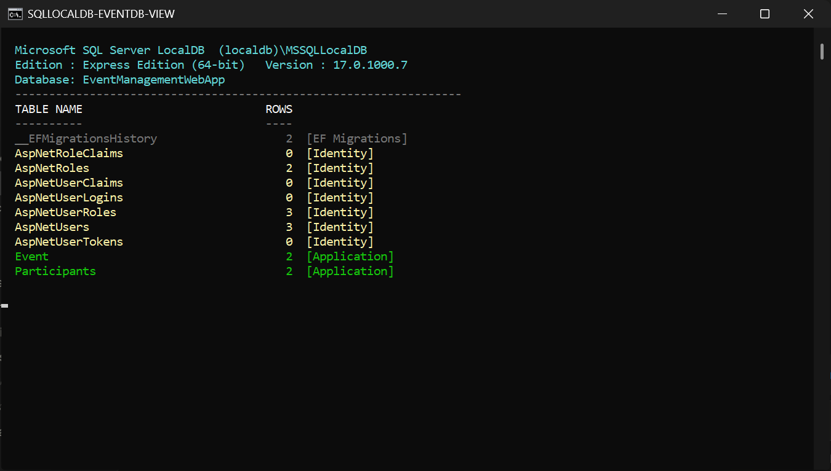
The EventManagementWebApp database in SQL Server LocalDB, showing the ASP.NET Core Identity tables (AspNetUsers, AspNetRoles, AspNetUserRoles, ...) alongside the application tables (Event, Participants) with live row counts.

Part B — Complete Source Code
EF Core migrations (Migrations/EventDb, Migrations/IdentityDb) are generated code and are omitted here for brevity; they are included in the project folder.

Project Configuration
📄 EventManagementWebApp.csproj
<Project Sdk="Microsoft.NET.Sdk.Web">

<PropertyGroup>
<TargetFramework>net8.0</TargetFramework>
<Nullable>disable</Nullable>
<ImplicitUsings>enable</ImplicitUsings>
<RootNamespace>EventManagementWebApp</RootNamespace>
</PropertyGroup>

<ItemGroup>
<PackageReference Include="Microsoft.AspNetCore.Identity.EntityFrameworkCore" Version="8.0.8" />
<PackageReference Include="Microsoft.AspNetCore.Identity.UI" Version="8.0.8" />
<PackageReference Include="Microsoft.EntityFrameworkCore.SqlServer" Version="8.0.8" />
<PackageReference Include="Microsoft.EntityFrameworkCore.Tools" Version="8.0.8" />
</ItemGroup>

</Project>

📄 Program.cs
using EventManagementWebApp.Data;
using EventManagementWebApp.Models;
using Microsoft.AspNetCore.Identity;
using Microsoft.EntityFrameworkCore;

var builder = WebApplication.CreateBuilder(args);

var connectionString = builder.Configuration.GetConnectionString("DefaultConnection");

// Application data (Events + Participants)
builder.Services.AddDbContext<EventDbContext>(options =>
options.UseSqlServer(connectionString));

// Identity data (AspNetUsers, AspNetRoles, ...)
builder.Services.AddDbContext<AppIdentityDbContext>(options =>
options.UseSqlServer(connectionString));

// ═══ Individual Accounts Authentication with Roles ═══
builder.Services.AddDefaultIdentity<IdentityUser>(options =>
{
options.SignIn.RequireConfirmedAccount = false;
options.Password.RequireDigit = true;
options.Password.RequiredLength = 6;
options.Password.RequireNonAlphanumeric = false;
options.Password.RequireUppercase = false;
})
.AddRoles<IdentityRole>()
.AddEntityFrameworkStores<AppIdentityDbContext>();

builder.Services.AddControllersWithViews();
builder.Services.AddRazorPages();

var app = builder.Build();

// ═══ Apply migrations and seed Roles + Administrator account ═══
using (var scope = app.Services.CreateScope())
{
var services = scope.ServiceProvider;
try
{
var eventDb = services.GetRequiredService<EventDbContext>();
var identityDb = services.GetRequiredService<AppIdentityDbContext>();
await eventDb.Database.MigrateAsync();
await identityDb.Database.MigrateAsync();

var userManager = services.GetRequiredService<UserManager<IdentityUser>>();
var roleManager = services.GetRequiredService<RoleManager<IdentityRole>>();
await DbInitializer.SeedRolesAndAdminAsync(userManager, roleManager);
}
catch (Exception ex)
{
var logger = services.GetRequiredService<ILogger<Program>>();
logger.LogError(ex, "An error occurred while migrating or seeding the database.");
}
}

if (!app.Environment.IsDevelopment())
{
app.UseExceptionHandler("/Home/Error");
app.UseHsts();
}

app.UseHttpsRedirection();
app.UseStaticFiles();

app.UseRouting();

app.UseAuthentication();
app.UseAuthorization();

app.MapControllerRoute(
name: "default",
pattern: "{controller=Home}/{action=Index}/{id?}");

app.MapRazorPages();

app.Run();

📄 appsettings.json
{
"ConnectionStrings": {
"DefaultConnection": "Server=(localdb)\\mssqllocaldb;Database=EventManagementWebApp;Trusted_Connection=True;MultipleActiveResultSets=true"
},
"Logging": {
"LogLevel": {
"Default": "Information",
"Microsoft.AspNetCore": "Warning"
}
},
"AllowedHosts": "*"
}

Models
📄 Models/EventInfo.cs
using System.ComponentModel.DataAnnotations;
using System.ComponentModel.DataAnnotations.Schema;

namespace EventManagementWebApp.Models
{
public class EventInfo
{
[Key]
public int EventId { get; set; }

public string EventName { get; set; }

public string EventLocation { get; set; }

// One-to-Many relationship
// Navigation Property to retrieve List of Participants
public virtual List<Participant> Participants { get; set; }
}
}

📄 Models/Participant.cs
namespace EventManagementWebApp.Models
{
public class Participant
{
public int Id { get; set; }
public string FullName { get; set; }
public string Email { get; set; }
public int Age { get; set; }

// Foreign Key
public int EventId { get; set; }

// Navigation property to retrieve information of registered Event
public virtual EventInfo Event { get; set; }
}
}

📄 Models/EventCreateEditViewModel.cs
using System.ComponentModel.DataAnnotations;

namespace EventManagementWebApp.Models
{
public class EventCreateEditViewModel
{
public int EventId { get; set; }

[Required]
public string EventName { get; set; }

[Required]
public string EventLocation { get; set; }
}
}

📄 Models/ParticipantCreateEditViewModel.cs
using System.ComponentModel.DataAnnotations;

namespace EventManagementWebApp.Models
{
public class ParticipantCreateEditViewModel
{
public int Id { get; set; }

[Required]
public string FullName { get; set; }

[Required]
[EmailAddress]
public string Email { get; set; }

[Required]
[Range(18, 100)]
public int Age { get; set; }

[Required]
public int EventId { get; set; }

// EventName is optional by specifying string?
public string? EventName { get; set; }
}
}

📄 Models/EventDbContext.cs
using Microsoft.EntityFrameworkCore;

namespace EventManagementWebApp.Models
{
public class EventDbContext : DbContext
{
// Constructor Injection
public EventDbContext(DbContextOptions<EventDbContext> options) : base(options) { }

public DbSet<Participant> Participants { get; set; }
public DbSet<EventInfo> Event { get; set; }

// Seed Data - Create the table with some initial records
protected override void OnModelCreating(ModelBuilder modelBuilder)
{
// Seeding data for the EventInfo entity using Fluent API
modelBuilder.Entity<EventInfo>().HasData(
new EventInfo { EventId = 1, EventName = "AI Fundamentals", EventLocation = "Hyderabad" },
new EventInfo { EventId = 2, EventName = "ASP.NET CORE Web Api Workshop", EventLocation = "Mumbai" }
);
}
}
}

📄 Models/ErrorViewModel.cs
namespace EventManagementWebApp.Models
{
public class ErrorViewModel
{
public string? RequestId { get; set; }
public bool ShowRequestId => !string.IsNullOrEmpty(RequestId);
}
}

Data (Identity Context + Seeder)
📄 Data/AppIdentityDbContext.cs
using Microsoft.AspNetCore.Identity;
using Microsoft.AspNetCore.Identity.EntityFrameworkCore;
using Microsoft.EntityFrameworkCore;

namespace EventManagementWebApp.Data
{
// Stores the ASP.NET Core Identity tables (AspNetUsers, AspNetRoles, ...)
public class AppIdentityDbContext : IdentityDbContext<IdentityUser>
{
public AppIdentityDbContext(DbContextOptions<AppIdentityDbContext> options)
: base(options)
{
}
}
}

📄 Data/DbInitializer.cs
using Microsoft.AspNetCore.Identity;

namespace EventManagementWebApp.Data
{
public static class DbInitializer
{
// Seeds the "Admin" / "User" roles and the manually-created Administrator account
public static async Task SeedRolesAndAdminAsync(
UserManager<IdentityUser> userManager,
RoleManager<IdentityRole> roleManager)
{
string[] roles = { "Admin", "User" };
foreach (var role in roles)
{
if (!await roleManager.RoleExistsAsync(role))
{
await roleManager.CreateAsync(new IdentityRole(role));
}
}

string adminEmail = "admin@eventapp.com";
string adminPassword = "Admin@123";

var adminUser = await userManager.FindByEmailAsync(adminEmail);
if (adminUser == null)
{
adminUser = new IdentityUser
{
UserName = adminEmail,
Email = adminEmail,
EmailConfirmed = true
};

var result = await userManager.CreateAsync(adminUser, adminPassword);
if (result.Succeeded)
{
await userManager.AddToRoleAsync(adminUser, "Admin");
}
}
else if (!await userManager.IsInRoleAsync(adminUser, "Admin"))
{
await userManager.AddToRoleAsync(adminUser, "Admin");
}
}
}
}

Controllers
📄 Controllers/HomeController.cs
using EventManagementWebApp.Models;
using Microsoft.AspNetCore.Identity;
using Microsoft.AspNetCore.Mvc;
using System.Diagnostics;

namespace EventManagementWebApp.Controllers
{
public class HomeController : Controller
{
private readonly UserManager<IdentityUser> userManager;
private readonly SignInManager<IdentityUser> signInManager;

public HomeController(UserManager<IdentityUser> userManager, SignInManager<IdentityUser> signInManager)
{
this.userManager = userManager;
this.signInManager = signInManager;
}

// Action Method
public async Task<IActionResult> Index()
{
if (User.Identity!.IsAuthenticated)
{
// Get the current logged in user details
var user = await userManager.GetUserAsync(User);

// Check if the current logged in user has not been assigned any role
if (!await userManager.IsInRoleAsync(user, "User") && !await userManager.IsInRoleAsync(user, "Admin"))
{
// Assign this user the role User
await userManager.AddToRoleAsync(user, "User");

// Refresh the authentication cookie so the new role takes effect
await signInManager.RefreshSignInAsync(user);
}
}
return View();
}

public IActionResult Privacy()
{
return View();
}

[ResponseCache(Duration = 0, Location = ResponseCacheLocation.None, NoStore = true)]
public IActionResult Error()
{
return View(new ErrorViewModel { RequestId = Activity.Current?.Id ?? HttpContext.TraceIdentifier });
}
}
}

📄 Controllers/EventInfoController.cs
using Microsoft.AspNetCore.Mvc;
using EventManagementWebApp.Models;
using Microsoft.AspNetCore.Authorization;
using Microsoft.EntityFrameworkCore;

namespace EventManagementWebApp.Controllers
{
[Authorize(Roles = "Admin")]
public class EventInfoController : Controller
{
EventDbContext dbContext;

// Constructor Dependency Injection to create the DbContext object
public EventInfoController(EventDbContext context)
{
dbContext = context;
}

// ═══ Anyone (including anonymous) can view the Event list ═══
[AllowAnonymous]
public IActionResult Index()
{
var eventList = dbContext.Event.ToList();
return View(eventList);
}

// ═══ Anyone (including anonymous) can view Event details ═══
[AllowAnonymous]
public IActionResult Details(int id)
{
var e = dbContext.Event.Find(id);
if (e == null) return NotFound();

// Store selected Event in TempData for Participant registration
TempData["EventId"] = e.EventId;

return View(e);
}

// ═══ Admin only — Create a new Event ═══
[HttpGet]
public IActionResult Create()
{
return View();
}

[HttpPost]
[ValidateAntiForgeryToken]
public IActionResult Create(EventCreateEditViewModel ev)
{
if (ModelState.IsValid)
{
EventInfo e = new EventInfo();
e.EventName = ev.EventName;
e.EventLocation = ev.EventLocation;
dbContext.Event.Add(e);
dbContext.SaveChanges();
TempData["SuccessMessage"] = $"Event '{e.EventName}' created successfully!";
return RedirectToAction("Index");
}
return View();
}

// ═══ Admin only — Edit an Event ═══
public IActionResult Edit(int id)
{
var e = dbContext.Event.Find(id);
if (e == null) return NotFound();

EventCreateEditViewModel ev = new EventCreateEditViewModel();
ev.EventId = e.EventId;
ev.EventName = e.EventName;
ev.EventLocation = e.EventLocation;
return View(ev);
}

[HttpPost]
[ValidateAntiForgeryToken]
public IActionResult Edit(int id, EventCreateEditViewModel evModified)
{
var e = dbContext.Event.Find(id);
if (e == null) return NotFound();

if (ModelState.IsValid)
{
e.EventName = evModified.EventName;
e.EventLocation = evModified.EventLocation;
dbContext.SaveChanges();
TempData["SuccessMessage"] = $"Event '{e.EventName}' updated successfully!";
return RedirectToAction("Index");
}
return View(evModified);
}

// ═══ Admin only — Delete an Event (with confirmation page) ═══
public IActionResult Delete(int id)
{
var e = dbContext.Event.Include(ev => ev.Participants)
.Where(ev => ev.EventId == id).SingleOrDefault();
if (e == null) return NotFound();

return View(e);
}

[HttpPost, ActionName("Delete")]
[ValidateAntiForgeryToken]
public IActionResult DeleteConfirmed(int id)
{
var e = dbContext.Event.Find(id);
if (e != null)
{
dbContext.Event.Remove(e);
dbContext.SaveChanges();
TempData["SuccessMessage"] = $"Event '{e.EventName}' deleted successfully!";
}
return RedirectToAction("Index");
}
}
}

📄 Controllers/ParticipantController.cs
using Microsoft.AspNetCore.Mvc;
using EventManagementWebApp.Models;
using Microsoft.AspNetCore.Mvc.Rendering;
using Microsoft.EntityFrameworkCore;
using Microsoft.AspNetCore.Authorization;

namespace EventManagementWebApp.Controllers
{
public class ParticipantController : Controller
{
EventDbContext dbContext;

public ParticipantController(EventDbContext context)
{
dbContext = context;
}

// ═══ Admin only — List of all Participants ═══
[Authorize(Roles = "Admin")]
public IActionResult Index()
{
var participants = dbContext.Participants.Include("Event").ToList();
return View(participants);
}

// ═══ User only — Register for an Event ═══
[Authorize(Roles = "User")]
[HttpGet]
public IActionResult Create()
{
// A user can register only once — redirect to profile if already registered
var existing = dbContext.Participants
.Where(pr => pr.Email == User.Identity.Name).FirstOrDefault();
if (existing != null)
{
TempData["InfoMessage"] = "You have already registered for an event. You can edit or delete your registration below.";
return RedirectToAction("MyProfile");
}

ViewBag.EventList = GetEventData();
ViewBag.Email = User.Identity.Name;

// Pre-select the event chosen from the Details page (if any)
var pv = new ParticipantCreateEditViewModel();
if (TempData["EventId"] != null)
{
pv.EventId = (int)TempData["EventId"];
}
pv.Email = User.Identity.Name;
return View(pv);
}

[Authorize(Roles = "User")]
[HttpPost]
[ValidateAntiForgeryToken]
public IActionResult Create(ParticipantCreateEditViewModel pv)
{
// Guard again on POST — one registration per user
var existing = dbContext.Participants
.Where(pr => pr.Email == User.Identity.Name).FirstOrDefault();
if (existing != null)
{
TempData["InfoMessage"] = "You have already registered for an event.";
return RedirectToAction("MyProfile");
}

if (ModelState.IsValid)
{
Participant p = new Participant();
p.FullName = pv.FullName;
p.Email = User.Identity.Name; // always the logged-in user's email
p.Age = pv.Age;
p.EventId = pv.EventId;
dbContext.Participants.Add(p);
dbContext.SaveChanges();

var ev = dbContext.Event.Find(pv.EventId);
TempData["SuccessMessage"] = $"Successfully registered for the event '{ev?.EventName}'!";
return RedirectToAction("MyProfile");
}

ViewBag.EventList = GetEventData();
ViewBag.Email = User.Identity.Name;
return View(pv);
}

// ═══ User only — Delete own registration ═══
[Authorize(Roles = "User")]
public IActionResult Delete(int id)
{
var p = dbContext.Participants.Find(id);
if (p == null || p.Email != User.Identity.Name) return NotFound();

dbContext.Participants.Remove(p);
dbContext.SaveChanges();
TempData["SuccessMessage"] = "Your event registration has been deleted.";
return RedirectToAction("MyProfile");
}

// ═══ User only — Edit own registration ═══
[Authorize(Roles = "User")]
public IActionResult Edit(int id)
{
var p = dbContext.Participants.Include("Event")
.Where(pr => pr.Id == id).SingleOrDefault();
if (p == null || p.Email != User.Identity.Name) return NotFound();

ParticipantCreateEditViewModel pv = new ParticipantCreateEditViewModel();
pv.Id = p.Id;
pv.FullName = p.FullName;
pv.Age = p.Age;
pv.Email = p.Email;
pv.EventId = p.EventId;

ViewBag.EventList = GetEventData();
return View(pv);
}

[Authorize(Roles = "User")]
[HttpPost]
[ValidateAntiForgeryToken]
public IActionResult Edit(int id, ParticipantCreateEditViewModel pvModified)
{
var p = dbContext.Participants.Include("Event")
.Where(pr => pr.Id == id).SingleOrDefault();
if (p == null || p.Email != User.Identity.Name) return NotFound();

if (ModelState.IsValid)
{
p.FullName = pvModified.FullName;
p.Age = pvModified.Age;
p.EventId = pvModified.EventId;
dbContext.SaveChanges();
TempData["SuccessMessage"] = "Your registration details have been updated.";
return RedirectToAction("MyProfile");
}

ViewBag.EventList = GetEventData();
return View(pvModified);
}

// ═══ User only — View own profile ═══
[Authorize(Roles = "User")]
public IActionResult MyProfile()
{
var p = dbContext.Participants.Include("Event")
.Where(pr => pr.Email == User.Identity.Name).FirstOrDefault();
return View(p);
}

// ═══ Admin only — View details of any Participant ═══
[Authorize(Roles = "Admin")]
public IActionResult Details(int id)
{
var p = dbContext.Participants.Include("Event")
.Where(pr => pr.Id == id).SingleOrDefault();
if (p == null) return NotFound();
return View(p);
}

// Method to populate dropdown with event details
private SelectList GetEventData()
{
var events = dbContext.Event.Select(e => new
{
EventId = e.EventId,
DisplayName = e.EventName + " (" + e.EventLocation + ")"
}).ToList();

return new SelectList(events, "EventId", "DisplayName");
}
}
}

Views — Shared Layout & Partials
📄 Views/_ViewImports.cshtml
@using EventManagementWebApp
@using EventManagementWebApp.Models
@addTagHelper *, Microsoft.AspNetCore.Mvc.TagHelpers

📄 Views/_ViewStart.cshtml
@{
Layout = "_Layout";
}

📄 Views/Shared/_Layout.cshtml
@using EventManagementWebApp.Models
@inject EventDbContext EventDb
<!DOCTYPE html>
<html lang="en">
<head>
<meta charset="utf-8" />
<meta name="viewport" content="width=device-width, initial-scale=1.0" />
<title>@ViewData["Title"] - EventManagementWebApp</title>

<link rel="stylesheet" href="https://cdn.jsdelivr.net/npm/bootstrap@5.3.0/dist/css/bootstrap.min.css" />
<link rel="stylesheet" href="~/css/site.css" asp-append-version="true" />
</head>
<body>
<header>
<nav class="navbar navbar-expand-sm navbar-toggleable-sm navbar-light bg-white border-bottom box-shadow mb-3">
<div class="container-fluid">
<a class="navbar-brand" asp-area="" asp-controller="Home" asp-action="Index">EventManagementWebApp</a>

<button class="navbar-toggler" type="button" data-bs-toggle="collapse" data-bs-target=".navbar-collapse"
aria-controls="navbarSupportedContent" aria-expanded="false" aria-label="Toggle navigation">
<span class="navbar-toggler-icon"></span>
</button>

<div class="navbar-collapse collapse d-sm-inline-flex justify-content-between">
<ul class="navbar-nav flex-grow-1">
<!-- Home -->
<li class="nav-item">
<a class="nav-link" asp-controller="Home" asp-action="Index">🏠 Home</a>
</li>

<!-- Events -->
<li class="nav-item">
<a class="nav-link" asp-controller="EventInfo" asp-action="Index">📅 Events</a>
</li>

@if (User.Identity!.IsAuthenticated)
{
// Participant Menu
if (User.IsInRole("User"))
{
// Show "Register for Event" only if the user has not already registered
var hasRegistered = EventDb.Participants.Any(p => p.Email == User.Identity.Name);
if (!hasRegistered)
{
<li class="nav-item">
<a class="nav-link" asp-controller="Participant" asp-action="Create">📝 Register for Event</a>
</li>
}

<li class="nav-item">
<a class="nav-link" asp-controller="Participant" asp-action="MyProfile">👤 My Profile</a>
</li>
}

// Administrator Menu
if (User.IsInRole("Admin"))
{
<li class="nav-item">
<a class="nav-link" asp-controller="Participant" asp-action="Index">👥 Participants</a>
</li>
}
}
</ul>

<partial name="_LoginPartial" />
</div>
</div>
</nav>
</header>

<div class="container">
<main role="main" class="pb-3">
<!-- ═══ Success / Info / Error messages ═══ -->
@if (TempData["SuccessMessage"] != null)
{
<div class="alert alert-success alert-dismissible fade show" role="alert">
@TempData["SuccessMessage"]
<button type="button" class="btn-close" data-bs-dismiss="alert"></button>
</div>
}
@if (TempData["InfoMessage"] != null)
{
<div class="alert alert-info alert-dismissible fade show" role="alert">
@TempData["InfoMessage"]
<button type="button" class="btn-close" data-bs-dismiss="alert"></button>
</div>
}
@if (TempData["ErrorMessage"] != null)
{
<div class="alert alert-danger alert-dismissible fade show" role="alert">
@TempData["ErrorMessage"]
<button type="button" class="btn-close" data-bs-dismiss="alert"></button>
</div>
}

@RenderBody()
</main>
</div>

<footer class="border-top footer text-muted">
<div class="container">
&copy; 2026 - EventManagementWebApp - <a asp-area="" asp-controller="Home" asp-action="Privacy">Privacy</a>
</div>
</footer>

<script src="https://cdn.jsdelivr.net/npm/jquery@3.7.0/dist/jquery.min.js"></script>
<script src="https://cdn.jsdelivr.net/npm/bootstrap@5.3.0/dist/js/bootstrap.bundle.min.js"></script>
<script src="~/js/site.js" asp-append-version="true"></script>

@await RenderSectionAsync("Scripts", required: false)
</body>
</html>

📄 Views/Shared/_LoginPartial.cshtml
@using Microsoft.AspNetCore.Identity
@inject SignInManager<IdentityUser> SignInManager
@inject UserManager<IdentityUser> UserManager

<ul class="navbar-nav">
@if (SignInManager.IsSignedIn(User))
{
<!-- ═══ Display the logged-in user's email in the navigation bar ═══ -->
<li class="nav-item">
<span class="nav-link text-primary">Logged in as: <strong>@User.Identity?.Name</strong></span>
</li>
<li class="nav-item">
<form class="form-inline" asp-area="Identity" asp-page="/Account/Logout"
asp-route-returnUrl="@Url.Action("Index", "Home", new { area = "" })" method="post">
<button type="submit" class="nav-link btn btn-link text-dark">🚪 Logout</button>
</form>
</li>
}
else
{
<li class="nav-item">
<a class="nav-link text-dark" asp-area="Identity" asp-page="/Account/Register">Register</a>
</li>
<li class="nav-item">
<a class="nav-link text-dark" asp-area="Identity" asp-page="/Account/Login">Login</a>
</li>
}
</ul>

📄 Views/Shared/_ValidationScriptsPartial.cshtml
<script src="https://cdn.jsdelivr.net/npm/jquery-validation@1.19.5/dist/jquery.validate.min.js"></script>
<script src="https://cdn.jsdelivr.net/npm/jquery-validation-unobtrusive@4.0.0/dist/jquery.validate.unobtrusive.min.js"></script>

📄 Views/Shared/Error.cshtml
@model ErrorViewModel
@{
ViewData["Title"] = "Error";
}

<h1 class="text-danger">Error.</h1>
<h2 class="text-danger">An error occurred while processing your request.</h2>

@if (Model.ShowRequestId)
{
<p>
<strong>Request ID:</strong> <code>@Model.RequestId</code>
</p>
}

Views — Home
📄 Views/Home/Index.cshtml
@{
ViewData["Title"] = "Home";
}

<div class="text-center">
<h1 class="display-4">Welcome to Event Management Web App</h1>
<p class="text-muted">A role-based event management system built with ASP.NET Core Identity.</p>

@if (User.Identity!.IsAuthenticated)
{
<div class="mt-4">
<h4>Hello, <span class="text-primary">@User.Identity.Name</span>!</h4>
<p>You are logged in. Use the navigation bar to access your features.</p>
</div>
}
else
{
<div class="row justify-content-center mt-4">
<div class="col-md-4">
<div class="card shadow-sm mb-3">
<div class="card-body">
<h5 class="card-title">New User?</h5>
<p class="card-text">Register to create your account and enroll for events.</p>
<a class="btn btn-primary" asp-area="Identity" asp-page="/Account/Register">Register Now</a>
</div>
</div>
</div>
<div class="col-md-4">
<div class="card shadow-sm mb-3">
<div class="card-body">
<h5 class="card-title">Already Registered?</h5>
<p class="card-text">Login to register for events and manage your profile.</p>
<a class="btn btn-success" asp-area="Identity" asp-page="/Account/Login">Login</a>
</div>
</div>
</div>
</div>
}

<div class="mt-4">
<h5>Upcoming Events</h5>
<a class="btn btn-outline-primary" asp-controller="EventInfo" asp-action="Index">Browse Events</a>
</div>
</div>

📄 Views/Home/Privacy.cshtml
@{
ViewData["Title"] = "Privacy Policy";
}
<h1>@ViewData["Title"]</h1>

<p>This application is an academic project. Registered emails and participant details are stored only for demonstrating event registration functionality.</p>

Views — EventInfo
📄 Views/EventInfo/Index.cshtml
@model IEnumerable<EventManagementWebApp.Models.EventInfo>
@{
ViewData["Title"] = "Events";
}

@if (User.IsInRole("Admin"))
{
<a asp-action="Create" class="btn btn-primary mb-2">Create Event</a>
}
<h3>List of Events</h3>
<hr />
<div class="row">
<div class="col-md-7">
<table class="table table-striped">
<thead>
<tr>
<th>Event Name</th>
<th>Location</th>
<th></th>
</tr>
</thead>
<tbody>
@foreach (var e in Model)
{
<tr>
<td>@e.EventName</td>
<td>@e.EventLocation</td>
<td>
<a asp-action="Details" asp-route-id="@e.EventId">View Details</a>
@if (User.IsInRole("Admin"))
{
<text> | </text>
<a asp-action="Edit" asp-route-id="@e.EventId">Edit</a>
<text> | </text>
<a asp-action="Delete" asp-route-id="@e.EventId" class="text-danger">Delete</a>
}
</td>
</tr>
}
</tbody>
</table>
</div>
</div>

📄 Views/EventInfo/Create.cshtml
@model EventManagementWebApp.Models.EventCreateEditViewModel
@{
ViewData["Title"] = "Create Event";
}

<h3 class="text-primary">Create a New Event</h3>
<hr />
<div class="row">
<div class="col-md-4">
<form asp-action="Create" method="post">
<div asp-validation-summary="ModelOnly" class="text-danger"></div>

<div class="form-group">
<label asp-for="EventName" class="control-label"></label>
<input asp-for="EventName" class="form-control"/>
<span asp-validation-for="EventName" class="text-danger"></span>
</div>

<div class="form-group">
<label asp-for="EventLocation" class="control-label"></label>
<input asp-for="EventLocation" class="form-control" />
<span asp-validation-for="EventLocation" class="text-danger"></span>
</div>

<br />
<div class="form-group">
<button class="btn btn-primary">Create</button>
<a asp-action="Index" class="btn btn-secondary">Back to List</a>
</div>
</form>
</div>
</div>

@section Scripts
{
<partial name="_ValidationScriptsPartial" />
}

📄 Views/EventInfo/Details.cshtml
@model EventManagementWebApp.Models.EventInfo
@{
ViewData["Title"] = "Event Details";
}

<h4 class="text-primary">Details of Event</h4>
<hr />
<table class="table table-striped">
<tr>
<td>Event Name</td>
<td>@Model.EventName</td>
</tr>
<tr>
<td>Event Location</td>
<td>@Model.EventLocation</td>
</tr>
<tr>
<td>
<a asp-action="Index" class="btn btn-secondary">Back to List</a>
</td>
<td>
@if (User.IsInRole("Admin"))
{
<a asp-action="Edit" asp-route-id="@Model.EventId" class="btn btn-primary">Edit Event Details</a>
}
else if (User.IsInRole("User"))
{
<a asp-action="Create" asp-controller="Participant" class="btn btn-primary">Register for Event</a>
}
</td>
</tr>
</table>

📄 Views/EventInfo/Edit.cshtml
@model EventManagementWebApp.Models.EventCreateEditViewModel
@{
ViewData["Title"] = "Edit Event";
}

<h3 class="text-primary">Edit the Event</h3>
<hr />
<div class="row">
<div class="col-md-4">
<form asp-action="Edit" method="post">
<div asp-validation-summary="ModelOnly" class="text-danger"></div>

<div class="form-group">
<label asp-for="EventName" class="control-label"></label>
<input asp-for="EventName" class="form-control" />
<span asp-validation-for="EventName" class="text-danger"></span>
</div>

<div class="form-group">
<label asp-for="EventLocation" class="control-label"></label>
<input asp-for="EventLocation" class="form-control" />
<span asp-validation-for="EventLocation" class="text-danger"></span>
</div>

<br />
<div class="form-group">
<button class="btn btn-primary">Save Changes</button>
<a asp-action="Index" class="btn btn-secondary">Back to List</a>
</div>
</form>
</div>
</div>

@section Scripts
{
<partial name="_ValidationScriptsPartial" />
}

📄 Views/EventInfo/Delete.cshtml
@model EventManagementWebApp.Models.EventInfo
@{
ViewData["Title"] = "Delete Event";
}

<h3 class="text-danger">Delete Event</h3>
<p>Are you sure you want to delete this event?</p>
<hr />
<table class="table table-striped">
<tr>
<td>Event Name</td>
<td>@Model.EventName</td>
</tr>
<tr>
<td>Event Location</td>
<td>@Model.EventLocation</td>
</tr>
<tr>
<td>Registered Participants</td>
<td>@(Model.Participants?.Count ?? 0)</td>
</tr>
</table>

<form asp-action="Delete" method="post">
<input type="hidden" asp-for="EventId" />
<button type="submit" class="btn btn-danger">Delete</button>
<a asp-action="Index" class="btn btn-secondary">Cancel</a>
</form>

Views — Participant
📄 Views/Participant/Index.cshtml
@model IEnumerable<EventManagementWebApp.Models.Participant>
@{
ViewData["Title"] = "Participants";
}

@if (!Model.Any())
{
<h3 class="text-warning">No Participants to Display</h3>
}
else
{
<h3 class="text-primary">List of Participants</h3>
<hr />
<table class="table table-striped">
<thead>
<tr>
<th>Full Name</th>
<th>Event Name</th>
<th></th>
</tr>
</thead>
<tbody>
@foreach (var p in Model)
{
<tr>
<td>@p.FullName</td>
<td>@p.Event.EventName</td>
<td>
<a asp-action="Details" asp-route-id="@p.Id">View Details</a>
</td>
</tr>
}
</tbody>
</table>
}

📄 Views/Participant/MyProfile.cshtml
@model EventManagementWebApp.Models.Participant
@{
ViewData["Title"] = "My Profile";
}

@if (Model == null)
{
<h5 class="text-warning">
Your Profile has not been registered.
Click <a asp-controller="Participant" asp-action="Create"
class="text-primary text-decoration-underline">
📝 Register for Event
</a>
</h5>
}
else
{
<h3 class="text-primary">Your Profile Registered for Event</h3>
<hr />
<table class="table table-striped">
<tr>
<td>FullName</td>
<td>@Model.FullName</td>
</tr>
<tr>
<td>Email</td>
<td>@Model.Email</td>
</tr>
<tr>
<td>Age</td>
<td>@Model.Age</td>
</tr>
<tr>
<td>Registered for Event</td>
<td>@Model.Event.EventName</td>
</tr>
<tr>
<td></td>
<td>
<a asp-action="Edit" asp-route-id="@Model.Id" class="btn btn-primary">Edit Details</a> |
<a asp-action="Delete" asp-route-id="@Model.Id"
onclick="return confirm('Do you wish to delete this registration?');"
class="btn btn-danger">Delete Registration</a>
</td>
</tr>
</table>
}

📄 Views/Participant/Create.cshtml
@model EventManagementWebApp.Models.ParticipantCreateEditViewModel
@{
ViewData["Title"] = "Register for Event";
}

<h3 class="text-primary">Register for the Event</h3>
<hr />

<div class="row">
<div class="col-md-4">
<form asp-action="Create" method="post">
<div asp-validation-summary="All" class="text-danger"></div>

<div class="form-group">
<label asp-for="FullName" class="control-label"></label>
<input asp-for="FullName" class="form-control" />
<span asp-validation-for="FullName" class="text-danger"></span>
</div>

<div class="form-group">
<label asp-for="Email" class="control-label"></label>
<input asp-for="Email" value="@ViewBag.Email" readonly class="form-control" />
<span asp-validation-for="Email" class="text-danger"></span>
</div>

<div class="form-group">
<label asp-for="Age" class="control-label"></label>
<input asp-for="Age" class="form-control" />
<span asp-validation-for="Age" class="text-danger"></span>
</div>

<div class="form-group">
<label class="control-label">Register For Event</label>
<select asp-for="EventId" asp-items="ViewBag.EventList" class="form-control"></select>
<span asp-validation-for="EventId" class="text-danger"></span>
</div>

<br />
<div class="form-group">
<input type="submit" value="Register" class="btn btn-primary" /> |
<a asp-action="MyProfile" class="btn btn-secondary">Back To MyProfile</a>
</div>
</form>
</div>
</div>

@section Scripts
{
<partial name="_ValidationScriptsPartial" />
}

📄 Views/Participant/Details.cshtml
@model EventManagementWebApp.Models.Participant
@{
ViewData["Title"] = "Participant Details";
}

<h3 class="text-primary">Your Registered Details</h3>
<hr />
<table class="table table-striped">
<tr>
<td>FullName</td>
<td>@Model.FullName</td>
</tr>
<tr>
<td>Email</td>
<td>@Model.Email</td>
</tr>
<tr>
<td>Age</td>
<td>@Model.Age</td>
</tr>
<tr>
<td>Registered for Event</td>
<td>@Model.Event.EventName</td>
</tr>
<tr>
<td></td>
<td>
<a asp-action="Index" class="btn btn-secondary">Back To List</a>
</td>
</tr>
</table>

📄 Views/Participant/Edit.cshtml
@model EventManagementWebApp.Models.ParticipantCreateEditViewModel
@{
ViewData["Title"] = "Edit Registration";
}

<h3 class="text-primary">Edit Your Registration Details</h3>
<hr />

<div class="row">
<div class="col-md-4">
<form asp-action="Edit" method="post">
<div asp-validation-summary="ModelOnly" class="text-danger"></div>

<div class="form-group">
<label asp-for="FullName" class="control-label"></label>
<input asp-for="FullName" class="form-control" />
<span asp-validation-for="FullName" class="text-danger"></span>
</div>

<div class="form-group">
<label asp-for="Email" class="control-label"></label>
<input asp-for="Email" readonly class="form-control" />
<span asp-validation-for="Email" class="text-danger"></span>
</div>

<div class="form-group">
<label asp-for="Age" class="control-label"></label>
<input asp-for="Age" class="form-control" />
<span asp-validation-for="Age" class="text-danger"></span>
</div>

<div class="form-group">
<label class="control-label">Register For Event</label>
<select asp-for="EventId" asp-items="ViewBag.EventList" class="form-control"></select>
<span asp-validation-for="EventId" class="text-danger"></span>
</div>

<br />
<div class="form-group">
<input type="submit" value="Save Changes" class="btn btn-primary" /> |
<a asp-action="MyProfile" class="btn btn-secondary">Back To MyProfile</a>
</div>
</form>
</div>
</div>

@section Scripts
{
<partial name="_ValidationScriptsPartial" />
}

Identity Pages (Areas/Identity/Pages)
📄 Areas/Identity/Pages/_ViewImports.cshtml
@using Microsoft.AspNetCore.Identity
@using EventManagementWebApp.Areas.Identity
@using EventManagementWebApp.Areas.Identity.Pages.Account
@addTagHelper *, Microsoft.AspNetCore.Mvc.TagHelpers

📄 Areas/Identity/Pages/_ViewStart.cshtml
@{
Layout = "/Views/Shared/_Layout.cshtml";
}

📄 Areas/Identity/Pages/Account/Login.cshtml
@page
@model LoginModel
@{
ViewData["Title"] = "Login";
}

<h2>@ViewData["Title"]</h2>
<hr />
<div class="row">
<div class="col-md-5">
<form id="account" method="post">
<div asp-validation-summary="ModelOnly" class="text-danger" role="alert"></div>

<div class="form-group mb-3">
<label asp-for="Input.Email" class="form-label">Email</label>
<input asp-for="Input.Email" class="form-control" autocomplete="username" aria-required="true" />
<span asp-validation-for="Input.Email" class="text-danger"></span>
</div>

<div class="form-group mb-3">
<label asp-for="Input.Password" class="form-label">Password</label>
<input asp-for="Input.Password" class="form-control" autocomplete="current-password" aria-required="true" />
<span asp-validation-for="Input.Password" class="text-danger"></span>
</div>

<div class="checkbox mb-3">
<label asp-for="Input.RememberMe" class="form-label">
<input class="form-check-input" asp-for="Input.RememberMe" />
Remember me?
</label>
</div>

<div>
<button id="login-submit" type="submit" class="btn btn-success">Login</button>
<a asp-page="./Register" class="btn btn-secondary">New user? Register</a>
</div>
</form>
</div>
</div>

@section Scripts {
<partial name="_ValidationScriptsPartial" />
}

📄 Areas/Identity/Pages/Account/Login.cshtml.cs
using System.ComponentModel.DataAnnotations;
using Microsoft.AspNetCore.Authorization;
using Microsoft.AspNetCore.Identity;
using Microsoft.AspNetCore.Mvc;
using Microsoft.AspNetCore.Mvc.RazorPages;

namespace EventManagementWebApp.Areas.Identity.Pages.Account
{
[AllowAnonymous]
public class LoginModel : PageModel
{
private readonly SignInManager<IdentityUser> _signInManager;
private readonly ILogger<LoginModel> _logger;

public LoginModel(SignInManager<IdentityUser> signInManager, ILogger<LoginModel> logger)
{
_signInManager = signInManager;
_logger = logger;
}

[BindProperty]
public InputModel Input { get; set; }

public string ReturnUrl { get; set; }

public class InputModel
{
[Required]
[EmailAddress]
public string Email { get; set; }

[Required]
[DataType(DataType.Password)]
public string Password { get; set; }

[Display(Name = "Remember me?")]
public bool RememberMe { get; set; }
}

public void OnGet(string returnUrl = null)
{
ReturnUrl = returnUrl ?? Url.Content("~/");
}

public async Task<IActionResult> OnPostAsync(string returnUrl = null)
{
returnUrl ??= Url.Content("~/");

if (ModelState.IsValid)
{
var result = await _signInManager.PasswordSignInAsync(
Input.Email, Input.Password, Input.RememberMe, lockoutOnFailure: false);

if (result.Succeeded)
{
_logger.LogInformation("User logged in.");
// ═══ Welcome message after successful login ═══
TempData["SuccessMessage"] = $"Welcome back, {Input.Email}! You have logged in successfully.";
return LocalRedirect(returnUrl);
}

ModelState.AddModelError(string.Empty, "Invalid login attempt.");
return Page();
}

return Page();
}
}
}

📄 Areas/Identity/Pages/Account/Register.cshtml
@page
@model RegisterModel
@{
ViewData["Title"] = "Register";
}

<h2>@ViewData["Title"]</h2>
<p class="text-muted">Create a new account. Every new account is automatically assigned the <strong>User</strong> role.</p>
<hr />
<div class="row">
<div class="col-md-5">
<form id="registerForm" asp-route-returnUrl="@Model.ReturnUrl" method="post">
<div asp-validation-summary="ModelOnly" class="text-danger" role="alert"></div>

<div class="form-group mb-3">
<label asp-for="Input.Email" class="form-label">Email</label>
<input asp-for="Input.Email" class="form-control" autocomplete="username" aria-required="true" />
<span asp-validation-for="Input.Email" class="text-danger"></span>
</div>

<div class="form-group mb-3">
<label asp-for="Input.Password" class="form-label">Password</label>
<input asp-for="Input.Password" class="form-control" autocomplete="new-password" aria-required="true" />
<span asp-validation-for="Input.Password" class="text-danger"></span>
</div>

<div class="form-group mb-3">
<label asp-for="Input.ConfirmPassword" class="form-label">Confirm Password</label>
<input asp-for="Input.ConfirmPassword" class="form-control" autocomplete="new-password" aria-required="true" />
<span asp-validation-for="Input.ConfirmPassword" class="text-danger"></span>
</div>

<button id="registerSubmit" type="submit" class="btn btn-primary">Register</button>
<a asp-page="./Login" class="btn btn-secondary">Already registered? Login</a>
</form>
</div>
</div>

@section Scripts {
<partial name="_ValidationScriptsPartial" />
}

📄 Areas/Identity/Pages/Account/Register.cshtml.cs
using System.ComponentModel.DataAnnotations;
using Microsoft.AspNetCore.Authorization;
using Microsoft.AspNetCore.Identity;
using Microsoft.AspNetCore.Mvc;
using Microsoft.AspNetCore.Mvc.RazorPages;

namespace EventManagementWebApp.Areas.Identity.Pages.Account
{
[AllowAnonymous]
public class RegisterModel : PageModel
{
private readonly SignInManager<IdentityUser> _signInManager;
private readonly UserManager<IdentityUser> _userManager;
private readonly ILogger<RegisterModel> _logger;

public RegisterModel(
UserManager<IdentityUser> userManager,
SignInManager<IdentityUser> signInManager,
ILogger<RegisterModel> logger)
{
_userManager = userManager;
_signInManager = signInManager;
_logger = logger;
}

[BindProperty]
public InputModel Input { get; set; }

public string ReturnUrl { get; set; }

public class InputModel
{
[Required]
[EmailAddress]
[Display(Name = "Email")]
public string Email { get; set; }

[Required]
[StringLength(100, ErrorMessage = "The {0} must be at least {2} and at max {1} characters long.", MinimumLength = 6)]
[DataType(DataType.Password)]
[Display(Name = "Password")]
public string Password { get; set; }

[DataType(DataType.Password)]
[Display(Name = "Confirm password")]
[Compare("Password", ErrorMessage = "The password and confirmation password do not match.")]
public string ConfirmPassword { get; set; }
}

public void OnGet(string returnUrl = null)
{
ReturnUrl = returnUrl;
}

public async Task<IActionResult> OnPostAsync(string returnUrl = null)
{
returnUrl ??= Url.Content("~/");

if (ModelState.IsValid)
{
var user = new IdentityUser
{
UserName = Input.Email,
Email = Input.Email,
EmailConfirmed = true
};

var result = await _userManager.CreateAsync(user, Input.Password);

if (result.Succeeded)
{
_logger.LogInformation("User created a new account with password.");

// ═══ Automatically assign the "User" role to every new registration ═══
await _userManager.AddToRoleAsync(user, "User");

await _signInManager.SignInAsync(user, isPersistent: false);

TempData["SuccessMessage"] = $"Welcome, {Input.Email}! Your account has been created successfully. You are registered as a User.";
return LocalRedirect(returnUrl);
}

foreach (var error in result.Errors)
{
ModelState.AddModelError(string.Empty, error.Description);
}
}

return Page();
}
}
}

📄 Areas/Identity/Pages/Account/Logout.cshtml
@page
@model LogoutModel
@{
ViewData["Title"] = "Logout";
}

<header>
<h2>@ViewData["Title"]</h2>
<p>You have successfully logged out of the application.</p>
</header>

📄 Areas/Identity/Pages/Account/Logout.cshtml.cs
using Microsoft.AspNetCore.Authorization;
using Microsoft.AspNetCore.Identity;
using Microsoft.AspNetCore.Mvc;
using Microsoft.AspNetCore.Mvc.RazorPages;

namespace EventManagementWebApp.Areas.Identity.Pages.Account
{
[AllowAnonymous]
public class LogoutModel : PageModel
{
private readonly SignInManager<IdentityUser> _signInManager;
private readonly ILogger<LogoutModel> _logger;

public LogoutModel(SignInManager<IdentityUser> signInManager, ILogger<LogoutModel> logger)
{
_signInManager = signInManager;
_logger = logger;
}

public async Task<IActionResult> OnPost(string returnUrl = null)
{
await _signInManager.SignOutAsync();
_logger.LogInformation("User logged out.");

// ═══ Message after successful logout ═══
TempData["SuccessMessage"] = "You have been logged out successfully.";

if (returnUrl != null)
{
return LocalRedirect(returnUrl);
}
else
{
return RedirectToPage();
}
}
}
}

📄 Areas/Identity/Pages/Account/AccessDenied.cshtml
@page
@model AccessDeniedModel
@{
ViewData["Title"] = "Access Denied";
}

<div class="text-center mt-5">
<h1 class="text-danger display-4">⛔ Access Denied</h1>
<p class="lead">You do not have permission to access this page.</p>
<p class="text-muted">This page is restricted. If you believe this is a mistake, contact the administrator.</p>
<a asp-controller="Home" asp-action="Index" asp-area="" class="btn btn-primary mt-3">Go Back Home</a>
</div>

📄 Areas/Identity/Pages/Account/AccessDenied.cshtml.cs
using Microsoft.AspNetCore.Authorization;
using Microsoft.AspNetCore.Mvc.RazorPages;

namespace EventManagementWebApp.Areas.Identity.Pages.Account
{
[AllowAnonymous]
public class AccessDeniedModel : PageModel
{
public void OnGet()
{
}
}
}

