**Andrea Irwin**

**CS 372-400 SP23**

**Client / Server Chat/Game**

Instructions

This program is written in the Python language, to be run using Python 3.9. The py file should be run in an IDE like VS Code or Pycharm.

1. To launch the program, open two integrated terminals on the same machine.
2. In one run server.py, then in the other run client.py. This will open and establish the chat room between server and client. They can then send messages to each other.
3. To start a game of [game] enter in “play [game]” as a normal message and the game will launch.
4. To end the game and chat room, type “\q” into either terminal. This will close out the socket and close the chat room for both parties.

Screenshots of Running Program

**Chat only**

Server.py:

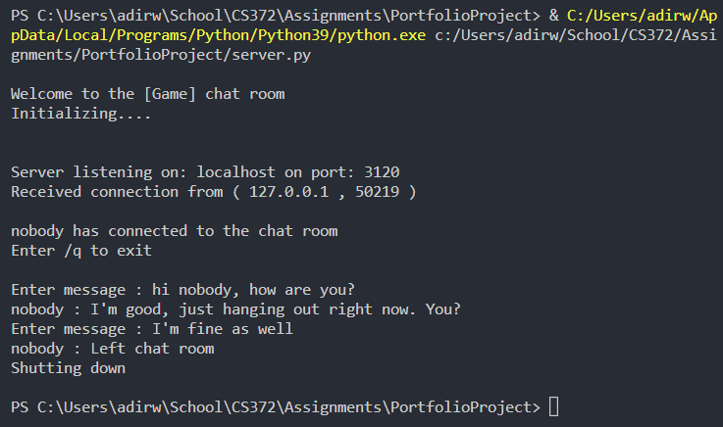

Client.py:

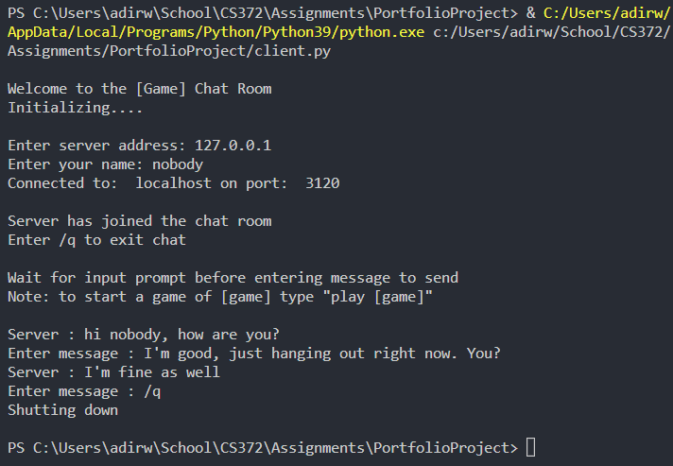

**Game and chat**