MICROMOUSE · PART 6
Electronics
Each topic explained step by step, with a simulation and every term defined
Topics in this document
- 6.1 Motors
- 6.2 PWM and the H-bridge motor driver
- 6.3 The battery and power
- 6.4 Power integrity: noise and brown-outs
- 6.5 Using a PCB someone else designed
- Part 6 at a glance, and flowcharts
This part is written to help you understand and bring up a board you did not design, not to design one from scratch.

How to read the simulations
Every graph in this document comes from a simulation of the equations in the text. The motor, battery and current numbers are typical examples (an example motor with 6 Ω winding resistance, a 300 mAh pack, and so on), not measurements of a particular part. Always check the datasheet of the parts you actually buy.

6.1 Motors
What a motor does. A small brushed DC motor turns electrical power into rotation. Its numbers decide how fast and how hard your mouse can accelerate.
Spec | Meaning
Rated voltage | The voltage the motor is designed for (for example 6 V)
No-load speed | How fast it spins with nothing attached, at the rated voltage
Stall torque / stall current | The torque and current when the shaft is held still (the worst case)
Gear ratio | How much the gearbox slows the motor and multiplies its torque

The key electrical relationship
A spinning motor also acts as a generator, so it pushes back against the supply. This is called back-EMF:
V = Ke · ω + I · R
The first term (back-EMF) grows with speed. The second (current through the winding resistance R) pays for torque. Two consequences:
- Top speed is where the back-EMF almost equals the supply voltage. This is why the Kv you measured in Part 4 exists.
- Stall current is V / R, the largest current the motor can draw. The driver and battery must survive it.
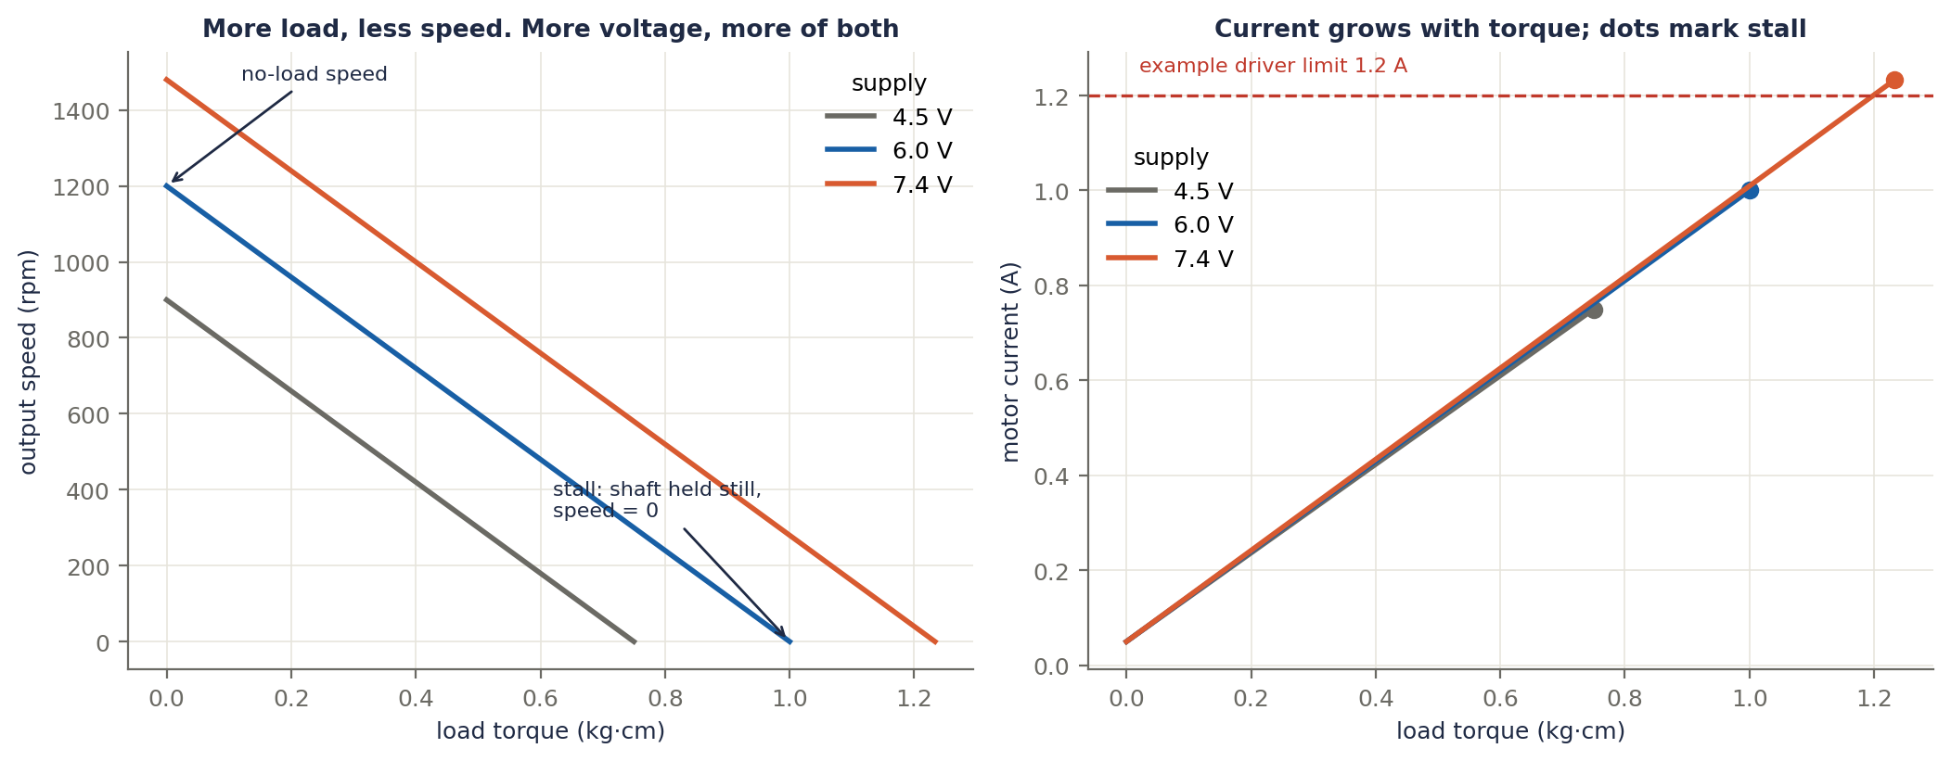
Figure 6.1a. An example motor (6 Ω winding, 1200 rpm no-load and 1.0 kg·cm stall at 6 V). Left: speed against load torque. More load means less speed, and more voltage moves the whole line up. Right: current depends on torque, not on voltage; a higher voltage simply lets the motor reach a larger stall point. At 7.4 V this motor would draw 1.23 A at stall, which is above the 1.2 A example limit of a typical small driver (at 6 V: 1 A).

Gears trade speed for torque
Output speed = motor speed / gear ratio. Output torque = motor torque × gear ratio (a bit less, because of gear losses).

A quick sizing example
Say the mouse weighs 100 g (0.1 kg) and you want 3 m/s² of acceleration. The total force is F = m · a = 0.1 × 3 = 0.3 N. With a 10 mm wheel radius, the total wheel torque is 0.3 × 0.010 = 0.003 N·m, about 1.5 mN·m per motor. That is small. The harder limit is usually speed: for 1 m/s with a 20 mm wheel, the wheel must turn 1000 / (π × 20) ≈ 15.9 turns per second, about 955 rpm at the wheel. Always check that the motor at your battery voltage can actually reach that speed, using the datasheet's no-load speed and the gear ratio.
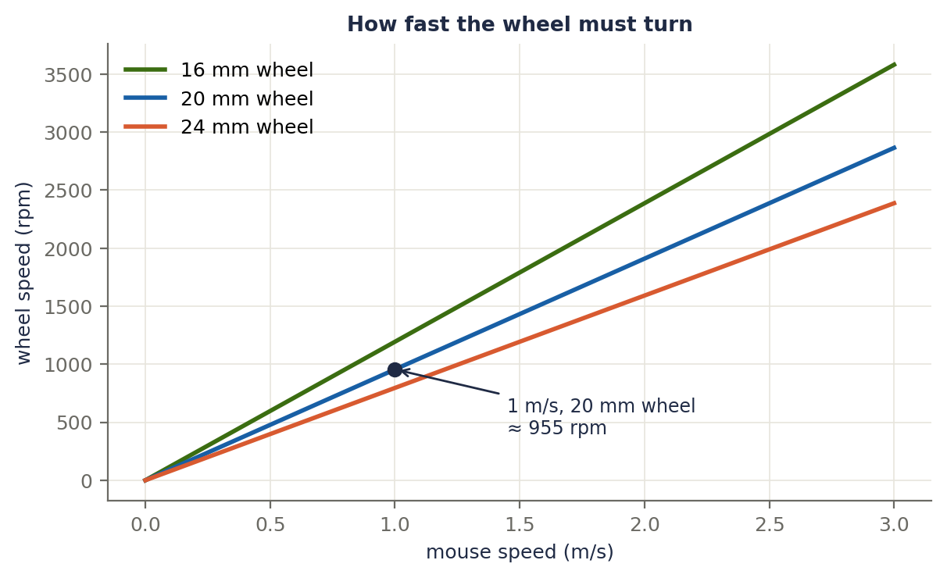
Figure 6.1b. The wheel speed needed for a given mouse speed, for three wheel sizes. A smaller wheel has to spin faster for the same speed.
A common trap. Many small gearmotors are rated for 6 V, but a 2S battery is 7.4 V (8.4 V full). Do not simply apply the full battery voltage all the time. Limit the average voltage with a PWM duty cap (the battery compensation from section 4.3 does this naturally), and check the motor's datasheet.

Terms explained
Term | Meaning
Brushed DC motor | A simple motor that reverses direction when you reverse the voltage.
Coreless motor | A lighter, faster-reacting design; better and more expensive.
Back-EMF | Voltage a spinning motor generates against the supply.
Stall torque / current | Torque and current when the shaft is held still.
No-load speed | Speed with no load at the rated voltage.
Gear ratio | Motor turns per output turn.
Winding resistance (R) | The motor's internal resistance.
Torque | Turning force, in N·m (or kg·cm).

6.2 PWM and the H-bridge motor driver
The problem. An ESP32 pin gives a tiny current and cannot reverse a motor. A motor driver is a chip that does both: you give it small logic signals, and it switches the battery power through the motor.

The H-bridge
Four switches arranged like the letter H, with the motor as the crossbar:
- Forward: top-left and bottom-right switches on, so current flows left to right through the motor.
- Reverse: top-right and bottom-left on, so current flows right to left.
- Brake: both bottom switches on, which shorts the motor so it resists turning.
- Coast: all switches off, so the motor spins freely.
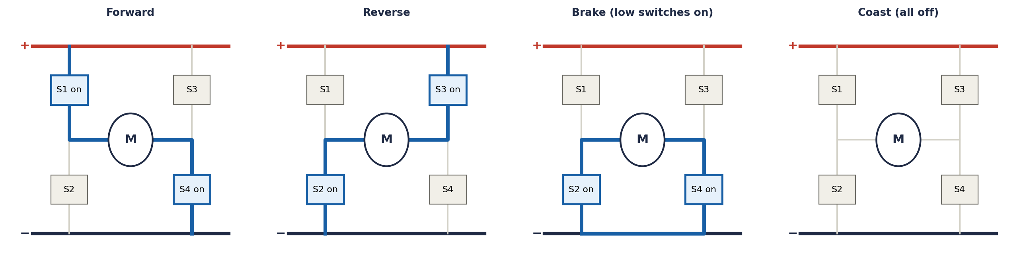
Figure 6.2a. The four H-bridge states. The blue line is the path of the current; highlighted boxes are the switches that are on.

PWM (pulse-width modulation)
To run the motor at half speed you do not use half the voltage: you switch the full voltage on and off very fast. The duty cycle is the fraction of time it is on. The motor's inductance smooths the pulses, so the average voltage = duty × battery voltage.
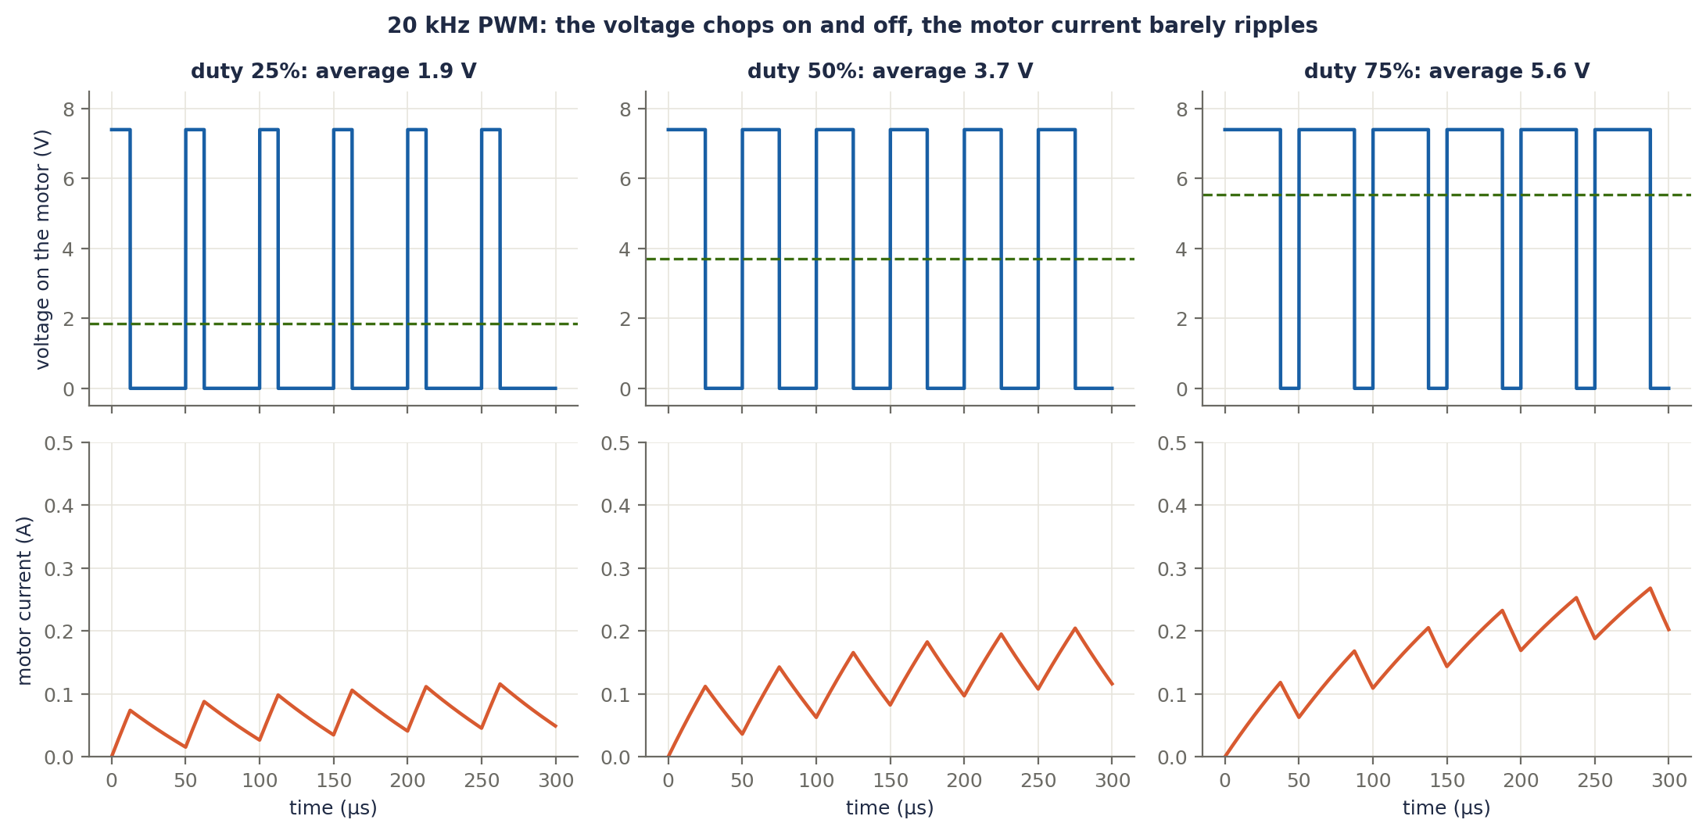
Figure 6.2b. 20 kHz PWM at 25%, 50% and 75% duty with a 7.4 V battery. Top: the voltage chops between 0 V and 7.4 V, and the dashed line is the average. Bottom: the motor current rises and falls only slightly, because the motor's inductance smooths it.
- At 60% duty the average is 0.6 × 7.4 = 4.4 V, so the motor runs at about 60% of full speed. This is the rule "duty = voltage wanted / battery voltage" from Part 4.
- Brake in the off time (called *slow decay*) is the usual choice for a mouse: it gives a more linear relationship between duty and speed and helps the mouse slow down. Coast (fast decay) is smoother in current but acts less like a brake.
- Use a PWM frequency of about 20 kHz, above what you can hear, so the motor does not whine. The ESP32's PWM hardware (LEDC) handles this at around 10-bit resolution (1024 duty steps).

Typical drivers (check the datasheet for exact limits)
Driver | Roughly | Notes
TB6612FNG | About 1.2 A continuous and 3.2 A peak per motor, supply up to 13.5 V | Inputs: IN1, IN2, PWM, and a STBY pin that must be high
DRV8833 | About 1.5 A per bridge, supply 2.7 to 10.8 V | Just IN1 and IN2: put the PWM on one of them

If the motor's stall current is higher than the driver's limit, a hard collision or a stuck wheel can overheat it. Check this number first.
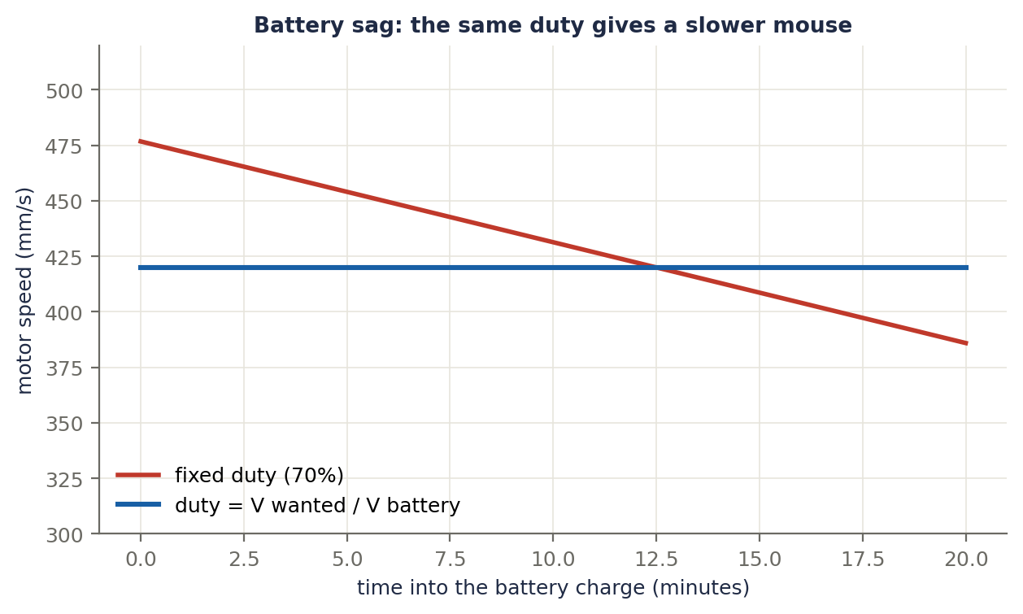
Figure 6.2c. What battery sag does. With a fixed 70% duty the motor speed falls from 477 to 386 mm/s as the battery drains from 8.4 V to 6.8 V. Computing the duty as voltage wanted divided by battery voltage keeps the speed constant at 420 mm/s.
// u is the wanted motor voltage (signed); vBat is the measured battery voltage
float duty = fabsf(u) / vBat; // battery compensation
if (duty > dutyMax) duty = dutyMax; // keep within the motor's rated average voltage
setDirection(u >= 0); // IN1 / IN2 pins
ledcWrite(pwmChannel, (int)(duty * 1023)); // 10-bit PWM at about 20 kHz

Terms explained
Term | Meaning
Motor driver | A chip that switches battery power through a motor, controlled by logic signals.
H-bridge | Four switches arranged so current can flow either way through the motor.
PWM | Switching power on and off quickly so the average voltage can be set.
Duty cycle | The fraction of each PWM cycle that the power is on.
PWM frequency | How many cycles per second (about 20 kHz here).
Brake / coast | Shorting the motor, or letting it spin freely, during the off time.
Slow / fast decay | Another name for brake or coast in the off time.
STBY | A standby pin that turns the driver on or off.
LEDC | The ESP32's hardware PWM generator.

6.3 The battery and power

2S LiPo
Two lithium-polymer cells in series.
 | Per cell | 2S pack
Full | 4.2 V | 8.4 V
Nominal | 3.7 V | 7.4 V
Do not go below | about 3.3 V | about 6.6 V

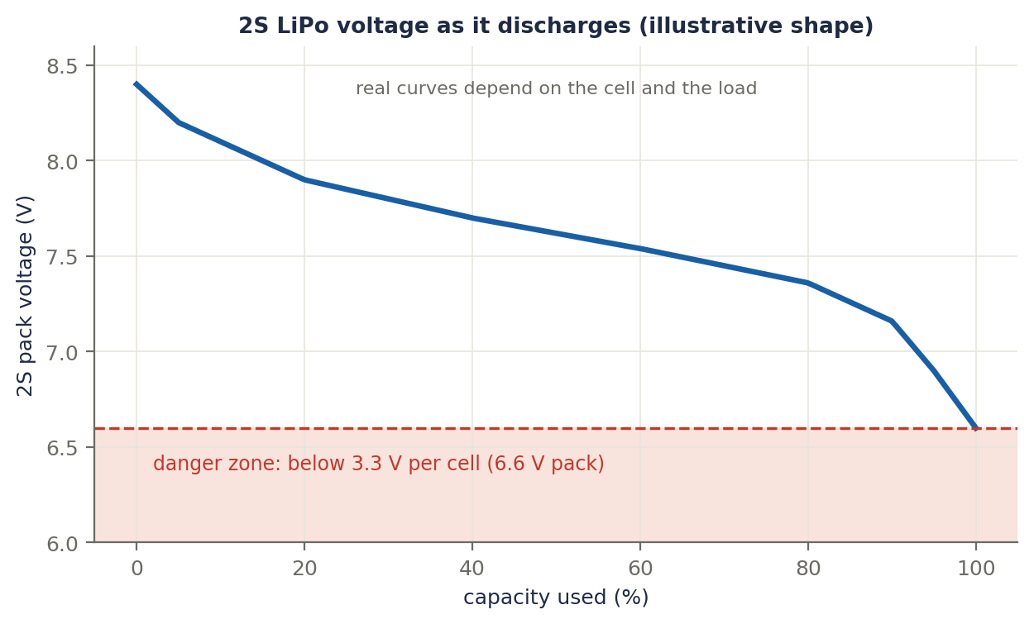
Figure 6.3a. The shape of a 2S LiPo discharge curve (illustrative; real curves depend on the cell and on the load). The voltage drops slowly for most of the charge and then falls quickly near the end, into the danger zone below 6.6 V.
- Never discharge below about 3.3 V per cell. This damages the cell and can make it unsafe.
- Use a proper balance charger, and never charge unattended. If a pack swells, gets hot or is damaged, stop using it.
- Storage: about 3.8 V per cell, not fully charged.
- Capacity (mAh) sets the run time. C rating is the maximum discharge current (current = C × capacity). Make sure it comfortably covers your peak current.

A current budget (an example, not a measurement)
Load | Typical current
ESP32 (more with WiFi on) | 100 to 240 mA
IR LED pulses (average) | about 30 mA
Gyro and encoders | about 10 mA
Two motors during a run | about 600 mA average, with higher peaks when accelerating
Total, roughly | about 810 mA

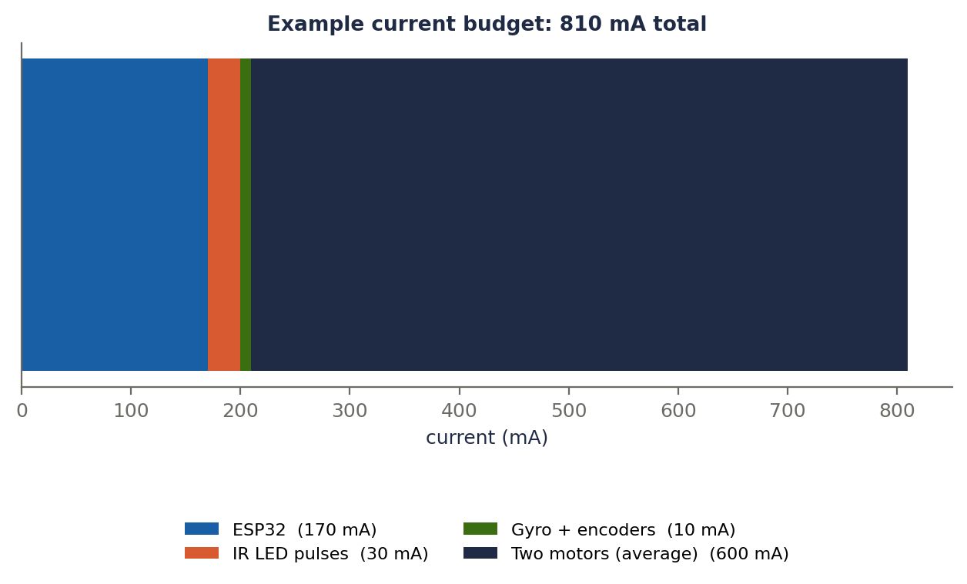
Figure 6.3b. The example budget. A 300 mAh pack would last about 300 / 810 × 60 ≈ 22 minutes. Peaks are much higher: stall or hard acceleration can pull amps for a moment, which matters for section 6.4.

The power tree
Different parts need different voltages. The motors run from the battery through the driver (check their rated voltage, as discussed in 6.1). The ESP32 and sensors need 3.3 V. Most ESP32 dev boards have an on-board regulator that takes about 5 V on the VIN pin, so a small 5 V buck converter (or a 3.3 V regulator) from the battery feeds the logic side. A switching (buck) regulator wastes less power than a linear one.
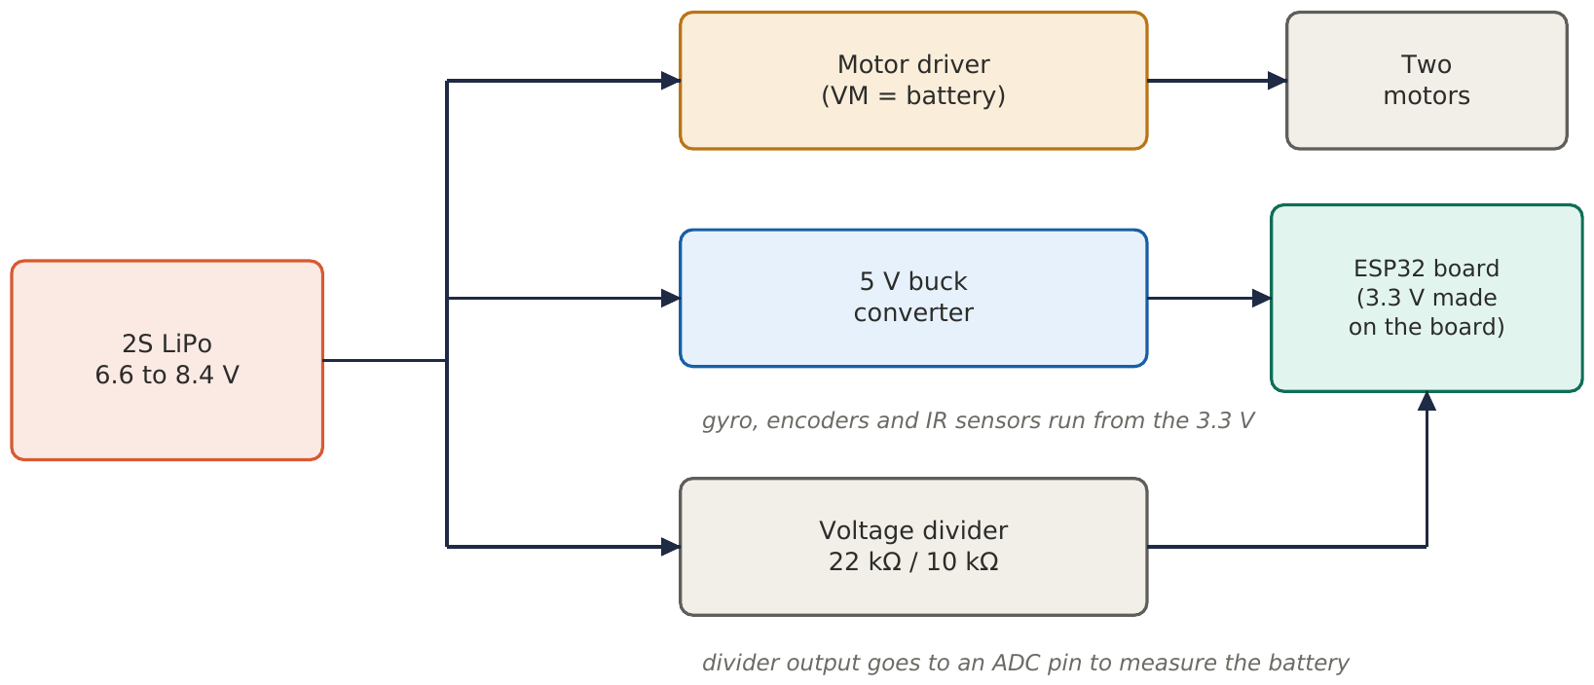
Figure 6.4. A typical power tree. The battery feeds the motor driver directly and the logic side through a buck converter. A voltage divider lets the ESP32 measure the battery.

Measuring the battery
The ESP32 ADC cannot take 8.4 V, so use a voltage divider: V_adc = V_bat × R2 / (R1 + R2). With R1 = 22 kΩ and R2 = 10 kΩ, 8.4 V gives 2.63 V (safely under 3.3 V). Then V_bat = V_adc × (R1 + R2) / R2. Use this reading in your battery compensation. The ESP32's ADC is nonlinear, so calibrate it against a multimeter.
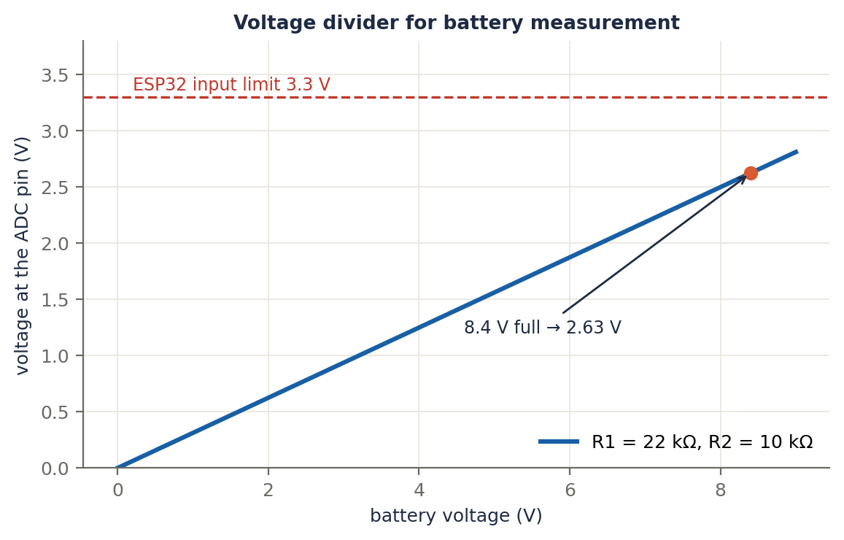
Figure 6.3c. The divider output against battery voltage. At the full-battery 8.4 V the ADC pin sees 2.63 V, below the ESP32 limit.
float vAdc = readAdcVolts(batteryPin); // 0 to about 3.1 V
float vBat = vAdc * (R1 + R2) / R2; // R1 = 22k, R2 = 10k
if (vBat < 6.8f) stopMotorsAndWarn(); // protect the battery

Terms explained
Term | Meaning
LiPo | Lithium-polymer rechargeable battery.
2S | Two cells in series (7.4 V nominal).
mAh | Capacity: milliamp-hours.
C rating | Maximum safe discharge, as a multiple of capacity.
Balance charger | A charger that keeps the cells in a pack at equal voltage.
Buck converter | A switching regulator that steps the voltage down efficiently.
LDO | A simple linear regulator (wastes the difference as heat).
Voltage divider | Two resistors that scale a voltage down.
Undervoltage cutoff | The voltage below which the mouse must stop.

6.4 Power integrity: noise and brown-outs
Motors are electrically noisy and draw sudden current. Two things can go wrong, and both look like "random" bugs:
- Noise: spikes from the motors get into the gyro or IR readings.
- Brown-out: when the motors suddenly draw a large current, the battery voltage dips and the ESP32 resets.

How a good board prevents them
- Decoupling capacitors: a small ceramic (for example 100 nF) right next to every chip's power pin soaks up fast noise, and a larger one (for example 10 to 100 µF) near the motor driver supplies sudden current.
- Short, wide power traces for the motor current, and a solid ground plane.
- Keep motor current away from sensitive ground: the large motor return current should not flow through the same ground path as the gyro and ADC.
- Logic levels: the ESP32 is 3.3 V. Make sure every sensor and driver input works at 3.3 V.
Symptom | Likely cause | What to check
ESP32 resets when the motors start | Supply dips (brown-out) | Battery C rating, bulk capacitor, thin power traces, wiring resistance
Gyro or IR readings jump when the motors run | Motor noise | Decoupling capacitors, ground routing, separate motor and sensor return paths
Motors whine | PWM frequency in the audible range | Raise it to about 20 kHz
Driver gets very hot | Current above its limit | Motor stall current, duty cap, wheel stuck or blocked

Terms explained
Term | Meaning
Decoupling (bypass) capacitor | A capacitor near a chip that supplies fast current and filters noise.
Bulk capacitor | A larger capacitor that supports the supply during current surges.
Brown-out | A supply dip that resets the microcontroller.
Ground plane | A large copper area used as a low-resistance ground.
Return current | Current flowing back to the battery through ground.
Logic level | The voltage that counts as "high" (3.3 V on the ESP32).

6.5 Using a PCB someone else designed
Since you are using an existing design, here is how to get from files to a running board.

1. Read before you order
- Schematic: find the power path (battery, regulator, motor driver), where the microcontroller connects, and the sensor circuits.
- BOM (bill of materials): every part with its value and package.
- Check compatibility with the ESP32. A design made for another controller (for example an Arduino Nano) may use pins or a 5 V logic level that the ESP32 does not match. Plan how to adapt (a board with an ESP32 footprint, or wiring a module and checking the 3.3 V levels).

2. Order
Send the Gerber files to a PCB maker (JLCPCB, PCBWay or an Indian fab). A thin board (for example 1.0 mm or less, if the design allows) saves weight. Check shipping and customs cost for India before ordering.

3. Solder in a safe order
- Power-related parts first (regulator, capacitors), then test.
- Then the motor driver and connectors.
- Then the sensors, and finally the microcontroller.

4. Bring-up checklist
Before connecting motors or an expensive chip:
- Look for solder bridges and wrong-way parts with a magnifier.
- With a multimeter, check for a short between the power rail and ground before powering up.
- Power from a current-limited supply (or a battery through a resistor first) and check that the 3.3 V rail is correct.
- Connect the microcontroller and run a small test program (blink an LED, print over serial).
- Test the gyro (read its ID), then the encoders, then the IR sensors one by one.
- Last: connect the motors, with the wheels off the ground, at low duty.

Terms explained
Term | Meaning
PCB | Printed circuit board: the board that holds and connects the parts.
Schematic | The circuit diagram.
BOM | Bill of materials: the list of parts.
Gerber files | The files a factory uses to make the board.
Footprint | The pad pattern for a part.
Bring-up | Powering and testing a new board step by step.
Short circuit | An unintended connection between two points, often power and ground.

Part 6 at a glance
Topic | The key idea
Motors | Back-EMF limits speed; stall current sets the driver and battery needs
PWM and H-bridge | Average voltage = duty × battery voltage; the bridge sets the direction and brake or coast
Battery | 2S LiPo: 8.4 V full, never below about 6.6 V; measure it and compensate
Power integrity | Decoupling capacitors and good grounding prevent noise and resets
Someone else's PCB | Read the schematic, check the ESP32 fit, solder in stages, test before the motors

Check yourself
If the battery sags from 7.4 V to 6.8 V during a hard acceleration and you keep the same PWM duty, what happens to the average motor voltage? What should the code do instead?
Answer. The average voltage drops in proportion (duty × battery voltage), so the mouse gets slower than planned (Figure 6.2c). The code should measure the battery voltage and compute duty = voltage wanted / battery voltage every control tick.

Flowchart 1: From a motor command to the driver
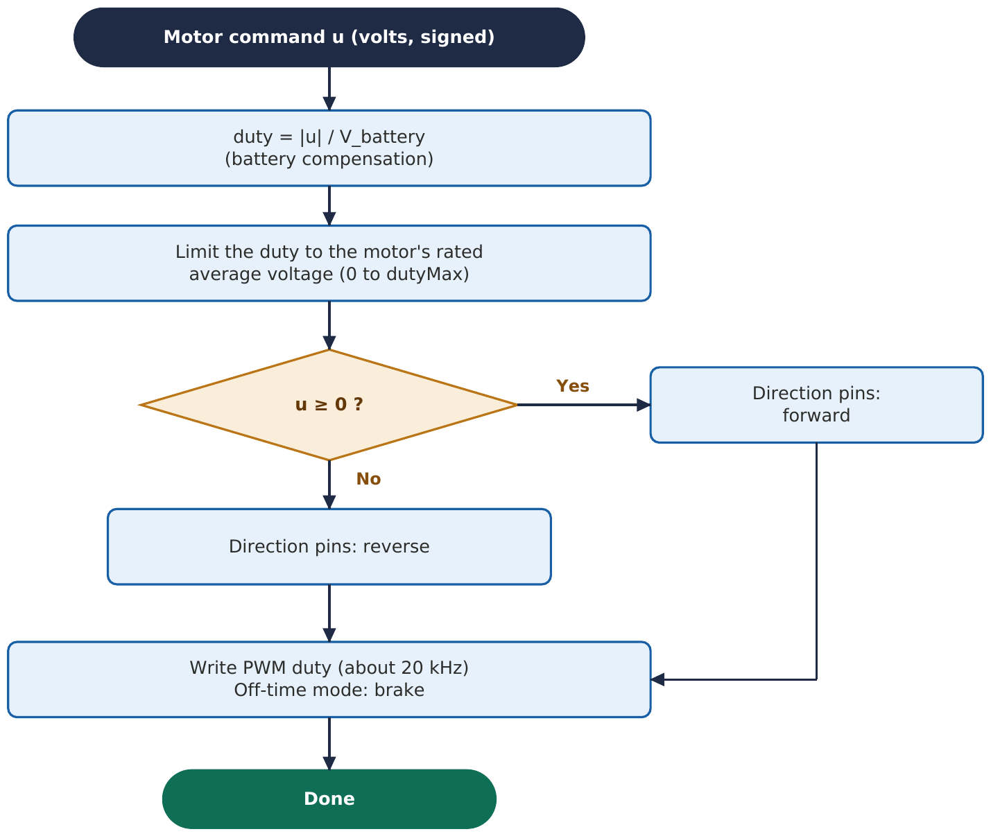

Flowchart 2: Bring-up of a new board
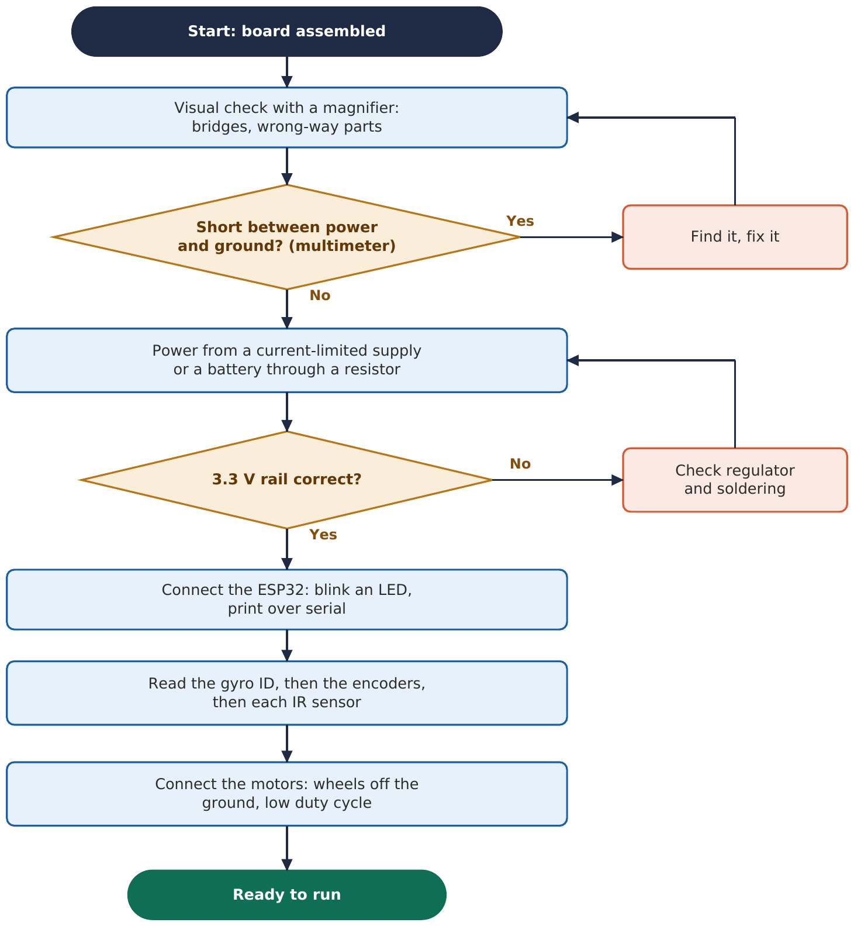

Next: the mechanical side: weight, wheels and tyres, the centre of gravity, and the build.

