MICROMOUSE
Maze Algorithms
Each topic explained step by step, with a simulation and every term defined
Topics in this document
- 3.1 Wall following
- 3.2 Flood fill
- 3.3 Modified flood fill
- 3.4 Search strategies
- 3.5 Dijkstra and A*
- 3.6 Diagonal paths
- 3.7 Data structures
- Flowcharts for every algorithm

How to read the simulations
Every diagram in this document comes from a real simulation: the algorithms were run in code on two small practice mazes, so the numbers and arrows are exactly what the algorithm produces. The mouse never sees the whole maze. It only feels the walls next to it.
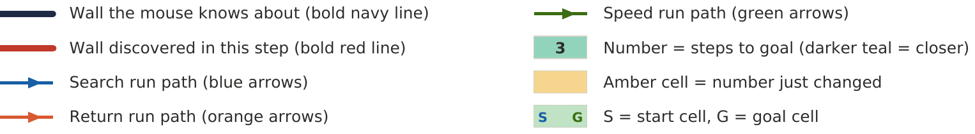
Symbols used in every simulation figure.
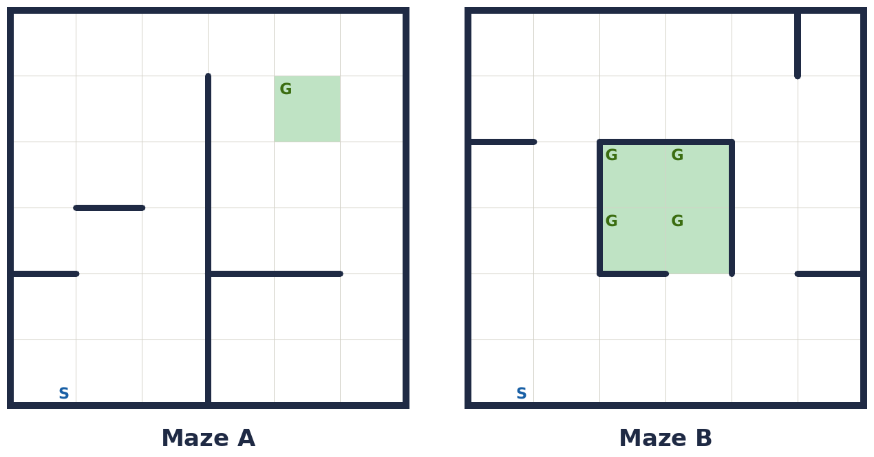
Maze A (left) has a long wall that blocks the direct route, so the mouse must discover the gap. Maze B (right) has the goal block as a free-standing island in the middle, like a real micromouse maze. Both are 6×6, with the start (S) in the bottom-left corner.

3.1 Wall following
What it is. The mouse keeps one hand (say the left) on a wall and keeps walking. It stores nothing: no map, no numbers. It only reacts to the walls beside it.

The rule, at every cell (left-hand version)
- If the left side is open, turn left and move forward.
- Else if the front is open, go straight.
- Else if the right is open, turn right and move forward.
- Else it is a dead end: turn around.

Why it works, and why it fails
If every wall in the maze is connected to the outer wall, following one wall visits every corridor, so it must pass the goal. In a micromouse maze the goal is the 2×2 block in the centre and its walls are not connected to the outer wall. The mouse keeps following the outside, comes back to where it started, and repeats forever. Mazes with loops can trap it the same way.
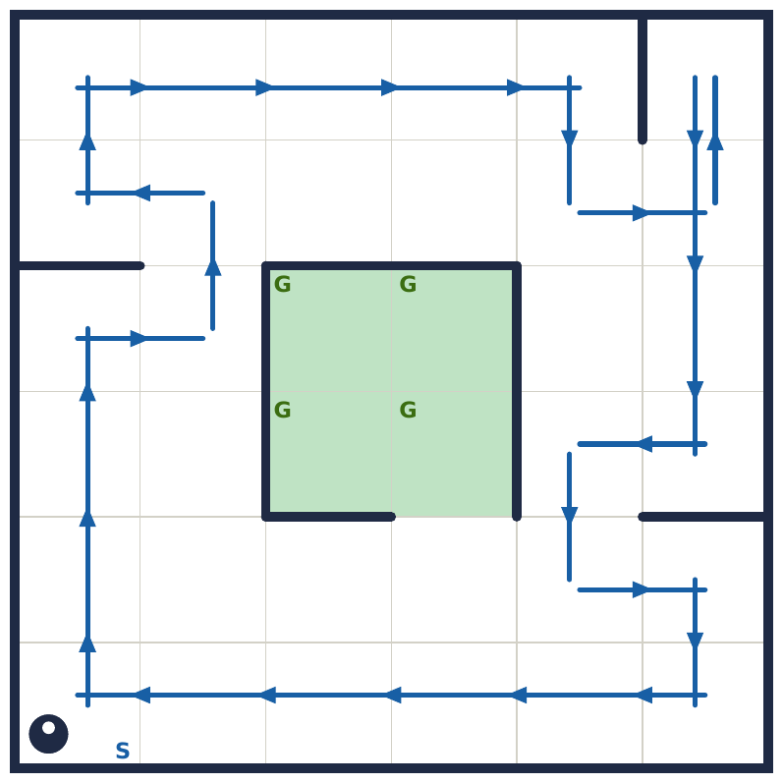
Figure 3.1. Left-hand wall follower in Maze B. After 27 moves it is back in a state it has already been in (same cell, same heading), so it will repeat forever and never enters the goal block. Arrows are shifted slightly to the right of travel so overlapping passes stay visible.
- Good for: a first test that your simulator, sensors and turning work. It needs almost no memory.
- Not good for: reaching a free-standing centre, escaping loops, or finding a short path.

Terms explained
Term | Meaning
Wall following | Navigating by always keeping the same side (left or right) against a wall.
Left-hand rule | The priority order left, front, right, back used to decide the next move.
Dead end | A cell with walls on three sides; the only move is to turn around.
Loop | A route that returns to a place the mouse has already been, in the same direction, so it repeats forever.
Free-standing goal (island) | A goal whose surrounding walls are not connected to the outer wall, so wall following never touches them.
State | The mouse's position plus the direction it faces. Seeing the same state twice means it is in a loop.
Autonomous | Running by itself, with no remote control or outside help.

3.2 Flood fill
The idea. Give every cell a number equal to its distance (in steps) from the goal. The mouse always moves to the neighbouring cell with the smaller number, so it is always walking downhill toward the goal.
Imagine pouring water into the goal. The water spreads outward one ring per step, and the step at which it reaches a cell is that cell's number.
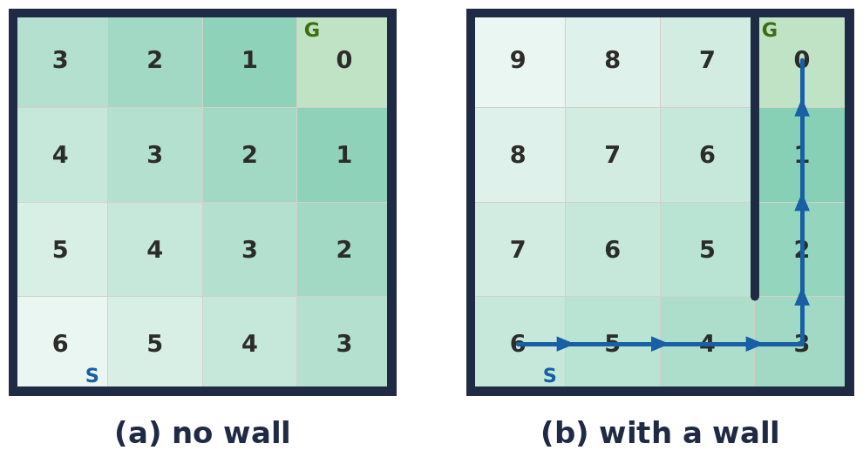
Figure 3.2a. A 4×4 room with the goal at the top-right. (a) With no wall, every ring is one more step and the mouse simply walks 6, 5, 4, … 0. (b) With a wall, the water has to flow around it, so the cells behind the wall get bigger numbers and the downhill path (blue) automatically goes through the gap.

How the numbers are made (BFS from the goal)
- Mark every cell as unvisited (for example -1) and set the goal cells to 0.
- Put the goal cells in a queue.
- Take a cell from the queue. For each neighbour that has no wall between and is still unvisited, set its number to (this cell's number + 1) and add it to the queue.
- Repeat until the queue is empty.

The search loop
- Sense the walls around the current cell.
- Save new walls in the wall map, on both sides of the boundary.
- Recompute the numbers.
- Move to the open neighbour with the smallest number.
- Repeat until the goal is reached.
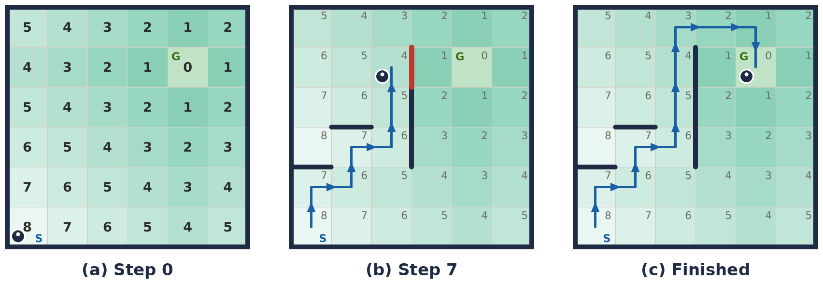
Figure 3.2b. Flood fill running in Maze A. (a) The mouse knows no walls, so the numbers are just straight-line grid distances. (b) At step 7 it feels a wall (red); the numbers jump and the route changes. (c) It finishes in 10 moves. Bold walls are only the ones it actually touched.

What happens to the numbers when a wall appears
- Every number is always 1 + the smallest number among its open neighbours.
- A new wall removes one neighbour. If that neighbour was the cell's best route, the cell's number goes up, and so do the numbers of the cells that were relying on it.
- Cells whose best route did not use that wall keep their numbers.
- Adding a wall can only raise numbers or leave them unchanged. It never lowers them, because blocking a path cannot make any route shorter.

Key points
- Optimistic assumption: walls the mouse has not felt are treated as open. It always plans the best route it can believe in, then corrects itself.
- Walls are stored on both sides: a wall between cells A and B is the east wall of A and the west wall of B. If only one side is stored, the two views disagree.
- Limit: it minimises the number of cells, not time, and it only knows what the mouse has seen.
- Cost: one recompute visits each cell once, 256 visits on a 16×16 maze. That is trivial for an ESP32.
The same step in C++ (this is the flood() method of the Maze struct in main.cpp):
void flood(const std::vector<Cell>& goals) {
for (int x = 0; x < W; x++)
for (int y = 0; y < H; y++) dist[x][y] = -1;
std::queue<Cell> q;
for (const Cell& g : goals) { dist[g.x][g.y] = 0; q.push(g); }
while (!q.empty()) {
Cell c = q.front(); q.pop();
for (int d = 0; d < 4; d++) {
if (wall[c.x][c.y][d]) continue; // wall between these two cells
int nx = c.x + DX[d], ny = c.y + DY[d];
if (inBounds(nx, ny) && dist[nx][ny] == -1) {
dist[nx][ny] = dist[c.x][c.y] + 1;
q.push({nx, ny});
}
}
}
}

Terms explained
Term | Meaning
Cell number (distance) | How many steps a cell is from the goal, given the walls known so far.
Goal cells | The target cells (the centre 2×2 block) that get number 0.
Neighbour | A cell directly north, east, south or west of another cell.
Open neighbour | A neighbour with no wall between it and the current cell.
Wall map | The mouse's memory of which walls exist, stored per cell.
Queue | A first-in, first-out list. BFS uses it to process cells ring by ring.
BFS (breadth-first search) | Exploring outward in rings from the start point, so the first time a cell is reached is by the fewest steps.
Ring | All cells at the same distance from the goal.
Downhill move | Stepping to the open neighbour with the smallest number.
Optimistic assumption | Treating unknown walls as if they do not exist.
Recompute | Running the flood again after new walls are saved.
Heading | The direction the mouse faces: north, east, south or west.

3.3 Modified flood fill
The problem. Plain flood fill recomputes all 256 cells every time the mouse finds a single wall. That is wasteful, and on a weak microcontroller it takes real time.
The idea. When a new wall appears, only the cells whose number is now wrong need fixing. Fix those and stop.
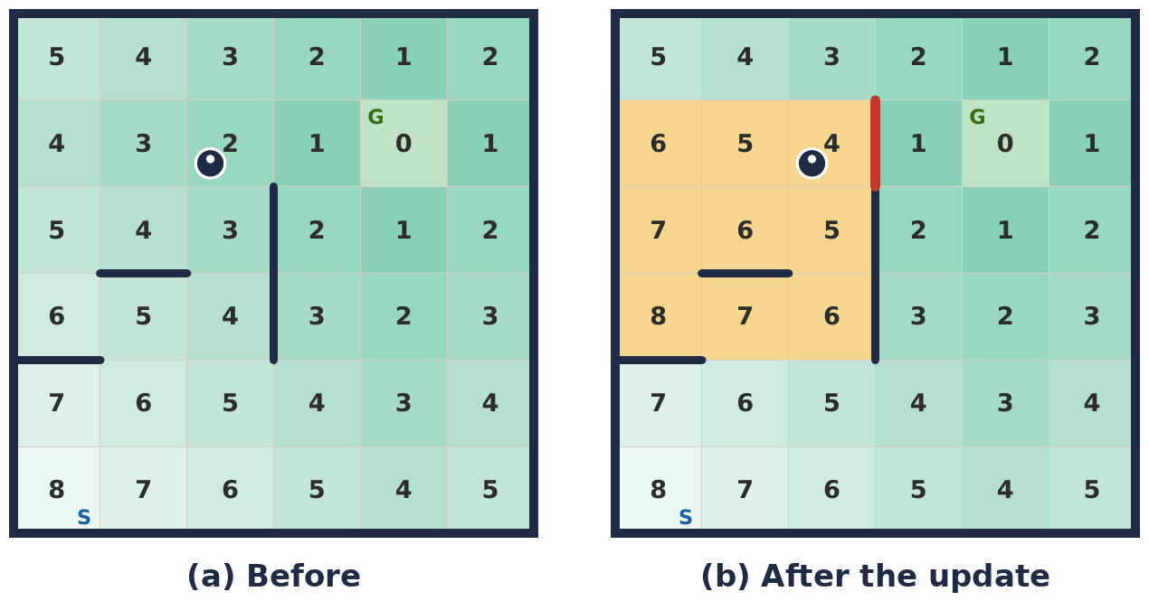
Figure 3.3. (a) Before: the mouse is about to feel a new wall and the numbers assume it is open. (b) After the update: the red wall is new, and only the 9 amber cells (out of 36) needed a new number. Every other cell kept its number.

Algorithm (incremental update with a stack)
- Push the current cell, and the cell on the other side of the new wall, onto a stack.
- Pop a cell. Look at its open neighbours and find the smallest neighbour number, m.
- If the cell's number is not m + 1 (and it is not a goal cell): set it to m + 1 and push all its open neighbours, because their numbers may now be wrong too.
- Repeat until the stack is empty.
Why it is valid. A cell's correct distance is always 1 plus its best open neighbour. If a cell already satisfies that rule, nothing beyond it needs to change, so the update stops spreading.
// helpers: isGoal(x, y), smallestOpenNeighbour(x, y), openNeighbours(x, y)
void update(int x, int y) { // called after a new wall is saved
std::vector<Cell> stack = {{x, y}};
while (!stack.empty()) {
Cell c = stack.back(); stack.pop_back();
if (isGoal(c.x, c.y)) continue;
int m = smallestOpenNeighbour(c.x, c.y);
if (dist[c.x][c.y] != m + 1) {
dist[c.x][c.y] = m + 1;
for (const Cell& n : openNeighbours(c.x, c.y)) stack.push_back(n);
}
}
}

The second meaning of "modified"
Competitive mice also stop exploring early: if the route they already know is provably the best, they run it instead of mapping the whole maze. That needs two views of the same maze, the optimistic map and the pessimistic map, which are shown in section 3.4.

Terms explained
Term | Meaning
Modified flood fill | Flood fill that only repairs the numbers that became wrong, instead of recomputing every cell.
Incremental update | Fixing only the part of the data that changed.
Stack | A last-in, first-out list: the newest item is processed first.
m | The smallest number among a cell's open neighbours. The cell's correct number is m + 1.
Open neighbour | A neighbour with no wall between it and the cell.
Optimistic map | The map in which unknown walls count as open. It gives the best path that could possibly exist.
Pessimistic map | The map in which unknown walls count as closed. It gives a path that is guaranteed to work.
Smart search | Stopping the search once the optimistic and pessimistic best paths agree.

3.4 Search strategies
A competition run is several phases, not one.
Phase | What happens | Goal
Search run | Explore from the start to the centre | Find a path and learn the walls
Return run | Go back to the start (flood fill with the goal moved to the start) | Be at the start line, and explore extra cells on the way
Speed run | Run the best known path as fast as possible | Minimum run time

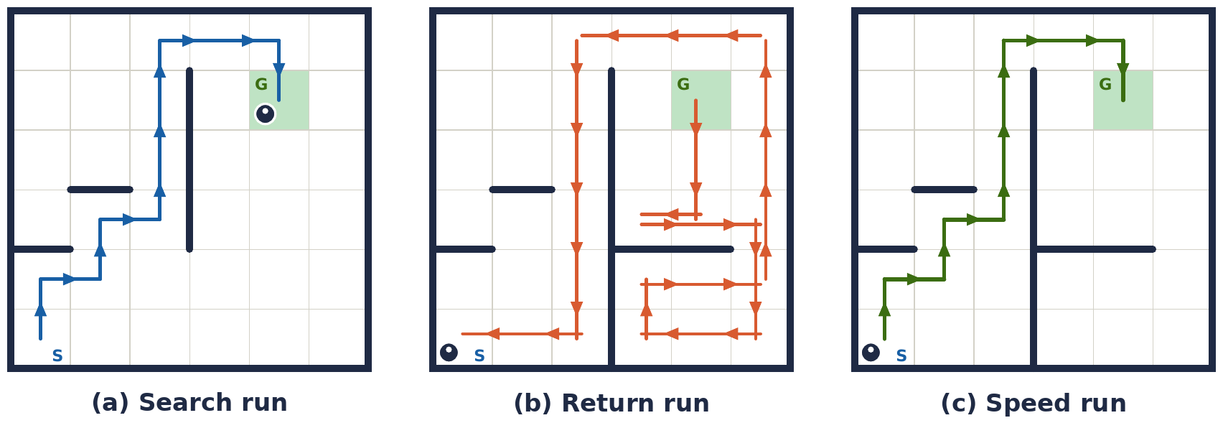
Figure 3.4a. The three phases in Maze A. (a) Search run: 10 moves, discovering walls on the way. (b) Return run: 26 moves back to S; the flood goal is now S and the mouse explores unknown cells on the way (arrows offset so overlaps show). (c) Speed run: the best path through cells it has verified, 10 moves.

Why the return trip matters
The mouse must be at the start to begin a timed run, and the trip back is free exploration. Flood fill with the goal changed to the start cell makes the return trip identical to the search.

Search strategies, from simple to smart
- Explore everything. Map all 256 cells, then compute the best path. Safe, but very slow.
- Explore until the centre is found. Faster, but the path may be far from optimal.
- Smart search. Flood twice, once optimistic and once pessimistic. If both give the same path, no unexplored cell can improve it: stop searching and start the speed run.
- Frontier-guided search. Prefer unexplored cells that lie on or near promising paths.
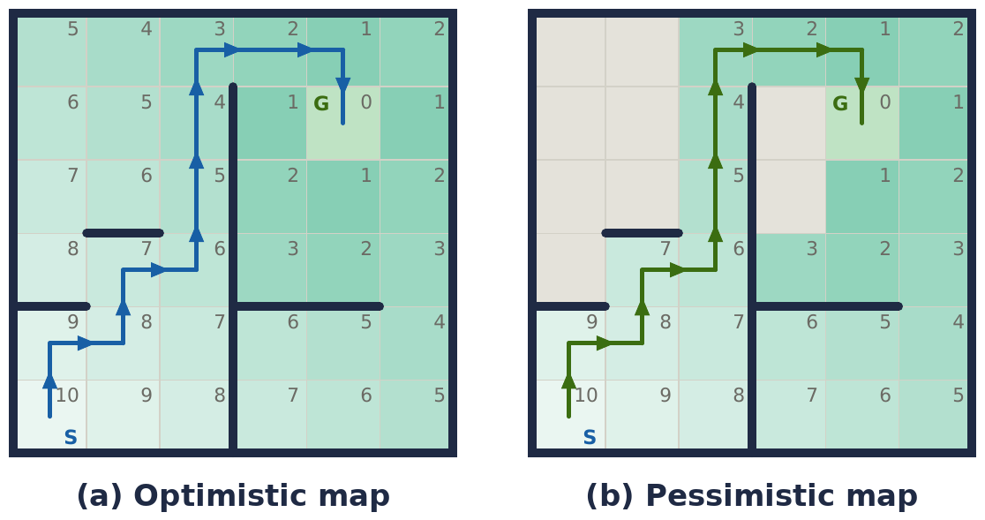
Figure 3.4b. The smart-search test after the search and return runs. (a) Optimistic map: unknown walls count as open; best possible path 10 moves. (b) Pessimistic map: grey cells were never visited, so they count as blocked; guaranteed path 10 moves. Both paths have the same length, so no unexplored cell can make the route shorter and the mouse can stop exploring.
Scoring trade-off. Many competitions add a fraction of the search time to the final score (commonly 1/30). More searching costs time but may reveal a faster path. Tune the balance to the rules of your event.

Terms explained
Term | Meaning
Search run | The first run, exploring to find the centre and learn walls.
Return run | The trip back to the start, usually exploring more cells on the way.
Speed run | A fast run along the best known path.
Visited cell | A cell the mouse has entered, so all its walls are known.
Optimistic map | Unknown walls treated as open.
Pessimistic map | Unknown walls treated as closed (only verified cells can be used).
Smart search | Stopping exploration once the optimistic and pessimistic best paths agree.
Frontier | The boundary between explored and unexplored cells.
Search-time penalty | The fraction of search time added to the score (commonly 1/30).

3.5 Dijkstra and A*
Why flood fill is not enough. It counts cells. But a mouse spends different time on different moves: a straight cell is fast, a turn means slowing down. Two routes with the same number of cells can have very different run times.
In the example below, a straight cell costs 1 unit and each turn adds 3 units. Route A is a staircase: 10 moves and 9 turns, cost = 10 + 9×3 = 37. Route B is long straights: 10 moves and 1 turn, cost = 10 + 1×3 = 13.
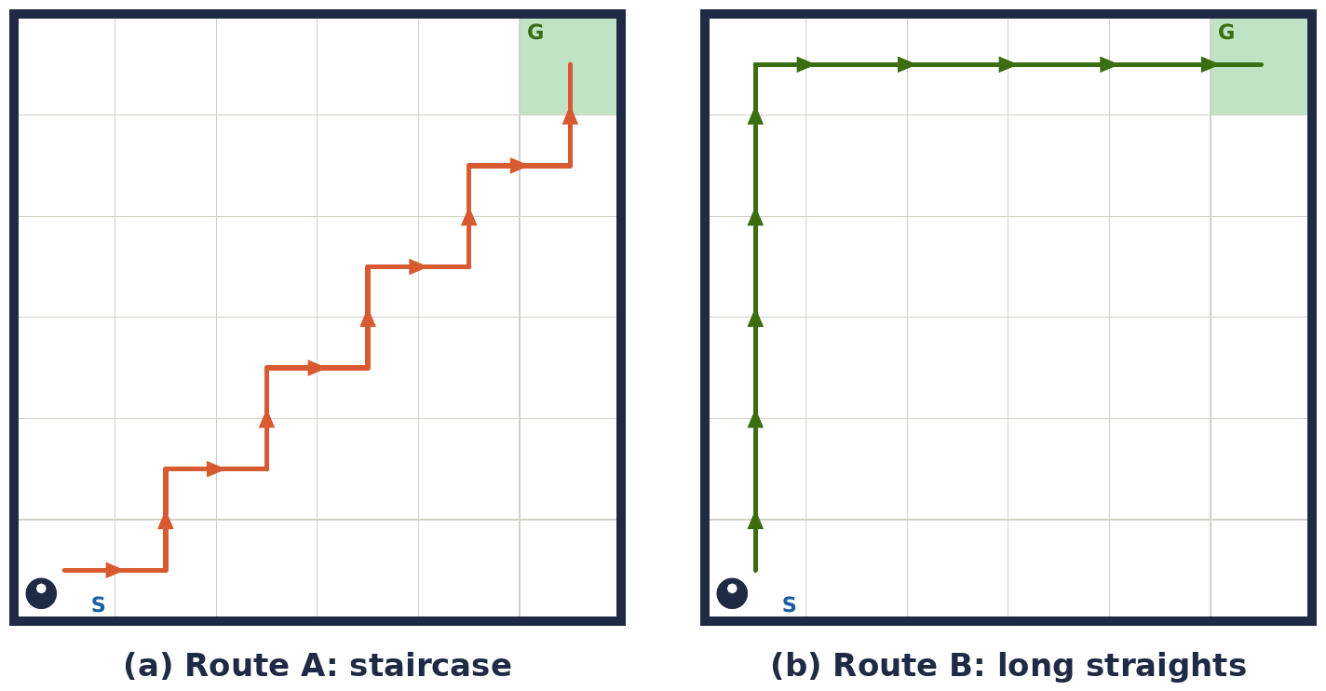
Figure 3.5. Same number of cells, very different cost. Flood fill sees both routes as 10 cells and may pick either one. Dijkstra sees that route B costs 13 against 37 and picks it.

Dijkstra's algorithm
- Give the start state cost 0, and every other state cost infinity.
- Repeatedly take the unfinished state with the lowest cost so far.
- For each move from it, compute new_cost = cost + move_cost. If that is lower than the stored value, update it and remember where you came from.
- Stop when the goal is taken. Follow the came-from links backward to get the path.
The state must be (x, y, heading), not just (x, y). The cost of a turn depends on which way you are already facing, so one cell is really four states. A 16×16 maze becomes 256 × 4 = 1024 states, which is still tiny.

Move costs for a real mouse
- Straight run of n cells: time from accelerate, cruise, brake. Longer straights are cheaper per cell.
- 90° turn: time of the curved turn at its speed.
- 45° and 135° turns and diagonal segments: their own measured times.

A* (A-star)
Dijkstra with a hint. The priority is g + h, where g is the cost so far and h is an estimate of the remaining cost (for example the straight grid distance to the goal times the cheapest cost per cell). h must never overestimate the true remaining cost, otherwise A* can return a non-optimal path. It expands fewer states than Dijkstra, but on a 16×16 maze both run fast, so the practical benefit is small.
 | Flood fill (BFS) | Dijkstra | A*
Minimises | Number of cells | Any cost (time) | Any cost (time)
Queue type | Plain first-in first-out | Priority queue | Priority queue
Speed | Fastest | Slower | Faster than Dijkstra
Use | Search run | Speed-run planning | Speed-run planning

Terms explained
Term | Meaning
Cost | The number a path is judged by. For a speed run it should represent time.
Turn cost | Extra cost added when the mouse changes direction, because it must slow down.
State | Everything the planner needs to know about where the mouse is: (x, y, heading).
Priority queue | A list that always gives back the entry with the lowest cost first.
Dijkstra | Finds the lowest-cost path by always expanding the cheapest unfinished state.
A* | Dijkstra guided by a heuristic, so it explores fewer states.
Heuristic (h) | An estimate of the remaining cost to the goal.
g | The cost already paid to reach a state.
Admissible heuristic | A heuristic that never overestimates the true remaining cost. Required for A* to stay optimal.
Came-from link | A record of the previous state, used to rebuild the path backward from the goal.
Relaxation | Updating a state's cost when a cheaper way to reach it is found.

3.6 Diagonal paths
The staircase problem. A path like right, up, right, up, right, up forces the mouse to turn at every cell. With diagonals the mouse flows through the same area in one straight line.
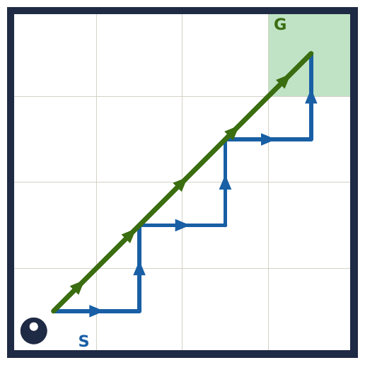
Figure 3.6. The same trip two ways. Blue: staircase, 6 cell moves = 6 × 180 mm = 1080 mm with 5 turns. Green: one diagonal line, √(540² + 540²) ≈ 763 mm with no turns in the middle: about 30% shorter.

Geometry facts (cell = 180 mm)
- One diagonal step (from the middle of one cell edge to the next) moves 90 mm sideways and 90 mm forward, a length of 90√2 ≈ 127 mm.
- A full cell diagonal is 180√2 ≈ 254 mm.
- The big win is not only distance: the mouse never has to slow down for the middle turns.

What a diagonal path needs from the mouse
- Path conversion. Take the optimal cell path and replace alternating turn-straight-turn patterns with diagonal segments.
- Entry and exit turns. Moving between straight and diagonal needs 45° (and sometimes 135°) turns: extra turn types in the motion library.
- Different sensing. On a diagonal the side walls are not beside the mouse. It uses the corner posts it passes, seen by IR sensors angled forward-sideways, for position correction.
- Strong gyro control. A small heading error grows with distance on a long diagonal.
Turn / segment | Used for
90° turn (smooth arc) | Normal corners between straights
45° turn in / out | Switching between a straight and a diagonal
135° turn | Sharp corners next to diagonals
Diagonal run | A chain of diagonal steps between two 45° turns

Practical order. Get straight-and-90° runs working reliably first, then add diagonals. Diagonals give the biggest speedup, and also the most ways to crash.

Terms explained
Term | Meaning
Diagonal path | A path that crosses cells corner to corner instead of following the grid.
Staircase path | A path that alternates right, up, right, up, forcing a turn at every cell.
45° turn | A half-right-angle turn, used to enter or leave a diagonal.
135° turn | A sharper turn that reverses most of the direction, used next to diagonals.
Corner post | The small 12 × 12 mm post at a cell corner. The mouse senses it to correct its position on diagonals.
Path conversion | Rewriting a cell path as straights, turns and diagonal segments.
Heading error | The difference between the direction the mouse faces and the direction it should face.
Gyro | A sensor measuring rotation rate; integrating it gives heading.

3.7 Data structures
The whole maze lives in a few hundred bytes of memory. These are the pieces.

1. Wall map (bitmask)
Store 4 bits per cell: North = 1, East = 2, South = 4, West = 8. A cell with walls on North and South has value 1 + 4 = 5 (binary 0101). Test a wall with walls[x][y] & EAST and set one with walls[x][y] |= EAST.
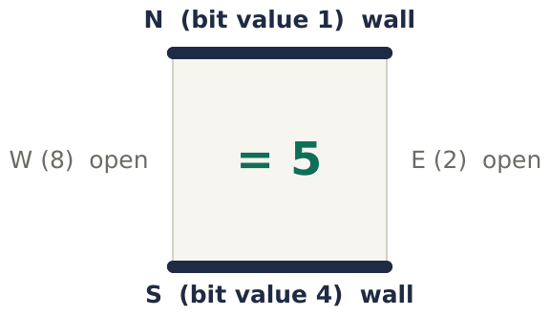
Figure 3.7a. One cell with two bold walls: value = N(1) + S(4) = 5.
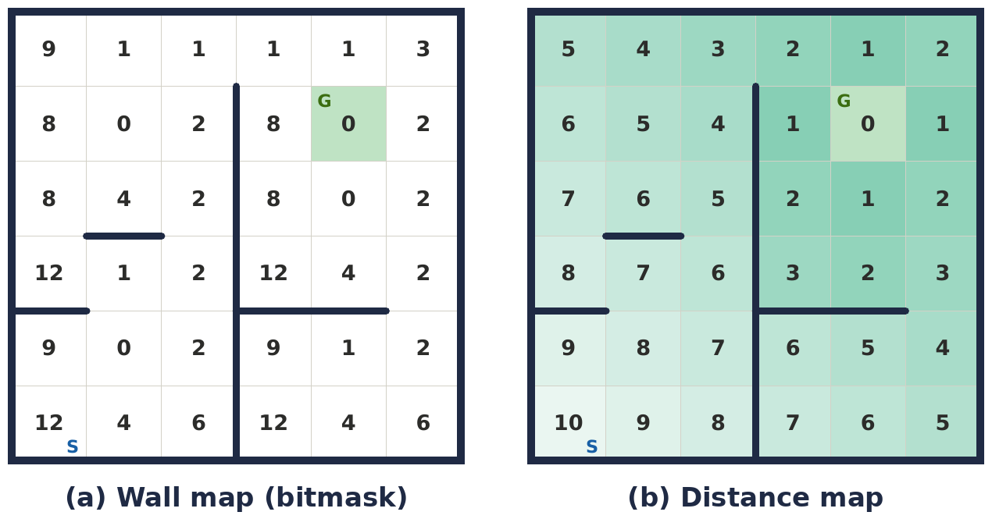
Figure 3.7b. Maze A as data. (a) Each cell shows its wall bitmask: one byte per cell, 36 bytes here and 256 bytes for 16×16. (b) The distance map: the final flood-fill numbers, one small integer per cell.

2. The seven structures
Structure | What it stores | Notes
Wall map | Walls per cell as 4 bits | Add a visited bit and a checked bit to tell unknown from open
Distance map | 16×16 array of small integers | Rewritten by every flood fill
Queue (BFS) | First in, first out | A circular buffer of 256 entries is enough
Stack (modified flood) | Last in, first out | Fixed array with one index
Priority queue | Lowest-cost entry first | Binary heap, bucket queue, or a simple scan for 1024 states
Coordinates and headings | (x, y) from 0 to 15, heading 0 to 3 | Turn right: (h+1)%4, left: (h+3)%4, around: (h+2)%4
Path as moves | FORWARD×3, TURN_RIGHT, DIAG×4, … | Merge consecutive forwards so the controller can accelerate across several cells

enum Dir { N = 0, E = 1, S = 2, W = 3 };
constexpr int DX[4] = {0, 1, 0, -1}; // neighbour in direction d is (x + DX[d], y + DY[d])
constexpr int DY[4] = {1, 0, -1, 0}; // maze coordinates with y growing northward

inline int turnRight(int h) { return (h + 1) % 4; }
inline int turnLeft(int h) { return (h + 3) % 4; }
inline int turnBack(int h) { return (h + 2) % 4; }

// wall bitmask, one byte per cell
constexpr uint8_t NORTH = 1, EAST = 2, SOUTH = 4, WEST = 8;
uint8_t walls[16][16];
bool hasEastWall = walls[x][y] & EAST; // test
walls[x][y] |= EAST; // set

Memory on a 16×16 maze
Structure | Size
Wall map | 256 bytes
Distance map | 256 bytes
BFS queue or stack | up to 256 entries
Dijkstra cost table (x, y, heading) | 1024 entries

All of this fits even in an Arduino Uno's 2 KB of RAM, but the ESP32 has far more room for logging and lookup tables.

Terms explained
Term | Meaning
Bit | A single 0 or 1. One bit per wall direction.
Bitmask | Several yes/no flags packed into one number, one bit per flag.
Wall map | The array of wall bitmasks for every cell.
Distance map | The array of flood-fill numbers for every cell.
Queue | First in, first out list, used by BFS.
Stack | Last in, first out list, used by the modified flood fill.
Priority queue | A list that always returns the lowest-cost entry first.
Binary heap | A compact structure that implements a priority queue efficiently.
Circular buffer | A fixed-size array used as a queue by wrapping the head and tail indexes around.
uint8 | An unsigned 8-bit integer (0 to 255): one byte.
Modulo (%) | The remainder after division. (h + 1) % 4 turns a heading right and wraps 3 back to 0.
Path as moves | A route stored as a list of straights, turns and diagonals rather than cells.

Flowcharts
Every algorithm as a step-by-step diagram. Rectangles are actions, diamonds are yes/no decisions.

Flowchart 1: Wall following (3.1)
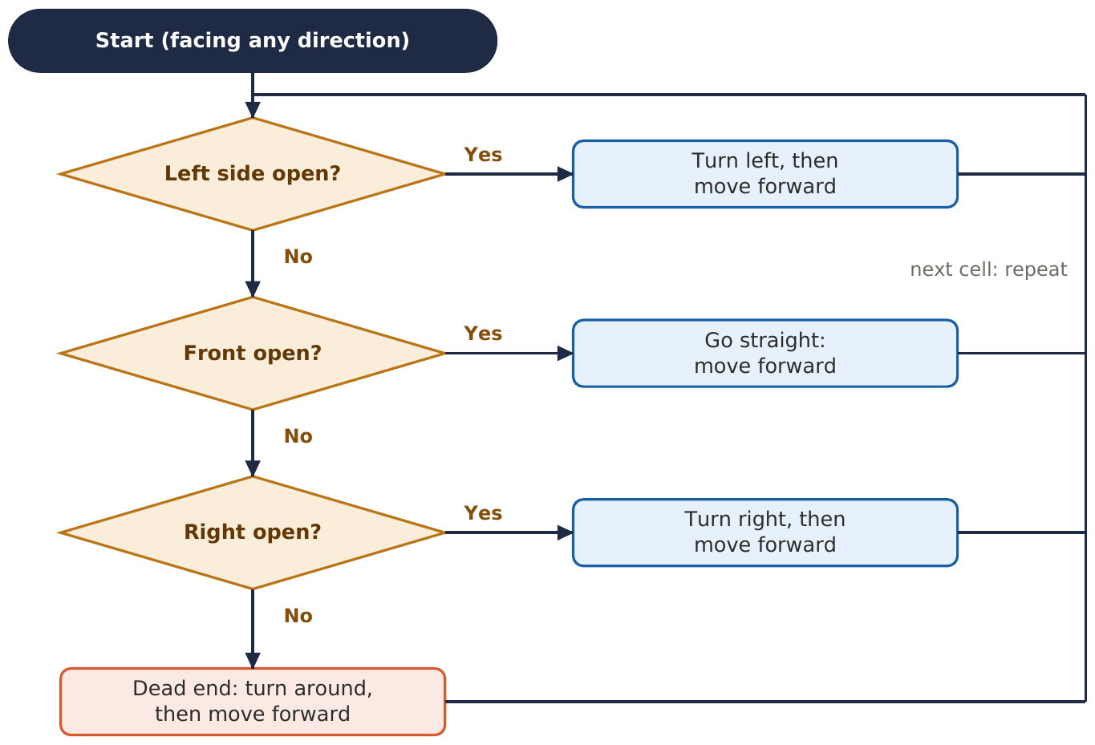

Flowchart 2: A full competition run (3.4)
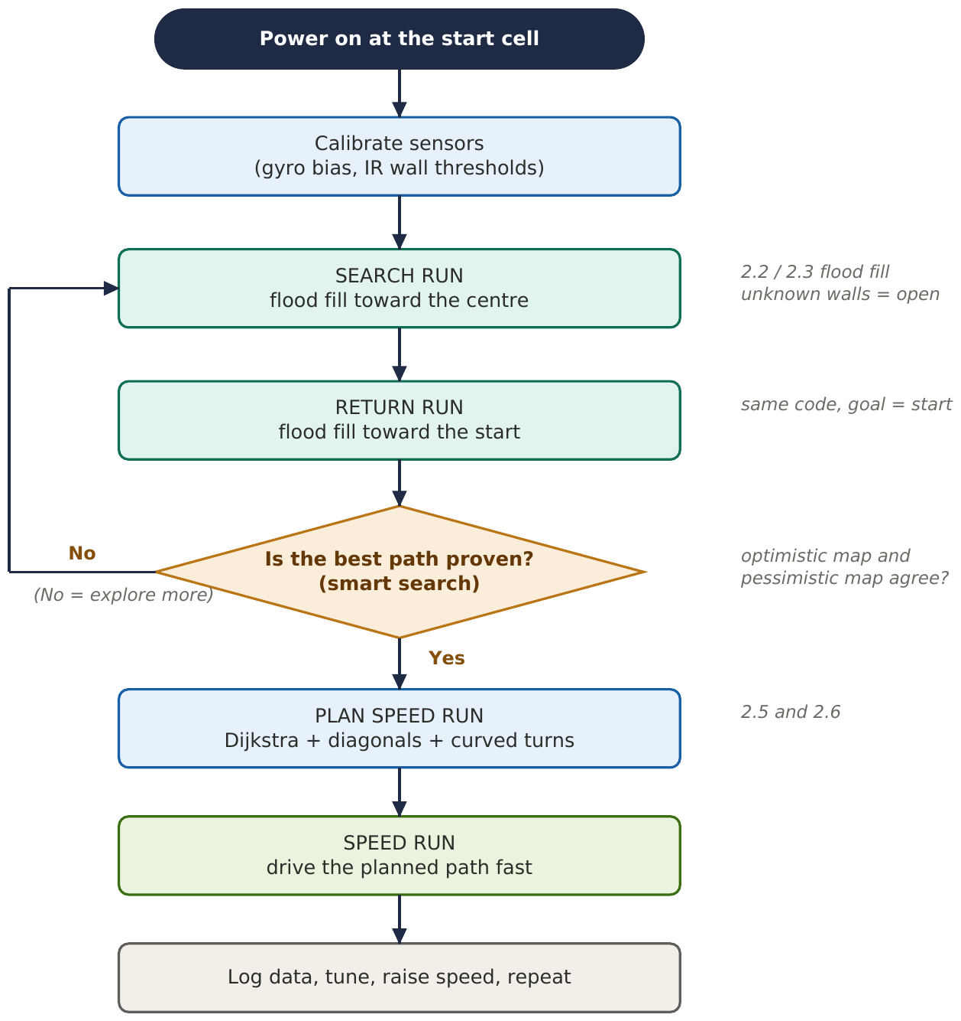

Flowchart 3: Flood fill search loop (3.2)
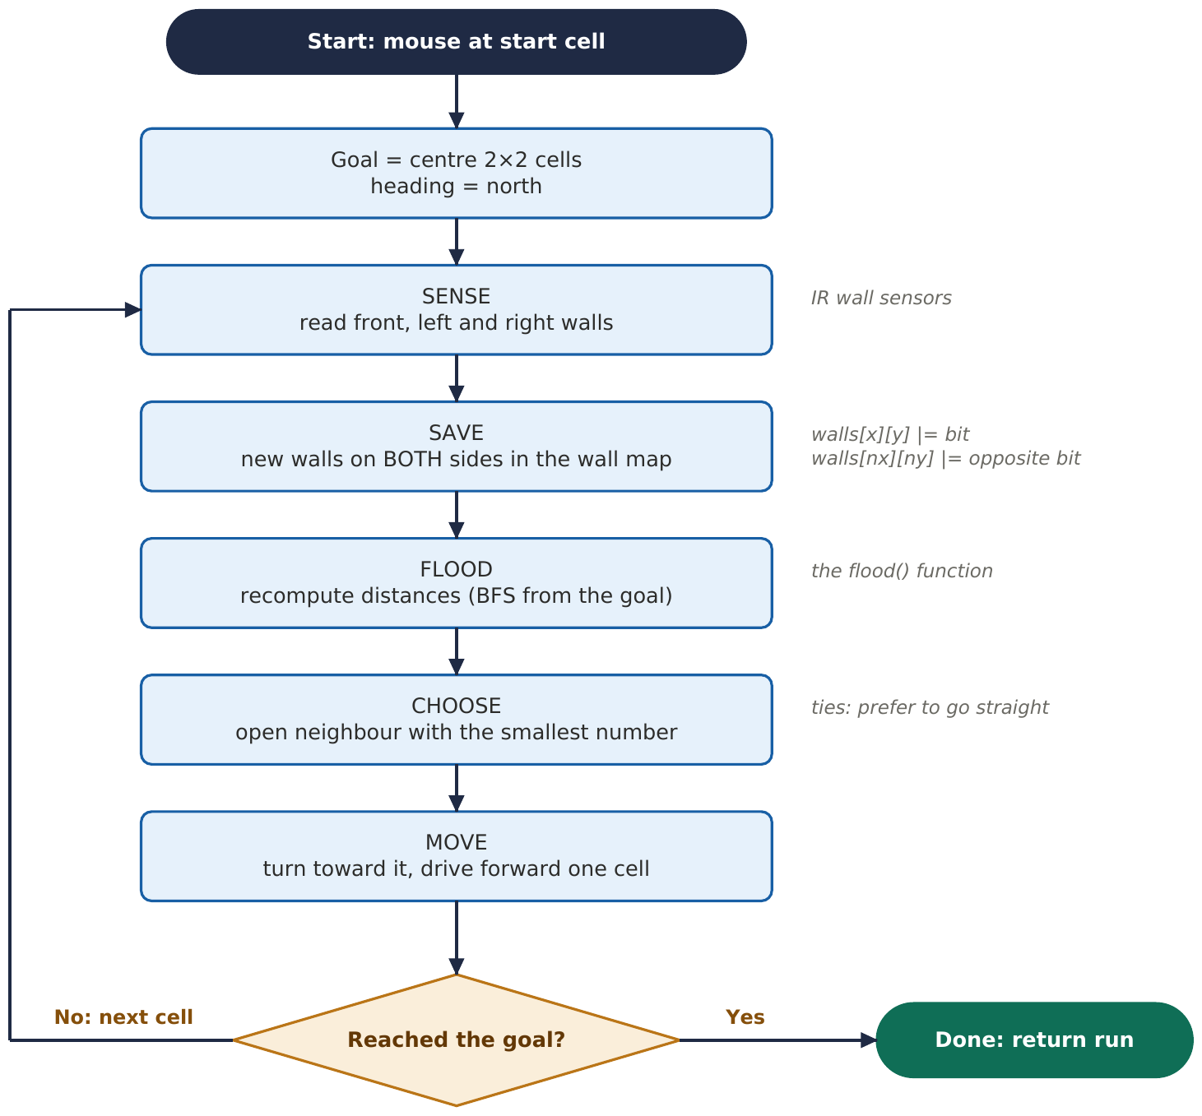

Flowchart 4: Modified flood fill update (3.3)
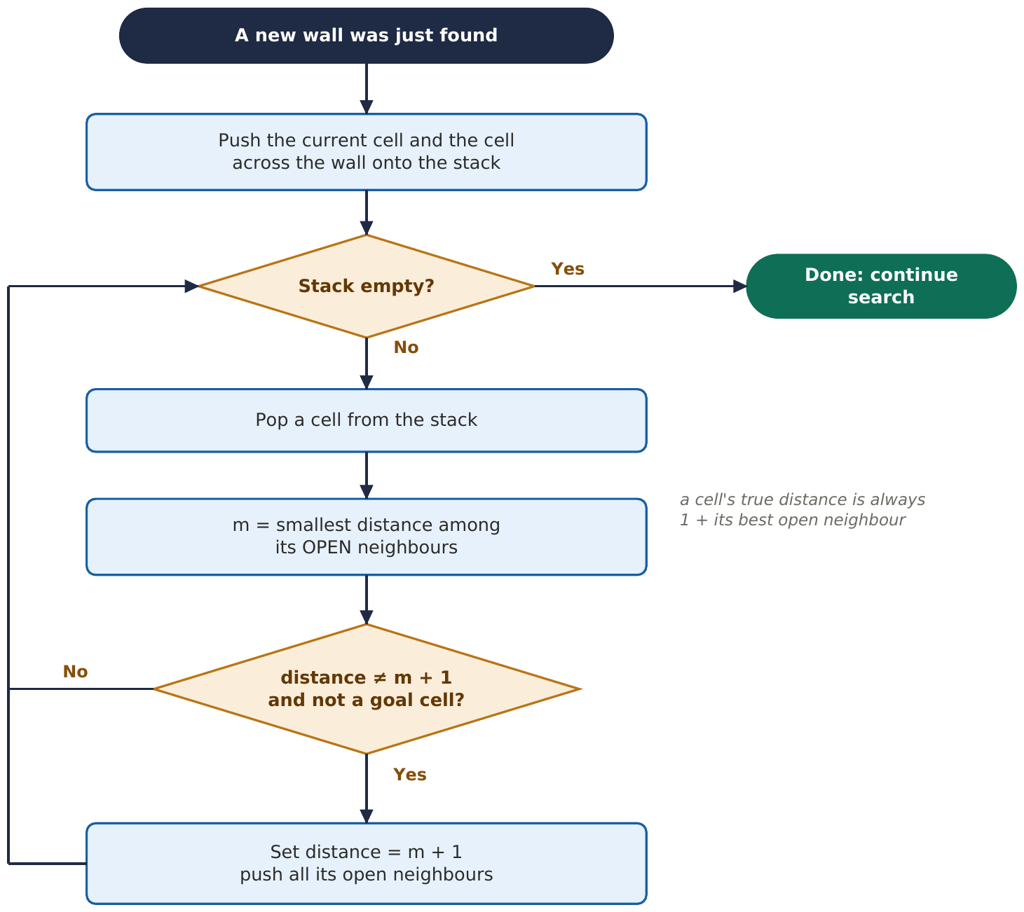

Flowchart 5: Dijkstra for the speed-run plan (3.5)
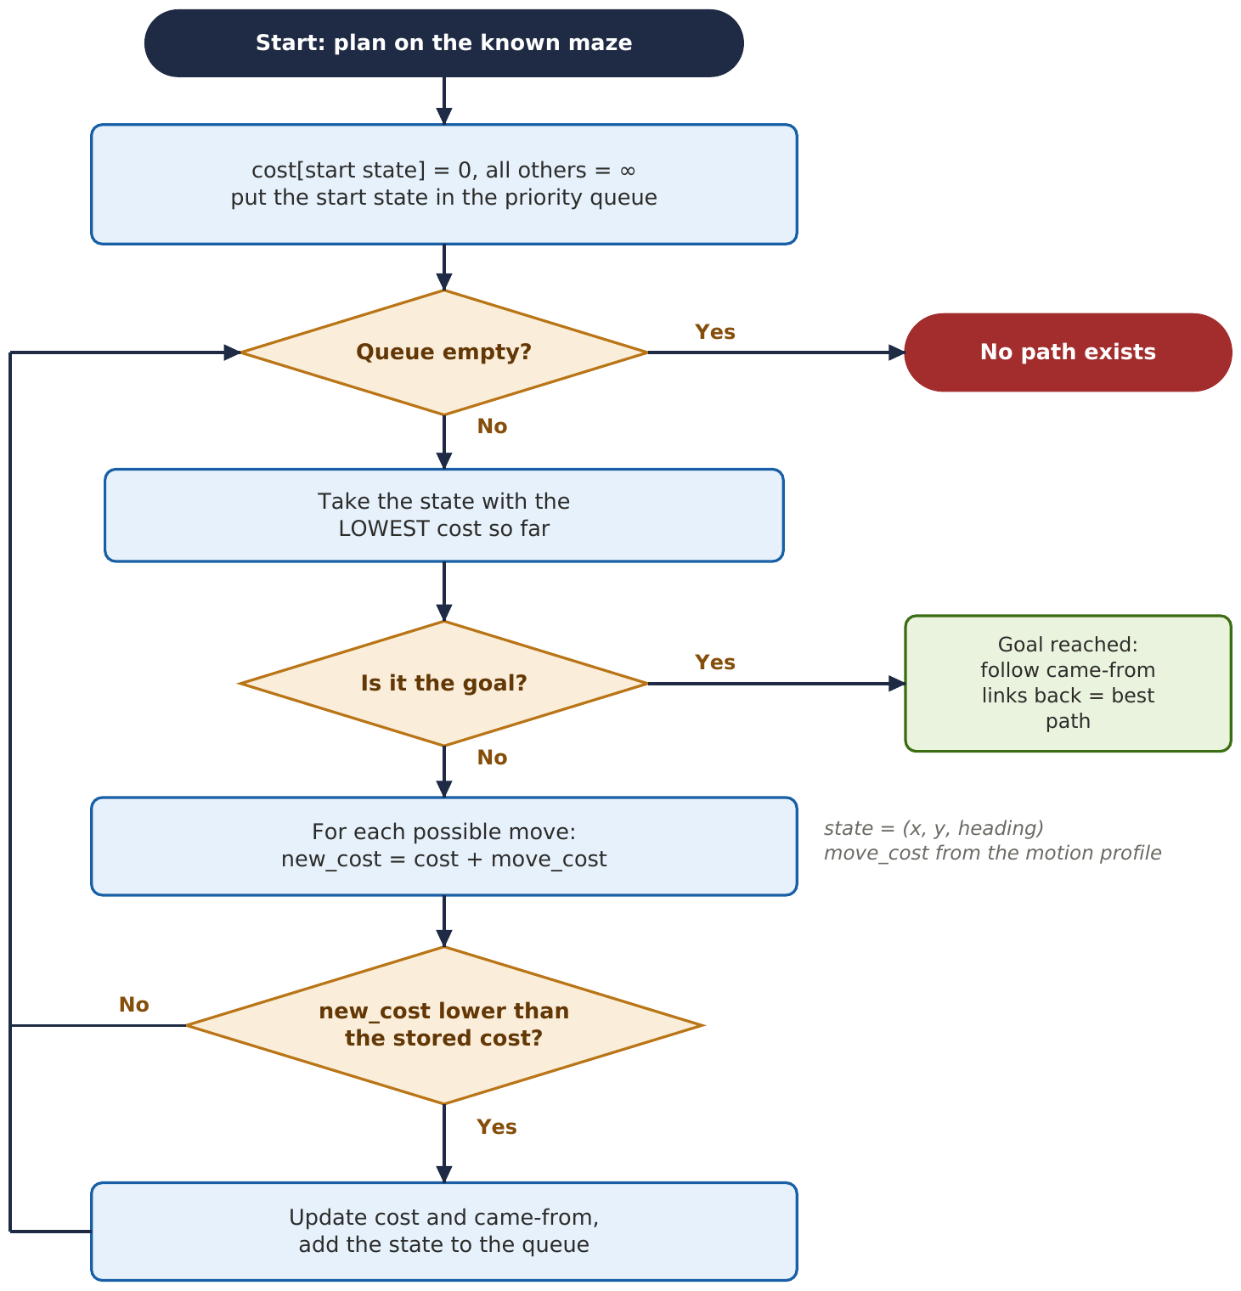

A* uses the same flowchart as Dijkstra. The only change: in "Take the state with the lowest cost", order the queue by cost + heuristic (g + h) instead of cost alone.

