MICROMOUSE · PART 4
Motion and Control Theory
Each topic explained step by step, with a simulation and every term defined
Topics in this document
- 4.1 Differential drive
- 4.2 Feedback control and PID
- 4.3 Feedforward
- 4.4 Velocity profile (trapezoid)
- 4.5 Odometry
- 4.6 Curved (smooth) turns
- 4.7 Wall-based correction
- Putting Part 4 together, and flowcharts

How to read the simulations
Every graph and path in this document comes from a real simulation: the equations in each section were run in code, so the curves are what those equations produce. The simulations use the following assumptions, so the numbers are examples of how the ideas behave rather than measurements of a particular robot.
Item | Value used
Wheel base W (distance between wheels) | 70 mm
Cell size | 180 mm
Motor model (speed control graphs) | Speed 600 mm/s at full power, reacts with a time constant of 80 ms, and the command takes 5 ms to take effect
Control loop rate | 1 kHz (one update every 1 ms)
Speed target in the PID graphs | 300 mm/s, with an extra load added at 1.5 s

4.1 Differential drive
What it is. The mouse has two wheels, each driven by its own motor, and nothing steers. It turns only because the two wheels run at different speeds.

The three formulas
Quantity | Formula | Meaning
Forward speed v | v = (vL + vR) / 2 | The average of the two wheel speeds
Turn rate ω | ω = (vR − vL) / W | How fast the heading changes. Positive = left turn (right wheel faster)
Turning radius R | R = (W/2) · (vR + vL) / (vR − vL) | Radius of the circle the mouse drives around

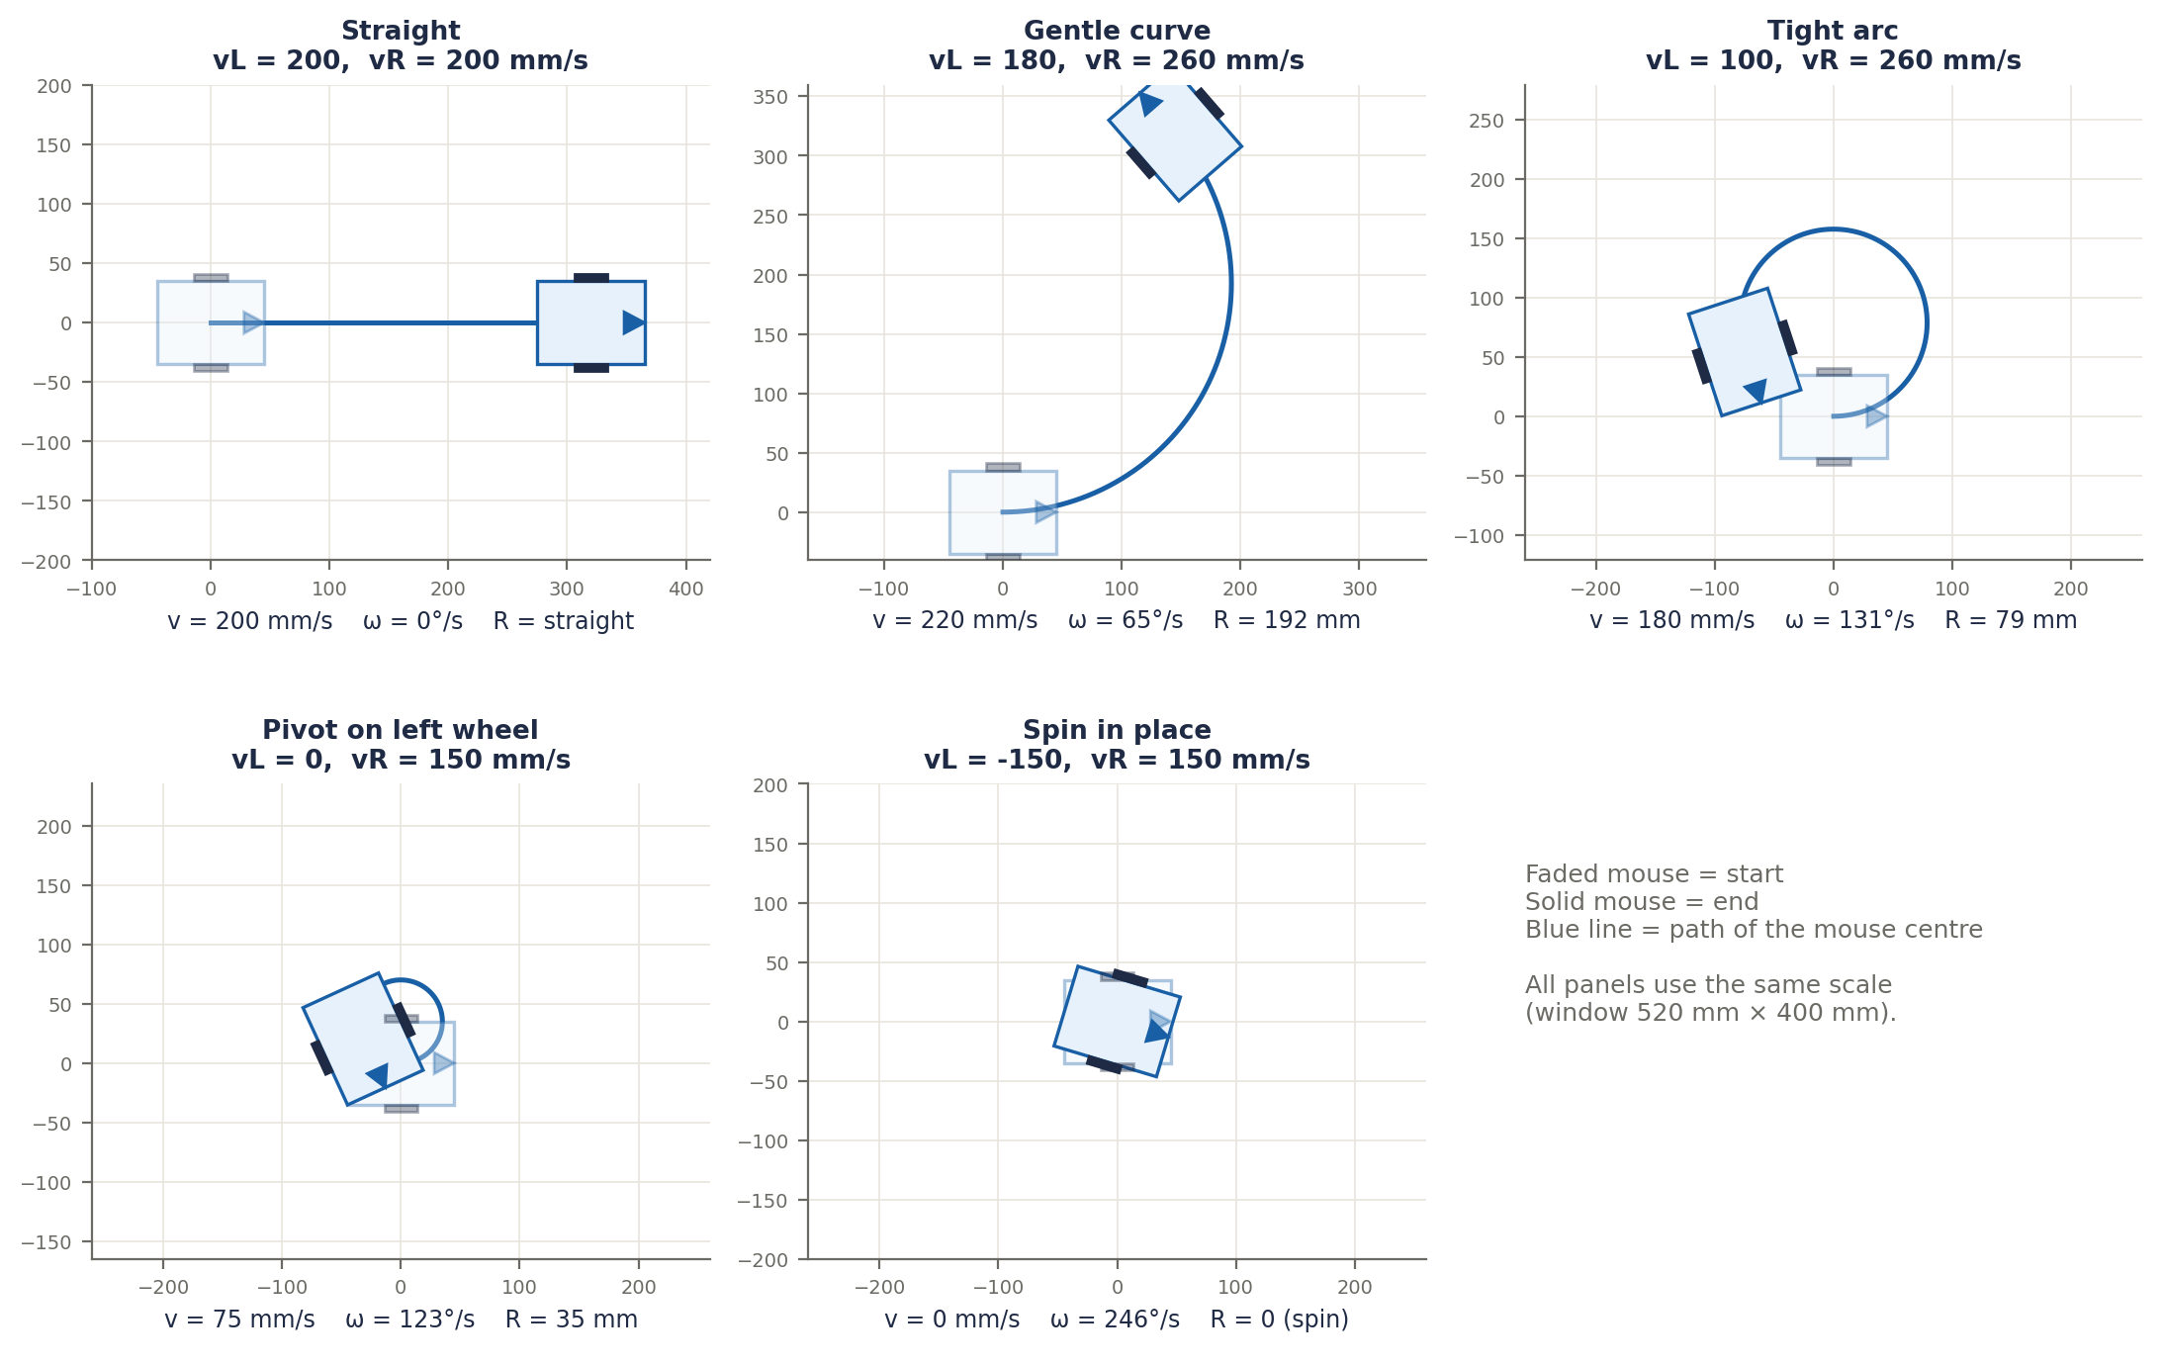
Figure 4.1a. Five wheel-speed combinations, each shown from the start (faded mouse) to the end (solid mouse). Equal speeds give a straight line. A small speed difference gives a gentle curve, a larger one a tight arc. With one wheel stopped the mouse pivots around it, and with opposite speeds it spins on the spot.
Wheel speeds | What the mouse does
vL = vR | Straight line (ω = 0, R is infinite)
vR slightly bigger than vL | Gentle left curve (large R)
vL = 0, vR > 0 | Pivots around the left wheel (R = W/2)
vL = −vR | Spins on the spot (R = 0, v = 0)

Worked example: a 90 mm radius turn
Goal: turn left with R = 90 mm while moving at v = 200 mm/s (W = 70 mm). First, vL + vR = 2v = 400. From the radius formula, vR − vL = (W/2) · 400 / R = 35 × 400 / 90 ≈ 155.6. So vR ≈ 278 mm/s and vL ≈ 122 mm/s. Check: ω = 155.6 / 70 ≈ 2.22 rad/s and R = v / ω = 200 / 2.22 = 90 mm. ✓
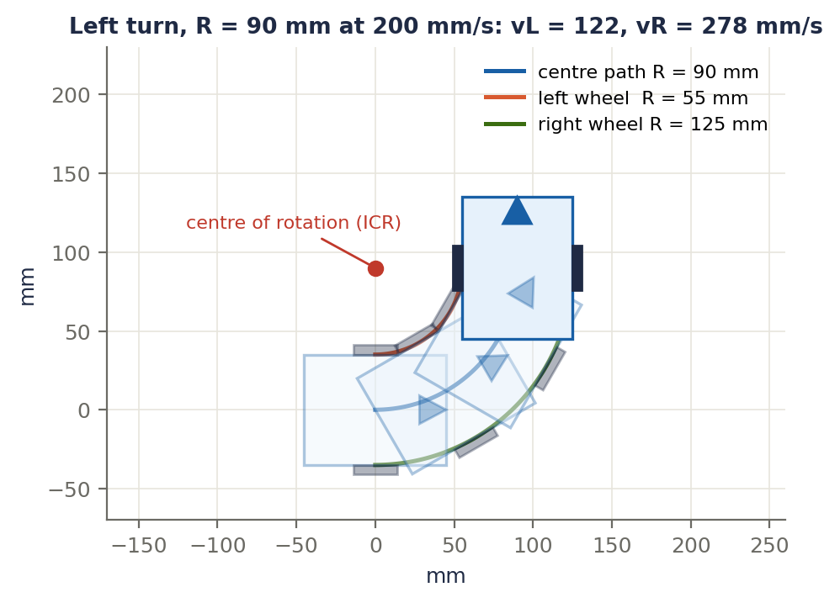
Figure 4.1b. The worked example. The centre of the mouse follows the blue arc (R = 90 mm). The left wheel travels on a smaller arc (55 mm) and the right wheel on a larger one (125 mm), which is why the right wheel must go faster. The red dot is the centre of rotation.

Terms explained
Term | Meaning
Differential drive | Steering by running two independently driven wheels at different speeds.
vL, vR | Left and right wheel speeds, in mm/s.
Forward speed (v) | How fast the centre of the mouse moves: the average of the two wheel speeds.
Wheel base (W) | Distance between the two wheels.
Angular velocity (ω) | How fast the heading changes, in rad/s or degrees per second. Positive means a left turn here.
Turning radius (R) | Radius of the circle the mouse follows. Small R means a sharp turn.
Instantaneous centre of rotation (ICR) | The point the mouse is momentarily circling.
Heading (θ) | The direction the mouse faces.
Pivot turn | Turning with one wheel stopped.
Spin in place | Turning with the wheels at equal and opposite speeds.

4.2 Feedback control and PID
The one-line idea. Measure what really happened, compare it with what you wanted, and correct the difference. That is all feedback control is. PID is a recipe for deciding how much to correct.
Everyday picture. Holding a car at 50 km/h: you look at the speedometer. At 40 you press the pedal a lot, at 48 a little, at 50 you hold it. You are acting as a PID controller: you use the size of the gap (P), how long it has been wrong (I) and how fast it is closing (D).

Open loop and closed loop
 | Open loop | Closed loop (feedback)
What it does | Sends "50% power" and hopes | Measures the real speed and adjusts the power
Problem | A sagging battery, friction or load gives a different speed each time | Corrects itself
Micromouse | Not good enough | What we use

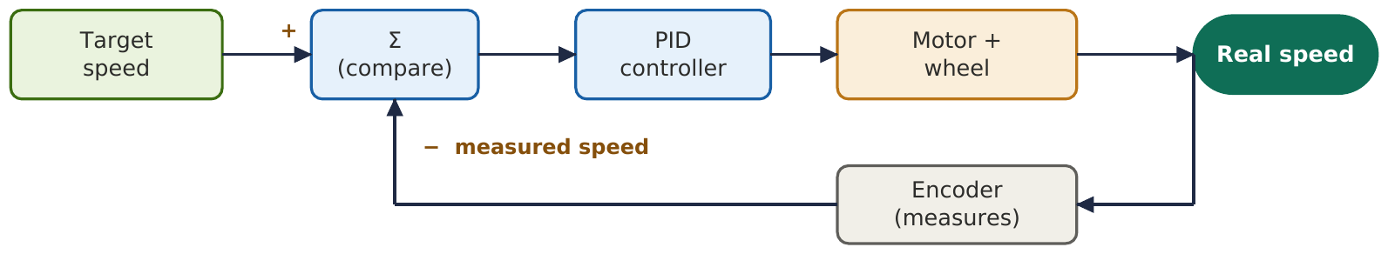
Figure 4.2a. The control loop. The encoder measures the real speed, the measurement is subtracted from the target to get the error, and the PID controller turns that error into a motor command. Then the cycle repeats.

The error
Error = target − measured. Target 300 and measured 250 gives +50 (too slow: add power). Measured 300 gives 0 (perfect). Measured 320 gives −20 (too fast: reduce power). The sign tells the direction and the size tells how big the correction should be.

The three parts
The controller output u is the motor command (for example power from −1 to +1):
u = Kp · e + Ki · (sum of error over time) + Kd · (rate of change of the measurement, with a minus sign)
P (proportional): how wrong am I right now? The push is Kp times the error: big error, big push. Example: Kp = 0.004 and error 50 gives 0.2, so 20% power. Two problems. First, steady-state error: the motor needs, say, 50% power just to hold 300 mm/s, but P only produces output when there is an error, so it settles below the target. Second, too much Kp makes the mouse overshoot, over-correct the other way and ring back and forth, because the motor delay makes the correction arrive late.
I (integral): how long have I been wrong? Every tick, add error × dt to a running total. If a small error lingers, the total keeps growing until the error is gone, which is why I removes the steady-state error. The problem is windup: if the motor is already at 100% power the error stays large, the total keeps growing in the background and causes a big overshoot later. The fix is anti-windup: stop adding to the total while the output is at its limit.
D (derivative): how fast is it changing? If the speed is rising fast, D pushes back a little, like a shock absorber, so the approach is calmer. The problem is noise: taking a rate of change magnifies random jitter, so a high Kd makes the motor buzz. Also, differentiating the error causes a huge spike when the target suddenly jumps (derivative kick), so we differentiate the measurement instead.
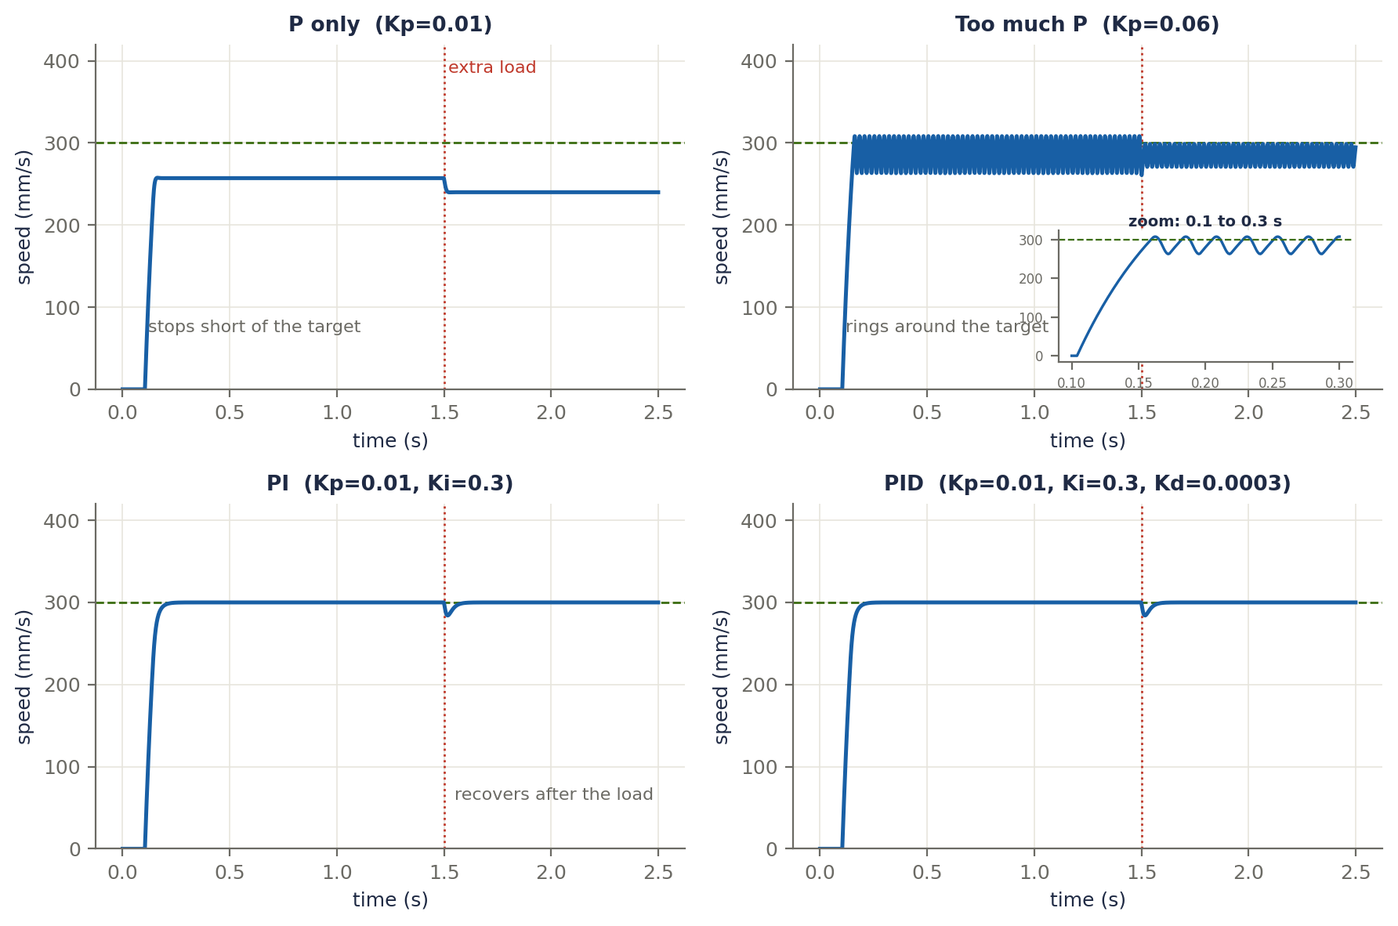
Figure 4.2b. The same motor and target with four different gain sets. P only stops short of the target (43 mm/s low, about 14%) and cannot recover from the extra load. Too much P rings (the inset zooms in on the fast oscillation). PI reaches exactly 300 and recovers after the load. Adding D smooths the approach.

A hand calculation
Target = 300 mm/s with Kp = 0.004, Ki = 0.03, Kd = 0.0002. To keep the arithmetic easy, pretend one tick is 0.1 s (the real loop uses 0.001 s, but the steps are identical).
Tick | Measured | Error | Integral | P | I | D | Output u
A | 200 | 100 | 10 | 0.40 | 0.30 | −0.10 | 0.60
B | 250 | 50 | 15 | 0.20 | 0.45 | −0.10 | 0.55
C | 280 | 20 | 17 | 0.08 | 0.51 | −0.06 | 0.53
D | 300 | 0 | 17 | 0.00 | 0.51 | −0.04 | 0.47

Reading the table: P fades out as the error shrinks. I grows and then holds at about 0.51, the "hold power" the motor needs, so it has learned the steady power. D stays slightly negative while the speed is rising, which gently slows the approach. The output ends near 0.5, the 50% needed to hold 300 mm/s.
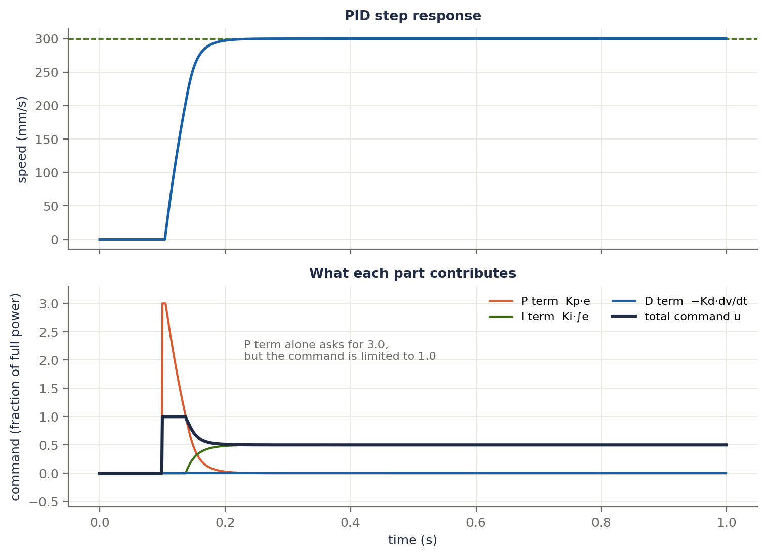
Figure 4.2c. The same idea in the simulation. The P term (orange) is large at the start and fades to zero. The I term (green) grows and settles at 0.5, which is exactly the power needed to hold 300 mm/s. The D term (blue) is a small brake while the speed rises. The total command u (dark) is limited to 1.0.

Anti-windup
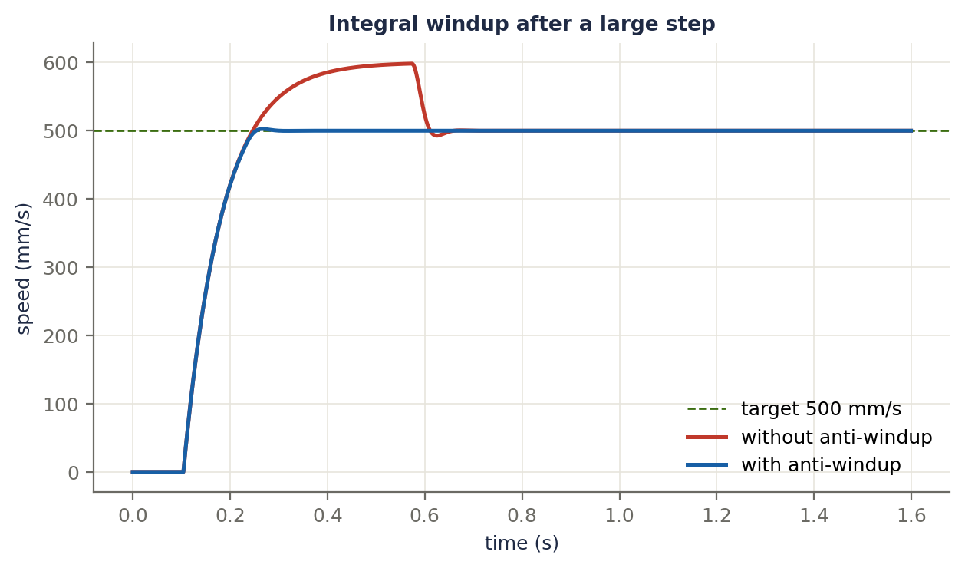
Figure 4.2d. A large speed step with the motor at full power for a while. Without anti-windup (red) the integral piles up while the output is saturated, and the speed overshoots by about 20%. With anti-windup (blue) the overshoot is only about 1%.

The code
struct PID {
float kp, ki, kd; // the three gains you tune
float integral = 0; // running total of error * time
float prevMeas = 0; // last measurement, for the D term

float update(float target, float meas, float dt, float uMax) {
float e = target - meas; // 1. the error
float d = -(meas - prevMeas) / dt; // 2. rate of change of the MEASUREMENT
prevMeas = meas;
float raw = kp * e + ki * integral + kd * d; // 3. the PID sum
float u = raw > uMax ? uMax : (raw < -uMax ? -uMax : raw); // 4. limit to the motor range
if (u == raw) integral += e * dt; // 5. anti-windup: only add when not clipped
return u;
}
};
The update function is called once per control tick from the 1 kHz timer interrupt. dt must be steady (0.001 s), because the I and D terms use it.

What goes wrong, and the fix
Symptom | Cause | Fix
Stops short of the target | P alone | Add I
Overshoot | Too much Kp or Ki | Lower them, add Kd
Oscillation | Kp too high for the delay | Lower Kp
Big overshoot after a long saturation | Integral windup | Anti-windup
Jittery, buzzing motor | Kd amplifies noise | Lower Kd or filter the measurement
Spike when the target changes | D on the error | D on the measurement

Tuning order that works
- Set Ki = 0 and Kd = 0.
- Raise Kp until the response is fast and just starts to ring.
- Back Kp off by about a third.
- Add Kd to calm the ringing.
- Add a small Ki to remove the leftover error.
- Change one gain at a time and look at the response each time.

How a mouse uses it
A mouse runs two PID loops, not one per wheel. The forward-speed loop controls v and the rotation loop controls ω (measured by the gyro). Their outputs are mixed: uL = uv − uω and uR = uv + uω. Both loops run from a timer interrupt at a fixed 1 kHz.

Terms explained
Term | Meaning
Control loop | The repeating cycle: measure, compare, correct.
Open loop | Sending a command without checking the result.
Closed loop / feedback | Checking the result and using it to correct the next command.
Target (setpoint) | The value you want, for example 300 mm/s.
Measured value | What the sensor says is really happening.
Error | Target minus measured.
Controller output (u) | The command sent to the motor, for example PWM power.
Kp, Ki, Kd | The three gains: how strongly each part reacts. You tune these.
Proportional (P) | Reacts to the current error size.
Integral (I) | Reacts to the total of past errors, which removes lingering error.
Derivative (D) | Reacts to how fast the measurement is changing, which damps motion.
dt | The time between control ticks (0.001 s at 1 kHz).
Steady-state error | A leftover error that never goes away.
Overshoot | Going past the target before settling.
Oscillation | Swinging back and forth around the target.
Settling time | How long until the value stays close to the target.
Rise time | How long to first reach the target.
Saturation | The output is stuck at its maximum or minimum limit.
Integral windup | The integral grows huge while saturated and then causes overshoot.
Anti-windup | Stopping or capping the integral to prevent windup.
Derivative kick | A spike in D when the target suddenly jumps.
Noise | Random jitter in a sensor reading.
Plant | The thing being controlled (here, the motor and wheel).
Delay (dead time) | The lag between a command and its effect; the reason high gains oscillate.
Control loop rate | How often the loop runs (1 kHz means every 1 ms).

4.3 Feedforward
Feedback is reactive: it waits for an error before acting. Feedforward is predictive: it calculates the command the motor should need and applies it straight away.
u_ff = Kv · v_target + Ka · a_target
- Kv: the voltage needed just to hold a speed. It cancels back-EMF and friction.
- Ka: the extra voltage needed to accelerate.
- The total command is u = u_ff + u_PID. Feedforward supplies most of the command and PID only has to fix the small leftover.
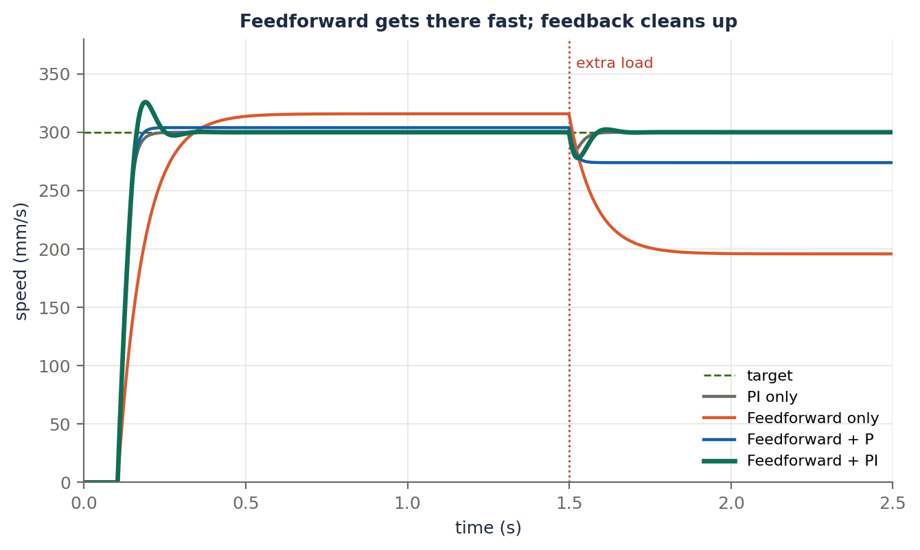
Figure 4.3a. Feedforward in the same simulation. Feedforward alone (orange) supplies about the right command immediately, but its model is slightly off (it assumes 570 mm/s per full power instead of 600) so it settles a little high, and it cannot cope with the extra load. Feedforward + P (blue) removes most of the model error. Feedforward + PI (green) reaches the target and recovers from the load. A feedback-only PI controller (grey) must wait for an error to build up before it can act.
Feedforward cannot make the motor itself faster: the speed still rises at the motor's own pace. What it removes is the need to wait for an error to build up before the controller reacts, and it leaves the feedback part with only small corrections to make.

How to find Kv and Ka
- Kv: run the motor at several fixed power levels and record the steady speed. Example: 50% duty gives 280 mm/s, so Kv = 0.5 / 280 ≈ 0.0018 duty per mm/s.
- Ka: apply a power step from rest and measure the initial acceleration.

Battery compensation
The battery voltage sags as it drains. Work in volts, then convert to duty: duty = V_wanted / V_battery. Example: you need 3.0 V. At 7.4 V that is 40.5% duty, and at 6.8 V it is 44.1%. Measure the battery voltage and compensate every loop.
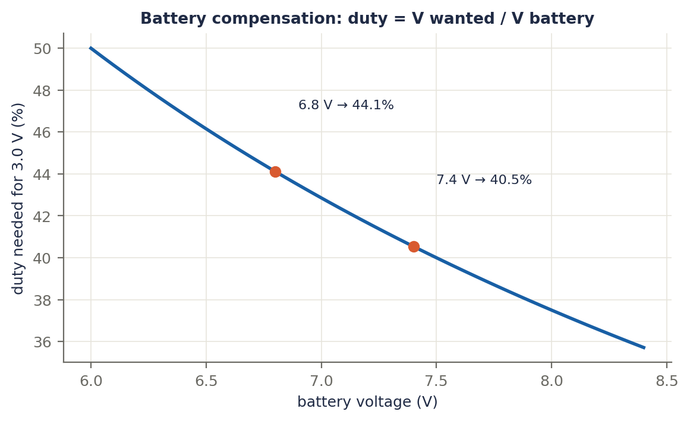
Figure 4.3b. The duty needed for 3.0 V as the battery voltage changes.
float volts = kv * vTarget + ka * aTarget + pidVolts; // feedforward + feedback, in volts
float duty = volts / vBattery; // battery compensation
if (duty > 1.0f) duty = 1.0f; // limit to the driver range
if (duty < -1.0f) duty = -1.0f;

Terms explained
Term | Meaning
Feedforward | Predicting the command needed and applying it without waiting for an error.
Model-based control | Control that uses a model of the motor to calculate the command.
Kv | Volts needed per unit of speed to hold a steady speed.
Ka | Volts needed per unit of acceleration.
Back-EMF | Voltage a spinning motor generates, opposing the supply. It grows with speed.
Static friction | The extra push needed to start moving from rest.
Battery compensation | Scaling the duty by the battery voltage so the same command gives the same motor voltage.
Duty cycle | The fraction of time the PWM signal is on; it sets the average motor voltage.

4.4 Velocity profile (trapezoid)
Never jump from 0 to full speed: the wheels slip and the controller saturates. Plan the speed over time: accelerate, cruise, decelerate.

The physics
From v² = v₀² + 2ad, speeding up from rest to speed v takes a distance d = v² / (2a), and braking from v to rest takes the same distance.
- Trapezoid: if the distance is long enough (D ≥ 2 · v² / (2a)), accelerate, cruise at v_max, then brake. Cruise time = (D − 2d) / v.
- Triangle: if the distance is too short to reach v_max, the peak speed is v_peak = √(a · D) and there is no cruise.
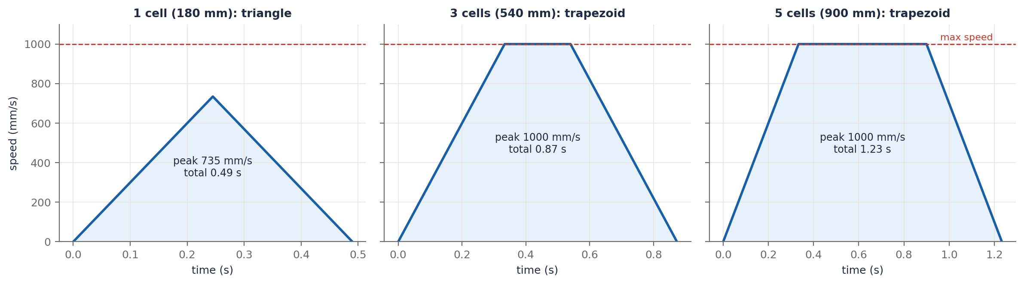
Figure 4.4a. Three moves with a = 3000 mm/s² and v_max = 1000 mm/s. One cell (180 mm) is too short to reach top speed, so it is a triangle: peak 735 mm/s, 0.49 s. Three cells (540 mm) just reach top speed for a short cruise: 0.87 s. Five cells (900 mm) cruise for longer: 1.23 s.
Worked numbers. One cell: the acceleration distance would be 1000² / (2 × 3000) = 167 mm, so 2d = 333 mm, which is more than 180 mm, so it is a triangle: v_peak = √(3000 × 180) ≈ 735 mm/s and time = 2 × 735 / 3000 ≈ 0.49 s. Five cells (900 mm): cruise distance = 900 − 333 = 567 mm, so time = 2 × 0.333 + 0.567 ≈ 1.23 s. This is why speed runs merge several cells into one long straight: on a long straight the mouse actually reaches a high speed instead of braking at every cell.
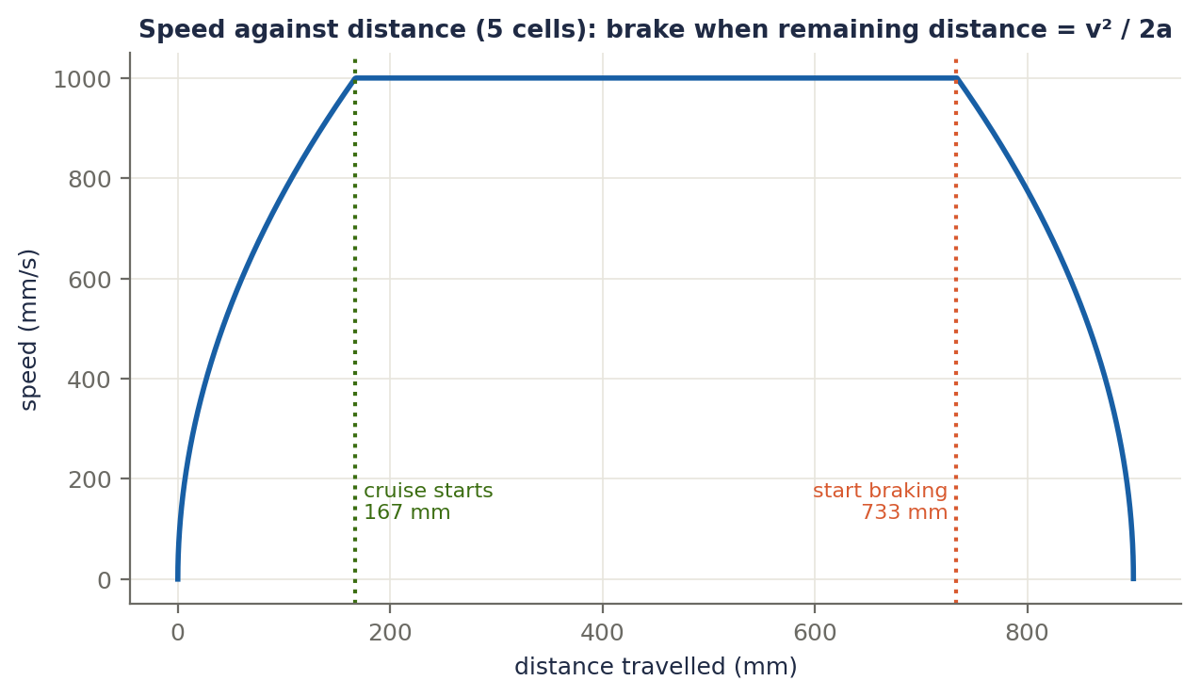
Figure 4.4b. The same five-cell move plotted against distance. The mouse must start braking when the remaining distance equals the braking distance v² / (2a), which here is 167 mm before the end (at 733 mm).

On the mouse
Every control tick: speed up by a·dt (capped at v_max), but first check the braking distance (v² − v_end²) / (2a). When the remaining distance is less than or equal to it, start decelerating. Using v_end instead of 0 lets the mouse enter the next move already at a planned speed, for example into a curved turn. Advanced mice also limit jerk (the rate of change of acceleration) for smoother S-curve profiles.
struct Profile {
float vel = 0, pos = 0; // current speed and distance travelled
float vMax, vEnd, accel, distance; // limits and the move length
void step(float dt) { // called every control tick
float brakeDist = (vel * vel - vEnd * vEnd) / (2 * accel);
if (distance - pos <= brakeDist) vel -= accel * dt; // brake
else if (vel < vMax) vel += accel * dt; // speed up
if (vel > vMax) vel = vMax;
if (vel < vEnd) vel = vEnd; // never slower than the exit speed
pos += vel * dt;
}
bool done() const { return pos >= distance; }
};

Terms explained
Term | Meaning
Velocity profile | The planned speed over time for a move.
Trapezoidal profile | Speed up, cruise at the limit, slow down: the speed graph is a trapezoid.
Triangular profile | Used when the move is too short to reach top speed: speed up then slow down.
Acceleration (a) | How quickly the speed changes, in mm/s².
Braking distance | The distance needed to slow from the current speed to the exit speed: (v² − v_end²) / (2a).
Exit speed (v_end) | The speed the mouse should have at the end of the move (0 for a stop).
Jerk | The rate of change of acceleration. Limiting it makes motion smoother.
S-curve profile | A profile with limited jerk, so the speed curve has rounded corners.

4.5 Odometry
Odometry means estimating where the mouse is from how far the wheels have turned.

Step 1: encoder counts to distance
For a quadrature encoder, counts per wheel turn = CPR × 4 × gear ratio. Example: 7 CPR with a 30:1 gearbox gives 7 × 4 × 30 = 840 counts per wheel turn. With a 20 mm wheel (circumference 62.8 mm), one count is 0.0748 mm.
float mmPerCount = M_PI * wheelDiameterMm / (cpr * 4 * gearRatio);
float dLeft = (countsLeft - prevCountsLeft) * mmPerCount; // distance since the last tick
float dRight = (countsRight - prevCountsRight) * mmPerCount;

Step 2: update the position every tick
- d = (dL + dR) / 2 (distance travelled)
- dθ = (dR − dL) / W (heading change from the wheels), or dθ = ω_gyro · dt (from the gyro, usually more accurate)
- x += d · cos(θ + dθ/2), y += d · sin(θ + dθ/2), θ += dθ. Using the middle heading θ + dθ/2 gives a better arc estimate.
struct Odometry {
float x = 0, y = 0, theta = 0; // mm, mm, radians
void update(float dLeft, float dRight, float dTheta) {
float d = (dLeft + dRight) / 2;
float mid = theta + dTheta / 2; // use the middle heading
x += d * cosf(mid);
y += d * sinf(mid);
theta += dTheta;
}
};

Why it drifts
Wheel slip, a slightly wrong wheel diameter and gyro bias all accumulate. In the simulation the mouse drives 1941 mm (a straight, a smooth 90° turn, another straight) with the right wheel reading just 1% high. Using the encoders for heading too, the estimated position ends 216 mm away from the truth and the heading is 16.3° off. Taking the heading from the gyro instead (with a small remaining bias of 0.3°/s) cuts the final error to about 14 mm.
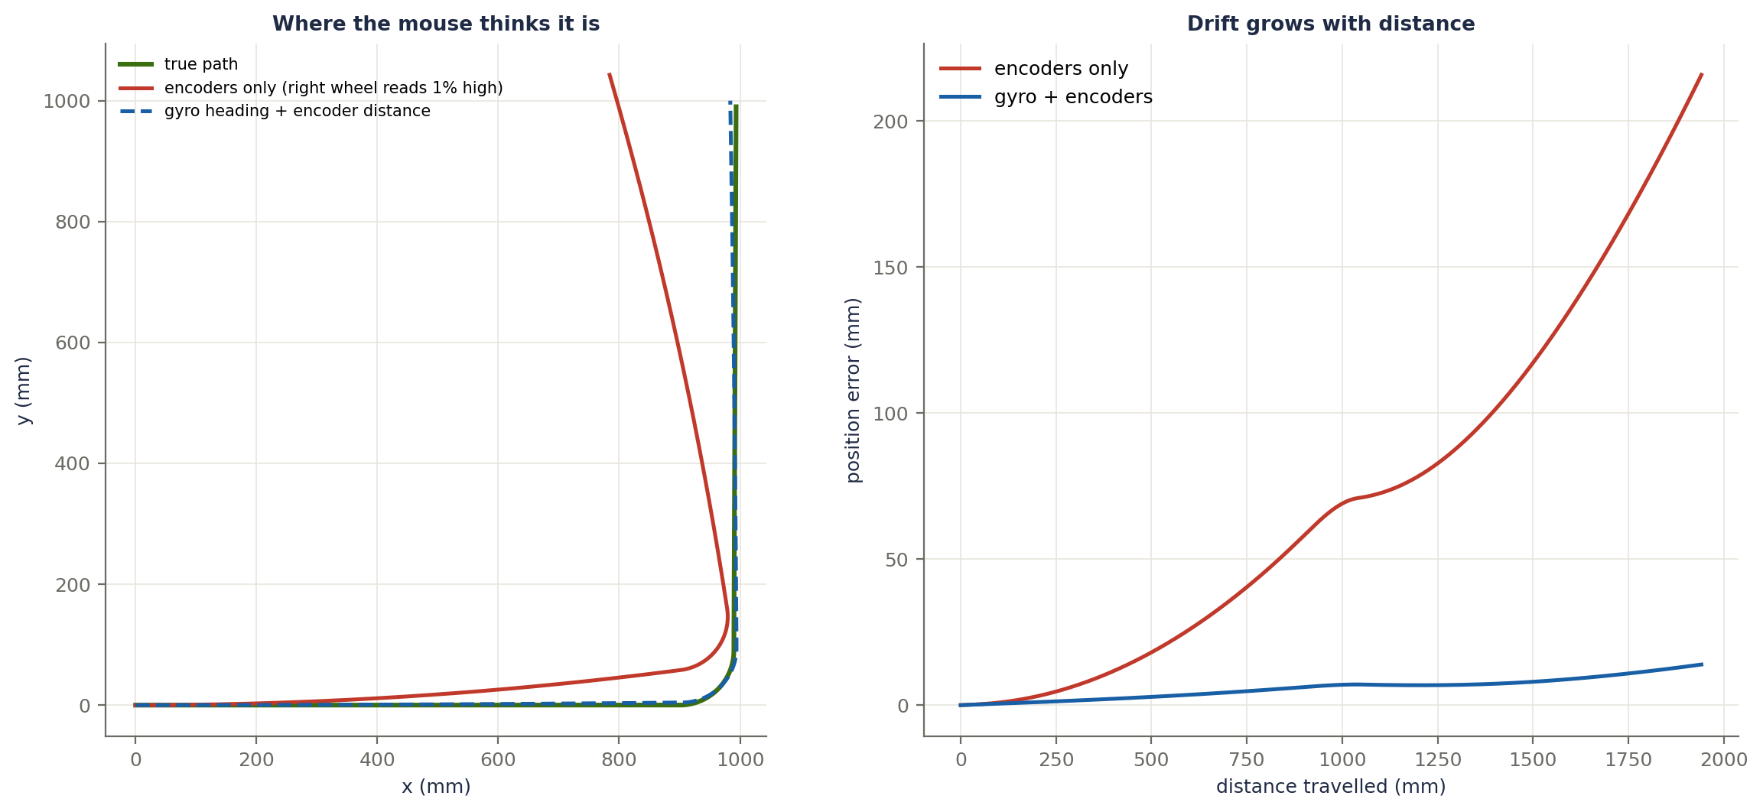
Figure 4.5. Left: the true path (green), the path estimated from encoders only (red), and the path estimated with gyro heading plus encoder distance (blue dashed). Right: the position error grows with distance, far faster with encoders only.
Fixes: calibrate the wheel diameter by driving a measured distance, calibrate the gyro bias at startup while stationary, use the gyro for heading, and correct with the walls (section 4.7). On the ESP32 the hardware pulse counter (PCNT) counts encoder edges with no CPU load: read it in the 1 kHz loop and take the difference from the previous reading.

Terms explained
Term | Meaning
Odometry | Estimating position from how far the wheels have turned.
CPR | Counts per revolution of the encoder (before 4× counting and the gearbox).
Quadrature (4× counting) | Counting every edge of both encoder channels, giving four counts per CPR step and the direction.
Gear ratio | How many motor turns make one wheel turn.
Counts per mm | How many encoder counts correspond to one millimetre of travel.
Dead reckoning | Working out the position from the previous position and the movement since.
Drift | An error that grows slowly with time or distance.
Gyro bias | The small non-zero reading a gyro gives when it is not rotating.

4.6 Curved (smooth) turns
Stop-and-turn means braking to a stop, spinning and accelerating again. A curved turn drives along an arc at speed, so the mouse never slows to zero.

The limit is grip
Going around a circle needs sideways (lateral) acceleration a_lat = v² / R. The tyres can only supply about a_lat ≤ μ · g (μ is around 1 and g = 9.8 m/s² for good tyres; use a safety margin). The maximum cornering speed is therefore:
v_max = √(a_lat · R)
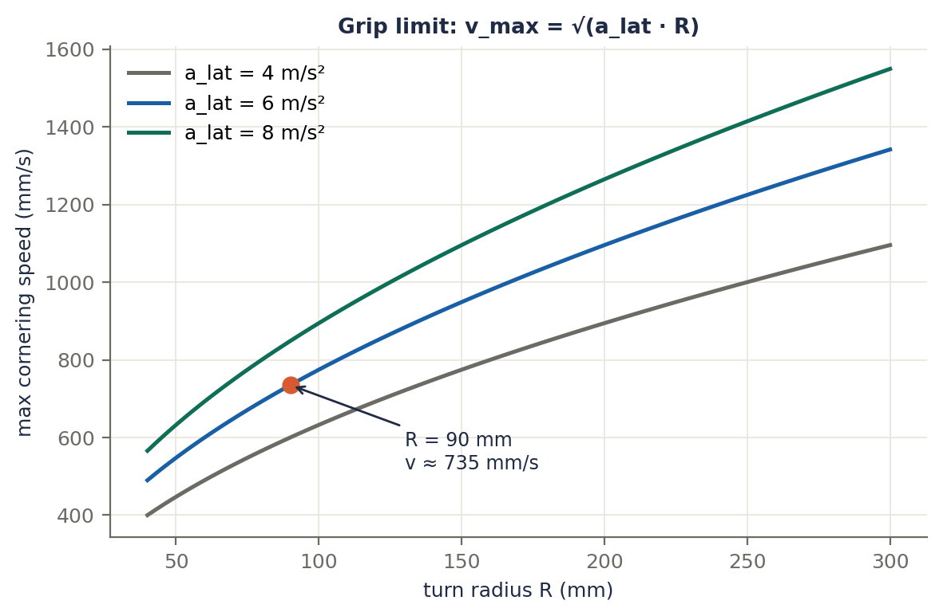
Figure 4.6a. Maximum cornering speed against turn radius for three grip levels. The orange dot is the worked example: R = 90 mm with a_lat = 6 m/s² gives about 735 mm/s.

Worked example
R = 90 mm = 0.09 m with a safe a_lat = 6 m/s²: v_max = √(6 × 0.09) ≈ 0.73 m/s = 735 mm/s. The arc is a quarter circle, R · π/2 = 0.09 × 1.571 ≈ 141 mm, taking about 0.19 s.
Link to 4.1: the wheel speeds in the arc. The mouse needs ω = v / R, so vL = ω(R − W/2) and vR = ω(R + W/2). With W = 70 mm: vL = 735 × 55/90 ≈ 449 mm/s and vR = 735 × 125/90 ≈ 1021 mm/s. The outer wheel must be able to reach that speed, so the motor limit also caps the turn speed.
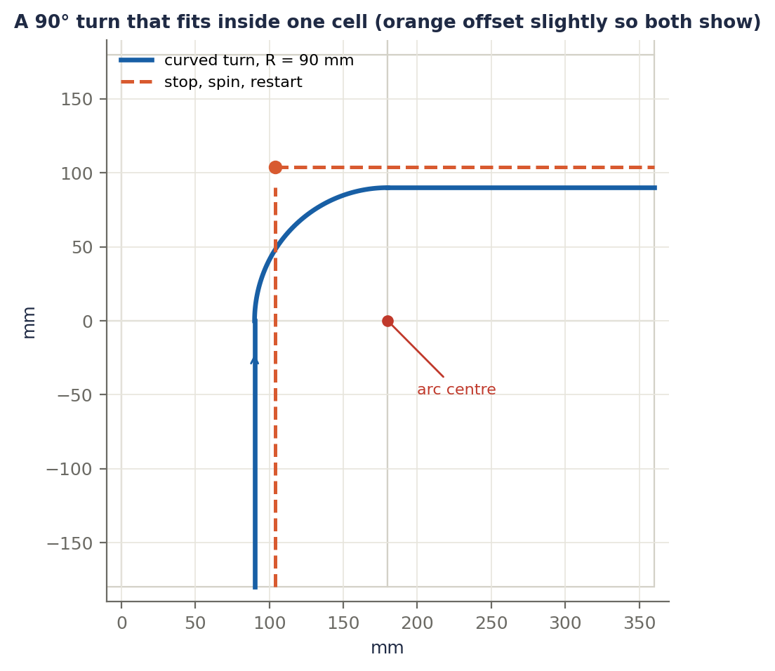
Figure 4.6b. A radius of half a cell (90 mm) lets a 90° arc fit exactly inside one cell, from the middle of one edge to the middle of the next (blue). The stop-and-spin alternative (orange, drawn slightly offset so both are visible) goes to the cell centre, stops, spins and sets off again.
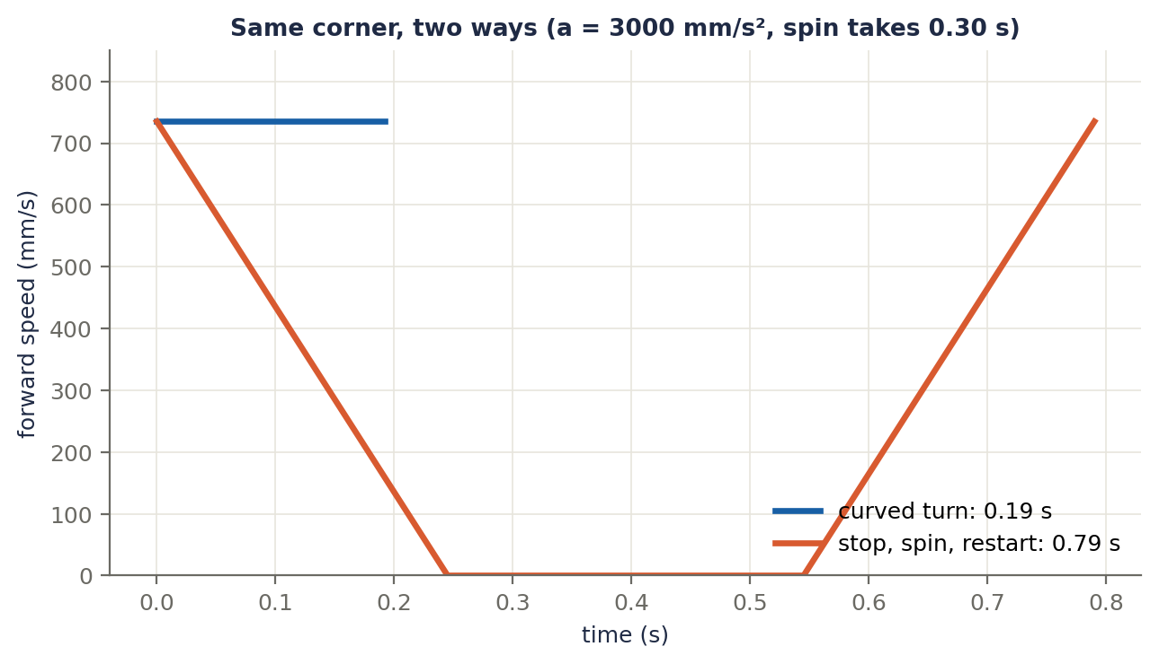
Figure 4.6c. Same corner, two ways, entering and leaving at 735 mm/s. The curved turn takes 0.19 s. Stopping costs braking and re-accelerating over 90 mm each at 3000 mm/s² (0.245 s each) plus an assumed 0.30 s for the spin, 0.79 s in total: about four times slower.

A turn is a set of parameters
Parameter | Meaning
Radius R | Size of the arc
Turn speed v | Speed while turning, limited by grip (and by the motors)
Run-in / run-out | Straight distance before and after the arc
Peak ω | v / R
Angle | 90°, 45°, 135°, 180° and so on

Competitive mice keep a library of turns: 90°, 45°, 135°, 180° and diagonal turns. To avoid a jolt at the start and end of an arc, ramp ω up and down smoothly (a clothoid-like curve) instead of switching it instantly. To tune, start with a low turn speed, raise it step by step until the mouse begins to slide, then back off. Log the gyro heading during the turn to check that it ends on target.
struct Turn {
float radius; // mm
float speed; // mm/s while turning
float runIn, runOut; // straight distance before and after the arc (mm)
float angle; // radians (positive = left)
float omega() const { return speed / radius; } // rad/s
float duration() const { return fabsf(angle) * radius / speed; } // seconds
};

Terms explained
Term | Meaning
Curved turn | Turning along an arc at speed instead of stopping to rotate.
Lateral acceleration | The sideways acceleration needed to follow a curve: v² / R.
Friction coefficient (μ) | How well the tyres grip. The grip limit is about μ · g.
Turn radius | Radius of the arc the mouse follows.
Turn library | A stored set of turn types and parameters (90°, 45°, 135°, 180°, diagonal).
Clothoid | A curve whose curvature changes steadily, giving a smooth start and end of a turn.
Run-in / run-out | The short straight sections before and after the arc.
Slip | The tyres losing grip and sliding sideways.

4.7 Wall-based correction
Even with good control, errors build up. The IR sensors give an absolute reference, the walls, to fix them.
- Centering: with walls on both sides, e = left reading − right reading. Feed a small correction into the rotation loop: ω_cmd = ω_planned + correction, where the correction steers away from the closer wall. Use a low gain and limit the correction so it never fights a planned turn.
- One wall only: compare that wall's reading with the value measured at the cell centre.
- Front wall alignment: when a wall is ahead, brake to a fixed IR reading so the stopping distance is exact.
- Wall edge detection: when a side wall ends, the sensor reading drops sharply. That tells the mouse it is at a known place (a cell boundary), so it can reset its position error along the corridor.
- Diagonals: there are no side walls beside the mouse, so it senses the corner posts instead.
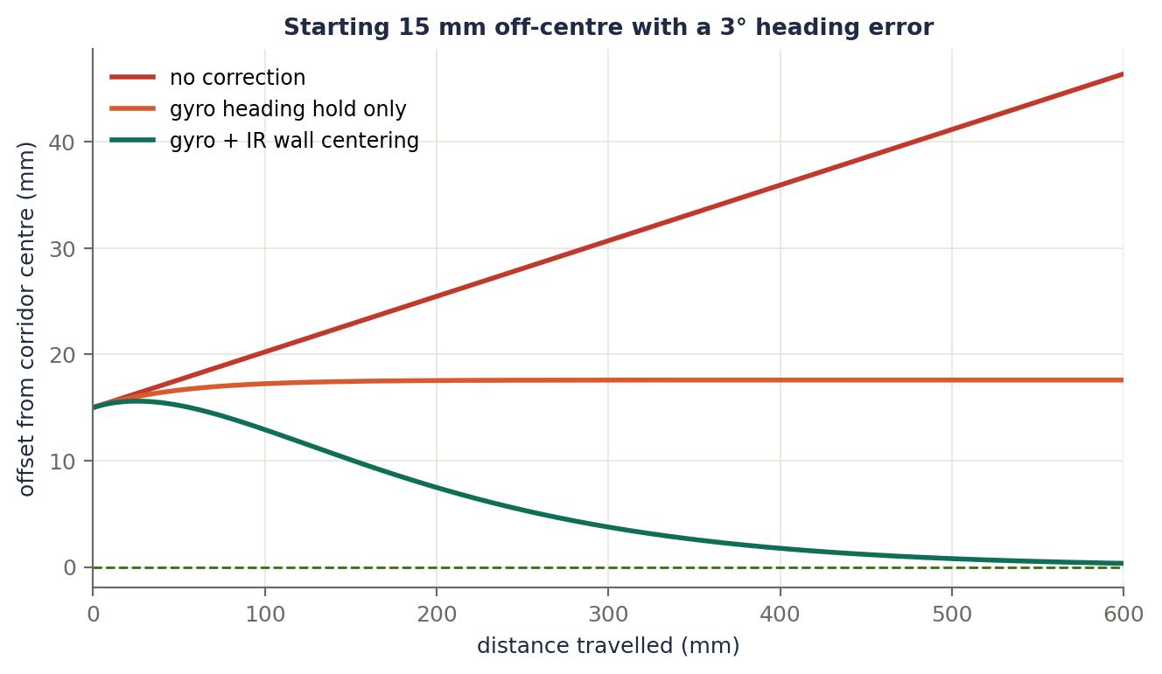
Figure 4.7. The mouse starts 15 mm off-centre with a 3° heading error and drives along a corridor. With no correction (red) it drifts steadily and is 46 mm off after 600 mm. With a gyro heading hold only (orange) the heading is fixed but the sideways offset stays (17.6 mm). With gyro and IR centering (green) the offset shrinks to about 0.3 mm. The gyro fixes the angle, and the walls fix the position.
// positive omega = turn left; e > 0 means the mouse is closer to the left wall
float e = leftIR - rightIR; // both walls present
float omegaCorr = -kWall * e; // steer away from the closer wall
if (omegaCorr > omegaMax) omegaCorr = omegaMax; // keep the correction small
if (omegaCorr < -omegaMax) omegaCorr = -omegaMax;
float omegaCmd = omegaPlanned + omegaCorr;

Make the IR readings reliable
- Take a reading with the LED off, then on, and subtract: this cancels room light.
- Pulse the LED briefly for a stronger signal.
- Calibrate the wall-present threshold and the centre value on your own maze.

Terms explained
Term | Meaning
Absolute reference | Something fixed in the world, such as a wall, that does not drift.
Centering error | The difference between the left and right IR readings; zero when centred.
Correction gain (kWall) | How strongly the centering error is turned into a steering correction.
Front-wall alignment | Stopping at a fixed IR reading from the wall ahead.
Wall-edge detection | Spotting the moment a side wall ends, to reset the position along the corridor.
Ambient light cancellation | Subtracting a reading taken with the LED off from one with it on.
Threshold | The reading above which a wall is considered present.

Putting Part 4 together
Everything in this part fits into one structure. The planner produces moves, the trajectory generator turns them into target speeds and arcs, two control loops (feedforward plus PID) turn the targets into motor voltages, and the sensors close the loop.
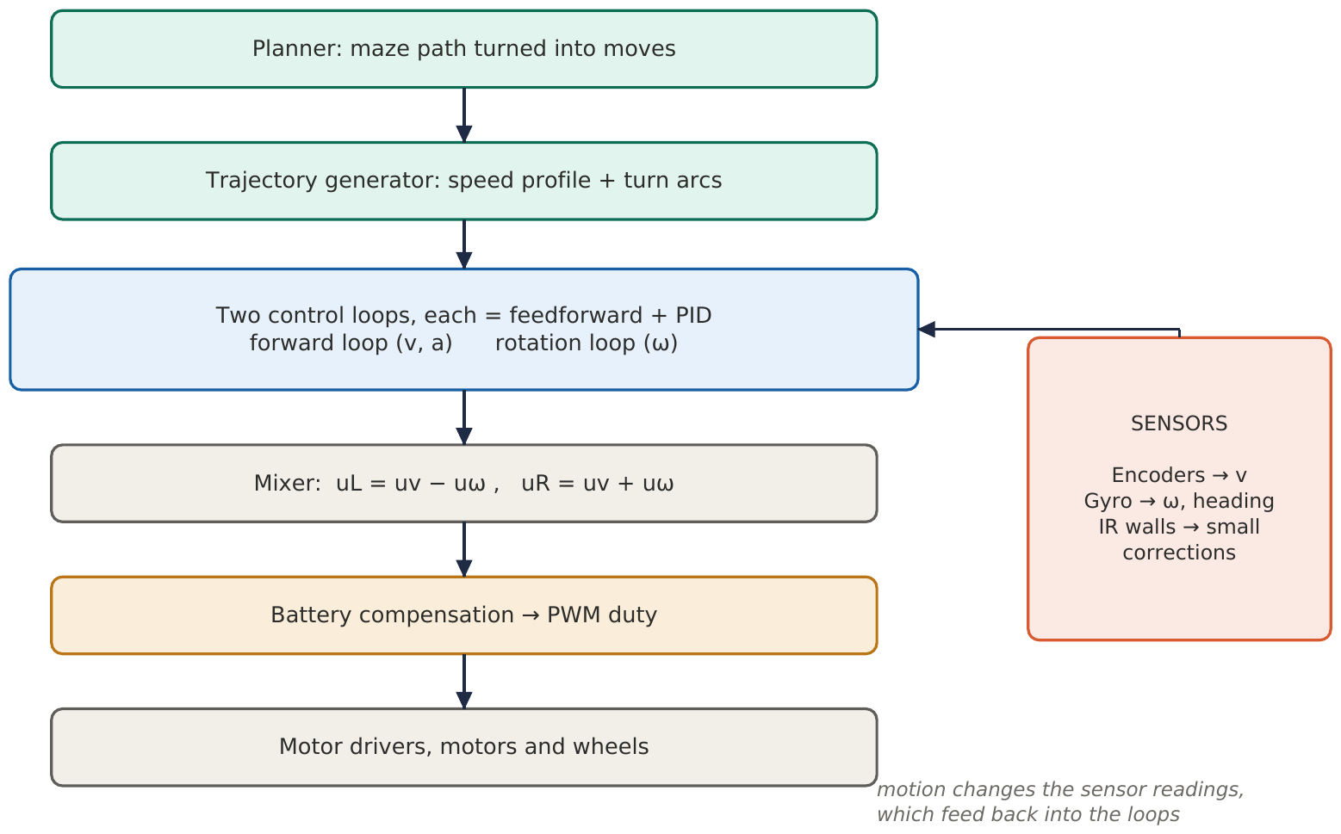
Figure 4.8. The motion control architecture. Everything runs from one 1 kHz timer interrupt.
A sketch of what runs every tick:
void controlTick() { // called from a 1 kHz hardware timer
const float dt = 0.001f;
readSensors(); // encoders, gyro, battery
float v = (dLeft + dRight) / (2 * dt); // measured forward speed
float w = gyroRate; // measured turn rate
odometry.update(dLeft, dRight, w * dt);
profile.step(dt); // planned speed and acceleration
float wTarget = turn.omega() + wallCorrection();
float uv = kv * profile.vel + ka * profile.acc + pidV.update(profile.vel, v, dt, uMax);
float uw = kvRot * wTarget + pidW.update(wTarget, w, dt, uMax);
float uL = uv - uw, uR = uv + uw; // volts for each wheel
setMotorDuty(uL / battery, uR / battery); // battery compensation and PWM
}

Flowcharts

Flowchart 1: One control tick
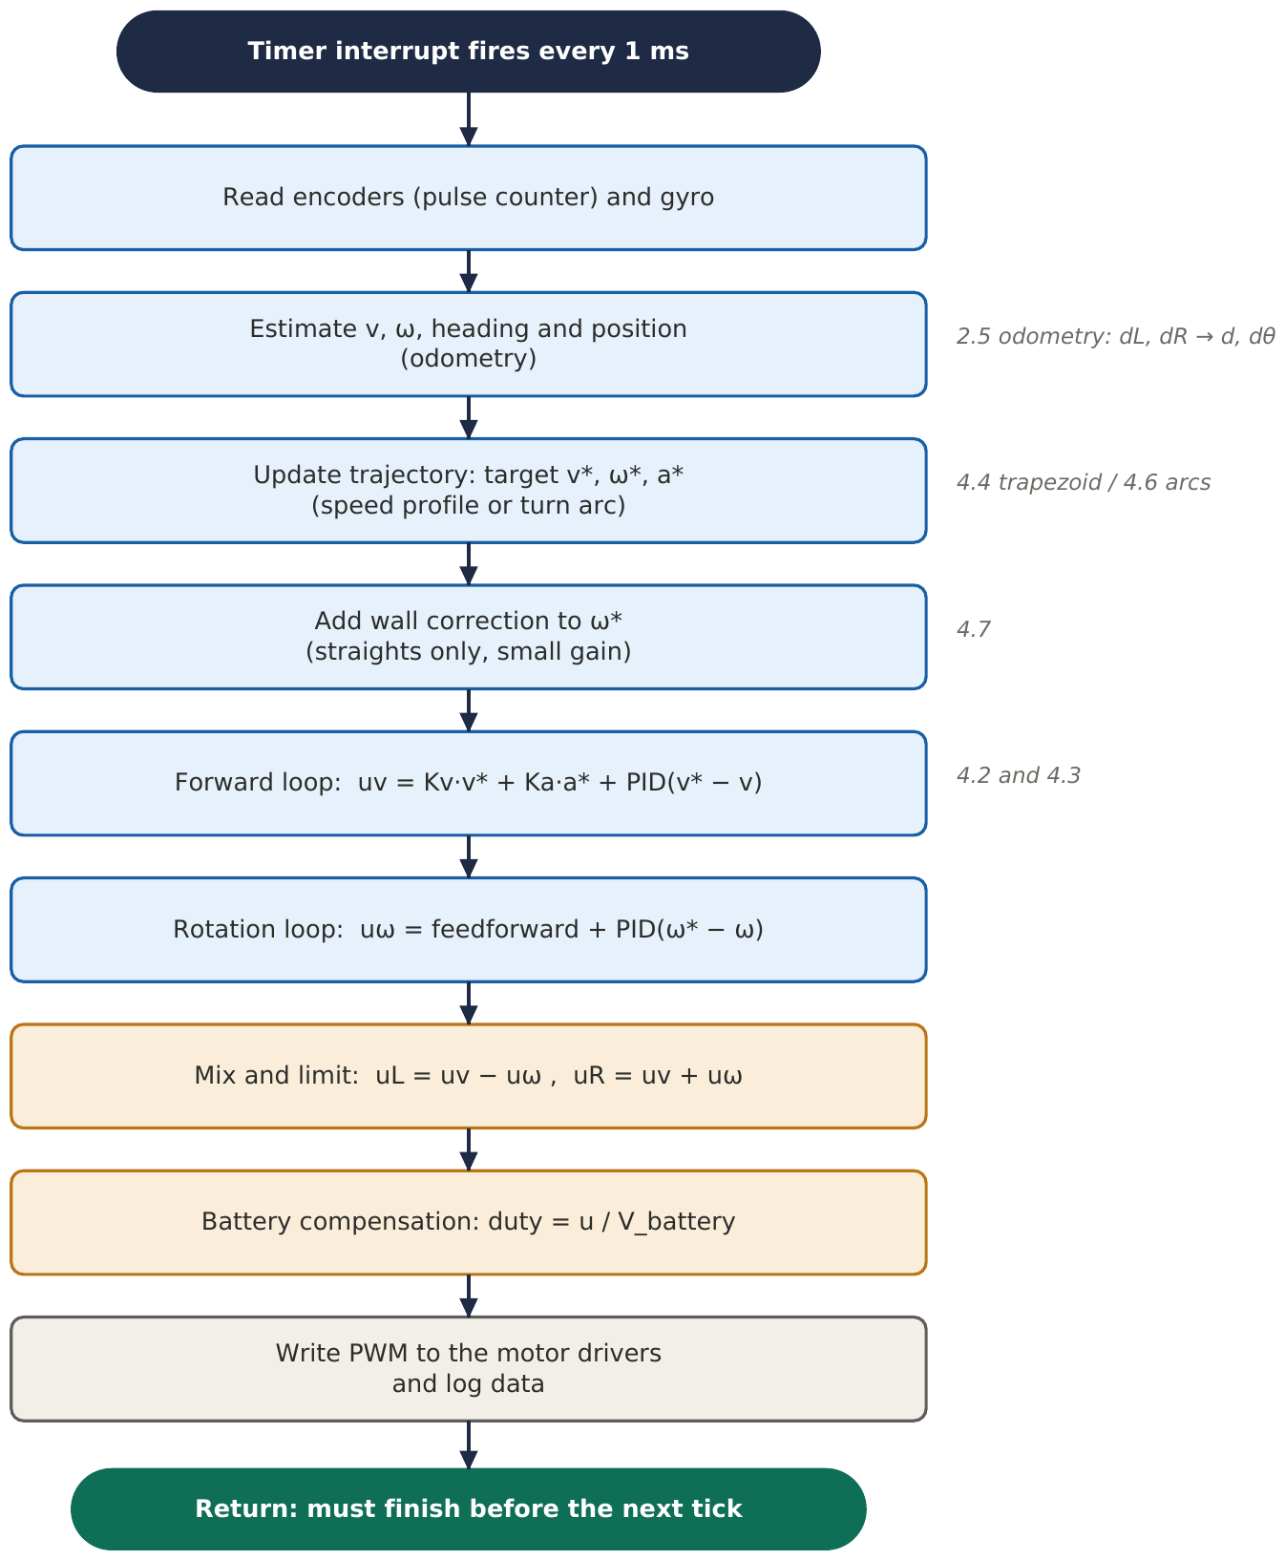

Flowchart 2: PID update (4.2)
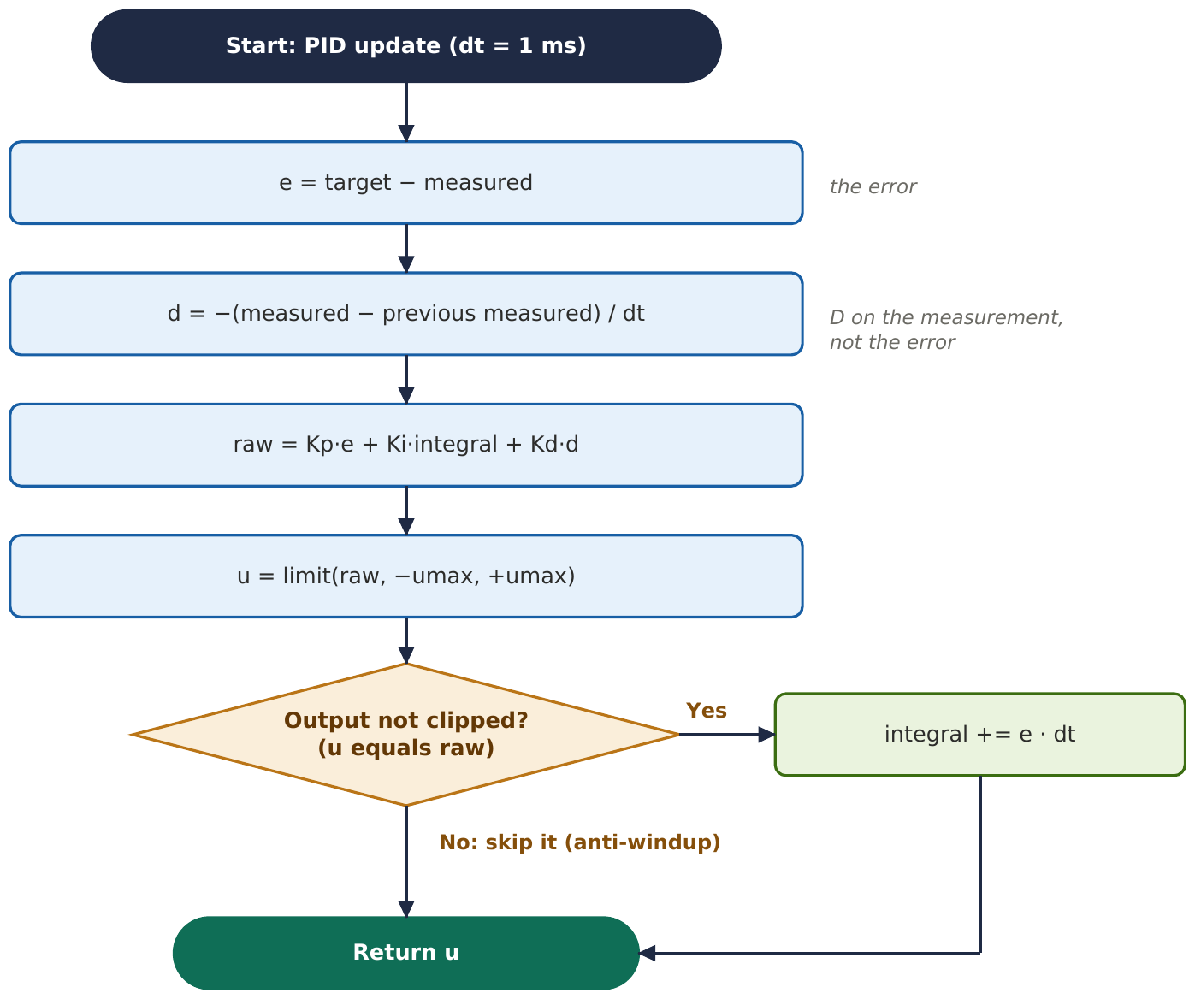

Next: the sensors in more detail: encoders, IR wall sensors, the gyro, and how they are combined (sensor fusion).

