MICROMOUSE · PART 5
Sensors
Each topic explained step by step, with a simulation and every term defined
Topics in this document
- 5.1 Encoders
- 5.2 IR wall sensors
- 5.3 Gyroscope
- 5.4 Sensor fusion
- Part 5 at a glance, and flowcharts
The mouse is blind without sensors. Each sensor tells it one thing well and another thing badly, and Part 5 is about combining them so the weak spots cancel.
Sensor | Tells the mouse | Weakness
Encoders | How far each wheel turned | Wheel slip, wheel size errors
IR wall sensors | How far the walls are | Noisy, nonlinear, affected by room light
Gyroscope | How fast the mouse is rotating | Drifts slowly over time
Sensor fusion | Combines all of the above | Needs careful tuning

How to read the simulations
Every graph in this document comes from a simulation of the equations in the text, so the curves are what those equations produce. The numbers (for example 0.0748 mm per count, a gyro bias of 1.5 °/s, a 1 kHz loop) are typical examples, not measurements of a particular robot.

5.1 Encoders
What it does. An encoder counts how much a wheel (or motor shaft) has turned. On the common small gearmotors it is a magnetic encoder: a small magnet disc on the motor shaft and a Hall sensor that sees the magnet's poles pass by.

Quadrature
The encoder gives two signals, A and B, which are the same square wave shifted by a quarter of a cycle (90°). That shift tells you the direction. With the usual convention:
- Turning one way, A leads B (B changes after A) and the AB pattern goes 00, 10, 11, 01.
- Turning the other way, B leads A and the pattern runs the other way: 00, 01, 11, 10.
- Which direction counts as "forward" depends only on how the encoder is wired. If your count goes down when the mouse drives forward, swap the A and B wires (or the two inputs in software).
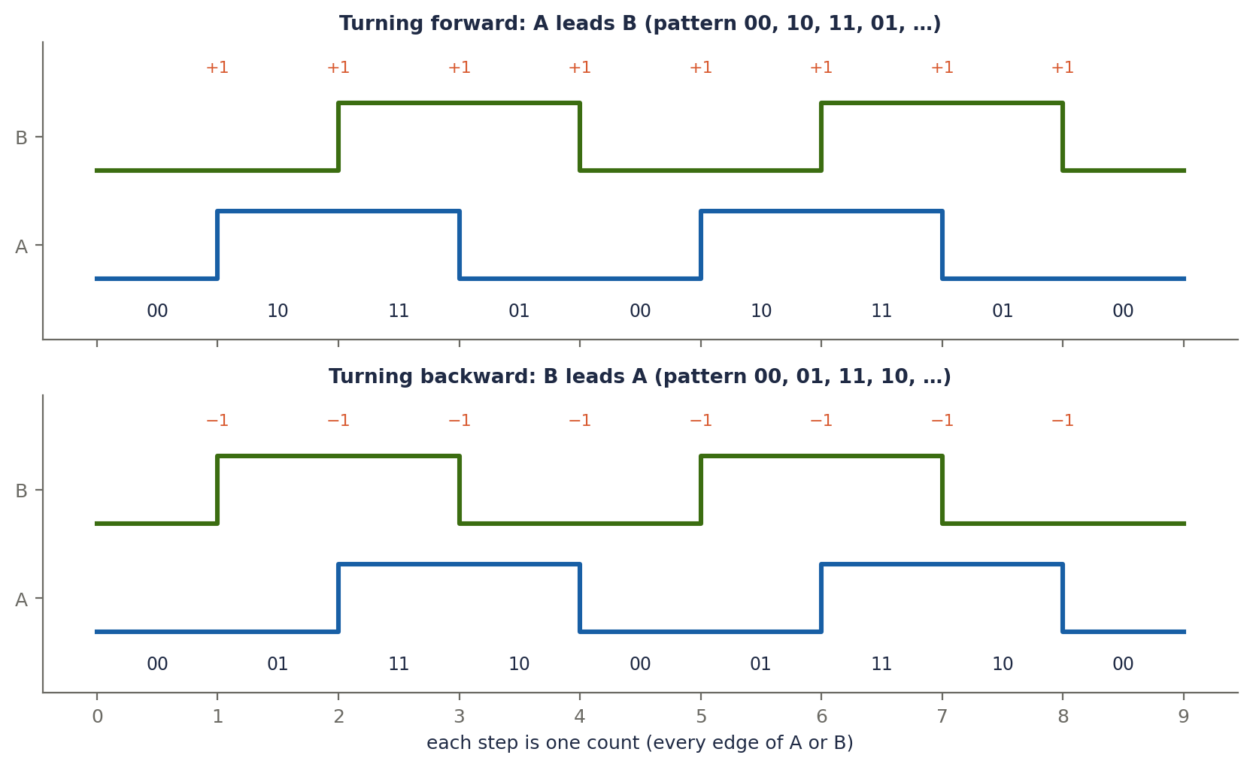
Figure 5.1a. Quadrature timing. Every edge of A or B is one count (4× counting), so one full cycle gives four counts. Reading which signal changed first gives the direction.

From counts to distance
- Counts per wheel turn = CPR × 4 × gear ratio. With 7 CPR and a 30:1 gearbox, that is 7 × 4 × 30 = 840.
- Distance per count = π × wheel diameter / counts per turn. With a 20 mm wheel: 62.83 / 840 ≈ 0.0748 mm.

The catch: measuring speed with few counts
At a 1 kHz control loop the mouse moves 0.5 mm per tick at 500 mm/s, which is only about 6.7 counts per tick. Speed is counts per tick divided by dt, so one count of error means 0.0748 mm / 0.001 s ≈ 74.8 mm/s, about 15% of 500 mm/s. The raw speed signal is quantized (it moves in steps), and feeding it straight into a PID makes the motor twitchy.
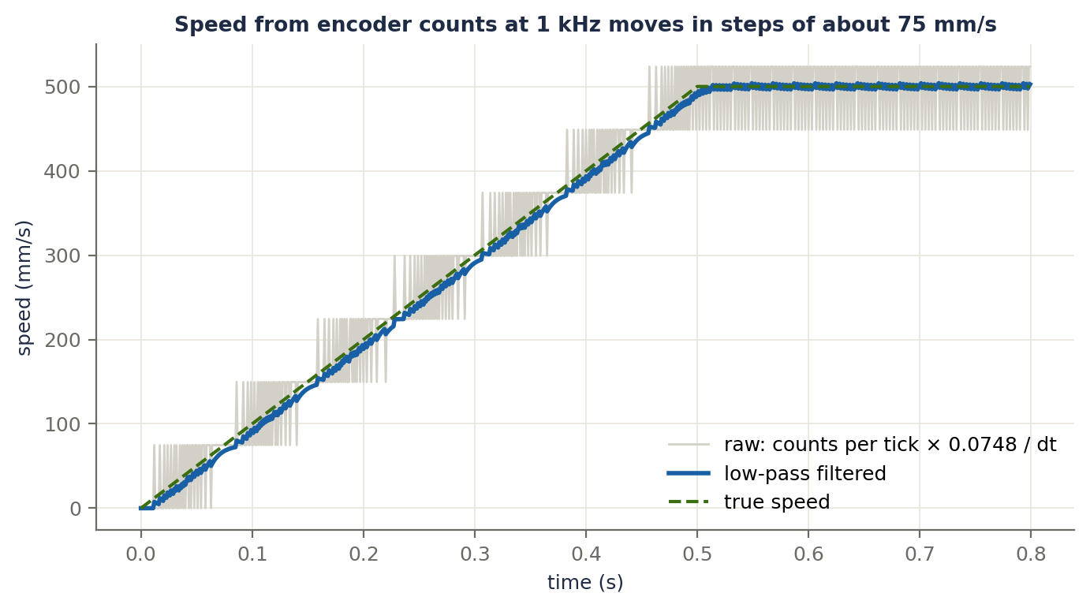
Figure 5.1b. Speed measured from counts at 1 kHz. The raw signal (light grey) jumps in steps of about 75 mm/s. A simple low-pass filter (blue) follows the true speed (green dashed) smoothly.
Three common fixes: average over several ticks, low-pass filter the speed, or use an encoder with more counts per turn.

On the ESP32
The hardware pulse counter (PCNT) counts A and B edges and direction by itself with no CPU time. Each control tick you read the counter and subtract the previous value.
int32_t counts = readPcnt(); // hardware pulse counter
int32_t delta = counts - prevCounts; // counts since the last tick
prevCounts = counts;
float dist = delta * mmPerCount; // mm moved this tick
float speedRaw = dist / dt; // mm/s, quantized
speed += 0.3f * (speedRaw - speed); // simple low-pass filter

Terms explained
Term | Meaning
Encoder | A sensor that counts how much a shaft has turned.
Magnetic encoder | A Hall sensor reading a magnet disc on the shaft; common on small motors.
Optical encoder | A light beam and a slotted disc; more precise but bigger.
Channels A and B | Two square-wave outputs, shifted by a quarter cycle.
Quadrature | The 90° shift between A and B, which gives the direction.
4× counting | Counting every edge of both channels, so one cycle gives 4 counts.
CPR | Counts per revolution of the encoder shaft, before 4× counting and the gearbox.
Gear ratio | How many motor turns make one wheel turn.
Counts per turn | CPR × 4 × gear ratio: the counts for one full wheel turn.
Quantization | Measuring in whole steps, so small changes are lost.
Low-pass filter | A filter that smooths fast jitter and keeps slow changes.
PCNT | The ESP32's hardware pulse counter.

5.2 IR wall sensors
What it does. An infrared LED shines at the wall and a phototransistor measures the light that bounces back. A closer wall reflects more light, so a bigger reading means a closer wall.

Why it is hard
- The reading is nonlinear: the reflected light falls off roughly with the square of the distance, so the sensor is very sensitive up close and almost flat far away.
- It depends on the wall's colour and surface.
- Room light (the sun, ceiling lights) adds to the reading and can look like a wall.
- On the ESP32 the ADC is noisy and nonlinear, so average several samples.

Cancelling room light (ambient subtraction)
- LED off: the reading is only the room light.
- LED on: the reading is room light plus the LED's reflection.
- Signal = on − off. The room light cancels.
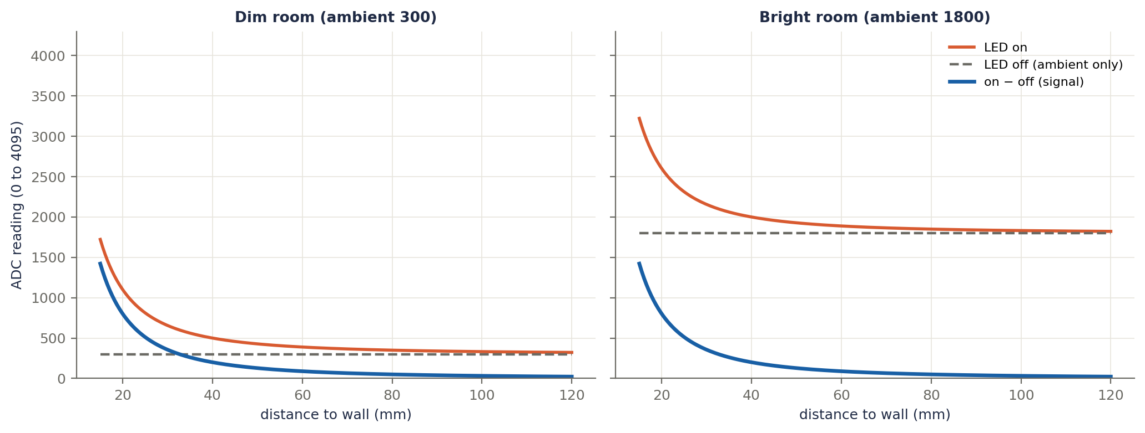
Figure 5.2a. The same wall measured in a dim room (left) and a bright room (right). The "LED on" reading (orange) sits on top of the ambient level (grey dashed), and the difference (blue) is the same in both rooms. This is only true while the reading is not clipped at the top of the ADC range (4095).
int readIR(int ch) {
int off = analogRead(sensorPin[ch]); // room light only
digitalWrite(ledPin[ch], HIGH);
delayMicroseconds(60); // let the sensor settle
int on = analogRead(sensorPin[ch]); // room light + reflection
digitalWrite(ledPin[ch], LOW);
return on - off; // reflection only
}
Other good habits: pulse the LED briefly (a short, strong pulse gives a clean signal and uses little power); do not fire neighbouring LEDs at the same time, because light from one leaks into the next sensor (read them one after another); and calibrate on your own maze by recording the reading with the mouse centred in a cell (the centre value) and the reading at the distance where you decide a wall is there (the threshold).

Using the readings
Use | How
Wall present? | Compare the side or front reading with the threshold.
Centering | Left reading minus right reading gives the error.
Front-wall stop | Brake until the front reading reaches a fixed value.
Wall edge detection | A sudden drop in a side reading means a wall just ended.

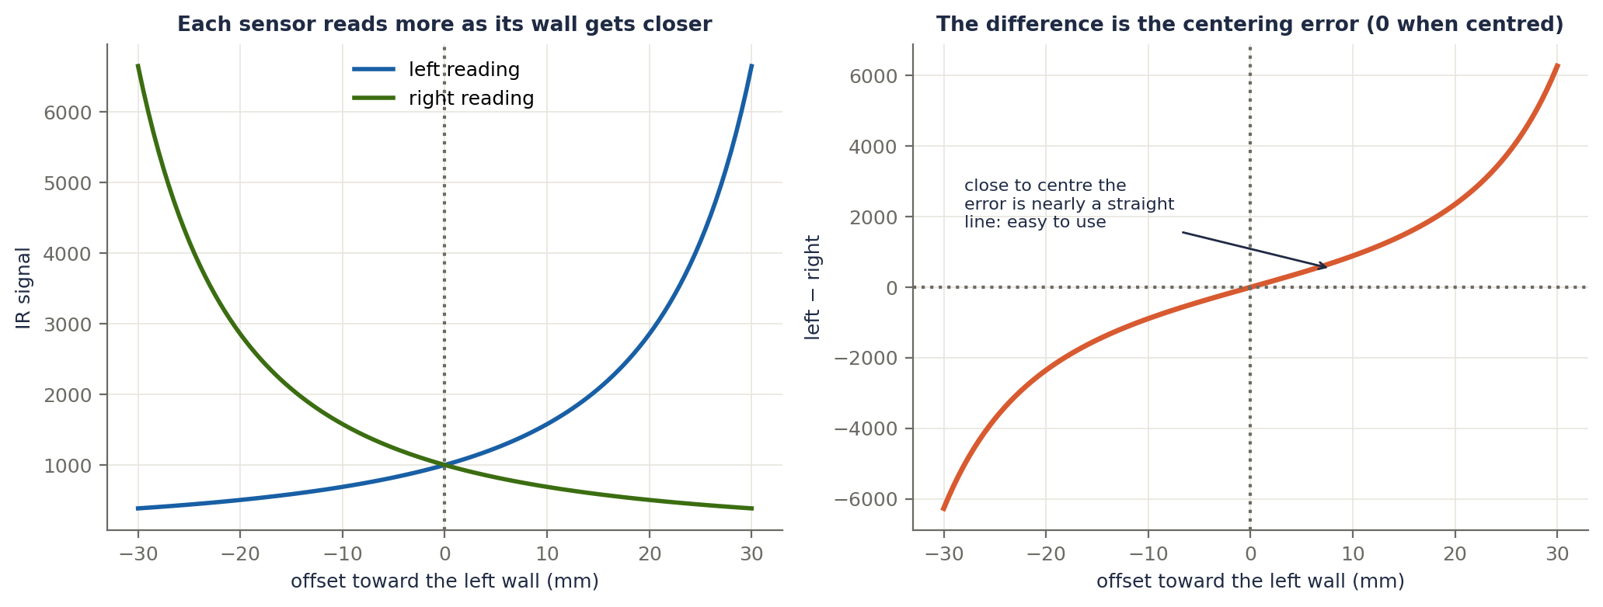
Figure 5.2b. Centering in a corridor (about 49 mm of gap on each side when centred). Left: each sensor reads more as its wall gets closer. Right: the difference left − right is zero when centred and close to a straight line near the centre, which makes it easy to use as the steering error in section 4.7.

Terms explained
Term | Meaning
IR LED (emitter) | Sends out infrared light.
Phototransistor (receiver) | Produces a signal that grows with the light that reaches it.
Reflected intensity | How much emitted light comes back; stronger when the wall is closer.
Nonlinear response | The reading does not change evenly with distance.
Ambient light | Light already in the room, which the sensor also sees.
Ambient subtraction | Taking a reading with the LED off and subtracting it from one with the LED on.
ADC | Converts the sensor voltage into a number (12 bits on the ESP32: 0 to 4095).
Averaging | Using several samples to reduce noise.
Threshold | The reading above which a wall counts as present.
Centre value | The reading when the mouse is centred in the cell.
Crosstalk | One sensor picking up another sensor's LED light.

5.3 Gyroscope
What it does. A gyro measures angular velocity ω (how fast the mouse is turning), in degrees per second. To get the heading, add it up over time:
θ += (ω − bias) × dt
Add up the turn rate over time and you get the angle turned. This is why the gyro is the best heading sensor for fast turns: it does not care about wheel slip.

Two problems
- Bias (offset). Even when the mouse is perfectly still, the gyro reads a small non-zero value. Integrating that makes the heading creep. Fix: at startup, hold the mouse still, average many readings (for example 1000) and subtract that average from every later reading.
- Drift. The bias is not perfectly constant (it changes with temperature and time), and noise accumulates. So even after calibration the heading slowly wanders.
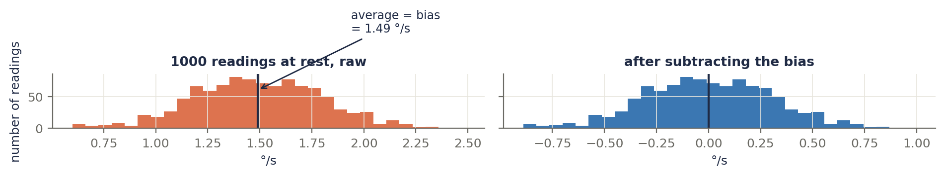
Figure 5.3a. 1000 readings with the mouse at rest. The raw readings centre on the bias (1.49 °/s in this simulation). Subtracting the average puts them around zero.
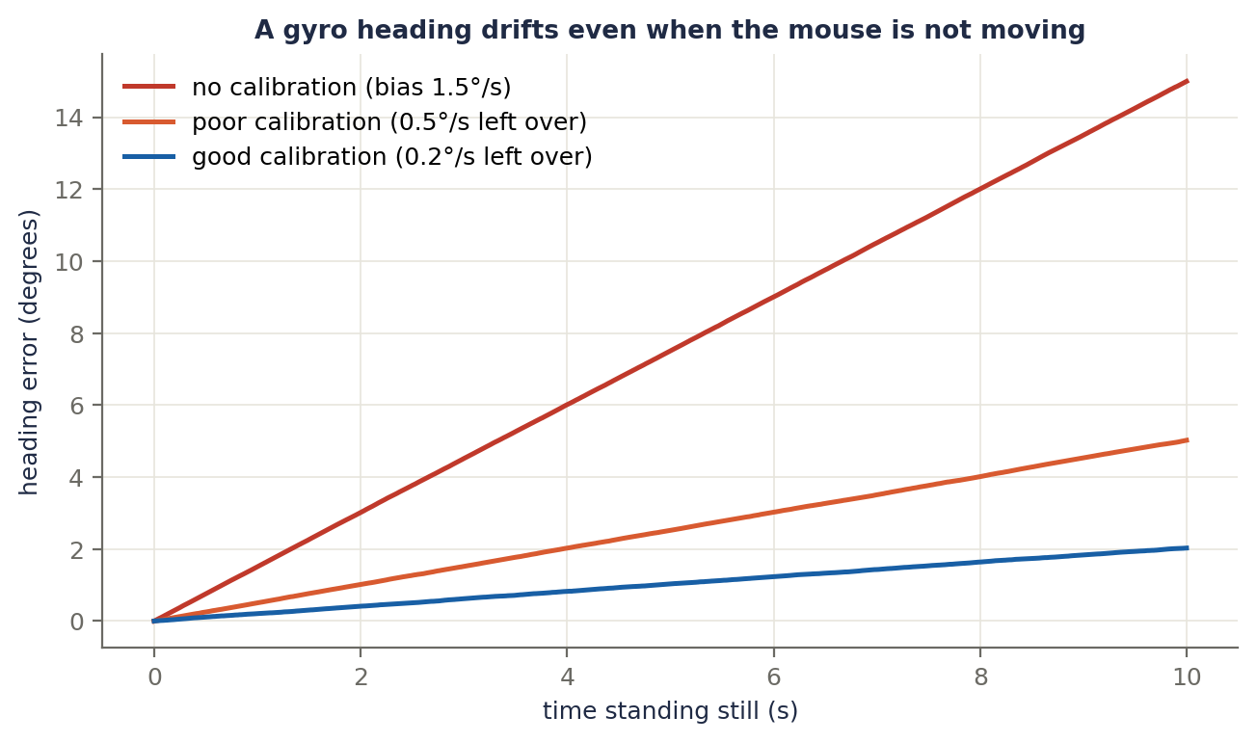
Figure 5.3b. Heading error while standing still. With no calibration, a 1.5 °/s bias turns into 15° of error in 10 s. A leftover bias of 0.5 °/s or 0.2 °/s grows more slowly, but it still grows.
Worked example. After calibration a bias of 0.2 °/s remains. In a 4 s run the heading is off by 0.2 × 4 = 0.8°. Over a 2 m run, that small angle grows to roughly 2000 mm × tan(0.8°) ≈ 28 mm of sideways error at the end (about 14 mm on average along the way). Small, but it keeps growing, which is why walls and encoders still matter.

Other things to get right
- Range and sensitivity. The chip has a selectable range (for example ±2000 °/s). The raw number is in "LSBs", and the datasheet gives the conversion (for example 16.4 LSB per °/s at ±2000 °/s; check your chip).
- Steady sample timing. Integration assumes a fixed dt, so read the gyro from the same 1 kHz timer interrupt, and use a fast bus (SPI).
- Mounting. Fix it firmly near the centre between the wheels, away from motor noise and vibration.
// at startup, with the mouse held still
float sum = 0;
for (int i = 0; i < 1000; i++) { sum += readGyroZ(); delay(1); }
float bias = sum / 1000; // deg/s

// every control tick
float omega = readGyroZ() - bias; // deg/s, bias removed
heading += omega * dt; // integrate to get the angle

Terms explained
Term | Meaning
Gyroscope | Measures rotation rate.
Angular velocity (ω) | How fast the heading is changing, in °/s.
Integration | Adding up a rate over time to get a total (rate × time).
Heading (θ) | The direction the mouse faces, from integrating ω.
Bias (offset) | The non-zero reading at rest.
Calibration | Measuring the bias at startup and subtracting it.
Drift | Slow, steady growth of the heading error.
Noise | Random jitter in the reading.
Sensitivity / range | How the raw number converts to °/s, and the largest rate the chip can measure.
IMU | A chip with a gyro and an accelerometer together.
SPI | A fast serial bus used to read the gyro.

5.4 Sensor fusion
The idea. Each sensor is good at something and bad at something else:
Sensor | Good at | Bad at
Gyro | Fast, smooth changes in heading | Slow drift
Encoders / walls (the reference) | Long-term truth, no drift | Noisy, slip, jumpy

Complementary filter
Trust the gyro for the short term, and let the reference pull the answer back slowly:
θ_fused = α × (θ_fused + ω × dt) + (1 − α) × θ_reference
- α close to 1 (for example 0.99): mostly gyro. Smooth, but a drifting gyro is corrected slowly.
- α smaller: the reference counts for more. Drift is corrected faster, but its noise gets through.
- The filter's time constant is roughly τ = α × dt / (1 − α). With α = 0.99 and dt = 0.001 s, τ ≈ 0.1 s.
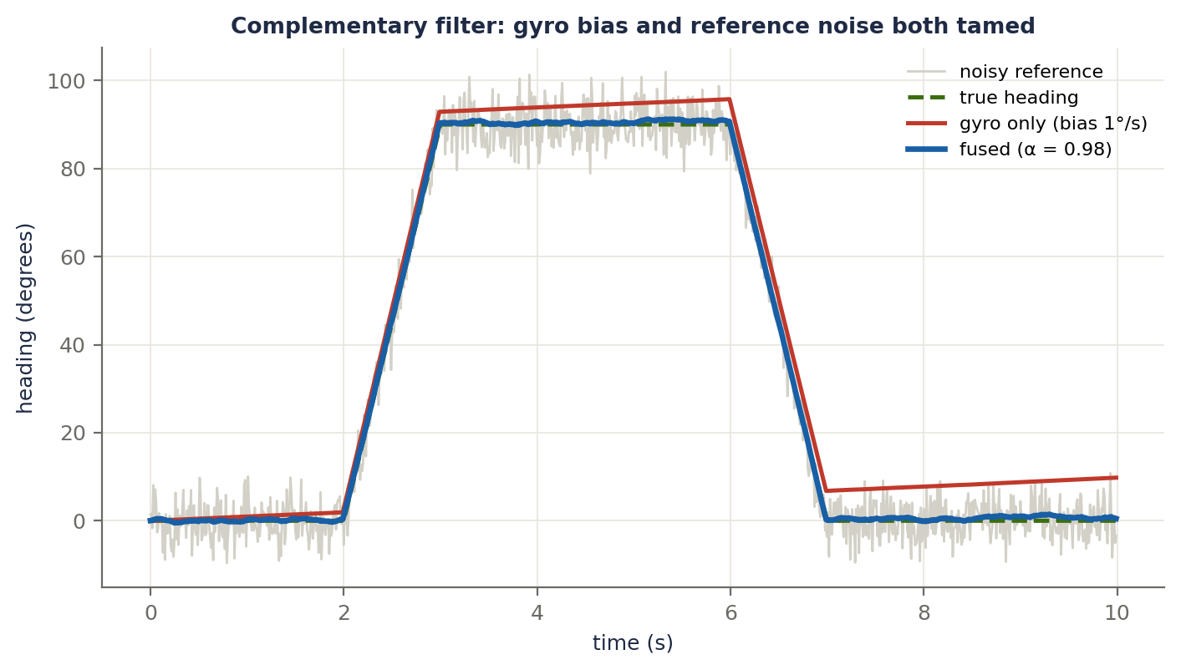
Figure 5.4a. The mouse turns 90° and back. The gyro has a 1 °/s bias (red drifts away) and the reference is noisy (grey). The fused estimate (blue) follows the truth closely. RMS errors: gyro only 5.5°, reference 4.1°, fused 0.6°.
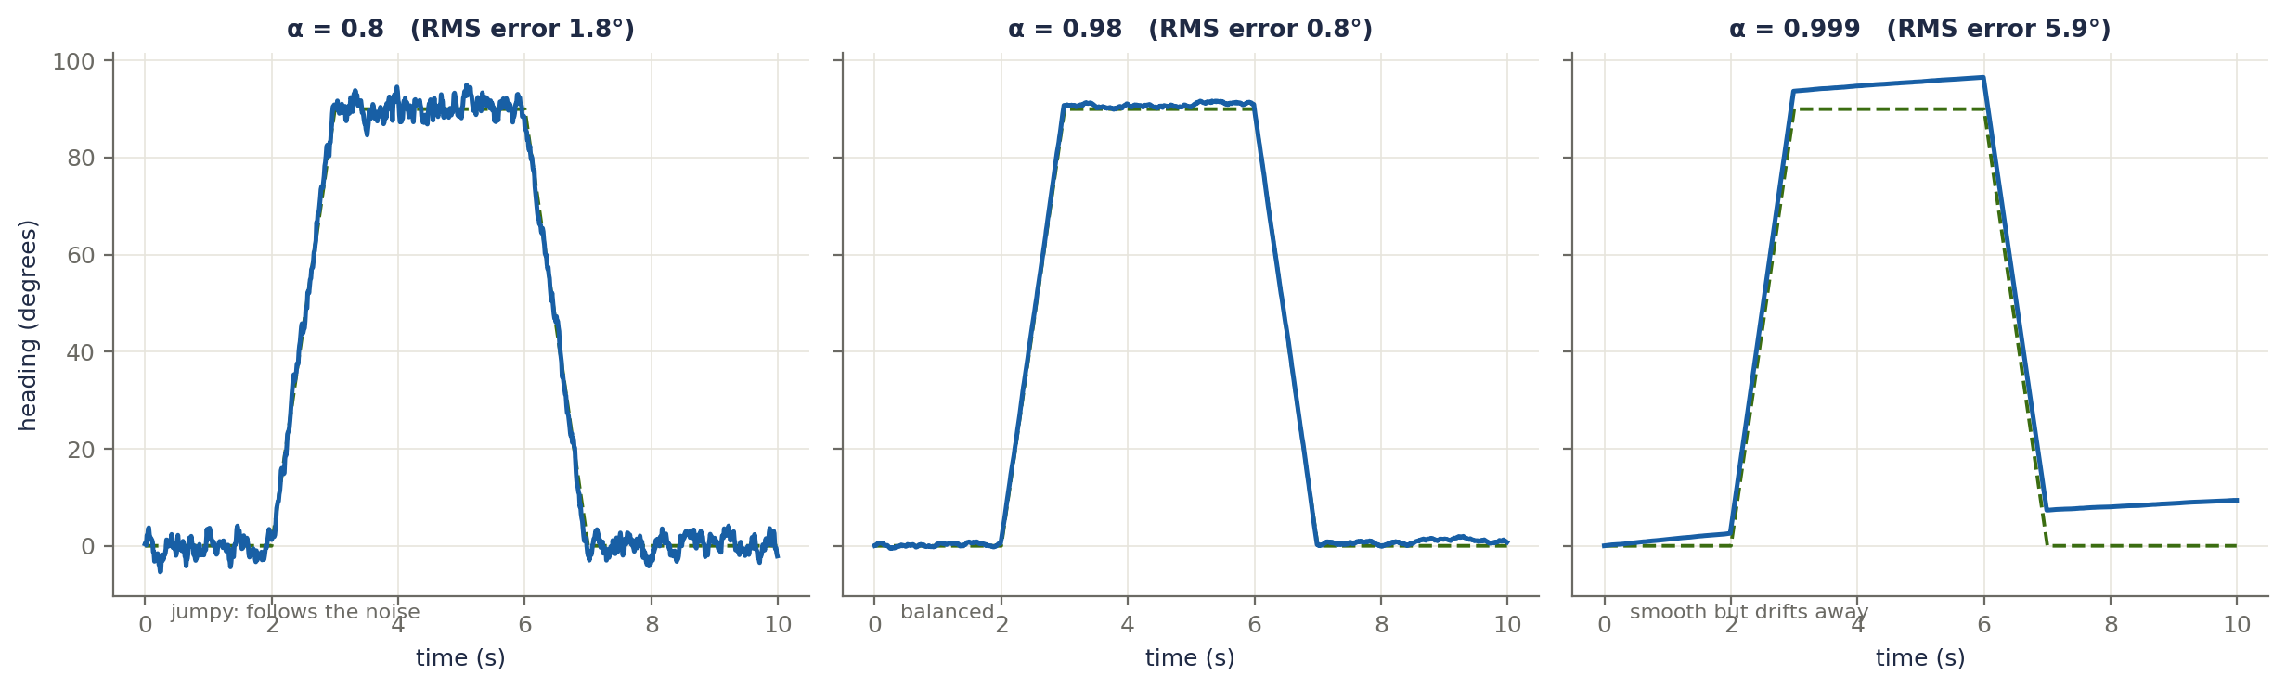
Figure 5.4b. The choice of α is a trade-off. α = 0.8 follows the noise (RMS error 1.8°). α = 0.98 is balanced (0.8°). α = 0.999 is smooth but corrects the drift so slowly that it drifts away (5.9°).
On the mouse. The gyro's heading is the fast "truth". The slow references that pull it back are the heading change from the wheel encoders and the wall angle from the IR sensors when walls are present. The complementary filter is simple, cheap and works well. A Kalman filter does the same job more cleverly by adjusting the trust automatically from the sensor noise, but it takes more maths and tuning, so it is a later upgrade.
// every tick
float thetaGyroStep = (gyroRate - bias) * dt; // predicted heading change
heading = alpha * (heading + thetaGyroStep) // trust the gyro short term
+ (1.0f - alpha) * headingRef; // pull slowly toward the reference

Terms explained
Term | Meaning
Sensor fusion | Combining several sensors so each covers the others' weaknesses.
Reference | A slower, drift-free but noisy measurement (wheel encoders, walls).
Complementary filter | Blending a fast sensor (gyro) with a slow one (reference) using a constant α.
α (alpha) | How much to trust the gyro, between 0 and 1.
Time constant (τ) | Roughly how long the reference takes to pull the estimate back.
Kalman filter | A filter that adjusts its trust automatically from the sensors' noise levels.
Fast / slow sensor | A fast sensor responds quickly but drifts; a slow one is steady but noisy or delayed.

Part 5 at a glance
 | Gives | Fix its weakness with
Encoders | Distance and speed | Gyro for heading, filtering for the quantized speed
IR walls | Distance to walls, wall edges | Ambient subtraction, calibration, averaging
Gyro | Heading and turn rate | Startup bias calibration, plus a reference in the filter
Fusion | A heading and position you can trust | Choose α, use walls as the absolute reference

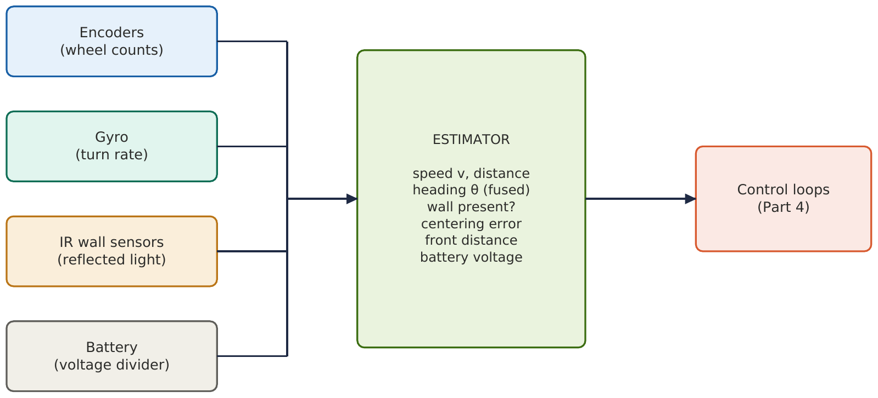
Figure 5.5. How the sensors feed the estimator, which in turn feeds the control loops of Part 4.

Flowchart 1: One sensing tick
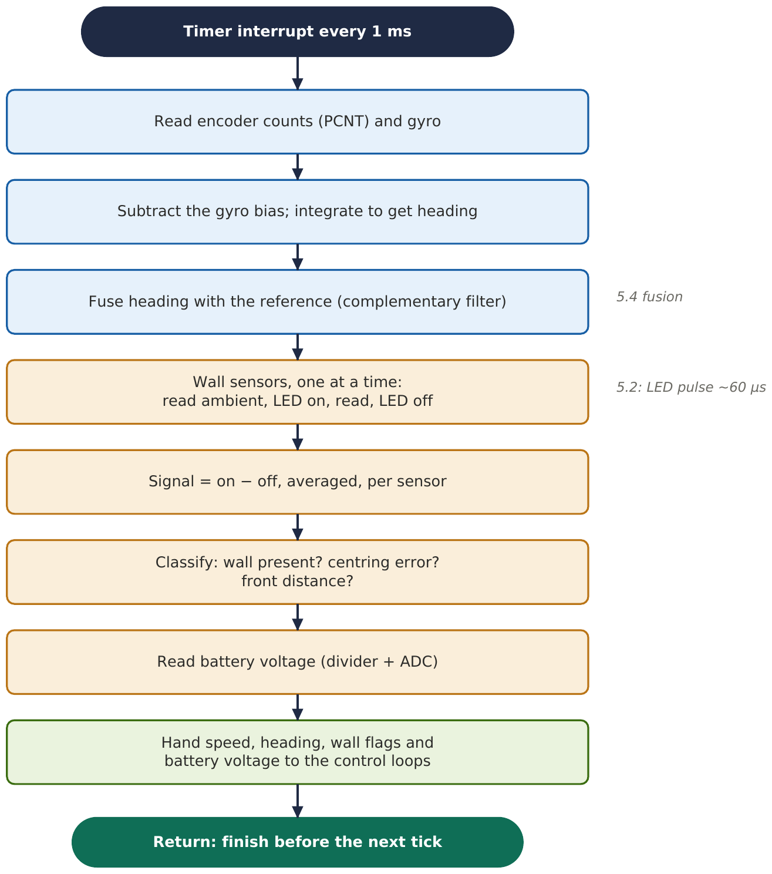

Flowchart 2: Gyro calibration at startup
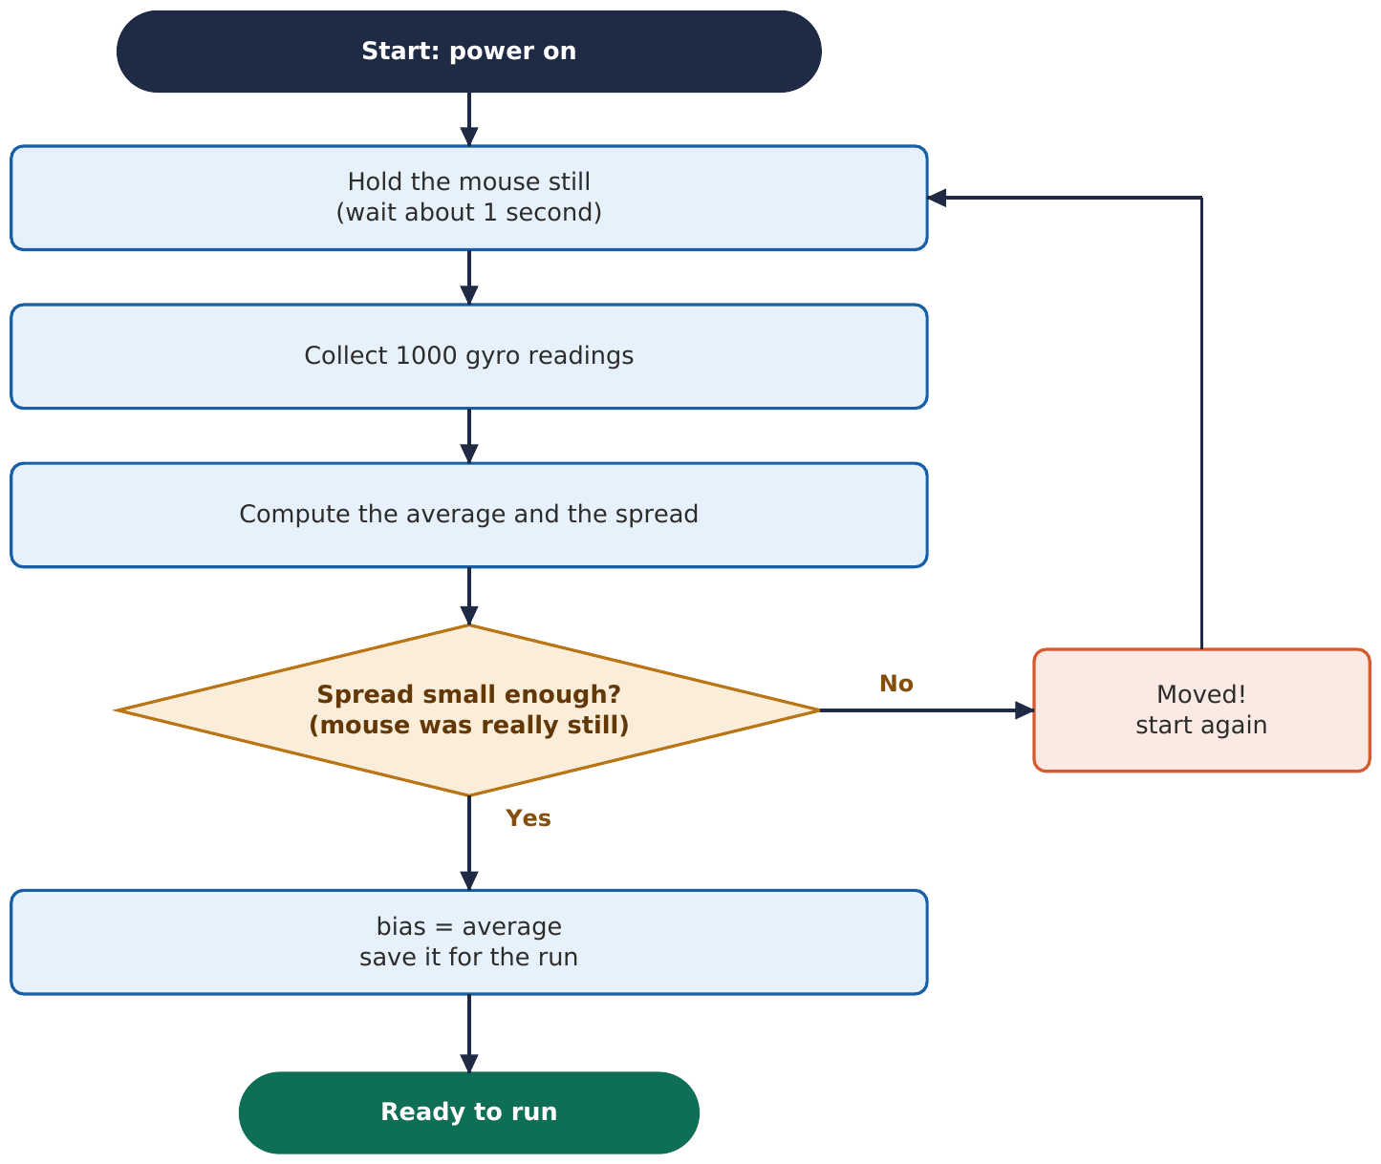

Next: the electronics: motors, motor drivers, PWM, the battery, power, and the PCB.

