1. What does an empty dictionary's code look like?

Ans - dict={'' : ""}

2. What is the value of a dictionary value with the key 'foo' and the value 42?

Ans = dict={'' : ""}

dict={'foo' : 42}

dict['foo']

42

3. What is the most significant distinction between a dictionary and a list?

Ans = List store object as value.

List = [1,2,3,5]

Dictionary store object in key and value pairs .

Dict = {‘one’: 1,

‘two’: 2 }

4. What happens if you try to access spam['foo'] if spam is {'bar': 100}?

Key error

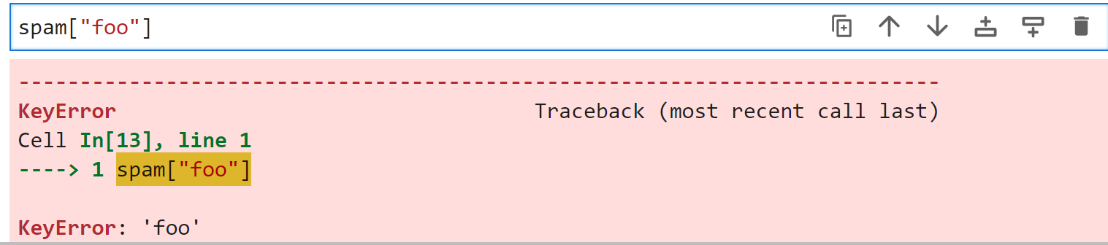

5. If a dictionary is stored in spam, what is the difference between the expressions 'cat' in spam and 'cat' in spam.keys()?

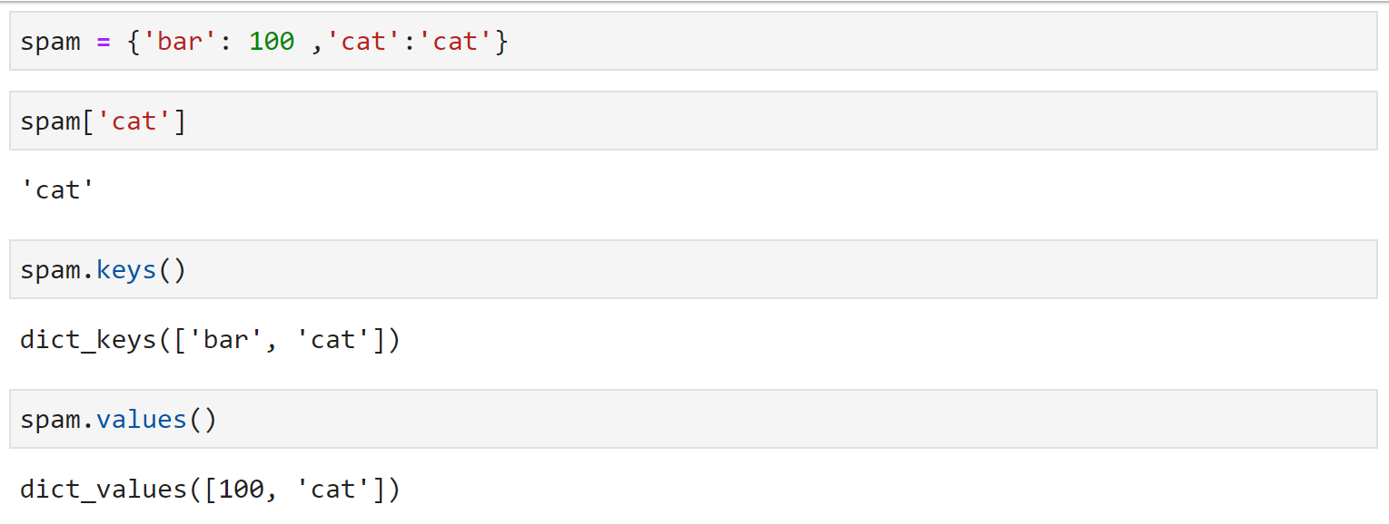

‘cat ’ – expression is the key in dict

'cat' in spam.keys() – PROVIDES a set-like object providing a view on D's keys

6. If a dictionary is stored in spam, what is the difference between the expressions 'cat' in spam and 'cat' in spam.values()?

‘cat ’ – expression is the VALUE in dict

'cat' in spam.keys() – PROVIDES a set-like object providing a view on D's VALUES

7. What is a shortcut for the following code?

if 'color' not in spam:

spam['color'] = 'black'

* We will use setdefault() method
* Definition - Insert key with a value of default if key is not in the dictionary.
* spam.setdefault('color','black')

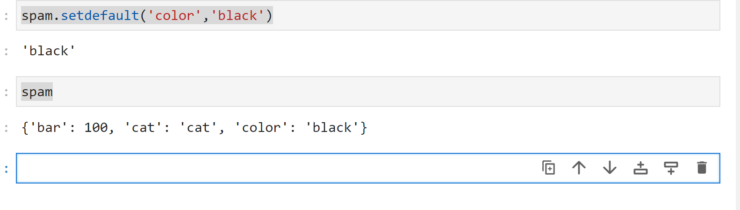

8. How do you "pretty print" dictionary values using which module and function?

Multiple ways of doing it

1. importing the json library –

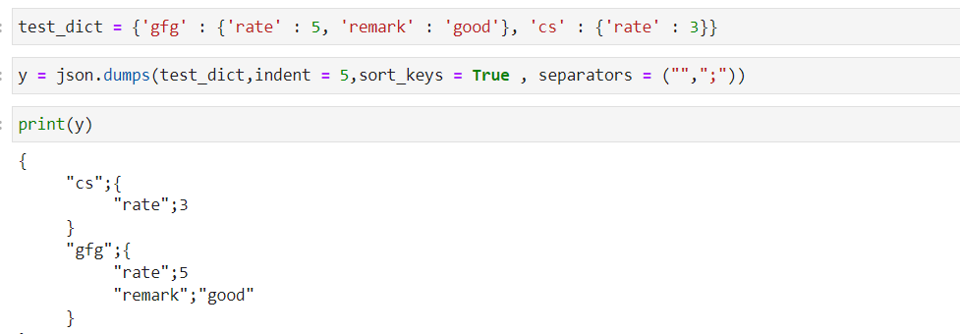

1. importing the pprint

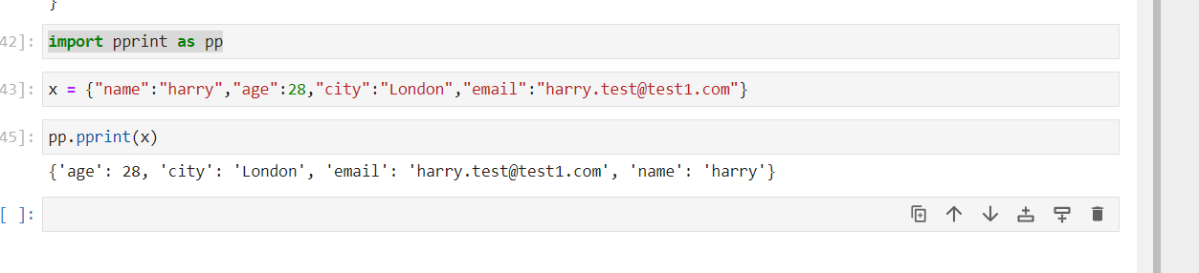

I still feel the way 1 is better