Task 2: API Integration & JSON Handling
Objective:
To understand API integration, JSON data handling, and exception handling using Python.

Tools Used:
- Python
- Google Colab
- Requests Library
- GitHub

Project Description:
This project demonstrates how to connect to a public API and retrieve data in JSON format. The program sends a request to the API, receives user information, and extracts useful details such as name, email, company, and city.

Code:
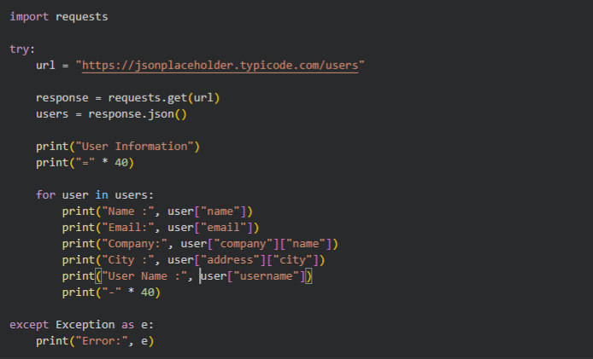
Output:
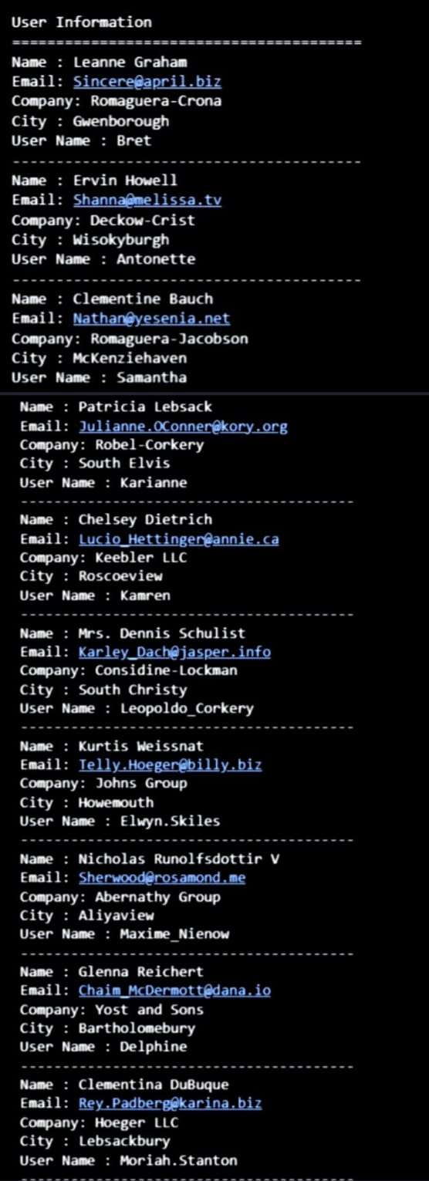
Concepts Covered:

- API Integration
- JSON Parsing
- Data Extraction
- Exception Handling

Conclusion:

This project helped me understand how APIs work and how Python can be used to fetch and process real-world data in JSON format.

GitHub Repository Link:

ADIMULAM-BHOOMIKA/API-Integration-and-JSON-Handling

Author:

ADIMULAM BHOOMIKA…

