Task 1: Python File Handling & Automation

Objective:

To understand Python file handling, automation logic, and exception handling using Python.

Tools Used:

- Python
- Google Colab
- GitHub

Requirements Covered:

- Read and write files
- Automate file organization
- Use exception handling
- Add comments in code

Project Explanation:

This project automatically organizes files into separate folders based on file type such as TXT, CSV, PDF, and Images. It also creates and reads a log file to confirm successful execution.

Code:

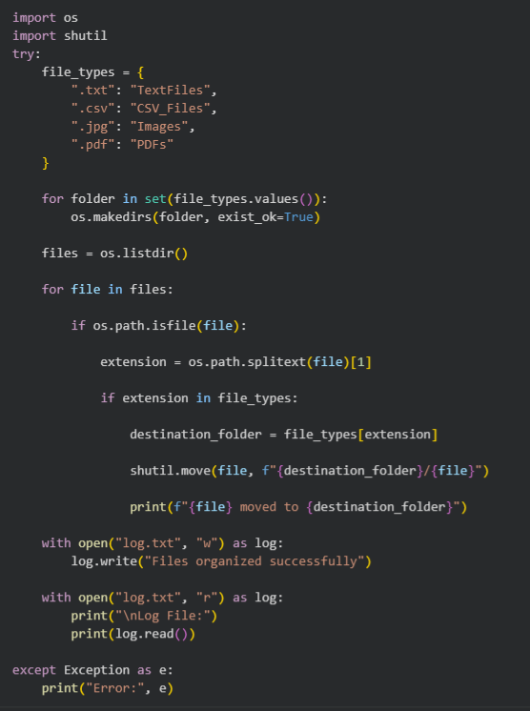

Output:

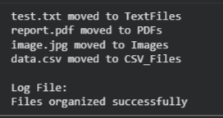

GitHub Repository Link:

ADIMULAM-BHOOMIKA/Python-File-Organizer

Conclusion:

Learned Python file handling, folder automation, and exception handling concepts through a practical project.

