CLOUD COMPUTING TECHNOLOGIES LAB
Lab Report
Deploying a Web Application on AWS
Using IAM, S3, EC2 and CloudWatch
Submitted by
ADITH V C
Date: 8 October 2026

1. Aim
To deploy a simple web application on Amazon Web Services (AWS) in a secure way, by using IAM for access control, S3 for storing the application files, EC2 for running the server, and CloudWatch for monitoring.

2. Overview
The lab was done in the US East (N. Virginia) region. The application, named CodeWave, is stored as a zip file in S3. An EC2 server downloads it using an IAM role (so no passwords or access keys are stored on the server) and runs it. CloudWatch watches the server and raises an alarm if the CPU becomes too busy.
Service | Resource | Purpose
IAM | CodeWave-EC2-Role | Gives the server permissions without access keys
S3 | codewave-app-artifacts-2026 | Private storage for the application build (app.zip)
EC2 | CodeWave-App-Server | Virtual server that runs the application
CloudWatch | CodeWave-High-CPU-Alarm | Alerts when CPU usage reaches 80% or more

3. Steps Performed

Step 1: Security and Access Management (AWS IAM)
IAM controls who or what is allowed to use AWS services. A role was created for the server so that it can access other AWS services safely.
- Created an IAM Role named CodeWave-EC2-Role for the application server.
- Attached AmazonS3ReadOnlyAccess so the server can download the build files from S3 without hard-coded access keys.
- Attached CloudWatchAgentServerPolicy so the server can send metrics and logs to CloudWatch.
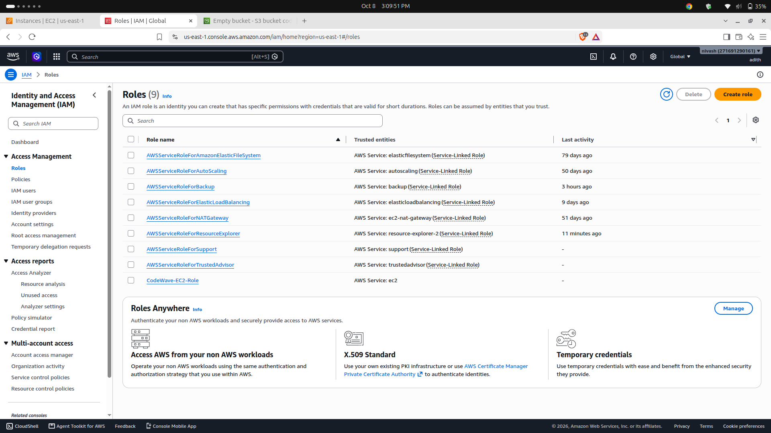
Figure 1: IAM Roles page showing CodeWave-EC2-Role

Step 2: Storage and Artifact Management (Amazon S3)
S3 is used to store files. Here it holds the application build that the server will download.
- Created a private bucket named codewave-app-artifacts-2026.
- Enabled Block Public Access so nobody on the internet can read the files.
- Enabled Bucket Versioning so older versions of files are kept.
- Uploaded the initial application build (app.zip) as the deployment source.
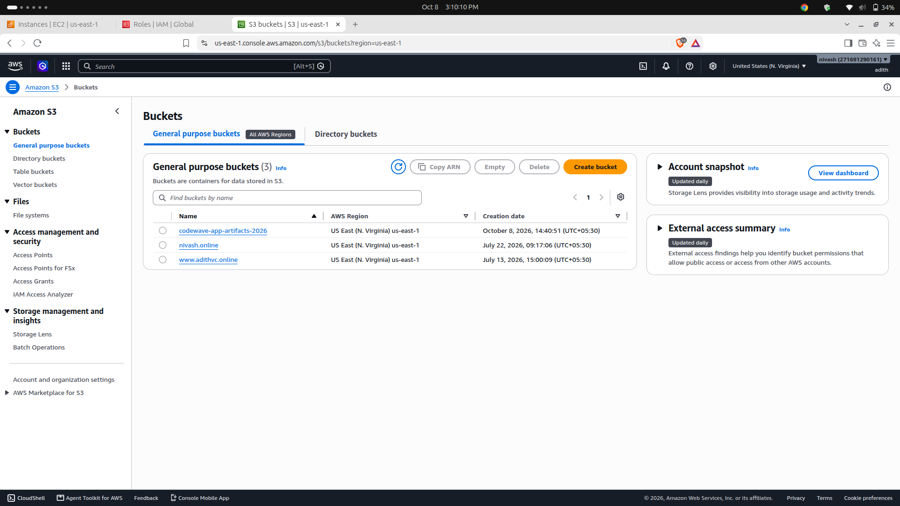
Figure 2: S3 bucket codewave-app-artifacts-2026

Step 3: Compute and Runtime Setup (Amazon EC2)
EC2 provides the virtual server on which the application runs.
- Launched an EC2 instance named CodeWave-App-Server and attached the CodeWave-EC2-Role to it.
- Configured the Security Group (firewall) inbound rules: Port 22 (SSH) only from my own IP for remote login; Port 80 (HTTP) and Port 3000 open for web traffic.
- Used a User Data script, which runs automatically at first boot, to install Node.js, Nginx and the AWS CLI, download the application from S3, and start the web service.
- Logged in to the instance and ran the command "aws s3 ls" to confirm that the IAM role works and the server can reach S3.
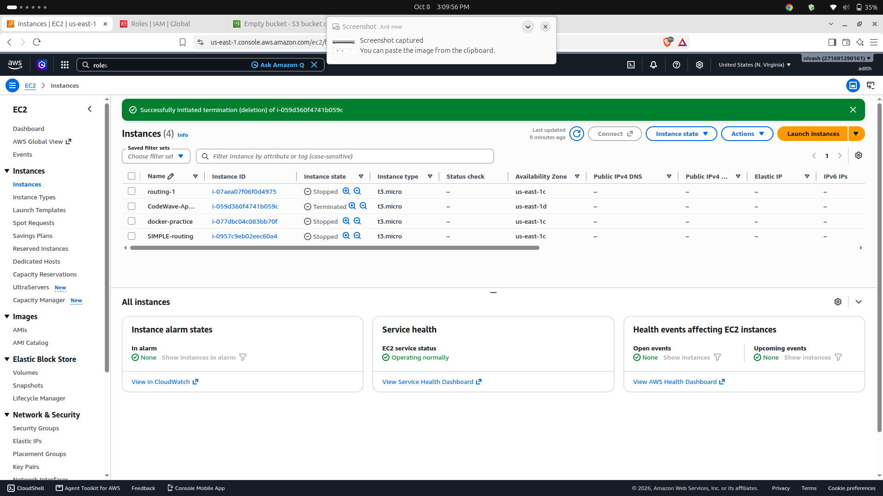
Figure 3: EC2 Instances page (the CodeWave instance was terminated after the lab to avoid charges)

Step 4: Monitoring and Alerts (Amazon CloudWatch)
CloudWatch collects data about the server so problems can be noticed early.
- Installed and configured the Unified CloudWatch Agent on the EC2 instance to collect system metrics and log files.
- Created an alarm named CodeWave-High-CPU-Alarm that triggers when EC2 CPU utilization reaches or exceeds 80%.

4. Result
The application server was set up successfully. The server obtains its application files from a private S3 bucket using an IAM role, runs the web application through Nginx, and sends its metrics and logs to CloudWatch, where an alarm monitors CPU usage.

5. Conclusion
This lab showed how four core AWS services work together to deploy an application securely. Using an IAM role instead of access keys improves security, a private versioned S3 bucket keeps the build files safe, EC2 with a User Data script automates server setup, and CloudWatch gives visibility into server health. After completing the lab, the resources were stopped or terminated to avoid unnecessary cost.

