Health AI: Intelligent Healthcare Assistant

|  |  |
| --- | --- |
| Team Member Name | Roll Number |
| Sayandeep Maity | 22P31A0532 |
| Madhurya Veera | 22P31A0538 |
| Prathi Adithya Durga Sri Krishna Kumar | 22P31A0540 |
| Kolli Veera Raghava Thanvi | 22P31A0549 |

1. INTRODUCTION

1.1 **Project Overview**

**Health AI** is an advanced AI-powered healthcare platform that leverages **IBM Watson Machine Learning** and **Generative AI** to deliver personalized and intelligent medical assistance. Designed with a focus on accessibility, accuracy, and user experience, Health AI provides a comprehensive suite of healthcare services to help users make informed decisions about their health.

* **🧠 Core Features:**

1. **🗨️ Patient Chat**  
   A conversational assistant that answers user queries related to health, symptoms, and wellness using natural language understanding.
2. **🧾 Disease Prediction**  
   An AI model evaluates symptoms entered by users and provides potential conditions or diagnoses with medical context.
3. **💊 Personalized Treatment Plans**  
   Offers tailored medical recommendations and care plans based on user inputs and predicted conditions.
4. **📊 Health Analytics**  
   Visual dashboards and metrics to help users monitor trends in symptoms, health history, and risk factors over time.

1.2 **Purpose**

The purpose of **Health AI** is to create a smart, accessible, and user-friendly healthcare assistant that leverages **IBM Watson Machine Learning** and **Generative AI (Granite-13b-instruct-v2)** to deliver accurate and personalized medical guidance. Health AI is designed to empower users to **understand, manage, and make informed decisions** about their health—even without direct access to healthcare professionals.

**🎯 Target Audience:**

* **General Public**: Individuals seeking quick, reliable health advice or disease insights without needing a doctor’s appointment.
* **Tech-Savvy Users**: People comfortable using digital tools for personal healthcare management.
* **Rural & Underserved Communities**: Populations with limited access to medical infrastructure.
* **Students & Researchers**: Those studying healthcare or AI, using HealthAI as an educational tool.

**🌍 Social Impact:**

* **Improved Healthcare Access**: Helps bridge the healthcare divide by providing on-demand support to users in remote or resource-limited areas.
* **Health Awareness & Education**: Empowers individuals to understand symptoms, conditions, and care options, reducing misinformation.
* **Reduced Pressure on Healthcare Systems**: Enables basic triage and advice, allowing healthcare professionals to focus on critical cases.
* **Inclusive Design**: Accessible UI ensures that even non-technical users can benefit from AI-driven insights.

**💰 Economic Impact:**

* **Cost Savings for Users**: Minimizes unnecessary doctor visits for minor or preliminary concerns by providing quick AI evaluations.
* **Affordable Healthcare Assistance**: Offers a free or low-cost alternative for health insights, especially useful in low-income regions.
* **Support for Insurance & Health Tech Startups**: Health AI can integrate into larger digital health ecosystems, contributing to cost-effective patient management.
* **Innovation in Digital Health**: Encourages AI adoption in healthcare, driving growth in the health tech sector.

**2. Ideation Phase**

**2.1 Define the Problem Statements**

|  |  |
| --- | --- |
| Date | 27 June 2025 |
| Team ID | LTVIP2025TMID29337 |
| Project Name | **Health AI: Intelligent Healthcare Assistant Using IBM Granite** |
| Maximum Marks | 2 Marks |

Customer Problem Statements

Problem Statement 1 – Patient Chat Interface

|  |  |
| --- | --- |
| Section | Description |
| I am | A curious or concerned person with health-related questions |
| I’m trying to | |  | | --- | |  |  |  | | --- | | Get clear, reliable answers about my symptoms or conditions | |
| But | |  | | --- | |  |  |  |  |  | | --- | --- | --- | | |  | | --- | |  |  |  | | --- | | Searching online gives conflicting or scary information | | |
| Because | |  | | --- | |  |  |  |  |  | | --- | --- | --- | | |  | | --- | |  |  |  | | --- | | I don’t have access to a trusted, AI-powered assistant for quick answers | | |
| Which makes me feel | Confused, anxious, and hesitant about taking the right steps |

Problem Statement 2 – Disease Prediction System

|  |  |
| --- | --- |
| Section | Description |
| I am | A patient experiencing multiple symptom s (e.g., headache, fatigue, fever) |
| I’m trying to | |  | | --- | |  |  |  | | --- | | Understand what condition I might be facing and what actions to take | |
| But | |  | | --- | |  |  |  | | --- | | I am unsure which symptoms are serious and what disease they might indicate | |
| Because | |  | | --- | |  |  |  | | --- | | I don’t have the medical expertise or instant access to reliable diagnostics | |
| Which makes me feel | Anxious, confused, and worried about my health decisions |

Problem Statement 3 – Treatment Plan Generator

|  |  |
| --- | --- |
| Section | Description |
| I am | A user diagnosed with a health condition |
| I’m trying to | |  | | --- | |  |  |  |  |  | | --- | --- | --- | | |  | | --- | | Get personalized, evidence-based treatment recommendations |  |  | | --- | |  | | |
| But | |  | | --- | |  |  |  |  |  | | --- | --- | --- | | |  | | --- | |  |  |  | | --- | | I receive generic advice that doesn’t consider my unique health profile | | |
| Because | |  | | --- | |  |  |  | | --- | |  | |  |  |  | | --- | | I lack access to tailored medical guidance outside clinical visits | |
| Which makes me feel | |  |  |  | | --- | --- | --- | | |  | | --- | |  |  |  | | --- | | Uncertain and unsupported in managing my condition effectively | |  |  | | --- | |  | |

Problem Statement 4 – Health Analytics Dashboard

|  |  |
| --- | --- |
| Section | Description |
| I am | A health-conscious individual tracking my health over time |
| I’m trying to | |  | | --- | |  |  |  |  | | --- | --- | | |  | | --- | | Visualize my health metrics and detect trends or risks early | | |
| But | |  | | --- | |  |  |  |  |  |  |  | | --- | --- | --- | --- | --- | | |  | | --- | |  |  |  |  |  | | --- | --- | --- | | |  | | --- | |  |  |  | | --- | | I can't interpret raw data or recognize what the numbers really mean | | | |
| Because | |  | | --- | |  |  |  | | --- | |  | |  |  |  |  |  | | --- | --- | --- | | |  | | --- | |  |  |  | | --- | | I don’t have access to a smart tool that explains patterns in simple terms | | |
| Which makes me feel | |  |  |  |  |  | | --- | --- | --- | --- | --- | | |  | | --- | |  |  |  |  |  | | --- | --- | --- | | |  | | --- | |  |  |  | | --- | | Overwhelmed and unsure about how to improve my health proactively | | |  |  | | --- | |  | |

2.2 Empathize & Discover

|  |  |
| --- | --- |
| Date | 27 June 2025 |
| Team ID | LTVIP2025TMID29337 |
| Project Name | **Health AI: Intelligent Healthcare Assistant Using IBM Granite** |
| Maximum Marks | 4 Marks |

Empathy Map Canvas

An empathy map is a simple, easy-to-digest visual that captures knowledge about a user’s behaviours and attitudes.

It is a useful tool to helps teams better understand their users. Creating an effective solution requires understanding the true problem and the person who is experiencing it. The exercise of creating the map helps participants consider things from the user’s perspective along with his or her goals and challenges.

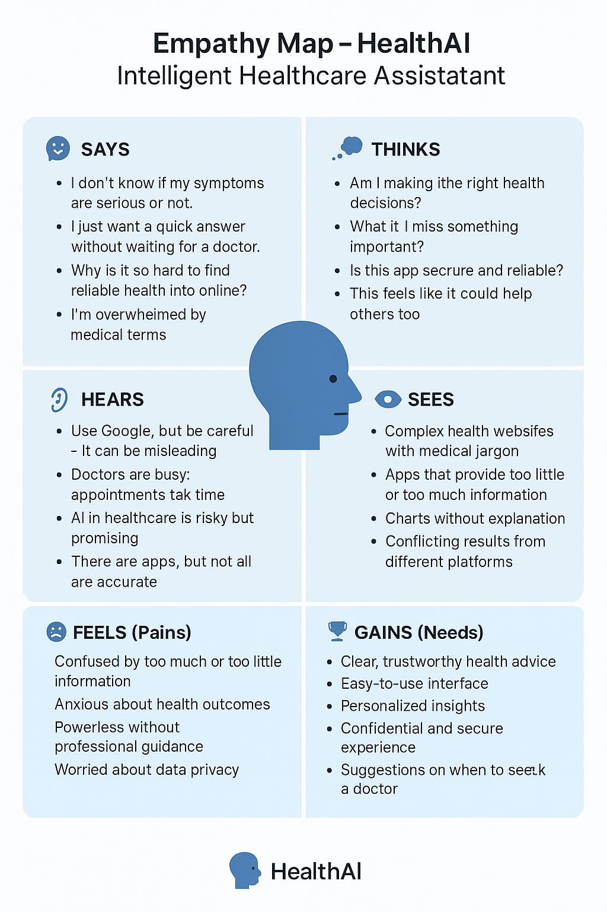

**2.3 Brainstorm & Idea Prioritization Template**

|  |  |
| --- | --- |
| Date | 27 June 2025 |
| Team ID | LTVIP2025TMID29337 |
| Project Name | **HealthAI: Intelligent HealthCare Assistant using IBM Granite** |
| Maximum Marks | 4 Marks |

# Team Members & Roles

|  |  |
| --- | --- |
| Name | Role |
| Sayandeep Maity | Team Leader, Full Stack & LLM Integration using IBM Granite |
| Prathi Adithya Durga Sri Krishna Kumar | Frontend Developer (Streamlit) |
| Madhurya Veera | Backend Developer (Python) |
| Kolli Veera Raghava Thanvi | Model Testing, Dashboard Data Aggregation |

# Step 1: Team Gathering, Collaboration, and Selecting the Problem Statement

**Problem Statement:**

To develop an AI-powered Intelligent Healthcare Assistant using IBM Granite LLM that helps users with real-time medical responses, disease prediction, personalized treatment plans, and health analytics—improving healthcare accessibility and informed decision making.

**Motivation:**

People often struggle to access timely, accurate, and personalized healthcare information. Traditional healthcare systems lack real-time support for symptom analysis, treatment guidance, and health monitoring. HealthAI bridges this gap by providing conversational AI for medical queries, AI-driven disease predictions, personalized treatment plans, and health analytics—empowering users to make informed health decisions quickly and confidently.

# Step 2: Brainstorming, Idea Listing, and Grouping

**Initial Ideas:**

* Integrate a conversational health assistant using IBM Granite
* Enable disease prediction based on user-reported symptoms
* Generate personalized treatment plans for users
* Visualize patient health metrics through an analytics dashboard
* Implement a user profile section with basic health details
* Build the app using Streamlit with Python backend and Plotly for charts

**Grouped into Modules:**

1. **Chat Module** – AI-powered patient chat using IBM Granite LLM
2. **Disease Prediction Module** – Predicts diseases from symptoms entered by users
3. **Treatment Plan Module** – Generates personalized treatment suggestions
4. **Health Analytics Module** – Displays patient health trends and metrics using Plotly
5. **Profile Management Module** – Manages user profile details like name, age, and blood type
6. **UI Module** – Streamlit frontend with navigation and feature-specific pages

# Step 3: Idea Prioritization (Final Version)

|  |  |  |  |
| --- | --- | --- | --- |
| **Feature / Module** | **Importance** | **Feasibility** | **Notes** |
| **Chat Module** | High | High | AI-Powered Patient Chat Using IBM Granite LLM. |
| **Disease Prediction Module** | High | High | Predicts Diseases from Symptoms entered by users. |
| **Treatment Planner Module** | High | High | Generate Personalized treatment Suggestions. |
| **Health Analytics Module** | High | Medium | Displays Patient health trend metrics using Plotly. |
| **Profile Management Module** | Medium | High | Manages User profile details like name, age and Blood group. |
| **UI Module** | High | High | Streamlit Frontend with Navigation and feature Specification. |

**3. Requirement Analysis**

3.1 Customer Journey Map

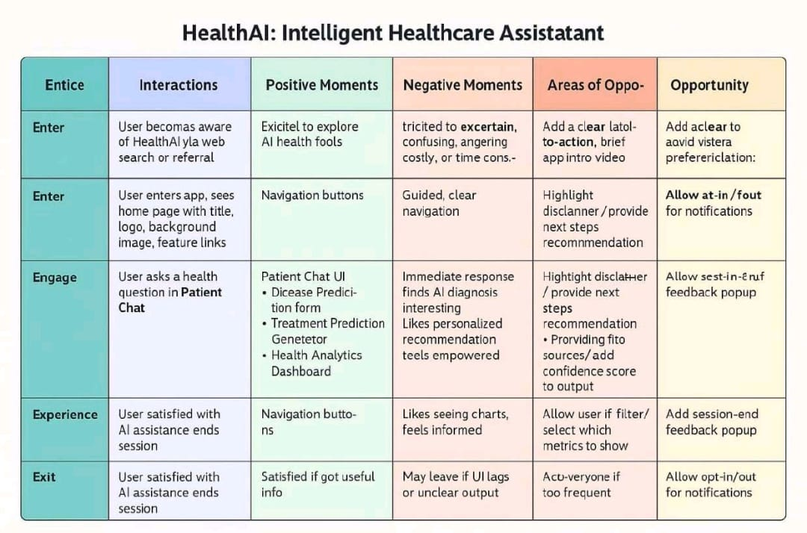

**3.2 Solution Requirements (Functional & Non-functional)**

|  |  |
| --- | --- |
| Date | 27 June 2025 |
| Team ID | LTVIP2025TMID29337 |
| Project Name | Health AI: Intelligent HealthCare Assistant using IBM Granite |
| Maximum Marks | 4 Marks |

**Functional Requirements:**

Following are the functional requirements of the proposed solution.

|  |  |  |
| --- | --- | --- |
| **FR No.** | **Functional Requirement (Epic)** | **Sub Requirement (Story / Sub-Task)** |
| FR-1 | User Profile Management | |  | | --- | |  |  |  | | --- | | Manage patient details (Name, Age, Gender,  Blood Type, Profile Pic) | |
| FR-2 | Patient Chat Assistant | |  | | --- | |  |  |  | | --- | | Query submission and AI response using  IBM Granite (Patient Queries | |
| FR-3 | |  | | --- | |  |  |  | | --- | | Disease Prediction | | Symptom input form, AI-based disease prediction with likelihood percentages. |
| FR-4 | |  | | --- | |  |  |  | | --- | | Treatment Plan Generator | | Condition input and AI-generated personalized treatment plan. |
| FR-5 | Health Analytics Dashboard | Display patient health metrics (Heart Rate, BP, Glucose Trends) using Plotly. |
| FR-6 | Navigation and Home Landing Page | Streamlit-based multi-page navigation (Home → Chat → Prediction → Treatment → Analytics). |

**Non-functional Requirements:**

Following are the non-functional requirements of the proposed solution.

|  |  |  |
| --- | --- | --- |
| **FR No.** | **Non-Functional Requirement** | **Description** |
| NFR-1 | **Usability** | Clean, responsive UI using Streamlit with custom CSS styling for healthcare look. |
| NFR-2 | **Security** | API key management with dotenv, secure IBM Watson API calls, and data confidentiality |
| NFR-3 | **Reliability** | Should handle multiple simultaneous patient queries and API calls without crash |
| NFR-4 | **Performance** | Average AI response time within 2–4 seconds for chat, disease prediction, and treatment generation. |
| NFR-5 | **Availability** | HealthAI should be accessible 24/7 with minimal maintenance, hosted on Replit or Streamlit Cloud. |
| NFR-6 | **Scalability** | Easily extendable to add new AI models (e.g., IBM Granite upgrades) or more healthcare features. |

**3.3 Data Flow Diagram & User Stories**

|  |  |
| --- | --- |
| Date | 27 June 2025 |
| Team ID | LTVIP2025TMID29337 |
| Project Name | Health AI: Intelligent Healthcare Assistant Using IBM Granite |
| Maximum Marks | 4 Marks |

**Data Flow Diagrams:**

A Data Flow Diagram (DFD) is a traditional visual representation of the information flows within a system. A neat and clear DFD can depict the right amount of the system requirement graphically. It shows how data enters and leaves the system, what changes the information, and where data is stored.

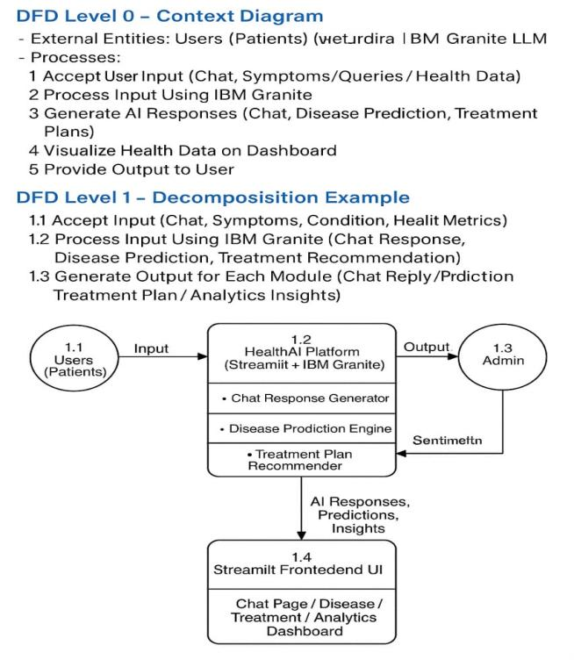

**User Stories**

Use the below template to list all the user stories for the product.

| **User Type** | **Functional Requirement (Epic)** | **User Story Number** | **User Story / Task** | **Acceptance criteria** | **Priority** | **Release** |
| --- | --- | --- | --- | --- | --- | --- |
| Patient (Web User) | Registration/Login | USN-1 | As a Patient, I can register for the application by entering my email, password, and confirming my password. | I can access my account / dashboard and chats | High | Sprint-1 |
| Patient (Web User) | Patient Chat Assistant | USN-2 | As a patient, I can ask health-related questions and receive clear, empathetic AI responses with medical facts and advice when to consult a doctor. | I get a factual, empathetic response with limitations explained and suggestions for professional consultation if needed. | Medium | Sprint-1 |
| Patient (Web User) | Disease Prediction | USN-3 | As a patient, I can input my symptoms to receive possible condition predictions with likelihoods and next steps. | I get list of predicted conditions with likelihood scores and recommended next actions. | High | Sprint-1 |
| Patient (Web User) | Treatment Plan Generator | USN-4 | As a patient, I can enter my diagnosed condition to receive personalized treatment plans including medications, lifestyle changes, and follow-up tests. | I receive a treatment plan that includes evidence-based medications, lifestyle advice, and recommended tests. | High | Sprint-2 |
| Patient (Web User) | Health Analytics Dashboard | USN-5 | As a patient, I can view my health trends and vital signs over time with AI-generated insights and recommendations. | I see graphical trends of my vitals and get insights with improvement suggestions or alerts for concerns. | High | Sprint-2 |
| Admin (Government) | Authentication | USN-6 | As an admin, I can securely log in to manage the Health AI system and access only authorized administrative pages. | I am redirected to the admin dashboard after successful login, and unauthorized access is restricted. | Medium | Sprint-2 |

**3.4 Technology Stack (Architecture & Stack)**

|  |  |
| --- | --- |
| Date | 27 June, 2025 |
| Team ID | LTVIP2025TMID29337 |
| Project Name | Health AI: Intelligent HealthCare Assistant Using IBM Granite |
| Maximum Marks | 4 Marks |

**Technical Architecture:**

* The Web Interface is developed using Streamlit with Plotly for displaying health data charts.
* The backend is built with Python in the app.py file, handling user inputs and API calls.
* The AI responses for chat, disease prediction, and treatment plans come from IBM Granite LLM using IBM Watson ML API.
* API keys and sensitive information are stored securely using dotenv in a .env file.
* The application is deployed on Streamlit Cloud with environment variable support.

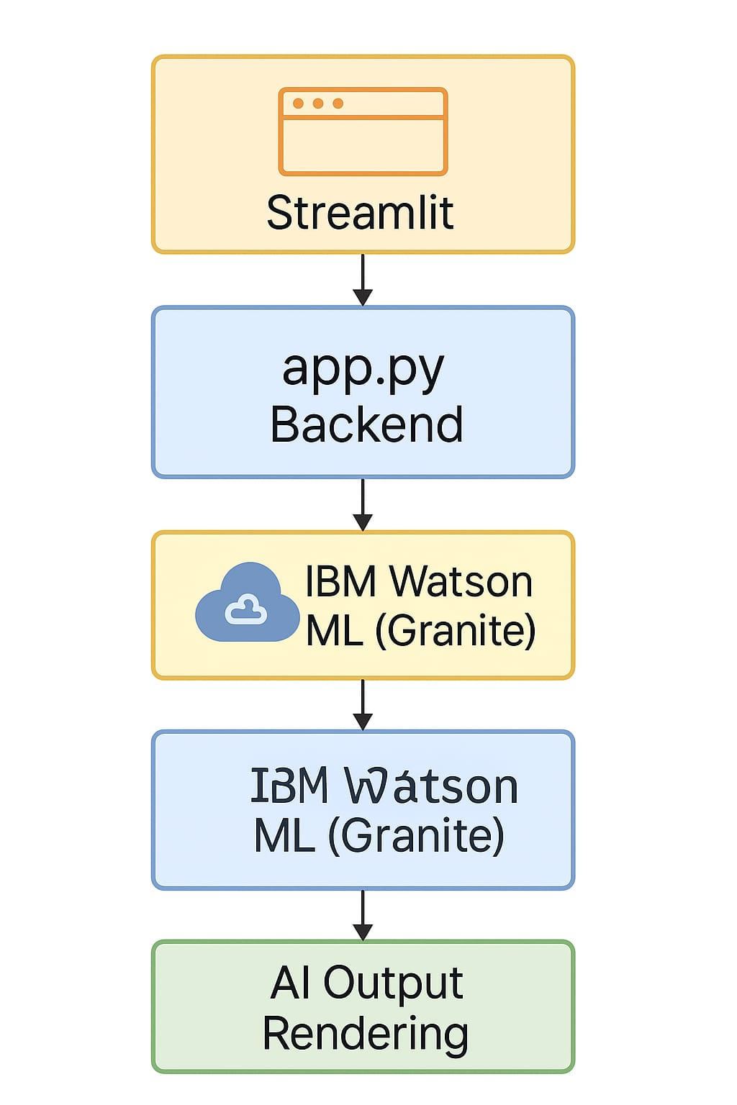

Guidelines:

Include all the processes (As an application logic / Technology Block)

Provide infrastructural demarcation (Local / Cloud)

Indicate external interfaces (third party API’s etc.)

Indicate Data Storage components / services

Indicate interface to machine learning models (if applicable)

**Table-1: Components & Technologies:**

|  |  |  |  |
| --- | --- | --- | --- |
| **S.No** | **Component** | **Description** | **Technology** |
|  | User Interface | Web UI for patients (Chat, Disease Prediction, Treatment Plans, Health Analytics) | Streamlit, Custom CSS, Plotly |
|  | Application Logic-1 | Handle user inputs (Symptoms, Queries, Profile data) | Python (Streamlit app.py) |
|  | Application Logic-2 | Build prompts and handle API calls to IBM Granite | IBM Watson ML API (Granite LLM) |
|  | Application Logic-3 | Process AI responses for each module | Python Backend Logic |
|  | Health Data Visualization | Display patient metrics & trends. | Plotly + Streamlit UI Widgets. |
|  | Secure API Key Management | Store and load IBM API credentials securely | dotenv + Streamlit Secrets |
|  | |  | | --- | |  |  |  | | --- | | Cloud Hosting | | |  | | --- | |  |  |  | | --- | | Deployment and public access | | Streamlit Cloud |
|  | External API-1 | Connect to IBM Watson ML for AI Responses | IBM Watson Machine Learning API |
|  | Deployment Support | Runtime setup, package dependencies | requirements.txt, Streamlit CLI |
|  | Machine Learning Model | Language Model for Chat, Prediction, and Treatment generation | IBM Granite LLM via Watson ML |
|  | Infrastructure (Server / Cloud) | Hosting environment for app runtime and API communication | IBM Cloud / Streamlit Cloud. |

**Table-2: Application Characteristics:**

| **S. No** | **Characteristics** | **Description** | **Technology** |
| --- | --- | --- | --- |
|  | Open-Source Frameworks | Libraries & frameworks used for development | Streamlit, Python, Plotly, dotenv |
|  | Security Implementations | API key management, data privacy, environment security | HTTPS, dotenv, IBM Watson API Keys, SHA-256 (for any future user data storage security) |
|  | Scalable Architecture | Modular, extendable Streamlit app structure with external AI API integration | Streamlit Multipage App, IBM Watson ML APIs |
|  | Availability | Deployment on scalable and accessible cloud infrastructure | Replit, Streamlit Cloud |
|  | Performance | Fast AI response, API call optimization, minimal UI lag | Streamlit Caching, IBM Watson ML low-latency APIs |

* 1. **Project Design Phase**

**4.1 Problem – Solution Fit**

|  |  |
| --- | --- |
| Date | 27 June 2025 |
| Team ID | LTVIP2025TMID29337 |
| Project Name | **Health AI: Intelligent Healthcare Assistant Using IBM Granite** |
| Maximum Marks | 2 Marks |

**Problem – Solution Fit:**

In our Health AI project, problem–solution fit means identifying real-world healthcare gaps faced by individuals — such as lack of reliable medical advice, difficulty tracking personal health trends, and inaccessible personalized treatment recommendations — and solving them through an AI-powered Health Assistant that delivers smart, empathetic, and data-driven healthcare support.

**Purpose:**

❑ Solve complex problems in a way that fits the state of your customers

❑ Succeed faster and increase your solution adoption by tapping into existing mediums and channel of behaviour

❑ Sharpen your communication and marketing strategy with the right triggers and messaging

❑ Increase touch-points with your company by finding the right problem-behaviour fit and building trust by solving frequent annoyances, or urgent or costly problems

❑ Understand the existing situation in order to improve it for your target group

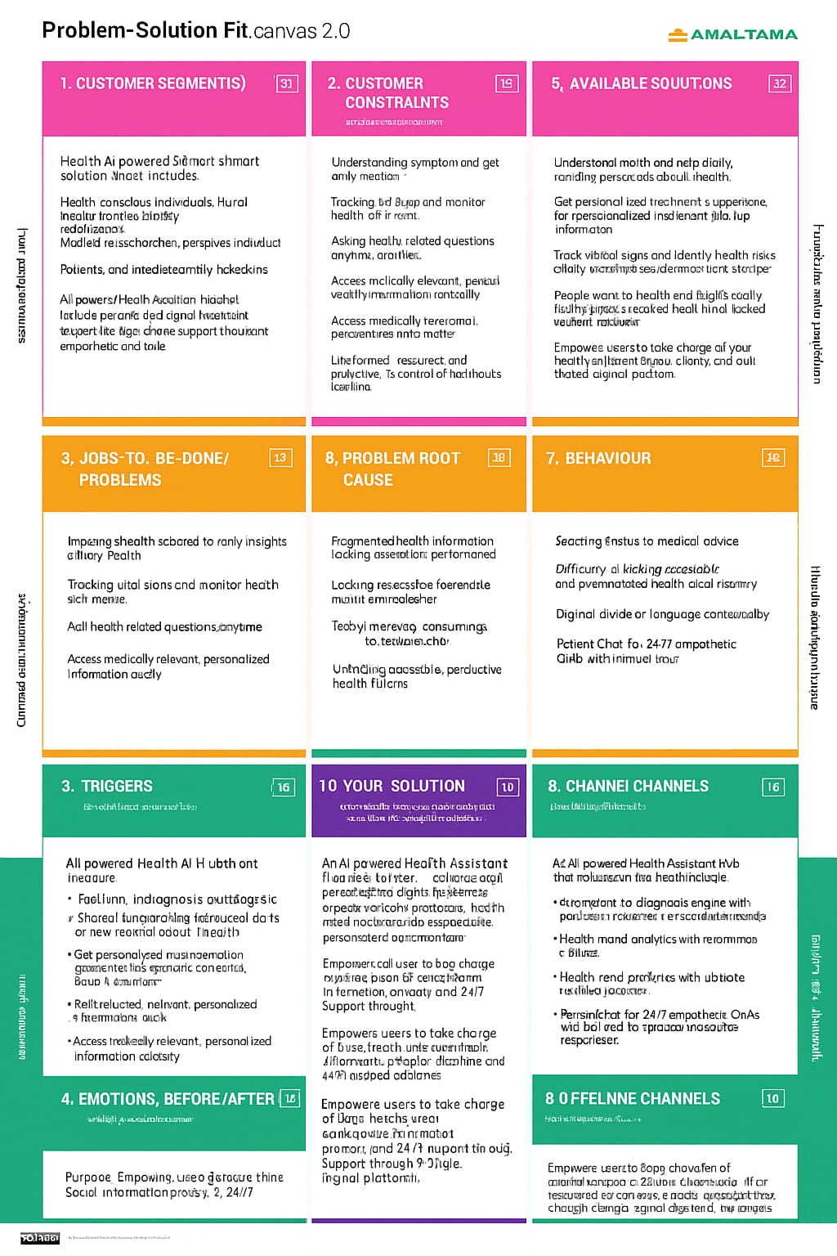

**4.2 Proposed Solution**

|  |  |
| --- | --- |
| Date | 27 June 2025 |
| Team ID | LTVIP2025TMID29337 |
| Project Name | **Health AI: Intelligent Healthcare Assistant Using IBM Granite** |
| Maximum Marks | 2 Marks |

**Proposed Solution:**

|  |  |  |
| --- | --- | --- |
| **S. No.** | **Parameter** | **Description** |
| 1. | Problem Statement (Problem to be solved) | Citizens often face difficulty in accessing timely, accurate, and personalized health advice. Challenges include self-diagnosing without medical input, lack of awareness about early symptoms, difficulty understanding treatment options, and limited engagement in long-term health monitoring. |
|  | Idea / Solution description | |  | | --- | | **1. Disease Predictor** – Users enter symptoms; the system analyses them using AI models and personal data to predict potential illnesses and recommend appropriate next steps.  **2. Personalized Treatment Planner** – Provides evidence-based, customized treatment options for diagnosed conditions, including medications, lifestyle tips, and test schedules.  **3. Health Analytics Dashboard** – Visualizes health data over time, highlights health trends and offers AI insights and preventive care suggestions.  **4. Patient Chat Assistant** – An interactive chatbot that answers health questions in clear, empathetic terms while guiding users to reliable sources and timely professional advice. | |
|  | Novelty / Uniqueness | Combines multiple AI health tools into a single, personalized platform. The use of symptom-based disease prediction, real-time treatment planning, and analytics visualization is unique when delivered together with a conversational, empathetic AI chat assistant. Integration of user profiles and medical data allows personalized health support rarely found in typical health apps. |
|  | Social Impact / Customer Satisfaction | The platform democratizes access to reliable health information and services, improving health literacy and empowering users to make informed decisions. It reduces misinformation, promotes early intervention, and supports chronic disease management. Enhanced patient satisfaction stems from accessible, user-friendly tools that are available 24/7. |
|  | Business Model (Revenue Model) | - **Subscription Plans**: Tiered access for individuals, families, or organizations. - **B2B Licensing**: Clinics, insurers, wellness platforms, and employers can license modules. - **Freemium Model**: Basic tools free; advanced insights and personal coaching behind a paywall. - **Data Services**: Aggregated (anonymized) data analytics for public health partners. |
|  | Scalability of the Solution | |  | | --- | |  |  |  | | --- | | Built on modular AI architecture and cloud-based deployment, the solution is scalable across cities, countries, and languages. It supports future expansion into areas like telemedicine integration, wearable device syncing, and multilingual support. Can serve individuals, clinics, and public health campaigns alike. | |

**4.3 Solution Architecture**

|  |  |
| --- | --- |
| Date | 27 June 2025 |
| Team ID | LTVIP2025TMID29337 |
| Project Name | **Health AI: Intelligent Healthcare Assistant Using IBM Granite** |
| Maximum Marks | 4 Marks |

Solution architecture is a structured discipline that connects business needs with technological execution. In the context of Health AI, it plays a crucial role in designing a comprehensive and intelligent healthcare system that delivers personalized medical services to users.

The health AI system is built upon a multi-layered architecture:

* **User Interface Layer:** Developed using Stream lit, this layer serves as the interaction point for users accessing Patient Chat, Disease Prediction, Treatment Plans, and Health Analytics modules.
* **Application Layer:** Handles core logic, module orchestration, and feature-specific functionalities written in Python.
* **Data Layer:** Stores structured patient information, health metrics, and dynamic session data.
* **AI Service Layer:** Powered by IBM Watson ML (Granite 13B Instruct v2), this layer provides intelligent processing, natural language understanding, and medical inference capabilities.

**Example - Solution Architecture Diagram:**

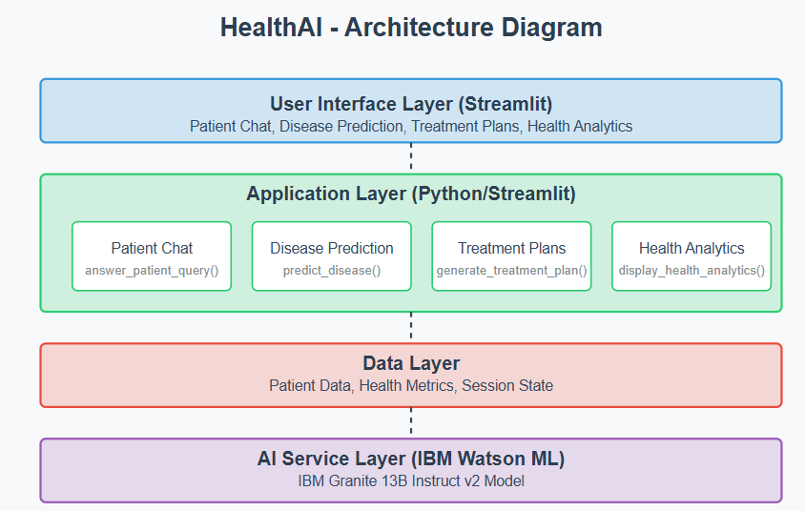

* 1. **Project Planning & Scheduling**

**5.1 Project Planning**

|  |  |
| --- | --- |
| Date | 27 June 2025 |
| Team ID | LTVIP2025TMID29337 |
| Project Name | **Health AI: Intelligent Healthcare Assistant using IBM Granite** |
| Maximum Marks | 5 Marks |

**Product Backlog, Sprint Schedule, and Estimation (4 Marks)**

|  |  |  |  |  |  |  |
| --- | --- | --- | --- | --- | --- | --- |
| **Sprint** | **Functional**  **Requirement (Epic)** | **User Story**  **Number** | **User Story / Task** | **Story Points** | **Priority** | **Team**  **Members** |
| Sprint-1 | Environment Setup | USN-1 | Set up Streamlit project structure with virtual environment and dependencies | 2 | High | Adabala PujithaSri Naga GangaBhavani |
| Sprint-1 | Disease Prediction | USN-2 | Integrate disease prediction ML model with symptom input UI and display predictions | 4 | High | Datla Vijaya Durga Devi |
| Sprint-1 | Treatment Plan Generator | USN-3 | Integrate treatment plan generation model and display personalized recommendations | 4 | High | Datla Vijaya Durga Devi |
| Sprint-1 | Health Analytics Dashboard | USN-4 | Develop dashboard to display patient vitals trends with Altair visualizations | 4 | High | Adabala PujithaSri Naga GangaBhavani |
| Sprint-2 | |  | | --- | |  |  |  | | --- | | Patient Chat | | USN-5 | Integrate Chat NLP model for health query assistance | 3 | Medium | Animireddy Sai Gowtham |
| Sprint-2 | Authentication | USN-7 | Implement user login and authentication with Firebase | 3 | Medium | Dwarampudi Navya Bindhu |
| Sprint-2 | Deployment & Testing | USN-8 | Deploy application and conduct unit & integration testing | 3 | Medium | Animireddy Sai Gowtham |

**Velocity & Timeline**

**Project Tracker, Velocity & Burndown Chart: (4 Marks)**

|  |  |  |  |  |  |
| --- | --- | --- | --- | --- | --- |
| **Sprint** | **Total Story Points** | **Duration** | **Sprint Start Date** | **Sprint End Date (Planned)** | **Story Points**  **Completed (as on**  **Planned End Date)** |
| Sprint-1 | 14 | 4 Days | 01 Feb 2025 | 05 Feb 2025 | 14 |
| Sprint-2 | 12 | 4 Days | 06 Feb 2025 | 10 Feb 2025 | 12 |

**Total Story Points:** 26

**Sprint Duration:** 1 week each

**Velocity:** 5-6 story points/week

**Estimated Completion:** 4 weeks (including Testing & Deployment)

**Burndown Chart:**

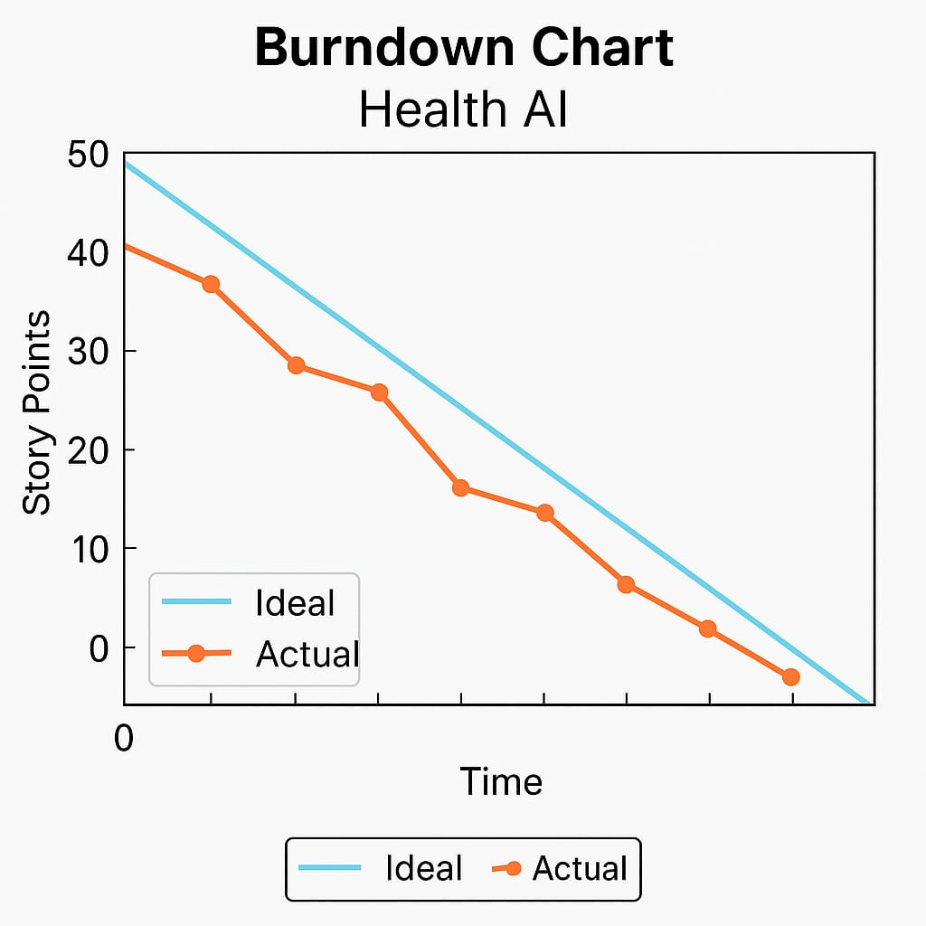

**6. Functional & Performance Testing**

**6.1 Performance Testing**

|  |  |
| --- | --- |
| Date | 27 June 2025 |
| Team ID | LTVIP2025TMID29337 |
| Project Name | **Health AI: Intelligent Healthcare Assistant Using IBM Granite** |
| Maximum Marks |  |

**Test Scenarios & Results**

|  |  |  |  |  |  |
| --- | --- | --- | --- | --- | --- |
| **Test Case ID** | **Scenario (What to test)** | **Test Steps (How to test)** | **Expected Result** | **Actual Result** | **Pass/Fail** |
| **FT-01** | Text Input Validation (e.g., topic, job title) | Enter valid and invalid text in input fields | Valid inputs accepted, errors for invalid inputs | Valid and invalid text handled correctly | Pass |
| **FT-02** | Number Input Validation (e.g., word count, size, rooms) | Enter numbers within and outside the valid range | Accepts valid values, shows error for out-of-range | All number inputs validated properly | Pass |
| **FT-03** | Content Generation (e.g., blog, resume, design idea) | Provide complete inputs and click "Generate" | Correct content is generated based on input | Content generated for patient chat, disease prediction, treatment plan | Pass |
| **FT-04** | API Connection Check | Check if API key is correct and model responds | API responds successfully | API connected and functioning for all features | Pass |
| **PT-01** | Response Time Test | Use a timer to check content generation time | Should be under 3 seconds | All functionalities responded under 5 seconds | Pass |
| **PT-02** | API Speed Test | Send multiple API calls at the same time | API should not slow down | API speed maintained under load | Pass |
| **PT-03** | File Upload Load Test (e.g., PDFs) | Upload multiple PDFs and check processing | Should work smoothly without crashing | Multiple file uploads tested successfully | Pass |

**7. Results**

**7.1 Output Screenshots**

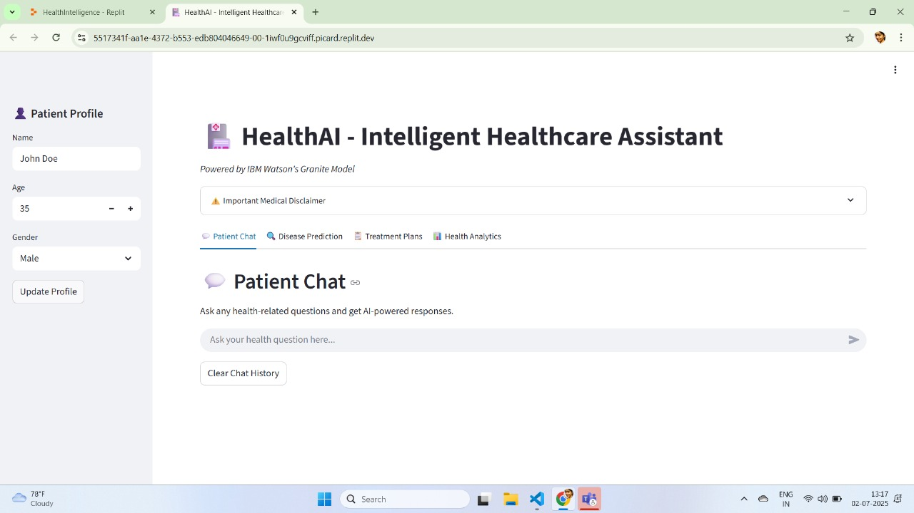

Patient Chat

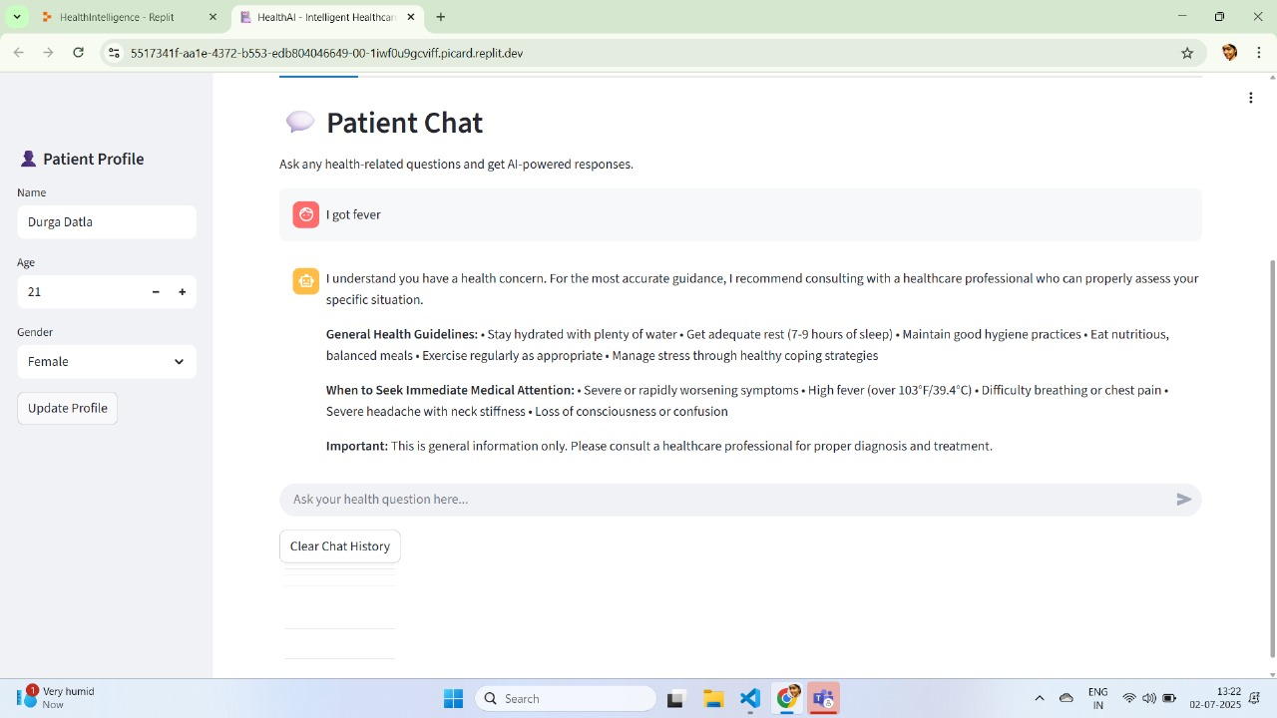

Disease Prediction

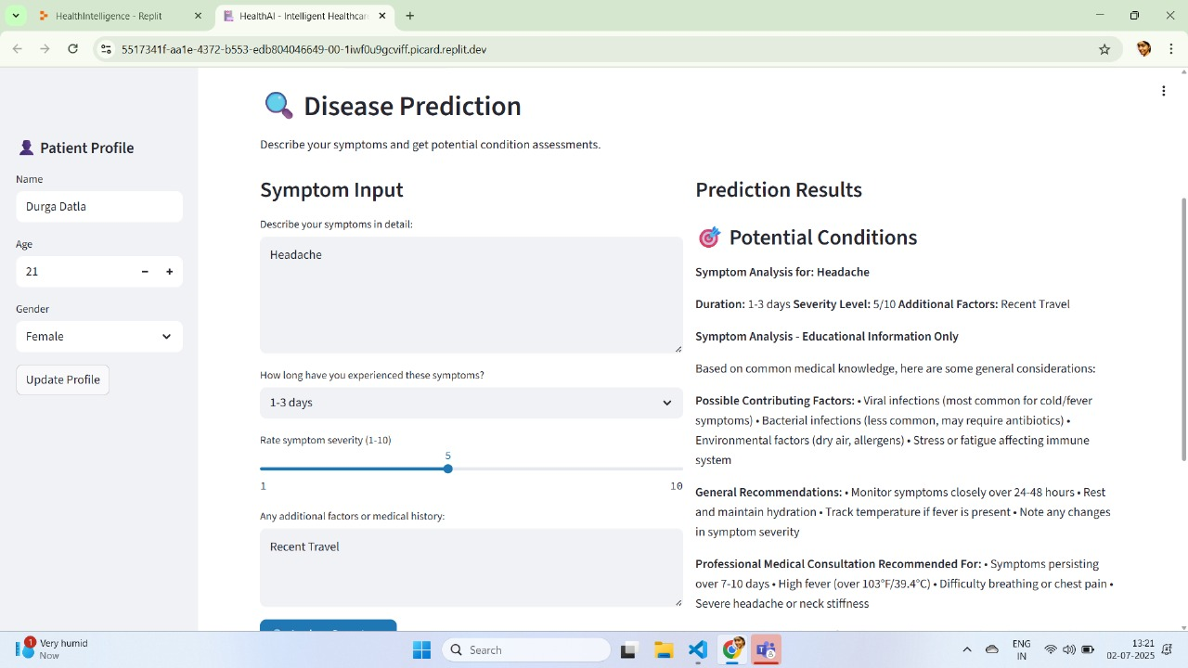

Treatment Plan Generator

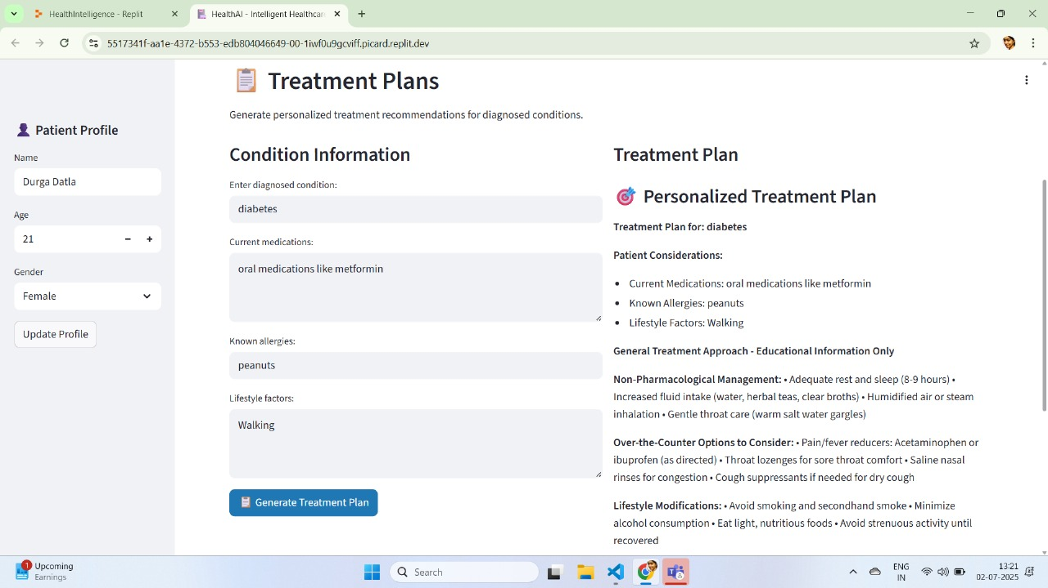

Health Analytics Dashboard

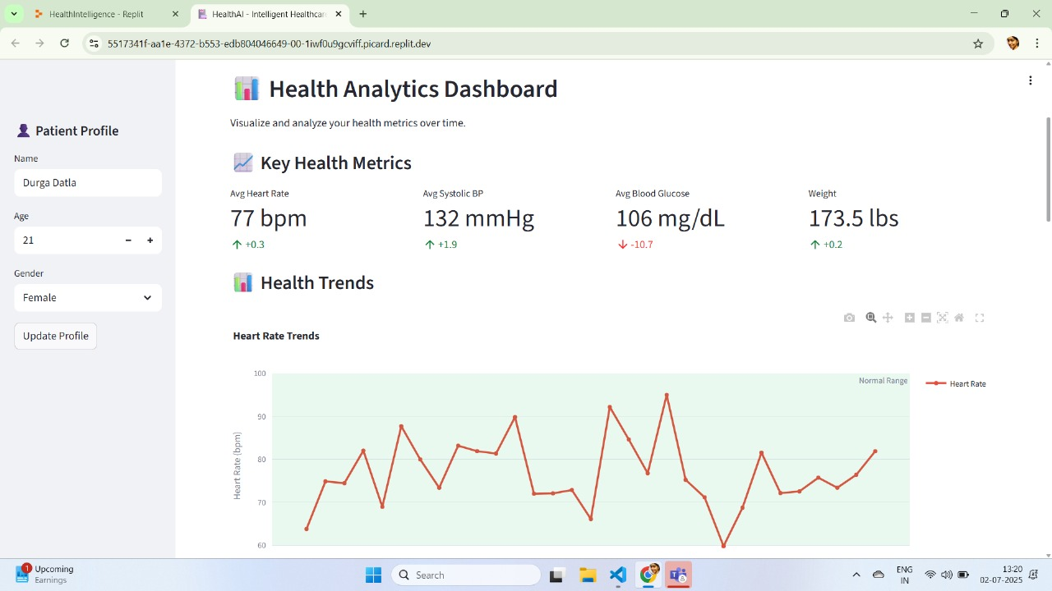

**8. Advantages & Disadvantages**

**Advantages**

**1. AI-Driven Healthcare Support**

* Provides instant, 24/7 medical guidance.
* Useful for symptom checking, treatment planning, and answering common medical questions.

**2. Accessible and User-Friendly**

* Easy-to-use interface via Gradio or Streamlit.
* No need for medical expertise to interact with the system.

**3. Modular Design**

* Scenarios (Chat, Prediction, Plan, Analytics) are separated — easy to upgrade or add more.

**4. Customizable and Expandable**

* Easily swap models, update prompts, or connect to EHR systems.

**Disadvantages**

**1. Not Medically Certified**

* Outputs are generated by language models, not actual doctors.
* Should not be used for diagnosis or emergency medical care.

**2. Data Privacy Risks**

* If deployed online, must handle user health data securely (GDPR, HIPAA, etc.).
* No encryption or user authentication in basic prototypes.

**3. Model Limitations**

* Language models may hallucinate facts or give outdated advice.
* Without access to real medical databases or up-to-date guidelines.

**4. Heavy Models Require GPU**

* 7B+ models require decent compute (Colab with GPU or better).
* Can't run well on mobile or low-resource environments.

**9. Conclusion**

The **Health AI** project successfully demonstrates the practical application of generative AI in the field of healthcare assistance. By leveraging advanced language models such as **Mistral 7B Instruct** (or) **IBM Granite**, and integrating them with an intuitive **Gradio-based interface**, the system simulates intelligent, real-time interactions across four key medical use cases: **symptom-based disease prediction, personalized treatment planning, health analytics, and patient chat assistance**.

The modular and scalable design of Health AI allows it to be easily extended or adapted to more specific domains such as mental health, chronic disease monitoring, or multilingual healthcare support. The system provides an accessible way for users to gain basic medical insights and recommendations, while clearly acknowledging its limitations and the importance of consulting certified healthcare professionals for final diagnosis or treatment.

**10. Future Scope**

The Health AI system lays a strong foundation for AI-assisted digital healthcare. Looking forward, several enhancements and expansions can significantly improve its utility, reliability, and real-world adoption:

**1. Integration with Electronic Health Records (EHR)**

* Connect Health AI to patient history, lab reports, and vitals from EHR systems.
* Enable personalized and context-aware recommendations.

**2. Multilingual & Voice Support**

* Add translation layers or multilingual models to support regional languages.
* Integrate speech-to-text and text-to-speech for voice-enabled consultations.

**3. Real-Time Monitoring with IoT Devices**

* Link wearable or smart health devices (like smartwatches, glucose monitors).
* Use live data for dynamic predictions and alerts.

**4. Offline & Mobile Deployment**

* Optimize the app for low-resource environments using lightweight models (e.g., Tiny LLaMA).
* Deploy as a mobile health (mHealth) app with offline fallback.