**My portfolio:**

## About Me

**Hi everyone, I am Aditi Bagaddeo. I am currently pursuing my B.Tech degree in Computer science engineering. Domains I mainly work upon are web development, so my skills includes HTML, Bootstrap, CSS, Javascript. Apart from these, I work on datasets using python, Seaborn and pandas. Apart from my professional life, I work on music.**

**My projects:**

**Project 1: Calculator Webapp:**

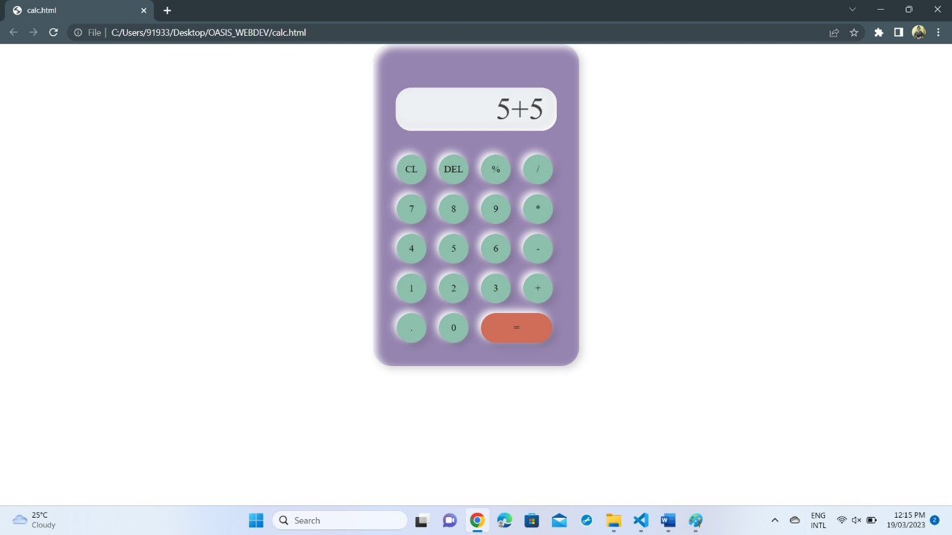

**Project 1 is about creating a calculator using HTML, CSS and ofcourse Javascript. Here the calculator is designed to make calculations easy and accesible for all and the languages, I used in making this webapp were pretty much simple and understandable. Hope this Calculator would help others.**

**Link:** **file:///C:/Users/91933/Desktop/OASIS_WEBDEV/calc.html**

**Project 2:**

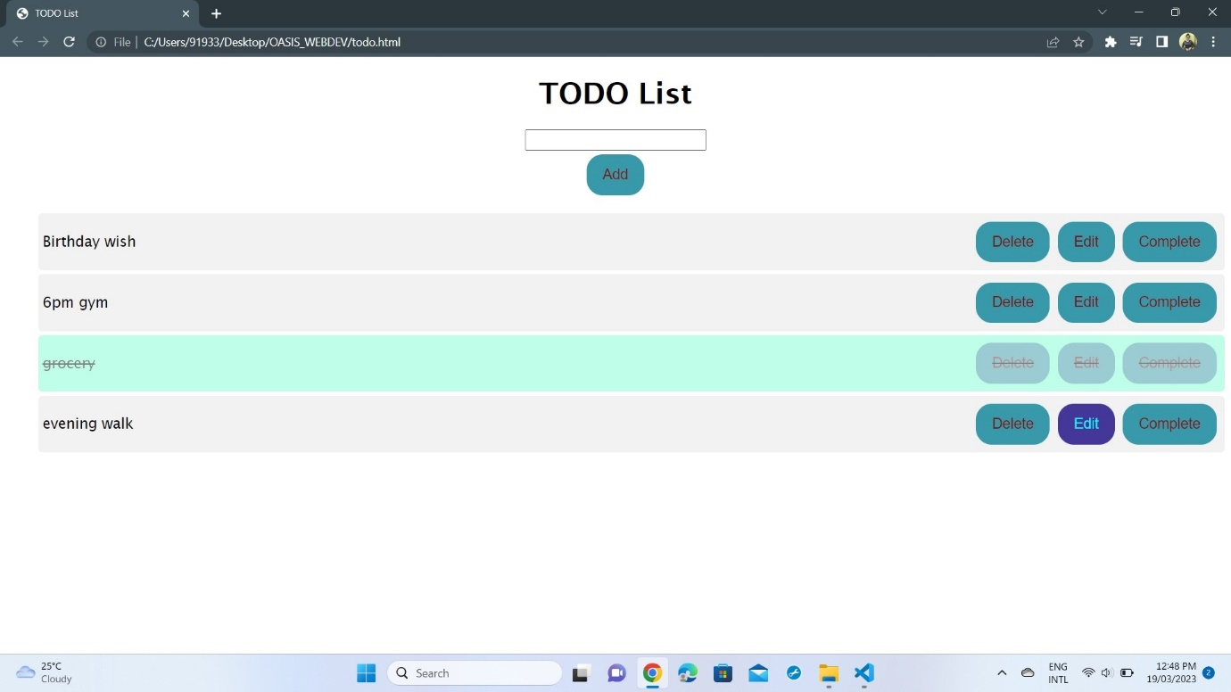

**The Project 2 is an TO_DO list webapp. This webapp is being desingned to organise and schedule your works in a convenient way. Here you add works to the list , if needed they can be edited to and once completed the user might delete the work to. So this webapp is easy to use and organises your TO-DO list the way you want.**

**Link:** **file:///C:/Users/91933/Desktop/OASIS_WEBDEV/todo.html**

**Contact me:**

**Linkedin Id:** [**https://www.linkedin.com/in/aditi-bagaddeo-a0bab2219/**](https://www.linkedin.com/in/aditi-bagaddeo-a0bab2219/)

**Gmail: aditibagaddeo@gmail.com**