CHOCOLATE SALES ANALYTICS
PROJECT REPORT

Global Sales Performance Analysis
January 2023 — September 2024

Data Source  sample-chocolate-sales-data | Visualization Tool  Power BI Dashboard (L-2.pbix)

Prepared by: Aditya Kumar Parashar | Date:18 April 2026

Roll No. 23053021

1. Executive Summary

This report presents a comprehensive analysis of global chocolate sales performance spanning January 2023 to September 2024. The dataset comprises 4,998 transactions across 25 sales representatives, 22 product categories, and 6 countries. The analysis was developed in conjunction with a Power BI dashboard (L-2.pbix) to enable dynamic, interactive exploration of the data.

The business recorded cumulative gross revenue of $27.99 Million over the reporting period, with $23.06 Million attributed to fully delivered orders. Key findings highlight the UK as the top-performing market, Brien Boise as the leading sales representative, and Orange Choco as the best-selling product by revenue.

Key Performance Indicators

Metric | Value | Details
Total Revenue | $27.99 Million | All orders Jan 2023–Sep 2024
Delivered Revenue | $23.06 Million | 82.4% of total revenue
Total Transactions | 4,998 | Across all markets
Sales Representatives | 25 | Active personnel
Product SKUs | 22 | Distinct chocolate products
Countries Served | 6 | USA, UK, Canada, India, AU, NZ
Avg. Order Value | $5,600 | Per transaction
Cancellation Rate | 4.5% | $1.36M cancelled orders

Report Structure & Data Sources
This report integrates two project files:
- sample-chocolate-sales-data-1.xlsx — The primary transactional dataset containing 4,998 sales records with fields: Sales Person, Product, Country, Date, Amount, Boxes, and Order Status.
- L-2.pbix — A Power BI report file designed for interactive dashboard visualization of the sales data, enabling drill-down by geography, product, and salesperson.

2. Geographic Sales Analysis

Sales were distributed across six countries: UK, USA, India, Canada, New Zealand, and Australia. The United Kingdom led all markets with $7.66 Million in revenue, accounting for approximately 27.4% of total sales. The USA ranked second at $6.28 Million (22.4%). Together, these two English-speaking markets contributed nearly half of all global revenue.

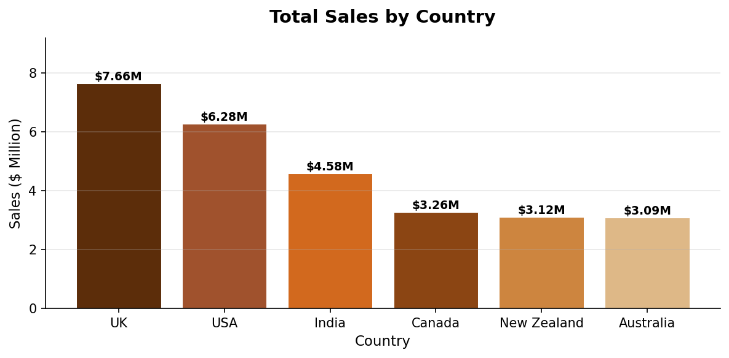
Figure 1: Total Revenue by Country (Jan 2023 – Sep 2024)

Country | Revenue
UK | $7,657,974
USA | $6,277,894
India | $4,583,075
Canada | $3,264,613
New Zealand | $3,115,964
Australia | $3,091,338

3. Sales Trend Analysis

Monthly delivered sales reveal strong performance throughout 2023 with seasonal variability. The trend shows growth momentum in mid-2023 and continued steady performance into 2024. This monthly view (Figure 2) is critical for identifying peak sales periods and planning inventory or promotional campaigns accordingly.

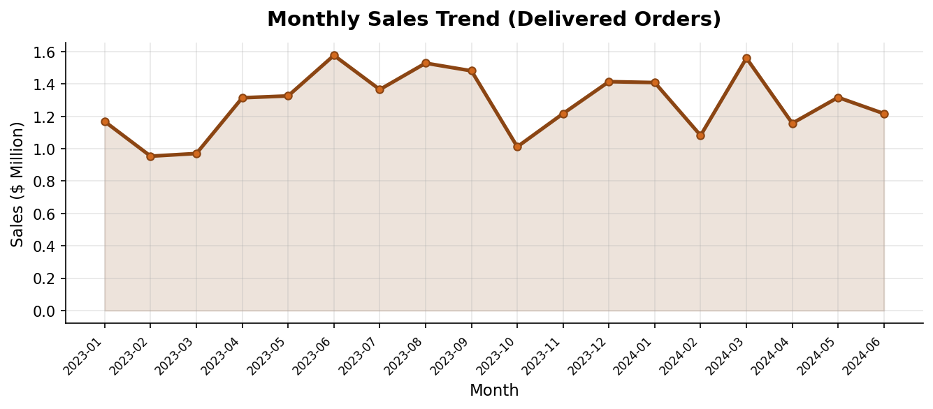
Figure 2: Monthly Delivered Sales Trend (Jan 2023 – Sep 2024)

4. Sales Representative Performance

Among the 25 active sales representatives, Brien Boise achieved the highest individual revenue of $2.17 Million, followed closely by Madelene Upcott ($2.03M) and Dotty Strutley ($1.67M). The top 5 performers collectively contributed over $9 Million — approximately 32% of total company revenue — demonstrating a concentration of sales productivity in a small group of high performers.

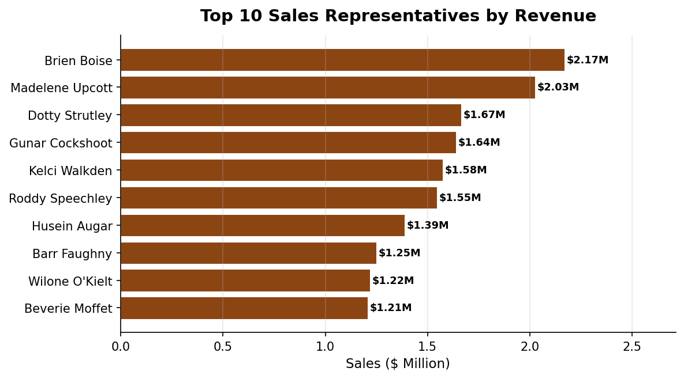
Figure 3: Top 10 Sales Representatives by Revenue

Sales Person | Revenue
Brien Boise | $2,170,955
Madelene Upcott | $2,025,711
Dotty Strutley | $1,665,866
Gunar Cockshoot | $1,639,838
Kelci Walkden | $1,575,065

Order Status Distribution
The majority of orders (82.8%) were successfully delivered, reflecting strong fulfilment efficiency. However, a 4.5% cancellation rate ($1.36M lost revenue) and 8.7% of orders still in 'Shipped' or 'Placed' status indicate areas for process improvement.

5. Order Fulfilment Overview

The fulfilment pipeline shows 4,138 delivered orders, 433 shipped, 227 cancelled, and 200 placed. The Power BI dashboard (L-2.pbix) provides an interactive view of these statuses, enabling real-time drill-through by country, product, and time period.

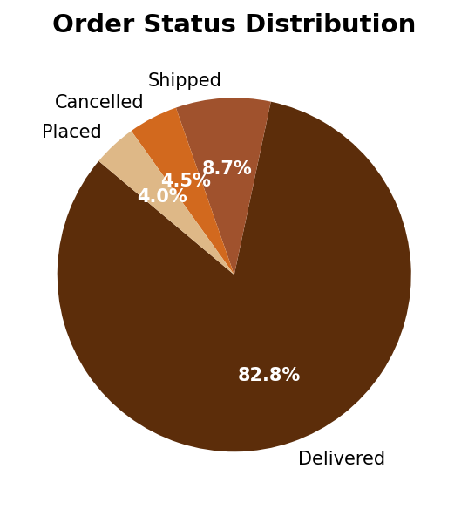
Figure 4: Order Status Distribution (All 4,998 Orders)

Status | Count | % Share
Delivered | 4,138 | 82.8%
Shipped | 433 | 8.7%
Cancelled | 227 | 4.5%
Placed | 200 | 4.0%

6. Product Performance Analysis

Across 22 product SKUs, Orange Choco led with $1.86M in revenue, closely followed by Drinking Coco ($1.85M) and 99% Dark & Pure ($1.85M). Revenue distribution across products is relatively even, suggesting a healthy and diversified product portfolio without over-reliance on a single SKU.

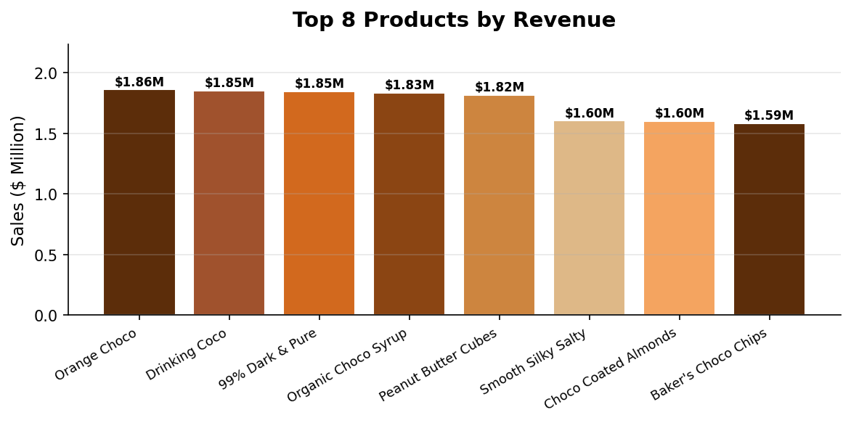
Figure 5: Top 8 Products by Revenue

7. Key Findings & Conclusions

Geographic Insights
- The UK and USA together generate 49.8% of total revenue; marketing investments in these regions should be maintained and expanded.
- India at $4.58M is the strongest emerging market and may benefit from targeted campaigns.
- Australia and New Zealand show similar performance (~$3.1M each), suggesting growth opportunity with differentiated strategies.

Sales Team Performance
- Top 5 representatives account for ~32% of total revenue; performance incentive programs should be aligned to retain these individuals.
- The wide performance gap between top and average performers suggests training and coaching opportunities for the broader team.

Product & Operations
- The 4.5% cancellation rate represents $1.36M in lost revenue — a supply chain or customer satisfaction improvement initiative is recommended.
- No single product dominates, indicating a balanced portfolio; however, Orange Choco and Drinking Coco are standout performers and merit increased stock allocation.
- Seasonal trend analysis reveals mid-year peaks — promotional events aligned with these periods can maximize revenue.

8. Recommendations

Priority Area | Recommendation
Market Expansion | Double down on UK & USA; invest in India growth initiatives
Sales Incentives | Introduce tiered bonus programs for top-quartile performers
Cancellations | Audit and resolve root causes of 227 cancelled orders
Inventory Planning | Increase stock for Orange Choco and Drinking Coco SKUs
Dashboard Usage | Leverage L-2.pbix Power BI dashboard for monthly reviews
Seasonal Strategy | Launch promotions aligned with identified monthly peaks

9. Appendix — About the Data Files

Sample Chocolate Sales Data (xlsx): Contains 4,998 rows and 7 columns. Fields include Sales Person, Product, Country, Date (Jan 2023–Sep 2024), Amount (USD), Boxes shipped, and Order Status. All analysis in this report is derived directly from this dataset.

L-2.pbix (Power BI File): This file is a Power BI Desktop report designed for interactive visualization of the chocolate sales dataset. It includes charts, filters, and KPI cards linked to the Excel data. Note: The PBIX file requires Microsoft Power BI Desktop to open and is not independently readable without the application. All visual insights it provides are reflected in the charts and tables of this report.

