LOAN APPROVAL PREDICTION SYSTEM
Machine Learning Project Report
Submitted by: Aditya Kadam
Domain: Data Analytics / Machine Learning

1. Abstract
The Loan Approval Prediction System is an end-to-end machine learning project designed to estimate whether a loan application is likely to be approved or rejected. The project combines data preparation, exploratory data analysis, categorical encoding, feature scaling, classification model comparison, model evaluation, feature-importance analysis, and an interactive Streamlit prediction interface. The objective is to demonstrate how applicant and financial data can be converted into actionable decision-support information.

2. Problem Statement
Loan processing requires evaluation of an applicant's financial profile, credit history, requested amount and repayment characteristics. A data-driven classification system can support this process by estimating the probability of approval from historical application patterns. The system developed in this project is intended as a decision-support prototype and not as an autonomous lending decision-maker.

3. Objectives
- Prepare and validate a structured loan application dataset.
- Perform exploratory analysis to understand approval patterns.
- Build and compare multiple classification algorithms.
- Evaluate models using accuracy, precision, recall, F1-score and ROC-AUC.
- Identify the variables that contribute most to model performance.
- Provide an interactive interface for testing individual loan applications.
- Translate analytical findings into practical business actions.

4. Dataset
The project uses an independently generated synthetic dataset containing 4,269 loan application records and 13 columns. The schema follows the structure of a publicly documented Loan Approval Prediction dataset, with fields for dependents, education, employment status, income, loan amount, loan term, CIBIL score and asset values. The synthetic dataset is included with the submission package so the project can be reproduced without relying on a third-party download.
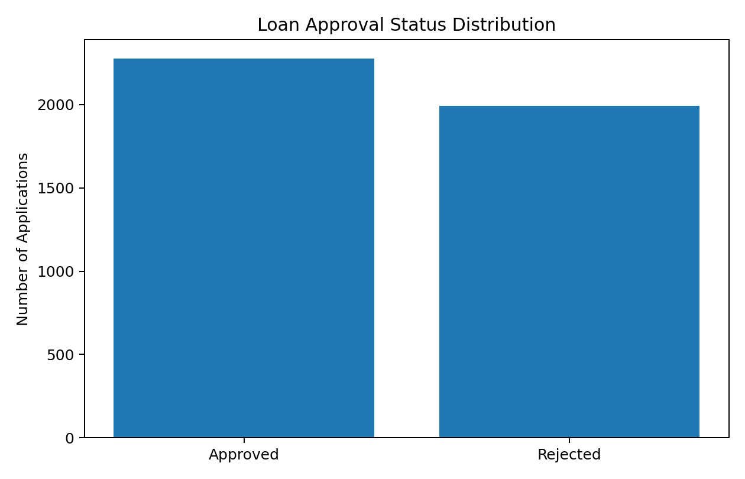

5. Data Preparation
The identifier column loan_id is excluded from model training. Categorical attributes are handled using one-hot encoding. Numerical variables are median-imputed and standardized for the Logistic Regression pipeline. Tree-based models receive the same consistent preprocessing pipeline, ensuring that the application uses the same transformations during prediction.

6. Exploratory Data Analysis
The analysis examines approval distribution, CIBIL score patterns and feature relationships. The CIBIL score is particularly informative in the model-based analysis. Asset-related variables show comparatively smaller incremental importance. The project focuses on decision-relevant information rather than maximizing the number of charts.
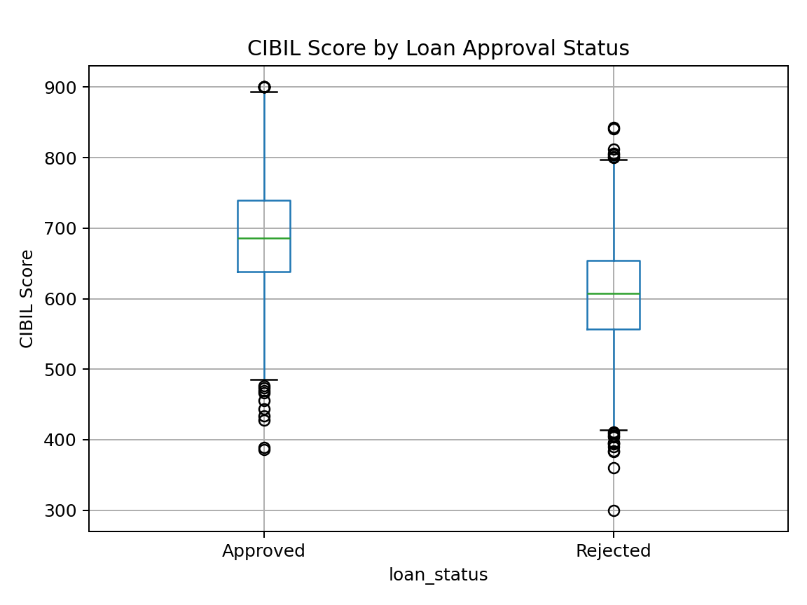

7. Model Development
Four classification algorithms were trained: Logistic Regression, Decision Tree, Random Forest and Gradient Boosting. The dataset was divided into training and test subsets using an 80:20 stratified split. A fixed random seed of 42 was used to make the experiment reproducible.

8. Model Evaluation
Model | Accuracy | Precision | Recall | F1 | ROC-AUC
Logistic Regression | 75.18% | 76.02% | 78.02% | 77.01% | 0.834
Decision Tree | 72.01% | 78.42% | 65.49% | 71.38% | 0.783
Random Forest | 75.41% | 75.68% | 79.34% | 77.47% | 0.822
Gradient Boosting | 74.82% | 75.75% | 77.58% | 76.66% | 0.823
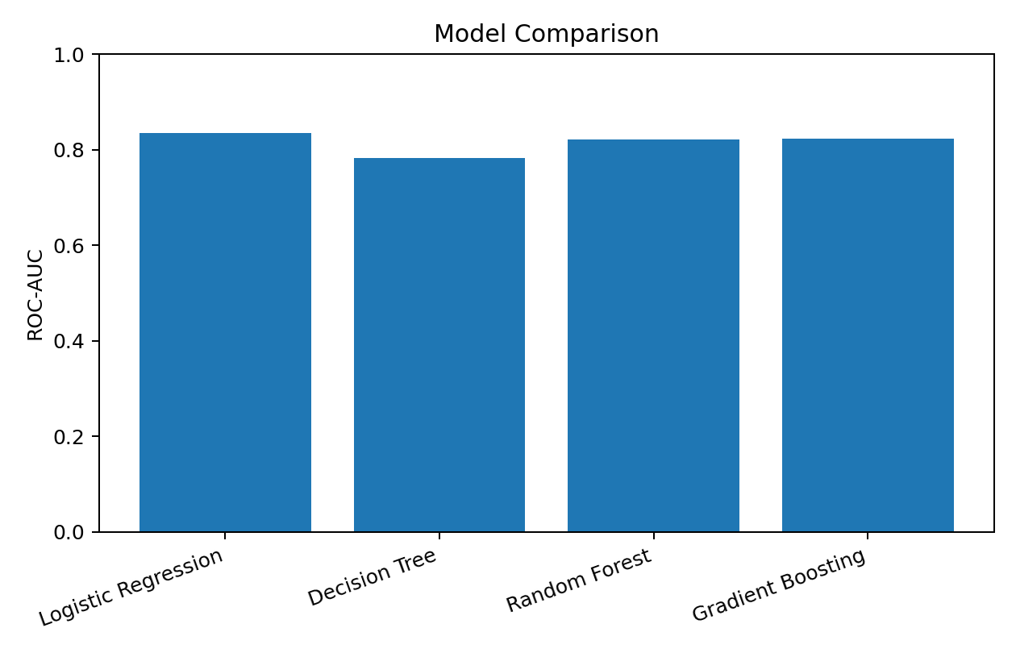
On the held-out test set, Logistic Regression produced the highest ROC-AUC of 0.834. Random Forest produced the highest accuracy at 75.41% and recall at 79.34% among the compared models. The choice of final model should therefore consider the business objective and not accuracy alone. For this submission, the application uses the model with the highest ROC-AUC.

9. Feature Importance
Permutation importance was used to measure how much the model's ROC-AUC changes when individual input variables are randomly permuted. CIBIL score was the dominant feature, followed by loan amount and annual income.
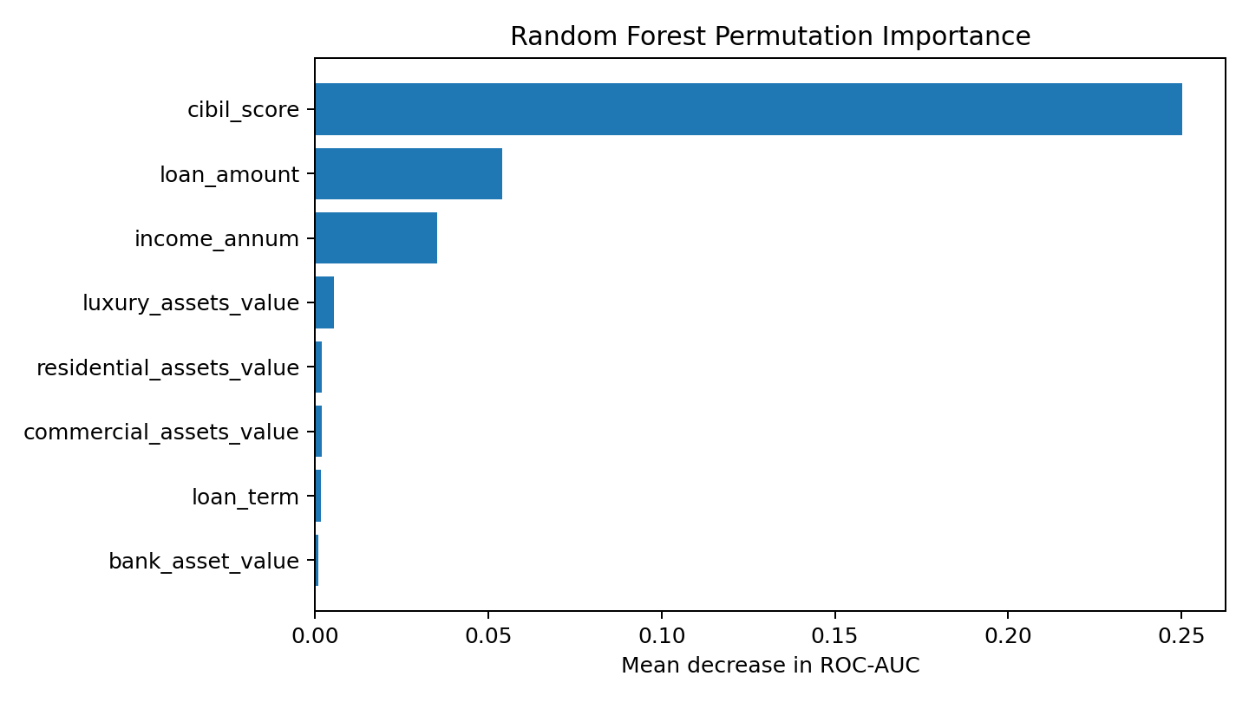

10. System Design
The application contains three functional sections. Executive Overview presents the main KPIs, approval distribution and important drivers. Model Analysis presents model comparison and a confusion matrix. Loan Prediction provides an input form where a user can enter applicant characteristics and obtain an estimated approval probability.
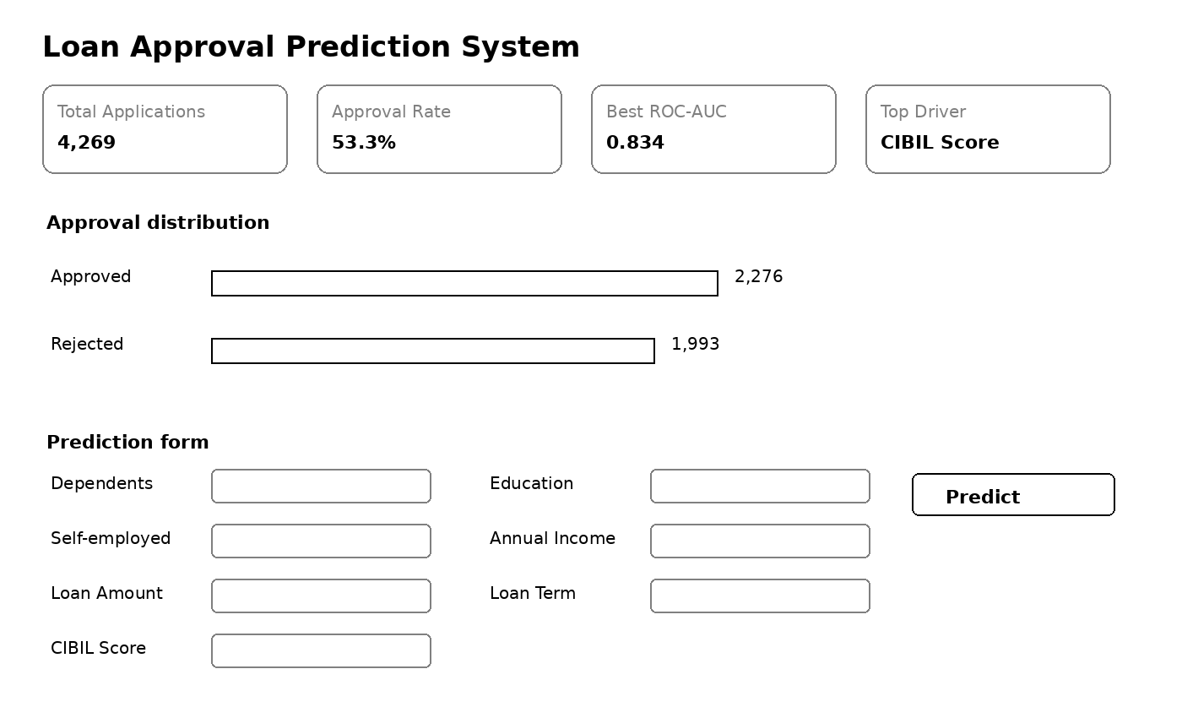

11. Business Insights
- Credit score is the strongest predictive signal in the developed model, making it a major variable for risk screening.
- Loan amount and annual income should be considered together because a large requested amount relative to income can indicate greater repayment pressure.
- Asset values add contextual information but have substantially lower permutation importance than credit score.
- Model probability should be combined with lending policy, verification and human review rather than used as an automatic approval rule.
- Model performance should be monitored after deployment because changes in applicant populations can reduce predictive reliability.

12. Risks and Limitations
The dataset is synthetic and is intended for academic demonstration. Results should not be interpreted as evidence about real-world lending outcomes. The model can also inherit limitations from the variables and assumptions used to generate the data. A real lending system would require larger validated historical datasets, fairness testing, calibration, monitoring, regulatory review, privacy controls and human oversight.

13. Future Scope
- Add probability calibration and threshold optimization.
- Add explainability using SHAP or comparable techniques.
- Introduce drift monitoring and periodic retraining.
- Deploy the model through a secure API and web application.
- Evaluate fairness and performance across relevant applicant groups.
- Integrate the system with a governed loan-processing workflow.

14. Conclusion
The project demonstrates a complete machine learning workflow for a business classification problem. It converts structured applicant data into predictive outputs, compares multiple models, identifies important drivers and presents the result through an interactive interface. The project follows the business-intelligence principle of moving from facts and insights toward actionable decision support.

15. References
1. Kaggle, Loan Approval Prediction Dataset, public dataset documentation: https://www.kaggle.com/datasets/architsharma01/loan-approval-prediction-dataset
2. Scikit-learn documentation, machine learning algorithms and evaluation metrics: https://scikit-learn.org/
3. Streamlit documentation, application framework: https://docs.streamlit.io/

