**RESULT:-**

We are considering two cases in which the same child is used to display both cases as given below :-

**CASE 1 :- Expression of anger given by normal child**

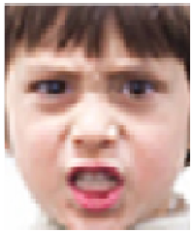

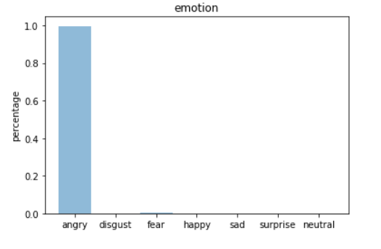

By checking the graph , we conclude that the program is able to recognise angry emotion correctly , reacted by normal child and other emotions are in the range of 0.0 - 0.1.

**CASE 2 :- Expression of anger given by child having autism disorder**

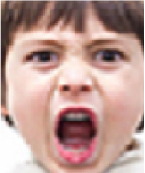

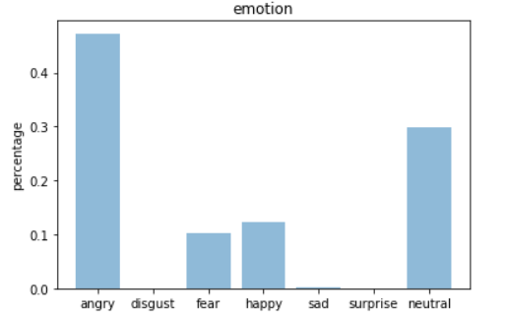

By checking the graph we conclude that the program is not able to appropriately distinguish

emotion i.e. there are more than one emotions namely angry, fear , happy , sad and neutral.

It has able to find out that the child is displaying angry reaction but at the same time its

displaying other emotions i.e. the program is not able to recognise the emotion given by

the child having autism disorder.