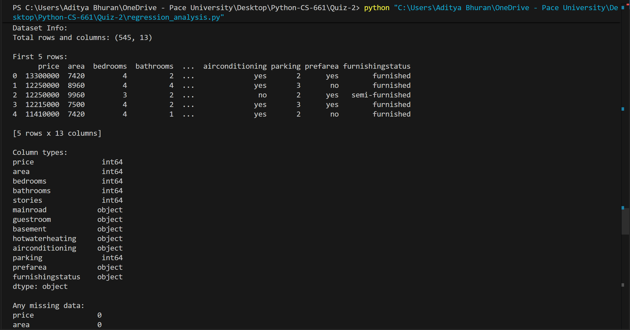

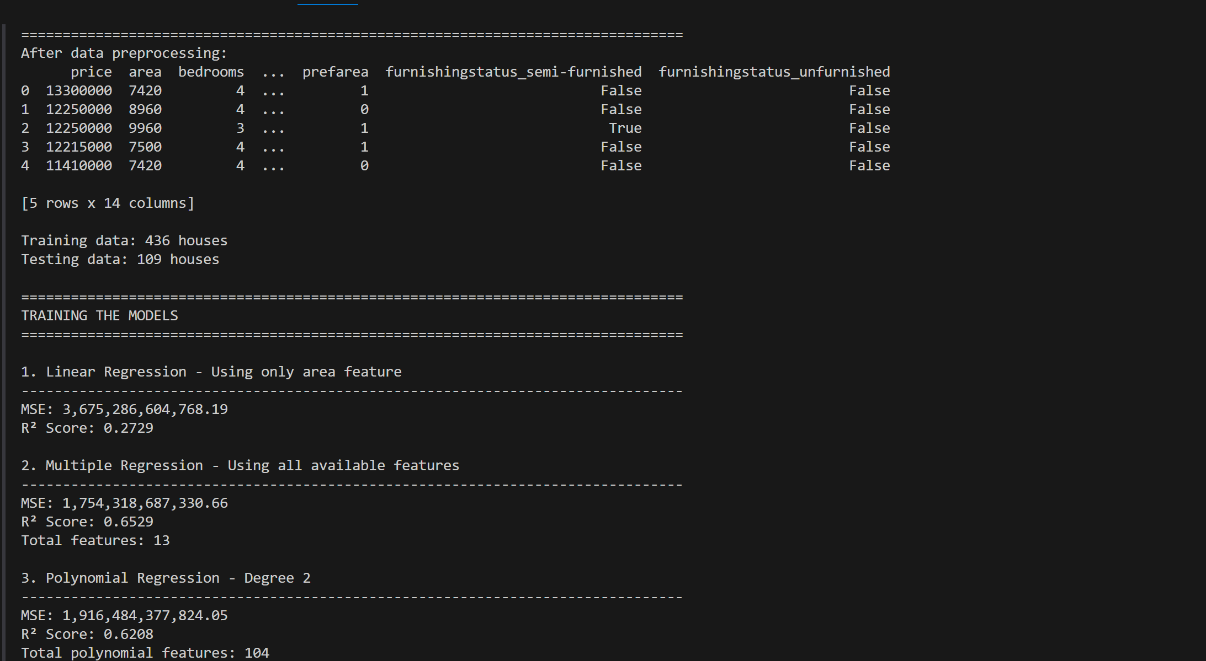
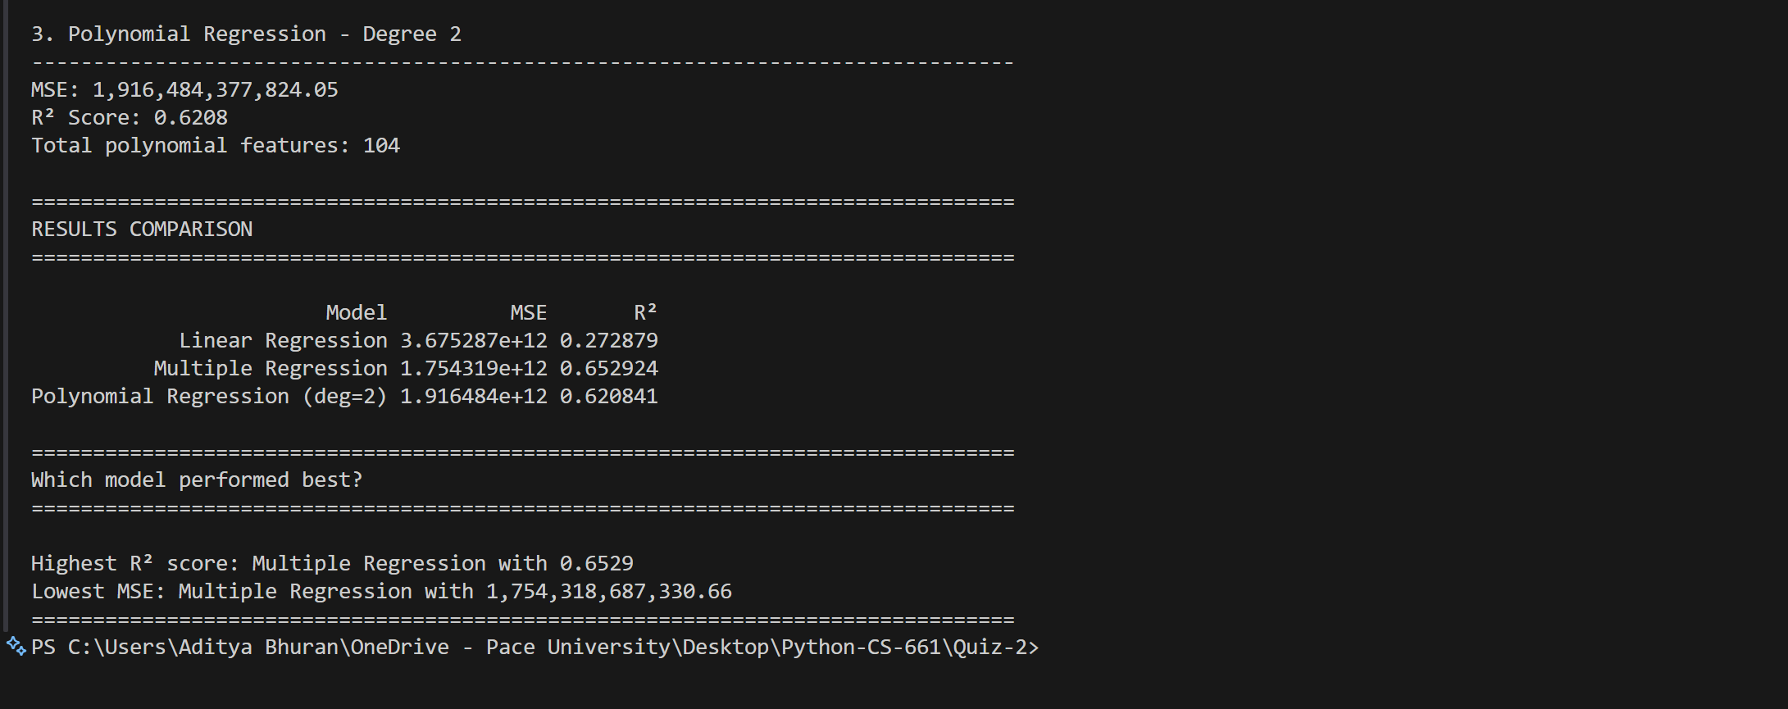
Table :
| Model | MSE | R² |
|-------------------------------- -|---------------------- |--------|
| Linear Regression | 3,675,286,604,768.19 | 0.2729 |
| Multiple Regression | 1,754,318,687,330.66 | 0.6529 |
| Polynomial Regression (deg=2) | 1,916,484,377,824.05 | 0.6208 |

Summary :
I trained three regression models on the Housing dataset to predict house prices and compared their performance using MSE and R² metrics. The results are: Linear Regression (MSE: 3,675,286,604,768.19, R²: 0.2729), Multiple Regression (MSE: 1,754,318,687,330.66, R²: 0.6529), and Polynomial Regression degree 2 (MSE: 1,916,484,377,824.05, R²: 0.6208). Multiple Regression generalizes the best with the highest R² of 0.6529, explaining about 65% of the variance in prices. Simple Linear Regression performs poorly because it only uses area, ignoring other important factors like bathrooms, location, and furnishing. Polynomial Regression improves over simple linear but doesn't beat Multiple Regression, likely because the relationships in this dataset are mostly linear and polynomial features add unnecessary complexity. Overall, Multiple Regression is the best choice as it effectively uses all features without overfitting.

