TaskFlow
A Collaborative Team Task & Project Management Web Application
Project Planning & System Architecture Report
Submitted for: Week 1 Task — Project Planning & System Architecture
Role: Junior Full Stack Developer Intern
Internship Duration: 26-Aug-2026 to 07-Oct-2026 (6 Weeks)
Platform: Yuva Intern
[Aditya yadav]
[yosefg7579@gmail.com]
Date: [26/08/2026]

Table of Contents
(If this table appears empty, right-click it and choose “Update Field”, or press Ctrl+A then F9, to populate it from the headings below.)
Table of Contents 1
1. Project Brief 2
1.1 Purpose 3
1.2 Target Users 3
1.3 Problem Statement 3
1.4 Core Features 3
2. Objectives & Success Criteria 3
3. Requirements 4
3.1 Functional Requirements 4
3.2 Non-Functional Requirements 4
4. User Interaction Flowcharts 4
4.1 Overall User Journey 4
4.2 Task Status Lifecycle 5
5. Wireframes 6
5.1 Login / Sign Up 6
5.2 Dashboard — Project List 6
5.3 Kanban Board 7
5.4 Task Detail Panel 7
6. Technical Architecture 7
6.1 Technology Stack & Rationale 8
7. Database Schema 9
7.1 Table Reference 9
8. API Endpoint Design 10
9. Design Rationale & Key Decisions 10
9.1 Why a Kanban board instead of a flat task list 11
9.2 Why a fixed status enum instead of freeform status text 11
9.3 Why WebSockets for board updates rather than polling 11
9.4 Why role-based access at the project level, not the task level 11
9.5 Scope Deliberately Left Out of Version 1 11
10. Conclusion & Next Steps 11

1. Project Brief

1.1 Purpose
Small and mid-sized teams frequently coordinate work across scattered channels — chat messages, spreadsheets, and email threads — which makes it hard to see who is working on what, what is overdue, and what is blocked. TaskFlow is a full-stack web application that gives a team a single shared space to organise projects, break work into tasks, track progress visually on a Kanban board, and communicate directly on each task. The goal is to reduce coordination overhead so teams spend less time asking “what's the status?” and more time doing the work.

1.2 Target Users
- Project Owners / Team Leads — create projects, invite members, assign tasks, and monitor overall progress.
- Team Members / Contributors — view assigned tasks, update status, comment, and attach files.
- Guests / Viewers (stretch goal) — read-only access to a project's board for stakeholders who need visibility without edit rights.

1.3 Problem Statement
Teams without a dedicated tool tend to lose track of task ownership and deadlines, duplicate effort, and struggle to reconstruct decisions after the fact because discussion is scattered across tools. TaskFlow addresses this by tying every task to one owner, one status, one due date, and one comment thread, all visible on a shared board.

1.4 Core Features
- User authentication (sign up, log in, JWT-based sessions)
- Project creation and membership management (roles: owner, editor, viewer)
- Kanban board per project with four columns: To Do, In Progress, In Review, Done
- Task creation with title, description, assignee, priority, and due date
- Drag-and-drop status updates that persist to the database
- Threaded comments and file attachments on each task
- In-app and email notifications for assignment, comments, and due-date reminders
- Real-time board updates across all connected members using WebSockets

2. Objectives & Success Criteria
- Enable a team of up to ~25 members per project to plan, assign, and track work without leaving the app.
- Keep the time from task creation to visibility on the board under one second (excluding network latency) via real-time sync.
- Ensure only authenticated, authorised members of a project can view or modify its tasks (role-based access control).
- Provide a responsive UI that works on both desktop and tablet screen sizes.
- Keep the initial feature set small enough to be buildable within a 6-week internship timeline, while leaving clear extension points (see Section 9.3).

3. Requirements

3.1 Functional Requirements
ID | Requirement
FR-1 | Users can register with name, email, and password; passwords are hashed before storage.
FR-2 | Users can log in and receive a signed JWT used to authenticate subsequent requests.
FR-3 | Authenticated users can create a project and become its owner.
FR-4 | Project owners can invite other registered users and assign them a role (editor / viewer).
FR-5 | Members with editor rights can create, edit, and delete tasks within a project they belong to.
FR-6 | Tasks can be moved between four fixed status columns; the change is persisted and broadcast to other online members in real time.
FR-7 | Users can comment on a task and attach files (stored in object storage, referenced by URL).
FR-8 | Users receive an in-app and email notification when they are assigned a task or mentioned in a comment.
FR-9 | Viewers can see the board and task details but cannot create, edit, or move tasks.

3.2 Non-Functional Requirements
ID | Requirement
NFR-1 | Security: passwords hashed with bcrypt; all traffic served over HTTPS; JWTs short-lived with refresh tokens.
NFR-2 | Performance: API responses for board loads should return within ~300ms under normal load, aided by Redis caching.
NFR-3 | Scalability: stateless API servers behind a load balancer so instances can be scaled horizontally.
NFR-4 | Availability: target 99.5% uptime for the hosted environment.
NFR-5 | Usability: core actions (create task, change status, comment) reachable within two clicks from the board.
NFR-6 | Maintainability: RESTful API with clear resource-based routes and a documented database schema (Sections 6–7).

4. User Interaction Flowcharts
The diagrams below trace how a user moves through the application, and how a task moves through its lifecycle once created.

4.1 Overall User Journey
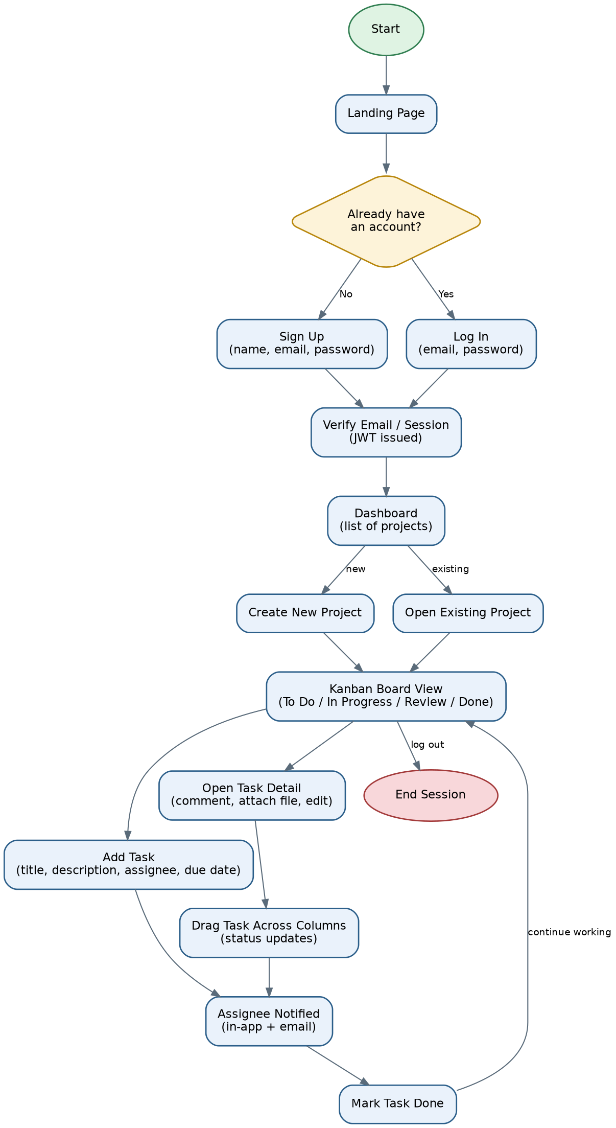
Figure 1. End-to-end user journey from landing page to task completion.

4.2 Task Status Lifecycle
Each task moves through a small state machine rather than a free-form status field, which keeps the board consistent and makes it possible to compute metrics such as cycle time later.
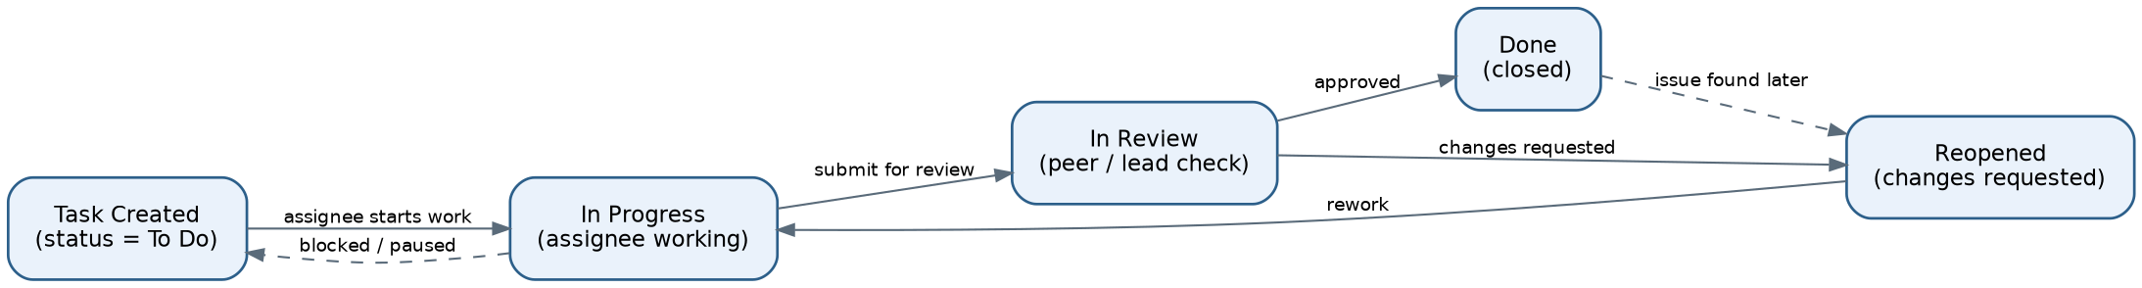
Figure 2. Task status state diagram, including rework and reopen paths.

5. Wireframes
Low-fidelity wireframes below outline layout and content priority for the four core screens. Visual styling (colour palette, spacing, iconography) is intentionally left for the UI design phase; these wireframes focus on information hierarchy and interaction placement.

5.1 Login / Sign Up
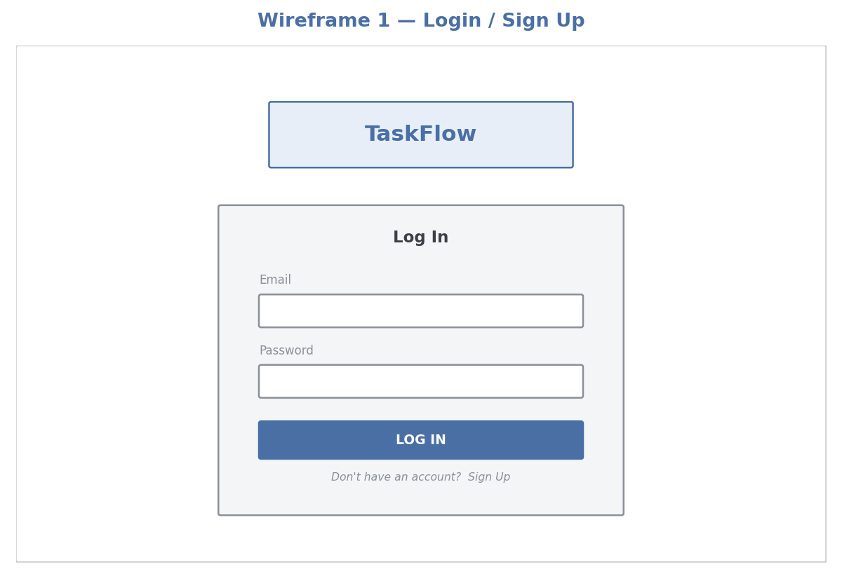
Figure 3. Login screen — minimal form, single primary action, link to sign-up.

5.2 Dashboard — Project List
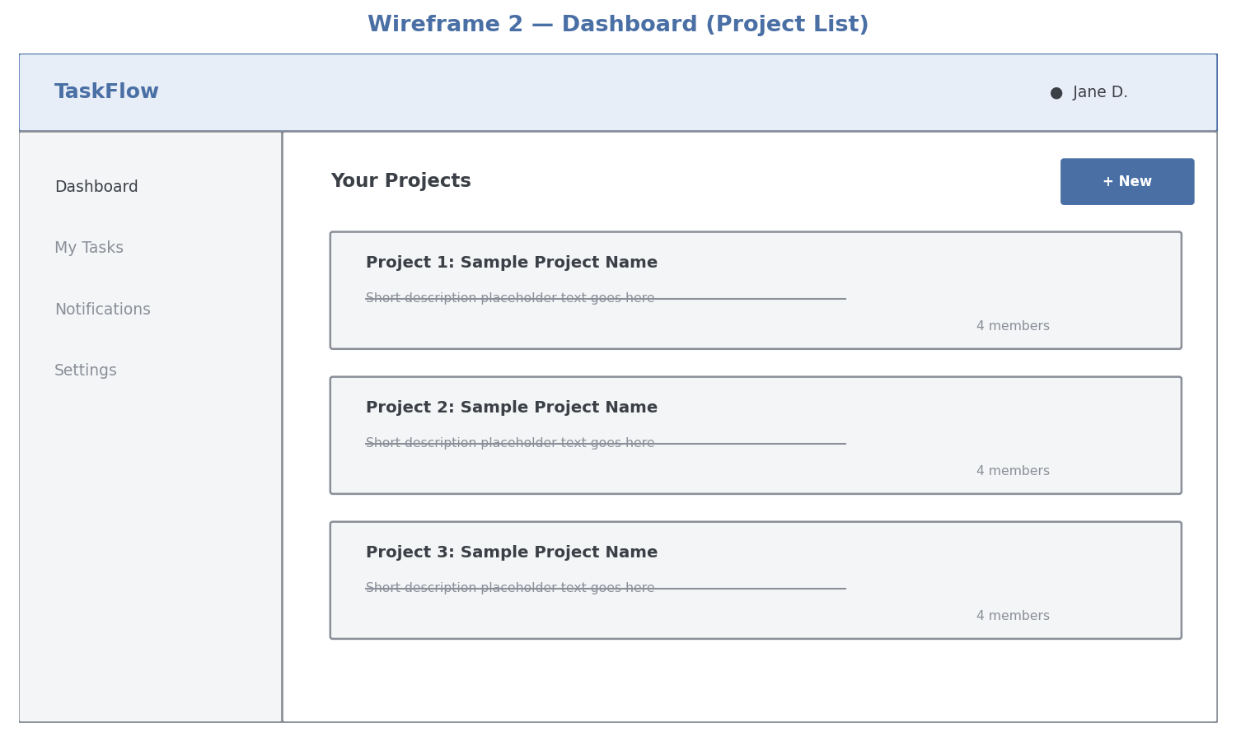
Figure 4. Dashboard listing the user's projects with a sidebar for global navigation.

5.3 Kanban Board
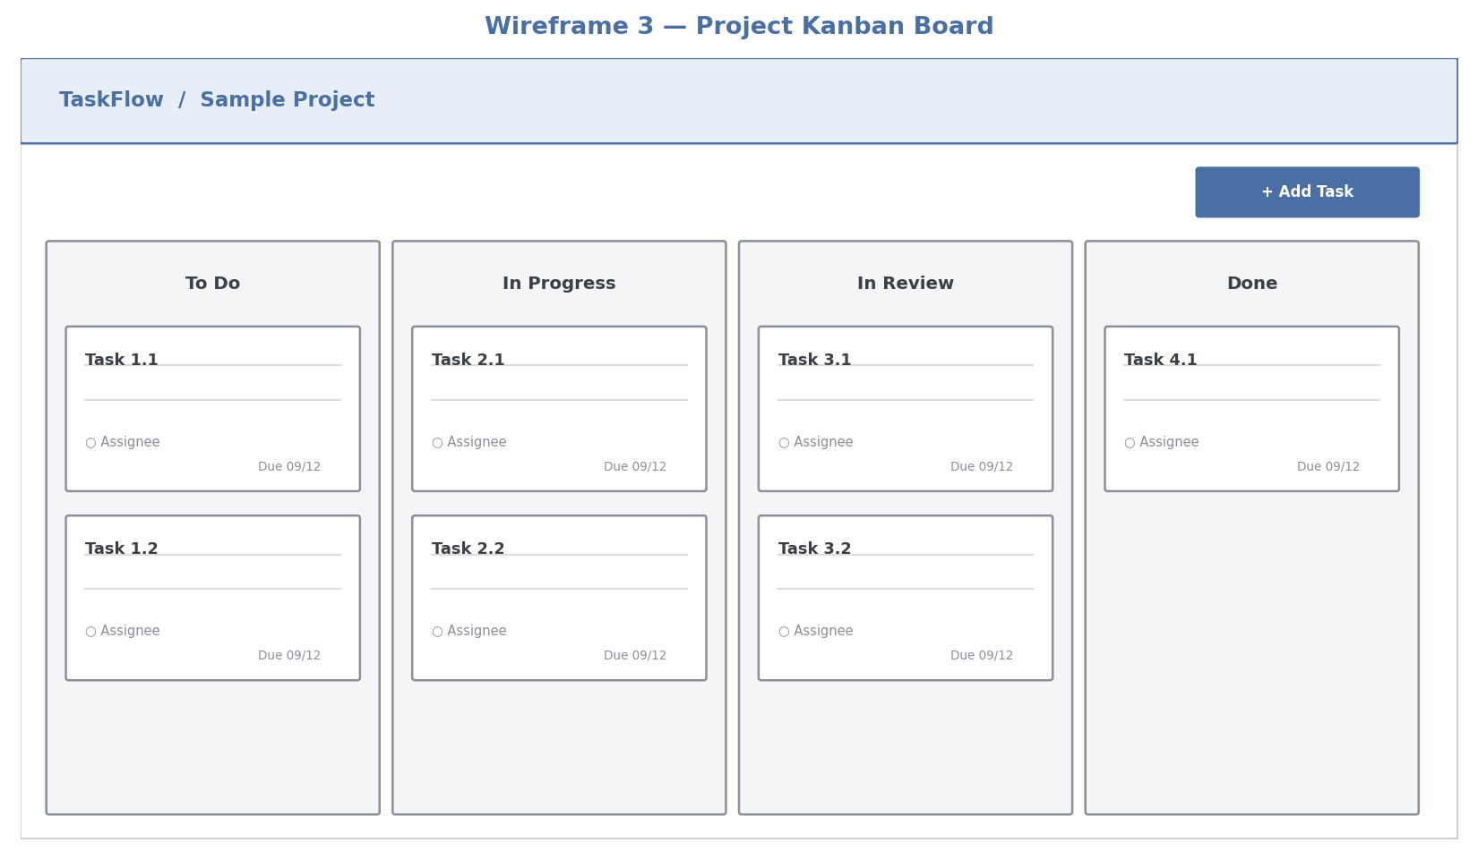
Figure 5. Project board with four status columns and draggable task cards.

5.4 Task Detail Panel
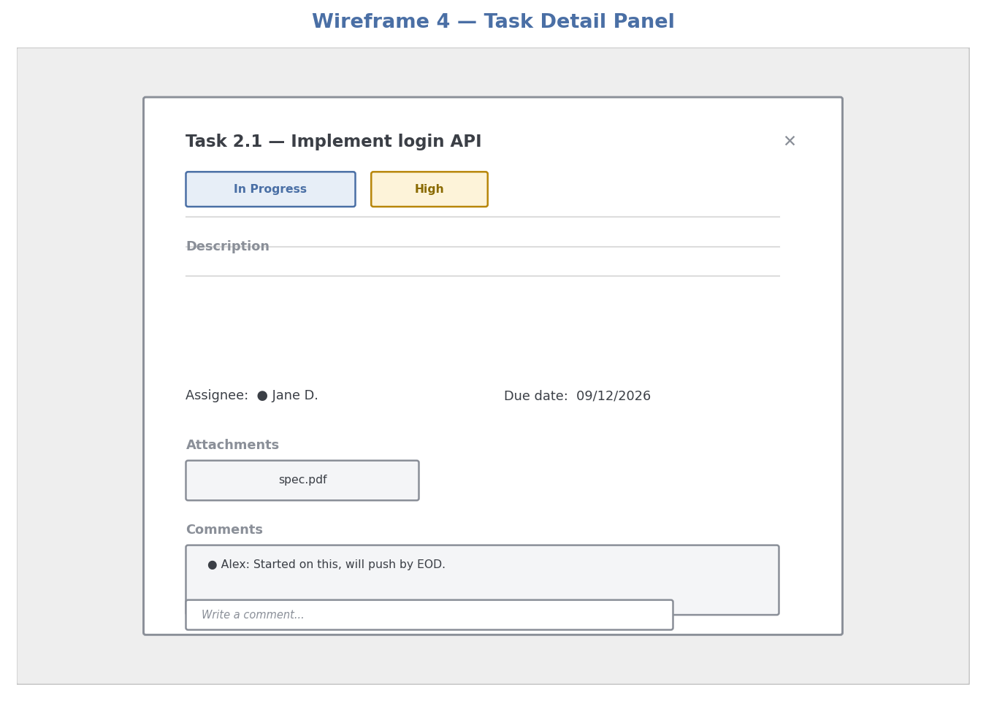
Figure 6. Task detail panel showing metadata, attachments, and comment thread.

6. Technical Architecture
TaskFlow follows a layered client–server architecture: a single-page front end communicates with a REST + WebSocket API, which in turn talks to a relational database, a cache, and object storage.
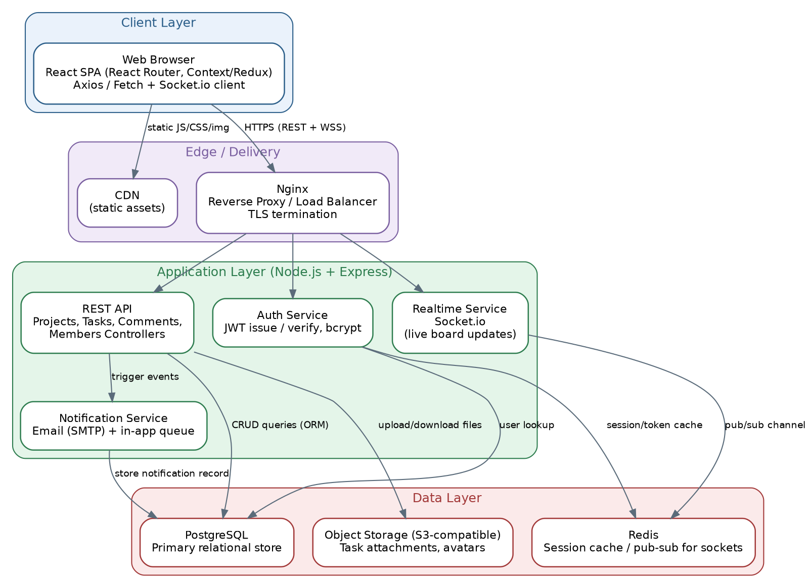
Figure 7. System architecture showing client, edge, application, and data layers.

6.1 Technology Stack & Rationale
Layer | Technology | Why
Front end | React + React Router, Context/Redux | Component model fits a board of reusable task cards; large ecosystem and hiring pool; Context/Redux keeps board state in sync across components.
Real-time | Socket.io | Simplest way to push board updates to all connected members without polling; falls back gracefully when WebSockets are unavailable.
Back end | Node.js + Express | Same language (JavaScript) as the front end reduces context-switching for a small team; Express keeps route/controller structure simple to reason about.
Auth | JWT + bcrypt | Stateless tokens avoid server-side session storage for the API tier; bcrypt is an industry-standard for password hashing.
Database | PostgreSQL | Task data is inherently relational (users, projects, tasks, comments); Postgres offers strong consistency and mature tooling.
Cache / pub-sub | Redis | Used for session/token caching and as the pub-sub backbone that lets multiple Socket.io server instances broadcast to the same room.
File storage | S3-compatible object storage | Keeps large binary attachments out of the primary database, which stays fast and easy to back up.
Delivery | Nginx, CDN | Nginx terminates TLS and load-balances across app instances; a CDN serves static front-end assets close to the user.
Deployment | Docker, GitHub Actions | Containerising the app makes local dev match production; GitHub Actions automates test-and-deploy on each push.

7. Database Schema
The schema below normalises the domain into seven tables. Projects and Users have a many-to-many relationship mediated by ProjectMembers (which also carries the member's role); Tasks, Comments, Attachments, and Notifications each belong to exactly one parent record, keeping ownership and cascade-delete rules simple.
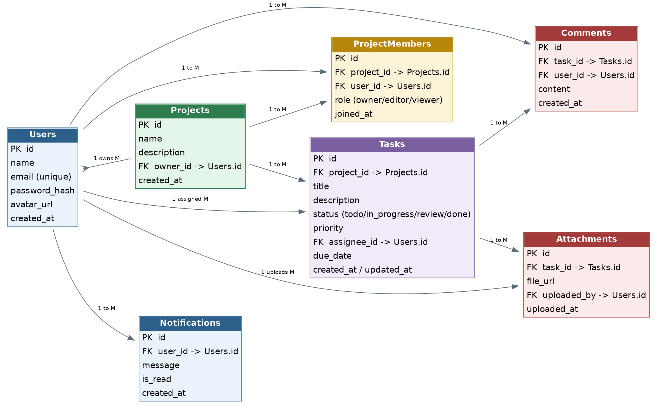
Figure 8. Entity-relationship diagram for the TaskFlow database.

7.1 Table Reference
Table | Key Columns | Notes
Users | id (PK), name, email (unique), password_hash, avatar_url, created_at | One row per registered account.
Projects | id (PK), name, description, owner_id (FK→Users), created_at | owner_id identifies the creator; ownership can be transferred later via an admin action.
ProjectMembers | id (PK), project_id (FK), user_id (FK), role, joined_at | Join table implementing the Users–Projects many-to-many relationship; role ∈ {owner, editor, viewer}.
Tasks | id (PK), project_id (FK), title, description, status, priority, assignee_id (FK→Users), due_date, created_at, updated_at | status is constrained to the four Kanban columns; indexed on (project_id, status) for fast board queries.
Comments | id (PK), task_id (FK), user_id (FK), content, created_at | Simple flat thread per task, ordered by created_at.
Attachments | id (PK), task_id (FK), file_url, uploaded_by (FK→Users), uploaded_at | file_url points to the object storage location; the file itself is never stored in Postgres.
Notifications | id (PK), user_id (FK), message, is_read, created_at | Populated by the Notification Service; polled or pushed to the client for the bell icon.

8. API Endpoint Design
The API is organised around the core resources (projects, tasks, comments) with nested routes reflecting ownership, following standard REST conventions.
Method & Path | Description
POST /api/auth/register | Create a new user account.
POST /api/auth/login | Authenticate and return a JWT (plus refresh token).
GET /api/auth/me | Return the currently authenticated user's profile.
GET /api/projects | List projects the current user is a member of.
POST /api/projects | Create a new project (creator becomes owner).
GET /api/projects/:id | Get a single project's details and member list.
PUT /api/projects/:id | Update project name/description (owner only).
DELETE /api/projects/:id | Delete a project and cascade its tasks (owner only).
POST /api/projects/:id/members | Invite a member and assign a role.
GET /api/projects/:id/tasks | List all tasks on a project's board.
POST /api/projects/:id/tasks | Create a new task within a project.
GET /api/tasks/:id | Get full task detail including comments and attachments.
PUT /api/tasks/:id | Edit task fields (title, description, assignee, priority, due date).
PATCH /api/tasks/:id/status | Update only the task's status (used by drag-and-drop).
DELETE /api/tasks/:id | Delete a task.
POST /api/tasks/:id/comments | Add a comment to a task.
POST /api/tasks/:id/attachments | Upload and link a file to a task.
GET /api/notifications | List the current user's notifications.
PATCH /api/notifications/:id/read | Mark a notification as read.

9. Design Rationale & Key Decisions

9.1 Why a Kanban board instead of a flat task list
A columnar board makes work-in-progress visible at a glance, which is the main pain point this project targets. A flat list would require extra filtering/sorting to answer “what's in progress right now,” whereas a board answers it visually with zero interaction.

9.2 Why a fixed status enum instead of freeform status text
Constraining status to four values (To Do, In Progress, In Review, Done) keeps the board's columns predictable and makes future reporting (e.g., cycle-time analytics) straightforward, at the cost of some flexibility that a freeform field would offer. Teams needing custom columns are treated as a post-MVP extension rather than a day-one requirement, to keep the initial data model simple.

9.3 Why WebSockets for board updates rather than polling
Polling every few seconds would be simpler to build but wastes requests when nothing has changed and still introduces a visible delay. Since multiple people editing the same board in real time is a core use case, a small Socket.io layer was included in the architecture from the start, backed by Redis pub-sub so it can be scaled across multiple server instances rather than being retrofitted later.

9.4 Why role-based access at the project level, not the task level
Permissions are checked once per project membership rather than per task, which keeps the authorisation logic in one place (the ProjectMembers table) and avoids a combinatorial explosion of per-task permission rows. This matches how real teams work — access is almost always granted at the project/team level, not per individual task.

9.5 Scope Deliberately Left Out of Version 1
- Custom/renameable Kanban columns per project
- Sub-tasks / checklists within a task
- Third-party calendar integration (Google Calendar sync for due dates)
- Mobile native apps (the responsive web UI covers tablet/desktop for now)
These were excluded to keep the first version buildable within a realistic timeframe while the architecture above (particularly the Tasks table and REST routes) leaves room to add them without a redesign.

10. Conclusion & Next Steps
This document lays out a complete plan for TaskFlow: the problem it solves, the features and requirements that follow from that problem, the user flows and wireframes that shape the interface, and the architecture and database schema needed to build it. Together these artifacts give a clear, implementable blueprint rather than just a feature list.
Suggested next steps for the following weeks of the internship:
- Set up the project repository, base Express server, and PostgreSQL schema from Section 7.
- Implement authentication (FR-1, FR-2) and project CRUD (FR-3, FR-4) end to end.
- Build the Kanban board UI against the API, wiring up drag-and-drop status changes (FR-6).
- Add comments, attachments, and notifications (FR-7, FR-8) in a later sprint.
- Layer in the Socket.io real-time updates once the core REST flow is stable.

