Title: AI Fitness Plan Generator using Gemini Models

1. Project Title
AI Fitness Plan Generator using Gemini Models

2. Abstract
The AI Fitness Plan Generator is a web-based application that generates personalized fitness workout plans based on user inputs such as age, weight, fitness goal, and available time. The system uses Google Gemini large language models to analyze user requirements and generate structured workout recommendations including exercises, sets, and repetitions. The goal of the project is to provide users with customized fitness plans without requiring a professional trainer.

3. Problem Statement
Many individuals struggle to design effective workout routines due to lack of knowledge about exercises, intensity levels, and proper scheduling. Hiring a personal trainer can be expensive, and generic fitness plans may not suit every individual.
This project addresses this problem by using AI to automatically generate personalized fitness plans based on user-specific parameters.

4. Objectives
- To build an AI-powered fitness plan generator.
- To integrate Google Gemini models for generating intelligent workout suggestions.
- To create a user-friendly interface where users can input their fitness details.
- To generate personalized workout routines automatically.
- To demonstrate practical integration of generative AI in health and fitness applications.

5. System Overview
The system collects user information such as:
- Age
- Gender
- Height
- Weight
- Fitness goal (Weight loss / Muscle gain / Maintenance)
- Available workout time
- Fitness level
This data is sent to the Gemini model, which processes the prompt and generates a structured workout plan for the user.

6. Key Features
- Personalized workout plan generation
- AI-powered recommendation system
- Simple user input interface
- Dynamic exercise suggestions
- Fitness goal-based planning
- Fast response using generative AI
AI fitness applications commonly generate routines tailored to user goals and preferences using large language models.

7. Technology Stack
Frontend
- HTML
- CSS
- JavaScript
Backend
- Python / Node.js (depending on your implementation)
AI Integration
- Google Gemini API
Development Tools
- GitHub
- VS Code
- REST API

8. System Architecture
Basic workflow:
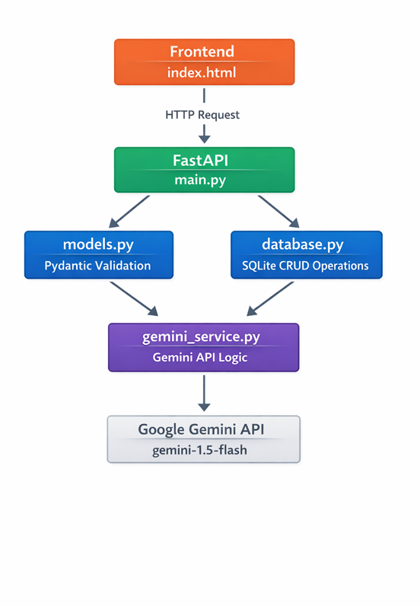

9. Working Methodology
- User opens the application interface.
- User enters fitness-related details.
- The system creates a prompt based on the input.
- The prompt is sent to the Gemini model through API.
- Gemini processes the request and generates a workout plan.
- The system displays the plan to the user.

10. Example Output
Example generated plan:
Goal: Muscle Gain
Day 1 – Chest & Triceps
• Push-ups – 3 sets × 12 reps
• Bench Press – 4 sets × 10 reps
• Tricep Dips – 3 sets × 12 reps
Day 2 – Back & Biceps
• Pull-ups – 3 sets × 10 reps
• Dumbbell Rows – 4 sets × 12 reps
• Bicep Curls – 3 sets × 12 reps

11. Advantages
- Personalized workout plans
- Saves time compared to manual planning
- Accessible to beginners
- AI-driven recommendations
- Scalable and customizable

12. Limitations
- Depends on AI response quality
- Requires internet for API calls
- Cannot replace professional medical advice
- Plans may need manual adjustments

13. Future Enhancements
- Diet plan generation
- Fitness progress tracking
- Exercise video integration
- Mobile app version
- Integration with wearable devices
- AI-based injury prevention suggestions

14. Applications
- Personal fitness planning
- Gym assistant tools
- Health and wellness platforms
- Smart coaching systems

15. Conclusion
The AI Fitness Plan Generator demonstrates how generative AI can be applied to real-world health and fitness problems. By integrating Gemini models with a simple web interface, the system provides personalized workout recommendations that help users achieve their fitness goals efficiently.

