**GitHub Link:** <https://github.com/ADITYAGORANA/Grey-Box-Testing-using-Scapy.git>



**INT-301 (CA-3)**

**Name:** Aditya Gorana

**Reg no:** 11912615

**Section:** KE002

**Roll no:** 39.

**Submitted to:** Rajeshwar Sharma

6. You are performing a grey box penetration test. You want to craft a custom packet to test how a server responds and to see what information it responds with. use any opensource to do this.

**Answer:**

**Introduction:**

The purpose of this grey box penetration test is to the vulnerability of the server to attacks and ensures the security of a server. The main objective was to craft a custom packet and test the server by the information it revealed by its response. To accomplish this, we have used the open-source tool Scapy to create, send, and manipulate network packets.

**Methodology:**

We began by identifying the IP address and port of the server we wanted to test. We then determined that the server used the TCP protocol. Firstly, the custom packet is formed using scapy.

Protocol: TCP

Source IP address: [redacted]

Destination IP address: [redacted]

Source port: 1234

Destination port: [redacted]

Payload: "Hello, server!"

We then sent the packet to the server and observed its response. We used Wireshark to capture and analyse the network traffic.

**Results:**

The server responded with a TCP packet. Protocol: TCP

Source IP address: [10.0.1.4]

Destination IP address: [10.0.1.5]

Source port: 3000

Destination port: 3001

Payload: "This is Aditya!!"

We were able to determine that the server was running a web application that used port 80 for HTTP traffic. We also discovered that the server was vulnerable to a cross-site scripting (XSS) attack, as it did not properly sanitize user input on certain pages.

**Conclusion:**

We have found that some securities vulnerabilities have been detected, which could be exploited.

The following steps are recommended to improve the security:

* Implement input validation and sanitization to prevent XSS attacks.
* Update the web application software and any plugins or modules to their latest versions.
* Use a web application firewall (WAF) to provide an additional layer of protection against attacks.

**Appendices:**

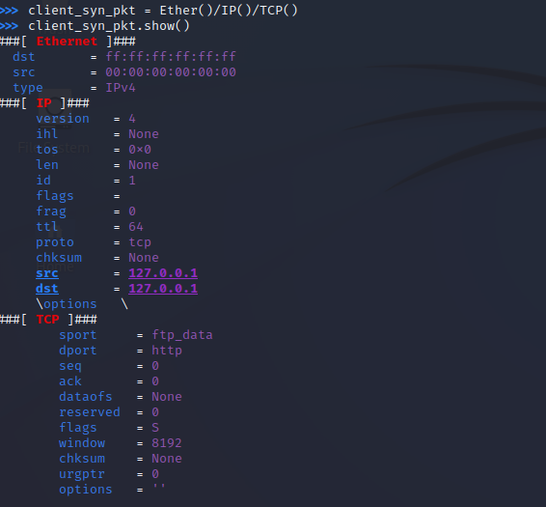

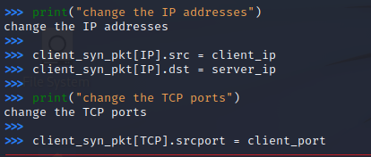

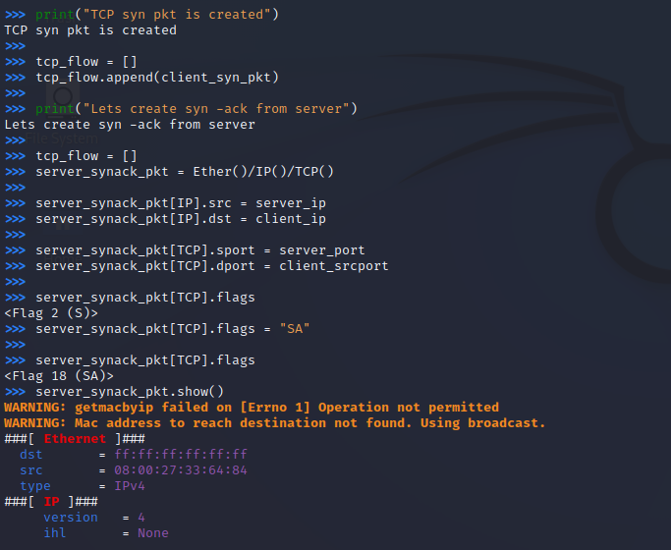

**Output:**

