

**Discrete Mathematics (BCSC 1010)**

**Practice Questions on Functions**

1.Consider the function f(x) = 2x + 3. Find f(4).

2.Suppose we have two functions: f(x) = x^2 and g(x) = 3x - 1. Calculate (g ∘ f)(x) and (f ∘ g)(x).

3.Given the piecewise function: f(x) = { x + 1 if x < 0

2x - 3 if x ≥ 0}. Find:

a) f(-2) b) f(1) c) Determine the domain and codomain of this function.

4. Explain the concept of injective, surjective and bijective functions.

5. Determine whether the function f: ℝ → ℝ defined by f(x) = 2x is surjective.

6. Determine whether the function g: ℝ → ℝ defined by g(x) = x^3 is injective.

7. Determine if the function h: ℤ → ℤ defined by h(x) = 2x - 1 is bijective.

8. Determine whether the function k: ℝ → ℝ defined by k(x) = 3x is bijective, surjective, injective, or neither.

9. Test the function p: ℝ → ℝ defined by p(x) = x^2 for surjectivity and injectivity.

10.

11.



12.

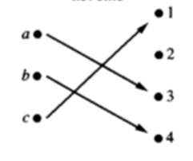13. Identify the type of functions for the following mappings:

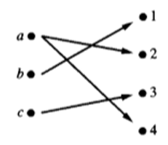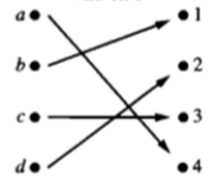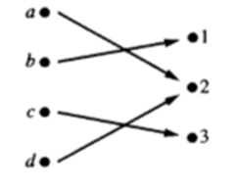

14. Let and $B=\{1,4,5,6\}$, then find out the relation from $A$ to $B$ defined by:

(a) “is less than or equal to” (b) “is less than”. Also find domain and range of the relations.

15. Let g be the function from the set {a, b, c} to itself such that g(a) = b, g(b) = c, and g(c) = a.

Let f be the function from the set {a, b, c} to the set {1, 2, 3} such that f (a) = 3, f (b) = 2, and

f (c) = 1. What is the composition of f and g.