

Experiment - 05

Student Name:ADITYA SHARMA
Branch: CSE - AIML Semester: 5
Subject Name: Advanced Database Management System
UID: 24BAI70379
Section/Group: 24_AIT_KRG-G1-A Date of Performance: 31/7/26 Subject Code: 24CSP-310

[A.]
A website maintains records of users who have registered on the platform and the status of confirmation requests sent to them. A confirmation request can either be successfully completed or may expire without completion.
For each registered user, calculate the confirmation rate, which is defined as:
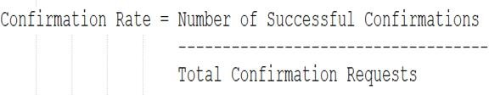

If a user has never received any confirmation request, their confirmation rate should be considered 0.
Display the user ID along with the confirmation rate rounded to 2 decimal places. The result can be returned in any order.
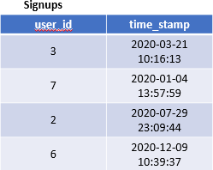
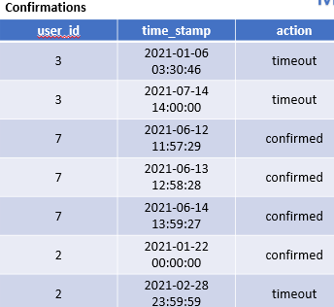

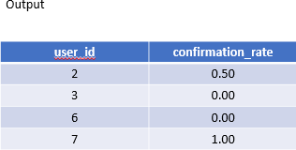
Ans.

SELECT
s.user_id, ROUND(

COALESCE( AVG(CASE
WHEN c.action = 'confirmed' THEN 1.0 ELSE 0.0

END), 0
), 2
) AS confirmation_rate FROM Signups s
LEFT JOIN Confirmations c ON s.user_id = c.user_id
GROUP BY s.user_id;

[B.]
A ride-booking company maintains information about trip requests and the users involved in those trips. Some users may be restricted from using the platform,
while others are active participants. Each trip can either be completed successfully or cancelled by one of the participants.
For each day between 2013-10-01 and 2013-10-03, determine the proportion of canceled trips among all valid trips. A trip should be considered valid only when both the customer and the driver associated with that trip are active users. The final result should display the date and the calculated cancellation rate rounded to two decimal places.
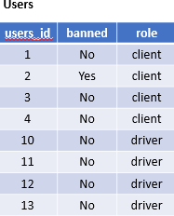
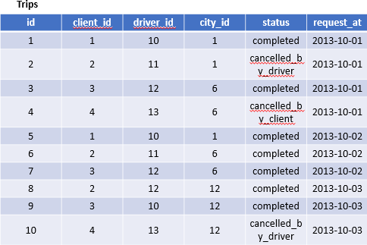
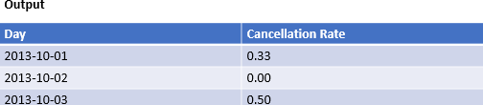

Ans.

SELECT
t.request_at AS day, ROUND(

AVG(
CASE
WHEN t.status LIKE 'cancelled%' THEN 1.0 ELSE 0.0

END
), 2
) AS cancellation_rate FROM Trips t
JOIN Users client
ON t.client_id = client.users_id JOIN Users driver
ON t.driver_id = driver.users_id WHERE client.banned = 'No'
AND driver.banned = 'No'
AND t.request_at BETWEEN '2013-10-01' AND '2013-10-03'
GROUP BY t.request_at ORDER BY t.request_at;

