

Experiment - 06

Student Name: ADITYA SHARMA
Branch: CSE - AIML Semester: 5
Subject Name: Advanced Database Management System
UID: 24BAI70379
Section/Group: 24_AIT_KRG-G1-A Date of Performance: 31/7/26 Subject Code: 24CSP-310

[A.]
A fruit distribution company records the number of apples and oranges sold each day. For every date, exactly one record exists for apples and one record exists for oranges.
Generate a daily sales comparison report showing the difference between the number of apples sold and the number of oranges sold on the same day. The difference should be calculated as:

Difference = Apples Sold - Oranges Sold
Display the sale date and the calculated difference. The result should be sorted by sale date in ascending order.
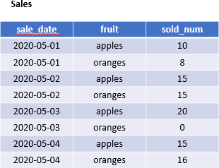
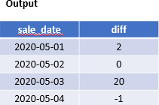

Ans.
SELECT
sale_date,
SUM(CASE WHEN fruit = 'apples' THEN sold_num ELSE 0 END)
-
SUM(CASE WHEN fruit = 'oranges' THEN sold_num ELSE 0 END) AS diff
FROM Sales

ORDER BY sale_date;

[B.]
A company stores hierarchical employee reporting information in a table. Each record represents a node in a hierarchy where:
- id represents the current node.
- p_id represents the parent node.
Classify every node into one of the following categories:
- Root: A node that does not have any parent.
- Leaf: A node that has a parent but does not have any children.
- Inner: A node that has both a parent and at least one child.
Display the node ID along with its category. Return the result sorted by node ID.

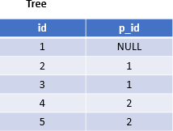
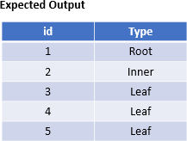
Ans:
SELECT
id, CASE
WHEN p_id IS NULL THEN 'Root'
WHEN id IN (SELECT p_id FROM Tree) THEN 'Inner' ELSE 'Leaf'
END AS Type FROM Tree
ORDER BY id;

