
Hometask - 06

Student Name: ADITYA SHARMA
Branch: CSE - AIML Semester: 5
Subject Name: Advanced Database Management System

UID: 24BAI70379
Section/Group: 24_AIT_KRG-G1-A Date of Performance: 31/7/26 Subject Code: 24CSP-310

[A.]
You are given three tables: Students, Friends and Packages. Students contains two columns: ID and Name. Friends contains two
columns: ID and Friend_ID (ID of the ONLY best friend). Packages contains two columns: ID and Salary (offered salary in $ thousands per month).
Write a query to output the names of those students whose best friends got offered a higher salary than them. Names must be ordered by the salary amount offered to the best friends. It is guaranteed that no two students got same salary offer.
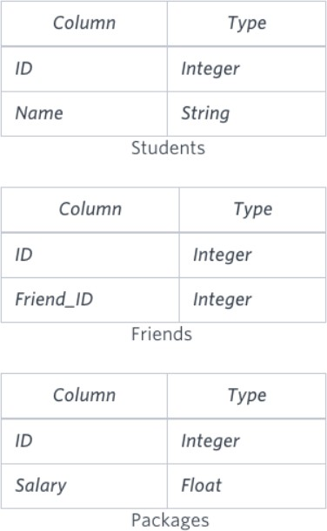


JOIN Friends f ON s.id = f.id
JOIN Packages p1 ON s.id = p1.id
JOIN Packages p2 ON f.friend_id = p2.id WHERE p2.salary > p1.salary
ORDER BY p2.salary;

[B.]
You are given a table, Functions, containing two columns: X and Y
Two pairs (X₁, Y₁) and (X₂, Y₂) are said to be symmetric pairs if X₁ = Y₂ and X₂ = Y₁.
Write a query to output all such symmetric pairs in ascending order by the value of X. List the rows such that X₁ ≤ Y₁
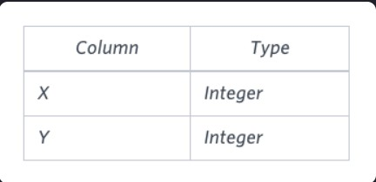

ANS:

SELECT f1.x, f1.y
FROM Functions f1 JOIN Functions f2
ON f1.x = f2.y AND f1.y = f2.x
GROUP BY f1.x, f1.y
HAVING COUNT(*) > 1 OR f1.x < f1.y ORDER BY f1.x;

