Experiment - 09

Student Name: ADITYA SHARMA UID: 24BAI70379
Branch: CSE - AIML Section/Group: 24AIT_KRG-1_A
Semester: 5 Date of Performance: 21/9/26
Subject Name: ADBMS Subject Code: 24CSP-310

(A)
An organization stores employee details in the employee_info table. Create a PostgreSQL stored procedure that accepts an employee's gender as an input parameter and calculates the total number of employees belonging to that gender. The calculated count should be returned through an OUT parameter and should also be displayed as a message using RAISE NOTICE.
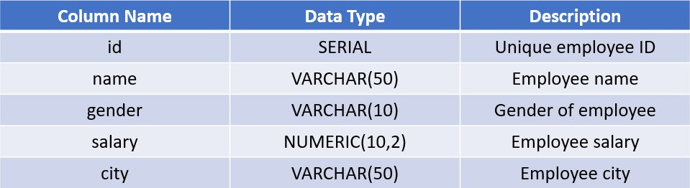
For example, if Male is passed to the procedure, it should count all employees whose gender is Male.

Solution:
CREATE OR REPLACE PROCEDURE SP_GET_GENDER_COUNT(IN P_GENDER VARCHAR(20), OUT P_TOTAL_COUNT INT)
LANGUAGE PLPGSQL AS
$$
BEGIN
SELECT COUNT(ID) INTO P_TOTAL_COUNT FROM EMPLOYEE_INFO
WHERE GENDER = P_GENDER;

RAISE NOTICE 'TOTAL EMPLOYEES WITH GENDER %: %', P_GENDER, P_TOTAL_COUNT;
END;
$$

CALL SP_GET_GENDER_COUNT('Female', NULL);

(B)
An e-commerce company maintains product stock information in the products table and stores completed orders in the sales table. Create a PostgreSQL stored procedure that accepts a product name and required quantity as input parameters and processes the purchase only when sufficient stock is available.
The procedure should verify the available quantity of the requested product. If sufficient stock exists, it should retrieve the product code and price, calculate the total sale amount, insert a new order into the sales table, reduce the available stock, and increase the total quantity sold. If sufficient stock is not available, the procedure should not modify any data and should display an appropriate notification message. The total sale amount should be calculated as:
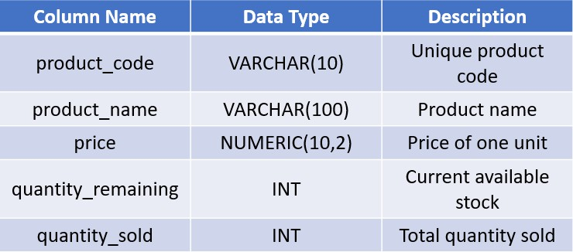
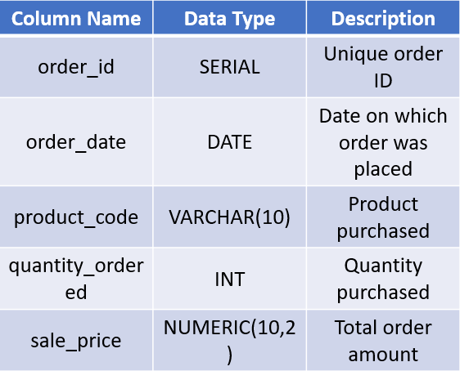
Sale Price = Product Price × Quantity Ordered Tables:

Solution:

CREATE OR REPLACE PROCEDURE PR_BUY_PRODUCTS(IN P_PRODUCT_NAME VARCHAR(20), IN P_QUANTITY INT)
LANGUAGE PLPGSQL AS
$$
DECLARE
V_PRODUCT_CODE VARCHAR; V_PRICE FLOAT;
V_COUNT INT; BEGIN
SELECT COUNT(*) INTO V_COUNT FROM PRODUCTS
WHERE PRODUCT_NAME=P_PRODUCT_NAME AND QUANTITY_REMAINING >= P_QUANTITY;

IF V_COUNT>0 THEN
SELECT PRODUCT_CODE, PRICE INTO V_PRODUCT_CODE, V_PRICE FROM PRODUCTS
WHERE PRODUCT_NAME=P_PRODUCT_NAME;
INSERT INTO SALES (ORDER_DATE, PRODUCT_CODE, QUANTITY_ORDERED, SALE_PRICE)
VALUES (CURRENT_DATE, V_PRODUCT_CODE, P_QUANTITY, (V_PRICE*P_QUANTITY));

UPDATE PRODUCTS
SET QUANTITY_REMAINING = QUANTITY_REMAINING - P_QUANTITY,
QUANTITY_SOLD = QUANTITY_SOLD + P_QUANTITY WHERE PRODUCT_CODE = V_PRODUCT_CODE;
RAISE NOTICE 'PRODUCT SOLD..! Order placed
successfully for % unit(s) of %.', P_QUANTITY, P_PRODUCT_NAME;
ELSE
RAISE NOTICE 'INSUFFICIENT QUANTITY..! Order cannot be processed for % unit(s) of %.', P_QUANTITY, P_PRODUCT_NAME;
END IF; END;
$$
CALL PR_BUY_PRODUCTS('Samsung Galaxy S23 Ultra', 1); SELECT * FROM PRODUCTS;

