Lab mst dbms—

Question 1

SELECT c.customer_name,c.city,SUM(o.amount) AS total_purchase
FROM customer c
JOIN orders o ON c.customer_id = o.customer_id
GROUP BY c.customer_id, c.customer_name, c.city
HAVING SUM(o.amount)=(SELECT MAX(city_total)FROM (SELECT SUM(o2.amount) AS city_totalFROM customer c2
JOIN orders o2 ON c2.customer_id = o2.customer_id
WHERE c2.city = c.city
GROUP BY c2.customer_id) AS city_totals
)ORDER BY c.city, c.customer_name;

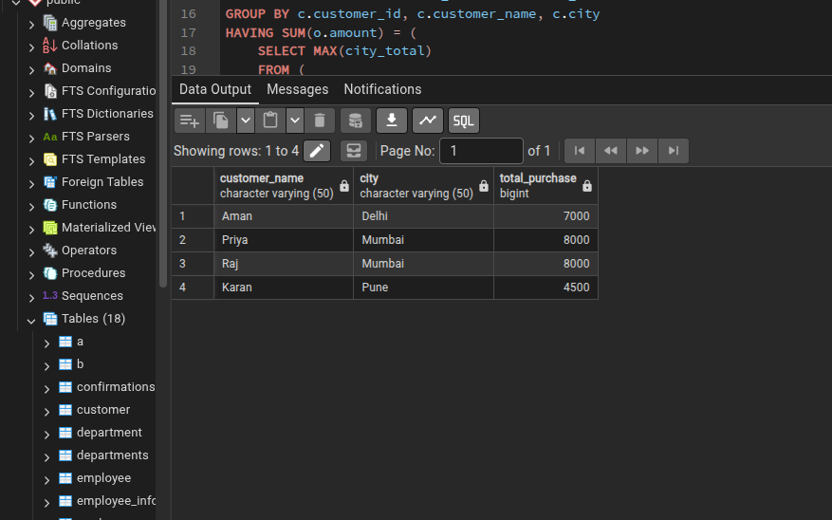

Question 2

create or replace function product_add()
returns trigger as $$
begin
insert into product_audit (product_id, product_name, action)
values (new.product_id, new.product_name, 'rodct added');
return new;
end;
$$ language plpgsql;

create trigger trg_product_added
after insert on product_inventory
for each row
execute function fn_product_added();

create or replace function fn_product_removed()
returns trigger as $$
begin
insert into product_audit (product_id, product_name, action)
values (old.product_id, old.product_name, 'remoed prodct');
return old;
end;
$$ language plpgsql;

create trigger trg_product_removed
after delete on product_inventory
for each row
execute function fn_product_removed();

insert into product_inventory values (103, 'tablet', 25000);
delete from product_inventory where product_id = 101;

select * from product_audit;

