Program 1: Write a OpenMP program to sort an array on n elements using both sequential and parallel mergesort (using Section). Record the difference in execution time.

#include <stdio.h>
#include <stdlib.h>
#include <omp.h>
#include <time.h>

// Function to merge two halves of the array
void merge(int* arr, int l, int m, int r)
{
int i, j, k;
int n1 = m - l + 1; int n2 = r - m;
int* L = (int*)malloc(n1 * sizeof(int));
int* R = (int*)malloc(n2 * sizeof(int));

for (i = 0; i < n1; i++)
L[i] = arr[l + i];
for (j = 0; j < n2; j++)
R[j] = arr[m + 1 + j];

i = 0; j = 0; k = l;
while (i < n1 && j < n2) {
arr[k++] = (L[i] <= R[j]) ? L[i++] : R[j++];
}
while (i < n1)
arr[k++] = L[i++];

while (j < n2)
arr[k++] = R[j++];
free(L);
free(R);
}

// Sequential MergeSort
void mergeSortSequential(int* arr, int l, int r)
{ if (l < r)
{
int m = (l + r) / 2;
mergeSortSequential(arr, l, m);
mergeSortSequential(arr, m + 1, r);
merge(arr, l, m, r);
}
}

// Parallel MergeSort using OpenMP sections
void mergeSortParallel(int* arr, int l, int r, int depth)
{
if (l < r) {
int m = (l + r) / 2;
if (depth <= 0) {
// Fallback to sequential at depth limit
mergeSortSequential(arr, l, m);
mergeSortSequential(arr, m + 1, r);
}
else {
#pragma omp parallel sections
{
#pragma omp section
mergeSortParallel(arr, l, m, depth - 1);

#pragma omp section
mergeSortParallel(arr, m + 1, r, depth - 1);
}
}

merge(arr, l, m, r);
}
}

// Helper to check if array is sorted
int isSorted(int* arr, int n) { for (int i = 1; i < n; i++) {
if (arr[i - 1] > arr[i]) return 0;
}
return 1;
}
//Main function
int main() {
int n = 1000000;
int* arrSeq = (int*)malloc(n * sizeof(int)); int* arrPar = (int*)malloc(n * sizeof(int));

// Seed for reproducibility
srand(42);
for (int i = 0; i < n; i++)
{ arrSeq[i] = rand() % 100000;
arrPar[i] = arrSeq[i];
}
// Time sequential sort
double start = omp_get_wtime();
mergeSortSequential(arrSeq, 0, n - 1);

double end = omp_get_wtime();
double timeSeq = end - start;

// Time parallel sort
start = omp_get_wtime();
mergeSortParallel(arrPar, 0, n - 1, 4); // You can tune depth
end = omp_get_wtime();
double timePar = end - start;

// Validate and output
printf("Sequential sort time: %.6f seconds\n", timeSeq); printf("Parallel sort time : %.6f seconds\n", timePar); printf("Speedup : %.2fx\n", timeSeq / timePar);
if (!isSorted(arrSeq, n)) printf("Sequential sort failed!\n");

if (!isSorted(arrPar, n))
printf("Parallel sort failed!\n");

free(arrSeq); free(arrPar);

return 0;
}

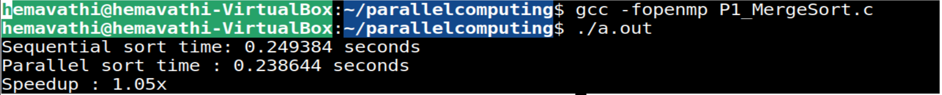

gcc –fopenmp test.c –o testoutput
./testoutput

