**The Linux Operating System**

**Challenges**

In this section you will find tasks that will help you to practice the commands we have seen and others.

* Display the content of the /etc/passwd, count how many lines it has and sort in a decreasing order (z-a).

Display the content of the /etc/passwd

For this task:

1. Open a Terminal: You can access WSL through a terminal application. In Windows 10 or 11, you can search for "Command Prompt" or "PowerShell" in the Start menu or use the shortcut Windows Key + X to access these tools. In Windows 11, you might also directly search for "WSL" in the Start menu.

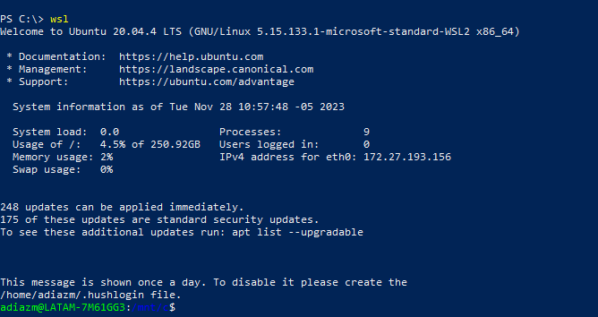

1. Start WSL: Once you have the terminal open, type in wsl and press Enter. This command will initiate WSL and bring up a Linux shell within your Windows environment.
2. To navigate to the directory where the /etc/passwd file is located in a Linux system using the terminal, you can use the cd command to change directories. However, the /etc/passwd file is typically found in the root directory, so you don't need to change directories to access it.

Check Current Directory: To check your current directory, use the command pwd and then move to the Root Directory (optional): If you're not already in the root directory and want to navigate there, you can use cd/

1. To display the content of the /etc/passwd file in Linux, you can use the cat command in the terminal. Open your terminal or WSL and enter the following command:

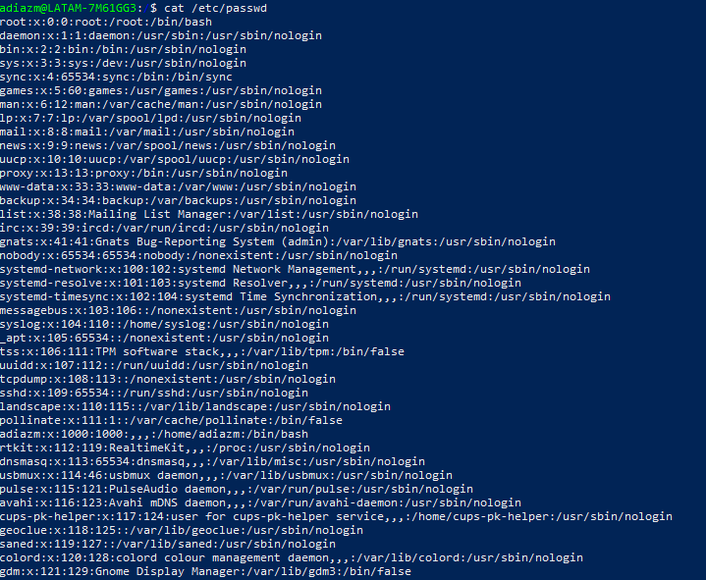

Or nano passwd

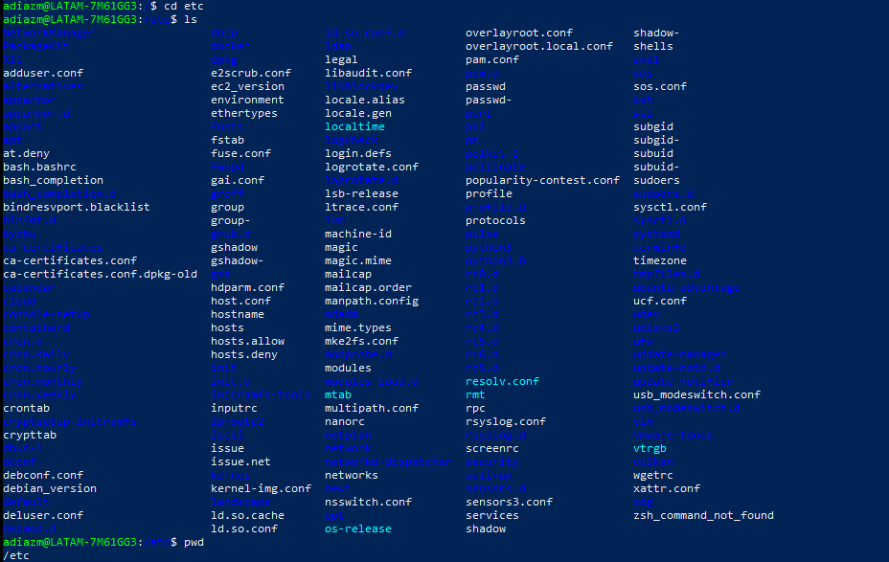



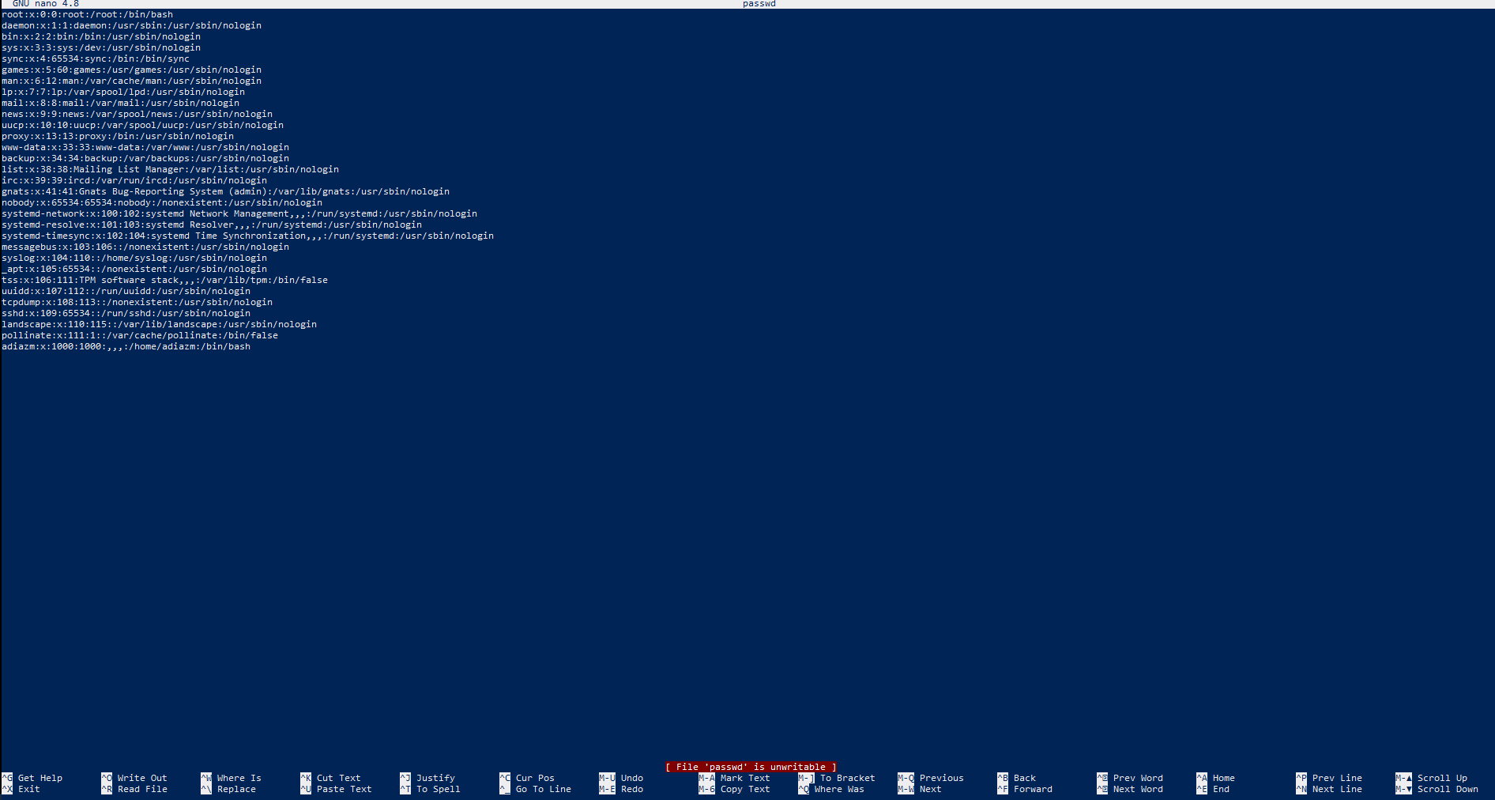

count how many lines it has and sort in a decreasing order (z-a)

for this part of the task use this command:

cat /etc/passwd | wc -l | sort -r



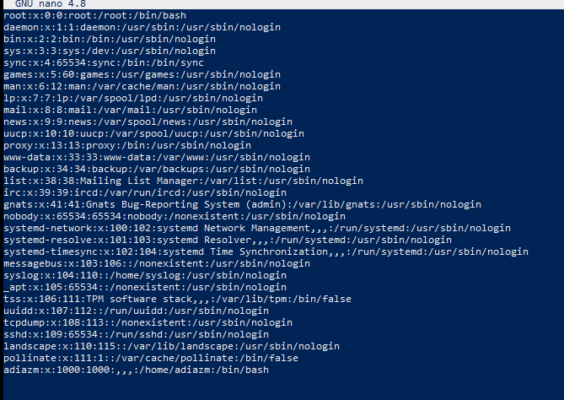

* Find what is your User ID and Group ID. This information is stored in the /etc/passwd file. Also, find what's the line they are. Of course, you should do this without displaying the file's content.





* List files and directories that are hidden on your $pwd. Also, list them by time (use the man page to see what flag you need).

List files and directories that are hidden on your $pwd

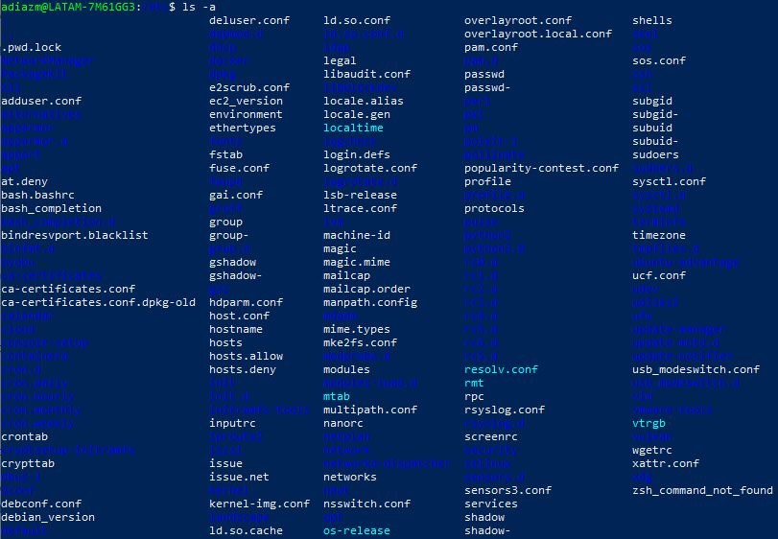

Also, list them by time (use the man page to see what flag you need).

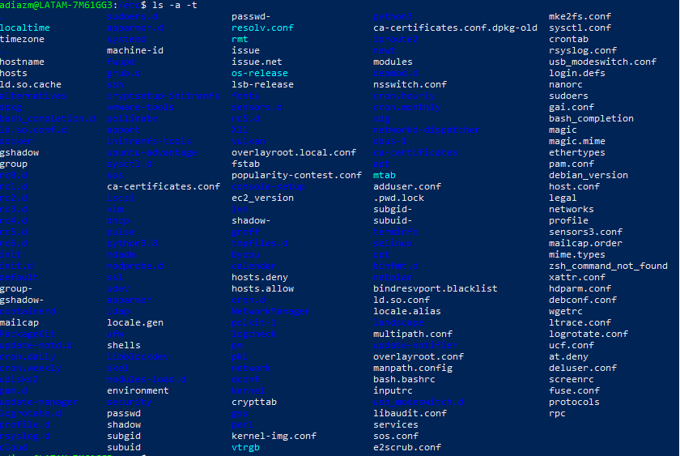

-a (all) for show hidden files and folders, this files and folders star with “.”.

-t use this instruction for sort by time

* Create a file called *myfile*. Update its permissions so only your user can read, write, and execute it.

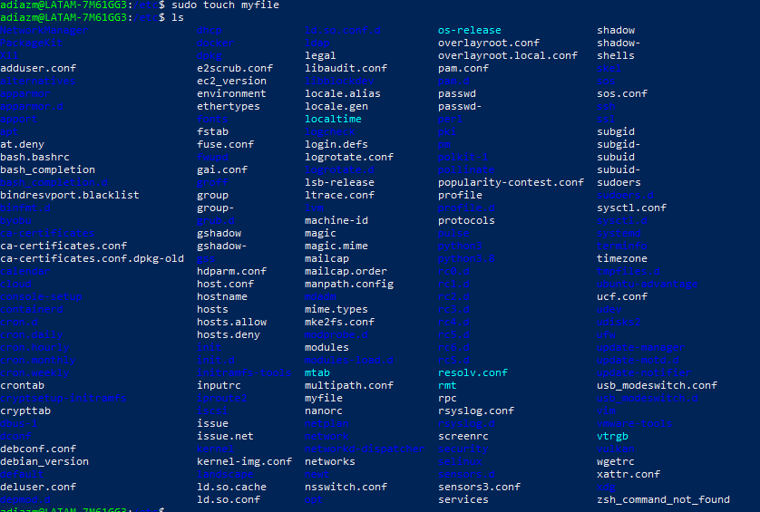

Update its permissions so only your user can read, write, and execute it





* Create 5 files (f1,f2,...,f5) without having to type 5 times the touch command.



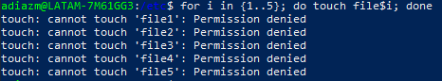

* Move to another location where those 5 files are not. Then do a search to find them, and execute the *ls -l* command to each of those. This should be done with just one command.

-type f: for regular files

-exec: execute actions in found files

find <ruta> -exec <comando> {} \;

* Create the directory d1/d2/d3/foo/d4. If the previous directories don't exist, then they should also be created automatically.

mkdir -p d1/d2/d3/foo/d4

-p: for créate intermediate directories

* Given the following text "We have 5 days to finish 5 lines of code of the Hi5b project" Replace all "5" by "five", the number must be alone, cannot be in a word.



sed: is the command used in Linux to perform text editing operations on files or on standard input.

's/\b5\b/five/g': This is the substitution operation that is performed with sed. Here is a breakdown of its components:

s: This is the substitution command.

/\b5\b/: This is the search pattern. It matches a single character "5" that is not preceded or followed by a word boundary.

/five/: This is the replacement string. It is the string that will replace the matched pattern.

g: This is the global flag. It tells sed to replace all occurrences of the matched pattern, not just the first one.

* List all processes running on your system and sort them by the username that's running each process.

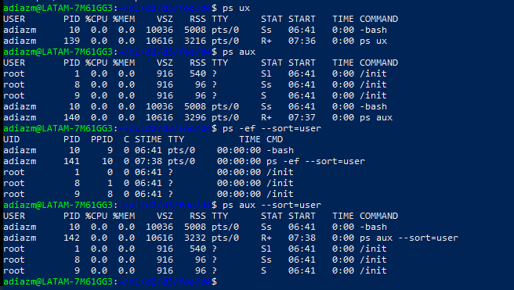

* Run the gedit program, search for it's PID and send it a signal to stop it. After this, send another one resume its execution.

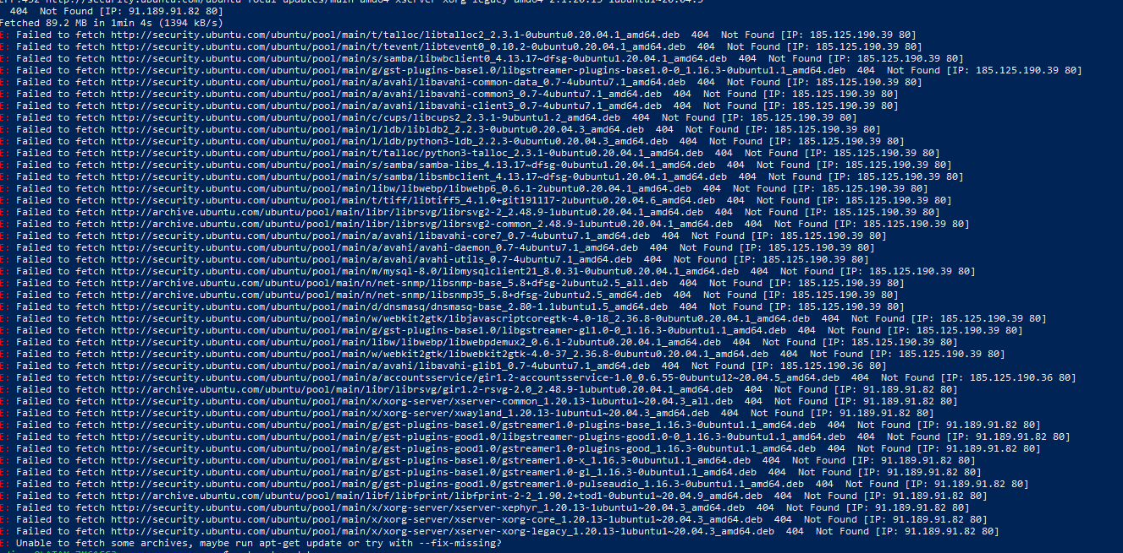

* Install SSH server. Start the service, and check its status. If it is not enabled, do it.

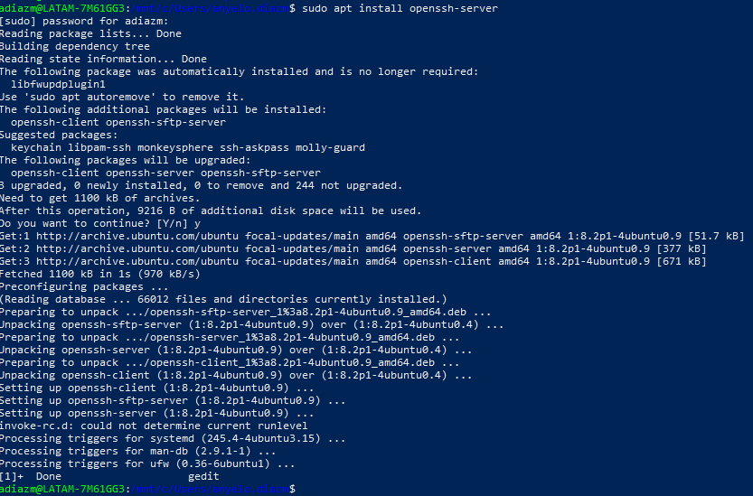



* Display the network interfaces on your system. Do you see one that isn't physical? What's that interface?

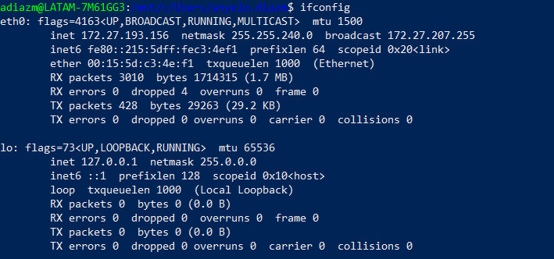

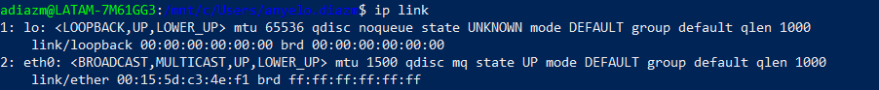

* What's your IP and MAC address?

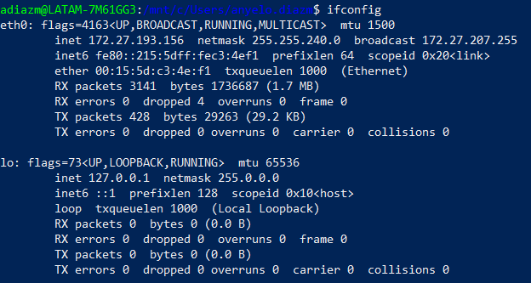

* Can you communicate outside your private network? Test this with a command.

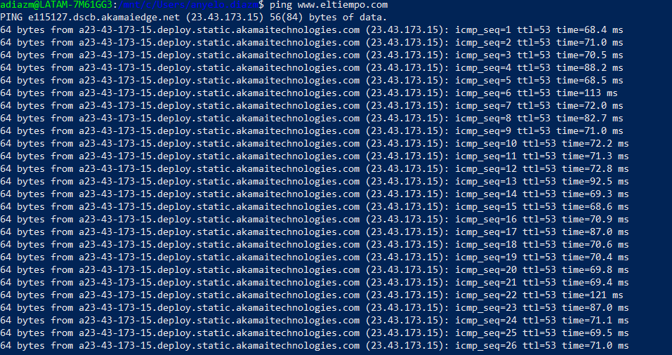

* What happens to a packet going to a host outside of the network?

When a host sends a packet to a destination outside of its own network, the host first checks its routing table to see if it has a route to the destination. If it does not have a route to the destination, the host will send the packet to its default gateway. The default gateway is a router that is configured to route traffic to destinations outside of the network.

Packet: refers to a unit of data that is sent over a network.

Host: refers to a device that is connected to a network.

Network: refers to a group of devices that are connected together.

Router: refers to a device that is used to route traffic between networks.

Default: refers to a setting that is used by default.

* What is the IP of your gateway(s)? Can you check this with two commands?



A gateway is a device that connects two or more networks that use different protocols or technologies. It is a type of router that is configured to route traffic between networks. Gateways are often used to connect a local area network (LAN) to a wide area network (WAN), such as the internet.

Gateways can be used to connect networks that use different protocols, such as IPv4 and IPv6. They can also be used to connect networks that use different technologies, such as Ethernet and Wi-Fi.

Gateways play an important role in the routing of data between networks. They are responsible for translating the data from one protocol or technology to another so that it can be understood by the other network.

Here are some examples of how gateways are used:

A company may use a gateway to connect its internal network to the internet.

A home user may use a gateway to connect their home network to their cable or DSL modem.

A mobile device may use a gateway to connect to the internet through a cellular network.

Gateways are an essential part of any network that needs to connect to other networks. They provide a way for devices on different networks to communicate with each other.

* Trace the route being taken to connect to cloudflare.com.

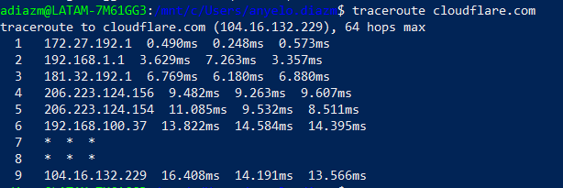

* What's the IP address of perficient.com? What's their mail server?

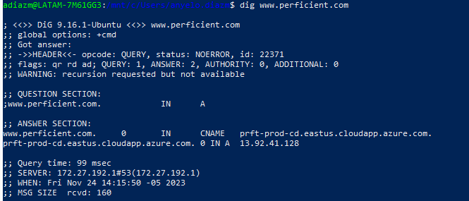

* List all TCP and UDP connections on the system.

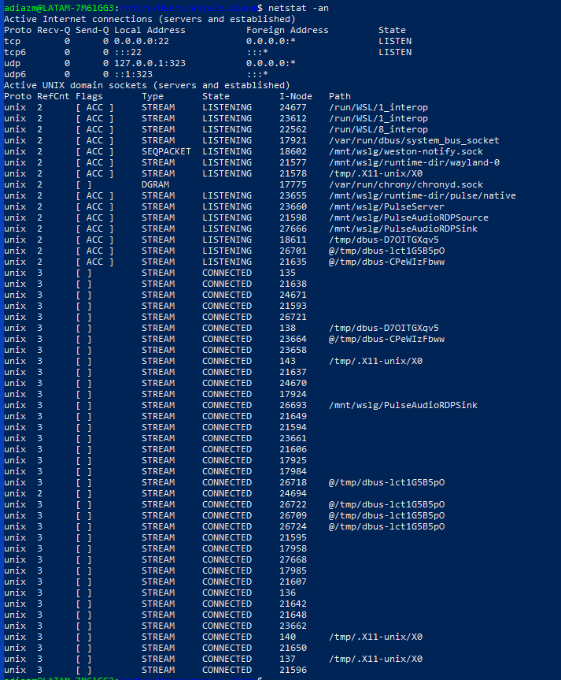

* What ports do you have open on the system?

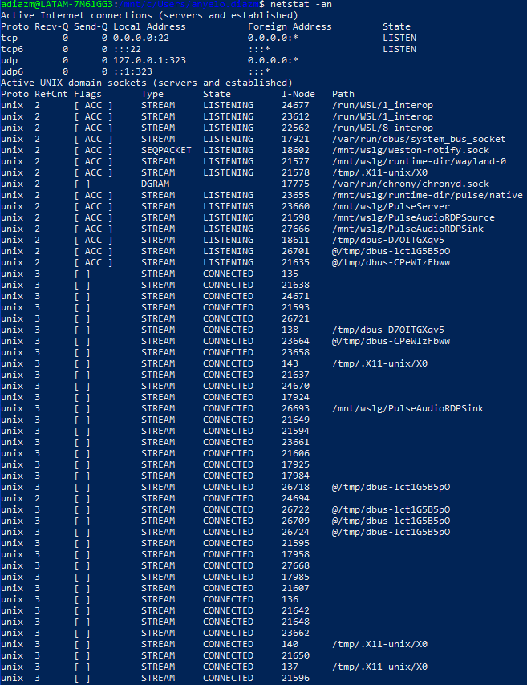

* List only the listening connections on the system.

