**Comparing Jessie’s dialogue between ‘Final Fantasy VII’ and ‘Final Fantasy VII Remake’**

The main analysis of the overall corpus shows that the proportion of female dialogue is slowly increasing over time. However, this does not necessarily mean that the portrayal of female characters is improving. To investigate this, this section uses the corpus to conduct a qualitative analysis of how a female character is portrayed through dialogue at two different points in time. This is a difficult in general, since the portrayal of characters differs by the story’s genre, the character’s role in the plot, the world of the game, game mechanics and many other factors. However, an opportunity for direct comparison is available since the opening chapters of 'Final Fantasy VII' (Square, 1997) was re-made more recently in 'Final Fantasy: VII Remake' (Square Enix, 2020). The two games have characters, plot and settings in common. This analysis focusses on the character of Jessie, and how she is portrayed through her dialogue in the two games.

**Background**

*Final Fantasy VII* is an action RPG in the 'Final Fantasy' series developed and produced by Squaresoft between 1994 and 1997, and published in 1997. It follows the adventures of Cloud, a soldier who joins an eco-terrorist group ('Avalanche') to fight against a mega-corporation attempting to drain the planet's lifeblood as an energy source (Final Fantasy Wiki, 2021). In 2020, Square Enix released *Final Fantasy VII Remake,* a new game made with modern high-definition graphics and game systems. It adapted the setting, characters and plot of the original, and re-tells the first part of the story of the original.

This analysis focusses on the character of Jessie Rasberry, a character in both games who used to work for the mega-corporation as senior engineer, but now works for Avalanche. During the first Avalanche mission to destroy a reactor, she hacks security doors and provides the explosives. In both games, she is injured during an Avalanche mission and (apparently) dies. While there are more prominent female characters, studying Jessie’s dialogue allows a more direct comparison than most, since her character arc is completed in both games.

**Data**

Jessie’s dialogue was extracted from the corpus for both games (including lines that are only heard if the player chooses to help Jessie after the explosion), along with preceding lines for contextual cues. Notable moments were identified for particular focus, such as the explosion at the Mako Reactor and Jessie's death.

In the original, Jessie has 32 lines with 655 words. In the remake she has 301 lines with 3,334 words. This is an increase both absolutely and proportionally compared with other characters.

The figure below shows the relative proportion of dialogue spoken by four female and four male characters in both games. Jessie has over three times more dialogue as a proportion of these characters.



**Methods**

**Thematic Analysis**

Thematic Analysis (TA) is a method of qualitative analysis that allows for the identification, analysis and interpretation of patterns of meaning or 'themes' (Braun and Clarke, 2017). This moves beyond counting words or phrases and focuses on identifying and describing both implicit and explicit content (Guest et al., 2012: 9). Therefore, TA allows for comparing data sets and analysing emerging themes in relation to their broader context, rather than just at a linguistic level.

Braun and Clarke's (2017) 5-step process was followed. The first step is familiarisation with the content. To aid this step, three YouTube videos were used to gain a more comprehensive overview of the dialogue and the context in which it was situated. World of Longplays (2016) provided a complete walkthrough of the original game and Gamer's Little Playground's (2020) allowed for greater understanding of Jessie's scenes and dialogue. For greater qualitative analysis, Infernix Gaming's (2020) video was used to directly compare Jessie's death scenes and identify differences in dialogue.

In the second step, “codes” are generated for each line of dialogue. In TA, “codes” are the smallest units of analysis that can capture interesting data features which help answer the research question (Braun and Clarke, 2016: 297). These small units are then related to broader themes. Finally, there is an iterative process of reviewing, defining and naming themes until they encompass the target domain. Finally, these themes were considered scene-by-scene to examine what functions Jessie's speech serves and whether her dialogue fulfils stereotypically 'feminine' roles within video games.

**Results**

The thematic analysis of Jessie's dialogue revealed that in *Final Fantasy VII*, Jessie's character is knowledgeable, confident in her role yet shy and sensitive in herself (see Figure 1). Despite the original game being produced in 1997, Jessie's dialogue avoids many pernicious gender stereotypes (although she does fall into the 'Damsel in Distress' trope, being rescued by Cloud when trapped after the explosion). Jessie gains confidence when she can use her knowledge as a technical expert, dispensing information to the player to help them progress through the game.

22% of Jessie’s dialogue from the original game involves dispensing information. This includes dialogue that instructs the player about the game mechanics (“Push the [OK] button in front of a ladder to grab on to it”), and the game world (“The 8 Reactors provide Midgar with electricity”). A further 22% of her dialogue involves displaying technical ability and knowledge (“Code deciphered”, and when setting the bomb “OK! Now everyone get back.”). The remaining 56% of dialogue falls under ‘personality revealing’. These are lines that function to help express Jessie’s personality (“Oh yeah, you might regret it. I'm the type who takes things personal”), flirting with Cloud (“It's me, Jessie. How do I look, Cloud? Do I look good in a Shinra uniform?”), and expressing regret over her actions (“Because... of our actions... many... ... people died... ... this probably... ... is our punishment...”).

Despite having a limited amount of dialogue in the original game, her character is not there to play a romantic role or serve as a reward to the main PC. Rather, the character is valued for her knowledge and what she brings as a technical expert and confident team player.

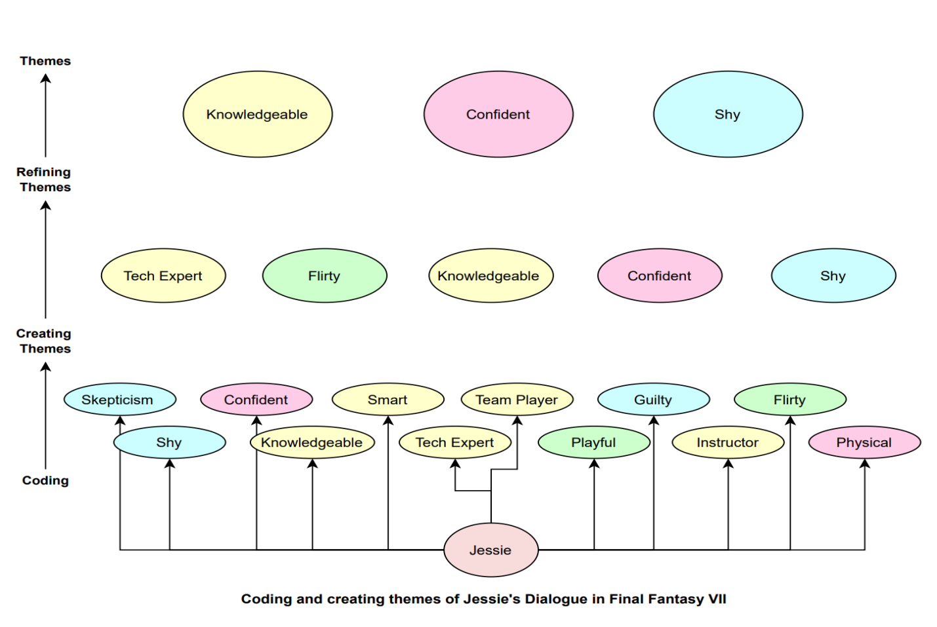

Figure 1: Codes and Themes of Jessie's Dialogue in Final Fantasy VII

In *Final Fantasy VII Remake*, Jessie has considerably more dialogue. The same themes are observable (see figure 2), but the proportion of dialogue devoted to each theme has changed (see Figure 3). 10% of lines are spent on technical ability/knowledge, 8% on dispensing information, and 82% on personality revealing dialogue. Jessie's character has changed in the remake to being less introverted and insecure toward the main PC and more confident, energetic and flirty. While the character still maintains her knowledgeable persona, it is more subtle when she acts explicitly as a technical expert, since there is less emphasis on Jessie deciphering 'code panels'. Instead, her character serves as more of a romantic interest for the player character (Cloud), being more playful, teasing, passionate, flirtatious and charismatic.

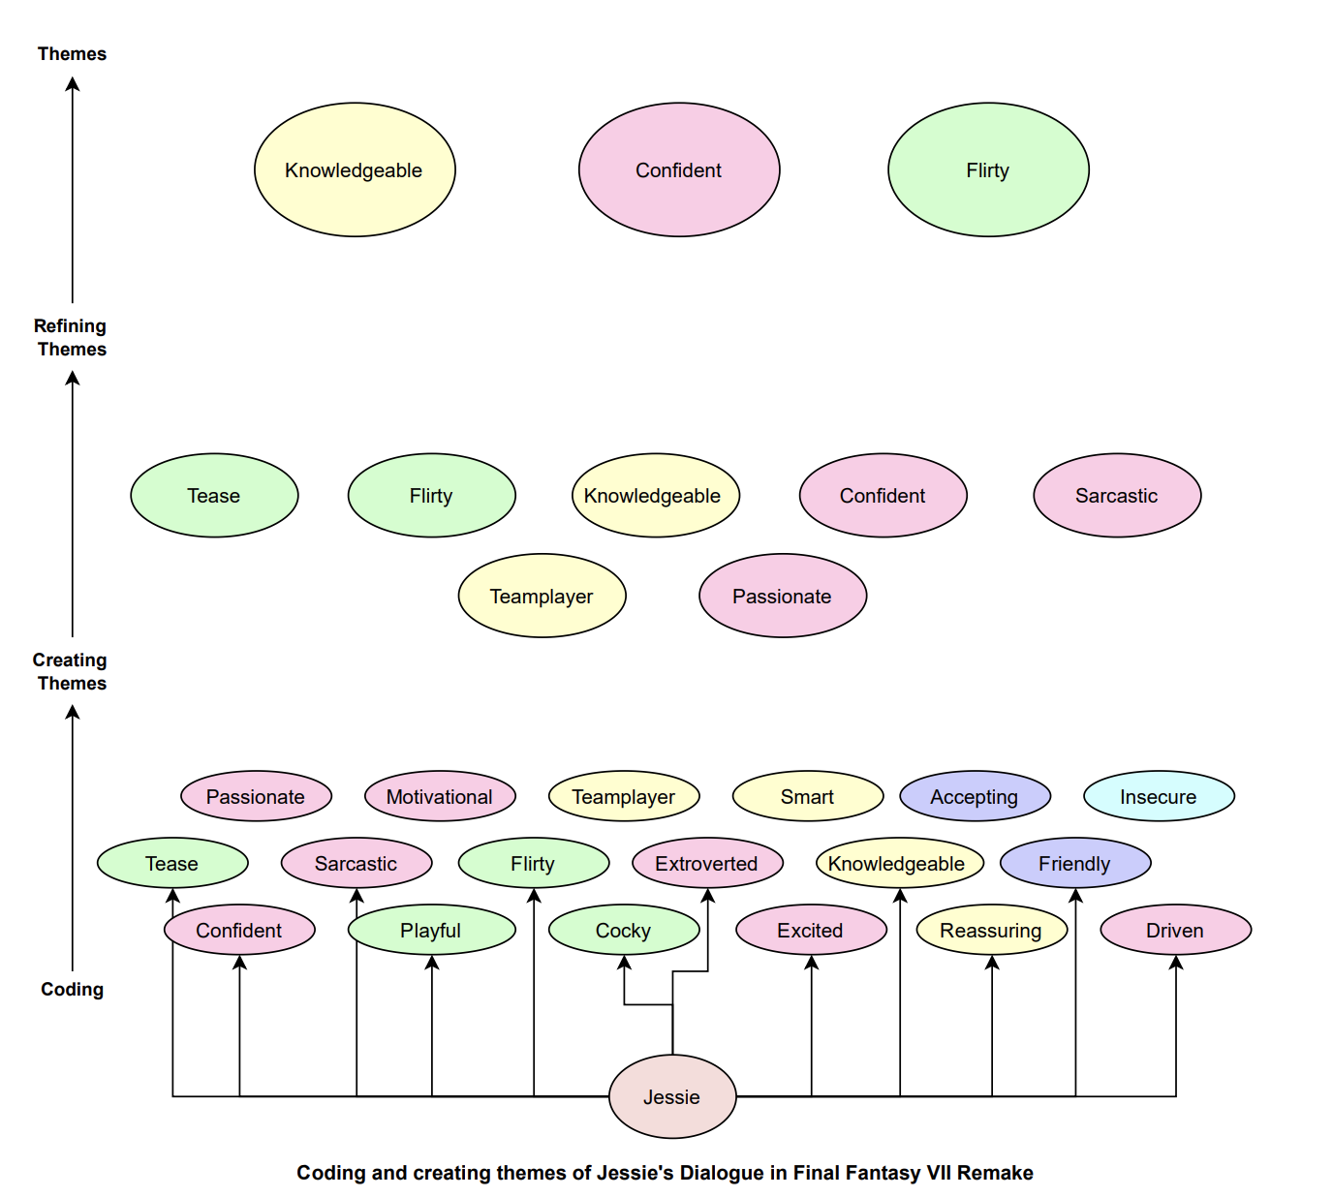

Figure 2: Codes and Themes of Jessie's Dialogue in Final Fantasy VII Remake

Figure 3: Functions of Jessie's Dialogue in Final Fantasy VII Remake

**Direct Comparison**

In the original script, Jessie’s character has 32 lines of dialogue, confining the Original Jessie to a minor supporting role. These lines are reflected in the Remake but are significantly expanded upon. This allowed for considerable character development from Jessie being a technical and bomb expert to being an unbridled, passionate and 'unforgettable' character (CBR, 2021).

For example, Table 1 shows a comparison between scenes. In the remake, Jessie's attraction towards Cloud is more explicit (see lines 1, 3, 4), and we gain more insight into her personality (confidence, sarcasm, flirtatiousness). This is the player's first introduction to Jessie's character; it is noticeable that the choice has been made to expand on her reaction towards Cloud rather than her technical expertise and knowledge.

|  |  |  |
| --- | --- | --- |
|  | **FINAL FANTASY VII** | **FINAL FANTASY VII Remake** |
| 1 | SOLDIER? Aren't they the enemy? What's he doing with us in AVALANCHE? | So, what's SOLDIER boy's deal? Is he one of us now? He's got balls, this, uh...  Uh... what was his name again? |
| 2 |  | Right. |
| 3 | Real joy to look at too. |
| 4 | Looks are what people notice first. |
| 5 | I'd say you're not even reading the same book. |
| 6 | Or even the same— |

***Table 1****: Jessie’s introduction to the main PC*

Example 2 similarly shows two scenes where Jessie expresses regret over making a mistake with the bomb. There are several differences: In the original, she reacts to the news, while in the remake she initiates the conversation by talking about her own failure. In the original, she seeks reassurance from Cloud (a man) about whether she is to blame, while in the remake she expresses her own thoughts. In the original, she initially blames the computer instructions then expresses that she must have made a mistake, while in the remake she searches for technical explanations and explicitly accepts the blame. Finally, Jessie expressive positive aspects of the event, but in the original she frames the event as a debut success, while in the remake she frames it as a learning experience, highlighting her value of learning. Taken together, the remake portrays Jessie as more thoughtful, proactive, less dependent on others’ opinions, and with a greater focus on technical expertise.

***Example 2:*** *Jessie discusses the explosion*

**Original:**

Jessie: Oops... Hey, look at the news... What a blast. Think it was all because of my bomb? But all I really did was just make it like the computer told me. Oh no! I must've made a miscalculation somewhere. Hey, that was my bomb's debut. Makes me kinda proud.

**Remake:**

Jessie: I can't stop thinking about it. The bomb I made shouldn't have produced an explosion that big. It doesn't make any sense... ,

Cloud: The explosion triggered a reaction with the mako. You said so yourself.,

Jessie: That was my first guess—but shouldn't a reactor have fail—safes to prevent that kinda thing? You mentioned \invisible enemies\ back there, right?,

Cloud: Right.

Jessie: Hmm... No. I'm just looking for excuses for something that was clearly my own fault. Gotta own up to it if I'm gonna learn from this and move on. Thanks, Cloud. You're a good listener.

*In a later scene ...*

Jessie: Just so you know, I'm not going plateside for the reason they think I am. Look—you saw the way the reactor went up. It was huge, right?,

Cloud: Because of all the mako. Isn't that what you said?,

Jessie: Yeah... that was wishful thinking. Deep down, I know it was my fault. I used a more powerful blasting agent than the directions called for. It had nothing to do with the mako.

Finally, Example 3 demonstrates Jessie's significant character development in her death sequence, where Jessie has nearly twice as many words in the remake as in the original. In both versions, Jessie expresses an attraction to the main player character (Cloud). In the original, this is subtle, mentioning her desire to talk to Cloud, and that she “likes” him. This is more overt in the remake (“My hero. So gentle …”), and referencing her prior invitation for Cloud to visit her, which was previously suggested to be a date.

is significantly developed upon in the Remake. Her flirtatiousness is originally subtle (Line 3) but becomes explicit in the Remake (Line 2), as well as her sarcastic nature (Line 1, 2 and 8). Jessie’s character accepts that her death is a punishment resulting from her actions rather than as a consequence of Avalanche's combined efforts. This is clear from her shift in pronouns. Originally Jessie uses 'our' to represent the group as a whole and diminishes her role in Avalanche. This changes in the Remake where she explicitly states that they were 'her' victims and that 'she [I] had it coming'. This further indicates Jessie’s character development from only being a minor role in Avalanche’s missions to that of a character who has a defined role within the group and signifies her significance to the context of the game.

***Example 3:*** Jessie’s death scene.

**Original**

Jessie: ... Cloud... I'm glad... ... I could talk with you... one last time.

*Player is presented with two choices:*

***CHOICE 1***

Cloud: Don't say 'last'......

Jessie: That's... all right... Because... of our actions... many... ... people died... ... this probably... ... is our punishment...

***CHOICE 2***

Cloud: "Is that so..."

Jessie: ... Is... that so... ... ? Ha... ... cool... ... as usual... ex-... SOLDIER. ... always... I liked that... in you...

**Remake**

Tifa: Jessie!,

Jessie: Oh, jeez... Tifa... If you could see the look on your face... ,

Jessie: So... you're the guy... who gets to hear my last words... Heh... Lucky me.,

Cloud: Like hell they're your last.,

Jessie: It's okay, Cloud... It's okay. They were my bombs. They were all... my victims. I had it... coming.,

Jessie: My hero. So gentle... ,

Cloud: Just try to hang on!,

Jessie: So dramatic... I... I just wish that... I could've had you over again... Everyone... With Mom's cooking... I really wanted... to believe... we could... ,

Cloud: Yeah. You owe me a pizza.,

Jessie: That's right. I do. But... I don't think... ,

Jessie: Oh no... Tifa's crying. Did I say something wrong?,

Jessie: Don't you guys... have somewhere to be? It's not polite... to stare... you know... ,

Tifa: Jessie... ,

Cloud: Hey... ,

**Conclusion**

Jessie's character is expressed differently in dialogue in the two games made more than twenty years apart. Although Jessie has more dialogue in the remake and therefore has a higher representation in the overall context of the game, the content of her dialogue has changed. She moves from a character who dispenses expert information that focuses on knowledge of coding and explosives to serving more as a flirtatious romantic interest for the player character. An unfortunate ramification of her more substantive characterisation as a love interest is that, in the Remake, Jessie more neatly falls into the 'disposable woman' trope, with her death being used to motivate the main character.

**References**

Beasley, B & Standley, T. C. (2002) Shirts vs. Skins: Clothing as an Indicator of Gender Role Stereotyping in Video Games. *Mass Communication and Society*, 5:3, 279-293

Braun, V. and Clarke, V. (2017). Thematic Analysis. *The Journal of Positive Psychology*, 12(3), pp.297-298.

CBR. (2021). *Jessie Rasberry Is FINAL FANTASY VII Remake's Best Character*. [online] Available at: <https://www.cbr.com/jessie-rasberry-final-fantasy-vii-remake-best-character/> [Accessed 11 May 2021].

Dickerman, C, Christensen, J. & Kerl-McClain, S. (2008). Big Breasts and Bad Guys: Depictions of Gender and Race in Video Games. *Journal of Creativity in Mental Health*, 3(1), pp.20-29.

Final Fantasy Wiki. (2021). *FINAL FANTASY VII*. [online] Available at: <https://finalfantasy.fandom.com/wiki/Final_Fantasy_VII#Characters> [Accessed 11 May 2021].

Gamer’s Little Playground. (2020). FINAL FANTASY 7 REMAKE – ALL Jessie Scenes. Available at: https://www.youtube.com/watch?v=KDVomVk9eIg. [Accessed 11 May 2021]

Guest, G., MacQueen, K.M. and Namey, E.E. (2012). Introduction to Applied Thematic Analysis. In: Applied Thematic Analysis, Thousand Oaks, CA: SAGE Publications, Inc. pp. 3-20.

Infernix Gaming. (2020). Change in Jessie’s Death Scene – FINAL FANTASY VII Remake PS4 vs Original PS1. Available at: https://www.youtube.com/watch?v=ttDTDkhv-Wo. [Accessed 11 May 2021].

Matthews, N, Lynch, T. & Martins, . (2016). Real ideal: Investigating how ideal and hyper-ideal video game bodies affect men and women. *Computers in Human Behavior*, 59, pp.155-164.

Perry, K. (2021). Damsels and darlings: decoding gender equality in video game communities. *Feminist Media Studies*, pp.1-18.

Square (1997). Final Fantasy VII. [Video Game]

Square Enix (2020). Final Fantasy VII: Remake. [Video Game]

World of Longplays. (2016). PSX Longplay [003] FINAL FANTASY VII (part 1 of 4). Available at: https://www.youtube.com/watch?v=BOUMiEbkZUM [Accessed 11 May 2021].