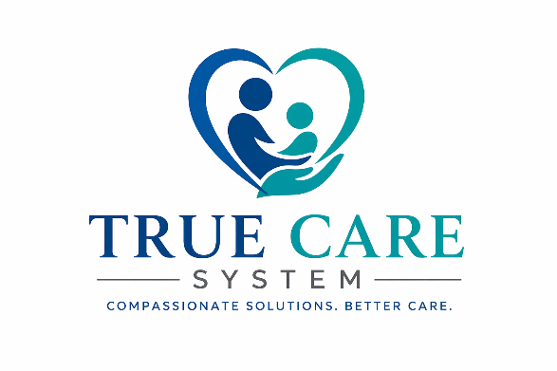
TRUE CARE SYSTEM, LLC
CONFIDENTIAL INVESTMENT MEMORANDUM

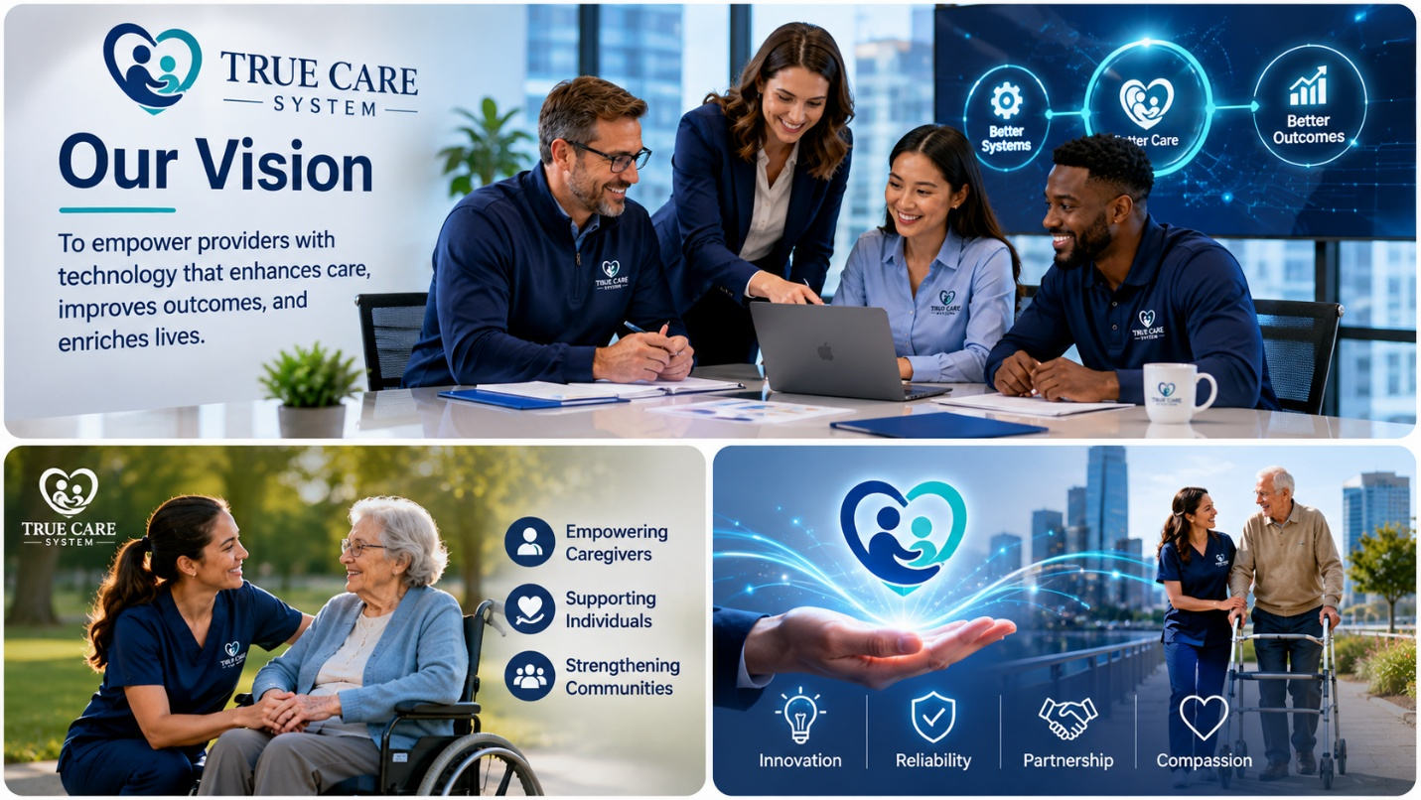

Production-Ready Healthcare SaaS Platform
Home Care • I/DD • Behavioral Health • Community-Based Services
Prepared for: Qualified Strategic Investors & Healthcare Partners

Website: http://truecaresystem.com
Email: admin@truecaresystem.com

August - 2026
Contents
SECTION I 8
EXECUTIVE OVERVIEW 8
1. Executive Summary 8
1.1 Company Overview 8
1.2 Investment Opportunity 8
1.3 Company Highlights 9
1.4 Core Technology 9
1.5 Financial Highlights 9
1.6 Investment Thesis 10
2. Investment Highlights 10
2.1 Why True Care System? 10
2.2 Key Investment Metrics 11
3. Company Overview 11
4. Mission, Vision & Core Values 11
4.1 Mission 11
4.2 Vision 12
4.3 Core Values 12
5. Investment Snapshot 12
SECTION II 13
LEADERSHIP & FOUNDER VALUE CREATION 13
1. Founder Story 13
1.1 Building a Healthcare Platform from Real-World Experience 13
1.2 Why We Built True Care System 13
2. Executive Leadership Team 14
2.1 Dr. Van Duong Chau - Founder & Chief Executive Officer 14
2.2 Thi Thuy Hang Tran, MHA - Co-Founder & Chief Operating Officer 15
2.3 Tu Chau - Co-Founder & Project Director 15
2.4 Leadership Philosophy 16
3. Historical Founder Contributions 17
3.1 Building Enterprise Value Before Seeking Investment 17
3.2 Areas of Contribution 17
4. Founders' Operational Contribution Valuation 20
4.1 Founder Commitment 20
4.2 Founder Contribution Assumptions 20
4.3 Founder Market-Equivalent Rates 21
4.4 Estimated Founders' Operational Contribution 21
4.5 Distribution of Founder Contributions 21
4.6 Why Founders' Operational ContributionMatters 22
4.7 Founder Alignment with Investors 22
5. FOUNDER DEVELOPMENT EXPENSES 23
5.1 Direct Founder-Funded Development Expenses 23
5.2 Historical Investment Categories 23
5.3 Founder Investment Philosophy 24
5.4 Historical Investment Summary 24
SECTION III 26
PRODUCT & TECHNOLOGY 26
1. Product Portfolio 26
1.1 Enterprise Healthcare Management Platform 26
1.2 Core Business Modules 26
1.3 Platform Benefits 27
1.4 Commercial Readiness 27
2. Enterprise SaaS Platform 28
2.1 Cloud-Native Architecture 28
2.2 Key Platform Capabilities 28
2.3 Designed for Growth 29
3. Mobile Applications 29
3.1 Workforce Mobility 29
3.2 Core Mobile Features 29
3.3 Supporting Healthcare Professionals 30
4. Electronic Visit Verification (EVV) 30
4.1 Supporting Regulatory Compliance 30
4.2 EVV Capabilities 30
4.3 Sandata Integration 30
5. HIPAA Compliance Framework 31
5.1 Security by Design 31
5.2 Security Features 31
5.3 Compliance Support 31
6. Artificial Intelligence Roadmap 32
6.1 Preparing for the Next Generation of Healthcare Technology 32
6.2 Planned AI Initiatives 32
7. Technology Architecture 32
7.1 Modern Technology Foundation 32
7.2 Technology Principles 33
8. Competitive Advantages 33
8.1 A Unified Healthcare Platform 33
8.2 Competitive Strengths 33
8.3 Long-Term Vision 34
SECTION IV 35
MARKET OPPORTUNITY 35
1. Industry Overview 35
1.1 A Growing Demand for Healthcare Technology 35
1.2 Industry Drivers 35
2. Target Market 36
2.1 Initial Market Focus 36
2.2 Customer Profile 36
2.3 Ideal Early Customer Profile 37
3. PHASED MARKET EXPANSION 38
3.1 Expansion Strategy 38
3.2 Role of Strategic Partners in Expansion 38
4. Competitive Landscape 39
4.1 A Competitive but Fragmented Market 39
4.2 Competitive Position 39
5. Customer Value Proposition 40
6. Growth Strategy 41
6.1 Long-Term Commercial Growth 41
6.2 Partnership-Led Growth 42
SECTION IV 43
Summary 43
SECTION V 44
BUSINESS PLAN & FINANCIAL PROJECTIONS 44
(2027–2031) 44
1. Business Objectives 44
1.1 Five-Year Strategic Objectives 44
1.2 Strategic Priorities 44
2. Five-Year Growth Plan 44
2.1 Provider Growth Projection 44
2.2 Average Active Clients per Provider 45
2.3 Total Active Clients 46
3. Pricing Strategy 46
4. Five-Year Revenue Projection 48
5. Customer Acquisition Plan 49
5.1 Net Provider Additions 49
5.2 Customer Acquisition Channels 49
5.3 Strategic Partner Contribution 50
6. Hiring Plan 50
7. Product Development Roadmap 51
8. Key Performance Indicators (KPIs) 51
9. Business Plan Summary 52
SECTION VI 54
FINANCIAL PLAN 54
1. Financial Assumptions 54
2. FIVE-YEAR ANNUALIZED REVENUE FORECAST 55
3. Cost of Revenue 55
4. Gross Profit 56
5. Operating Expense Budget 56
6. EBITDA Projection 57
7. EBITDA Margin 58
8. Cash Flow Projection 58
9. Break-even Analysis 59
10. Financial Highlights 59
SECTION VII 61
INVESTMENT OPPORTUNITY 61
1. Investment Opportunity 61
1.1 Accelerating the Next Phase of Growth 61
1.2 Strategic Partnership Approach 61
1.3 Investment Objectives 62
2. Use of Funds 63
2.1 Preliminary Allocation Framework 63
2.2 Strategic Contributions Beyond Capital 63
3. Expected Business Milestones 64
4. RISK MANAGEMENT 65
5. POTENTIAL LONG-TERM STRATEGIC OUTCOMES 66
6. INVESTMENT PROCESS AND NEXT STEPS 66
6.1 Preliminary Nature of Discussions 66
6.2 Strategic Fit Review 67
6.3 Due Diligence and Definitive Agreements 67
SECTION VII – SUMMARY 68
Appendix A 69
Executive Leadership Team 69
Appendix B 70
Product Portfolio 70
Appendix C 76
Technology Overview 76
Appendix D 79
Sandata Production Integration 79
Closing Statement 83

SECTION I

EXECUTIVE OVERVIEW

1. Executive Summary

1.1 Company Overview
True Care System, LLC is a U.S.-based healthcare technology company developing a cloud-native Software-as-a-Service (SaaS) platform for Home Care, Intellectual & Developmental Disabilities (I/DD), Behavioral Health, and Community-Based Service providers.
The platform unifies workforce management, Electronic Visit Verification (EVV), scheduling, billing, payroll, compliance, reporting, and mobile workforce operations into a single enterprise solution.
Originally developed to solve real operational challenges within a healthcare provider organization, the platform has evolved into a commercial SaaS product designed for nationwide expansion.

1.2 Investment Opportunity
True Care System is entering its commercialization phase after more than three years of product development and operational validation.
The Company is seeking strategic investment and long-term strategic partnerships to accelerate the next phase of growth, including:
- Customer acquisition
- Product development
- Engineering expansion
- Sales & marketing
- Customer success
- National market expansion
Beyond capital, True Care System welcomes partners who contribute healthcare expertise, commercialization experience, strategic relationships, operational leadership, or technology innovation. Management believes that the right strategic partnership can accelerate enterprise value creation more effectively than financial investment alone.
The objective is to establish True Care System as a leading enterprise healthcare management platform serving providers across the United States.

1.3 Company Highlights
- Founded : 2023
- Headquarters : Pennsylvania, USA
- Business Model : Software-as-a-Service (SaaS)
- Current Product Status : Production Ready
- Primary Markets
- Home Care
- I/DD Providers
- Behavioral Health
- Community-Based Services

1.4 Core Technology
- Enterprise SaaS Platform
- Native iOS & Android Applications
- Multi-Tenant Cloud Architecture
- Production Sandata EVV Integration
- HIPAA Compliance Framework
- Artificial Intelligence Ready Architecture

1.5 Financial Highlights
- Founder Development Period : October 2023 – July 2026
- Estimated Founders' Operational Contribution : $1,327,000
- Founder Development Expenses : $120,000
- Total Historical Founder Investment : $1,447,000
- Commercial Launch : 2026
- Starting Subscription Price : $25 per Active Client per Month
- Annual Price Adjustment Assumption : 5%
- Target 2027 Annual Recurring Revenue (ARR) : Approximately $1.7 Million

1.6 Investment Thesis
True Care System combines deep healthcare operational expertise with modern cloud technology to address one of the healthcare industry's most significant challenges: replacing fragmented administrative systems with a unified enterprise platform.
With a production-ready platform, validated healthcare workflows, successful production deployment, and a scalable recurring SaaS business model, True Care System has substantially reduced the technology execution risk typically associated with early-stage software companies.
Future investment is therefore expected to accelerate commercialization, customer acquisition, strategic partnerships, and nationwide expansion rather than funding the initial creation of the technology platform.

2. Investment Highlights

2.1 Why True Care System?
- Production-ready SaaS platform
- Proven healthcare operational expertise
- Recurring subscription revenue model
- Large and growing healthcare technology market
- Production Sandata EVV integration
- HIPAA-focused platform architecture
- Scalable multi-tenant cloud infrastructure
- AI-ready technology foundation
- Experienced founding team with significant personal investment
- Clear five-year commercialization strategy

2.2 Key Investment Metrics
Metric | Value
Development Period | Oct 2023 – July 2026
Founders' Operational Contribution | $1,327,000
SaaS Pricing | $25 / Client / Month
Annual Price Increase | 5%
2027 Target ARR | ~$1.7M
Target Market | U.S. Healthcare Providers
Revenue Model | Recurring SaaS Subscription

3. Company Overview
True Care System was established to modernize healthcare operations through a single, integrated technology platform.
Unlike traditional software vendors that focus on individual functions, the Company delivers an enterprise solution supporting scheduling, workforce management, EVV, billing, payroll, compliance, reporting, and mobile workforce operations within one secure cloud environment.
The platform has been developed over more than three years through continuous investment by its founders and has reached a stage where commercial expansion is now the Company's primary strategic objective.

4. Mission, Vision & Core Values

4.1 Mission
To simplify healthcare operations through innovative technology that improves efficiency, strengthens compliance, and enables providers to deliver higher-quality care.

4.2 Vision
To become one of the most trusted healthcare technology platforms supporting provider organizations across the United States.

4.3 Core Values
- Customer Success
- Innovation
- Integrity
- Security & Compliance
- Operational Excellence
- Continuous Improvement
- Long-Term Partnership

5. Investment Snapshot
Metric | Value
Development Started | October 2023
Current Status | Production Ready
Commercial Launch | 2026
Founders' Operational Contribution | $1,327,000
Founder Development Expenses | $120,000
Total Founder Investment | $1,447,000
Business Model | Healthcare SaaS
Revenue Model | Recurring Subscription
Initial Market | Pennsylvania
Expansion Strategy | Nationwide

SECTION II

LEADERSHIP & FOUNDER VALUE CREATION

1. Founder Story

1.1 Building a Healthcare Platform from Real-World Experience
True Care System was founded with a simple vision: to eliminate fragmented healthcare operations by building one integrated platform capable of managing the entire provider organization.
Rather than starting with a software concept, the founders began with firsthand experience operating a healthcare provider. Daily exposure to disconnected systems, repetitive administrative work, regulatory complexity, and inefficient workflows revealed a significant opportunity for innovation.
In October 2023, the founding team initiated the development of True Care System as a long-term technology investment. Over the following three years, they personally funded product development, led system architecture, designed healthcare workflows, and guided the platform from concept to a production-ready enterprise SaaS solution.
Today, True Care System represents the result of thousands of hours of executive leadership, software planning, healthcare operational expertise, and continuous product development—all completed prior to seeking institutional investment.
The founders are now seeking strategic partners who can complement this foundation with healthcare industry expertise, technology capabilities, commercialization experience, and access to provider networks across multiple states.

1.2 Why We Built True Care System
The founders identified several recurring challenges shared by healthcare providers:
- Fragmented software systems
- Manual administrative processes
- Increasing regulatory complexity
- Workforce shortages
- Limited operational visibility
- Inefficient billing and payroll workflows
- Lack of integrated reporting
- Rising operating costs
Instead of addressing these challenges with isolated applications, the founders chose to build a unified enterprise platform capable of supporting every major operational function within a healthcare organization.
This long-term vision continues to guide the Company's product strategy and commercial growth.

2. Executive Leadership Team

2.1 Dr. Van Duong Chau - Founder & Chief Executive Officer
Dr. Van Duong Chau is the Founder and Chief Executive Officer of True Care System, LLC.
He brings more than twenty years of executive leadership experience in organizational management, strategic planning, and educational leadership. Since relocating to the United States, he has focused on healthcare operations and technology innovation, leading the development of True Care System from its initial concept to a production-ready SaaS platform.
As CEO, Dr. Chau is responsible for:
- Corporate strategy
- Product vision
- Technology roadmap
- Enterprise architecture
- Business analysis
- System architecture and technology oversight
- Strategic partnerships
- Capital planning
- Investor relations
- Long-term business growth
His leadership has been instrumental in transforming operational healthcare experience into a scalable technology platform designed for nationwide commercialization.

2.2 Thi Thuy Hang Tran, MHA - Co-Founder & Chief Operating Officer
Thi Thuy Hang Tran serves as Co-Founder and Chief Operating Officer.
She holds a Master's Degree in Healthcare Administration and contributes extensive experience in healthcare operations, quality management, and organizational leadership.
Ms. Tran oversees operational planning, workflow optimization, customer implementation, and organizational development. She plays a key role in ensuring that the platform reflects the practical needs of healthcare providers while maintaining a strong focus on regulatory compliance and operational excellence.
Her responsibilities include:
- Healthcare operations
- Product workflow design
- Customer implementation
- Quality improvement
- Quality assurance and user acceptance testing
- Product validation
- Business operations
- Customer success

2.3 Tu Chau - Co-Founder & Project Director
Bachelor of Healthcare Administration Candidate
Tu Chau serves as Project Director and leads project coordination, implementation planning, quality assurance, and cross-functional execution.
He has contributed significantly to system implementation, testing, documentation, release management, and product quality throughout the Company's development.
His responsibilities include:
- Project management
- Product implementation
- Implementation coordination
- Release documentation
- Quality assurance
- System testing
- Documentation
- Product releases
- Customer implementation support

2.4 Leadership Philosophy
The founders believe that technology should simplify healthcare operations rather than increase administrative complexity.
Every major product decision is evaluated based on four principles:
- Improve operational efficiency.
- Strengthen regulatory compliance.
- Enhance workforce productivity.
- Deliver measurable value to healthcare providers.
This philosophy has guided the Company's development since its inception and remains central to its long-term growth strategy.
The same philosophy will guide the Company's selection of future investors and strategic partners. The founders intend to work with partners whose expertise, relationships, and long-term objectives are aligned with the mission of expanding True Care System across multiple healthcare markets.

3. Historical Founder Contributions

3.1 Building Enterprise Value Before Seeking Investment
Unlike many technology startups that seek external funding during the early development stage, the founders of True Care System chose to build a commercially viable product before approaching investors.
From October 2023 through July 2026, the founding team personally invested substantial time, expertise, leadership, and financial resources into the creation and commercialization preparation of the Company's technology platform.
Their contributions extended far beyond software development and included executive leadership, healthcare operations, business strategy, regulatory implementation, product design, customer validation, and commercialization planning.

3.2 Areas of Contribution
The founders collectively led the following initiatives:

3.2.1 Executive Leadership
- Corporate strategy
- Business planning
- Product vision
- Investment planning

3.2.2 Product Strategy
- Product roadmap
- Feature prioritization
- User experience planning
- Workflow optimization

3.2.3 Technology Development
- Enterprise architecture
- SaaS platform design
- Mobile application planning
- Cloud infrastructure
- Security architecture

3.2.4 Healthcare Operations
- Clinical workflow design
- Workforce management
- Scheduling optimization
- Billing workflows
- Payroll workflows
- Compliance processes

3.2.5 Regulatory Compliance
- HIPAA implementation
- Electronic Visit Verification (EVV)
- Sandata Production integration
- Security controls
- Audit framework

3.2.6 Commercialization
- Market research
- Product positioning
- Business model development
- Customer implementation planning
- Investor preparation

3.2.7 Historical Development Timeline
Year | Major Milestones
2023 | Product concept, healthcare workflow research, market analysis, enterprise architecture, and initial platform planning and development
2024 | Core platform modules, scheduling, workforce management, reporting, mobile foundation
2025 | Billing, Payroll, HIPAA Framework, Behavioral Support Services, and Mobile Applications
2026 | Sandata Production integration, HIPAA and audit framework expansion, production readiness, enterprise documentation, commercialization planning, and investor preparation

3.2.8 Value Creation Before External Capital
By the time the Company initiated discussions with strategic investors, the founders had already completed:
- Enterprise SaaS Platform
- Native Mobile Applications
- Multi-Tenant Cloud Architecture
- HIPAA Compliance Framework
- Production Sandata Integration
- Workforce Management System
- Billing Platform
- Payroll Foundation
- Reporting & Analytics
- Executive Dashboard
- Behavioral Support Services Module
- Enterprise Documentation Framework
This foundation significantly reduces initial technology development risk and allows future capital and strategic partnership resources to focus primarily on commercialization, customer acquisition, organizational growth, technology enhancement, and multi-state expansion.

4. Founders' Operational Contribution Valuation

4.1 Founder Commitment
Since the inception of True Care System in October 2023, the founding team has invested significant professional time, executive leadership, technical expertise, and operational knowledge into the design, development, validation, and commercialization of the Company's enterprise healthcare platform.
Rather than receiving market-rate compensation during the development phase, the founders chose to reinvest their efforts into building long-term enterprise value. This commitment enabled the Company to develop a production-ready healthcare platform before seeking external investment.
The following analysis presents an estimated market-equivalent value of the founders' professional contributions using rates associated with comparable executive, healthcare operations, technology architecture, implementation, and project leadership responsibilities.

4.2 Founder Contribution Assumptions
The estimated value of founder contributions is based on the following assumptions:
Item | Assumption
Development Period | October 2023 – July 2026
Founder Contributions | Based on each founder's actual estimated time commitment during the development period
Hourly Rates | Based on comparable market rates for executive and project leadership positions
Total Development Period | Approximately 34 Months (2.83 Years)
Total Hours of Founders | 10,600 Hours

Note: The estimated founder hours are based on each founder's level of participation, responsibilities, and time commitment during the development of True Care System from October 2023 through July 2026. The rates are intended solely to illustrate the market-equivalent value of the professional services contributed and do not represent salaries paid or amounts currently owed by the Company.

4.3 Founder Market-Equivalent Rates
Founder | Primary Roles | Market-Equivalent Rate
Van Duong Chau | Founder & CEO, Business Analyst, System Architect | $170
Thi Thuy Hang Tran | Co-Founder & COO, Healthcare Operations, QA Lead | $115
Tu Chau | Co-Founder & Project Director, Implementation, Documentation | $95

4.4 Estimated Founders' Operational Contribution
Founder | Total Hours | Market-Equivalent Rate | Estimated Value
Van Duong Chau | 3,200 | $170 | $544,000
Thi Thuy Hang Tran | 4,000 | $115 | $460,000
Tu Chau | 3,400 | $95 | $323,000
Total | 10,600 | — | $1,327,000

4.5 Distribution of Founder Contributions
The founders' contributions extended well beyond software engineering and included executive leadership, healthcare operations, strategic planning, technology architecture, commercialization, regulatory implementation, and organizational development.
Area of Contribution | Estimated Allocation
Executive Leadership & Strategic Planning | 20%
Product Strategy & Roadmap | 15%
Enterprise Architecture & Technology Leadership | 20%
Healthcare Operations & Workflow Design | 15%
Software Development Oversight | 10%
HIPAA, EVV & Regulatory Compliance | 8%
Quality Assurance & Testing | 5%
Documentation & Knowledge Management | 4%
Commercialization & Business Development | 3%

The allocation is presented as a high-level summary of the founders' collective contributions and is not intended to assign each activity exclusively to a single founder.

4.6 Why Founders' Operational ContributionMatters
The estimated Founders' Operational Contribution represents the economic value of the professional services contributed during the Company's development phase.
These contributions enabled True Care System to reach commercialization without relying on institutional venture capital during its formative years.
As a result, future investment and strategic partnership resources can be directed primarily toward customer acquisition, implementation capacity, engineering enhancement, sales and marketing, provider-network development, and multi-state expansion rather than the initial creation of the core platform.

4.7 Founder Alignment with Investors
The founders remain committed to the long-term success of True Care System.
Their objective is to build a sustainable healthcare technology company that delivers recurring revenue, continuous innovation, and long-term value for customers, employees, and shareholders.
The founders intend to remain actively involved in the Company's leadership, product direction, and long-term development following any future investment transaction. Their priority is to establish an ownership and governance structure that aligns the interests of the founders and strategic partners while supporting the strongest possible path for commercial growth.
The founders are initially prepared to consider an investment structure involving up to 49% ownership. However, they remain open to discussing alternative structures with an exceptional strategic partner whose healthcare expertise, provider relationships, technology capabilities, or commercialization resources could materially accelerate the Company's multi-state expansion and long-term value.

5. FOUNDER DEVELOPMENT EXPENSES

5.1 Direct Founder-Funded Development Expenses
In addition to contributing professional services, the founders have personally funded the development of True Care System since October 2023.
These expenses were funded without institutional financing and supported the Company's transition from concept to a production-ready enterprise SaaS platform.
The founders have financed essential infrastructure, software subscriptions, regulatory compliance activities, business operations, and commercialization efforts using personal resources.

5.2 Historical Investment Categories
Category | Description
Cloud Infrastructure | Vercel, Render, Supabase, cloud hosting services
Software Development Tools | GitHub, development software, testing tools
Mobile Platforms | Apple Developer Program, Google Play Developer Program
Domain & Web Services | Domain registration, DNS, SSL certificates
Technology Equipment | Computers, peripherals, testing devices
Office Operations | Office rent, electricity, water, internet, and office utilities
Legal & Corporate | Company formation, legal consultation, contracts
Accounting & Tax | Accounting, bookkeeping, tax preparation, and related professional services
Marketing & Branding | Website, promotional materials, brand development
Business Travel | Customer meetings, conferences, partner discussions
Miscellaneous Operating Costs | Office supplies, subscriptions, administrative expenses

5.3 Founder Investment Philosophy
Throughout the development period, the founders prioritized long-term product quality over short-term financial return.
Instead of minimizing investment during the early stages, they deliberately committed both financial resources and professional expertise to establish a scalable enterprise platform capable of supporting future commercialization.
This disciplined investment approach has resulted in a mature technology platform and significantly reduced execution risk for future investors.

5.4 Historical Investment Summary
By the end of July 2026, the founders had contributed to the Company through two primary forms of investment:

Investment Type | Estimated Value
Founders' Operational Contribution | $1,327,000
Founder Development Expenses | $120,000
Total Historical Founder Investment | $1,447,000

Founder Development Expenses represent the founders' direct out-of-pocket expenditures incurred during the development and commercialization preparation of True Care System, including technology infrastructure, software and cloud services, office operations, equipment, legal and professional services, marketing, business development, and other project-related operating expenses.
The total historical founder investment is presented as evidence of the founders' financial and professional commitment and should not be interpreted as an independent valuation of the Company.

SECTION III

PRODUCT & TECHNOLOGY

1. Product Portfolio

1.1 Enterprise Healthcare Management Platform
True Care System is a cloud-based Software-as-a-Service (SaaS) platform designed to help healthcare providers manage their daily operations through a single, integrated solution.
The platform is designed to reduce reliance on fragmented software systems by providing a unified environment for healthcare operations, workforce management, compliance, billing, payroll, reporting, and mobile workforce activities.
Designed with scalability in mind, the platform supports organizations ranging from small agencies to multi-location healthcare providers.

1.2 Core Business Modules
The platform currently includes the following integrated modules:
- Dashboard & Business Intelligence
- Provider Management
- Individual Management
- Employee Management
- Scheduling & Workforce Management
- Electronic Visit Verification (EVV)
- Billing & Claims Management
- Payroll Management
- Human Resources
- Behavioral Support Services (BSS)
- Health & Incident Reporting
- Compliance Management
- Document Management
- Reporting & Analytics
- System Administration
These categories represent the platform's primary commercial and operational modules. The detailed engineering development model presented later in this memorandum separates certain platform capabilities, infrastructure functions, mobile applications, security controls, and deployment activities into additional technical work modules for estimation purposes.
The modules operate within a shared data environment, allowing information to move across authorized workflows while reducing duplicate data entry and improving operational visibility

1.3 Platform Benefits
Depending on customer configuration, implementation, and use, True Care System is intended to help healthcare providers:
- Improve operational efficiency
- Streamline workforce management
- Enhance regulatory compliance
- Reduce administrative workload
- Increase billing accuracy
- Improve reporting and decision-making
- Support mobile field staff
- Scale operations through cloud technology

1.4 Commercial Readiness
Following approximately 34 months of development and operational validation, the platform has reached commercial readiness, with core workflows operating in a production environment and additional capabilities continuing to be enhanced.
The Company's ongoing product strategy focuses on controlled enhancement, implementation readiness, security, scalability, and usability as the platform enters broader commercialization.

2. Enterprise SaaS Platform

2.1 Cloud-Native Architecture
True Care System is built as a cloud-native Software-as-a-Service platform, enabling healthcare organizations to securely access the system from any location without maintaining on-premises infrastructure.
The platform is designed to support multiple provider organizations within a secure multi-tenant environment using provider-level access controls and logical separation of customer data.

2.2 Key Platform Capabilities
- Cloud-based deployment with security controls
- Multi-tenant architecture
- Role-based access control
- Near-real-time data synchronization across supported workflows
- Centralized document management
- Configurable workflows
- Automated notifications
- Comprehensive reporting
- Scalable infrastructure
- Controlled software releases and updates

2.3 Designed for Growth
The platform architecture supports future expansion through modular development, allowing new features, integrations, and healthcare programs to be introduced with limited impact on existing operations when properly planned and tested.
This modular design is intended to help the Company respond to evolving customer needs, operating models, and regulatory requirements.

3. Mobile Applications

3.1 Workforce Mobility
True Care System includes mobile applications for iOS and Android, enabling field staff to perform supported job functions while working in community-based settings.
The mobile experience is designed to simplify field workflows, improve communication between office and direct-care staff, and provide timely access to authorized operational information.

3.2 Core Mobile Features
- Employee scheduling
- Visit management
- Electronic Visit Verification (EVV)
- GPS-supported check-in and check-out
- Shift notifications
- Shift claim functionality
- Health & Incident reporting
- Authorized document access
- Operational alerts and communication
- Assigned task visibility

3.3 Supporting Healthcare Professionals
By providing authorized information and workflow tools directly to field staff, the mobile applications are intended to reduce paperwork, support more timely documentation, and improve communication between caregivers and office personnel.

4. Electronic Visit Verification (EVV)

4.1 Supporting Regulatory Compliance
Electronic Visit Verification (EVV) is an essential component of healthcare service delivery and regulatory compliance.
True Care System incorporates EVV functionality into scheduling and workforce workflows to support visit capture, documentation, review, and required data exchange.

4.2 EVV Capabilities
- Mobile visit check-in and check-out
- GPS-supported location capture
- Visit and service documentation
- Visit exception review
- Service verification
- Audit history
- Compliance-oriented reporting

4.3 Sandata Integration
rue Care System includes a production integration pathway with Sandata for the transmission of supported employee, client, and visit records. The integration has been implemented and tested using production endpoints and is intended to support participating providers' EVV data-submission workflows.
Provider eligibility, payer requirements, Sandata configuration, data acceptance, and ongoing compliance remain subject to the applicable program rules, implementation requirements, and third-party systems.

5. HIPAA Compliance Framework

5.1 Security by Design
Protecting healthcare information is a core design principle of True Care System.
The platform incorporates administrative, technical, application, and operational controls intended to support healthcare organizations in managing sensitive information securely and responsibly.

5.2 Security Features
- Role-based permissions
- User authentication and session controls
- Audit logging
- User and activity history
- PHI access monitoring
- Secure application communications
- Encryption controls for supported data flows and storage services
- Security event tracking
- Provider-level data isolation
- Support-session and impersonation audit history

5.3 Compliance Support
True Care System is designed to assist healthcare providers in maintaining operational processes that align with applicable privacy and security requirements while supporting accountability and transparency throughout the organization.
Use of the platform does not, by itself, establish or guarantee a customer's compliance with HIPAA or other legal requirements. Each provider remains responsible for its own policies, workforce practices, risk assessments, configurations, and regulatory obligations.

6. Artificial Intelligence Roadmap

6.1 Preparing for the Next Generation of Healthcare Technology
Artificial Intelligence (AI) represents an important opportunity to improve operational efficiency, automate administrative tasks, and support data-driven decision-making within healthcare organizations.
True Care System has been designed with a flexible architecture that will support the future integration of AI-powered capabilities.

6.2 Planned AI Initiatives
Subject to available resources, customer demand, regulatory review, and appropriate governance, future development may include:
- Intelligent scheduling assistance
- Workforce optimization
- Predictive staffing analysis
- Operational analytics
- Automated documentation support
- Compliance monitoring
- Executive decision support
- Business performance insights
Any future AI capabilities are expected to be introduced in phases and evaluated for privacy, security, human oversight, data quality, clinical and operational appropriateness, and applicable regulatory requirements.

7. Technology Architecture

7.1 Modern Technology Foundation
True Care System is built using modern cloud technologies that emphasize scalability, reliability, security, and maintainability.
The platform follows a modular application architecture, allowing major functional areas to be maintained and enhanced within a unified enterprise ecosystem.

7.2 Technology Principles
- Cloud-based infrastructure
- Modular application architecture
- Secure API communication
- Scalable database design
- Web and mobile accessibility
- Controlled CI/CD and release management
- Availability, backup, and recovery planning
- Layered security controls
- Multi-tenant provider isolation
- Auditability and operational monitoring
These principles provide a practical foundation for continued product development, customer growth, security enhancement, and long-term system maintainability.

8. Competitive Advantages

8.1 A Unified Healthcare Platform
Unlike many solutions that require providers to manage multiple disconnected systems, True Care System delivers an integrated platform designed to support key operational, administrative, workforce, reporting, and compliance-related workflows within healthcare provider organizations.

8.2 Competitive Strengths
- Unified enterprise platform
- Built from real provider operating workflows
- Integrated workforce management
- Mobile applications for field staff
- Electronic Visit Verification (EVV)
- Production Sandata integration pathway
- HIPAA-focused security and audit framework
- Cloud-based deployment
- Scalable multi-tenant architecture
- Modular product design
- Operational and financial reporting
- Continuous product improvement

8.3 Long-Term Vision
The Company's long-term objective is to expand True Care System into a multi-state healthcare SaaS platform serving provider organizations across a range of home- and community-based service models.
Achieving this objective will require continued product development, regulatory adaptation, implementation capacity, customer support, and strategic partnerships with individuals or organizations that contribute healthcare expertise, technology capabilities, market access, or provider-network relationships.
The Company intends to pursue this growth in a disciplined manner while maintaining a strong focus on security, operational usefulness, customer success, and sustainable recurring revenue.

SECTION IV

MARKET OPPORTUNITY

1. Industry Overview

1.1 A Growing Demand for Healthcare Technology
Healthcare providers in the United States continue to face increasing administrative, workforce, reimbursement, documentation, and compliance demands. These operating challenges create a practical need for technology platforms that help organizations coordinate staff, manage service delivery, maintain records, support billing workflows, and improve access to operational information.
Cloud-based healthcare software can help providers consolidate selected functions within a common operating environment. However, purchasing decisions are typically influenced by product reliability, regulatory fit, implementation requirements, pricing, customer support, and the provider's existing technology environment.
True Care System is being developed and commercialized in response to these practical operating needs, with an initial focus on organizations delivering home- and community-based services.

1.2 Industry Drivers
Several long-term trends are contributing to sustained demand for healthcare management software:
- Growth in home- and community-based services
- Increasing regulatory and documentation requirements
- Workforce shortages and scheduling complexity
- Digital transformation initiatives
- Demand for operational efficiency
- Increasing focus on service quality, accountability, and measurable outcomes
- Growing reliance on mobile tools for field-based and community-based workforces
- Need for improved coordination between office personnel and direct-care staff

These conditions create an opportunity for healthcare-focused SaaS platforms that can demonstrate practical workflow value, dependable implementation, appropriate security controls, responsive customer support, and alignment with provider operating requirements.

2. Target Market

2.1 Initial Market Focus
True Care System's initial commercialization strategy focuses on healthcare providers delivering home- and community-based services in Pennsylvania, where the founders have direct operating experience and familiarity with provider workflows, workforce requirements, Electronic Visit Verification, and state-specific administrative processes.
The Company's initial target customers include organizations providing:
- Home Care Services
- Intellectual and Developmental Disabilities (I/DD) Services
- Behavioral Health Services
- Home- and Community-Based Programs
- Residential and Community Living Services
This focused approach is intended to help the Company refine customer onboarding, implementation, support, pricing, and product-market fit before committing substantial resources to additional states.

2.2 Customer Profile
The platform is designed for healthcare organizations seeking to reduce dependence on multiple disconnected systems and manage selected operational functions within a more integrated environment.
- Typical customers include providers that require:
- Workforce scheduling and employee coordination
- Mobile support for field-based staff
- Electronic Visit Verification (EVV)
- Visit review and service documentation
- Billing and payroll workflow support
- Compliance-related workflow and audit support
- Operational and financial reporting
- Multi-location or multi-program management
- Role-based access and provider-level data controls

2.3 Ideal Early Customer Profile
During the initial commercialization phase, True Care System expects to prioritize providers that:
Customer Characteristic | Initial Fit
Geographic Focus | Pennsylvania-based or operating in nearby markets
Service Model | Home Care, I/DD, Behavioral Health, residential, or community-based services
Operational Need | Seeking improved coordination across scheduling, workforce, EVV, billing, payroll, compliance, and reporting
Organization Size | Small to mid-sized providers with growth potential
Implementation Readiness | Management team prepared to participate in workflow review, data preparation, training, and onboarding
Technology Need | Interested in consolidating selected operational functions within a cloud-based platform
Partnership Potential | Willing to provide structured product feedback during early commercialization

3. PHASED MARKET EXPANSION

3.1 Expansion Strategy
The Company intends to pursue geographic expansion in stages, allowing product configuration, implementation procedures, customer support capacity, regulatory review, and commercial resources to develop alongside customer growth.
- Phase 1: Pennsylvania
Acquire initial provider customers, validate pricing and onboarding assumptions, refine implementation procedures, and strengthen customer support processes.
- Phase 2: Neighboring States
Evaluate and enter selected neighboring or regional states based on provider demand, regulatory requirements, EVV integration needs, implementation cost, and the availability of qualified partners or customer relationships.
- Phase 3: National Expansion
Pursue broader multi-state expansion in markets where the Company has demonstrated product fit, implementation capability, regulatory readiness, customer support capacity, and a sustainable customer acquisition model.
This phased approach is intended to reduce expansion risk, preserve implementation quality, and allow management to allocate product, compliance, sales, and support resources according to demonstrated market demand.

3.2 Role of Strategic Partners in Expansion
Multi-state expansion will require more than financial capital. It will also require knowledge of state-specific provider operations, Medicaid and EVV environments, implementation practices, enterprise sales, customer support, and healthcare technology commercialization.
True Care System therefore welcomes strategic partners who can contribute one or more of the following:
- Healthcare provider relationships
- Multi-state operating experience
- Enterprise healthcare sales capabilities
- Technology architecture and product development expertise
- EVV, billing, payroll, or compliance knowledge
- Customer implementation and support infrastructure
- Industry association or channel relationships
- Strategic guidance and governance experience
Management believes that a qualified strategic partner may materially reduce the time, cost, and execution risk associated with entering additional markets.

4. Competitive Landscape

4.1 A Competitive but Fragmented Market
Healthcare providers often rely on multiple software systems to manage scheduling, billing, payroll, compliance, reporting, and workforce operations.
This fragmented approach increases administrative effort, creates duplicate data entry, and limits operational visibility.
True Care System is designed to address selected aspects of this fragmentation by bringing core workforce, visit, EVV, billing, payroll, compliance-related, reporting, and mobile workflows into a shared platform environment.

4.2 Competitive Position
True Care System competes by emphasizing:
- Product design informed by direct provider operating experience
- Integrated Web and mobile workflows
- Scheduling, visit management, and EVV within a shared environment
- Production Sandata integration pathway
- Multi-tenant provider architecture
- Role-based access and provider-level data isolation
- HIPAA-focused audit and access-history framework
- Support for billing, payroll, BSS, reporting, and administrative workflows
- Modular architecture intended for continued product expansion
- Direct founder involvement in product and customer implementation

Rather than competing solely on individual features, the Company intends to differentiate through practical workflow integration, founder-led implementation knowledge, responsive product development, and a platform designed around the operating needs of home- and community-based service providers.
The Company has not completed an independent competitive market study, and the healthcare software market includes established vendors with greater financial resources, larger customer bases, broader integration networks, and longer operating histories. True Care System's ability to compete will depend on product reliability, implementation quality, pricing, customer support, continued innovation, and successful market execution.

5. Customer Value Proposition
Supporting More Coordinated Healthcare Operations: True Care System is designed to help healthcare providers reduce administrative complexity while improving visibility across daily operations. Actual outcomes will depend on customer implementation, data quality, staff adoption, workflow configuration, training, and continued management involvement.
Key customer benefits include:
- More centralized access to operational information
- Reduced duplicate data entry across supported workflows
- Improved visibility into scheduling and workforce activities
- Better coordination between office personnel and field employees
- Support for EVV, audit, and compliance-related processes
- More consistent access to operational and financial reports
- Support for billing review and payroll preparation
- Timelier access to visit, employee, and individual information
- Mobile workflow support for direct-care staff
- Improved management visibility through dashboards and reporting

By integrating selected functions within a shared platform, providers may be able to reduce administrative fragmentation and direct more management attention toward service quality, workforce support, and organizational growth.

6. Growth Strategy

6.1 Long-Term Commercial Growth
The Company's growth strategy is built around sustainable expansion rather than rapid customer acquisition.
Key strategic priorities include:
- Disciplined customer acquisition
- Continued product enhancement
- Reliable implementation and customer support
- Customer retention and account growth
- Expansion into selected healthcare markets
- Strategic healthcare and technology partnerships
- Repeatable onboarding and implementation processes
- Ongoing investment in security, infrastructure, and product quality
- Development of referral, channel, and provider-network relationships
- Careful adaptation to state-specific regulatory and EVV requirements
This approach is intended to support recurring revenue growth while allowing the Company to manage implementation quality, customer support demands, product development priorities, and the financial requirements of multi-state expansion.

6.2 Partnership-Led Growth
Management recognizes that the Company's growth may be accelerated through partnerships with healthcare operators, technology professionals, industry advisors, provider networks, and organizations with established customer relationships.
The founders are prepared to evaluate partnership structures based not only on financial investment, but also on the strategic value a partner can contribute through:

Strategic Contribution | Potential Value to True Care System
Provider Network Access | Shorter customer acquisition cycle and stronger market entry
Healthcare Operating Expertise | Improved product fit and implementation planning
Multi-State Experience | Better understanding of state-specific operating and regulatory requirements
Technology Expertise | Faster product enhancement, integration, security, and scalability
Enterprise Sales Capability | Stronger commercial pipeline and account development
Implementation Infrastructure | Increased capacity to onboard and support provider organizations
Industry Relationships | Greater access to associations, referral channels, and strategic alliances
Governance Experience | Stronger planning, accountability, and long-term organizational development

The founders' objective is to select partners whose participation can increase the probability and speed of sustainable commercial success, rather than evaluating potential partners solely on the amount of capital offered.

SECTION IV

Summary

Healthcare providers continue to face administrative complexity, workforce challenges, documentation requirements, EVV obligations, billing demands, and the need for better operational visibility. These conditions create an opportunity for integrated healthcare technology platforms that can demonstrate reliability, practical workflow value, appropriate security controls, and responsive implementation support.
True Care System plans to begin broader commercialization with Pennsylvania providers in the Home Care, I/DD, Behavioral Health, residential, and community-based service sectors. This initial market focus is intended to allow the Company to refine onboarding, customer support, pricing, product configuration, and implementation procedures before entering additional states.
Future expansion will be pursued in phases and will depend on demonstrated customer demand, product readiness, regulatory requirements, financial resources, implementation capacity, and the availability of qualified strategic partners. The Company is particularly interested in partners who can contribute healthcare expertise, technology capabilities, commercialization experience, provider-network relationships, or multi-state operating knowledge in addition to financial capital.
By combining a recurring SaaS model with disciplined market entry, continued product development, and strategic collaboration, management intends to build a sustainable healthcare technology business serving provider organizations across multiple states.

SECTION V

BUSINESS PLAN & FINANCIAL PROJECTIONS

(2027–2031)

1. Business Objectives

1.1 Five-Year Strategic Objectives
True Care System's five-year objective is to establish a sustainable multi-state healthcare SaaS business serving Home Care, I/DD, Behavioral Health, and Community-Based service providers.
Over the next five years, the Company will focus on expanding its customer base, strengthening its technology platform, developing strategic partnerships, and building an organization capable of supporting recurring revenue growth across multiple states.

1.2 Strategic Priorities
- Build an initial provider customer base in Pennsylvania
- Refine onboarding, implementation, training, and support processes
- Enter selected additional states based on demonstrated demand and regulatory readiness
- Continue product, security, and infrastructure development
- Develop strategic healthcare and technology partnerships
- Build repeatable sales and customer-acquisition processes
- Target customer satisfaction and retention above 95%
- Pursue sustainable recurring subscription revenue growth

2. Five-Year Growth Plan

2.1 Provider Growth Projection
The following growth plan represents management's current planning assumptions rather than guaranteed results. Actual provider and client growth will depend on capital availability, customer acquisition, implementation capacity, strategic partnerships, product readiness, regulatory requirements, and market conditions.
Year | Providers | Year-over-Year Growth
2027 | 22 | —
2028 | 34 | 55%
2029 | 50 | 47%
2030 | 68 | 36%
2031 | 90 | 32%

Provider counts represent active subscribing provider organizations projected at year-end.

2.2 Average Active Clients per Provider
Average active clients per provider are planning assumptions based on the Company's intended customer profile and may vary materially by provider size, service model, location, and implementation scope.
Year | Average Clients
2027 | 260
2028 | 290
2029 | 320
2030 | 350
2031 | 380

2.3 Total Active Clients
Year | Clients
2027 | 5,720
2028 | 9,860
2029 | 16,000
2030 | 23,800
2031 | 34,200

Total active clients are calculated by multiplying projected active providers by the projected average active clients per provider for each year.

3. Pricing Strategy
True Care System intends to generate recurring revenue through a Software-as-a-Service subscription model based primarily on the number of active clients managed within the platform.
Management has established an initial reference price of approximately $30 per active client per month. To reduce the financial and operational barriers associated with adopting a new healthcare management platform, the founders propose an introductory commercialization program consisting of:
- A three-month trial period for qualified provider organizations;
- An introductory subscription fee of $25 per active client per month following the trial period; and
- An assumed annual price adjustment of approximately 5% during the five-year planning period.
The trial period is intended to give participating providers an opportunity to evaluate the platform, train staff, configure workflows, and assess its practical value before beginning regular subscription payments. The introductory pricing is intended to support early customer adoption, build reference accounts, collect structured product feedback, and strengthen long-term customer relationships.

Introductory Subscription Pricing
Year | Monthly Fee per Active Client | Pricing Position
2027 | $25.00 | Introductory commercial rate
2028 | $26.25 | Gradual annual adjustment
2029 | $27.56 | Gradual annual adjustment
2030 | $28.94 | Approaching standard reference price
2031 | $30.39 | Approximate normalized market rate

The pricing projection assumes an average annual adjustment of approximately 5%. Actual pricing may vary based on product scope, provider size, implementation requirements, contract terms, competitive conditions, inflation, customer support requirements, and additional functionality.
The three-month trial and introductory subscription rate are intended as initial customer-acquisition and marketing strategies. Eligibility, trial scope, onboarding support, data preparation requirements, and conversion terms will be defined through the applicable customer agreement.
Management may also introduce minimum monthly fees, implementation charges, training services, premium modules, integration services, or enterprise pricing in future periods. These potential revenue sources are not included in the core subscription projections presented below unless otherwise stated.
Pricing Governance
The pricing structure presented in this memorandum reflects the founders’ current preliminary commercialization strategy. It is not intended to restrict future management decisions or establish a permanent pricing policy.
Following the admission of a strategic investor or partner, pricing, trial programs, discounts, contract terms, and customer-acquisition policies will be reviewed collaboratively based on market conditions, customer feedback, competitive positioning, financial objectives, and the long-term interests of True Care System.
The founders are committed to maintaining a practical and collaborative approach. They are prepared to revise the proposed pricing model and related commercial policies when a different strategy is reasonably expected to improve customer adoption, recurring revenue, market expansion, or the long-term value of the Company.

4. Five-Year Revenue Projection
Annualized Subscription Revenue Projection
Year | Clients | Monthly Fee | Annual Revenue
2027 | 5,720 | $25.00 | $1,716,000
2028 | 9,860 | $26.25 | $3,105,900
2029 | 16,000 | $27.56 | $5,291,520
2030 | 23,800 | $28.94 | $8,265,264
2031 | 34,200 | $30.39 | $12,472,056
Five-Year Cumulative Projected Revenue: Approximately $30.9 Million

Revenue Projection Note: The figures above represent an annualized subscription revenue model based on the projected active client counts and stated monthly fees. Actual recognized revenue may be lower, particularly during the initial commercialization period, because qualified providers may receive a three-month trial, customers may be onboarded at different times throughout the year, and active client counts may fluctuate. Accordingly, these projections are intended for business-planning purposes and should not be interpreted as guaranteed cash-revenue results.

5. Customer Acquisition Plan

5.1 Net Provider Additions
Year | New Providers
2027 | 22
2028 | 12
2029 | 16
2030 | 18
2031 | 22

Net provider additions represent new provider customers after considering potential customer attrition.

5.2 Customer Acquisition Channels
The Company intends to acquire customers through a combination of direct, referral, partnership, and industry-based channels, including:
- Direct sales
- Referral programs
- Strategic partnerships
- Healthcare conferences
- Digital marketing
- Industry associations
- Founder and provider relationships
- Channel and implementation partners
- Demonstration and pilot engagements
Customer acquisition priorities and spending will be adjusted based on channel performance, customer acquisition cost, implementation capacity, sales-cycle length, and customer retention.

5.3 Strategic Partner Contribution
Strategic partners may support customer acquisition by introducing the Company to provider networks, healthcare associations, enterprise customers, implementation organizations, technology partners, and state-specific industry relationships.
Management will evaluate strategic partners based on the quality and relevance of their market access, healthcare expertise, commercialization capabilities, and ability to support sustainable customer adoption—not solely on the amount of capital invested.

6. Hiring Plan
Planned Year-End Operating Team
Department | 2027 | 2028 | 2029 | 2030 | 2031
Engineering | 2 | 4 | 4 | 5 | 5
Sales & Marketing | 2 | 3 | 4 | 5 | 6
Customer Success & Technical Support | 1 | 2 | 3 | 4 | 5
Administration & Operations | 1 | 2 | 2 | 3 | 3
Total Employees | 6 | 11 | 13 | 17 | 19

The table reflects planned year-end operating headcount and excludes the three founders unless otherwise stated.
Hiring will be phased according to customer growth, implementation demand, available capital, partner capabilities, and operating performance. Certain functions may initially be supported by founders, contractors, or strategic partners before conversion to full-time positions.

7. Product Development Roadmap
Planned Product Expansion
2027
- AI-assisted scheduling evaluation and development
- Enhanced reporting
- Customer self-service portal
2028
- Expanded payroll automation
- Advanced operational analytics
- Configurable workflow automation
2029
- AI-assisted documentation capabilities
- Predictive staffing analysis
- AI-supported executive insights
2030
- Multi-state compliance configuration framework
- Enterprise API and integration framework
- Selected third-party integrations
2031
- Expanded AI-enabled operational capabilities
- Broader multi-state commercialization
- Enterprise-scale customer support capabilities

8. Key Performance Indicators (KPIs)
The Company will monitor the following performance indicators:
KPI | 2027 Planning Target
Active Providers | 22
Active Clients | 5,720
Annualized Subscription Revenue | Approximately $1.7M
Customer Retention | 95% or higher
System Availability | 99.5% or higher
Customer Satisfaction | 90% or higher
Standard Implementation Time | 30–60 Days
Customer Support Response | Defined service-level targets
Gross Revenue Retention | To be monitored after commercial launch

9. Business Plan Summary
Over the 2027–2031 planning period, True Care System intends to pursue a phased commercialization strategy focused on provider adoption, recurring subscription revenue, product quality, implementation capacity, customer support, and controlled multi-state expansion.
The business plan assumes growth from 22 active provider organizations and approximately 5,720 active clients in 2027 to 90 providers and approximately 34,200 active clients by 2031. Pricing begins at $25 per active client per month in 2027, with an assumed annual adjustment of approximately 5%. Based on these assumptions, annualized subscription revenue could increase from approximately $1.7 million in 2027 to approximately $12.5 million by 2031.
These figures are management planning projections rather than guaranteed results. Actual performance will depend on provider acquisition, onboarding timing, customer retention, implementation capacity, regulatory readiness, product performance, available capital, competitive conditions, and the contribution of strategic partners.
Management believes the most valuable investor relationship will combine financial resources with healthcare expertise, technology capabilities, provider-network access, commercialization experience, or implementation infrastructure. Such a partnership may help True Care System enter additional states more efficiently and build a stronger long-term healthcare technology business.

SECTION VI

FINANCIAL PLAN

1. Financial Assumptions
The financial projections presented in this memorandum are based on management's current operating assumptions and are intended solely for planning purposes.
These projections are not guarantees of future performance. Actual results may vary materially based on customer acquisition timing, trial periods, onboarding schedules, active client volumes, pricing decisions, customer retention, hiring, infrastructure requirements, market conditions, available capital, and strategic partner contributions.
Key Assumptions
Assumption | Planning Basis
Standard Reference Price | Approximately $30 per Active Client per Month
Introductory Subscription Fee (2027) | $25 per Active Client per Month
Initial Trial Program | Up to 3 Months for Qualified Providers
Annual Price Adjustment | Approximately 5%
Customer Retention Target | 95% or Higher
Gross Margin Planning Target | 80%
General Inflation Assumption | 3%
Corporate Income Taxes | Excluded from Projections
Projection Period | 2027–2031

The introductory trial and pricing programs reflect the founders' current preliminary commercialization strategy and may be revised collaboratively following the admission of a strategic investor or partner.

2. FIVE-YEAR ANNUALIZED REVENUE FORECAST
Year | Annualized Subscription Revenue
2027 | $1,716,000
2028 | $3,105,900
2029 | $5,291,520
2030 | $8,265,264
2031 | $12,472,056

The revenue forecast is derived from the projected active client counts and monthly subscription fees presented in Section V. Because providers may receive an introductory trial and may begin service at different times during the year, actual recognized revenue may be lower than the annualized figures shown above.

3. Cost of Revenue
Primary costs associated with delivering the SaaS platform may include cloud hosting and data services, customer onboarding, implementation support, technical support, third-party software licensing, payment processing, data storage, monitoring, and other costs that vary with customer and platform usage.
Year | Cost of Revenue | Gross Margin Target
2027 | $343,200 | 80%
2028 | $621,180 | 80%
2029 | $1,058,304 | 80%
2030 | $1,653,053 | 80%
2031 | $2,494,411 | 80%

The 80% gross margin is a planning target rather than a guaranteed result. Actual margins may vary based on infrastructure usage, implementation intensity, support requirements, third-party fees, pricing, and customer scale.

4. Gross Profit
Year | Gross Profit
2027 | $1,372,800
2028 | $2,484,720
2029 | $4,233,216
2030 | $6,612,211
2031 | $9,977,645

5. Operating Expense Budget
The following operating expense budget represents management's current estimate of the organizational resources required to support the growth plan. Actual spending will be phased according to customer growth, available capital, implementation demand, hiring decisions, partner capabilities, and operating performance.
Category | 2027 | 2028 | 2029 | 2030 | 2031
Payroll | $650,000 | $1,050,000 | $1,550,000 | $2,050,000 | $2,650,000
Sales & Marketing | $120,000 | $250,000 | $420,000 | $620,000 | $900,000
Platform Infrastructure & Internal Technology | $60,000 | $90,000 | $140,000 | $200,000 | $280,000
Office & Administration | $75,000 | $90,000 | $105,000 | $120,000 | $135,000
Insurance & Legal | $40,000 | $45,000 | $55,000 | $65,000 | $75,000
Accounting & Professional Services | $35,000 | $45,000 | $55,000 | $65,000 | $80,000
Research & Development | $100,000 | $150,000 | $220,000 | $320,000 | $450,000
Miscellaneous | $20,000 | $25,000 | $30,000 | $40,000 | $50,000
Total Operating Expenses | $1,100,000 | $1,745,000 | $2,575,000 | $3,480,000 | $4,620,000

Payroll assumptions should be reviewed together with the hiring plan in Section V. Certain functions may initially be performed by founders, contractors, or strategic partners, which may change both payroll timing and total operating expenses.

6. EBITDA Projection
Year | Gross Profit | Operating Expenses | Projected EBITDA
2027 | $1,372,800 | $1,100,000 | $272,800
2028 | $2,484,720 | $1,745,000 | $739,720
2029 | $4,233,216 | $2,575,000 | $1,658,216
2030 | $6,612,211 | $3,480,000 | $3,132,211
2031 | $9,977,645 | $4,620,000 | $5,357,645

EBITDA is presented as a planning measure before interest, taxes, depreciation, and amortization. It does not represent net income or available cash and may be materially affected by actual revenue recognition, hiring, customer acquisition costs, implementation requirements, and future investment decisions.

7. EBITDA Margin
Year | Projected EBITDA Margin
2027 | 15.9%
2028 | 23.8%
2029 | 31.3%
2030 | 37.9%
2031 | 43.0%

The projected margin expansion assumes that recurring revenue grows faster than fixed operating expenses. Actual margins may differ substantially if customer acquisition, implementation, staffing, infrastructure, or regulatory costs exceed current assumptions.

8. Cash Flow Projection
Year | Indicative Operating Cash Flow
2027 | Approximately $250,000
2028 | Approximately $700,000
2029 | Approximately $1,600,000
2030 | Approximately $3,000,000
2031 | Approximately $5,200,000
The indicative operating cash flow outlook is based on management's preliminary assumptions regarding revenue collection, operating expenses, working capital, and customer growth. It does not represent a detailed statement of cash flows and excludes potential financing transactions, capital expenditures, taxes, debt service, changes in accounts receivable, and other timing differences.
A more detailed cash flow model should be prepared with the Company's financial and strategic partners before final investment decisions are made.

9. Break-even Analysis
Based on the current 2027 cost structure and an assumed gross margin of 80%, management estimates that the Company would require approximately $1.38 million in annualized subscription revenue to cover projected operating expenses before interest, taxes, depreciation, and amortization.
The break-even estimate does not account for free-trial periods, customer onboarding timing, taxes, capital expenditures, financing costs, or changes in working capital. Actual break-even timing may therefore differ from this planning estimate.

Metric | Estimated Value
Annual Operating Expense Base | Approximately $1.10 Million
Gross Margin Assumption | 80%
Annual Break-Even Revenue | Approximately $1.38 Million
Monthly Break-Even Revenue | Approximately $115,000
Paying Active Clients at $25/Month | Approximately 4,600
Equivalent Providers at 260 Clients Each | Approximately 18

10. Financial Highlights
Metric | Planning Value
Five-Year Annualized Subscription Revenue | Approximately $30.9 million
2031 Annualized Subscription Revenue | Approximately $12.47 million
Gross Margin Planning Target | 80%
Projected EBITDA (2031) | Approximately $5.36 million
Projected EBITDA Margin (2031) | Approximately 43.0%
Customer Retention Target | 95% or higher
Estimated Annual Break-Even Revenue | Approximately $1.38 million
Estimated Break-Even Active Clients | Approximately 4,600

SECTION VII

INVESTMENT OPPORTUNITY

1. Investment Opportunity

1.1 Accelerating the Next Phase of Growth
Following approximately 34 months of founder-funded product development, operational validation, and commercialization preparation, True Care System has established a production-ready healthcare SaaS platform with core Web, mobile, workforce, EVV, billing, reporting, security, and administrative capabilities.
The Company's next phase is focused on customer acquisition, implementation capacity, continued product enhancement, organizational development, strategic partnerships, and disciplined multi-state expansion.
To support this transition, True Care System is seeking strategic investment and long-term partnership from individuals or organizations that share the Company's objective of improving healthcare-provider operations through practical and responsible technology.
The founders are particularly interested in partners who can contribute healthcare industry experience, provider relationships, technology capabilities, commercialization knowledge, implementation resources, enterprise sales experience, or multi-state operating expertise in addition to financial capital.

1.2 Strategic Partnership Approach
True Care System is not seeking capital solely to complete an undeveloped software concept. The founders have already invested substantial professional time and direct expenses to establish the Company's core technology and prepare it for broader commercialization.
The purpose of the proposed investment is to combine this existing foundation with the financial resources, experience, relationships, and capabilities required to accelerate customer adoption and expand into additional healthcare markets.
The founders' initial transaction framework contemplates making available up to 49% of the Company's ownership for a qualified investment and strategic partnership. This percentage is intended as a starting framework for discussion rather than a fixed or automatic offer.
The founders expect to remain actively involved in the Company's leadership, product direction, healthcare workflow development, and long-term strategy. Their objective is to establish a balanced ownership and governance structure that supports accountability, collaboration, and sustainable value creation.
Where a prospective partner can provide exceptional strategic value—such as established healthcare-provider networks, multi-state operating capabilities, advanced technology resources, enterprise commercialization infrastructure, or significant industry relationships—the founders are prepared to consider alternative ownership structures, including a position in which their combined ownership may be below 50%, when they reasonably believe that such a partnership offers a stronger long-term path for True Care System.

1.3 Investment Objectives
Capital and strategic resources contributed through the proposed partnership are expected to support the following priorities:
- Product development and security enhancement
- Sales and provider acquisition
- Marketing and brand development
- Customer onboarding and implementation
- Customer success and technical support
- Cloud infrastructure and operational scalability
- Multi-state regulatory and integration readiness
- Working capital and organizational development

The Company's objective is to build recurring subscription revenue through disciplined customer acquisition, reliable implementation, responsive support, continued product development, and responsible financial management.

2. Use of Funds

2.1 Preliminary Allocation Framework
Management's preliminary allocation framework is presented below. Actual allocations will depend on the amount and form of investment, customer growth, implementation demand, strategic partner capabilities, market conditions, and the priorities jointly approved following the transaction.

Category | Preliminary Allocation
Product, Engineering & Security | 25%
Sales & Provider Acquisition | 20%
Marketing & Brand Development | 20%
Customer Implementation, Success & Support | 15%
Cloud Infrastructure & Operational Scalability | 10%
Working Capital & Organizational Development | 10%
Total | 100%

This framework is intended to balance product quality, commercial growth, implementation capacity, customer support, infrastructure, and organizational stability. Management and future strategic partners may revise the allocation when a different use of resources is expected to produce stronger long-term results.

2.2 Strategic Contributions Beyond Capital
In addition to financial investment, a strategic partner may contribute resources that reduce the Company's direct cash requirements or accelerate execution.

Potential Partner Contribution | Expected Business Benefit
Healthcare Provider Network | Faster access to qualified prospective customers
Sales and Distribution Infrastructure | Shorter commercialization cycle
Technology and Engineering Resources | Faster product development, integration, and security enhancement
Implementation Personnel | Greater onboarding and customer-support capacity
Multi-State Operating Experience | Better preparation for state-specific requirements
Industry and Association Relationships | Increased visibility, referrals, and partnership opportunities
Governance and Financial Experience | Stronger planning, controls, and organizational accountability

Such non-cash contributions will be evaluated as part of the overall strategic value of a proposed partnership and may influence the final investment, ownership, and governance structure.

3. Expected Business Milestones
The Company has established the following strategic milestones for the next five years.
Year | Planning Milestone
2027 | Establish initial Pennsylvania provider base; refine onboarding, support, pricing, and customer implementation
2028 | Begin selected multi-state expansion based on demand, regulatory readiness, and partner capabilities
2029 | Develop broader provider, referral, channel, and strategic partner relationships
2030 | Expand recurring subscription revenue and strengthen implementation and customer-support capacity
2031 | Operate as a broader multi-state healthcare SaaS platform with a path toward sustained profitability

These milestones are management planning objectives rather than guaranteed outcomes. Timing and execution may be adjusted based on customer demand, available capital, regulatory requirements, product readiness, implementation capacity, strategic partner contributions, and competitive conditions.

4. RISK MANAGEMENT
As True Care System continues to grow, management recognizes that every expanding healthcare technology company faces operational, commercial, regulatory, and market risks. The Company is committed to proactively identifying, monitoring, and managing these risks through sound operational practices, continuous product improvement, cybersecurity, financial discipline, and effective corporate governance.
Risk Area | Management Response
Market Adoption | Continue strengthening provider onboarding, customer success, and strategic partnerships.
Regulatory Environment | Continuously monitor regulatory changes and update the platform as required.
Technology & Cybersecurity | Continue investing in platform reliability, cybersecurity, and infrastructure.
Competition | Maintain product innovation and high-quality customer support.
Commercial Execution | Strengthen sales, implementation, and customer success capabilities.
Business Growth | Scale operations through disciplined organizational development and strategic partnerships.
Management believes that effective risk management is an ongoing process and remains committed to continuously strengthening the Company's operational excellence, cybersecurity, financial management, and corporate governance as the business grows.

5. POTENTIAL LONG-TERM STRATEGIC OUTCOMES
If the Company successfully executes its long-term strategy, multiple potential pathways may become available for creating and realizing shareholder value.
Potential strategic outcomes may include:
- Long-term independent operation supported by recurring subscription revenue
- Strategic partnership or joint-venture expansion
- Strategic merger with a complementary healthcare or technology organization
- Minority or majority investment by a healthcare-focused or technology-focused investor
- Acquisition by a healthcare technology, workforce-management, EVV, payroll, or related software company
- Investment or acquisition by a private equity or growth-capital organization

The Company is not currently committed to any specific liquidity or exit strategy. Management's primary focus is to build a sustainable healthcare technology business, strengthen recurring revenue, serve customers effectively, and preserve strategic flexibility for shareholders.

6. INVESTMENT PROCESS AND NEXT STEPS

6.1 Preliminary Nature of Discussions
The ownership percentage, investment amount, valuation, governance rights, use of funds, strategic contributions, and transaction structure described in this memorandum are preliminary and subject to further discussion, due diligence, negotiation, legal documentation, and final approval by the founders and prospective partner.

6.2 Strategic Fit Review
In evaluating a potential partner, the founders expect to consider:
- Financial capacity and proposed investment
- Healthcare-industry knowledge
- Provider and market relationships
- Technology and commercialization capabilities
- Multi-state experience
- Governance approach
- Long-term commitment
- Alignment with the Company's mission and values
- Ability to collaborate with the existing founder team

6.3 Due Diligence and Definitive Agreements
Interested parties may request additional financial, technical, operational, legal, ownership, product, security, and commercialization information subject to appropriate confidentiality protections.
No investment or ownership transfer will occur unless and until the parties complete satisfactory due diligence and execute mutually acceptable definitive agreements.

SECTION VII – SUMMARY

True Care System is seeking a strategic partnership that combines capital with capabilities that can accelerate responsible commercial growth. The founders have established an initial framework involving up to 49% ownership but remain flexible when a prospective partner can contribute exceptional long-term value through healthcare relationships, technology resources, commercialization infrastructure, multi-state experience, or other strategic capabilities.
The founders expect to remain actively involved in the Company's leadership and development. Their priority is not simply to preserve the highest possible ownership percentage, but to establish the partnership and governance structure most likely to support True Care System's long-term success.
All proposed terms remain preliminary and subject to due diligence, negotiation, and definitive agreements.

=============//=============

Appendix A

Executive Leadership Team

- Founder & CEO Biography
Dr. Van Duong Chau (Founder & Chief Executive Officer)
Dr. Van Duong Chau is the Founder and Chief Executive Officer of True Care System, LLC. He holds a Doctorate in Educational Management and has more than 20 years of leadership experience in education management, organizational development, and healthcare operations. He is also the CEO of Blue Angels Care, LLC in Pennsylvania. Dr. Chau leads the Company's corporate strategy, product vision, technology roadmap, and long-term business development.
- Co-Founder & COO Biography
Thi Thuy Hang Tran, MHA (Co-Founder & Chief Operating Officer)
Thi Thuy Hang Tran serves as Co-Founder and Chief Operating Officer of True Care System. She holds a Master's Degree in Healthcare Administration and has more than 18 years of experience in education management and healthcare operations. She oversees operational management, customer implementation, workflow optimization, and organizational development while ensuring the platform reflects the practical needs of healthcare providers.
- Project Director Biography
Tu Chau (Co-Founder & Project Director)
Tu Chau serves as Project Director and is a Bachelor of Healthcare Administration candidate. He is responsible for project coordination, implementation planning, quality assurance, product testing, and release management. His contributions have been instrumental in transforming product concepts into a production-ready healthcare SaaS platform while supporting continuous product improvement and customer implementation.

Appendix B

Product Portfolio

This appendix provides a high-level overview of the True Care System platform, including representative product screenshots and a summary of the major functional modules. The materials are intended to illustrate the maturity, breadth, and usability of the current product.
- Platform Overview
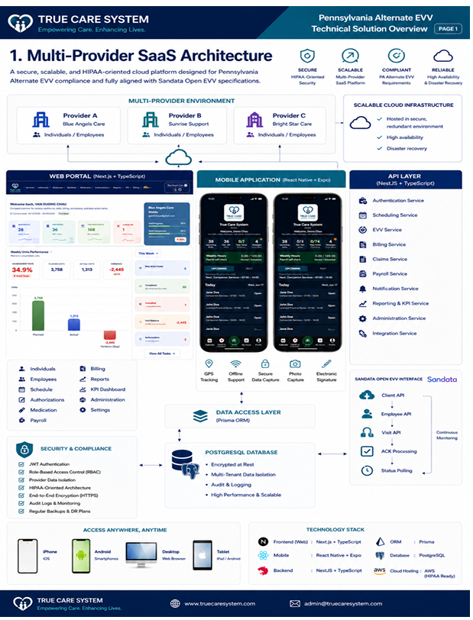
- Product Screenshots
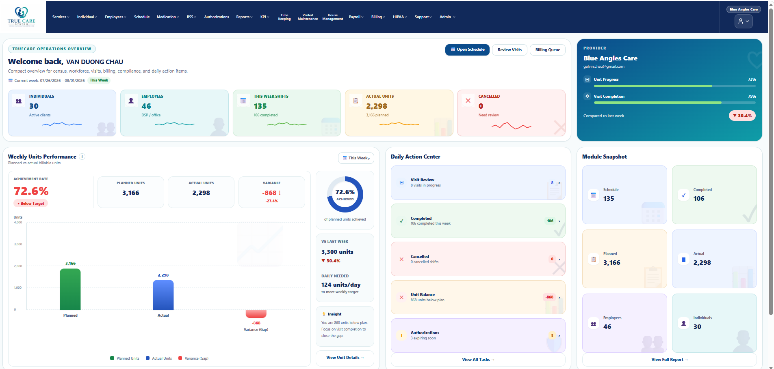
Dashboard
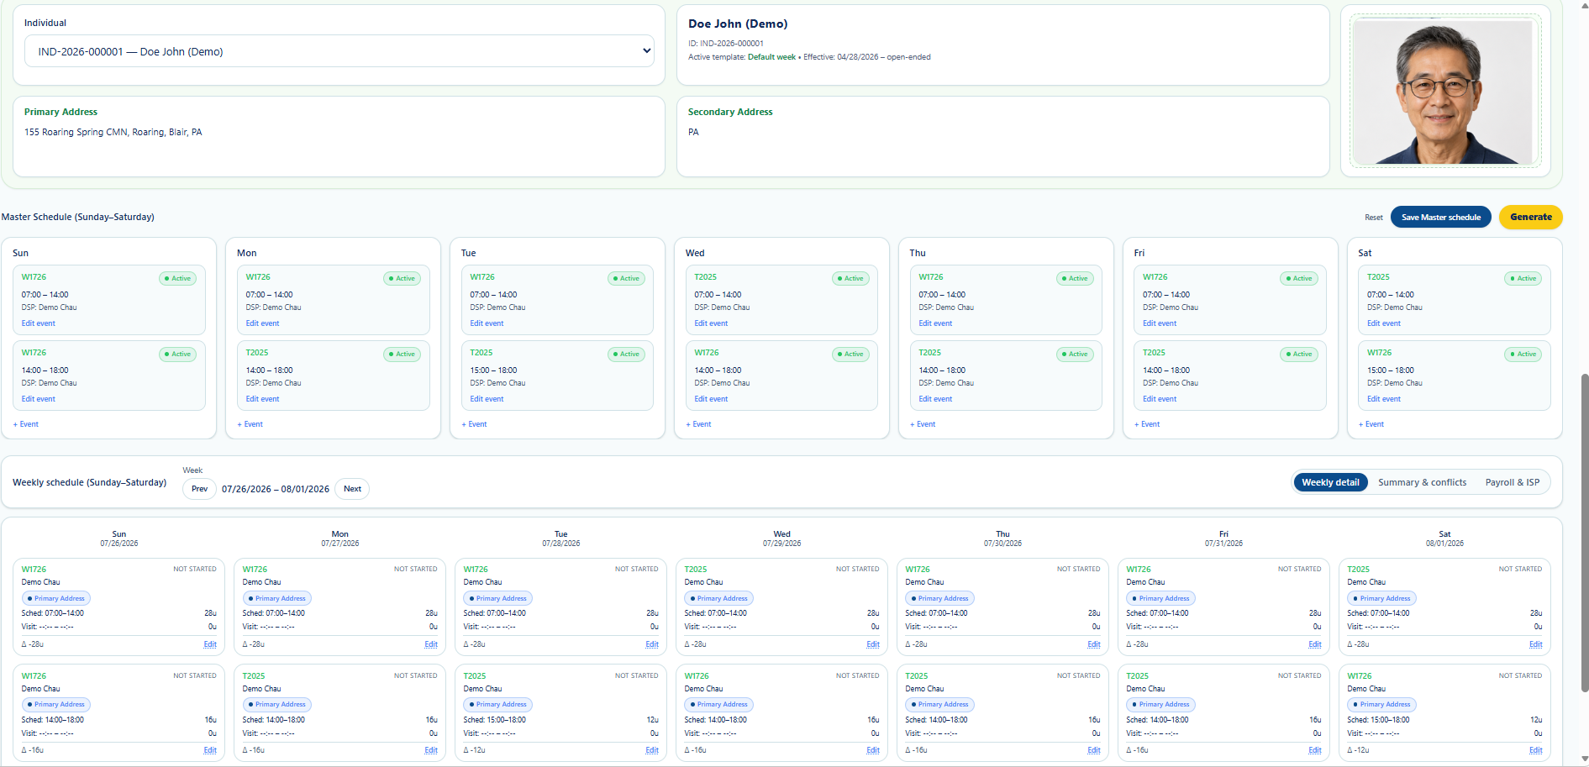
Scheduling
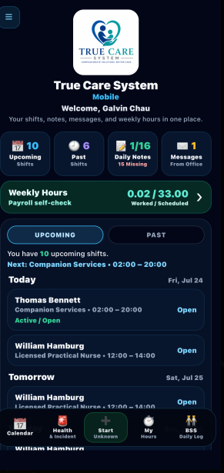
Mobile App
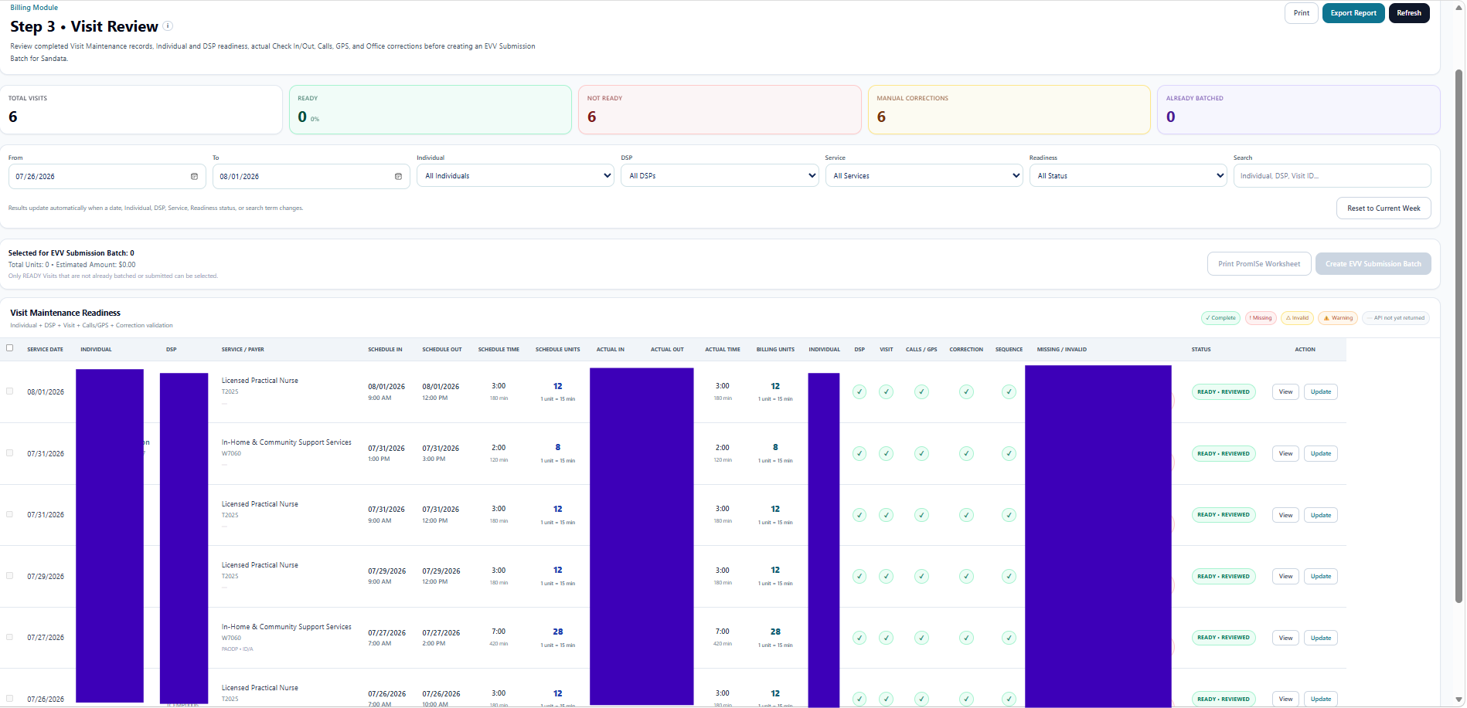
Visit Recorded
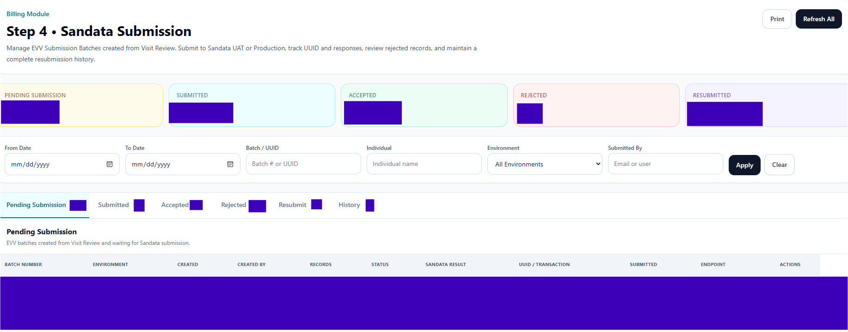
Billing
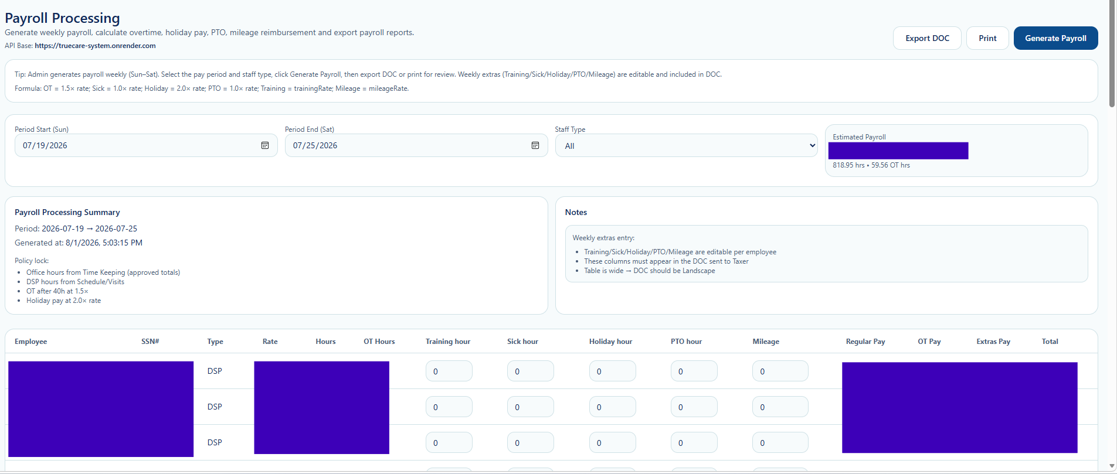
Payroll
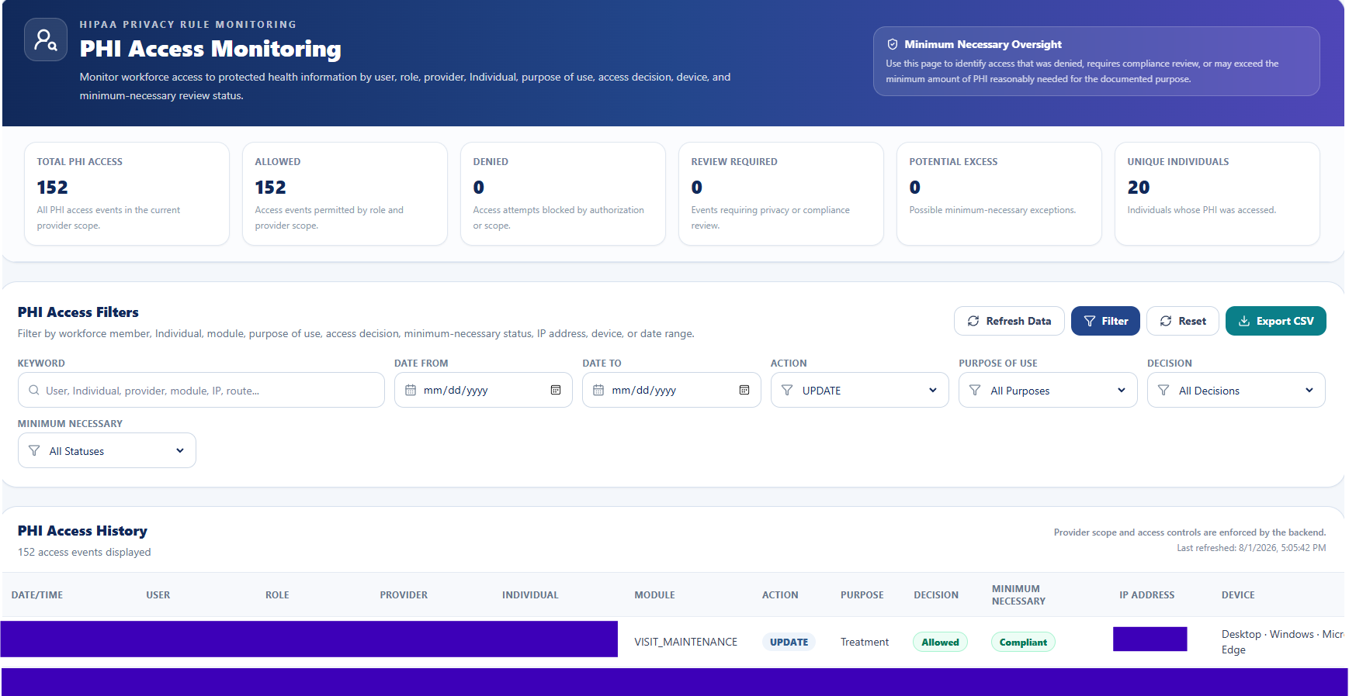
HIPAA
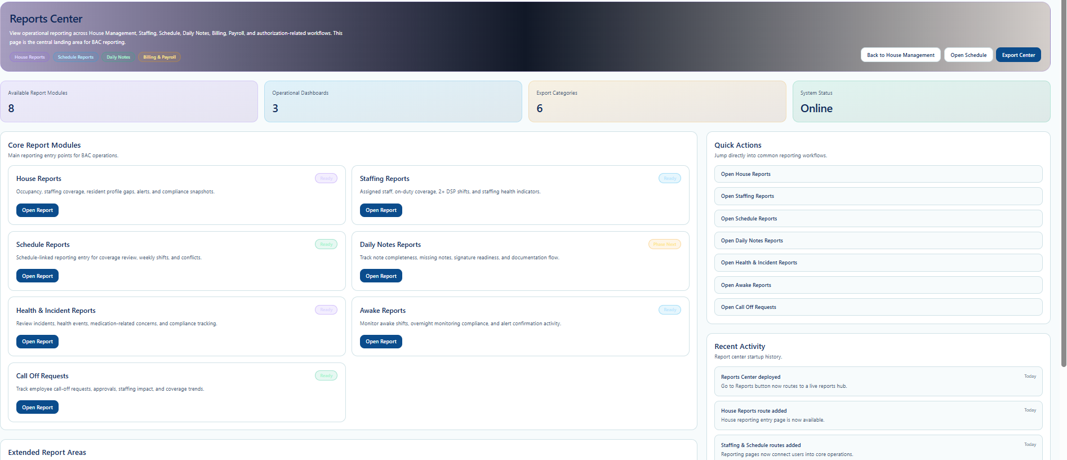
Reports Center

- Module Summary
Category | Modules
Administration | User, Role, Provider
Clinical | Individual, Medication, BSS
Workforce | Employee, Scheduling, EVV
Financial | Billing, Payroll
Compliance | HIPAA, Audit
Mobile | iOS, Android

Appendix C

Technology Overview

This appendix summarizes the underlying technology architecture used to develop, secure, deploy, and operate the True Care System platform.

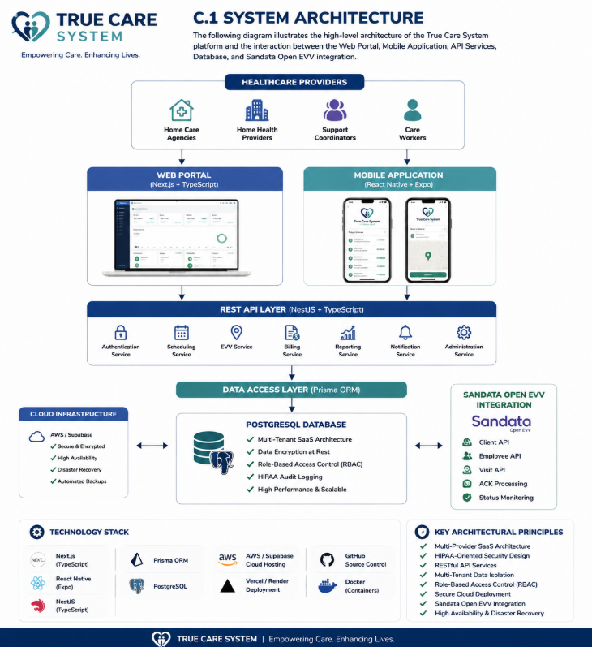
Figure 1. High-level architecture of the True Care System platform, demonstrating the integration of Web Portal, Mobile Application, cloud infrastructure, PostgreSQL, and Sandata Open EVV within a secure, scalable, and HIPAA-compliant SaaS environment.
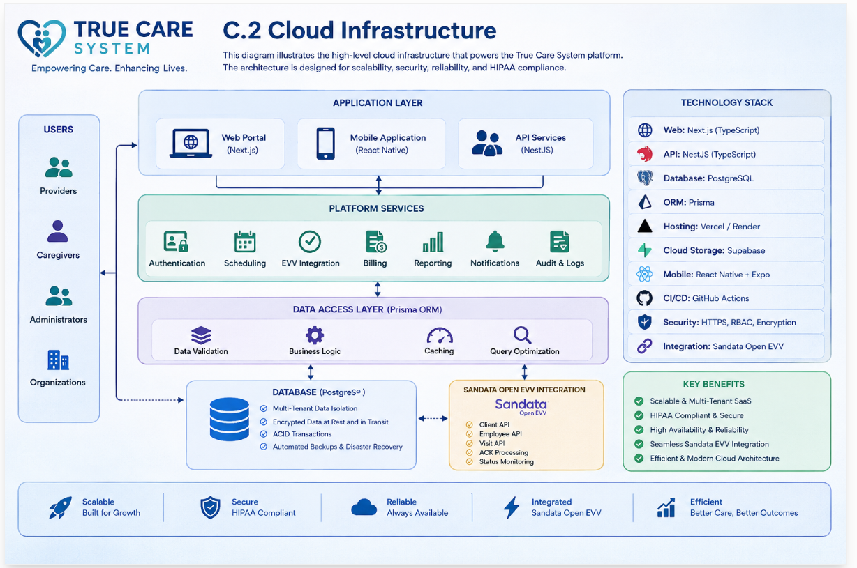
Figure 2. High-level cloud infrastructure architecture illustrating how True Care System leverages a modern, scalable, and secure cloud platform to support multi-provider SaaS operations, HIPAA compliance, high availability, and Sandata Open EVV integration.
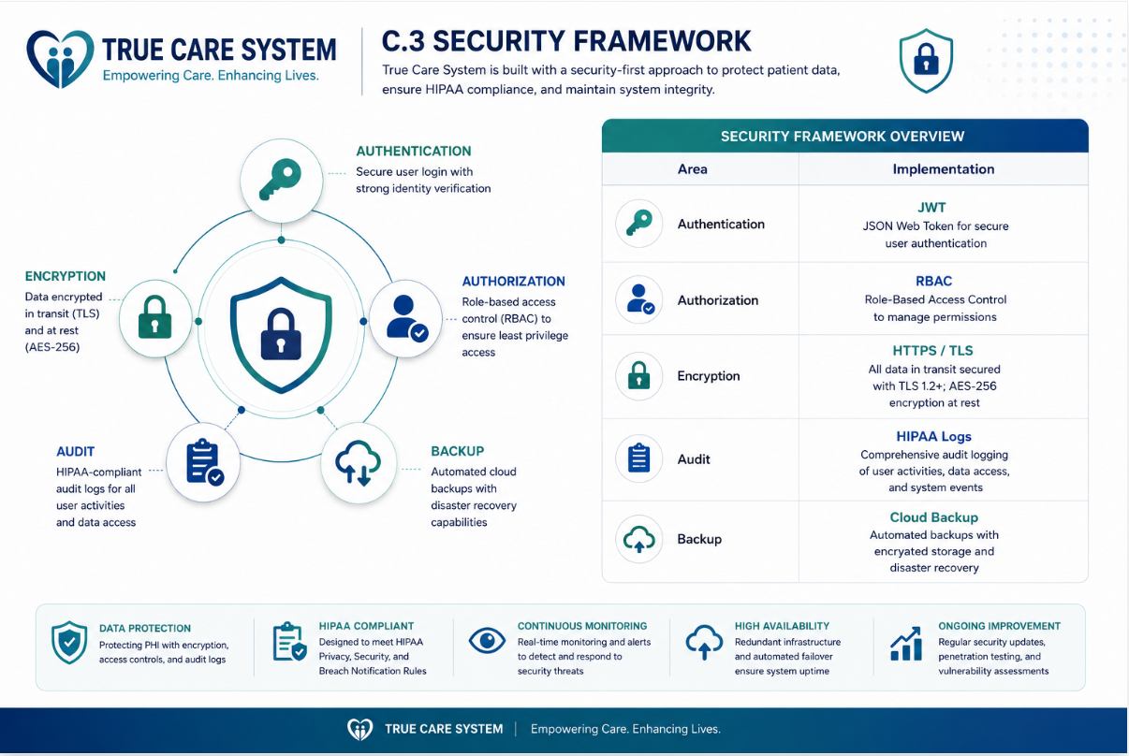
Figure 3. Security framework overview demonstrating the core security controls implemented by True Care System, including authentication, role-based access control, encryption, HIPAA audit logging, automated backup, and continuous security monitoring to protect sensitive healthcare information.

For partners interested in conducting a more detailed technical review, comprehensive product, architecture, API, implementation, HIPAA, and operational documentation is available through the True Care System Documentation Portal under the Documentation Support section of our website, or directly at:
https://www.truecaresystem.com/documentation/index.html
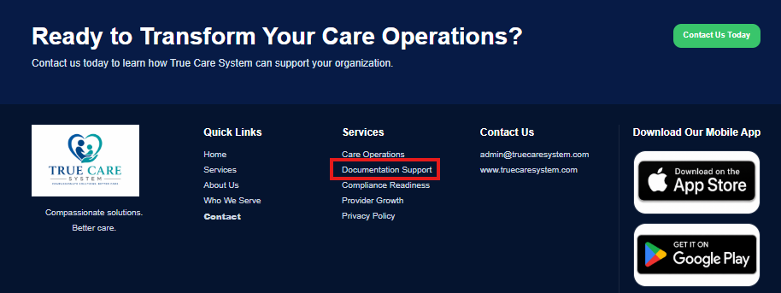

Appendix D

Sandata Production Integration

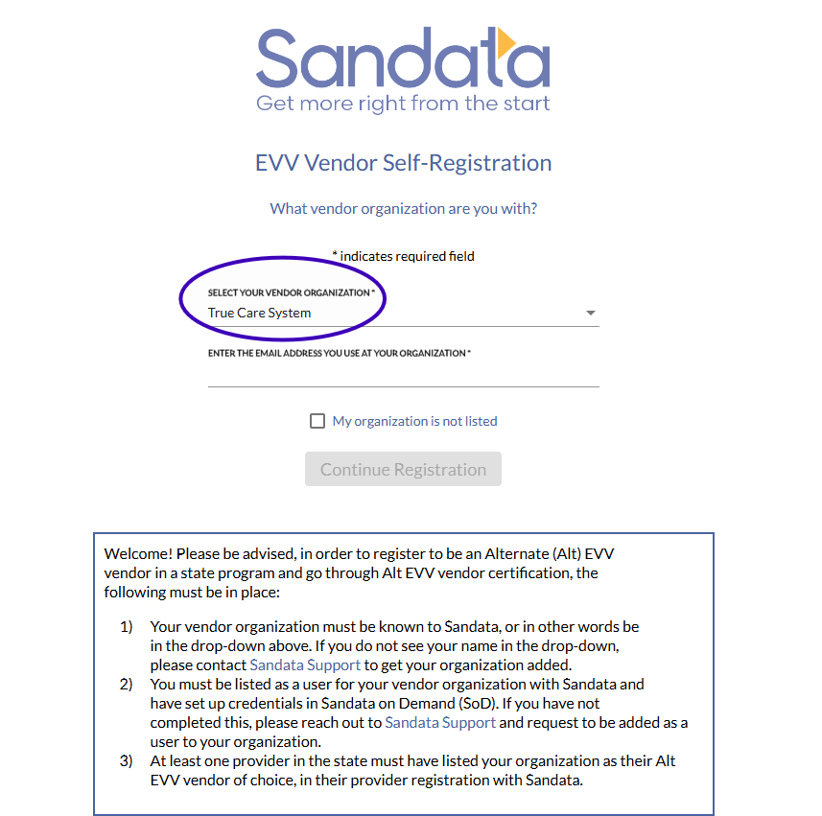
Figure 1: True Care System is officially listed as a registered EVV Vendor Organization within the Sandata platform, supporting certified EVV integration for participating healthcare providers.
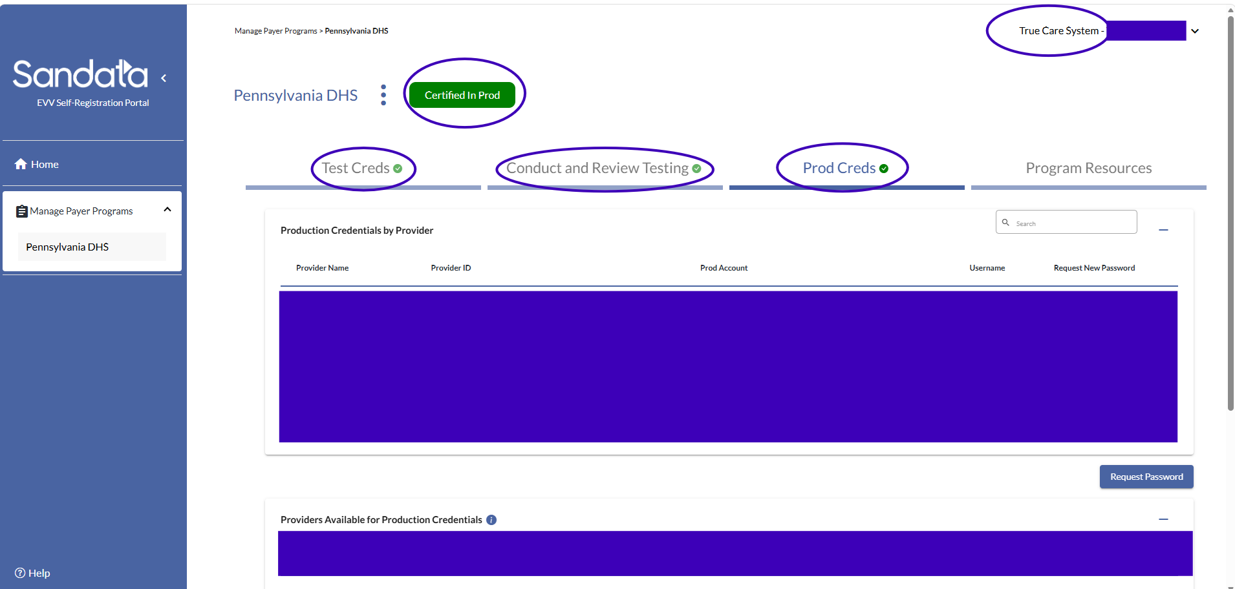
Figure 2. True Care System successfully achieved Sandata Production Certification ("Certified in Prod"), confirming that the platform has met Sandata's production integration requirements and is authorized to exchange EVV data with the Sandata Production environment.
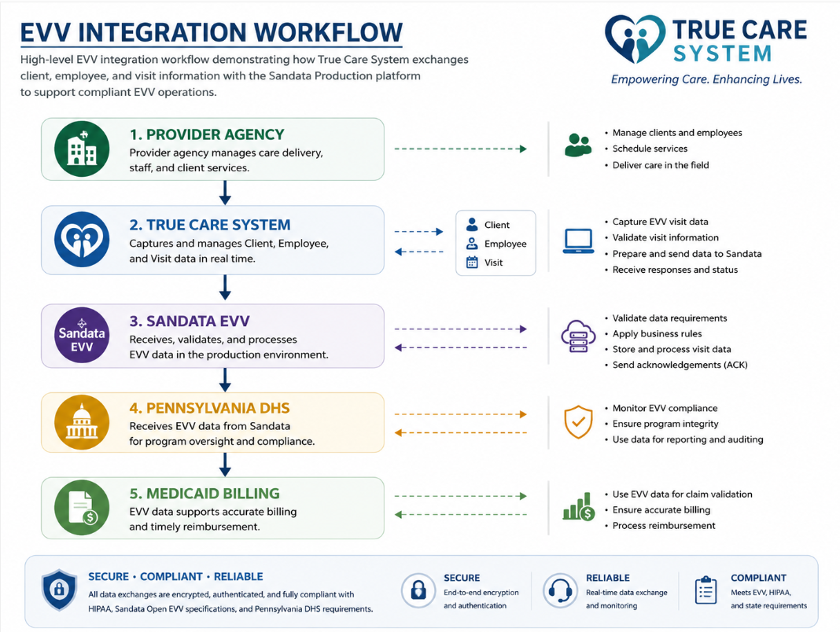
Figure 3. High-level EVV integration workflow demonstrating how True Care System exchanges client, employee, and visit information with the Sandata Production platform to support compliant EVV operations.
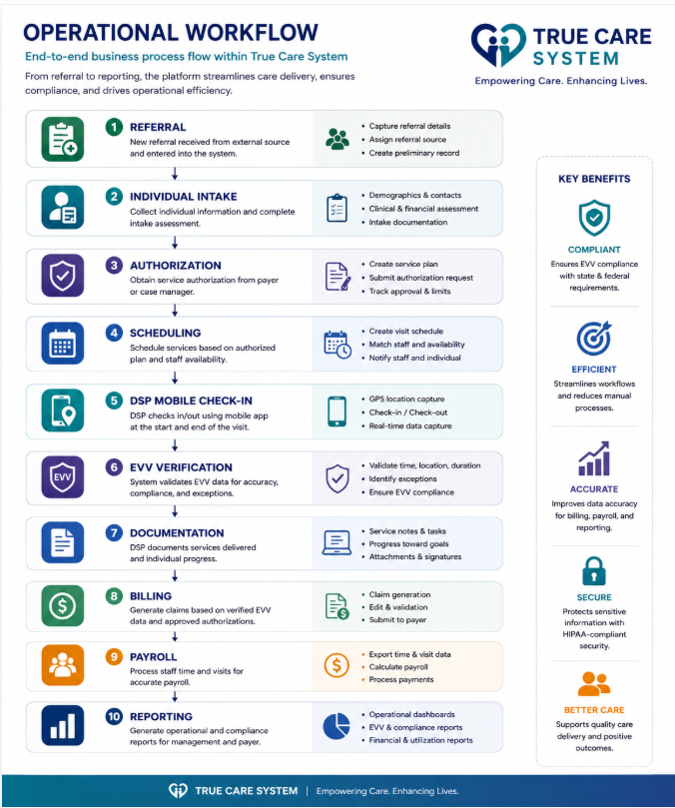
Figure 4. End-to-end operational workflow illustrating the complete care delivery lifecycle supported by the True Care System platform, from client intake through scheduling, EVV, billing, payroll, and operational reporting.

Closing Statement
The founders of True Care System are seeking more than financial investment. We are looking for strategic partners who share our long-term vision of building one of the leading healthcare technology platforms serving providers across multiple U.S. states.
We highly value partners who can contribute industry expertise, healthcare networks, operational experience, technology innovation, or strategic guidance. The founders believe that the right partnership can create significantly greater long-term value than capital alone, and therefore remain open to structuring a mutually beneficial partnership that aligns with the shared vision for True Care System.
We are committed to building a trusted, scalable, and sustainable healthcare technology company that delivers meaningful value to providers, caregivers, and the communities they serve.

Confidentiality Notice
This Investment Memorandum contains confidential and proprietary information of True Care System, LLC. It is provided solely for the purpose of evaluating a potential investment or strategic partnership.
Recipients are respectfully requested to maintain the confidentiality of all information contained in this document and not disclose, reproduce, or distribute any part of it without the prior written consent of True Care System, LLC.

Contact Information
If you are interested in learning more about True Care System or discussing a potential investment or strategic partnership, we would welcome the opportunity to connect with you. For further information regarding this Investment Memorandum or potential strategic partnership opportunities, please contact:
CEO: VAN DUONG CHAU
True Care System, LLC
Email: admin@truecaresystem.com
Thank you for your time and consideration.
We look forward to building the future of healthcare technology together.

