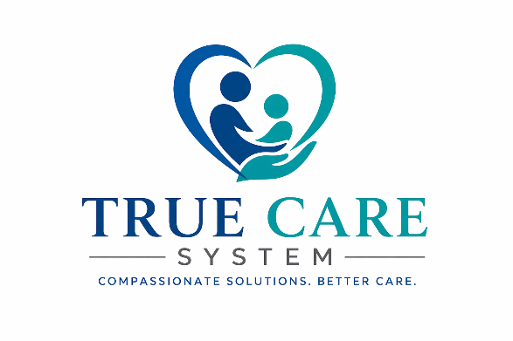
TRUE CARE SYSTEM, LLC
OPPORTUNITY SUMMARY
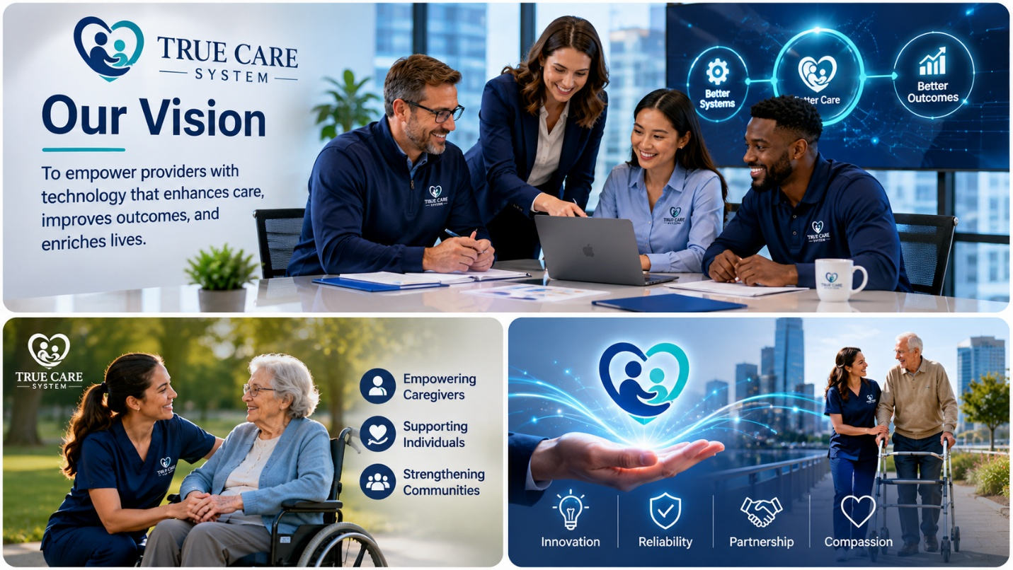

Production-Ready Healthcare SaaS Platform
Home Care • I/DD • Behavioral Health • Community-Based Services
Prepared for: Qualified Strategic Investors & Healthcare Partners

Website: http://truecaresystem.com
Email: admin@truecaresystem.com
August 2026
True Care System
Executive Opportunity Summary

True Care System is a cloud-based enterprise SaaS platform developed for Home Care, I/DD, Behavioral Health, and Community-Based Service providers.
The platform integrates patient management, workforce management, scheduling, EVV, billing, payroll, compliance, reporting, mobile applications, and enterprise administration into one unified healthcare ecosystem.
Developed from real-world healthcare operations, True Care System has evolved into a production-ready platform featuring HIPAA-oriented security, Sandata EVV Production integration, multi-tenant cloud architecture, and AI-ready technology.
After more than three years of product development, real-world operational validation, and continuous platform enhancement, True Care System has evolved into a production-ready healthcare platform and is now entering its commercialization phase, focused on strategic partnerships and multi-state expansion.

- Current Business Position
The Company has successfully completed the most resource-intensive phase of product development and has transitioned from concept validation into commercial readiness.
Key achievements include:
- Production-ready multi-tenant SaaS platform
- Native Web and Mobile applications
- HIPAA-oriented security architecture
- Enterprise documentation framework
- Production integration with Sandata EVV
- Support for complete healthcare operational workflows
- Scalable cloud infrastructure designed for multi-state deployment
- AI-ready platform architecture for future intelligent automation
Unlike many healthcare technology startups that are still building their core products, True Care System has already completed product development, achieved production deployment, and successfully integrated with the Sandata EVV Production environment. The platform has progressed beyond concept validation into commercial readiness, allowing future investment to focus primarily on business growth rather than core software development.
Today, True Care System is actively used by a licensed healthcare provider to manage its complete end-to-end daily operations, including patient management, workforce management, scheduling, Electronic Visit Verification (EVV), billing, payroll, compliance, reporting, and administrative workflows. This successful real-world deployment has validated the platform's operational reliability and demonstrated its practical value within an active healthcare organization.
Following successful Sandata Production Certification and official vendor registration, True Care System has become an approved technology platform capable of securely exchanging EVV data within the Sandata ecosystem. The successful implementation has also generated positive interest from regional healthcare stakeholders, and management has been encouraged to introduce the platform to additional provider organizations throughout the region following Sandata Production certification.
These accomplishments significantly reduce technology execution risk and provide a strong foundation for commercialization, customer acquisition, strategic partnerships, and future expansion across Pennsylvania and other Sandata-supported states.

- Market Opportunity
The U.S. healthcare industry continues to experience rapid growth in demand for technology solutions that improve operational efficiency, workforce management, regulatory compliance, and reimbursement accuracy.
Home Care, I/DD, and Community-Based Service providers increasingly require integrated software platforms capable of supporting complex regulatory environments while simplifying day-to-day operations.
True Care System is positioned to address this market by delivering an enterprise platform that combines operational management, compliance, mobility, and future AI capabilities into a single solution.
The Company's long-term vision is to become a trusted healthcare technology platform serving providers across multiple U.S. states.

- Why We Are Seeking Strategic Partners
The founders believe that the next stage of growth requires more than financial investment alone.
While the core platform has already been developed and validated, accelerating commercialization will benefit significantly from experienced strategic partners who can contribute industry knowledge, healthcare relationships, operational expertise, implementation experience, and market access.
Accordingly, True Care System is seeking partners who share the Company's long-term vision of building a scalable healthcare technology platform capable of serving provider organizations nationwide.
Future investment is expected to support:
- Customer acquisition and sales expansion
- Product enhancement and AI capabilities
- Customer implementation and success
- Multi-state commercialization
- Cloud infrastructure scaling
- Strategic partnerships and business development
Future investment will primarily support commercialization, customer acquisition, strategic partnerships, implementation capacity, and multi-state expansion, rather than core software development.
- Why True Care System
True Care System differentiates itself from many early-stage healthcare technology companies through several key strengths:
- Built from Real Healthcare Operations: Designed and validated through real-world provider operations rather than theoretical product assumptions.
- Production-Ready Platform: Fully developed, tested, and deployed, allowing investment to focus on commercialization instead of core software development.
- Sandata Production Certified: Successfully integrated with the Sandata EVV Production environment and authorized to exchange production EVV data.
- Proven in Daily Operations: Currently supporting the complete day-to-day operations of an active healthcare provider across clinical, operational, billing, payroll, and compliance workflows.
- Scalable Growth Platform: Built on a secure cloud architecture with multi-tenant capability, HIPAA compliance, and readiness for AI-driven automation and multi-state expansion.

- Partnership Philosophy
True Care System welcomes both financial investors and strategic partners. However, the founders believe the greatest long-term value can be created by partners who contribute not only capital, but also industry expertise, operational experience, healthcare relationships, and strategic guidance.
The founders believe that successful healthcare technology companies are built through complementary expertise, trusted relationships, shared vision, and disciplined execution.
Accordingly, the Company remains open to structuring future partnerships based not only on financial investment, but also on the strategic value, operational capabilities, healthcare network, and long-term contributions that a partner can bring to accelerate the Company's growth.

- Invitation
The accompanying Confidential Investment Memorandum provides a comprehensive overview of True Care System's technology platform, market opportunity, business strategy, commercialization roadmap, financial assumptions, operational development, and long-term vision.
We invite qualified investors and strategic partners to review the accompanying Confidential Investment Memorandum and explore opportunities to help accelerate the next stage of True Care System's growth.
We appreciate your interest in True Care System.
If you believe there may be a potential strategic fit, we would be pleased to continue the discussion. For additional information or to request the complete Confidential Investment Memorandum, please contact:
Van Duong Chau (CEO)
Email: admin@truecaresystem.com
Qualified investors and strategic partners will be provided with the Company's complete Confidential Investment Memorandum, which includes detailed information regarding the technology platform, commercialization strategy, financial assumptions, valuation methodology, operational development, and supporting materials for a comprehensive investment evaluation.
We look forward to discussing how we can build the future of healthcare technology together.

