1. Buttons: from left to right: Login Project Filter Sync
2. main workflow:

* login >> select project >> sync-download >> all issues will be downloaded to local database, and list in viewer.
* filter >> choose the filter (company, issue type, due date). you can firstly take a look at the list on desktop or iPad version to get an idea what kind of filter could be valid. >> only the issues the on-site engineer is interested in will be listed
* in the list view, the left icon of each item means issue status. The right icon means if it has attachments.

touch the area of left icon>> the status dialog will pop out, change the status if needed.

touch the area of right icon>> the attachment activity will pop out, change the status if needed.

* After you confirmed the status, click sync-upload. It will update the issues status to Field.

Click Login button

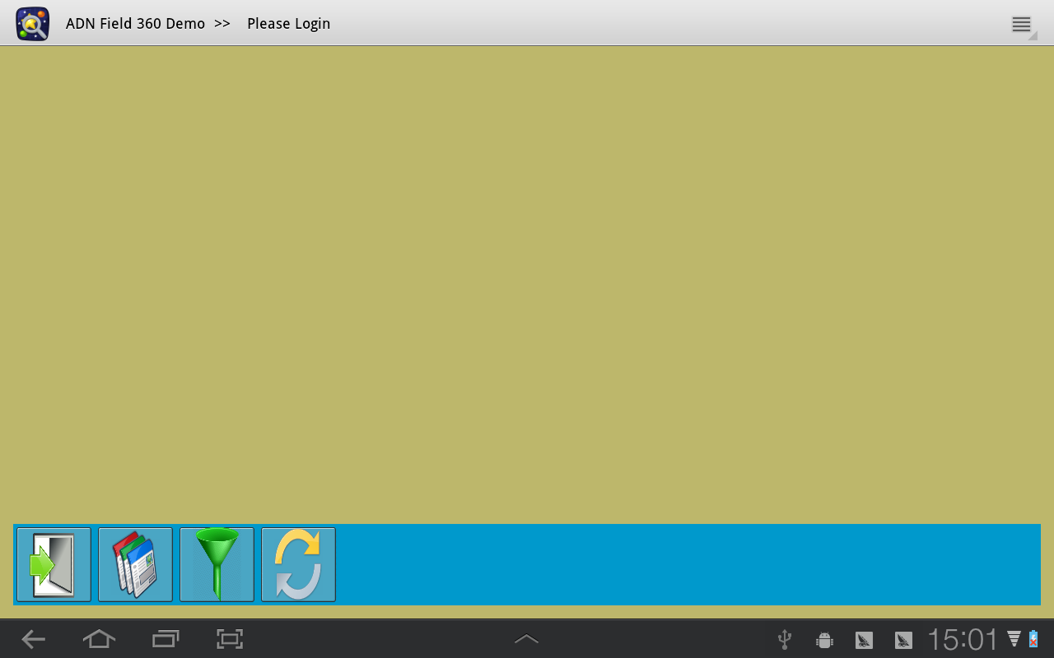

Sign in

It can auto complete the user name and password. It requires one successful login. After that, the user name and password are remembered.

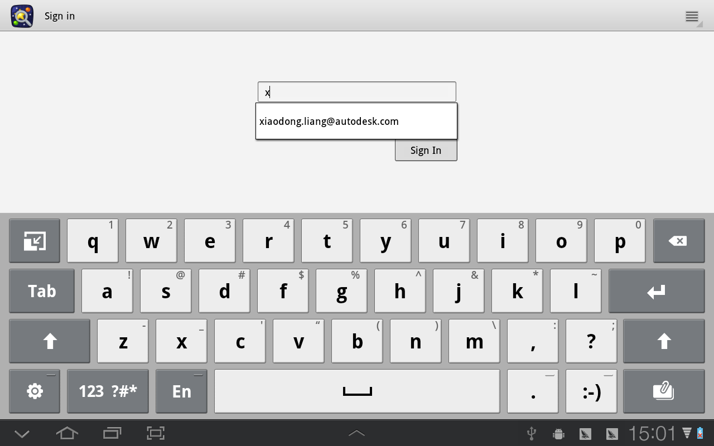

Click project button, select the project

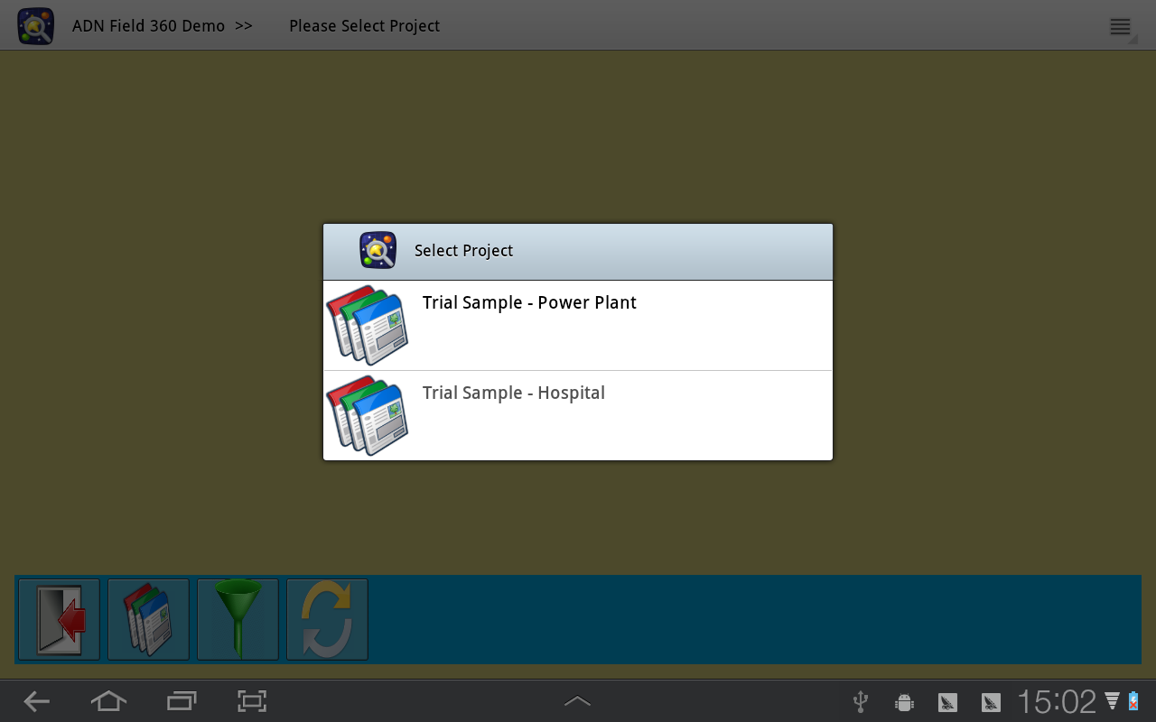

Click Sync button to download issues

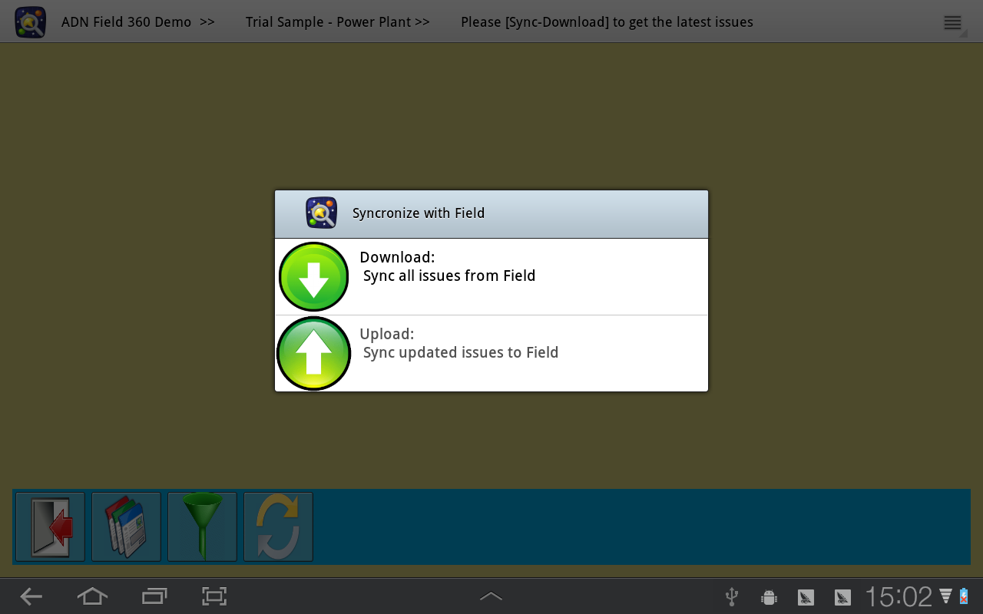

Click **the area of** the status icon. The status option dialog pops out

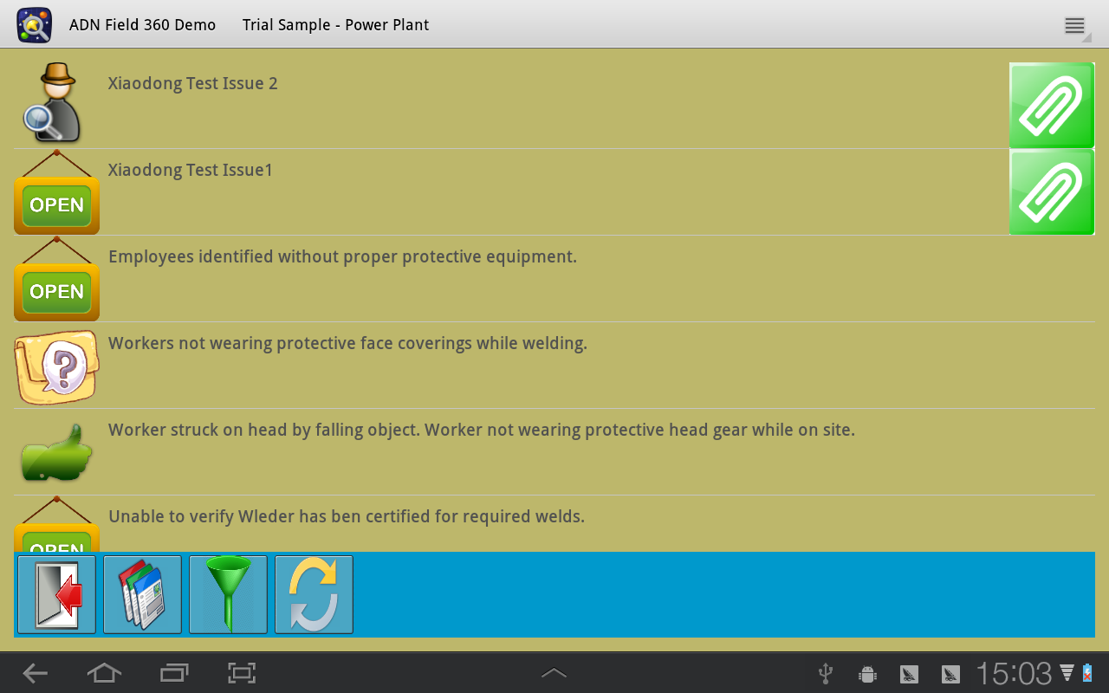

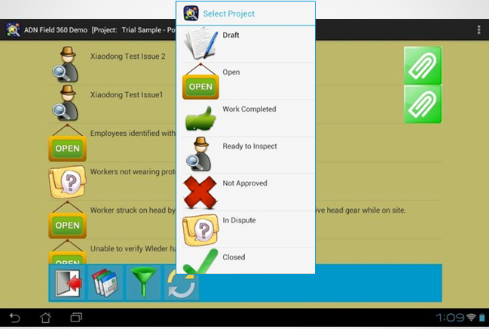

Click **the area of** the attachment icon, the attachment activity pops out, listing the thumbnails.

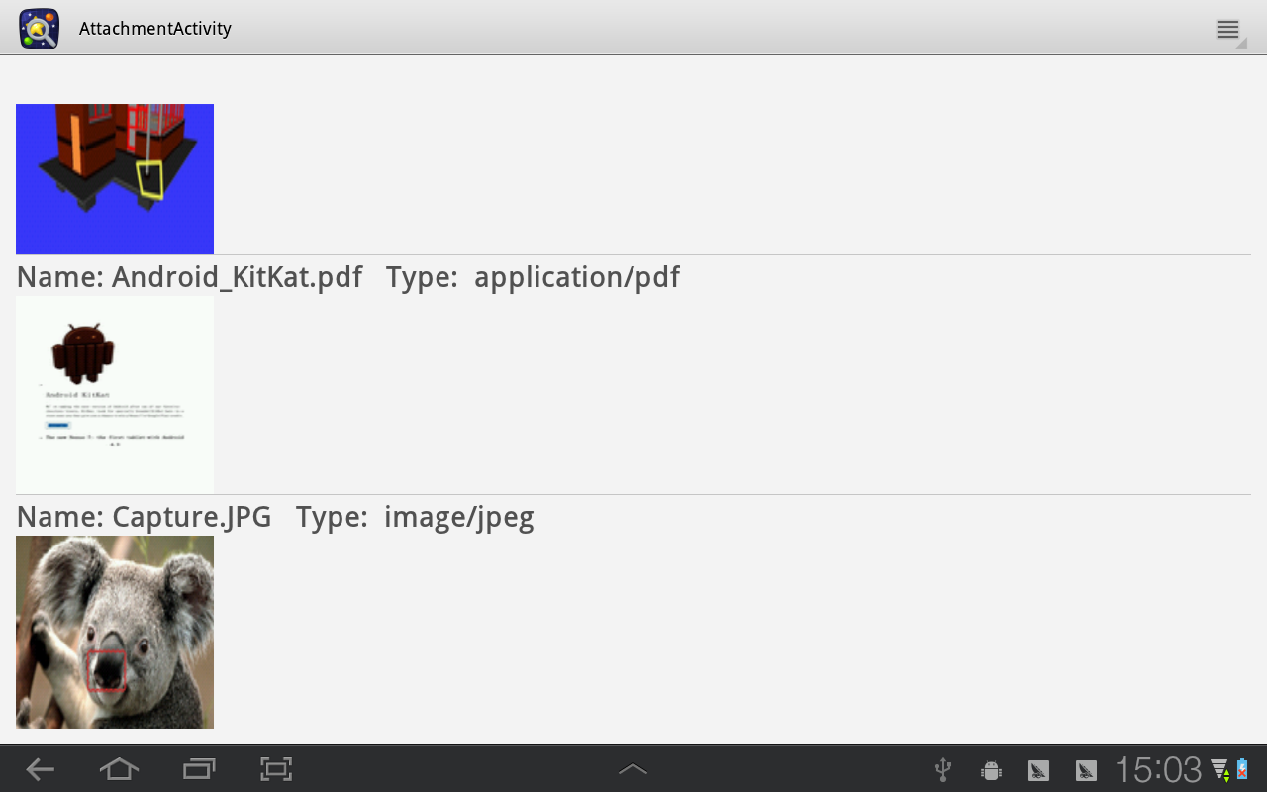

Click the item, the built-in photo viewer will pop out, you can view the big picture, including composite info if it is an image. If the attachment is not a picture, the photo still lists the thumbnail

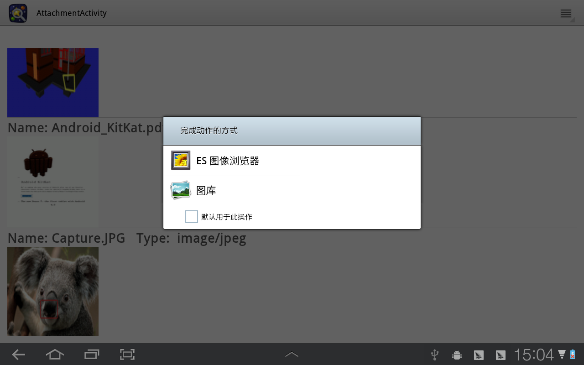

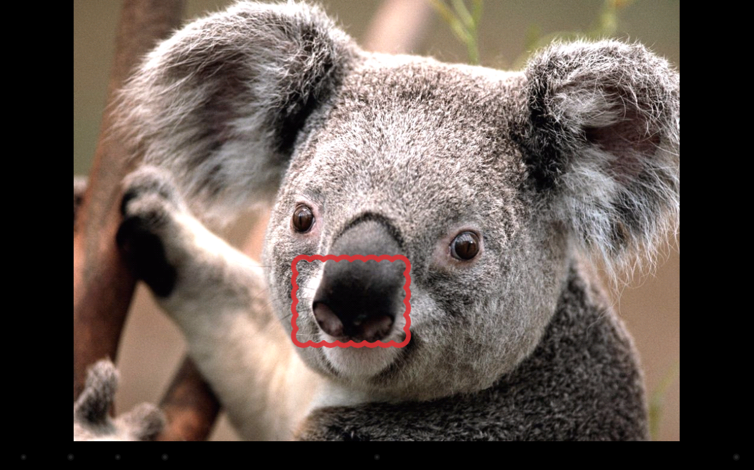

Click back arrow, you can return the last view.

Click filter button, you can set the filter.

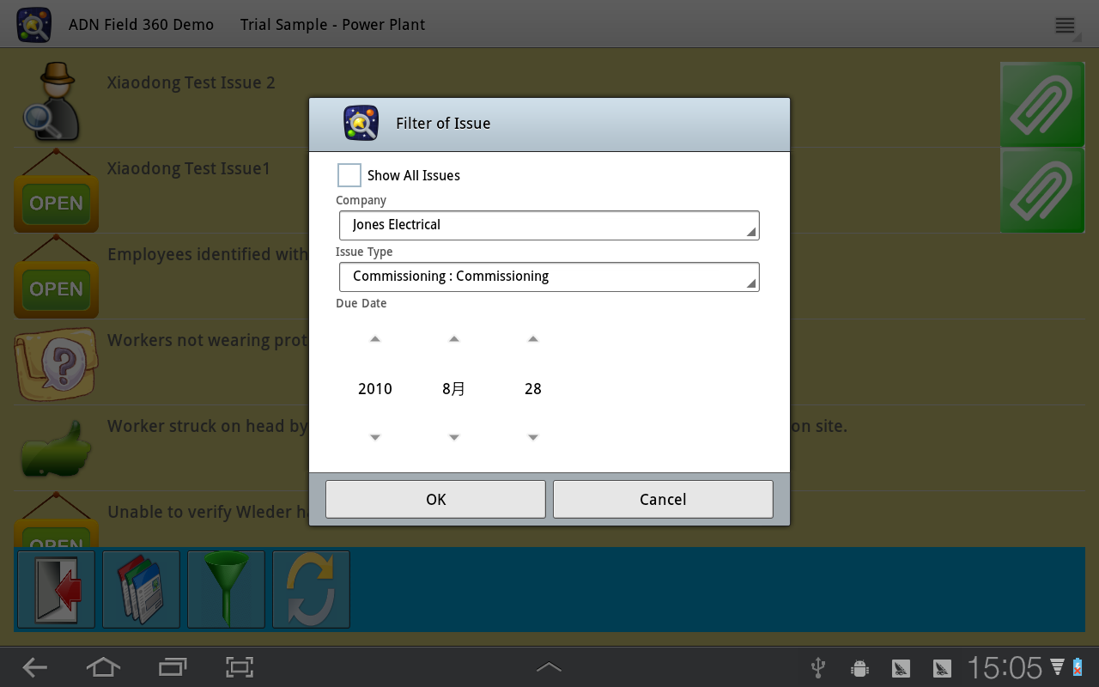

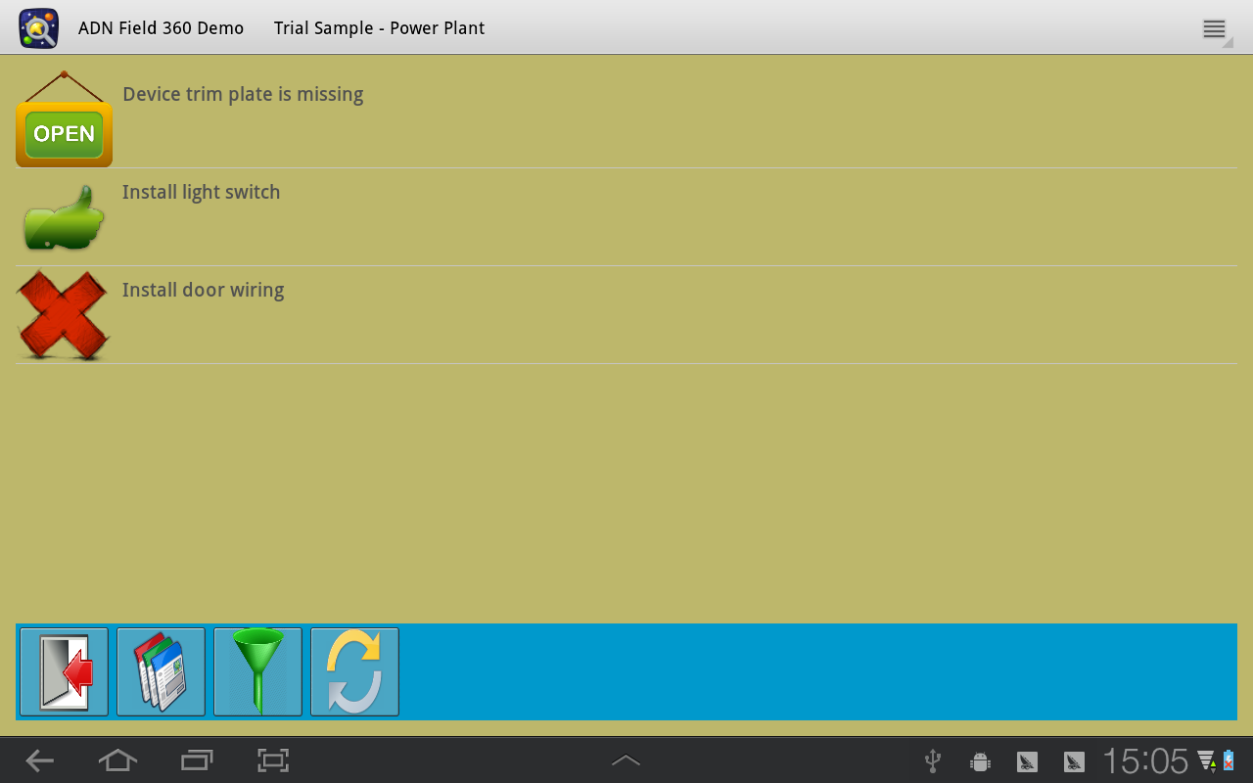

Finally, you can click Sync button to upload the update to field.

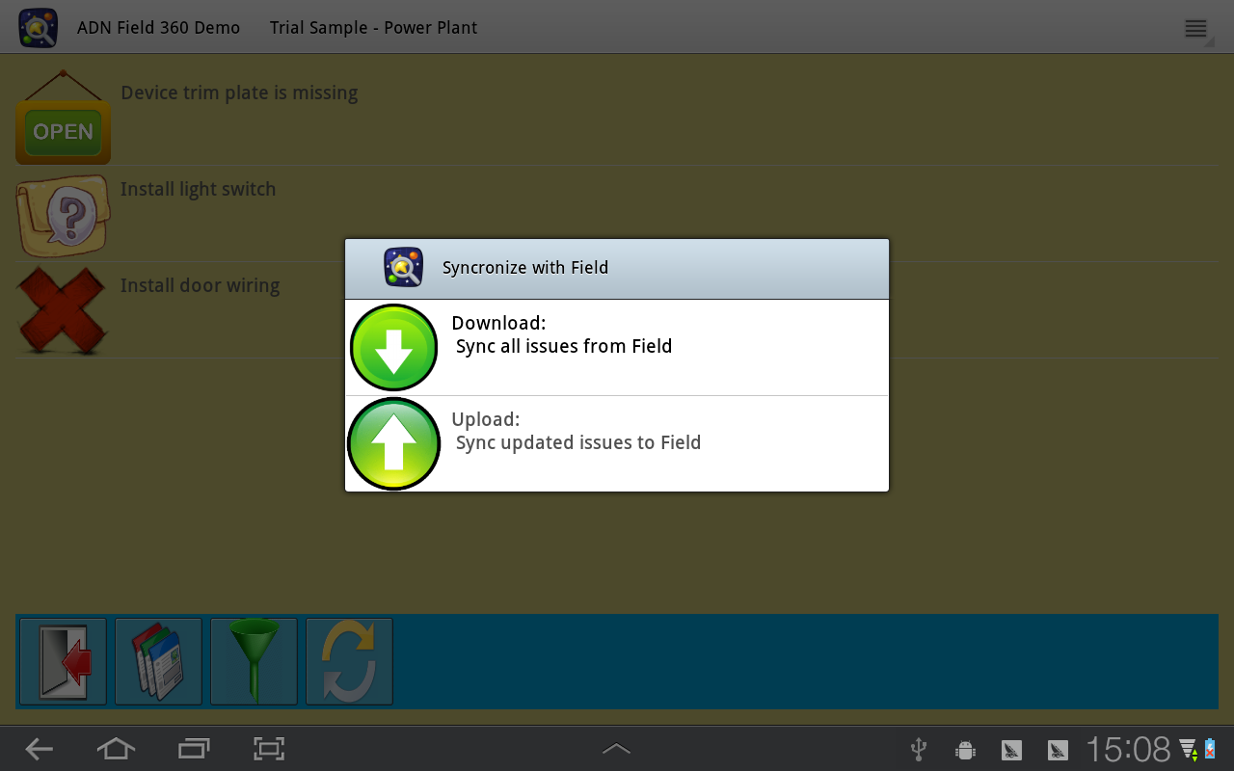

Xiaodong Liang

Developer Technical Services

Autodesk